The TalkTime call center is a very well known call center in Florida. The call center requires some employees to handle calls at night. They have conducted some interview session and have selected few candidates. The call center needs to develop an application for their daily operations.
Assume you are one of the developers at TalkTime call center and have to perform the following operations:
Create a desktop application to store the following data of an employee, including:
  - Name
  - Age
  - Address
  - Years of Experience (Limit it up to 0-2 years)
  - Phone number
  - Email ID
  - Date of Joining in the mm-dd-yyyy format
All the above information is stored in a text file (employees.txt) located in the current application’s directory.
The application GUI is divided into 2 regions:
On the left side: a table displays all the information of all employees in the text file
On the right side: provide necessary controls so that users can perform the following features:
- Add a new employee to the table
- Update an employee. User will select one employee from the table to update
- Delete an employee from the table
- Save data in the table to the text file.
- The application must provide a link to the Website of the TalkTime call center, which is http://talktime.com

You are free to organize your file format. One of the possibilities is:
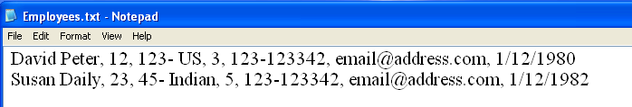

Submission Requirements
The exercise is contained in a project. All files must be packaged in .zip or .rar. At the beginning of your program, include comments with the following information formatted neatly, and reflecting accurate information for you.

/* Lab 3 */
/* Course: Summer 2010 - SE.4xx */
/* Family Name: Student */
/* Given Name: John */
/* Student Number: 123-456-789 */
/* */
/* I declare that the attached assignment is my own work in accordance with */
/* FPT UniversityPolicy. No part of this assignment has been copied manually */

