1. **Problem 1**

**1. Finding Entities, key Attributes and related Attributes**

* Entities: Hospital, Doctor, Patient, Treatment
* Key Attributes: Doctor: doctor code, Patient: patient identification, Treatment: date of treatment, duration of treatment, results.
* Related Attributes:
* Doctor: doctor's name, date of employment, specialty
* Patient: patient name

**2. Finding Relationship**

* One-to-Many Relationship: One Doctor can admit/treat multiple Patients, Hospital can save many treatments.
* Many-to-Many Relationship: A Doctor can treat multiple Patients, and a Patient can be treated by multiple Doctors.
* Hospital - Doctor: employ
* Doctor - Patient: Admit
* Patient - Doctor: Treated by
* Doctor - Treatment: Save

**3. Weak Entities and weak Relationship**

* Weak Entities: Treatment

**4. ER model**

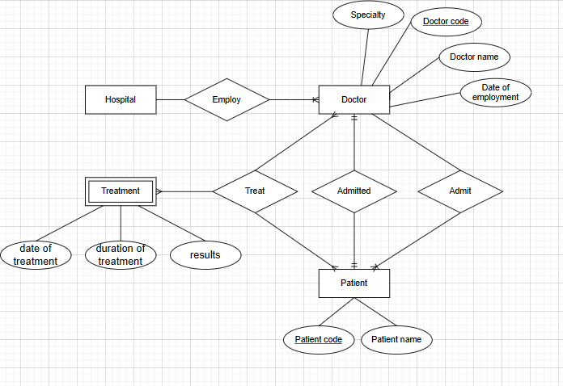

1. **Problem 2**

**1. Finding Entities, key Attributes and related Attributes**

* Entities: University, Faculty, Class, Student, Subject, Library Card
* Key Attributes:
* Faculty: Faculty Code
* Class: Class code
* Student: Student ID
* Subject: Subject code
* Library Card: Card number
* Related Attributes:
* Faculty: Faculty Name
* Class: Class name, Wholesale number
* Student: Full name, Date of birth, gender, address, graduation point
* Subject: Subject name, number of credits, exam score
* Library Card: Issue date, Expiration date.

**2. Finding Relationship**

* University - Faculty: Has (one-to-many)
* Faculty - Class: Has (one-to-many)
* Class - Student: Placed in(one-to-many)
* Student - Subject: Study (many-to-many)
* Library Card - Student: Owned (one-to-one)

**3. Weak Entities and weak Relationship**

* Entities: Library Card
* Relationship: Library Card - Student

**4. ER Model**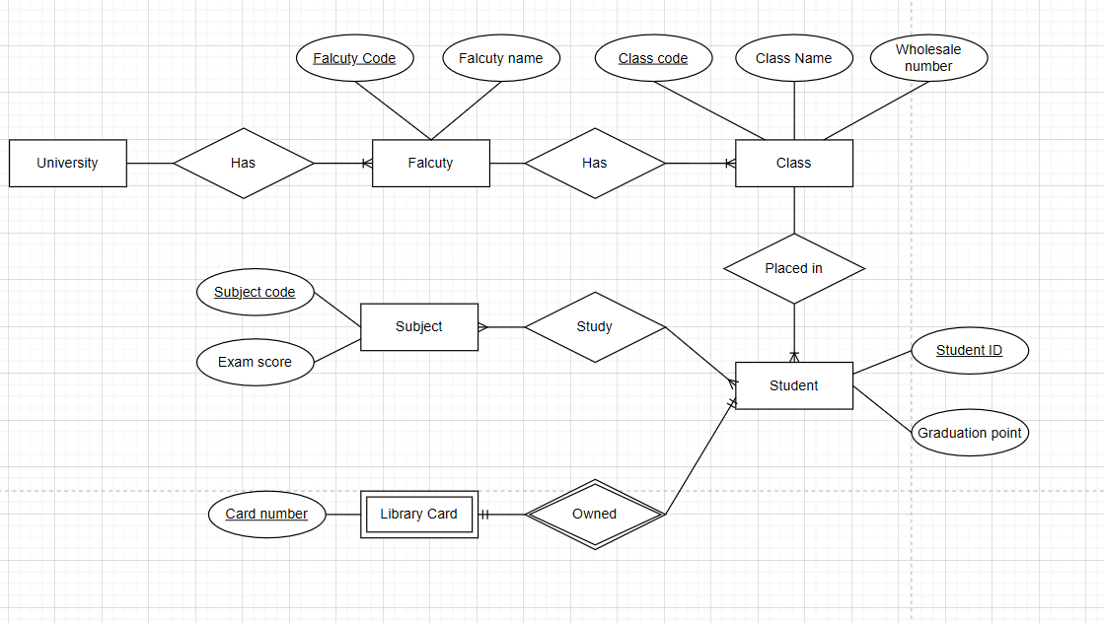

**Problem 3**

**1. Finding Entities, key Attributes and related Attributes**

* Entities: Hotel, Room, Floor, Guest, Service, Invoice
* Key Attributes:
* Room: Room Code
* Floor: Floor Code
* Guest: Identity card number
* Service: Service Code
* Invoice: Invoice Code
* Related Attributes:
* Room: room name
* Floor: floor name
* Guest: full name, phone number
* Service: service name, amount
* Invoice: identity card code, full name, number of days stay, room number, room price, service name, total service amount

**2. Finding Relationship**

* Hotel - Floor: Has (one-to-many)
* Floor - Room: Has (one-to-many)
* Room - Guest: Stay (many-to-many)
* Service - Room: Attached (many-to-many)
* Guest - Invoice: Pay (one-to-many)
* Room - Invoice: Include (one-to-many)
* Invoice - Service: Store (one-to-many)

**3. Weak Entities and weak Relationship**

**4. ER Model**

