1. **Problem 1 .Building an ER model from Database Schema**

**1. Finding Entities, key Attributes and related Attributes**

* **Entities:** Customers, Staff, Products, Invoice, Detail of invoice
* **Key Attributes:**
* Customers: Customer ID
* Staff: Staff ID
* Product: Product ID
* Invoice: Invoice ID
* Detail of invoice: Invoice ID, Product ID
* **Related Attributes:**
* Customers: FULLNAME, ADDRESS, PHONE, BIRTHDAY, SALE, REGISTRATION DATE
* Staff: FULLNAME, DAY OF ENTRY, PHONE
* Product: PRODUCTNAME, UNIT, NATION, PRICE
* Invoice: PURCHASE DATE, CUSTOMERID, STAFFID, VALUE
* Detail of invoice: QUANTITY

**2. Finding Relationship**

* Customer - Invoice: Received (One-to-Many)
* Customer - Product: Buy (One-to-Many)
* Staff - Invoice: Handle (One-to-Many)
* Invoice - Detail of Invoice: Contain (One-to-Many)
* Product - Detail of Invoice: Included (One-to-Many)

**3. Weak Entities and weak Relationship**

**4. ER model**

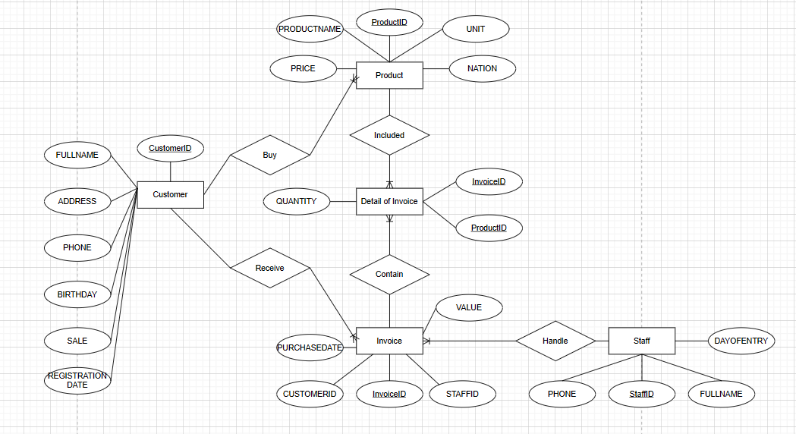

1. **Problem 2**

**1. Finding Entities, key Attributes and related Attributes**

* Entities: Employees, Department, Projects, Relatives, Location
* Key Attributes:
* Employees: EmployeeID
* Department: DepartmentID
* Projects: ProjectID
* Relatives: Name
* Related Attributes:
* Employees: Full name(Middle and First Name), DOB, Address, gender, Salaries, Position, ManagerID, Department, Working Hours
* Department: Room name, ManagerID
* Projects: Project Name, Location
* Relatives: DOB, Relationship

**2. Finding Relationship**

* Department - Employee: Belong (One-to-Many)
* Department - Location: Has (One-to-Many)
* Department - Projects: Manage (One-to-Many)
* Employees - Projects: Participate (Many-to-Many)
* Employees - Relatives: Has (One-to-Many)

**3. Weak Entities and weak Relationship**

* Entities: Relatives
* Employees - Relatives: Has (One-to-Many)

**4. ER Model**

