Xin Chao AA

Ban La HUong

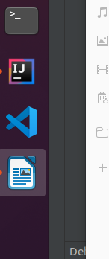

Buoc 1: ssh oracle[/vit3@2016](mailto:monitor/vit3@2016) vao db

Buoc 2: cd /u01/app/oracle/admin/idico/dpdump/

Buoc 3: backup file

mv myexp.dmp myexp.dmp_bk

mv myexp.log myexp.log_bk

Buoc 4: cd *u01*

Buoc 4: chay lenh:

expdp SYSTEM DUMPFILE=myexp.dmp FULL=y LOG=myexp.log

Nhap user/pass cua sys:

sys/vit3#2016

Ket qua la 2 file: myexp.dmp va myexp.log

Rooid aO

1. 1. aaa

2.XXX