Royal University of Phnom Penh 2026-Feb-11
Dr. VENG Sotheara
Math for Data Science

Applications of Fast Fourier Transform: Audio de-noising and Speech enhancement
- Introduction
Audio denoising is the critical process of isolating and removing unwanted background interference (noise) from a primary audio signal to improve its clarity and fidelity. In the context of speech processing, this is essential for high-fidelity audio consumption and for preparing clean datasets for machine learning tasks. This project explores the transition of sound from a physical wave to a digital representation and the use of the Fast Fourier Transform (FFT) to filter out non-stationary background noise, such as that from a coffee machine or traffic.

- Foundation of Digital Signal Processing
To understand how audio is cleaned, we must first define the mathematical tools and terms used in the process
- The Fourier Transform (FT): The FT acts as a mathematical "prism," allowing us to see the individual frequency components (colors) of a signal that are otherwise tangled in the time domain. To understand this, imagine trying to have a conversation at a crowded party filled with talking and music. The FT acts as a magical pair of glasses that allows you to see each distinct sound as a specific color, enabling you to identify your friend's voice and filter out the distracting background elements. The Fast Fourier Transform (FFT) is the optimized algorithm used to compute this shift efficiently.
- Non-Stationarity: Human speech is non-stationary, meaning its frequency content (pitch and volume) changes every few milliseconds.
- Short-Time Fourier Transform (STFT): Performing a single FFT on a whole recording would mix the constant noise and blend it evenly with human speech. To solve this, we use the STFT, which divides the audio into small frames (20 - 40ms) and applied FFT on the divided window before moving to next frames. Here the overview of STFT:
- The Windowing (The Frames): The STFT breaks the long audio signal into tiny, overlapping chunks or "frames" (usually 20 - 40ms).
- The Individual FFTs: A "Normal FFT" is performed on each individual frame. This tells us which frequencies are present during that specific 20ms of time.
- The Stacking: These vertical slices of frequency data are lined up side-by-side chronologically.
FFT on whole noisy audio
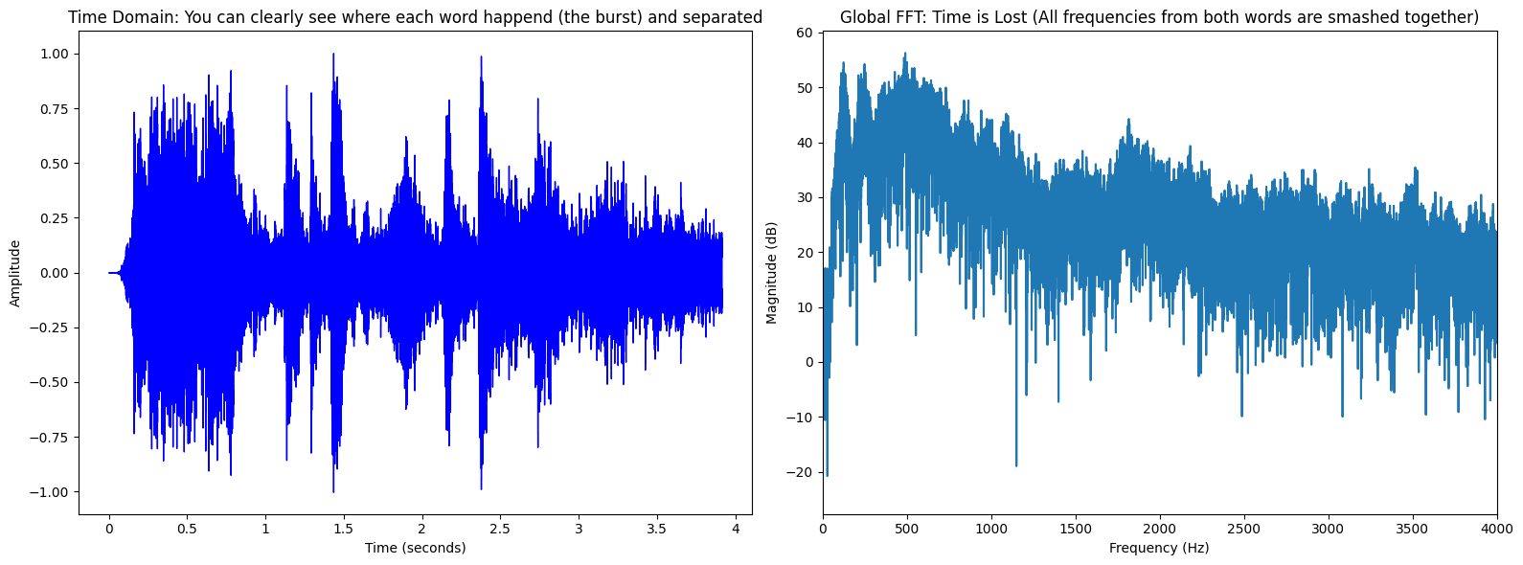
All the peak (frequency) extract by FFT is smear together, because of human speech is non-stationary and change every seconds. So with FFT alone, we don’t know when each sound happened.
FFT on whole audio vs short timeframe comparison
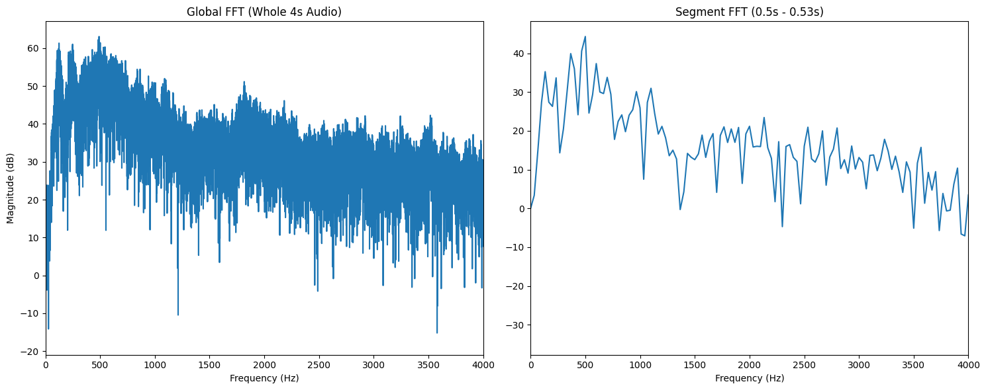
By applying the FFT to a small, 30ms segment of audio rather than the whole signal, we gain significant clarity in the frequency domain. There is distinct peaks between 0 – 1000 Hz and the rest of signal above 1500 Hz levels off significantly, resting at a magnitude of approximately 20 dB.
STFT on noisy audio
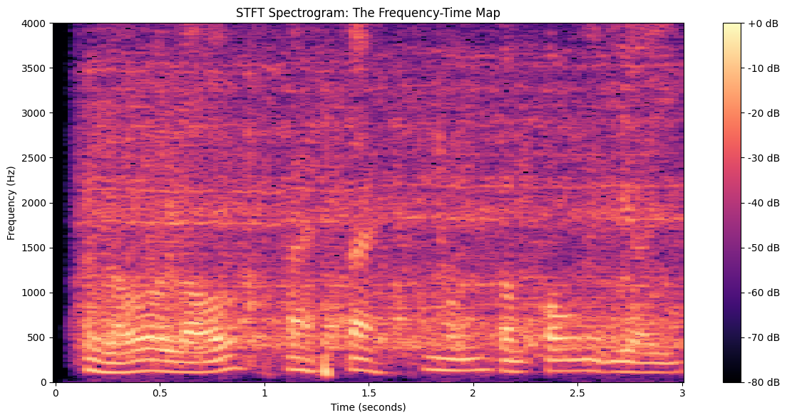
The Short-Time Fourier Transform (STFT) create a spectrogram "3D heat map" that plots frequency against time, with color intensity representing magnitude (loudness). This visualization reveals two distinct properties of the signal:
  - Speech Characteristics: Between 0 - 1500 Hz, There is high-intensity (bright) signal. These represent human speech, their abrupt starting and stopping points confirm the non-stationary nature of the voice. By comparing this to the time-domain waveform, we can see these "islands" of energy correspond exactly to the amplitude bursts between 0.5 - 1.0s and 1.5 - 2.0s.
  - Noise Floor: Throughout the entire recording, a lower-intensity haze "lower" (purple color) is visible across higher frequencies and persists even during the gaps in conversation.
- Methodology
We have tested few different strategy in denoising as below:
Method 1: Spectral Subtraction - Fixed Noise Subtraction
- Logic: Initially, we calculated the mean noise power of the first 0.1s and created a basic binary mask: if a frequency was louder than the noise, it stayed; otherwise, it was silenced. We then evolved this by introducing a subtraction factor alpha (α) and a spectral floor beta (β)
- Result & Trade-off: The initial binary approach produced significant "Musical Noise" (robotic chirps) because the binary "on/off" nature of the mask created jagged edges in the frequency domain. Adding the spectral floor ensured that background noise never dropped to zero, making the audio sound more natural and less "dead". However this method also assume that noise happened right in the beginning of the audio and stay more or less the same during the entire audio, so it might struggle on non-stationary noise such as engine noise etc.
FFT on initial 0.1s of audio to identified noise signal
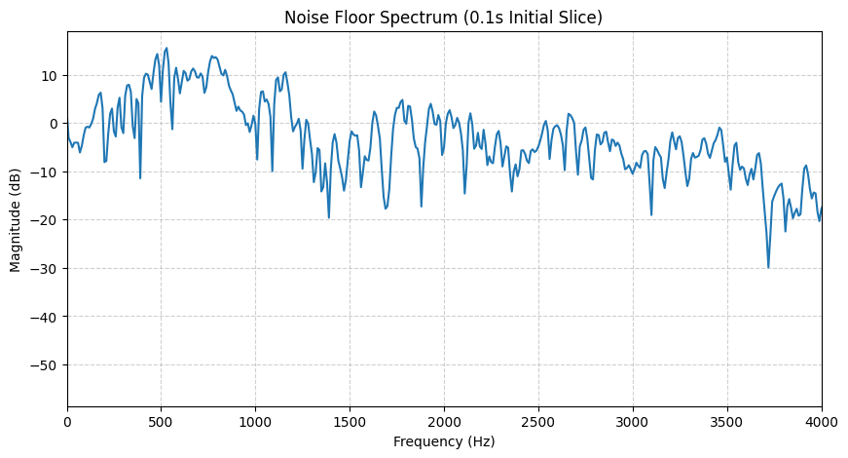
We capture the first 0.1s of audio (assuming it is period before human start talking) as baseline for noise floor. During filtering, if the frequency of speech is not louder than noise, we will deem it a noise and reduced it.
Method 2: Wiener-Style Filtering: Unlike Spectral Subtraction, which treats noise as a fixed value to be removed, Wiener-style filtering treats noise as a statistical probability.
- Logic: It calculates a Gain for every time-frequency bin based on the Signal-to-Noise Ratio. If a frequency bin has high power compared to the noise floor, the gain is near 1.0 (passed through). If the power is low (likely noise), the gain drops toward 0.0 (suppressed)
- Result: This provided a smoother, more "mathematically optimal" reduction but still struggled with changing background sounds.
Method 3: Adaptive Median-Based Denoising - Adaptive Median -Noise Subtraction
- Logic: Instead of taking a single noise snapshot at the beginning, the algorithm uses a Sliding Median Filter. The Sliding Window: It analyzes a 1.5-second window around every moment of the audio
- The Median Logic: Because speech is "bursty" (it has gaps between words), the median energy in a 1.5-second window represents the consistent background noise, even while someone is talking
- Dynamic Tracking: As the coffee machine gets louder, the median value rises, and the filter automatically subtracts more.
- Result: This help the algorithms adapt to non-stationary background noise.
- Pipeline Implementation
Whether using basic subtraction or advanced statistical filters, our implementation follows a standard 6-step pipeline:
- Load: The physical sound wave is digitized and loaded into an array of numbers.
- STFT: The Short-Time Fourier Transform breaks the audio into a Spectrogram, revealing a map of frequencies over time.
- Noise Estimation: The algorithm analyzes a specific portion of the audio (e.g., the first 0.5 seconds) where no speech is present to calculate the "average noise" baseline or Median windowing to estimation the background noise throughout the audio.
- The Mask (The Filter): A set of mathematical instructions is generated. If a frequency is louder than the noise estimate, it is kept; if it is quieter, it is deemed noise and reduced.
  - Alpha (α): Determines how aggressively to remove noise. A high α kills more noise but can make the voice sound thin.
  - Beta (β): Known as the "Spectral Floor." Instead of reducing noise to absolute zero, it sets a minimum threshold (e.g., 15%) to maintain a natural sound.
- Smoothing: The mask is blurred over time so volume adjustments are gradual, preventing sudden, unnatural audio glitches.
- iSTFT (Reconstruction): The Inverse FFT is applied to transform the manipulated frequencies back into a listenable time-domain sound wave
Result
Comparison Time-Domain of Noisy and Cleaned Audio
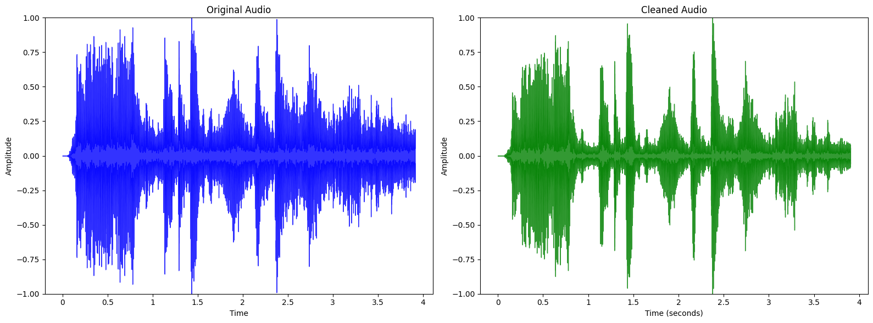
Note there is significant reduction in amplitude during non-speech burst intervals. This indicates that the background amplitude has been suppressed.
Comparison Spectrograms of Noisy and Cleaned Audio
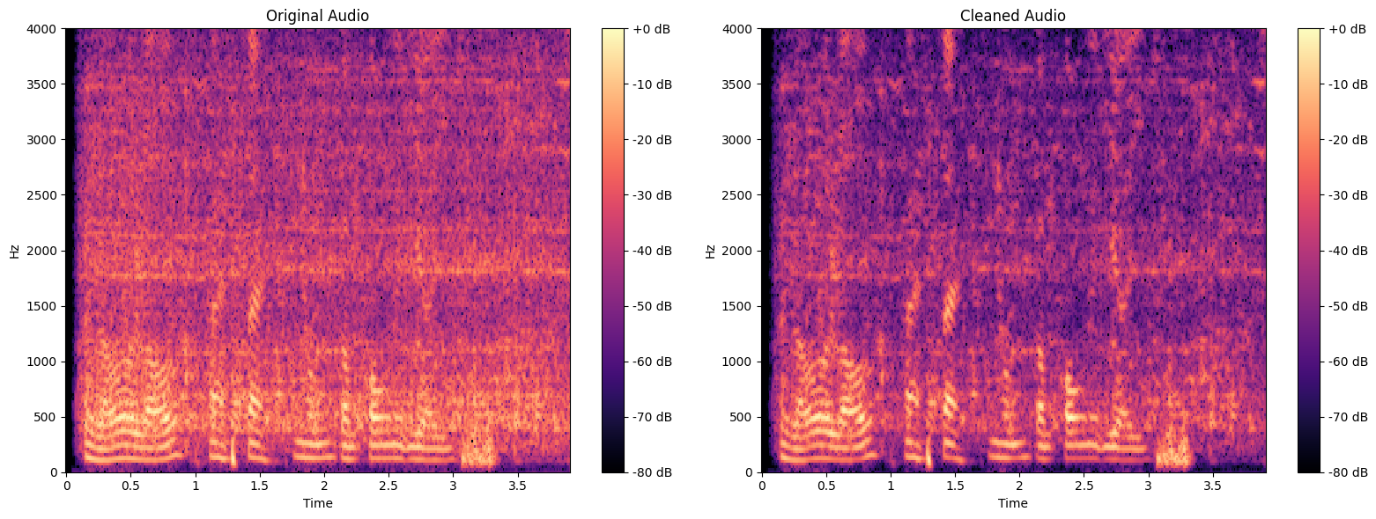
We see that the background haze from the original audio is noticeably darker (lower intensity) on the cleaned audio. While the speech signal (brighter color from 0 – 1500 hz) remain bright and sharp. We can conclude that the algorithms have successfully reduce the background while preserving the integrity of human speech.
- Engineering Trade-offs and Limitations
- Musical Noise vs. Naturalness: If we subtract 100% of the noise, the resulting audio has "holes" that sound like robotic chirping (Musical Noise). To fix this, we implement a Spectral Floor (beta) of 0.15, which leaves 15% of the noise floor intact to keep the audio sounding natural.
- Latency vs. Frequency Resolution: Using a larger FFT window (e.g., 2048) provides better frequency resolution, making it easier to target specific noises. However, it increases processing time (latency), which is a trade-off if this were used for real-time applications like a live phone call.
- Limitation: While Short-Time Fourier Transform has reduce background noise and improve audio quality; it does not completely remove the noise.

- Conclusion
By applying the FFT via the STFT pipeline, we successfully increased the Signal-to-Noise Ratio (SNR) of a speech recording. While FFT-based denoising is highly effective for stationary sounds, adaptive tracking is necessary for real-world environments with changing background noise. The project demonstrates that mathematical transformations like the FFT are not just theoretical, but essential tools for solving modern data science problems in audio processing.

