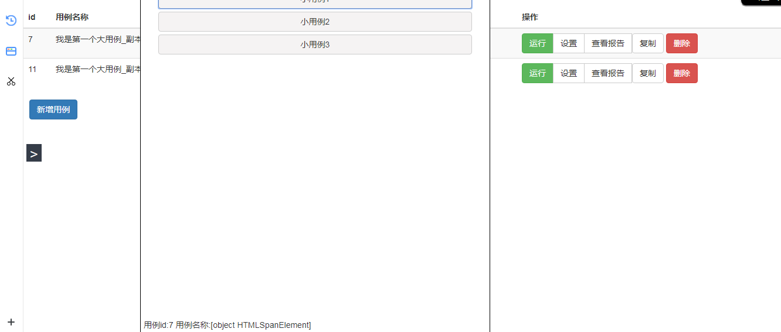
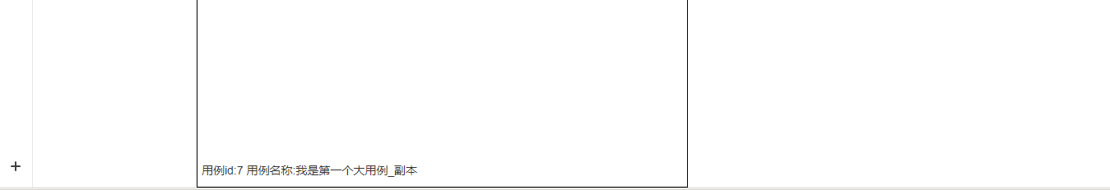

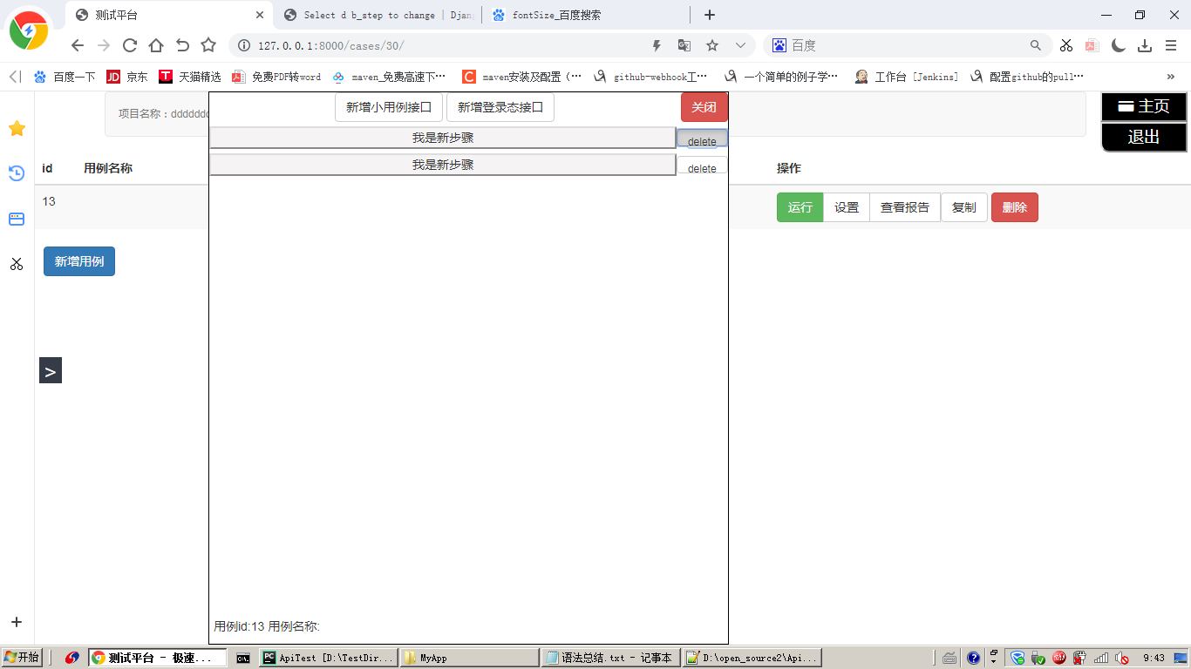
Delete 按下底部有按钮样

删除不掉
原来正则里出错了
r'^delete_step/$' 带了个ID
r'^delete_step/(?P<eid>.*)/$' 匹配前端传给后端的ID

