Problems with Touch Technologies:[1]

It’s very important to note that although the new generation of notebooks/smart TV users are more “tending” to “touch” their screens comparing to “older” users, still they have good reasons not to be very eager to do it on a huge multi-panel screen in a public place or over an extended period of time: [1][2][5]

* They can set their hands in one place and barely move them, while doing everything they want to do.
* They might need to keep distance of the monitor, for example if they are also doing something with the other hand they might prefer to be far, safe, away from the panels.
* They might not like to actively “touch” the screens--because they don't want to get greasy fingerprints all over it!
* Some may not like it when other students come over and stab their greasy fingers into the screen-panels! The last thing they want is for folks to feel like they are*supposed* to do that.
* The huge size of the panels means extra walking, moving and waving their hands and many might not be comfortable with at all.
* The [latency](http://www.youtube.com/watch?feature=player_embedded&v=vOvQCPLkPt4#!) is also a major set back for touch technologies, that range from 50 msec, on average, to 100msec. The latency is of more importance when the panels of connected through one hub and one clock is only used among all the monitors. [4]  
    
  Pro’s of Gesture Recognition Technologies:

Gesture recognition is a relatively a new technology that could successfully replace the “touch” capability of the monitor and provide as much interaction that “touch” would provide for the users.

An inch square of a 65 inch Touch Samsung LED monitor would weight 0.7 lb and would cost $3.6, while the electricity consumption of HP Touchsmart 301 is actually twice as of the Samsung PX2370 for the Default Brightness, Ref7. Note that the power consumption of the system is separate and could be investigated separately. [8][9][7]

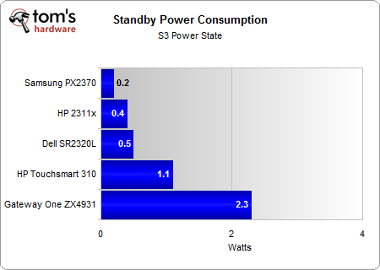

Image taken from [7]

While using gesture recognition devices this extra money could be invested in buying higher resolutions and higher frequency visualization, Webcams and other user-interface hardware’s.

|  |  |  |  |  |  |
| --- | --- | --- | --- | --- | --- |
| Product | Response Time | Reliability | Weight(lb) | Other Spec | Price |
| TS-Series 65 Samsung Interactive | 5.5 msec | 50,000 | 154 | Only 1 HDMI | $7,952.00 |
| 65” LED, 8000 Samsung | NA | One year warranties | 63 | 3 HDMI, LED type, | $3,499.00 |

Comparison table for the 65 inch TV from Samsung- smart TV vs the interactive White-Board (Touch screen)[8][9]

Solution:

Added Values:

Contents:

Technologies that add self awareness are priceless, if the provided knowledge is about the students, the research trends, hot news in research-top-media, etc then it’s an interesting content that could relate to a higher majority of the students, researchers and finally faculty members of the department.

Suggested Solution:

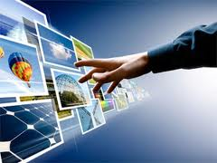

Body gesture MYO plus image detection sensors could provide the software user interaction by tapping into Mouse click and Mouse position controls. Their package is available and will serve on top of the system directly controlling the mouse pointers therefore not dependent on the Monitors or how they are connected. [3] [4]

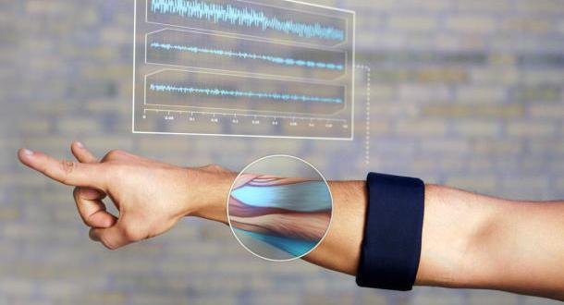

An application that can Weave a Single Display from multiple Displays and back would be used to assign just enough Displays that an interacting user requests. In one of the Hacks that I did, PennApps 2012 [I noticed a similar app for iPhones and iPads](http://techcrunch.com/2013/04/02/mosaic-lets-you-weave-a-single-display-from-multiple-iphones-and-ipads-offers-sdk-for-developers/) using only one clock to maximize the Synchronization. Similar applications could be developed to more harvest the resources available more efficiently. [6]

Image detection technologies used as a redundancy for the hand gesture control. The Image detection technologies are computationally heavier than other methods, not stable as muscle detectors and accelerometers and involve high latency as a result of these two. Wearable gloves for those who are interacting with the detecting cameras is suggested. Image detection techs are produce best results when a homogenous stationary background is at the scene.

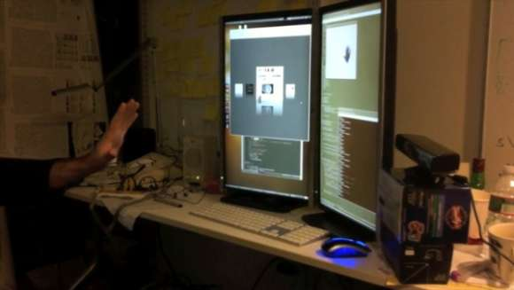

# References:

[1] Henry Blodget, [Do People Really Want to Touch their Screens?!](http://www.businessinsider.com/windows-8-touch-laptop-screen-2013-1), Business Insider, Jan 2013

[2] [SoftKinetic, DepthSenseSensor](http://www.hdtvexpert.com/?tag=gesture-recognition), HDTV Expert online, June 2012: Eyesight gesture detection used in the Smart TV by Samsung from SoftKinetic

[3] [Gesture Recognition Technologies Review](http://www.technologyreview.com/tagged/gesture-recognition/), MIT Technology Review

[4] Rick Burgess, [Advances in touch screens](http://www.techspot.com/news/47784-advances-in-touch-screens-promise-1ms-input-lag-instead-of-100ms.html), March 2012: Advanced in Touch screens

[5] David Poge, [Why Touch Screen Will not Take Over](http://www.scientificamerican.com/article.cfm?id=why-touch-screens-will-not-take-over), Scientific American, Jan 2013

# [6] Darrel Etherington, Mosaic Lets You Weave A Single Display From Multiple iPhones And iPads, Offers SDK For Developers, April 2013

[7] Andrew Ku, [Power Consumption](http://www.tomshardware.com/reviews/gateway-zx4931-hp-touchsmart-310-touchscreen,2922-12.html), Tom’s Hardware, May 2011

[8] Product Overview- [Samsung SyncMaster 650TS-2 65” LCD flat panel display](http://www.bestbuybusiness.com/bbfb/en/US/adirect/bestbuy?cmd=catProductDetail&showAddButton=true&productID=BB11443808&psrid=33338946)

[9] Product Overview- [Samsung 65” Class 3D LED Smart HDTV](http://www.hhgregg.com/samsung-65-class-3d-1080p-240hz-led-smart-hdtv/item/UN65ES8000?psrid=33339246#reviewFocusTarget1)

1. Hoofar Pourzand, Penn State University, July 2013, contact: hpourzand@gmail.com