S&P 500 Volatility Forecasting During Market Stress Using a Hybrid Exponential Generalized Autoregressive Conditional Heteroskedasticity-Modified Light Gated Recurrent Unit Model
Abstract
The S&P 500 index, which comprises 500 of the largest publicly traded firms in the United States, is widely known for its volatile behavior. Stock volatility represents the extent and speed at which a stock’s (or market index’s) price fluctuates over time. For investors aiming to optimize their gains and organizations relying on market insights for strategic planning, precisely forecasting shifts in S&P 500 volatility is essential. Conventionally, this task is addressed through advanced statistical modeling techniques, yet these approaches often struggle with accuracy and fall short when dealing with the complex, nonlinear patterns found in financial time series data. While developments in machine learning have paved the way for Artificial Intelligence algorithms to predict stock volatility with enhanced accuracy and effectiveness, they frequently experience weak learning signals and high data requirements. A hybrid econometrics-machine learning model could provide a novel approach by preserving the advantages of econometrics models in estimating overall trends while enabling the more effective capture of complex and nonlinear patterns in financial time series data by neural networks. However, the current hybrid architecture remains limited by its increased architectural complexity and computational requirements. This study proposes a hybrid Exponential Generalized Autoregressive Conditional Heteroskedasticity (EGARCH)-modified Light Gated Recurrent Unit (LiGRU) framework that predicts the logarithm of the squared daily returns during major S&P 500 market stress. In this model, S&P 500 daily returns during market stress were fed into an EGARCH model to generate conditional volatility predictions, which were used as an expert feature alongside the raw returns in a modified LiGRU network. This design allows the modified LiGRU network to utilize the pre-structured volatility information, thereby enabling it to focus on refining the logarithm of the squared daily returns forecast. This research compared the predictive accuracy and the computational cost of three architectures: a standalone EGARCH, a modified LiGRU, and the proposed hybrid EGARCH- modified LiGRU. The predictive accuracy of each model is measured by Root Mean Square Error (RMSE), loss metrics, Quasi-Likelihood (QLIKE), and prediction fit graphs, while the computational efficiency is evaluated in terms of peak RAM usage and training time. Across the same set of prespecified seeds, the models were evaluated using expanding-window experiments with separate held-out test periods corresponding to the different periods of market stress. The hypothesis states that the hybrid framework would outperform the EGARCH and the modified LiGRU models, while incurring higher computational costs. The results indicate that the hybrid model achieved a comparable mean and a lower standard deviation of the test metrics and required modestly greater computational cost than the modified LiGRU. However, it outperformed the EGARCH baseline on the test RMSE by approximately 59.74%. These findings may offer useful insights to the field of financial volatility forecasting.

Introduction

Accurate market volatility forecasting during market stress is critical for derivative pricing, risk management, and portfolio optimization^{1,2}. Before the adoption of machine learning in finance, the dominant approach involved the statistical modeling of financial time series, with the Generalized Autoregressive Conditional Heteroskedasticity (GARCH) family serving as the industry standard for decades^{3,4,5}. Specifically, the Exponential GARCH (EGARCH) model is widely favored because it accounts for the leverage effect, in which negative returns lead to higher subsequent volatility than positive returns of the same magnitude⁶. However, the EGARCH model relies on a fixed equation with estimated coefficients designed to capture general volatility patterns in past returns. Its performance may be complicated by heteroskedasticity, where the variance of returns is not constant but evolves⁷. Moreover, the EGARCH model is based on the assumptions of logarithmic linear dependence and stationarity in its autoregressive component. These assumptions make it exceptionally well-suited for modeling data with strongly persistent volatility, while also causing it to react slowly to market stress or black swan events^{7,8}.
In recent years, Machine Learning (ML) techniques have been applied to financial forecasting to capture non-linear patterns^{9,10,11,12,13}. Recurrent Neural Networks (RNNs), especially Long Short-Term Memory (LSTM), have shown success in modeling temporal dependencies, which refers to the influence of past observations on future values in a time series^{10,11,12,13}. One comparative study between neural networks and statistical models concludes that conventional econometrics approaches tend to deliver lower predictive performance while also being more challenging to fine-tune than machine learning techniques¹³. To reduce the computational complexity of LSTMs, the Light Gated Recurrent Unit (LiGRU) was proposed by simplifying the gate structure¹⁴. Although LiGRU was originally developed for speech recognition, its single-gate design reduces redundant gating while retaining recurrent memory, making it well suited to modeling nonlinear temporal dependencies with limited model complexity. Despite these advancements, classical neural networks often struggle to generalize from limited financial datasets and can be prone to overfitting noise^{15,16}.
A hybrid econometrics-machine learning model has emerged as a potential solution to the expressibility limitations of classical networks^{17,18}. Table 1 provides a review of recent hybrid econometric-machine learning approaches, including the hybrid approaches, the prediction targets, the econometric components, the machine learning components, and the results. Overall, the literature reports mixed but generally favorable results for the hybrid econometric–machine learning models. Some studies find that the hybrid models outperform both the standalone econometric and the ML models, while others report improvements primarily over the econometric benchmark^{19,20,21,22,23}. Existing hybrid approaches face challenges, including increasing architectural complexity, potentially introducing additional parameters without necessarily yielding proportional improvements in forecasting accuracy^{24,25}. This gap motivates the present study, which develops a hybrid EGARCH-modified LiGRU framework that integrates the strengths of both approaches: the EGARCH component captures the general trend and accounts for the leverage effect in volatility, while the modified LiGRU network responds rapidly to the market stress and models the short-term fluctuations. The objective of this research is to evaluate the predictive accuracy and the computational cost of the hybrid model, by comparing its performance in forecasting the logarithm of the squared daily returns against the standalone EGARCH and the modified LiGRU architectures, particularly during the periods of market stress.

Table 1: A Review of Recent Hybrid Econometric-Machine Learning Approaches
Hybrid Approach | Prediction Target | Econometric Component | ML  Component | Results of the Hybrid Models vs the Baselines
GARCH EGARCH Exponentially Weighted Moving Average (GEW)-LSTM | Stock index volatility | GARCH/ EGARCH/ EWMA | LSTM
  Outperformed both the econometric and the ML baselines.
Adaptive Wavelet Transform (AWT)-LSTM-ARIMA-GARCH | Stock index | ARIMA-GARCH | LSTM | Outperformed the econometric baseline.
GARCH-MIDAS-LSTM | Stock market  volatility | GARCH-MIDAS | LSTM | Outperformed the econometric baseline.
Hybrid GARCH/EGARCH/APGARCH-LSTM/DFFNN | Cryptocurrency volatility | GARCH/ EGARCH/  APGARCH | LSTM/DFFNN | Outperformed both the econometric and the ML baselines.
Hybrid GARCH-LSTM | Crude-oil volatility | GARCH | LSTM | Outperformed the econometric baseline.
Methods
Data Acquisition and Preprocessing:
The input feature is the historical daily returns for the S&P 500 index from 1987 to 2022, specifically during the periods of market stress: the 1987 Black Monday, the 2000–2002 dot-com bubble burst, the 2008 Global Financial Crisis (GFC), and the 2020–2022 COVID-19 period²⁶. The 1987 window was selected to capture the elevated market volatility surrounding the October 1987 Black Monday crash, the 2000–2002 window to represent a prolonged decline associated with the dot-com bubble burst, the 2008 window to capture the financial turmoil triggered by the United States housing and subprime mortgage crisis, and the 2020–2022 window to represent the sharp volatility and subsequent market disruptions associated with the COVID-19 pandemic and the Monetary Tightening Phase. The four episodes are representative of the distinct forms of market stress, although not exhaustive. For each regime, the full set of historical daily returns over the entire crisis window was collected, comprising 2014 values in total. These S&P 500 daily returns effectively captured the overall market behavior during the periods of market stress²⁷. The target variable is defined as the logarithm of the squared daily returns
$y_{t}=\log\left(r_{t}^{2}+ϵ\right)$ (1)
, where $r_{t}$is the daily return on day $t$ and $ϵ$ is a constant used to avoid taking the logarithm of zero. It is a transformation commonly used as a proxy for stock volatility and an observable estimate of the variability of asset returns over a given period²⁸.

Figure 1: The Return Distribution and Q–Q Plot
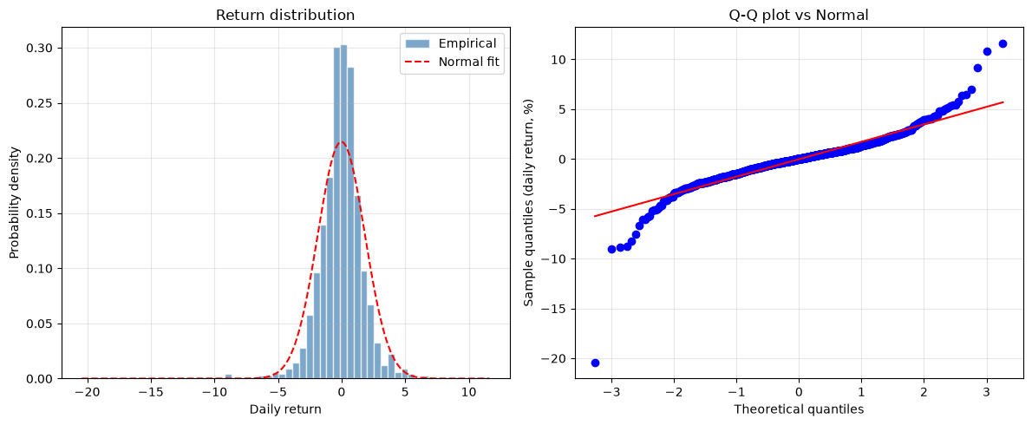
Figure 2: The ACFs of Returns and Squared Returns
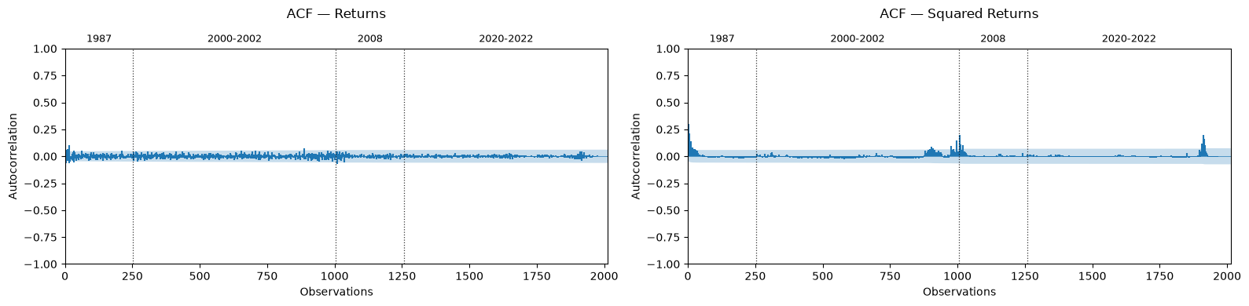
The daily returns were stored as decimals and exhibited substantial non-normality across the four market-stress episodes. Figure 1 presents the return distribution and Q–Q plot. Across all 2,014 observations, the returns exhibited a mean close to zero, a standard deviation of 0.018, a minimum of −0.205, a maximum of 0.116, a skewness of −0.786, and an excess kurtosis of 14.680; the 1987 episode displayed particularly pronounced negative skewness (−4.039) and excess kurtosis (42.575). Figure 2 demonstrates the Autocorrelation Functions (ACFs) of the returns and the squared returns. Diagnostics consistently supported stationarity, with the Augmented Dickey-Fuller test rejecting the unit-root null for the overall samples and the Kwiatkowski–Phillips–Schmidt–Shin test failing to reject stationarity. The Autoregressive Conditional Heteroskedasticity (ARCH) diagnostics indicated the presence of conditional heteroskedasticity: both the Ljung–Box test on squared returns and the ARCH‑Lagrange Multiplier (LM) test were highly significant overall, with weaker evidence from the ARCH‑LM test for the 1987 episode. These diagnostics support the use of models in this study capable of capturing temporal dependence and conditional heteroskedasticity.
Each of the 2014 samples in the dataset contains one feature and one target value. A 20-day look-back window was used to build overlapping input sequences in each subset, where every input sequence now contains 20 feature observations and 1 subsequent target value²⁹. This transformation enabled the model to capture the temporal dependencies in the input feature. The length of the look-back window was selected through grid search. Any look-back sequences which straddled the period boundaries between market stress were invalid and were discarded to prevent the model from treating the potentially genuine temporal gaps as consecutive observations. Algorithm 1 presents the generation of multivariate sequences with crisis-regime consistency filtering. The dataset yielded 1,934 usable non-boundary-crossing 20-day sequences, comprising 233 from 1987, 732 from 2000–2002, 233 from 2008, and 736 from 2020–2022. Then, the valid input feature was standardized using a RobustScaler, which scales data based on the interquartile range (IQR) rather than the mean and the standard deviation, while the target variable was transformed using a StandardScaler³⁰. All scaling transformations, fitted using the training observations only, were then applied unchanged to the corresponding validation and test observations to prevent data leakage, where information from the held-out test set influences model training. After these preprocessing steps, the input was ready to be fed into all models in this study.
Algorithm 1: Generation of Multivariate Sequences with Crisis-Regime Consistency Filtering
Input:
ret_data : Daily return data
vol_data : Daily EGARCH conditional-volatility data
target_data : Daily target data
seq_len : Lookback sequence length
crisis_labels : Crisis-regime label for each observation
Output:
X : Valid multivariate input sequences
y : Corresponding target values
start_indices : Starting index of each valid sequence

1: X ← []
2: y ← []
3: start_indices ← []
4: for start_idx = 0 to len(ret_data) – seq_len – 1 do
5: window_labels ← crisis_labels[start_idx : start_idx + seq_len]
6: if len(unique(window_labels)) > 1 then
7: continue. # remove windows that straddle market stress boundaries
8: end if
9: ret_seq ← ret_data[start_idx : start_idx + seq_len]
10: vol_seq ← vol_data[start_idx : start_idx + seq_len]
11: X_seq ← concatenate(ret_seq, vol_seq)
12: target ← target_data[start_idx + seq_len]
13: X.append(X_seq)
14: y.append(target)
15: start_indices.append(start_idx)
16:end for
17:return X, y, start_indices

An expanding-window framework was used to evaluate the model performance separately across the selected market stress. This evaluation method helps preserve the temporal ordering of the observations and provides a more realistic assessment of model performance as additional historical information becomes available. A fold, defined as a chronological division of the data into training, validation, and test periods, uses all observations available before the test period for training. The expanding-window framework contains three folds, with each evaluating the models’ performance on a different market stress. For example, the Monetary Tightening Phase fold assesses the predictive accuracy during the Monetary Tightening Phase. Table 2 reports the start and end dates and the number of observations used for the training, validation, and test sets for each fold. The COVID-19 Shock fold follows a 69/15/16 split, while the Monetary Tightening Phase and the GFC folds use a 70/15/15 split, to maintain comparable validation and test set sizes and also to ensure that the held-out test sets include the periods of selected market stress. To further assess the robustness against overfitting, the Monetary Tightening Phase fold was evaluated under two additional train-validation-test sequential splits: 80/10/10 and 60/20/20.
Table 2: The Start and End Dates and the Number of Observations Used for the Training, Validation, and Test Sets for Each Fold After the Removal of the Observations that Straddle the Market Stress Boundaries.
Fold | Training | Validation | Test
Monetary Tightening Phase | 1987-01-30–2020-09-11  n = 1354 | 2020-09-14–2021-11-04  n = 290 | 2021-11-05–2022-12-30  n = 290
COVID-19 Shock | 1987-01-30–2008-02-29  n = 986 | 2008-03-03–2008-12-31  n = 212 | 2020-01-31–2020-12-31  n = 233
GFC | 1987-01-30–2002-07-01  n = 838 | 2002-07-02–2008-04-16  n = 180 | 2008-04-17–2008-12-31  n = 180
Model Architectures:
Two classical baselines were implemented to provide benchmarks for assessing the performance improvements of the proposed approach. First, an EGARCH model with the input feature as the S&P 500 historical daily returns $r$was estimated using the Arch Python library to provide a purely econometric forecast of conditional volatility $\overset{ˆ}{σ}$⁶. $\overset{ˆ}{σ}$ was subsequently transformed to $\log\left({\overset{ˆ}{σ}}^{2}\right)$ to compare against the target $\log\left(r^{2}+ϵ\right)$. The EGARCH baseline was specified as an EGARCH(1,1), corresponding to $\left(p,o,q\right)=\left(1,1,1\right)$with a zero-mean return equation and normally distributed innovations. The EGARCH conditional variance ${\overset{ˆ}{σ}}^{2}$ was recursively updated as new returns became available:
$\log\left(σ_{t}^{2}\right)=ω+α_{1}\left(\left|\frac{r_{t-1}}{σ_{t-1}}\right|-\text{E}\left[\left|\frac{r_{t-1}}{σ_{t-1}}\right|\right]\right)+γ_{1}\frac{r_{t-1}}{σ_{t-1}}+β_{1}\log\left(σ_{t-1}^{2}\right)$ (2)
where $σ_{t}^{2}$ denotes the conditional variance, $α$controls the magnitude response to the standardized innovation, $γ$captures asymmetric effects, and $β$controls volatility persistence. Algorithm 2 presents the EGARCH modeling and the input and the output transformation. The model was estimated by maximum likelihood on the entire dataset of each fold. The parameters, fitted on the training set of each fold, were held fixed during the corresponding validation and test periods to prevent data leakage. The estimation used the parameter constraints and numerical optimization procedure.
Algorithm 2: EGARCH Modeling and Input and Output Transformation

Input:
r : Daily return data
n : Number of return observations
tp : Training percentage
Output:
$l$ₜ : Transformed EGARCH outputs

1: train_split ← floor(tp × n)
2: scaler ← RobustScaler()
3: scaler.fit(r[0:train_split])
4: r_scaled ← scaler.transform®
5: am ← EGARCH(p=1, o=1, q=1, mean=Zero, dist=Normal)
6: res ← fit(am, r_scaled, last_obs=train_split)
7: θ ← res.parameters
8: res_full ← fix(am, θ)
9: σ̂ ← res_full.conditional_volatility / 100
10: ε ← 10⁻⁶
11: for t = 1 to n do
12: $l$ₜ ← log(σ̂ₜ² + ε)
13: end for
14:return $l$ₜ
Figure 3: Modified LiGRU Cell Architecture
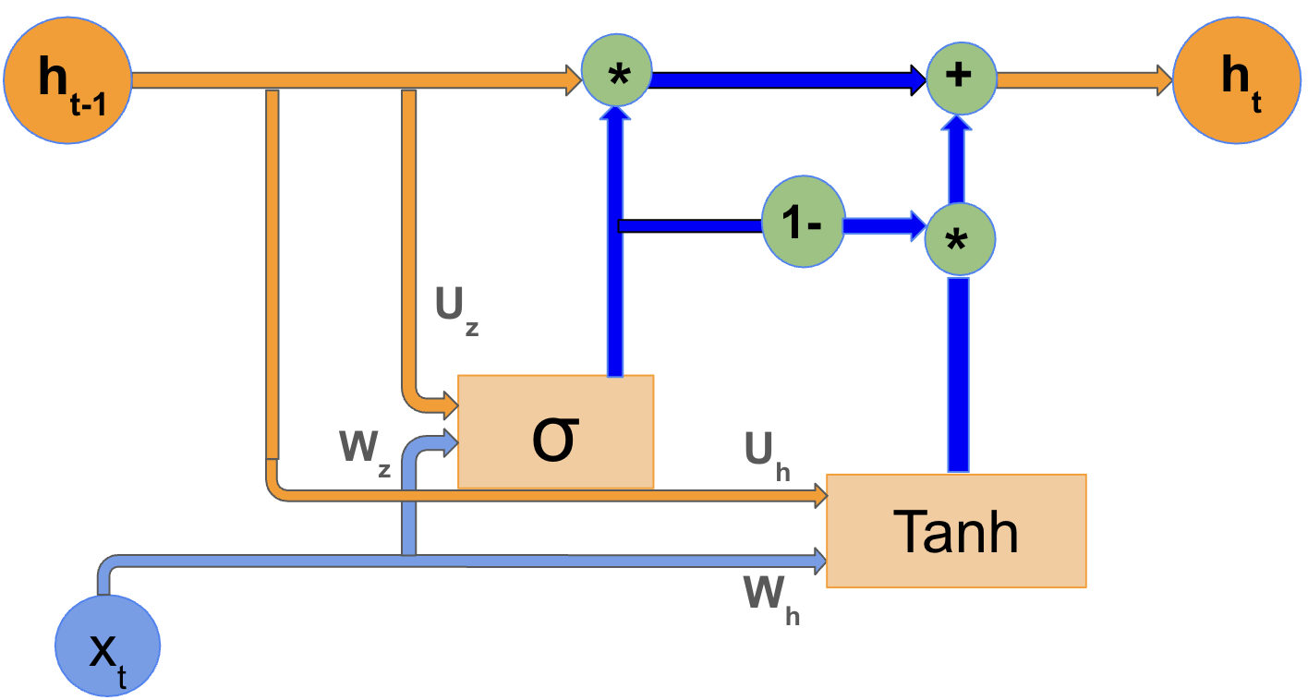
A LiGRU model is composed of the stacked layers of Gated Recurrent Unit (GRU) cells, where the output at all time steps of one cell becomes the input to the next, enabling progressively more abstract feature extraction¹⁴. Each GRU cell processes input time step by time step while updating a hidden state, the information the model carries forward through time. In this study, the classical GRU cell was modified. Its architecture is shown in Figure 3 and can be expressed as
$z_{t}=σ\left(W_{z}x_{t}+U_{z}h_{t-1}+b_{z}\right)$ (3a)
${\overset{˜}{h}}_{t}=\tanh\left(W_{h}x_{t}+U_{h}h_{t-1}+b_{h}\right)$ (3b)
$h_{t}=z_{t}⊙h_{t-1}+\left(1-z_{t}\right)⊙{\overset{˜}{h}}_{t}$ (3c)
, where $z_{t}$ is the update gate, $\tilde{h_{t}}$ represents the candidate hidden state, and $h_{t}$ is the final hidden state. $z_{t}$ controls how much of the previous hidden state is preserved versus how much is replaced by the newly proposed state derived from the current input and the past context. $h_{t}$ is a weighted combination of the previous hidden state and $\tilde{h_{t}}$, allowing the network to selectively retain or overwrite information across time steps.
More specifically, $z_{t}$ is obtained by applying a sigmoid activation function $σ\left(·\right)$ to an affine combination of the current input $x_{t}$, the previous hidden state $h_{t-1}$ that contains the past temporal information, and the bias term $b_{z}$, where $x_{t}$and $h_{t-1}$ are first transformed by the learnable weight matrices $W_{z}$ and $U_{z}$. Similarly, $\tilde{h_{t}}$ is computed by applying a hyperbolic tangent activation $tanh\left(·\right)$ to an analogous affine transformation of $x_{t}$ and $h_{t-1}$. $h_{t}$ is computed as a weighted combination of $h_{t-1}$ and $\tilde{h_{t}}$, where $z_{t}$ determines how much information is retained from $h_{t-1}$ and how much is incorporated from $\tilde{h_{t}}$. $W_{z}$ and $W_{h}$ project $x_{t}$ into $z_{t}$ and $\tilde{h_{t}}$,, respectively, whereas $U_{z}$ and $U_{h}$ determine how $h_{t-1}$ influences $z_{t}$ and $\tilde{h_{t}}$ computations. $σ\left(·\right)$ constrains the value of $z_{t}$ to lie between 0 and 1, while $tanh\left(·\right)$ introduces nonlinearity into the modified LiGRU model. $b_{z}$ and $b_{h}$ shift the activation values so they are not constrained to pass through zero. Compared to the classical LiGRU cells, this modified version replaced the $ReLU\left(·\right)$ with the $tanh\left(·\right)$ and omitted batch normalization to improve fitting. Dropout, a technique in which a fraction of neurons is randomly deactivated during training, was applied between cells to reduce the chance of overfitting, where the model performs well on training data but poorly on unseen data. The final hidden state was mapped through a readout function, a single-neuron output head, to directly predict the standardized log-transformed target $\log\left(r^{2}+ϵ\right)$. This process can be expressed as
${\overset{ˆ}{y}}_{t+1}=h_{t}W_{o}+b_{o}$ (4)
, where $W_{0}$is the weight matrix and $b_{0}$is the bias term of the output layer. During post-processing, the scaled predictions ${\overset{ˆ}{y}}^{*}$ was first inverse-scaled to the $\overset{ˆ}{y}$ and then exponentiated to the variance scale, with the numerical stabilizer $ϵ$ subtracted. The recovered variance estimate was then constrained to remain positive using a lower floor. No clipping was applied before inverse transformation. These $\overset{ˆ}{y}$ were then used to calculate the test metrics and generate the prediction graphs.
Figure 4: Flowchart for Hybrid EGARCH-modified LiGRU Modeling
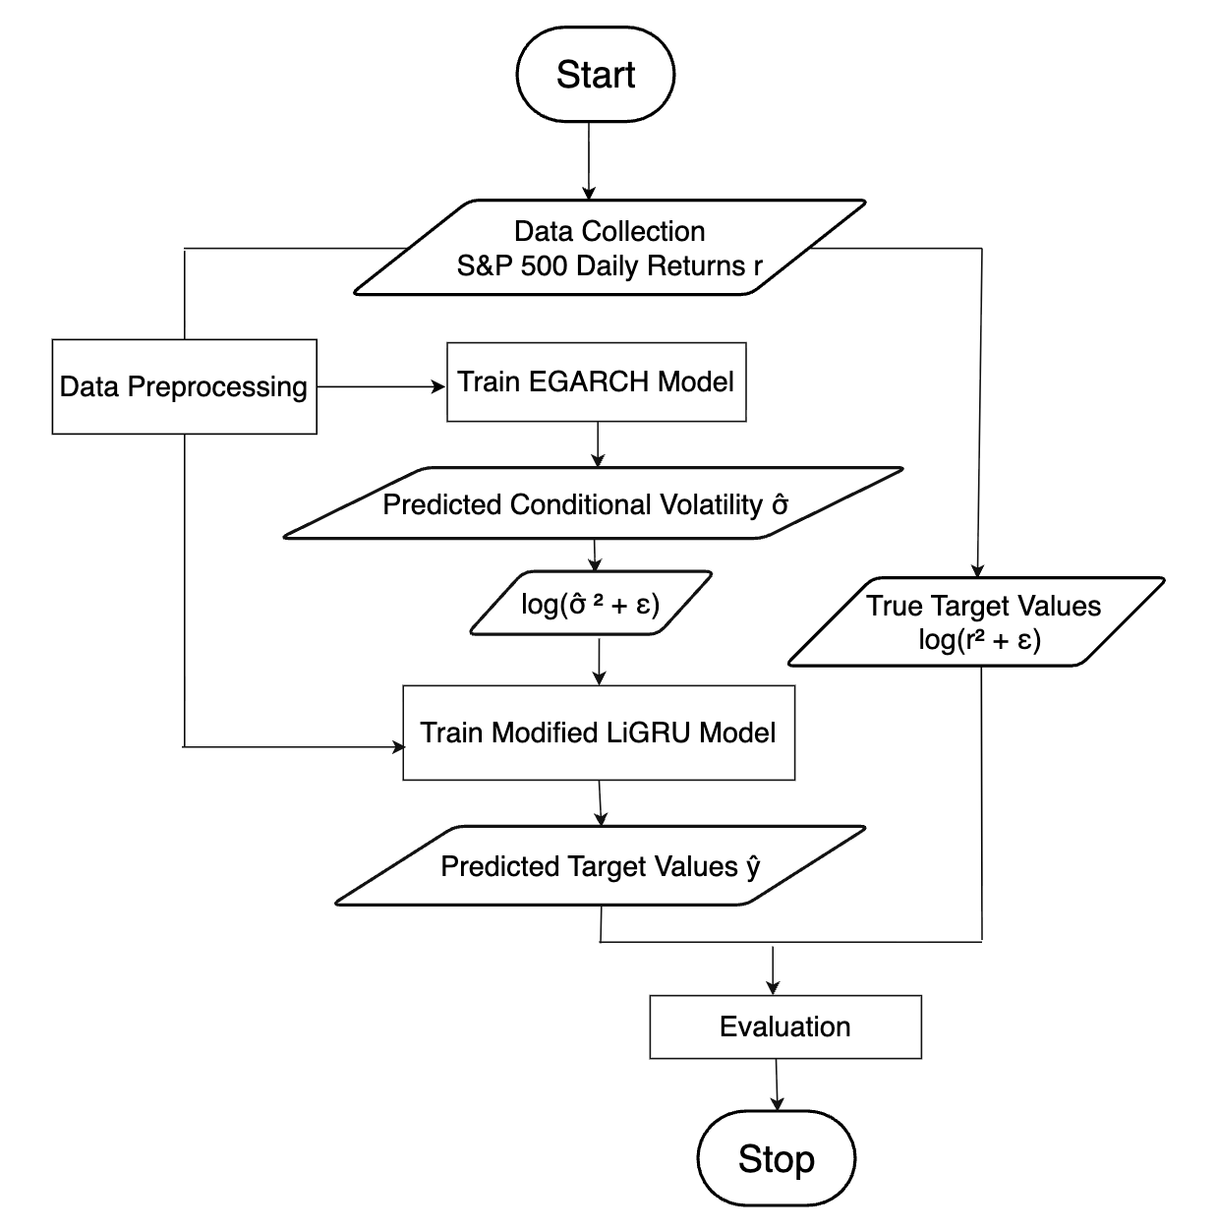
Figure 4 outlines the structured progression of the hybrid EGARCH-modified LiGRU model. First, an EGARCH framework was fitted to the S&P 500 daily returns $r$, and its output $σ$ was extracted. Then, the modified LiGRU architecture was fed with $\log\left({\overset{ˆ}{σ}}^{2}+ϵ\right)$ and the historical daily returns $r$, and it produced the predicted standardized logarithm of the squared daily returns $\hat{y}$, which was compared against the target $log⁡(r^{2}+ϵ)$ for loss evaluation. This flow is different from the standard approach of a hybrid econometrics-machine learning framework, where the input features to the neural network are random residuals. This allowed the modified LiGRU model to learn a refinement function, which takes an initial prediction $\log\left({\overset{ˆ}{σ}}^{2}+ϵ\right)$and adjusts it by modeling patterns not captured by the EGARCH forecast. The modified LiGRU architecture no longer tried to learn the entire signal; instead, it focused on modeling refinements to the EGARCH-generated conditional volatility. Figure 5 presents a time-indexed data-flow diagram of the hybrid model. The scaling of the returns and the target variable, as well as the EGARCH parameter estimation, were completed at the beginning of the process. These scalers and parameters remained fixed for the rest of the modeling. EGARCH predicted the $\overset{ˆ}{σ_{t}}$ at all time steps, and the full sequence of $\log\left({\hat{σ}}_{t}^{2}+ϵ\right)$ was then passed to the modified LiGRU, providing a one-step-ahead forecast at each forecasting origin. The input to the modified LiGRU forecasting problem is defined as $x_{t}=\left[r_{t-19:t}, {\log\left({\overset{ˆ}{σ}}^{2}+ϵ\right)}_{t-19:t}\right]$. Each pair of $r_{t}$and $\log\left({\overset{ˆ}{σ}}_{t}^{2}+ϵ\right)$ together with the hidden state from the previous time step $h_{t-1}$ produced one estimate. The prediction ${\overset{ˆ}{y}}_{t+1}$ depends on the estimation results from the preceding 20 time steps.
Figure 5: Time-Indexed Forecasting Diagram​
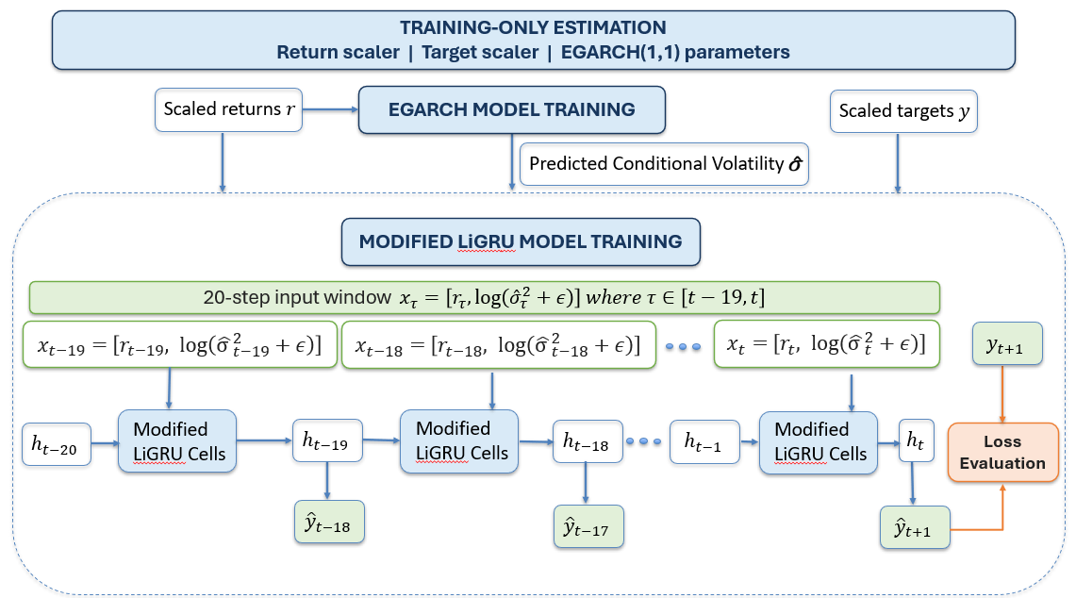

To confirm the contribution of the EGARCH component, a series of controlled ablation experiments were conducted in the Monetary Tightening Phase fold by isolating the function of the EGARCH component. The hybrid EAGRCH-modified LiGRU was compared with a EAGRCH feature only hybrid model, as well as with the variants which have the EGARCH feature shuffled and the EGARCH residual-correction. The same hyperparameter settings were maintained throughout all ablation experiments to ensure a fair comparison. In each experiment, the test RMSE, the test loss, and the test QLIKE were recorded.

Training
The LiGRU model was trained to minimize the loss metrics. To assess whether any observed differences in performance are robust to stochastic variation, the machine learning models were trained using the same set of 15 random seeds. For each seed, the validation-selected checkpoint was used to select the best model to generate one archived prediction vector for the held-out test observations and also to prevent overfitting. The predictive accuracy of each model, evaluated on the validation and the test set, was assessed using the RMSE, the loss metric, and the QLIKE values, with the prediction fit graph serving as a supplementary illustration, and then compared across models to evaluate their relative effectiveness. The predictive accuracy of the modified LiGRU and the hybrid model was additionally compared using the Wilcoxon signed-rank test to determine if the forecast errors of the two models differ statistically. The null hypothesis of the Wilcoxon signed-rank test was that they had equal expected predictive accuracy. The EGARCH model was not evaluated by less metric, because its parameters are estimated by maximizing the likelihood of the specified conditional volatility distribution rather than by minimizing a prediction loss such as Mean Square Error. Besides the predictive accuracy, the computational cost of each ML model in the Monetary Tightening Phase fold was evaluated using the number of trainable parameters, the training time, and the peak RAM usage .
To select the value of $ϵ$ in equation (1), the sensitivity analysis using the hybrid model was carried out on the Monetary Tightening Phase fold. The analysis showed that $ϵ={10}^{-6}$provided the highest predictive accuracy, with a test RMSE of 0.867, compared with 0.894 for $ϵ={10}^{-7}$and 0.904 for $ϵ={10}^{-5}$. Therefore, $ϵ$ was set to ${10}^{-6}$. Of the 2,014 observations, 135 values (6.70%) are less than or equal to $ϵ$ = 10⁻⁶. Training was conducted for 300 epochs. Since no significant overfitting was observed, no additional regularization method, such as L2 weight decay, was applied. The Adam optimizer was used for training to improve the convergence stability. The hyperparameters were selected through grid search separately for each ML model and fold based on the validation performance. The final hyperparameter configurations for the Monetary Tightening Phase fold are reported in Table 3.

Table 3: Hyperparameter Configurations for the Modified LiGRU and the Hybrid EAGRCH -Modified LiGRU for the Monetary Tightening Phase Fold
Model | Hidden Dim | Batch Size | Learning Rate | Dropout Rate | # of Cells
Modified LiGRU | 4 | 32 | 0.001 | 0.3 | 2
Hybrid EAGRCH-Modified LiGRU | 6 | 64 | 0.0005 | 0.4 | 2
Results
Table 4 summarizes the mean and the standard deviation of the test RMSE, the test loss, the test QLIKE, and the Wilcoxon signed-rank test results across the random seeds of the modified LiGRU and the hybrid EGARCH-modified LiGRU models for each fold, as well as the test RMSE and the test QLIKE of the EGARCH model for each fold. Table 5 reports the results obtained using alternative data splits for the two ML models for the Monetary Tightening Phase fold. Table 6 compares the trainable parameter count, the training time, and the peak RAM usage of the two ML models for this fold. Table 7 presents the predictive accuracy of the ablation experiments for the hybrid model for this fold. Table 4, 6 and 7 use the data splitting specified in Table 2.
The prediction fit graph and the train and the validation loss curves for the three models are presented in Figures 6-8, Figures 9-11 and Figures 12-14 for the Monetary Tightening Phase fold, the COVID-19 shock fold and the GFC fold respectively.
Table 4: The Mean and the Standard Deviation of the Test RMSE, the Test Loss, and the Test QLIKE, and the Wilcoxon Signed-Rank Test Results of the EGARCH, the Modified LiGRU, and the Hybrid EGARCH-Modified LiGRU Models Across All Folds
Fold | Model | Test RMSE | Test Loss | Test QLIKE | Wilxocon Test  p-Values
Monetary Tightening Phase | EAGRCH | 2.270 | N/A | 1.645
Monetary Tightening Phase | Modified LiGRU | 0.920 ± 0.019 | 0.850 ± 0.036 | 2.451 ± 0.380 | p = 0.842
Monetary Tightening Phase | Hybrid EAGRCH-Modified LiGRU | 0.921 ± 0.014 | 0.850 ± 0.026 | 2.636 ± 0.156 | p = 0.842
COVID-19 Shock | EGARCH | 2.198 | N/A | 1.742
COVID-19 Shock | Modified LiGRU | 0.920 ± 0.039 | 0.843 ± 0.072 | 2.493 ± 1.128 | p = 0.369
COVID-19 Shock | Hybrid EAGRCH-Modified LiGRU | 0.915 ± 0.021 | 0.838 ± 0.038 | 2.468 ± 0.567 | p = 0.369
GFC | EGARCH | 2.233 | N/A | 1.752
GFC | Modified LiGRU | 0.989 ± 0.043 | 0.979 ± 0.088 | 3.273 ± 0.846 | p = 0.482
GFC | Hybrid EAGRCH-Modified LiGRU | 0.972 ± 0.019 | 0.946 ± 0.037 | 3.016 ± 0.631 | p = 0.482
Table 5: The Mean and the Standard Deviation of the Test RMSE, the Test Loss, and the Test QLIKE of the Modified LiGRU and the Hybrid EGARCH-Modified LiGRU Models Under the Different Splits For the Monetary Tightening Phase Fold
Split | Model | Test RMSE | Test Loss | Test QLIKE
60/20/20 | Modified LiGRU | 0.925 ± 0.023 | 0.851 ± 0.034 | 2.459 ± 0.401
60/20/20 | Hybrid EAGRCH-Modified LiGRU | 0.927 ± 0.014 | 0.853 ± 0.027 | 2.648 ± 0.162
70/15/15 | Modified LiGRU | 0.920 ± 0.019 | 0.850 ± 0.036 | 2.451 ± 0.380
70/15/15 | Hybrid EAGRCH-Modified LiGRU | 0.921 ± 0.014 | 0.850 ± 0.026 | 2.636 ± 0.156
80/10/10 | Modified LiGRU | 0.900 ± 0.018 | 0.806 ± 0.017 | 3.189 ± 0.324
80/10/10 | Hybrid EAGRCH-Modified LiGRU | 0.899 ± 0.017 | 0.804 ± 0.030 | 3.190 ± 0.323
Table 6: The Number of Trainable Parameters, the Training Time, and the Peak RAM Usage of the Modified LiGRU and the Hybrid EGARCH-Modified LiGRU Models for the Monetary Tightening Phase Fold
Model | # of Trainable Parameters | Training Time (s) | Peak RAM usage (mb)
Modified LiGRU | 125 | 292.941 | 270.560
Hybrid EGARCH-Modified LiGRU | 271 | 341.822 | 283.563
Table 7: The Mean and the Standard Deviation of the Test RMSE, the Test Loss, and the Test QLIKE in the Ablation Experiments for the Hybrid EGARCH-Modified LiGRU Model in the Monetary Tightening Phase Fold
Model | Test RMSE | Test Loss | Test QLIKE
Modified LiGRU | 0.920 ± 0.019 | 0.850 ± 0.036 | 2.451 ± 0.380
Hybrid EGARCH-Modified LiGRU | 0.921 ± 0.014 | 0.850 ± 0.026 | 2.636 ± 0.156
EGARCH Feature Only | 0.925 ± 0.006 | 0.856 ± 0.011 | 2.682 ± 0.075
Returns Plus a Shuffled EGARCH Feature | 0.944 ± 0.028 | 0.892 ± 0.054 | 3.138 ± 0.465
EGARCH-Residual Correction | 0.971 ± 0.026 | 0.944 ± 0.052 | 2.495 ± 0.350
Figure 6: True vs Predicted Logarithm of the Squared Daily Returns for the EGARCH Model for the Monetary Tightening Phase Fold. The blue line represents true values, and the orange line represents model predictions.
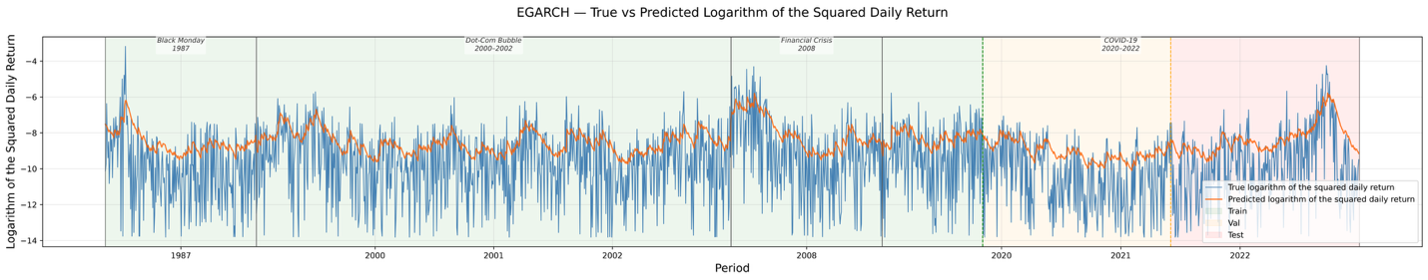
Figure 7. a): True vs Predicted Logarithm of the Squared Daily Returns for the Modified LiGRU Model for the Monetary Tightening Phase Fold. The blue line represents true values, and the orange line represents model predictions.
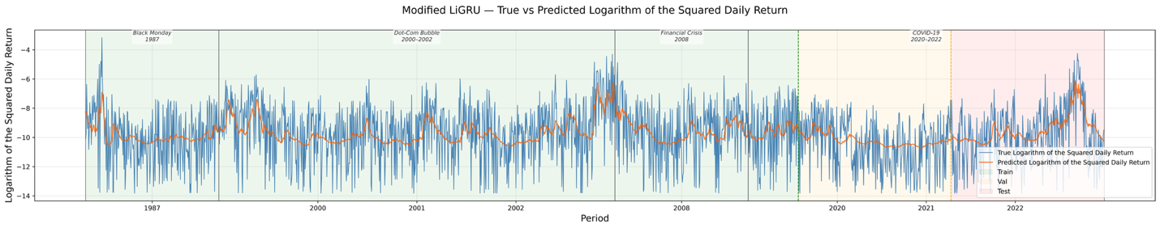
Figure 7. b): Train and Validation Loss Curves for the Modified LiGRU Model for the Monetary Tightening Phase Fold
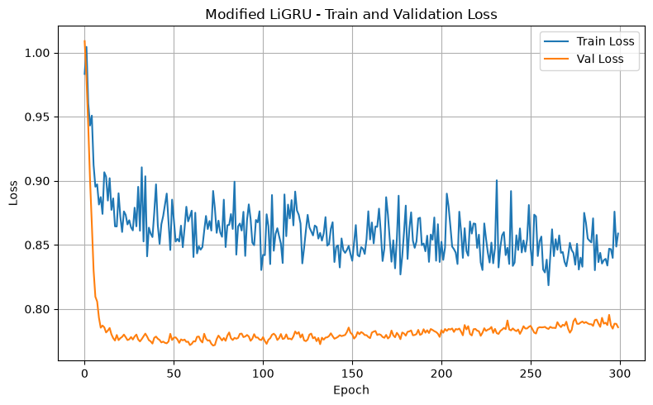
Figure 8. a): True vs Predicted Logarithm of the Squared Daily Returns for the Hybrid EAGRCH-Modified LiGRU Model for the Monetary Tightening Phase Fold. The blue line represents true values, and the orange line represents model predictions.
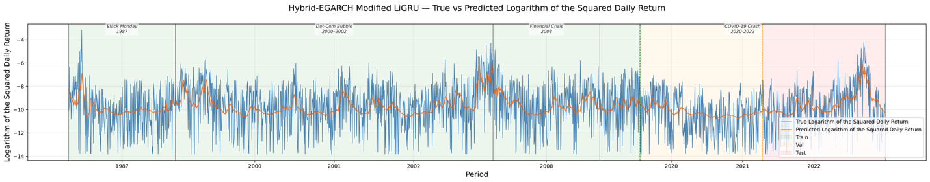
Figure 8. b): Train and Validation Loss Curves for the Hybrid EAGRCH-Modified LiGRU Model for the Monetary Tightening Phase Fold
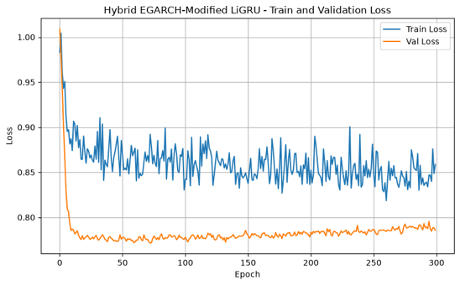
Figure 9: True vs Predicted Logarithm of the Squared Daily Returns for the EGARCH Model for the COVID-19 Shock Fold. The blue line represents true values, and the orange line represents model predictions.
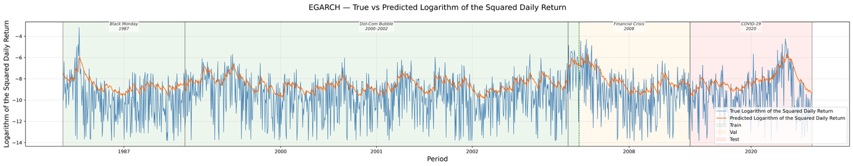
Figure 10. a): True vs Predicted Logarithm of the Squared Daily Returns for the Modified LiGRU Model for the COVID-19 Shock Fold. The blue line represents true values, and the orange line represents model predictions.
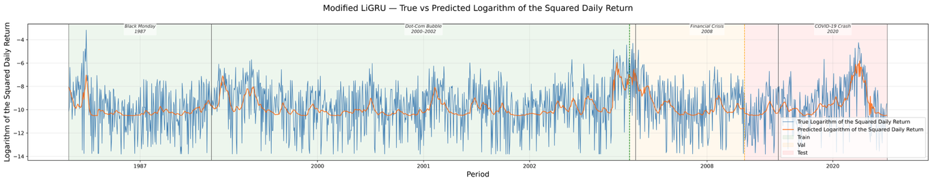
Figure 10. b): Train and Validation Loss Curves for the Modified LiGRU Model for the CVOID-19 Shock Fold
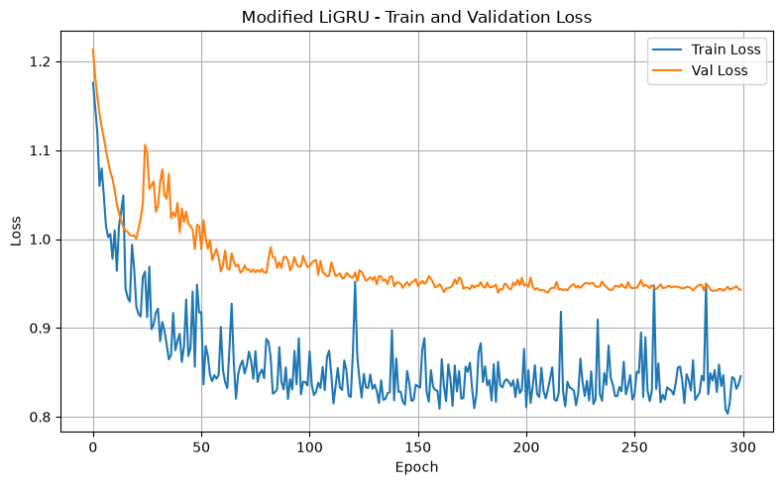
Figure 11. a): True vs Predicted Logarithm of the Squared Daily Returns for the Hybrid EAGRCH-Modified LiGRU Model for the COVID-19 Shock Fold. The blue line represents true values, and the orange line represents model predictions.
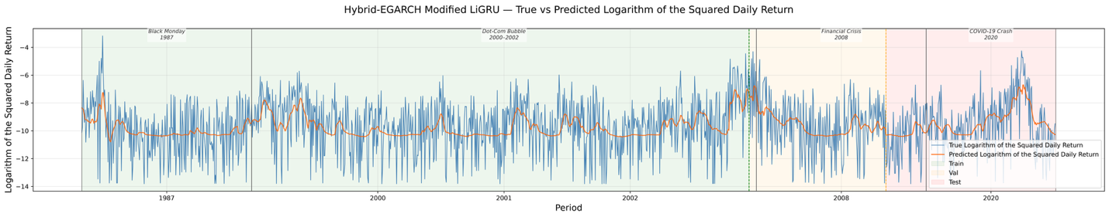
Figure 11. b): Train and Validation Loss Curves for the Hybrid EAGRCH-Modified LiGRU Model for the COVID-19 Shock Fold
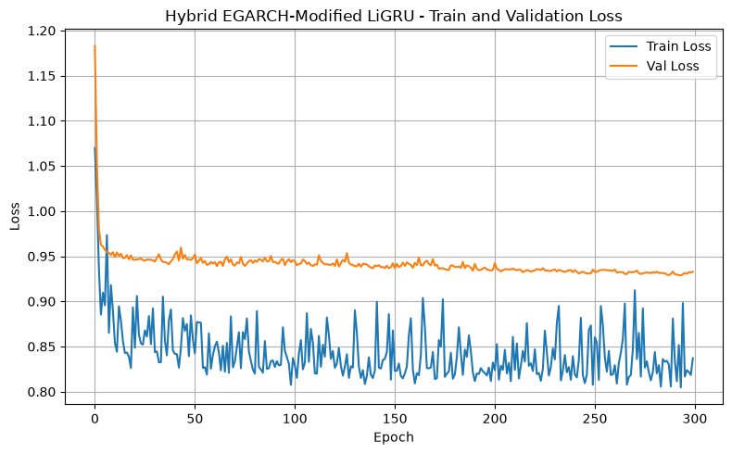
Figure 12: True vs Predicted Logarithm of the Squared Daily Returns for the EGARCH Model for the GFC Fold. The blue line represents true values, and the orange line represents model predictions.
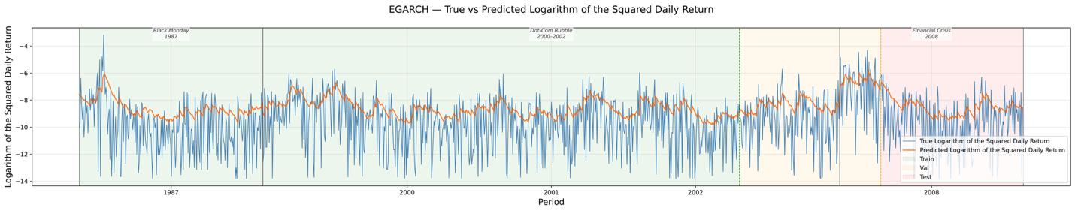
Figure 13. a): True vs Predicted Logarithm of the Squared Daily Returns for the Modified LiGRU Model for the GFC Fold. The blue line represents true values, and the orange line represents model predictions.
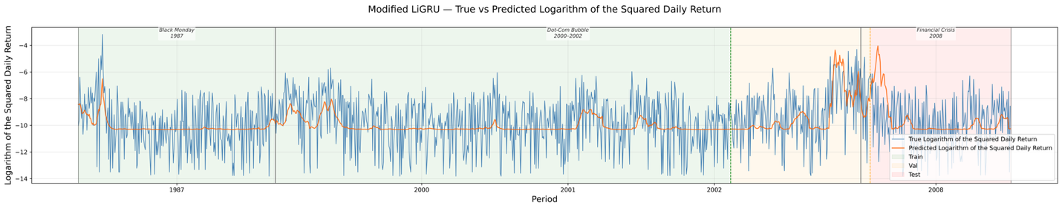
Figure 13. b): Train and Validation Loss Curves for the Modified LiGRU Model for the GFC Fold
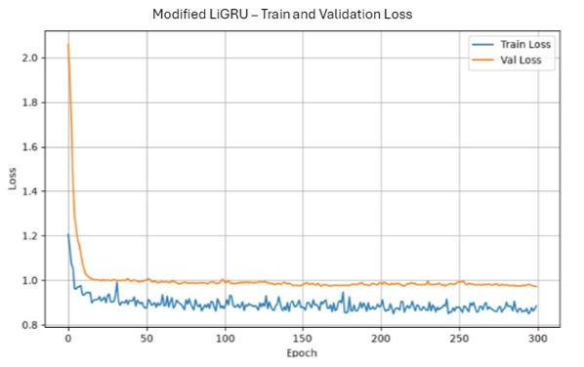
Figure 14. a): True vs Predicted Logarithm of the Squared Daily Returns for the Hybrid EAGRCH-Modified LiGRU Model for the GFC Shock Fold. The blue line represents true values, and the orange line represents model predictions.
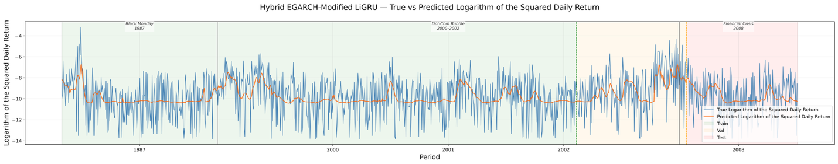
Figure 14. b): Train and Validation Loss Curves for the Hybrid EAGRCH-Modified LiGRU Model for the GFC Fold
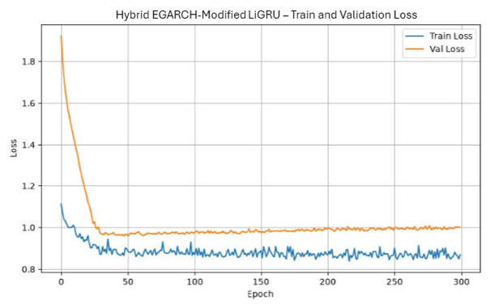

Discussion
Based on the comparison of the test RMSE, the test loss, the test QLIKE, the prediction fit graphs, the train and validation loss curves, the number of trainable parameters, the training time, and the peak RAM usage of the hybrid EGARCH-modified LiGRU and the modified LiGRU architectures, it can be concluded that the hybrid model provides comparable predictive performance to the modified LiGRU model with modest additional computational cost, while demonstrating greater stability in forecasting the logarithm of the squared daily returns. The hybrid model provides substantially greater predictive accuracy improvements compared to the EAGRCH model.
According to Table 4, for the Monetary Tightening Phase fold, the modified LiGRU achieved a 0.11% lower test RMSE (0.920 vs. 0.921), the same test loss (0.850), and a 7.02% lower test QLIKE (2.451 vs. 2.636) than the hybrid model. For the COVID-19 Shock fold, the hybrid model modestly outperformed the modified LiGRU, achieving a 0.52% lower test RMSE (0.915 vs. 0.920), a 0.57% lower test loss (0.838 vs. 0.843), and a 0.99% lower test QLIKE (2.468 vs. 2.493). For the GFC fold, the hybrid model achieved a 1.77% lower test RMSE (0.972 vs. 0.989), a 3.64% lower test loss (0.944 vs. 0.979), and a 7.88% lower test QLIKE (3.016 vs. 3.274) than the modified LiGRU. The hybrid model also demonstrated lower test RMSE variability than the modified LiGRU across all three folds - by 26.3% in the Monetary Tightening Phase fold, 46.2% in the COVID-19 Shock fold, and 55.8% in the GFC fold. The Wilcoxon signed-rank test showed $p$-values exceeding 0.05s in the Monetary Tightening Phase (p = 0.841), COVID-19 Shock (p = 0.368), and GFC (p = 0.482) folds. Compared with the modified LiGRU, the hybrid model performed better in some evaluation periods but worse in others, with no statistically significant difference, but the hybrid model generally exhibited more consistent performance than the modified LiGRU. Overall, these results suggest that the hybrid model provides comparable predictive performance and greater stability than the modified LiGRU. Thes conclusions are further supported by the modeling with different data splits in Table 5. Compared to the standalone EGARCH model, the hybrid model demonstrated substantial numerical improvements in test RMSE across all evaluated folds. Specifically, test RMSE decreased from 2.270 to 0.921 (a 59.4% reduction) in the Monetary Tightening Phase fold, from 2.198 to 0.915 (a 58.4% reduction) in the COVID-19 Shock fold, and from 2.233 to 0.972 (a 56.5% reduction) in the GFC fold. These results indicate that the hybrid model achieved significantly better predictive performance than the EGARCH baseline. The results in Table 5 also provide evidence for the robustness against overfitting. Increasing the training proportion from 60% to 80% lowered the test errors for both models, with the test RMSE falling by 2.70% (0.925 to 0.900) for the modified LiGRU and 3.02% (0.927 to 0.899) for the hybrid model, and the test loss falling by 5.29% (0.851 to 0.806) and 5.74% (0.853 to 0.804), respectively. The results in Table 4 and Table 5 combined prove the robustness against overfitting in both models across all the random seeds and all the folds. Given these results, the hybrid model should be characterized as a feature-augmented modified LiGRU.
According to Table 6, the hybrid model required 341.822 seconds of training time compared with 292.941 seconds for the modified LiGRU, representing a 16.0% increase. Peak RAM usage was also slightly higher for the hybrid model (283.563 MB) than for the modified LiGRU (270.560 MB), representing a 4.8% increase. The hybrid model also used more trainable parameters than the modified. Taken together, the results indicate that the hybrid approach incurs a modest increase in the computational cost compared to the modified LiGRU under the experimental setup used in this study.
Based on Table 7, compared to the hybrid model, the EGARCH Feature Only configuration increased the test errors, indicating that the EGARCH feature alone is not sufficient. The shuffled EGARCH feature variant produced higher errors than the hybrid model, demonstrating that the original EGARCH feature contains information that is not preserved after shuffling. The explicit EGARCH-residual correction variant also resulted in higher test errors, indicating that the information contained in the original EGARCH feature is more useful when provided directly to the modified LiGRU. Compared with the modified LiGRU, the hybrid model only showed comparable errors, suggesting that The EGARCH features may provide limited or redundant additional information, resulting in only modest—or even reduced—improvements in predictive accuracy when used in a neural network. Overall, these results suggest that both the daily returns and the EGARCH feature used in this study may contain informative volatility signals that the modified LiGRU requires to achieve better predictive performance, compared to the other variants of the EGARCH feature.
Although the EGARCH model captures the leverage effect, adding its outputs to the modified LiGRU does not necessarily improve forecasting when their information is already partially captured by the historical daily return³¹. The modified LiGRU can learn temporal volatility patterns directly from the returns. Moreover, the simplified LiGRU architecture may have limited capacity to capture the complex nonlinear relationships and interactions present in the data. Another reason of the comparable prediction accuracy may be that the target used in this study is a volatility-related transformation of daily returns rather than realized volatility or realized variance itself. This transformation focuses the prediction task on short-term changes in return variability.
Future work could investigate whether alternative econometric models, such as GJR-GARCH, GARCH, can provide information that is less redundant with the return sequence. Alternative volatility measures, including the direct forecast of realized volatility, may help determine whether the inconsistent, modest performance observed here persists for other target definitions. Stronger trend components and non-stationarity are major challenges in direct realized volatility prediction. Moreover, reducing the architectural and computational complexity of the hybrid model while preserving its predictive performance would be important for determining whether the additional EGARCH component provides sufficient practical benefit over the simpler modified LiGRU baseline. Finally, the present analysis focuses on four selected market-stress episodes and one-step-ahead forecasting within those periods. Future studies should test the framework across additional market events and continuous out-of-sample periods to assess its robustness beyond the selected windows, while maintaining strict temporal separation to avoid data leakage.
Conclusion
Stock volatility, a key indicator of market behavior, provides valuable insights for both investors and companies. This study aimed to identify an effective framework for forecasting S&P 500 volatility during market stress by integrating statistical and machine learning approaches. Specifically, a hybrid EGARCH–modified LiGRU model was implemented, combining the conditional volatility predictions from an EGARCH model as expert features with raw returns in a modified LiGRU network. The hybrid framework was compared to standalone EGARCH and modified LiGRU models, with the predictive accuracy evaluated using the RMSE, the loss metrics, the QLIKE, and the prediction fit graphs and the computational cost evaluated using the number of trainable parameters, the training time, and the peak RAM usage. Results indicate that the hybrid EGARCH–modified LiGRU outperforms the EGARCH model and remains comparable with the modified LiGRU in terms of the predictive accuracy, while incurring modestly higher computational cost.
The study investigated the value of combining econometrics robustness with the expressive power of neural networks for financial prediction tasks. Accurate volatility forecasts from the hybrid model may assist investors, risk managers, and firms in making more informed decisions, optimizing portfolio strategies, and mitigating financial risks. Future research could extend this work by incorporating additional macroeconomics, market microstructure, and human behavior variables, as well as testing alternative neural architectures. Upcoming studies could focus on directly forecasting realized volatility measures as a target, reducing input redundancy by investigating other econometrics models, and testing alternative machine learning architectures.

References
- N. Roszyk, R. Ślepaczuk. The hybrid forecast of S&P 500 volatility ensembles from VIX, GARCH and LSTM models. arXiv.org, 2024, https://doi.org/10.48550/arXiv.2407.16780.
- M. Otaif. Importance and causes of stock market volatility: Literature review. SSRN Electronic Journal, 2015, https://papers.ssrn.com/sol3/papers.cfm?abstract_id=4126655.
- R. F. Engle. Autoregressive conditional heteroscedasticity with estimates of the variance of United Kingdom inflation. Econometrica: Journal of the Econometric Society. Vol. 50, pg. 987–1007, 1982, https://www.jstor.org/stable/1912773.
- C. Dritsaki. An empirical evaluation in GARCH volatility modeling: Evidence from the Stockholm Stock Exchange. Journal of Mathematical Finance. Vol. 7, pg. 366–390, 2017, https://www.scirp.org/journal/paperinformation?paperid=76274.
- T. Bollerslev. Generalized autoregressive conditional heteroskedasticity. Journal of Econometrics. Vol. 31, pg. 307–327, 1986, https://www.sciencedirect.com/science/article/abs/pii/0304407686900631?via%3Dihub.
- D. B. Nelson. Conditional heteroskedasticity in asset returns: A new approach. Econometrica. Vol. 59, pg. 347–370, 1991, https://doi.org/10.2307/2938260.
- Y. Feng and A. J. McNeil. Modelling of scale change, periodicity and conditional heteroskedasticity in return volatility. Economic Modelling, Vol. 25(5), 850–867, 2008, https://doi.org/10.1016/j.econmod.2007.11.007.
- W. Ben Romdhane, H. Boubaker. A hybrid HAR-LSTM-GARCH model for forecasting volatility in energy markets. Journal of Risk and Financial Management. Vol. 19, pg. 77, 2026, https://doi.org/10.3390/jrfm19010077.
- W. Bao, Y. Cao, Y. Yang, H. Che, J. Huang, S. Wen. Data-driven stock forecasting models based on neural networks: A review. Information Fusion. Vol. 113, pg. 102616, 2025, https://www.sciencedirect.com/science/article/pii/S1566253524003944.
- M. Mailagaha Kumbure, C. Lohrmann, P. Luukka, and J. Porras (2022), “Machine learning techniques and data for stock market forecasting: A literature review,” Expert Systems with Applications, Vol. 197, 116659, 2022, https://www.sciencedirect.com/science/article/pii/S0957417422001452?via%3Dihub.
- S. Hochreiter, J. Schmidhuber. Long short-term memory. Neural Computation. Vol. 9, pg. 1735–1780, 1997, https://www.bioinf.jku.at/publications/older/2604.pdf.
- T. Phuoc, D. T. Tran, P. H. Tam, T. Q. Nguyen. Applying machine learning algorithms to predict the stock price trend in the stock market – the case of Vietnam. Humanities and Social Sciences Communications. Vol. 11, pg. 393, 2024, https://www.nature.com/articles/s41599-024-02807-x.
- M. R. Bakır, B. Ibrahim, and O. Emre. Statistical techniques vs machine learning models: A comparative analysis for exchange rate forecasting in Fragile Five countries. Economic Computation and Economic Cybernetics Studies and Research, Vol. 57(3), pg. 295–312, 2023, https://www.researchgate.net/publication/374115248_STATISTICAL_TECHNIQUES_VS_MACHINE_LEARNING_MODELS_A_COMPARATIVE_ANALYSIS_FOR_EXCHANGE_RATE_FORECASTING_IN_FRAGILE_FIVE_COUNTRIES.
- M. Ravanelli, P. Brakel, M. Omologo, Y. Bengio. Light gated recurrent units for speech recognition. IEEE Transactions on Emerging Topics in Computational Intelligence. Vol. 2, pg. 92–102, 2018, https://arxiv.org/abs/1803.10225.
- Y. Baek, H.Y. Kim. ModAugNet: A new forecasting framework for stock market index value with an overfitting prevention LSTM module and a prediction LSTM module. Expert Systems with Applications, Vol. 113, pg. 457–480, 2018, https://www.sciencedirect.com/science/article/abs/pii/S0957417418304342?.
- J. V. Tu. Advantages and disadvantages of using artificial neural networks versus logistic regression for predicting medical outcomes. Journal of Clinical Epidemiology. Vol. 49, pg. 1225–1231, 1996, https://doi.org/10.1016/S0895-4356(96)00002-9.
- S. Giantsidi, C. Tarantola. Deep learning for financial forecasting: a review of recent trends. International Review of Economics & Finance. Vol. 104, pg. 104719, 2025, https://doi.org/10.1016/j.iref.2025.104719.
- B. Amirshahi, S. Lahmiri. Hybrid deep learning and GARCH-family models for forecasting volatility of cryptocurrencies. Machine Learning with Applications. Vol. 12, pg. 100465, 2023, https://doi.org/10.1016/j.mlwa.2023.100465.
- H. Y. Kim, C. H. Won, Forecasting the volatility of stock price index: A hybrid model integrating LSTM with multiple GARCH-type models. Expert Systems with Applications. Vol. 103, pg. 25–37, 2018, https://doi.org/10.1016/j.eswa.2018.03.002.
- M. Zolfaghari, S. Gholami, A hybrid approach of adaptive wavelet transform, long short-term memory and ARIMA-GARCH family models for the stock index prediction. Expert Systems with Applications. Vol. 182, pg. 115149, 2021, https://doi.org/10.1016/j.eswa.2021.115149.
- Ö. Ö. Ersin, M. Bildirici, Financial volatility modeling with the GARCH-MIDAS-LSTM approach: The effects of economic expectations, geopolitical risks and industrial production during COVID-19. Mathematics. Vol. 11, pg. pg. 1785, 2023, https://doi.org/10.3390/math11081785.
- B. Amirshahi, S. Lahmiri, Hybrid deep learning and GARCH-family models for forecasting volatility of cryptocurrencies. Machine Learning with Applications. Vol. 12, pg. pg. 100465, 2023, https://doi.org/10.1016/j.mlwa.2023.100465.
- S. Verma, Forecasting volatility of crude oil futures using a GARCH–RNN hybrid approach. Intelligent Systems in Accounting, Finance and Management. Vol. 28, pg. 130–142, 2021, https://doi.org/10.1002/isaf.1489.
- M. Mahyaoui, M. Lazrak, R. Krami, Modeling volatility with multivariate GARCH models through the integration of deep learning: A literature review. International Journal of Accounting, Finance, Auditing, Management and Economics. Vol. 6, pg. 765–778, 2025, https://doi.org/10.5281/zenodo.17503501.
- W. Ge, P. Lalbakhsh, L. Isai, A. Lenskiy, H. Suominen. Neural network-based financial volatility forecasting: A systematic review. ACM Computing Surveys. Vol. 55, pp. 14:1–14:30, 2022, https://doi.org/10.1145/3483596.
- “S&P 500 Historical Data”, Investing.com, 5/26/2026, https://www.investing.com/indices/us-spx-500-historical-data.
- P. F. Christoffersen, F. X. Diebold. Financial asset returns, direction-of-change forecasting, and volatility dynamics. Management Science. Vol. 52, pg. 1273–1287, 2006, https://doi.org/10.1287/mnsc.1060.0520.
- P. Perron, Z. Qu. Long-memory and level shifts in the volatility of stock market return indices. Journal of Business & Economic Statistics. Vol. 28, pg. 275–290, 2010, https://doi.org/10.1198/jbes.2009.06171.
- A. Petrozziello, L. Troiano, A. Serra, I. Jordanov, G. Storti, R. Tagliaferri, M. La Rocca. Deep learning for volatility forecasting in asset management. Soft Computing. Vol. 26, pg. 8553–8574, 2022, https://doi.org/10.1007/s00500-022-07161-1.
- L. B. V. de Amorim, G. D. C. Cavalcanti, R. M. O. Cruz. The choice of scaling technique matters for classification performance. Applied Soft Computing. Vol. 133, Article 109924, 2023, https://doi.org/10.1016/j.asoc.2022.109924.
- F. Yang. Attributing forecast gains in hybrid GARCH–deep learning models: A critical review of architecture, information, and evaluation. SSRN. 2026, https://doi.org/10.2139/ssrn.7090918.

