**Installation**

1. Copy the CW6_CONTROL folder to the computer. Placed in C:/CW6_CONTROL for this instruction set

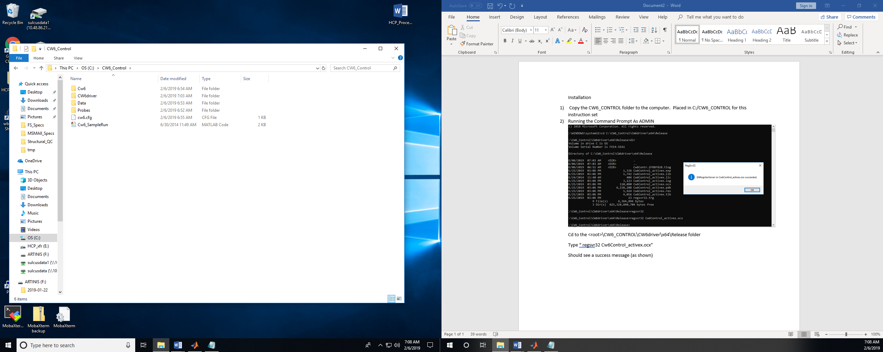

1. Running the Command Prompt As ADMIN

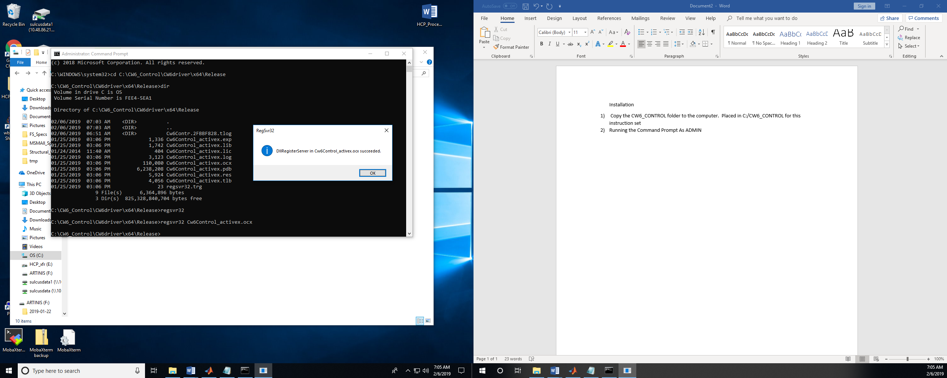

Cd to the <root>\CW6_CONTROL\CW6driver\x64\Release folder

Type “ regsvr32 Cw6Control_activex.ocx”

Should see a success message (as shown)

1. Check that is installed properly and registered with Matlab.

Launch Matlab (I am using 2018b in this example)

Type “info = actxcontrollist”

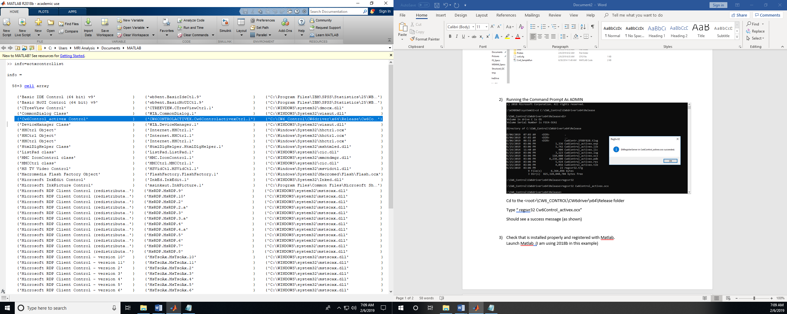

You should see the CW6 control in the activeX list. If not, the control didn’t register properly for some reason (you are on a 32bit machine and I only gave the 64x driver?)

1. Set the matlab path

Add with subfolders the “C:\CW6_Control” folder

1. Edit the cw6.cfg file if needed. This file sets up the default folder locations etc for your computer. Change the directory of the PROBE and DATA folders to match your computer. If you placed this in the C:\ folder, this is already fine. This is probably the only thing you need to change.

#CW6 Data Acquisition Control

#Configuration file

#

#Version 1.5 (Feb 6, 2019)

#Written by T. Huppert

#huppertt@upmc.edu

#Data and Probe Folders

PROBE_DIR='C:\Cw6_Control\Probes';

DATA_DIR='C:\Cw6_Control\Data';

SYSTEM_TYPE='CW6';

NUM_SRC=32;

NUM_DET=32;

NUM_LAMBDA=2;

LAMBDA=[690 830];

SAMPLE_RATE=20;

MAX_DET_GAIN=255;

# FLAG to allow software control of laser power

BOOL_ADJ_LASERS = 0;

MAX_LASER_INTEN = 9;

1. Testing the code. The software is a front end GUI called “Cw6.m” that interfaces to the activeX control that you just installed. This control can be called directly from Matlab command line (with no GUI) using the “CW6_SampleRun.m” code. For example:

cw=actxcontrol('CW6CONTROLACTIVEX.Cw6ControlactivexCtrl.1');

%These are the methods for this controller

disp(methods(cw));

cw.AllOn(); %All lasers on

cw.AllOff(); %All lasers off

1. Setting up a study.

The data folder (default C:\CW6_Control\Data) contains subfolders for investigators and studies. These folders are used to populate the register subject step in the CW6 gui. Inside the study folder, you need to place the probe file (*.sdg) for that study. This is a text file. The structure of the file is given at the end of this document.

1. Running the actual GUI.

Type “Cw6” in matlab to launch the GUI

**Example Probe file (MotorProbe4x8.sdg)**

Sample Probe Geometry

#Start with "!Description" Header

!Description:

This is a 4x8 motor probe for testing

Comment line 2

#Start with "geometry" Header

!Geometry:

NumSrc = 4

NumDet = 8

DetPos 1 = [2 -1 0];

DetPos 2 = [0 -1 0];

DetPos 3 = [-2 -1 0];

DetPos 4 = [-4 -1 0];

DetPos 5 = [0 1 0];

DetPos 6 = [-2 1 0];

DetPos 7 = [-4 1 0];

DetPos 8 = [-6 1 0];

SrcPos 1 = [1 0 0];

SrcPos 2 = [-1 0 0];

SrcPos 3 = [-3 0 0];

SrcPos 4 = [-5 0 0];

#Define the laser/source mapping

!Laser Map:

Laser S1-L1L2

Laser S2-L3L4

Laser S3-L5L6

Laser S4-L7L8

#Define the measurement combinations

!Measurement Map:

NumStates = 1

State 1

measurement S1-D1D2D5

measurement S2-D2D3D5D6

measurement S3-D3D4D6D7

measurement S4-D4D7D8

Notes:

1. Use the headers (eg “!Geometry”) as noted to denote the sections
2. Geometry header- Specifies the X/Y/Z coordinates of the probe for drawing purposes.
3. Laser Map. This maps the laser diodes to their source position. E.g. Laser S1-L1L2 means lasers 1 and 2 went to source 1 (S1). The notation is S#-L#L#. For most (all) studies this will be similar to shown above
4. Measurement Map. This sets which source detectors are used. The NumStates and State {1,2,3} is used for time-multiplexing. I am not sure if that still works in the code since I haven’t used it in years. The example above is for a 1 state (non-switching) setup

The notation “measurement S#-D#” and can be extended to save typing. E.g. S1-D1D2D5 means source-1 was connected to detectors 1,2, and 5. You could use something like “S1S2-D1” for sources 1 and 2 to detector 5. SALL and DALL can be used for all sources and all detectors. SALL-DALL would be the full 32x32 Cw6 data.

1. There should be only 1 probe (sdg) file per study folder.