1. 问题：茅台明年规划

期望文本：202303302678012267

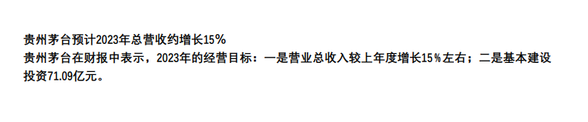

结果：

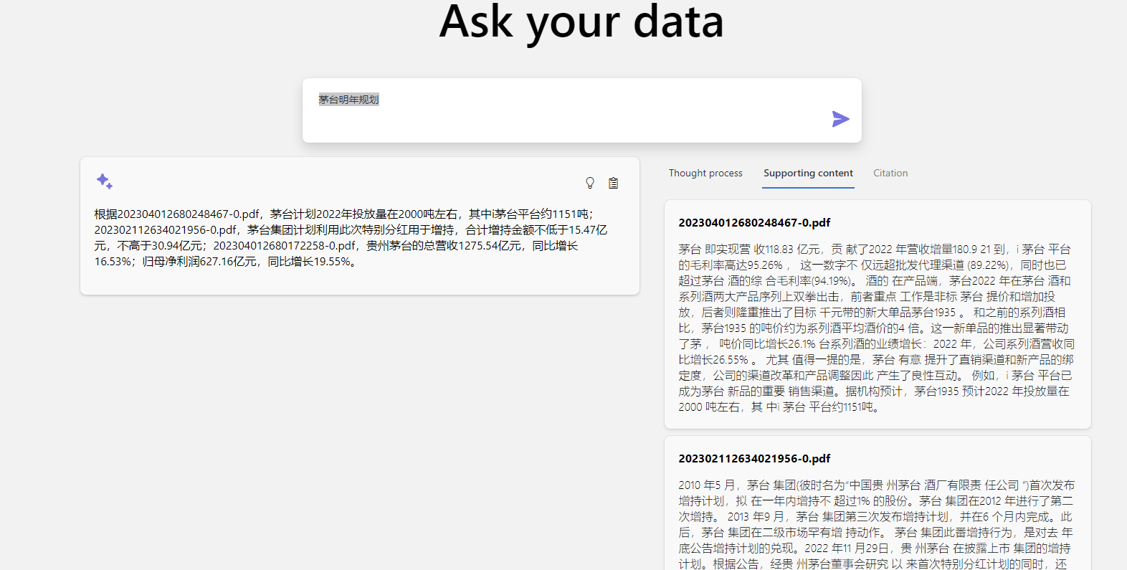

原因：对于日期，不能泛化，要较为精确匹配

*MS： 需要对提问修正，不是日期（加不加都可以）*

*提问因该是经营目标不是规划*

*比如：*

1. *茅台2023年的经营目标*
2. *茅台经营目标*

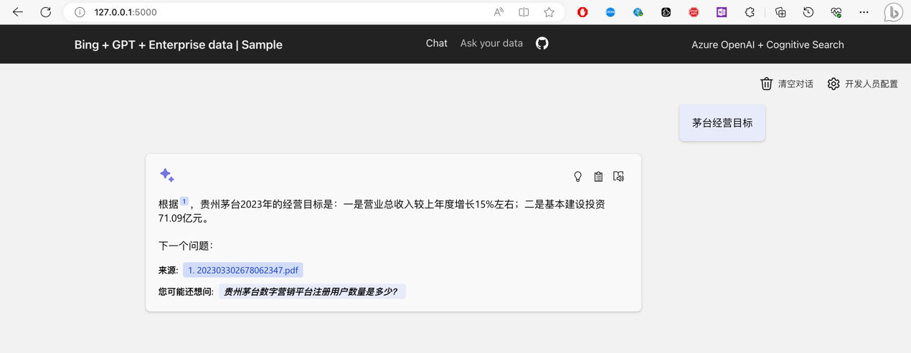

1. 问题：贵州茅台融资余额

期望文本：202303032652364575

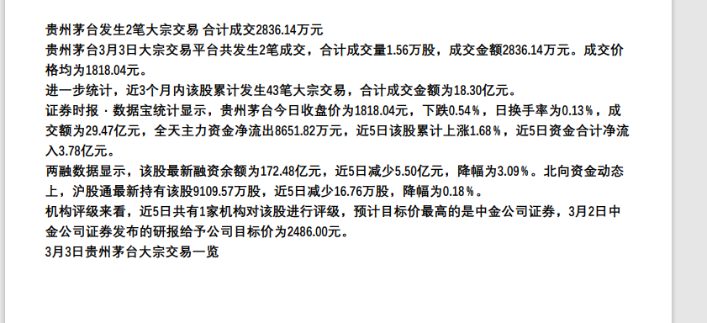

结果：

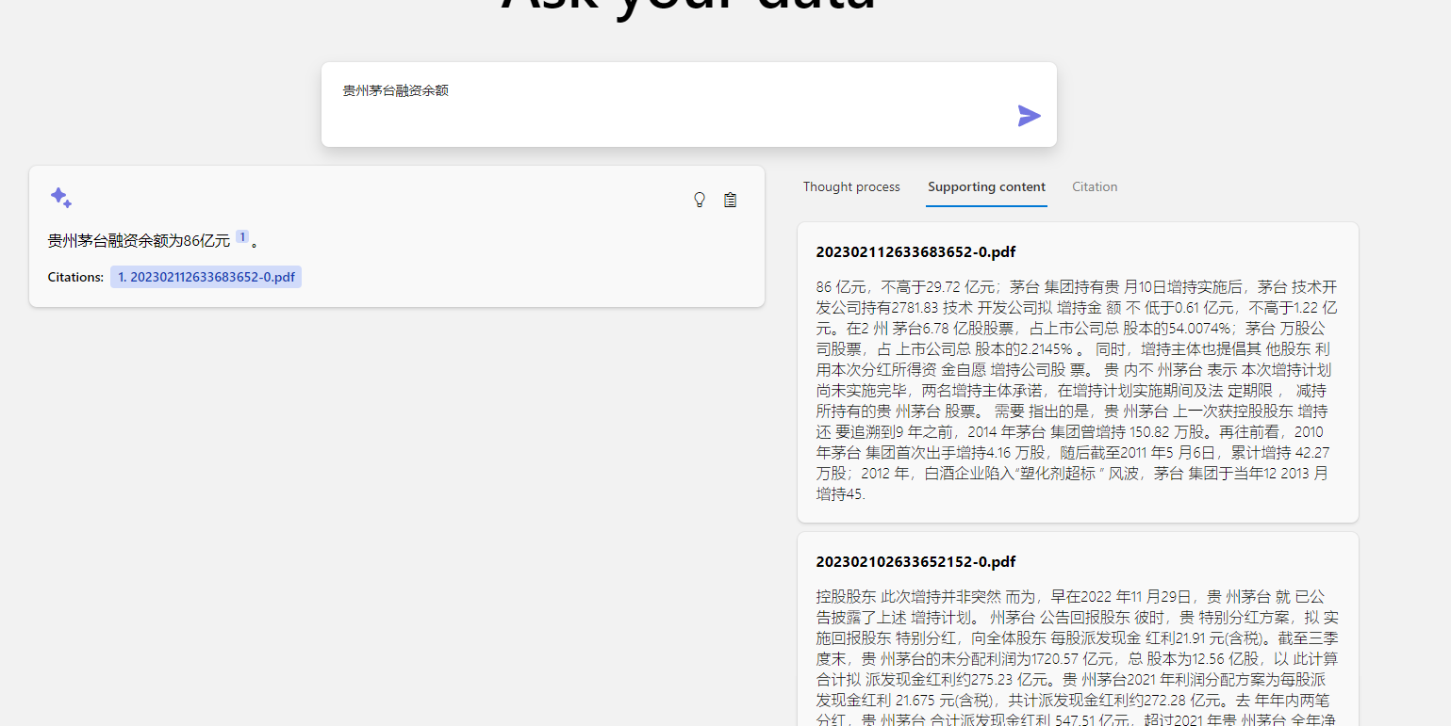

原因：答案错误吧

***MS： 根据搜索结果来看，前三名确实有相同的内容：***

***可以根据内容，引导用户提出更加明确的问题。***

***比如：***

***2023年3月3日，贵州茅台融资余额***

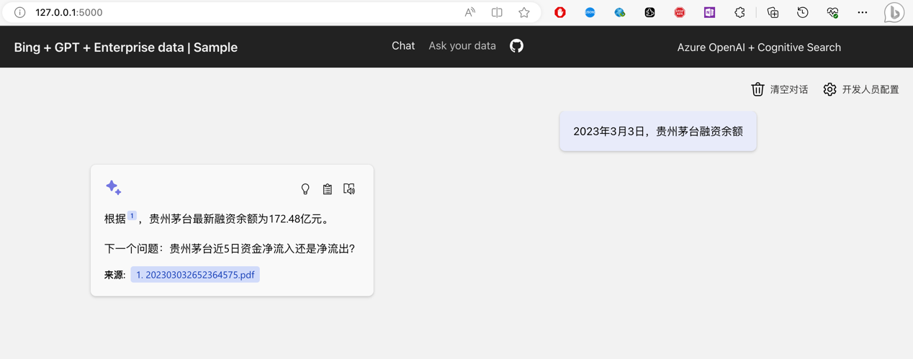

{

"@search.score": 10.143477,

"@search.rerankerScore": 0.8265304565429688,

"sourcefile": "202303232670883561.pdf"

},

{

"@search.score": 11.96368,

"@search.rerankerScore": 0.6851119995117188, "sourcefile": "202303092657473838.pdf"

},

{

"@search.score": 10.181519,

"@search.rerankerScore": 0.4407691955566406,

"sourcefile": "202303032652364575.pdf"

}

1. 问题：济川药业近期大机构评价如何

期望文本：202303302678012267

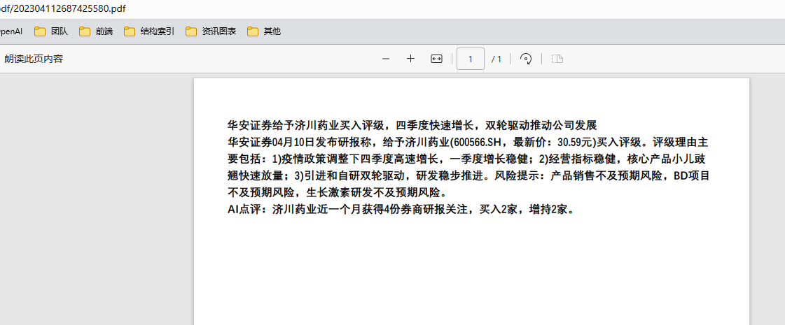

结果：

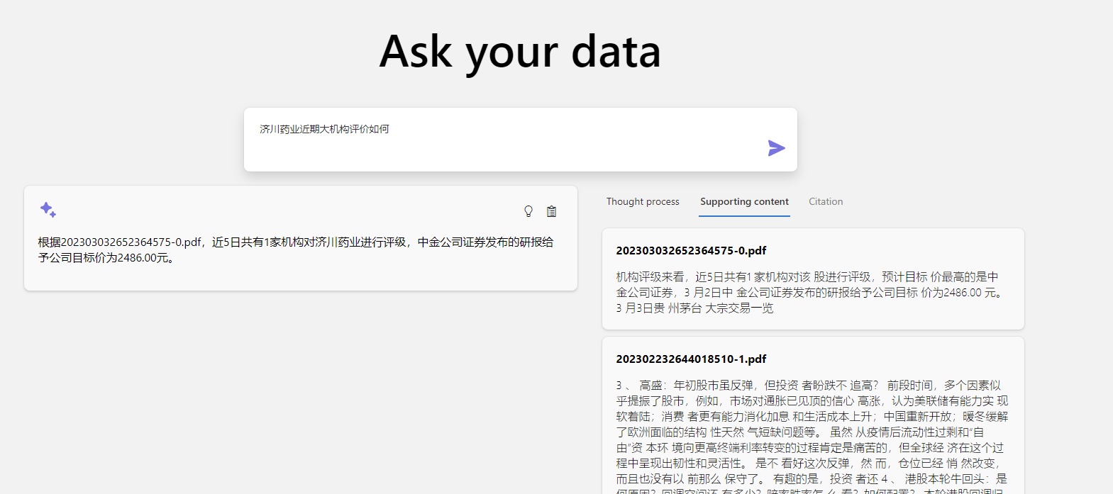

原因：文本不相干

MS：上面的源文件应该是本身就是错误的，应该是：202304112687425580.pdf

结果是正确的。

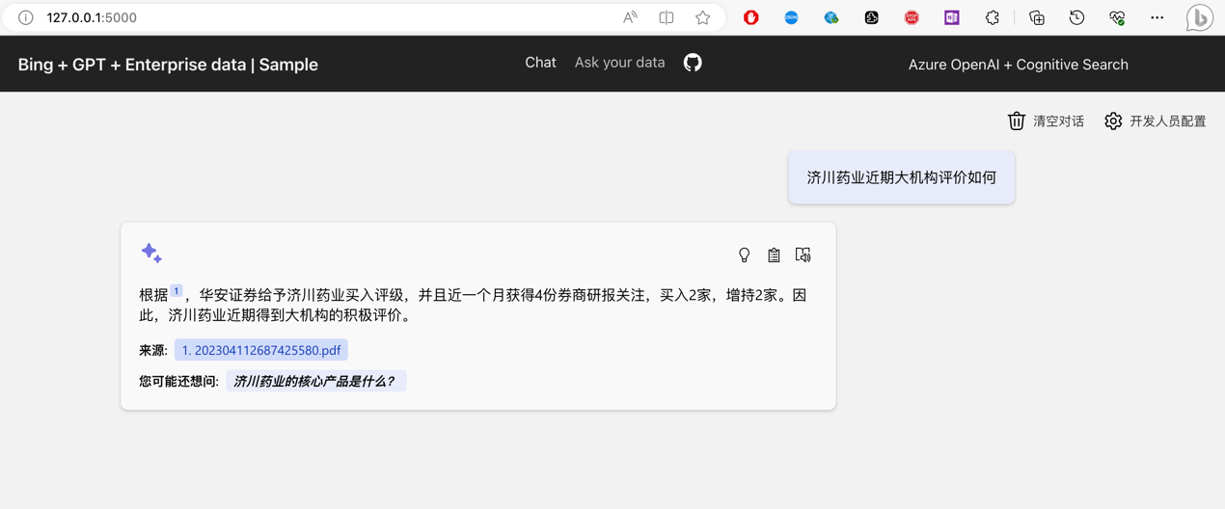

、{

"@search.score": 17.879696,

"@search.rerankerScore": 0.32230281829833984,

"sourcefile": "202304112687425580.pdf"

}

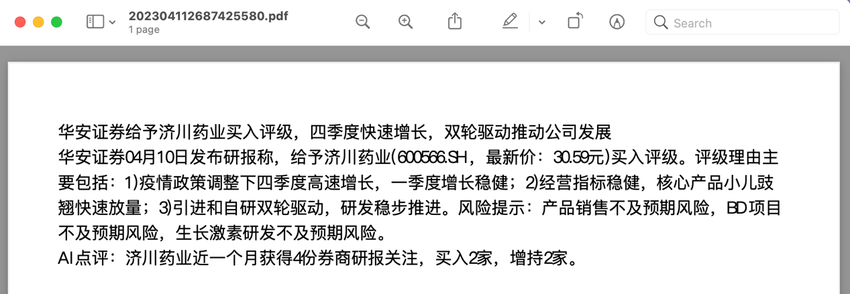

1. 问题：银行业近期风向

期望文本：202304112687466441

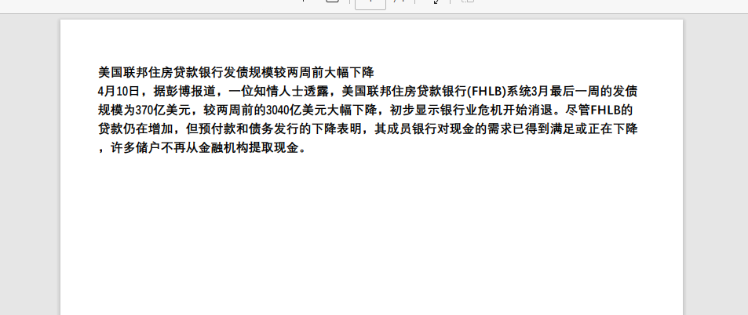

结果：

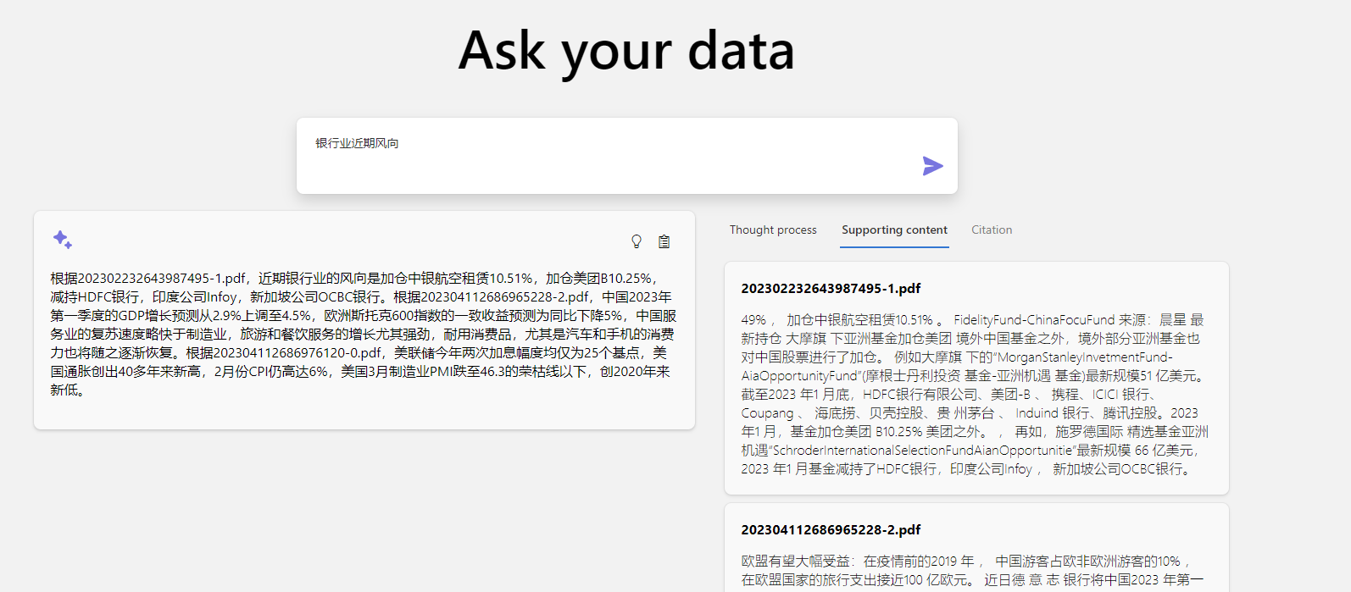

原因：文本不相干

***MS： 确实有相似的文档，需要进一步明确答案。无论是词频还是语义排名都不算靠前。***

***推荐提问：***

***美国联邦住房贷款银行发债规模***

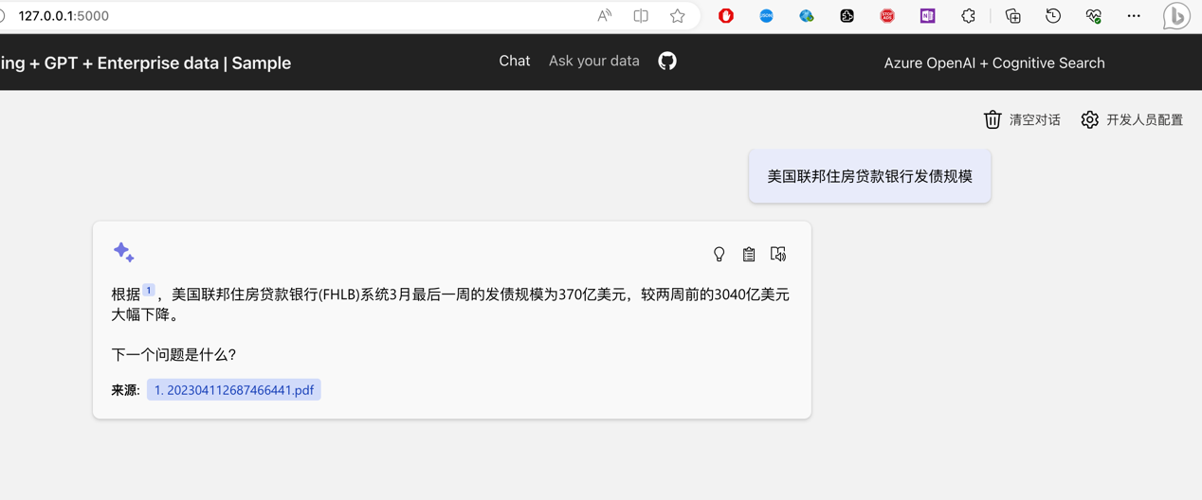

{

"@search.score": 6.325797,

"@search.rerankerScore": 0.8897514343261719,

"sourcefile": "202304112687633031.pdf"

},

{

"@search.score": 10.865248,

"@search.rerankerScore": 0.6839923858642578,

"sourcefile": "202304112687537755.pdf"

},

{

"@search.score": 8.005198,

"@search.rerankerScore": 0.6796712875366211,

"sourcefile": "202304112687599754.pdf"

},

{

"@search.score": 6.8112087,

"@search.rerankerScore": 0.6178722381591797,

"sourcefile": "202304112687476477.pdf"

},

{

"@search.score": 7.0644107,

"@search.rerankerScore": 0.5933914184570312,

"sourcefile": "202304112687462386.pdf"

},

{

"@search.score": 6.8790035,

"@search.rerankerScore": 0.5757694244384766,

"sourcefile": "202304112687604980.pdf"

},

{

"@search.score": 8.376717,

"@search.rerankerScore": 0.5649814605712891,

"sourcefile": "202304112687614989.pdf"

},

{

"@search.score": 10.650865,

"@search.rerankerScore": 0.5603504180908203,

"sourcefile": "202304112687468657.pdf"

},

{

"@search.score": 5.108481,

"@search.rerankerScore": 0.5461597442626953,

"sourcefile": "202304112687492191.pdf"

},

{

"@search.score": 5.329586,

"@search.rerankerScore": 0.5147552490234375,

"sourcefile": "202304112687660035.pdf"

},

{

"@search.score": 4.5717416,

"@search.rerankerScore": 0.4716644287109375,

"sourcefile": "202304112687424122.pdf"

},

{

"@search.score": 4.76437,

"@search.rerankerScore": 0.4708080291748047,

"sourcefile": "202304112687620450.pdf"

},

{

"@search.score": 5.9148874,

"@search.rerankerScore": 0.4604835510253906,

"sourcefile": "202304112687642393.pdf"

},

***{***

***"@search.score": 7.5343738,***

***"@search.rerankerScore": 0.4577484130859375,***

***"sourcefile": "202304112687466441.pdf"***

***}***