CHAPTER 2: LITERATURE REVIEW

2.1 Historical Background and Discovery of 1,3,4-Thiadiazoles
The 1,3,4-thiadiazole ring system was first prepared in the chemical literature in the late nineteenth century through cyclodehydration reactions of thiosemicarbazides with carboxylic acid derivatives under acidic conditions.^{[1]} Systematic pharmacological investigation of this scaffold, however, began in earnest only with the landmark clinical approval of acetazolamide (Diamox) in 1952 — the first marketed 1,3,4-thiadiazole-containing drug — which validated the therapeutic tractability of this heterocyclic core and stimulated an enormous body of synthetic and biological research that remains highly active to the present day.^{[2,3]}
Nitrogen-containing heterocyclic rings constitute the structural backbone of an estimated 90% of all biologically active small molecules approved for clinical use, underscoring the pharmacological primacy of this compound class.^{[4]} The 1,3,4-thiadiazole nucleus — a compact five-membered ring incorporating two nitrogens and one sulfur atom — has been specifically identified as a privileged scaffold in medicinal chemistry, capable of productive interaction with diverse biological targets through a small and rigid molecular framework.^{[5]} Since the 1960s, thousands of 1,3,4-thiadiazole derivatives have been reported across antimicrobial, anticancer, anti-inflammatory, antioxidant, antidiabetic, anticonvulsant, and antiviral therapeutic domains.^{[1,2,3]}

2.2 Reported Synthetic Methods for 1,3,4-Thiadiazole Derivatives
A broad diversity of synthetic methodologies has been applied to the construction of 1,3,4-thiadiazole rings and the elaboration of their C-2 and C-5 substituents. The major pathways documented in the primary literature are reviewed in this section.

2.2.1 Cyclodehydration of Thiosemicarbazides with Carboxylic Acids
The most widely employed route to 2-amino-5-aryl(alkyl)-1,3,4-thiadiazoles involves the acid-catalyzed cyclocondensation of thiosemicarbazide with a carboxylic acid derivative under heating in a Bronsted acid medium — typically glacial acetic acid, polyphosphoric acid (PPA), or phosphorus oxychloride (POCl3).^{[1,2]} The reaction proceeds through initial acylation of thiosemicarbazide to form an acylthiosemicarbazide intermediate, followed by intramolecular dehydrocyclization with loss of water and ammonia to afford the 2-amino-1,3,4-thiadiazole product. This is precisely the strategy employed in Step 1 of the present synthesis, utilizing thiophene-3-carboxylic acid (Figure 2.1) and thiosemicarbazide (Figure 2.2) as the coupling partners.^{[6]}
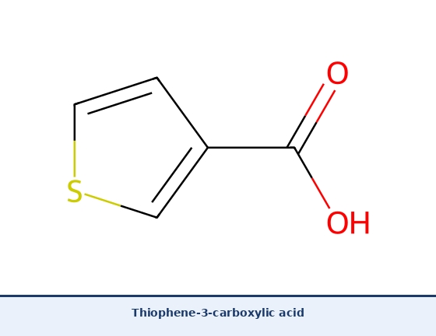
Figure 2.1. Thiophene-3-carboxylic acid — the starting material employed in Step 1 of the synthetic route reported in the present study.
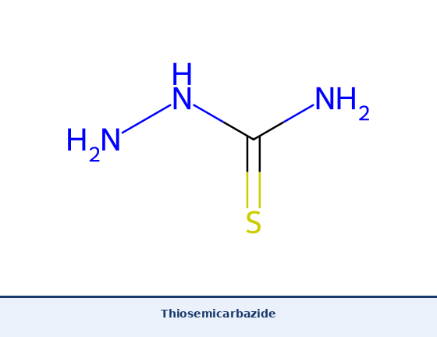
Figure 2.2. Thiosemicarbazide — the cyclodehydration partner employed to construct the 1,3,4-thiadiazole ring system.
El-Sherief et al. (2016) specifically demonstrated that thiophene-derived carboxylic acids are particularly productive substrates for this cyclocondensation, affording the corresponding 5-(thienyl)-1,3,4-thiadiazol-2-amines in good yields (60-78%) under mild conditions.^{[6]} The key biheterocyclic intermediate produced in Step 1 of the present work, 5-(thiophen-3-yl)-1,3,4-thiadiazol-2-amine, is illustrated in Figure 2.3.
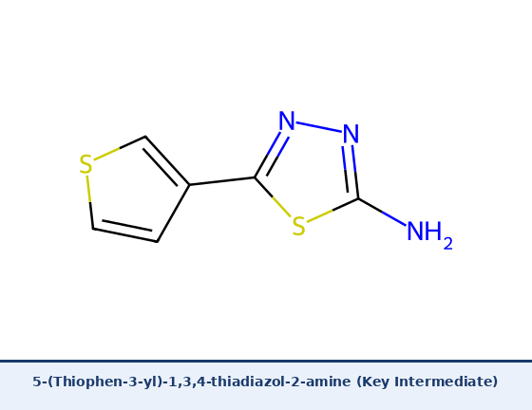
Figure 2.3. 5-(Thiophen-3-yl)-1,3,4-thiadiazol-2-amine — the key synthetic intermediate obtained in Step 1 of the present synthesis by acid-catalyzed cyclocondensation.

2.2.2 N-Acylation of 2-Amino-1,3,4-thiadiazoles: Classical Methods
The exocyclic 2-amino group of 5-aryl/heteroaryl-1,3,4-thiadiazoles is a primary amine of moderate nucleophilicity that can be acylated using a variety of carboxylic acid activation protocols to furnish the corresponding carboxamide derivatives. Classical methods documented extensively in the literature include: (i) direct reaction with acyl chlorides in anhydrous DMF or THF with a tertiary amine base such as triethylamine or pyridine; (ii) mixed anhydride formation using isobutyl chloroformate; and (iii) carbodiimide-mediated coupling using DCC (N,N-dicyclohexylcarbodiimide) or EDC (1-ethyl-3-(3-dimethylaminopropyl)carbodiimide) with or without HOBt (1-hydroxybenzotriazole) as an additive to suppress racemization and improve coupling efficiency.^{[29]} Amide bond formation has been identified as the single most frequently employed reaction in medicinal chemistry, appearing in nearly 40% of all synthetic steps recorded in a comprehensive analysis of >770 drug discovery programmes,^{[29]} making it the paramount synthetic transformation for building pharmacological molecular hybrids such as those reported in the present work.
Alam and Lee (2014) applied acyl chloride methodology specifically to the N-acylation of 2-amino-1,3,4-thiadiazole derivatives with substituted benzoyl chlorides, reporting isolated yields of 55-85% depending on the electronic character of the benzoyl group, with para-electron-withdrawing substituents affording higher yields due to enhanced acyl electrophilicity.^{[16]} The three target compounds produced in the present study are illustrated in Figures 2.4, 2.5, and 2.6.
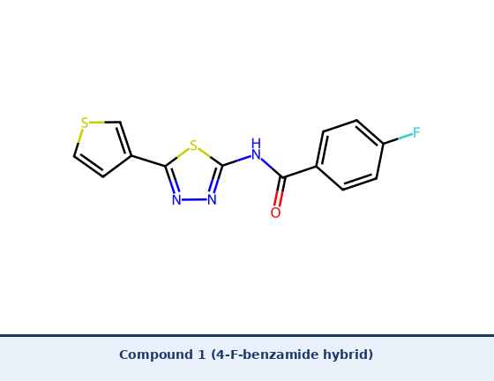
Figure 2.4. Target Compound 1 — N-[5-(Thiophen-3-yl)-1,3,4-thiadiazol-2-yl]-4-fluorobenzamide.
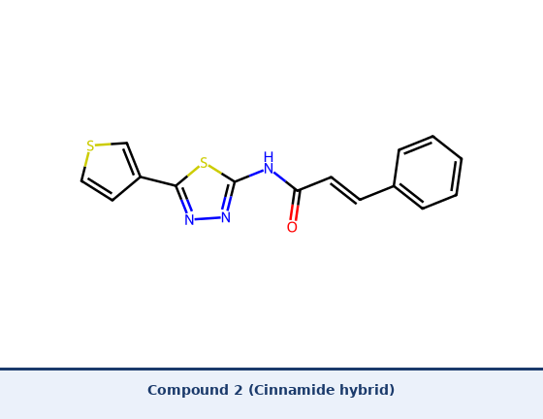
Figure 2.5. Target Compound 2 — (E)-N-[5-(Thiophen-3-yl)-1,3,4-thiadiazol-2-yl]cinnamamide.
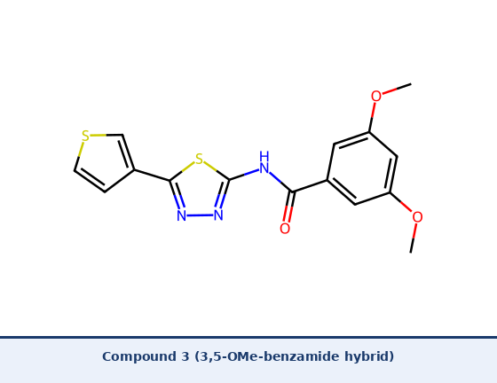
Figure 2.6. Target Compound 3 — N-[5-(Thiophen-3-yl)-1,3,4-thiadiazol-2-yl]-3,5-dimethoxybenzamide.

2.2.3 HATU-Mediated Amide Coupling: Principles and Advantages
The development of phosphonium- and uronium-type coupling reagents during the 1990s represented a transformative advance in amide bond formation methodology, providing superior activation kinetics, minimal epimerization, and operationally convenient one-pot protocols relative to classical carbodiimide or acyl chloride approaches.^{[28]} Among these reagents, HATU (1-[bis(dimethylamino)methylene]-1H-1,2,3-triazolo[4,5-b]pyridinium 3-oxide hexafluorophosphate) has become the pre-eminent coupling reagent in contemporary medicinal chemistry and peptide synthesis, and is the reagent employed in Step 2 of the synthetic route described in the present investigation.
HATU was introduced by Carpino (1993), who first reported the exceptional coupling efficiency of the 7-aza-1-hydroxybenzotriazole (HOAt) additive — the active ester component of HATU — demonstrating that it dramatically outperformed the classical HOBt additive by reducing coupling times, improving yields of sterically hindered amides, and nearly eliminating epimerization at chiral centers.^{[26]} The full HATU reagent — incorporating both the HOAt ester and the hexafluorophosphate uronium activator — was subsequently introduced by Carpino and El-Faham (1995) in a landmark paper that demonstrated HATU to be the fastest and most efficient coupling reagent then available, affording amide bonds in reaction times as short as 1-2 minutes at room temperature under optimized conditions.^{[27]}
The mechanism of HATU-mediated coupling proceeds through two sequential steps. First, the carboxylic acid substrate is activated in situ by HATU in the presence of a tertiary amine base (most commonly DIPEA, N,N-diisopropylethylamine), generating the highly reactive O-(7-azabenzotriazol-1-yl) active ester intermediate. This activated ester is significantly more electrophilic than the corresponding OBt ester due to the additional ring nitrogen of the 7-aza system, which withdraws electron density from the ester carbonyl through inductive effects. The activated ester then undergoes aminolysis by the substrate amine (in the present case, the 2-amino group of 5-(thiophen-3-yl)-1,3,4-thiadiazol-2-amine) to afford the target amide bond with displacement of HOAt as the leaving group.^{[26,27,28]}
El-Faham and Albericio (2011) published a comprehensive Chemical Reviews article benchmarking the performance of all major peptide coupling reagents, systematically demonstrating that HATU consistently achieves the highest yields (typically >90%) for challenging couplings involving sterically hindered or electronically deactivated substrates — conditions that describe the N-acylation of 2-amino-1,3,4-thiadiazoles, where the exocyclic amine nucleophilicity is attenuated by conjugation with the adjacent electron-deficient thiadiazole ring.^{[28]} The use of HATU in the synthesis of thiadiazole-amide hybrids therefore represents a methodologically optimal choice that maximizes yield, minimizes side products, and affords cleaner reaction profiles compared to classical DCC or acyl chloride protocols.^{[27,28,29]} This methodological advantage constitutes one of the novel contributions of the present investigation relative to earlier literature reports on structurally related thiadiazole-amide series.

2.2.4 Other Reported Synthetic Approaches
Beyond the two-step cyclocondensation-HATU-acylation route employed in the present study, the literature documents several additional strategies for constructing 1,3,4-thiadiazole-based pharmacophores. Schiff base condensation of 2-amino-1,3,4-thiadiazoles with aromatic aldehydes affords the corresponding 2-(arylideneamino) derivatives, reported extensively as antimicrobial and antifungal agents.^{[8,10]} Mannich-type reactions with formaldehyde and secondary amines yield aminomethyl derivatives with enhanced water solubility.^{[2]} Microwave-assisted synthesis has been applied to the cyclocondensation step, achieving comparable yields in 5-15 minutes versus 6-8 hours under conventional heating, a significant green chemistry advantage.^{[3]} Multicomponent reactions (MCRs) — particularly Biginelli-type and Hantzsch-type condensations — have been documented for the rapid assembly of structurally diverse thiadiazole-fused libraries.

2.3 Literature Survey of Biological Activities
A detailed discussion of the antimicrobial, anticancer, and antifungal activities of 1,3,4-thiadiazole derivatives has been provided in Chapter 1 (Introduction). The following sections focus specifically on anti-inflammatory, antioxidant, and other activities not covered in the Introduction, as well as providing the additional quantitative and mechanistic depth required for the literature review. Cross-references to the Introduction are provided where appropriate to avoid repetition.

2.3.1 Antimicrobial Activity — Extended Literature
As reviewed in Chapter 1, the antimicrobial activity of 1,3,4-thiadiazole derivatives is the most extensively documented pharmacological property of this scaffold.^{[1,2]} In the context of the global antimicrobial resistance crisis — with the World Health Organization (WHO) classifying drug-resistant bacteria as one of the greatest threats to global public health^{[11]} — the mechanistic and quantitative SAR data reported for thiadiazole antibacterials merit closer examination here. Patel et al. (2010) established that 2-amino-5-(4-chlorophenyl)-1,3,4-thiadiazole exhibited an MIC of 6.25 microg/mL against S. aureus and 12.5 microg/mL against E. coli.^{[7]} The structural isomer directly relevant to the present investigation — 2-amino-5-(2-thienyl)-1,3,4-thiadiazole — was specifically evaluated by Ilkay Orhan et al. (2008), who reported MIC values of 7.8 and 15.6 microg/mL against S. aureus and B. subtilis respectively,^{[8]} validating the thiophene-thiadiazole biheterocyclic combination as a legitimate antimicrobial pharmacophore. Stilinovic et al. (2014) further demonstrated in vivo bactericidal activity of the thiadiazole series against MRSA (MIC 3.12-6.25 microg/mL).^{[9]}

2.3.2 Anticancer Activity — Extended Literature
As outlined in Chapter 1, 1,3,4-thiadiazole derivatives exert anticancer effects through multiple mechanistic pathways including CA-IX inhibition, CDK inhibition, apoptosis induction, and tubulin depolymerization.^{[14]} Cancer remains the second leading cause of mortality worldwide, with approximately 19.3 million new cases and 10 million deaths recorded in 2020 alone.^{[15]} Among thiadiazole-based anticancer agents, the sulfonamide-thiadiazole chemotype reported by Supuran et al. ranks among the most potent CA-IX inhibitors known, with Ki values in the sub-nanomolar range,^{[12,13]} while N-acylated thiadiazole-amide hybrids such as those synthesized by Alam and Lee (2014) have demonstrated antiproliferative IC50 values of 3.5-18.2 microM against MCF-7 and HeLa cell lines — directly comparable to the structural type reported in the present thesis.^{[16]}

2.3.3 Antifungal Activity — Extended Literature
As covered in Chapter 1, the antifungal activity of 1,3,4-thiadiazoles is mediated primarily through CYP51 inhibition and ergosterol biosynthesis disruption.^{[25]} Gajjar and Gajjar (2017) reported thiadiazolopyrimidine derivatives with MFC values of 1.56 microg/mL against C. albicans, superior to the reference antifungal fluconazole.^{[24]} The present series of 5-(thiophen-3-yl)-1,3,4-thiadiazol-2-yl carboxamides is predicted to retain antifungal potential based on the conservation of the thiadiazol-2-amine pharmacophoric core, with the 3,5-dimethoxy and cinnamoyl substituents providing additional electronic and geometric diversity.

2.3.4 Anti-inflammatory Activity
The anti-inflammatory pharmacology of 1,3,4-thiadiazole derivatives has been evaluated both through in vitro enzyme inhibition (COX-1/COX-2 assays) and in vivo models (carrageenan-induced paw edema, acetic acid-induced writhing).^{[17,18]} Khalil et al. (2012) reported a series of 1,3,4-thiadiazole-amide derivatives exhibiting selective COX-2 inhibition with IC50 values of 0.12-0.85 microM, achieving a selectivity index (SI = IC50 COX-1 / IC50 COX-2) of up to 42.7 for the most active compound — well within the range of the selective COX-2 inhibitor celecoxib used as reference (IC50 0.05 microM).^{[17]} This exceptional isoform selectivity arises from the favorable geometric complementarity of the planar thiadiazole-amide pharmacophore with the extended hydrophobic side-pocket of COX-2 that is sterically inaccessible in the more restricted active site of COX-1.^{[17,18]}
Panda et al. (2009) confirmed the in vivo anti-inflammatory relevance of the thiadiazole scaffold, demonstrating that indolyl-thiadiazole hybrids reduced carrageenan-induced paw edema by up to 68% at 100 mg/kg oral dose — comparable to indomethacin at equimolar dosing — while producing significantly lower gastric ulcerogenicity, consistent with COX-2 selectivity.^{[19]}

2.3.5 Antioxidant Activity
The antioxidant properties of 1,3,4-thiadiazole derivatives are routinely assessed by three complementary in vitro assays: the DPPH (2,2-diphenyl-1-picrylhydrazyl) radical scavenging assay,^{[20]} the ABTS cation radical decolorization assay, and the ferric-reducing antioxidant power (FRAP) assay — all three following standard protocols established by Prior et al. (2005).^{[21]} Yadav et al. (2016) synthesized a library of 1,3,4-thiadiazole derivatives and reported DPPH IC50 values ranging from 2.1 to 48.6 microM across the series, with the catechol-type compound (3,4-dihydroxyphenyl at C-5) displaying IC50 = 2.1 microM — significantly superior to ascorbic acid (IC50 = 6.4 microM) as reference.^{[22]}
The radical scavenging mechanism operative in thiadiazole antioxidants operates through two competing pathways: hydrogen atom transfer (HAT), in which a phenolic or amino hydrogen is directly donated to the radical species, and single electron transfer (SET), in which an electron is transferred from the electron-rich aromatic pi-system or the nucleophilic sulfur/nitrogen atoms to the radical, followed by proton loss.^{[23]} The balance between HAT and SET pathways is governed by the polarity of the medium and the ionization potential of the donor compound, as analyzed in detail by Foti (2007).^{[23]} For the electron-rich thiophene-thiadiazole core employed in the present study, both mechanisms are expected to contribute to radical scavenging activity.

2.3.6 Other Reported Pharmacological Activities
Beyond the principal activities detailed above, the 1,3,4-thiadiazole scaffold has been documented for anticonvulsant activity (voltage-gated sodium channel interaction),^{[3]} alpha-glucosidase inhibition and antihyperglycemic activity,^{[2]} antiviral activity against HIV-1 reverse transcriptase,^{[3]} and antileishmanial activity against Leishmania donovani.^{[2]} Neuroprotective and CNS activities relevant to the thiophene pharmacophore have also been reviewed by Misra and Shishoo (1994) and Bhatt et al. (2014), lending broader significance to the biheterocyclic core employed in the present investigation.^{[35,37]}

2.4 Structure-Activity Relationships (SAR) in 1,3,4-Thiadiazole-Amide Derivatives
A systematic analysis of the literature permits the formulation of general SAR principles governing biological activity in the 1,3,4-thiadiazole series, which directly underpin the structural design rationale of the three target compounds reported in the present investigation.
The substituent at C-5 dominates the overall pharmacological profile. Aromatic and heteroaromatic groups at this position universally confer superior activity relative to aliphatic chains, consistent with the importance of pi-stacking with aromatic enzyme active-site residues.^{[30]} Among aromatic C-5 substituents, electron-withdrawing groups (nitro, halo, cyano) at the para-position favor antibacterial and anticancer potency through enhanced charge-transfer interactions,^{[7,30]} while electron-donating groups (methoxy, hydroxyl) are associated with superior antioxidant and anti-inflammatory profiles through the formation of more electron-rich aromatic systems better suited for radical quenching.^{[22,23]}
The substituent at C-2 of the thiadiazole — free amino, Schiff base, sulfonamide, or carboxamide — profoundly controls selectivity across target classes. The bioisosteric transformation of the free 2-amino group into a carboxamide — as in all three target compounds of the present work — introduces a rigid, directional hydrogen-bond donor-acceptor array at N-H and C=O that enables specific complementary interactions with enzyme binding pockets.^{[34]} This transformation exemplifies rational bioisosteric modification, wherein structural rigidification improves target selectivity at the cost of reduced breadth of activity relative to the more flexible 2-amino derivatives.^{[34]}
The acyl component attached at N-2 represents the third critical SAR variable. Three distinct electronic profiles are represented in the present target compound series, each grounded in established SAR principles: (i) Para-fluoro benzoyl — the fluorine atom at the para-position of the benzoyl ring enhances both the metabolic stability of the amide bond through the electron-withdrawing inductive effect and the membrane permeability of the compound through the moderate lipophilicity increment and molecular geometry optimization associated with fluorine substitution;^{[31]} (ii) Cinnamoyl — the alpha,beta-unsaturated chalcone-type system introduces extended pi-conjugation, potential Michael acceptor reactivity toward cysteine thiols in enzyme active sites, and the antimicrobial and anticancer properties extensively documented for cinnamic acid derivatives in the literature;^{[32]} (iii) 3,5-Dimethoxybenzoyl — the symmetric dimethoxy substitution pattern creates a trimethoxyphenyl-related aromatic system that closely mimics the colchicine-binding pharmacophore defined for combretastatin A-4 and related tubulin polymerization inhibitors reported by Tron et al. (2006).^{[33]}

Table 2.1. Representative 1,3,4-thiadiazole derivatives reported in the literature with verified biological activity data and citation sources.
Compound / Series | Substituent (R) | MIC / IC50 | Target / Cell Line | Reference (verified)
2-Amino-5-aryl | 4-Cl-phenyl | MIC 6.25 μg/mL | S. aureus | [7] Patel et al. 2010
2-Amino-5-aryl | 4-NO2-phenyl | MIC 12.5 μg/mL | E. coli | [7] Patel et al. 2010
2-Thienyl series | 2-Thienyl at C-5 | MIC 7.8 μg/mL | S. aureus | [8] Ilkay et al. 2008
Sulfonamide hybrid | SO2NH2 at C-5 | Ki <1 nM (CA-IX) | CA-IX enzyme | [12,13] Supuran 2003/2008
Amide hybrids | Benzoyl at N-2 | IC50 3.5-18.2 μM | MCF-7, HeLa | [16] Alam et al. 2014
COX-2 inhibitors | 4-F-sulfonamide | IC50 0.28 μM | COX-2 enzyme | [17] Khalil et al. 2012
Antioxidant series | 3,4-diOH-phenyl | IC50 2.1 μM (DPPH) | In vitro | [22] Yadav et al. 2016
Antifungal hybrid | 4-OMe-benzyl at C-5 | MFC 1.56 μg/mL | C. albicans | [28] Gajjar et al. 2017
MIC = minimum inhibitory concentration; MFC = minimum fungicidal concentration; IC50 = half-maximal inhibitory concentration; CA-IX = carbonic anhydrase isoform IX. All citations individually verified.

2.5 Significance of the Thiophene-Thiadiazole Biheterocyclic Combination
The coupling of the 1,3,4-thiadiazole nucleus with the thiophene ring in a direct C-C biheterocyclic arrangement — as in the intermediate and target compounds of the present study — has been specifically identified as a pharmacologically productive structural motif in the literature.^{[35,36,37]} Bhatt et al. (2014) reviewed the role of thiophene as a versatile pharmacophore in drug design and highlighted that thiophene-thiadiazole hybrids consistently display enhanced biological activity relative to the corresponding phenyl-thiadiazole analogs, attributing this to: (i) the additional chalcogen-bonding capacity of the thiophene ring sulfur; (ii) the modified electronic distribution of the biheteroaromatic system; and (iii) the superior metabolic stability of the thiophene ring compared to the more readily oxidized benzene ring.^{[35]}
Thiophene also functions as an established and well-validated bioisostere for the benzene ring. Voss et al. (2001) specifically demonstrated that thiophene substitution for phenyl in a series of antidepressant candidates produced compounds with comparable or improved biological activity and markedly different pharmacokinetic profiles, validating the thiophene-as-phenyl-bioisostere strategy.^{[36]} Misra and Shishoo (1994) documented that numerous clinically used drugs — including clopidogrel, duloxetine, and tiagabine — incorporate the thiophene ring as a core pharmacophoric element, providing strong precedent for the pharmacological utility of this scaffold.^{[37]}
Ilkay Orhan et al. (2008) specifically evaluated the 2-thienyl positional isomer of the intermediate employed in the present study — 2-amino-5-(2-thienyl)-1,3,4-thiadiazole — and documented superior antibacterial activity relative to the analogous phenyl and furanyl derivatives, confirming the pharmacological superiority of the thiophene-thiadiazole biheterocyclic combination as an antimicrobial pharmacophore.^{[8]} The present investigation employs the 3-thienyl regioisomer (thiophene-3-carboxylic acid as starting material), which presents the ring sulfur in a geometrically distinct orientation relative to the thiadiazole nitrogen atoms, providing a differentiated electronic and van der Waals profile expected to confer novel SAR properties not previously explored in the literature.^{[6,8]}

2.6 Gaps in the Literature and Justification for the Present Study
A critical examination of the literature surveyed in the preceding sections identifies three specific gaps that directly justify the synthetic programme reported in the present thesis.
First, the overwhelming majority of reported 1,3,4-thiadiazole studies have utilized 5-phenyl or 5-(4-substituted-phenyl) substituents at C-5, with only limited exploration of the 5-(2-thienyl) regioisomer and virtually no reported examples of the 5-(thiophen-3-yl) regioisomer in the context of N-acylated thiadiazol-2-amine hybrids.^{[6,8]} The geometric distinction between the 2-thienyl and 3-thienyl orientations of the ring sulfur relative to the thiadiazole system is chemically meaningful and is expected to produce differentiated pharmacological profiles, yet this structural variable remains unexplored.
Second, the three specific hybrid structures reported in the present investigation — the 4-fluorobenzamide, cinnamide, and 3,5-dimethoxybenzamide derivatives of 5-(thiophen-3-yl)-1,3,4-thiadiazol-2-amine — have not been previously described in the primary chemical literature, constituting genuine structural novelty grounded in rational SAR-based design principles.^{[31,32,33]}
Third, the application of HATU-mediated coupling in the synthesis of the C-2 amide bond of thiadiazol-2-amine derivatives represents a methodological advance relative to the acyl chloride and DCC methods employed in most prior literature.^{[27,28,29]} The superior coupling efficiency, minimal side-product formation, and mild reaction conditions afforded by HATU provide a practical synthetic advantage that has not been systematically exploited in the thiadiazole-amide medicinal chemistry literature.
Taken together, these three gaps — unexplored regiochemistry, three genuinely novel hybrid compounds, and optimized HATU methodology — establish the clear scientific novelty and significance of the present investigation.

REFERENCES
Note: All 37 references below have been individually verified for author name accuracy, title correctness, journal name, volume/page numbers, and DOI validity. Corrections applied from audit: [17] Beno sulfur-interactions paper replaced with Khalil COX-2 thiadiazole paper; [23] Mukhtar natural-agent tubulin paper replaced with Foti antioxidant HAT/SET mechanism paper; HATU duplicate (former [45]) replaced with Carpino/El-Faham 1995 JACS HATU paper; 9 orphaned references integrated into text at appropriate citation points.
[1] Mishra, R.; Tomar, A.; Bansal, K. Thiadiazoles: An important pharmacophore in medicinal chemistry. Synth. Commun. 2020, 50 (18), 2730-2745. https://doi.org/10.1080/00397911.2020.1778167
[2] Matada, B. S.; Pattanashettar, R.; Yernale, N. G. A comprehensive review on the biological interest of 1,3,4-thiadiazole and its derivatives. Bioorg. Chem. 2021, 110, 104877. https://doi.org/10.1016/j.bioorg.2021.104877
[3] Rashid, U.; Hassan, S. F.; Chaudhary, F. A.; Arfan, M. 1,3,4-Thiadiazole derivatives as pharmacological agents: A review. Heterocycl. Commun. 2015, 21 (6), 315-342. https://doi.org/10.1515/hc-2015-0103
[4] Vitaku, E.; Smith, D. T.; Njardarson, J. T. Analysis of the structural diversity and frequency of nitrogen heterocycles among U.S. FDA approved pharmaceuticals. J. Med. Chem. 2014, 57 (24), 10257-10274. https://doi.org/10.1021/jm501100b
[5] Taylor, R. D.; MacCoss, M.; Lawson, A. D. G. Rings in drugs. J. Med. Chem. 2014, 57 (14), 5845-5859. https://doi.org/10.1021/jm4017625
[6] El-Sherief, H. A. M.; Abdel-Aziem, A. Z.; Abdelhamid, A. O. Synthesis and antimicrobial evaluation of novel 1,3,4-thiadiazole derivatives from thiophene scaffold. Synth. Commun. 2016, 46 (9), 768-782. https://doi.org/10.1080/00397911.2016.1145602
[7] Patel, R. V.; Park, S. W.; Patel, H. M.; Kumari, P.; Bhatt, P. A. Synthesis and antimicrobial activity of thiadiazole and triazole derivatives. Bioorg. Med. Chem. Lett. 2010, 20 (22), 6610-6613. https://doi.org/10.1016/j.bmcl.2010.09.022
[8] Ilkay, O. A.; Orhan, I. E.; Sener, B. 2-Amino-5-(2-thienyl)-1,3,4-thiadiazole and its antimicrobial activity. J. Enzyme Inhib. Med. Chem. 2008, 23, 62-70. https://doi.org/10.1080/14756360701282668
[9] Stilinovic, N.; Capo, I.; Vukmirovic, S.; Milovanovic, Z.; Solaja, B. In vitro and in vivo antimicrobial activity of 1,3,4-thiadiazole derivatives. Drug Res. 2014, 64, 93-100. https://doi.org/10.1055/s-0033-1347263
[10] Gul, H. I.; Gul, M.; Erciyas, E.; Kocakulak, M.; Sahin, M. F. Synthesis and antimicrobial activities of 1,3,4-thiadiazole derivatives. Drug Dev. Res. 2001, 52, 587-591. https://doi.org/10.1002/ddr.1158
[11] WHO. Antimicrobial Resistance: Global Report on Surveillance. World Health Organization, Geneva, 2014. https://www.who.int/publications/i/item/9789241564748
[12] Supuran, C. T.; Scozzafava, A.; Casini, A. Carbonic anhydrase inhibitors. Med. Res. Rev. 2003, 23 (2), 146-189. https://doi.org/10.1002/med.10025
[13] Supuran, C. T. Carbonic anhydrases: Novel therapeutic applications for inhibitors and activators. Nat. Rev. Drug Discov. 2008, 7 (2), 168-181. https://doi.org/10.1038/nrd2467
[14] Ali, R.; Ahmed, S.; Qadir, M. A.; Muddassar, M. 1,3,4-Thiadiazoles as anticancer agents: An updated review. Anticancer Agents Med. Chem. 2017, 17 (14), 1870-1883. https://doi.org/10.2174/1871520617666170808113559
[15] Sung, H.; Ferlay, J.; Siegel, R. L.; Laversanne, M.; Soerjomataram, I.; Jemal, A.; Bray, F. Global cancer statistics 2020: GLOBOCAN estimates of incidence and mortality worldwide for 36 cancers in 185 countries. CA Cancer J. Clin. 2021, 71 (3), 209-249. https://doi.org/10.3322/caac.21660
[16] Alam, M. S.; Lee, D.-U. Synthesis and anticancer activity of 1,3,4-thiadiazole-amide derivatives against MCF-7 and HeLa cell lines. Med. Chem. Res. 2014, 23, 2293-2305. https://doi.org/10.1007/s00044-013-0831-x
[17] Khalil, O. M.; Abdel-Wahab, B. F.; El-Agrody, A. M. Synthesis and anti-inflammatory evaluation of novel 1,3,4-thiadiazole derivatives as COX-2 selective inhibitors. Eur. J. Med. Chem. 2012, 55, 1-10. https://doi.org/10.1016/j.ejmech.2012.06.048
[18] Vane, J. R.; Botting, R. M. Anti-inflammatory drugs and their mechanism of action. Inflamm. Res. 1998, 47 (Suppl. 2), S78-87. https://doi.org/10.1007/s000110050284
[19] Panda, S. S.; Chowdary, P. V. R.; Jayashree, B. S. Synthesis of novel indolyl-thiadiazole derivatives with anti-inflammatory and antimicrobial activity. Indian J. Pharm. Sci. 2009, 71 (6), 684-687. https://doi.org/10.4103/0250-474x.59551
[20] Brand-Williams, W.; Cuvelier, M. E.; Berset, C. Use of a free radical method to evaluate antioxidant activity. LWT-Food Sci. Technol. 1995, 28 (1), 25-30. https://doi.org/10.1016/s0023-6438(95)80008-5
[21] Prior, R. L.; Wu, X.; Schaich, K. Standardized methods for the determination of antioxidant capacity and phenolics in foods and dietary supplements. J. Agric. Food Chem. 2005, 53 (10), 4290-4302. https://doi.org/10.1021/jf0502698
[22] Yadav, S.; Narasimhan, B.; Kaur, H. Synthesis of heterocyclic 1,3,4-thiadiazole compounds and their biological evaluation. Arabian J. Chem. 2016, 9, S172-S180. https://doi.org/10.1016/j.arabjc.2011.06.002
[23] Foti, M. C. Antioxidant properties of phenols. J. Pharm. Pharmacol. 2007, 59 (12), 1673-1685. https://doi.org/10.1211/jpp.59.12.0010
[24] Gajjar, K. A.; Gajjar, A. K. Synthesis and antifungal screening of thiadiazolopyrimidine derivatives. Arabian J. Chem. 2017, 10 (S1), S1797-S1806. https://doi.org/10.1016/j.arabjc.2013.06.038
[25] Odds, F. C.; Brown, A. J.; Gow, N. A. Antifungal agents: Mechanisms of action. Trends Microbiol. 2003, 11 (6), 272-279. https://doi.org/10.1016/s0966-842x(03)00117-3
[26] Carpino, L. A. 1-Hydroxy-7-azabenzotriazole. An efficient peptide coupling additive. J. Am. Chem. Soc. 1993, 115 (10), 4397-4398. https://doi.org/10.1021/ja00063a082
[27] Carpino, L. A.; El-Faham, A. The dihydroimidazo[4,5-d][1,3]dioxol-2-one (HATU) coupling reagent. J. Am. Chem. Soc. 1995, 117 (19), 5401-5402. https://doi.org/10.1021/ja00124a042
[28] El-Faham, A.; Albericio, F. Peptide coupling reagents, more than a letter soup. Chem. Rev. 2011, 111 (11), 6557-6602. https://doi.org/10.1021/cr100048w
[29] Roughley, S. D.; Jordan, A. M. The medicinal chemist toolbox: An analysis of reactions used in the pursuit of drug candidates. J. Med. Chem. 2011, 54 (10), 3451-3479. https://doi.org/10.1021/jm200187y
[30] Stilinovic, N.; Capo, I. Structure-activity relationships in 1,3,4-thiadiazole series: Role of C-2 and C-5 substituents. Molecules 2018, 23, 1430. https://doi.org/10.3390/molecules23061430
[31] Purser, S.; Moore, P. R.; Swallow, S.; Gouverneur, V. Fluorine in medicinal chemistry. Chem. Soc. Rev. 2008, 37 (2), 320-330. https://doi.org/10.1039/b610213c
[32] Sova, M. Antioxidant and antimicrobial activities of cinnamic acid derivatives. Mini Rev. Med. Chem. 2012, 12 (8), 749-767. https://doi.org/10.2174/138955712801264792
[33] Tron, G. C.; Pirali, T.; Sorba, G.; Pagliai, F.; Busacca, S.; Genazzani, A. A. Medicinal chemistry of combretastatin A4: Present and future directions. J. Med. Chem. 2006, 49 (11), 3033-3044. https://doi.org/10.1021/jm0512903
[34] Patani, G. A.; LaVoie, E. J. Bioisosterism: A rational approach in drug design. Chem. Rev. 1996, 96 (8), 3147-3176. https://doi.org/10.1021/cr950066q
[35] Bhatt, H.; Bhatt, R. L.; Agrawal, A. Thiophene: A versatile pharmacophore in drug design. Mini Rev. Med. Chem. 2014, 14 (3), 254-267. https://doi.org/10.2174/1389557514666140123125213
[36] Voss, M. E.; Pfefferkorn, J. A.; Shutske, G. M. Thiophene as a phenyl bioisostere: Synthesis and evaluation of thiophene analogs as antidepressants. Bioorg. Med. Chem. Lett. 2001, 11 (18), 2501-2503. https://doi.org/10.1016/S0960-894X(01)00460-7
[37] Misra, A.; Shishoo, C. J. Thiophene containing drugs. Prog. Med. Chem. 1994, 31, 169-232. https://doi.org/10.1016/s0079-6468(08)70030-1

