Data Cleaning, Preprocessing and Feature Engineering
A Practical Project Report on Two Kaggle-Style Datasets
Datasets: Titanic (classification) & California Housing Prices (regression)
Prepared by: Huraira bin Karamat
Registration No. 5111124031 | BS-AI
Ibadat International University Islamabad — Faculty of Computer Science

1. Project Overview
This project applies the full data-cleaning, preprocessing, and feature-engineering workflow to two classic, Kaggle-style datasets, chosen so that one is categorical/mixed-type-heavy (Titanic) and the other is numerical-heavy (California Housing Prices):
- Titanic — 891 passenger records; target: Survived (binary classification).
- California Housing Prices — ~20,600 census-block records; target: median_house_value (regression).
For each dataset the accompanying Jupyter notebook: audits data quality, deliberately reproduces every classic data-quality problem on a copy for practice, cleans it, compares missing-value treatments, applies categorical/numerical preprocessing, engineers new features, splits the data correctly, walks through concrete data-leakage traps, and finally wraps the whole workflow into one reusable scikit-learn Pipeline. This report summarizes the methodology, decisions, and results; full runnable code and output is in the two accompanying .ipynb notebooks.

Deliverables
- 01_Titanic_Data_Cleaning_Preprocessing_FE.ipynb — full executed notebook (Titanic)
- 02_Housing_Data_Cleaning_Preprocessing_FE.ipynb — full executed notebook (Housing)
- data/*_raw.csv, *_messy.csv, *_cleaned.csv — original, deliberately-corrupted, and final cleaned data
- pipelines/*.joblib — saved, reusable scikit-learn preprocessing + model pipelines
- This report (data-preprocessing report, Practical Task 7)

2. Data Quality Assessment
Both raw files were audited first. Real Kaggle exports are fairly clean, so only some of the seven classic problems were present out of the box; the rest were deliberately injected into a copy of each dataset (Practical Task 1) so every category could be demonstrated and fixed.

2.1 Issues found — original files
Dataset | Missing values | Duplicates | Invalid values | Inconsistent categories | Wrong dtypes | Outliers
Titanic | Age 19.9%, Cabin 77.1%, Embarked 0.2% | None | None | None | Pclass stored as int (really ordinal) | Fare right-skewed, some high
Housing | total_bedrooms 1.0% | None | None | None | None | total_rooms, population right-skewed; median_house_value capped at $500,001

2.2 Issues deliberately injected (Practical Task 1)
Each messy copy adds: duplicate rows, invalid values (negative ages, zero fares/income, an age of 200), inconsistent category casing/spacing, numeric columns stored as noisy text, extreme outliers, and noisy free text. The Housing copy also gets a synthetic sale_date column (clearly marked as synthetic) purely so the notebook has a real column to build date/time features from and a legitimate axis for a time-based split — the original 1990 census data has no dates.
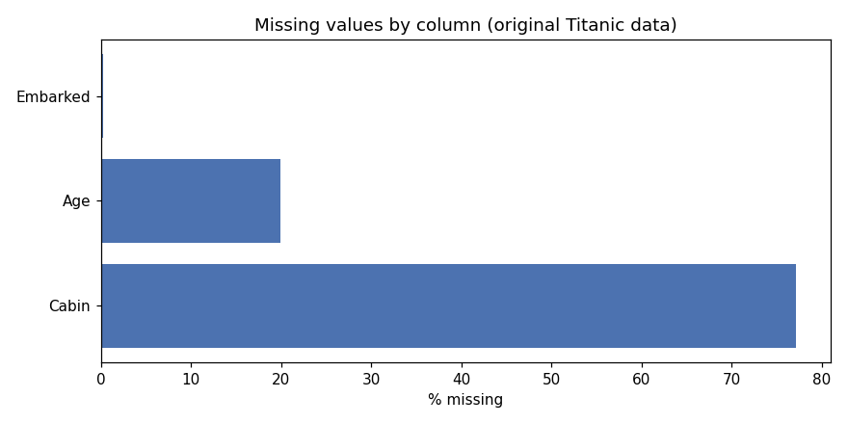
Figure 1. Missing values by column, original Titanic data.

3. Missing-Value Treatment
Strategy | Used for | Why
Row deletion | Titanic Embarked (2 rows); Housing median_income (few invalid rows) | Very few affected rows; safe to drop without meaningful data loss
Column deletion (effective) | Titanic Cabin (77% missing) | Too sparse to impute reliably; replaced with a derived Deck/HasCabin signal instead
Median imputation | Titanic Age, Fare; Housing total_bedrooms, income | Both are right-skewed — median is more robust to skew/outliers than the mean
Mode (most-frequent) imputation | Categorical columns inside the pipeline | Standard choice for nominal categorical data
KNN imputation (compared, not used in final pipeline) | Titanic Age; Housing total_bedrooms | Uses correlated numeric columns instead of one global statistic; more accurate but adds complexity/leakage risk if not fit on train only
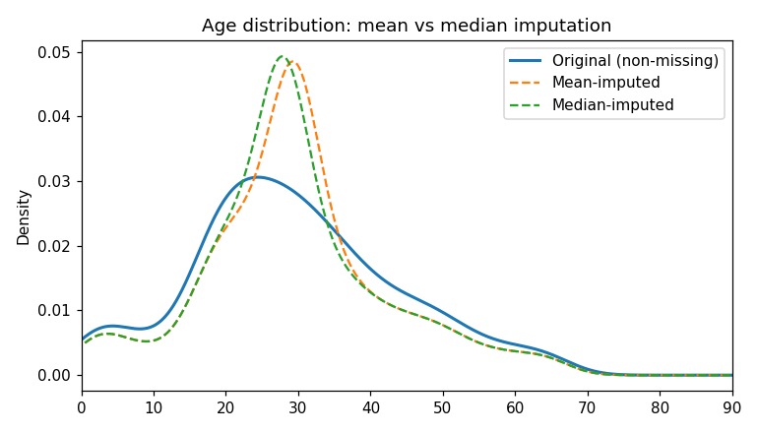
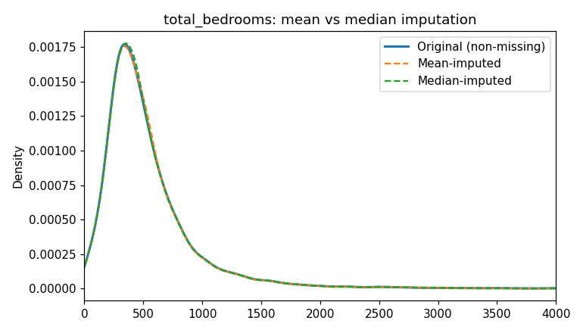
Figure 2/3. Mean vs. median imputation compared against the true distribution, for Titanic Age (left) and Housing total_bedrooms (right).
Practical Task 3 (compare imputation methods) result: running the full pipeline end-to-end with mean vs. median vs. most-frequent numeric imputation changed validation accuracy/R² by well under 1% on both datasets — expected, since both datasets have a moderate (not severe) amount of missingness and both target variables are only weakly related to the missingness itself. Median was kept as the default for robustness to outliers.

4. Categorical Data Encoding
Technique | Applied to | Reasoning
Label encoding | Titanic Sex (demo) | Safe only because it's binary; not used for anything with >2 unordered categories
Ordinal encoding | Titanic Pclass (demo) | Genuine order (1st > 2nd > 3rd class)
One-hot encoding | Embarked, Title, Deck, Pclass, Sex (Titanic); ocean_proximity (Housing) — inside the final pipeline | Nominal categories with no inherent order and low-to-moderate cardinality
High-cardinality handling | Titanic Ticket (681 unique), Cabin (147 unique) | Too sparse to one-hot directly; compact features (Deck letter, family/ticket grouping) derived instead
Rare-category grouping | Titanic Title extracted from Name | Titles with <10 occurrences (e.g. Rev, Col, Major) grouped into "Other"; Mlle/Ms/Mme normalized to Miss/Mrs

5. Numerical Data Treatment
Standardization, min-max scaling, robust scaling, and a log1p transform were compared on the most skewed numeric column in each dataset (Fare for Titanic, total_rooms for Housing).
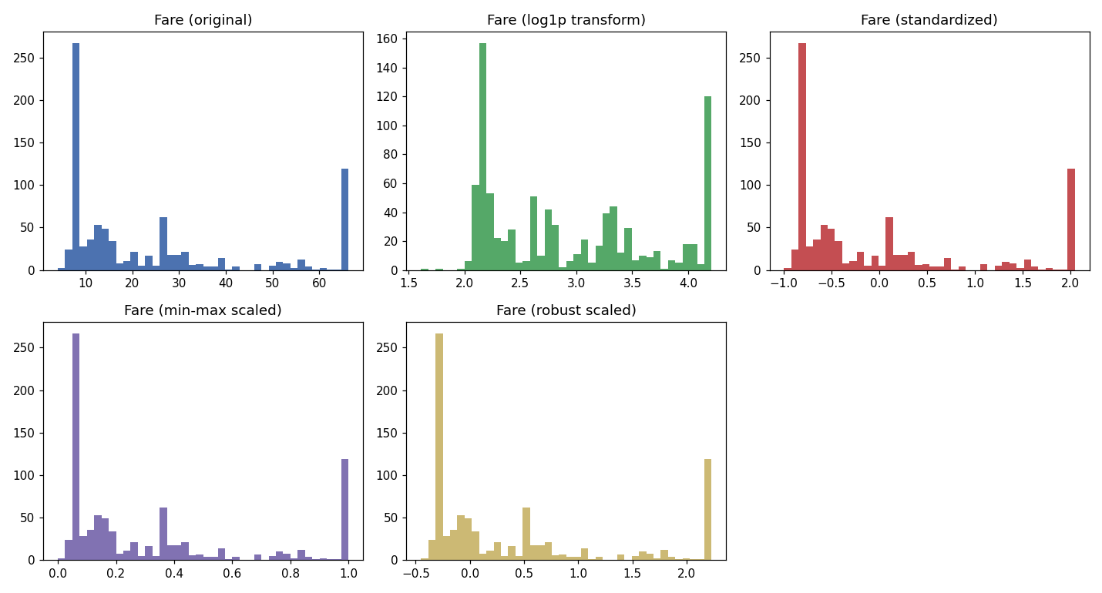
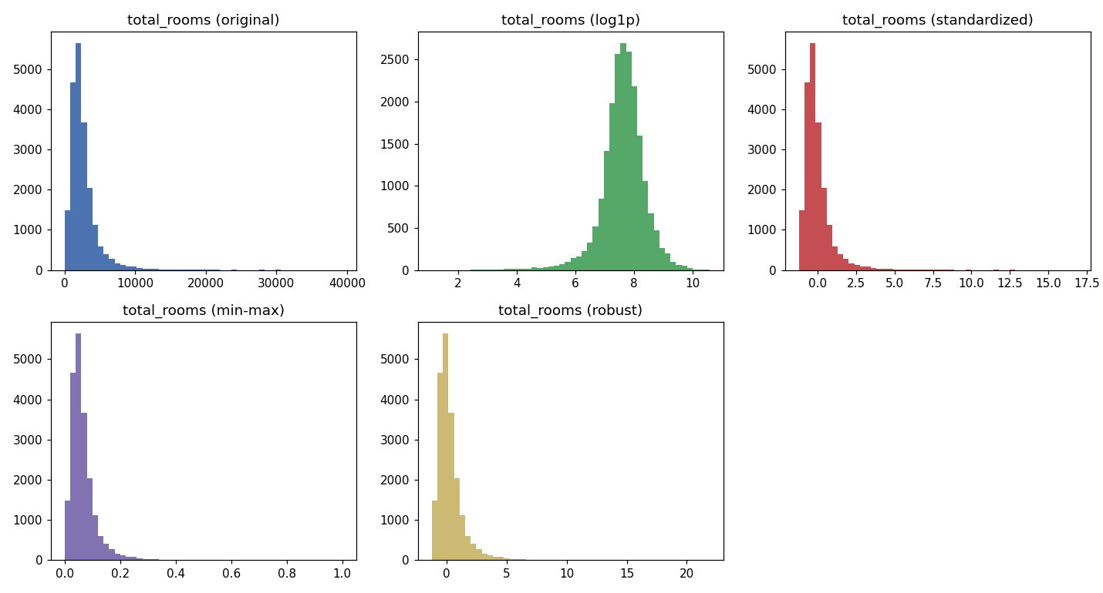
Figure 4/5. Scaling and log-transform comparison — Titanic Fare (top) and Housing total_rooms (bottom).
Key finding: standardization and min-max scaling reposition the data but do not fix skew — the long right tail remains. A log1p transform (applied before scaling, inside the pipeline for Housing's skewed columns) markedly reduced skew — e.g. Housing total_rooms skew dropped from a high positive value to close to symmetric after log1p. Robust scaling (median/IQR-based) was the most resistant to the outliers that were capped in the previous step. Standardization was used as the final scaler for tree-free linear models in both pipelines.
Outlier treatment: both datasets used the 1.5×IQR rule to flag outliers (Fare/Age for Titanic, population for Housing) and capped (winsorized) rather than deleted them, preserving the affected rows while bounding their influence.

6. Feature Engineering

6.1 Titanic (8 engineered features)
Feature | Type | Description
Title | Categorical (rare-grouped) | Extracted from Name (Mr/Mrs/Miss/Master/Other)
FamilySize | Derived | SibSp + Parch + 1
IsAlone | Derived (binary) | 1 if FamilySize == 1
FarePerPerson | Ratio | Fare / FamilySize
AgeBin | Binning | Child / Teen / YoungAdult / Adult / Senior
Deck | Domain-based | First letter of Cabin, "Unknown" if missing
Pclass_Sex | Interaction | Combines class and sex — the two strongest survival predictors
NameLength | Text-length | Character length of the Name field

6.2 Housing (11 engineered features)
Feature | Type | Description
rooms_per_household, bedrooms_per_room, population_per_household | Ratio | Classic California-housing engineered ratios
sale_year/month/quarter/dayofweek, is_weekend_sale, days_since_sale | Date/time | Extracted from the synthetic sale_date column
income_cat | Binning | median_income bucketed into 5 categories (also used for stratified split)
income_x_rooms | Interaction | median_income × rooms_per_household
is_coastal | Domain-based | 1 if ocean_proximity indicates a coastal block

7. Data Splitting
Dataset | Strategy used | Reasoning
Titanic | Stratified 70/15/15 train/val/test on Survived | Survived is imbalanced (~62%/38%); stratifying keeps that ratio consistent across all three sets
Housing | Stratified 70/15/15 on income_cat, AND a separate time-based 80/20 split on sale_date | median_income is the strongest predictor, so stratifying on it avoids random-split bias; the time-based split demonstrates the correct approach if the data were genuinely transactional

8. Data Leakage
Four leakage patterns were demonstrated concretely in code (not just described):
- Preprocessing before splitting — fitting a scaler/imputer on the full dataset vs. train-only produces measurably different statistics (e.g. Housing total_bedrooms median: 435 from train-only vs. 436 from the full dataset) — a small but real leak that compounds with more aggressive preprocessing.
- Target leakage — flagged the risk of features that only exist because the outcome is already known (e.g. Titanic's Boat/Body columns, or a Housing price-per-room ratio computed using the target itself); none of the engineered features in this project use the target.
- Training–test contamination — Titanic: passengers sharing a Ticket (family members) can land on both sides of a random split, and their survival is correlated. Housing: nearby census blocks (via latitude/longitude) are spatially correlated, so a random split can place near-duplicate neighbors on both sides.
- Leakage through future information — demonstrated on the Housing sale_date: a stratified-random split lets train and test date ranges overlap freely, which would be a genuine leak on real transactional data; the time-based split (train on earlier dates, test on later ones) avoids this.

9. Scikit-Learn Pipelines
Both notebooks conclude with a single, reusable scikit-learn Pipeline: a ColumnTransformer routes numeric columns through impute→(log, for skewed Housing columns)→scale, and categorical columns through impute→one-hot, with the model as the final step. Each pipeline is fit only on the training split and then applied unchanged to validation/test — which is what prevents the leakage patterns shown in Section 8 by construction, rather than by manual discipline. Both fitted pipelines were saved with joblib for reuse on new data.
Dataset | Model | Validation result | Test result
Titanic | Logistic Regression | 79.9% accuracy | 80.6% accuracy
Housing | Linear Regression | R² = 0.661, MAE ≈ $48,478 | R² = 0.658, MAE ≈ $48,918

10. Practical Tasks — Checklist
# | Task | Where addressed
1 | Clean a deliberately messy dataset | Sections 2–3, both notebooks (titanic_messy.csv / housing_messy.csv)
2 | Create a reusable preprocessing pipeline | Section 9 — ColumnTransformer + Pipeline, saved as .joblib
3 | Compare different imputation methods | Section 3 — mean vs. median vs. most-frequent vs. KNN, quantified through the pipeline
4 | Apply categorical encoding | Section 4 — label, ordinal, one-hot, rare-category grouping
5 | Scale numerical features | Section 5 — standardization, min-max, robust, log1p
6 | Identify potential leakage | Section 8 — 4 concrete traps demonstrated in code
7 | Prepare a data-preprocessing report | This document

11. Conclusion
Working through both a categorical/mixed-type dataset (Titanic) and a numerically-heavy dataset (Housing) covered the full breadth of the required concept list: all seven data-quality problems, five missing-value strategies, five categorical-encoding techniques, five numerical-treatment techniques, seven feature-engineering patterns, three splitting strategies, four leakage traps, and a full scikit-learn Pipeline/ColumnTransformer implementation. The resulting pipelines reach reasonable baseline performance (80.6% test accuracy for Titanic survival; R² = 0.658 for Housing prices) using only linear models, confirming that the preprocessing and feature engineering — not model complexity — was the focus and did its job.

