**Software for Mobile Devices**

**Task 04**

Name: Huraira Muzammal

Section: BCS 6B

Roll number: 22F-3853

Submission on: February 19, 2025

Submitted to: Mam Kanwal Naz

Question 1 : Reading from file

Code:

package com.example.feb_18;  
  
import android.os.Bundle;  
  
import androidx.activity.EdgeToEdge;  
import androidx.appcompat.app.AppCompatActivity;  
import androidx.core.graphics.Insets;  
import androidx.core.view.ViewCompat;  
import androidx.core.view.WindowInsetsCompat;  
import android.widget.Button;  
import android.widget.TextView;  
  
  
public class MainActivity extends AppCompatActivity {  
Button sendBtn;  
TextView view;  
 @Override  
 protected void onCreate(Bundle savedInstanceState) {  
 super.onCreate(savedInstanceState);  
 EdgeToEdge.*enable*(this);  
 setContentView(R.layout.*activity_main*);  
  
 sendBtn=findViewById(R.id.*read*);  
 view=findViewById(R.id.*textView*);  
  
 ViewCompat.*setOnApplyWindowInsetsListener*(findViewById(R.id.*main*), (v, insets) -> {  
 Insets systemBars = insets.getInsets(WindowInsetsCompat.Type.*systemBars*());  
 v.setPadding(systemBars.left, systemBars.top, systemBars.right, systemBars.bottom);  
 return insets;  
 });  
 sendBtn.setOnClickListener(v -> {  
 // Read file from assets and display content in TextView  
 String fileContent = FileReader.*readFileFromAssets*(MainActivity.this, "sample.txt");  
 view.setText(fileContent);  
 });  
 }  
  
}

Organization of folder

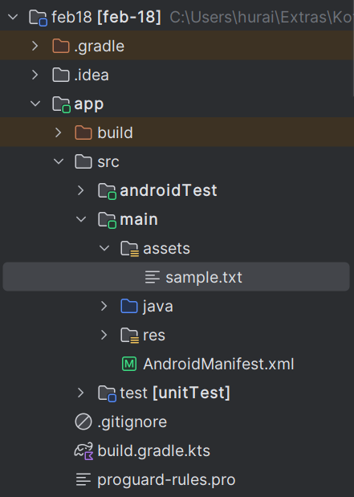

File sample.txt

Hello, this is a sample text file.  
Welcome to Android developmant!

End of file