Software for Mobile Devices

Class task and home task

Name: Muhammad Abu Huraira

Roll Number: 22F-3853

Section: BCS 6B

Submission on: February 27,2025

Task set the recycler view dependency in gradle

Main Java

package com.example.feb27_task1;  
  
import android.os.Bundle;  
  
import androidx.activity.EdgeToEdge;  
import androidx.appcompat.app.AppCompatActivity;  
import androidx.core.graphics.Insets;  
import androidx.core.view.ViewCompat;  
import androidx.core.view.WindowInsetsCompat;  
import androidx.recyclerview.widget.LinearLayoutManager;  
import androidx.recyclerview.widget.RecyclerView;  
  
import java.util.ArrayList;  
import java.util.List;  
  
public class MainActivity extends AppCompatActivity {  
  
 @Override  
 protected void onCreate(Bundle savedInstanceState) {  
 super.onCreate(savedInstanceState);  
 EdgeToEdge.*enable*(this);  
 setContentView(R.layout.*activity_main*);  
  
  
 RecyclerView recyclerView=findViewById(R.id.*recycle1*);  
 recyclerView.setLayoutManager(new LinearLayoutManager(this));  
  
 List<Student> studentList=new ArrayList<>();  
  
 for (int i=1;i<=20;i++)  
 {  
 studentList.add(new Student("Name"+i,"Roll number"+i));  
 }  
  
 Student_adapter adapter=new Student_adapter(studentList);  
 recyclerView.setAdapter(adapter);  
 ViewCompat.*setOnApplyWindowInsetsListener*(findViewById(R.id.*main*), (v, insets) -> {  
 Insets systemBars = insets.getInsets(WindowInsetsCompat.Type.*systemBars*());  
 v.setPadding(systemBars.left, systemBars.top, systemBars.right, systemBars.bottom);  
 return insets;  
 });  
 }  
}

Student file

package com.example.feb27_task1;  
  
public class Student {  
  
  
 private String name;  
 private String rollNo;  
  
  
 public Student(String _name,String _rollNo){  
  
 this.name =_name;  
 this.rollNo=_rollNo;  
 }  
  
 public String getName() {  
 return name;  
 }  
  
  
 public String getRollNo() {  
 return rollNo;  
 }  
  
  
}

Student adapter file

package com.example.feb27_task1;  
  
import android.view.LayoutInflater;  
import android.view.View;  
import android.view.ViewGroup;  
import android.widget.TextView;  
  
import androidx.annotation.NonNull;  
import androidx.cardview.widget.CardView;  
import androidx.recyclerview.widget.RecyclerView;  
  
import java.util.List;  
  
public class Student_adapter extends RecyclerView.Adapter<Student_adapter.ViewHolder> {  
  
  
 private List<Student> studentsList;  
  
  
  
 Student_adapter(List<Student> _list)  
 {  
 this.studentsList=_list;  
 }  
  
  
  
 @NonNull  
 @Override  
 public Student_adapter.ViewHolder onCreateViewHolder(@NonNull ViewGroup parent, int viewType) {  
  
 View view= LayoutInflater.*from*(parent.getContext()).inflate(R.layout.*item_card*,parent,false);  
 return new ViewHolder(view);  
 }  
  
 @Override  
 public void onBindViewHolder(@NonNull Student_adapter.ViewHolder holder, int position) {  
 Student student=studentsList.get(position);  
 holder.nameText.setText(student.getName());  
 holder.rollText.setText(student.getRollNo());  
  
 }  
  
 @Override  
 public int getItemCount() {  
 return studentsList.size();  
 }  
  
 public class ViewHolder extends RecyclerView.ViewHolder {  
  
 TextView nameText,rollText;  
 CardView cardView;  
 public ViewHolder(@NonNull View itemView) {  
 super(itemView);  
  
 nameText= itemView.findViewById(R.id.*textView*);  
 rollText= itemView.findViewById(R.id.*textView2*);  
 cardView= itemView.findViewById(R.id.*card2*);  
  
 }  
 }  
}

activity main xml

<?xml version="1.0" encoding="utf-8"?>  
<androidx.constraintlayout.widget.ConstraintLayout xmlns:android="http://schemas.android.com/apk/res/android"  
 xmlns:app="http://schemas.android.com/apk/res-auto"  
 xmlns:tools="http://schemas.android.com/tools"  
 android:id="@+id/main"  
 android:layout_width="match_parent"  
 android:layout_height="match_parent"  
 tools:context=".MainActivity">  
  
 <androidx.recyclerview.widget.RecyclerView  
 android:id="@+id/recycle1"  
 android:layout_width="409dp"  
 android:layout_height="729dp"  
 tools:layout_editor_absoluteX="1dp"  
 tools:layout_editor_absoluteY="1dp" />  
</androidx.constraintlayout.widget.ConstraintLayout>

Item card java

<?xml version="1.0" encoding="utf-8"?>  
<androidx.cardview.widget.CardView xmlns:android="http://schemas.android.com/apk/res/android"  
 android:id="@+id/card2"  
 android:layout_width="match_parent"  
 android:layout_height="wrap_content">  
  
 <LinearLayout  
 android:layout_width="match_parent"  
 android:layout_height="match_parent"  
 android:orientation="vertical">  
  
 <TextView  
 android:id="@+id/textView"  
 android:layout_width="match_parent"  
 android:layout_height="wrap_content"  
 android:text="TextView" />  
  
 <TextView  
 android:id="@+id/textView2"  
 android:layout_width="match_parent"  
 android:layout_height="40dp"  
 android:text="TextView" />  
 </LinearLayout>  
</androidx.cardview.widget.CardView>

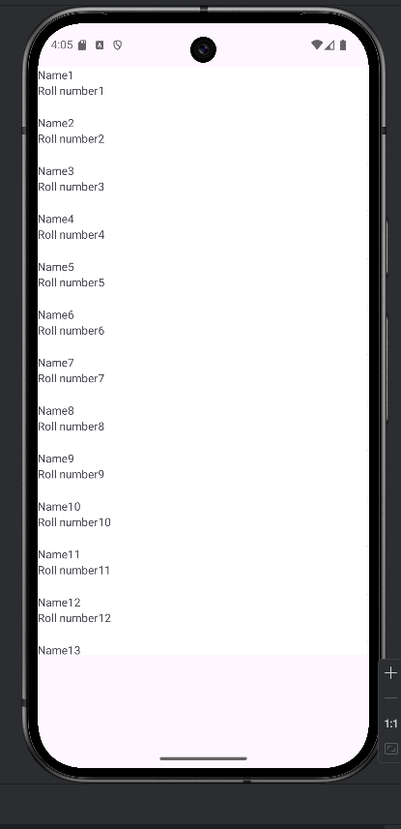

Task 2:

Main activity

package com.example.smd_feb27_task2;  
  
import android.content.Context;  
import android.media.MediaScannerConnection;  
import android.os.Bundle;  
import android.widget.TimePicker;  
import android.widget.Toast;  
  
import androidx.activity.EdgeToEdge;  
import androidx.appcompat.app.AppCompatActivity;  
import androidx.core.graphics.Insets;  
import androidx.core.view.ViewCompat;  
import androidx.core.view.WindowInsetsCompat;  
  
import java.io.FileNotFoundException;  
import java.io.FileOutputStream;  
import java.io.IOError;  
import java.io.IOException;  
  
public class MainActivity extends AppCompatActivity {  
  
 @Override  
 protected void onCreate(Bundle savedInstanceState) {  
 super.onCreate(savedInstanceState);  
 EdgeToEdge.*enable*(this);  
 setContentView(R.layout.*activity_main*);  
  
 String data="This is Simple file in internal Storage.";  
  
  
  
 try {  
 FileOutputStream fos=openFileOutput("myfile.text", Context.*MODE_PRIVATE*);  
  
 fos.write(data.getBytes());  
  
 fos.close();  
  
 Toast.*makeText*(this,"File write complete",Toast.*LENGTH_SHORT*).show();  
  
 }catch (FileNotFoundException e)  
 {  
 throw new RuntimeException(e);  
 } catch (IOException e) {  
 Toast.*makeText*(this,"Error writing file",Toast.*LENGTH_SHORT*).show();  
 }  
  
 String filePath=getFilesDir().getPath()+"/myfile.txt";  
  
 MediaScannerConnection.*scanFile*(this,new String[]{filePath},null,((path, uri) -> Toast.*makeText*(this,"File Scanned",Toast.*LENGTH_SHORT*).show()));  
 }  
}

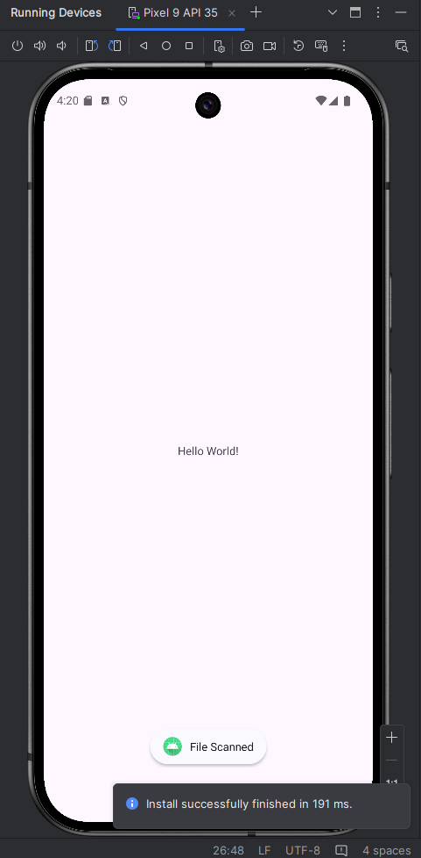

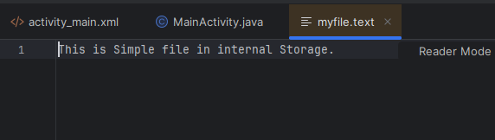

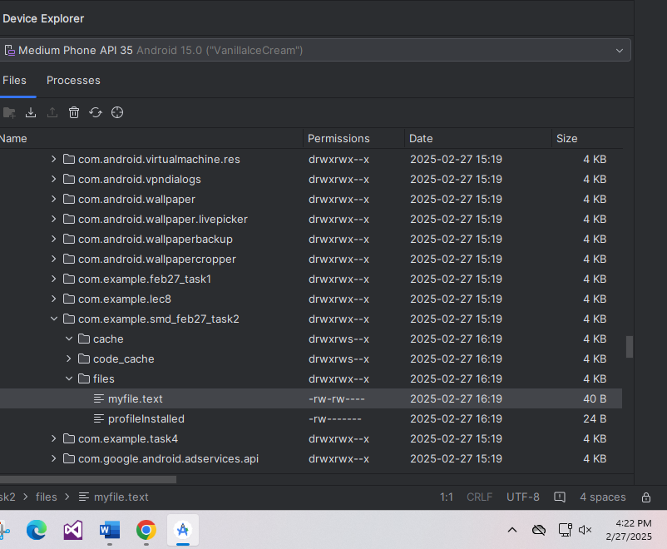

Home task 1

Modified xml for image upload

<?xml version="1.0" encoding="utf-8"?>  
<androidx.cardview.widget.CardView xmlns:android="http://schemas.android.com/apk/res/android"  
 xmlns:app="http://schemas.android.com/apk/res-auto"  
 xmlns:tools="http://schemas.android.com/tools"  
 android:id="@+id/c1"  
 android:layout_width="match_parent"  
 android:layout_height="wrap_content">  
  
 <LinearLayout  
 android:layout_width="match_parent"  
 android:layout_height="wrap_content"  
 android:orientation="horizontal">  
  
 <ImageView  
 android:id="@+id/imageView2"  
  
 android:layout_width="50dp"  
 android:layout_height="50dp"  
 android:layout_marginEnd="10dp"  
 android:scaleType="centerCrop"  
 app:srcCompat="@drawable/baseline_group_24" />  
  
 <LinearLayout  
 android:layout_width="match_parent"  
 android:layout_height="match_parent"  
 android:orientation="vertical">  
  
 <TextView  
 android:id="@+id/textView"  
 android:layout_width="match_parent"  
 android:layout_height="wrap_content"  
 android:text="Name"  
 android:textStyle="bold" />  
  
 <TextView  
 android:id="@+id/textView2"  
 android:layout_width="match_parent"  
 android:layout_height="40dp"  
 android:text="Roll Number" />  
  
  
 </LinearLayout>  
 </LinearLayout>  
</androidx.cardview.widget.CardView>

Student adapter

package com.example.feb27_task1;  
  
import android.view.LayoutInflater;  
import android.view.View;  
import android.view.ViewGroup;  
import android.widget.ImageView;  
import android.widget.TextView;  
  
import androidx.annotation.NonNull;  
import androidx.cardview.widget.CardView;  
import androidx.recyclerview.widget.RecyclerView;  
  
import java.util.List;  
  
public class Student_adapter extends RecyclerView.Adapter<Student_adapter.ViewHolder> {  
  
 private List<Student> stdList;  
  
 // Constructor  
 Student_adapter(List<Student> list) {  
 this.stdList = list;  
 }  
  
 @NonNull  
 @Override  
 public Student_adapter.ViewHolder onCreateViewHolder(@NonNull ViewGroup parent, int viewType) {  
 View view = LayoutInflater.*from*(parent.getContext()).inflate(R.layout.*item_card*, parent, false);  
 return new ViewHolder(view);  
 }  
  
 @Override  
 public void onBindViewHolder(@NonNull Student_adapter.ViewHolder holder, int position) {  
 Student student = stdList.get(position);  
 holder.nameText.setText(student.getName());  
 holder.rollText.setText(student.getRollNo());  
 holder.imageView.setImageResource(student.getImageResId()); // Set image  
 }  
  
 @Override  
 public int getItemCount() {  
 return stdList.size();  
 }  
  
 public class ViewHolder extends RecyclerView.ViewHolder {  
 TextView nameText, rollText;  
 ImageView imageView;  
 CardView cardView;  
  
 public ViewHolder(@NonNull View itemView) {  
 super(itemView);  
 nameText = itemView.findViewById(R.id.*textView*);  
 rollText = itemView.findViewById(R.id.*textView2*);  
 imageView = itemView.findViewById(R.id.*imageView2*); // Find ImageView  
 cardView = itemView.findViewById(R.id.*c1*);  
 }  
 }  
}

Student.java file

package com.example.feb27_task1;  
  
import android.view.LayoutInflater;  
import android.view.View;  
import android.view.ViewGroup;  
import android.widget.ImageView;  
import android.widget.TextView;  
  
import androidx.annotation.NonNull;  
import androidx.cardview.widget.CardView;  
import androidx.recyclerview.widget.RecyclerView;  
  
import java.util.List;  
  
public class Student_adapter extends RecyclerView.Adapter<Student_adapter.ViewHolder> {  
  
 private List<Student> stdList;  
  
 // Constructor  
 Student_adapter(List<Student> list) {  
 this.stdList = list;  
 }  
  
 @NonNull  
 @Override  
 public Student_adapter.ViewHolder onCreateViewHolder(@NonNull ViewGroup parent, int viewType) {  
 View view = LayoutInflater.*from*(parent.getContext()).inflate(R.layout.*item_card*, parent, false);  
 return new ViewHolder(view);  
 }  
  
 @Override  
 public void onBindViewHolder(@NonNull Student_adapter.ViewHolder holder, int position) {  
 Student student = stdList.get(position);  
 holder.nameText.setText(student.getName());  
 holder.rollText.setText(student.getRollNo());  
 holder.imageView.setImageResource(student.getImageResId()); // Set image  
 }  
  
 @Override  
 public int getItemCount() {  
 return stdList.size();  
 }  
  
 public class ViewHolder extends RecyclerView.ViewHolder {  
 TextView nameText, rollText;  
 ImageView imageView;  
 CardView cardView;  
  
 public ViewHolder(@NonNull View itemView) {  
 super(itemView);  
 nameText = itemView.findViewById(R.id.*textView*);  
 rollText = itemView.findViewById(R.id.*textView2*);  
 imageView = itemView.findViewById(R.id.*imageView2*); // Find ImageView  
 cardView = itemView.findViewById(R.id.*c1*);  
 }  
 }  
}

Main activity file

package com.example.feb27_task1;  
  
import android.os.Bundle;  
  
import androidx.activity.EdgeToEdge;  
import androidx.appcompat.app.AppCompatActivity;  
import androidx.core.graphics.Insets;  
import androidx.core.view.ViewCompat;  
import androidx.core.view.WindowInsetsCompat;  
import androidx.recyclerview.widget.LinearLayoutManager;  
import androidx.recyclerview.widget.RecyclerView;  
  
import java.util.ArrayList;  
import java.util.List;  
  
public class MainActivity extends AppCompatActivity {  
  
 @Override  
 protected void onCreate(Bundle savedInstanceState) {  
 super.onCreate(savedInstanceState);  
 EdgeToEdge.*enable*(this);  
 setContentView(R.layout.*activity_main*);  
  
 RecyclerView recyclerView = findViewById(R.id.*r1*);  
 recyclerView.setLayoutManager(new LinearLayoutManager(this));  
  
 List<Student> studentList = new ArrayList<>();  
  
 // Adding students with images  
 for (int i = 1; i <= 20; i++) {  
 studentList.add(new Student("Name: " + i, "Roll number: " + i, R.drawable.*baseline_group_24*));  
 }  
  
 Student_adapter adapter = new Student_adapter(studentList);  
 recyclerView.setAdapter(adapter);  
  
 ViewCompat.*setOnApplyWindowInsetsListener*(findViewById(R.id.*main*), (v, insets) -> {  
 Insets systemBars = insets.getInsets(WindowInsetsCompat.Type.*systemBars*());  
 v.setPadding(systemBars.left, systemBars.top, systemBars.right, systemBars.bottom);  
 return insets;  
 });  
 }  
}

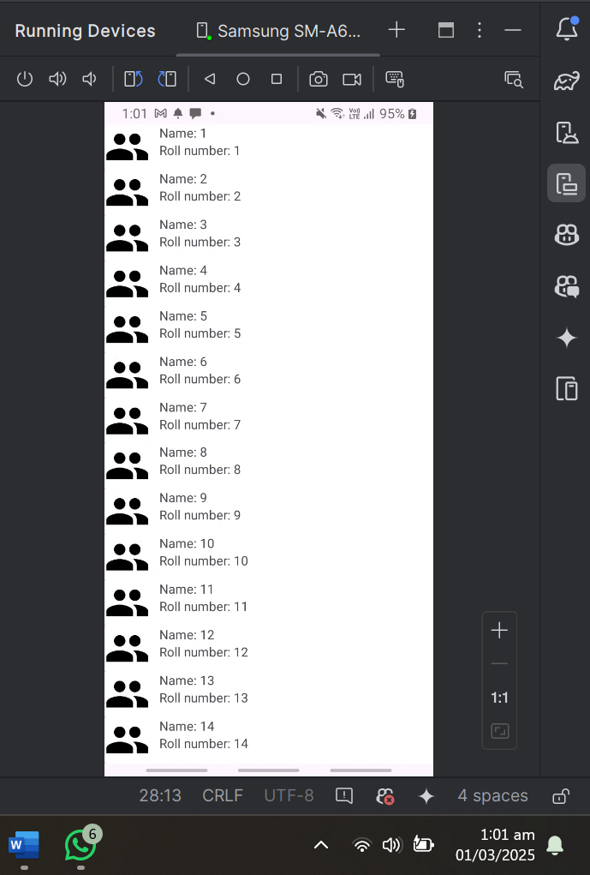

Home task 2

Reading data from inputFile.txt

Creation of assets folder and creating inputText file

Input file name

package com.example.smd_feb27_task2;  
  
  
  
import android.content.Context;  
import java.io.InputStream;  
  
import java.io.IOException;  
public class FileReader {  
 public static String readFileFromAssets(Context context, String fileName)  
 {  
 StringBuilder content = new StringBuilder();  
 try {  
 InputStream inputStream = context.getAssets().open("inputFile.txt");  
 int size = inputStream.available();  
 byte[] buffer = new byte[size];  
 inputStream.read(buffer);  
 inputStream.close();  
 content.append(new String(buffer));  
 } catch (IOException e) {  
 e.printStackTrace();  
 }  
 return content.toString();  
 }  
}

File path and content

With click of button content from file is written on screen

Device actual screenshot

content from file can be seen on screen

