Name: Muhammad Abu Huraira

Roll# 22F-3853

Section: BCS 6B

Submission on: February 11, 2025

Main acitivity 1

package com.example.myapplication;  
  
import android.app.ComponentCaller;  
import android.content.Intent;  
import android.os.Bundle;  
  
import androidx.activity.EdgeToEdge;  
import androidx.annotation.NonNull;  
import androidx.annotation.Nullable;  
import androidx.appcompat.app.AppCompatActivity;  
import androidx.core.graphics.Insets;  
import androidx.core.view.ViewCompat;  
import androidx.core.view.WindowInsetsCompat;  
  
import android.view.View;  
import android.widget.Button;  
import android.widget.EditText;  
import android.widget.TextView;  
  
public class MainActivity extends AppCompatActivity {  
  
 EditText name,roll_number;  
  
 final static int *REQUEST_CODE*=1;  
 Button send;  
 TextView display1;  
 @Override  
 protected void onCreate(Bundle savedInstanceState) {  
 super.onCreate(savedInstanceState);  
 EdgeToEdge.*enable*(this);  
 setContentView(R.layout.*activity_main*);  
  
 display1=findViewById(R.id.*field*);  
 name=findViewById(R.id.*name*);  
 roll_number=findViewById(R.id.*roll_num*);  
 send=findViewById(R.id.*send_sc1*);  
  
  
 send.setOnClickListener(  
 new View.OnClickListener() {  
 @Override  
 public void onClick(View v) {  
 String name1=name.getText().toString();  
 String roll_num=roll_number.getText().toString().trim();  
 Intent intent=new Intent(MainActivity.this, MainActivity2.class);  
 intent.putExtra("name",name1);  
 intent.putExtra("Roll number",roll_num);  
 startActivityForResult(intent,*REQUEST_CODE*);  
 }  
 }  
 );  
 ViewCompat.*setOnApplyWindowInsetsListener*(findViewById(R.id.*main*), (v, insets) -> {  
 Insets systemBars = insets.getInsets(WindowInsetsCompat.Type.*systemBars*());  
 v.setPadding(systemBars.left, systemBars.top, systemBars.right, systemBars.bottom);  
 return insets;  
 });  
 }  
  
 @Override  
 public void onActivityResult(int requestCode, int resultCode, @Nullable Intent data, @NonNull ComponentCaller caller) {  
 super.onActivityResult(requestCode, resultCode, data, caller);  
 if(requestCode==*REQUEST_CODE*&& resultCode==MainActivity2.*RESULT_OK*)  
 {  
  
// Intent intent=getIntent();  
 String university=data.getStringExtra("name");  
 String grade=data.getStringExtra("Roll number");  
 String name1=name.getText().toString();  
 String roll_num=roll_number.getText().toString();  
  
 String displayText="Name: "+ name1+" Roll number: "+ roll_num+ "University: "+university+" Grade: "+grade;  
 display1.setText(displayText);  
  
  
 }  
 }  
}

Main activity 2

package com.example.myapplication;  
  
import android.content.Intent;  
import android.os.Bundle;  
  
import androidx.activity.EdgeToEdge;  
import androidx.appcompat.app.AppCompatActivity;  
import androidx.core.graphics.Insets;  
import androidx.core.view.ViewCompat;  
import androidx.core.view.WindowInsetsCompat;  
  
import android.view.View;  
import android.widget.Button;  
import android.widget.TextView;  
import android.widget.EditText;  
  
public class MainActivity2 extends AppCompatActivity {  
  
 EditText university,grade;  
  
 final static int *REQUEST_CODE*=1;  
 Button send;  
 TextView display1;  
  
 @Override  
 protected void onCreate(Bundle savedInstanceState) {  
 super.onCreate(savedInstanceState);  
 EdgeToEdge.*enable*(this);  
 setContentView(R.layout.*activity_main2*);  
 display1=findViewById(R.id.*textView*);  
 university=findViewById(R.id.*university*);  
 grade=findViewById(R.id.*grade*);  
 send=findViewById(R.id.*send_sc2*);  
 Intent intent=getIntent();  
 String name=intent.getStringExtra("name");  
 String roll_num=intent.getStringExtra("Roll number");  
 display1.setText("Name: "+name+" Roll number: "+roll_num);  
  
  
 send.setOnClickListener(  
 new View.OnClickListener() {  
 @Override  
 public void onClick(View v) {  
 String name1=university.getText().toString();  
 String grade1=grade.getText().toString();  
  
 Intent returnintent=new Intent();  
 returnintent.putExtra("university",name1);  
 returnintent.putExtra("grade",grade1);  
 setResult(MainActivity.*RESULT_OK*,returnintent);  
 finish();  
  
  
  
 }  
 }  
 );  
  
  
  
  
 ViewCompat.*setOnApplyWindowInsetsListener*(findViewById(R.id.*main*), (v, insets) -> {  
 Insets systemBars = insets.getInsets(WindowInsetsCompat.Type.*systemBars*());  
 v.setPadding(systemBars.left, systemBars.top, systemBars.right, systemBars.bottom);  
 return insets;  
 });  
 }  
}

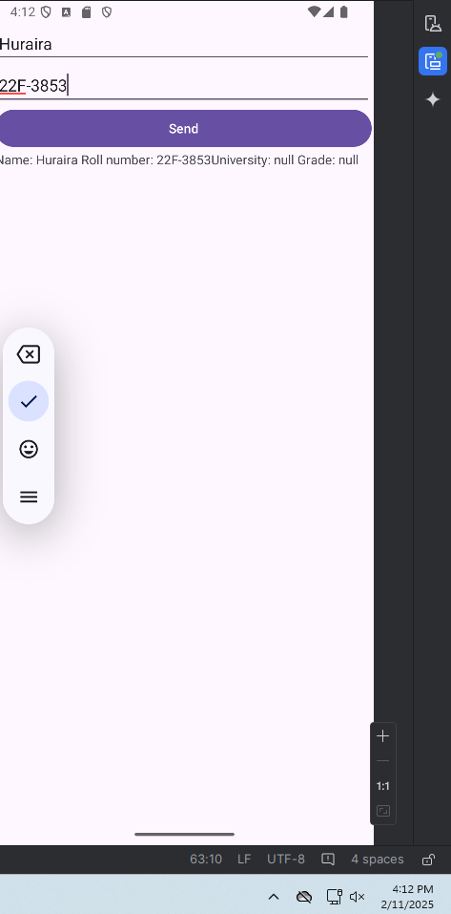

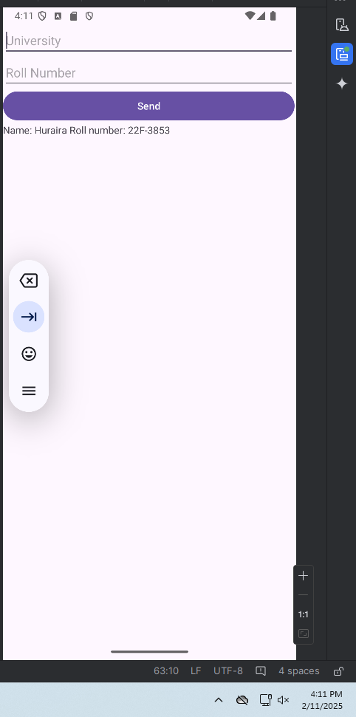

Task 2

Code:

package com.example.myapplication;  
  
import android.os.Bundle;  
import android.widget.ArrayAdapter;  
import android.widget.ListView;  
  
import androidx.activity.EdgeToEdge;  
import androidx.appcompat.app.AppCompatActivity;  
import androidx.core.graphics.Insets;  
import androidx.core.view.ViewCompat;  
import androidx.core.view.WindowInsetsCompat;  
  
public class MainActivity extends AppCompatActivity {  
  
 ListView simpleList;  
 String Name[]={"Ali","Bilal","Umar","Abu Huraira","Hassan"};  
 @Override  
 protected void onCreate(Bundle savedInstanceState) {  
 super.onCreate(savedInstanceState);  
 EdgeToEdge.*enable*(this);  
 setContentView(R.layout.*activity_main*);  
  
  
 simpleList=findViewById(R.id.*listview*);  
 ArrayAdapter<String> arrayAdapter=new ArrayAdapter<String>(this,R.layout.*activity_main2*,R.id.*textView*,Name);  
  
 simpleList.setAdapter(arrayAdapter);  
  
 ViewCompat.*setOnApplyWindowInsetsListener*(findViewById(R.id.*main*), (v, insets) -> {  
 Insets systemBars = insets.getInsets(WindowInsetsCompat.Type.*systemBars*());  
 v.setPadding(systemBars.left, systemBars.top, systemBars.right, systemBars.bottom);  
 return insets;  
  
  
 });  
 }  
}

