Software for Mobile Devices

Name: Muhammad Abu Huraira

Section: BCS 6B

Roll Number:22F-3853

Submission on: April 20,2025

Submitted to: Mam Kanwal Naz

Task 1:

Main Activity

// MainActivity.java  
package com.example.android_firebase_task;  
  
import androidx.annotation.NonNull;  
import androidx.appcompat.app.AppCompatActivity;  
import androidx.core.graphics.Insets;  
import androidx.core.view.ViewCompat;  
import androidx.core.view.WindowInsetsCompat;  
import androidx.recyclerview.widget.LinearLayoutManager;  
import androidx.recyclerview.widget.RecyclerView;  
  
import android.app.AlertDialog;  
import android.os.Bundle;  
import android.view.LayoutInflater;  
import android.view.View;  
import android.widget.Button;  
import android.widget.EditText;  
import android.widget.Toast;  
  
import com.google.firebase.database.DataSnapshot;  
import com.google.firebase.database.DatabaseError;  
import com.google.firebase.database.DatabaseReference;  
import com.google.firebase.database.FirebaseDatabase;  
import com.google.firebase.database.ValueEventListener;  
  
import java.util.ArrayList;  
import java.util.List;  
  
public class MainActivity extends AppCompatActivity {  
 private RecyclerView recyclerView;  
 private DataAdapter adapter;  
 private DatabaseReference databaseReference;  
  
 @Override  
 protected void onCreate(Bundle savedInstanceState) {  
 super.onCreate(savedInstanceState);  
 setContentView(R.layout.activity_main);  
  
 // Initialize Firebase  
 FirebaseDatabase database = FirebaseDatabase.getInstance();  
 databaseReference = database.getReference("data");  
  
 // Setup RecyclerView  
 recyclerView = findViewById(R.id.recyclerView);  
 recyclerView.setLayoutManager(new LinearLayoutManager(this));  
 adapter = new DataAdapter(new ArrayList<>());  
 recyclerView.setAdapter(adapter);  
  
 // Add Data Button  
 Button btnAdd = findViewById(R.id.btn_add);  
 btnAdd.setOnClickListener(v -> showAddDataDialog());  
  
 // Read Data from Firebase  
 readData();  
 }  
  
 private void showAddDataDialog() {  
 AlertDialog.Builder builder = new AlertDialog.Builder(this);  
 builder.setTitle("Add New Data");  
  
 // Inflate the layout for the dialog  
 View view = LayoutInflater.from(this).inflate(R.layout.activity_add_data, null);  
 EditText etName = view.findViewById(R.id.et_name);  
 EditText etDescription = view.findViewById(R.id.et_description);  
  
 builder.setView(view);  
  
 // Set up the buttons  
 builder.setPositiveButton("Add", (dialog, which) -> {  
 String name = etName.getText().toString().trim();  
 String description = etDescription.getText().toString().trim();  
  
 if (!name.isEmpty() && !description.isEmpty()) {  
 addDataToFirebase(name, description);  
 } else {  
 Toast.makeText(MainActivity.this, "Please fill in all fields", Toast.LENGTH_SHORT).show();  
 }  
 });  
  
 builder.setNegativeButton("Cancel", (dialog, which) -> dialog.cancel());  
  
 builder.show();  
 }  
  
 private void addDataToFirebase(String name, String description) {  
 String id = databaseReference.push().getKey();  
 DataModel data = new DataModel(id, name, description);  
  
 if (id != null) {  
 databaseReference.child(id).setValue(data)  
 .addOnSuccessListener(aVoid -> Toast.makeText(MainActivity.this, "Data added successfully", Toast.LENGTH_SHORT).show())  
 .addOnFailureListener(e -> Toast.makeText(MainActivity.this, "Failed to add data: " + e.getMessage(), Toast.LENGTH_SHORT).show());  
 }  
 }  
  
 private void readData() {  
 databaseReference.addValueEventListener(new ValueEventListener() {  
 @Override  
 public void onDataChange(@NonNull DataSnapshot snapshot) {  
 List<DataModel> dataList = new ArrayList<>();  
 for (DataSnapshot dataSnapshot : snapshot.getChildren()) {  
 DataModel data = dataSnapshot.getValue(DataModel.class);  
 if (data != null) {  
 dataList.add(data);  
 }  
 }  
 adapter.setData(dataList);  
 }  
  
 @Override  
 public void onCancelled(@NonNull DatabaseError error) {  
 Toast.makeText(MainActivity.this, "Error: " + error.getMessage(), Toast.LENGTH_SHORT).show();  
 }  
 });  
 }  
}

View Data Activity

package com.example.android_firebase_task;  
  
import android.os.Bundle;  
import android.util.Log;  
import android.widget.Toast;  
import androidx.annotation.NonNull;  
import androidx.appcompat.app.AppCompatActivity;  
import androidx.recyclerview.widget.LinearLayoutManager;  
import androidx.recyclerview.widget.RecyclerView;  
  
import com.google.android.gms.tasks.OnFailureListener;  
import com.google.android.gms.tasks.OnSuccessListener;  
import com.google.firebase.storage.FirebaseStorage;  
import com.google.firebase.storage.ListResult;  
import com.google.firebase.storage.StorageReference;  
  
import java.util.ArrayList;  
import java.util.List;  
  
public class ViewDataActivity extends AppCompatActivity {  
  
 private RecyclerView recyclerView;  
 private DataAdapter adapter;  
 private StorageReference storageReference;  
  
 @Override  
 protected void onCreate(Bundle savedInstanceState) {  
 super.onCreate(savedInstanceState);  
 setContentView(R.layout.*activity_view_data*);  
  
 recyclerView = findViewById(R.id.*recyclerView*);  
 recyclerView.setLayoutManager(new LinearLayoutManager(this));  
 adapter = new DataAdapter(new ArrayList<>());  
 recyclerView.setAdapter(adapter);  
  
 // Initialize Firebase Storage reference to the 'data' directory  
 storageReference = FirebaseStorage.*getInstance*().getReference().child("data");  
  
 fetchData();  
 }  
  
 private void fetchData() {  
 // List all files in the 'data' directory  
 storageReference.listAll()  
 .addOnSuccessListener(new OnSuccessListener<ListResult>() {  
 @Override  
 public void onSuccess(ListResult listResult) {  
 List<DataModel> list = new ArrayList<>();  
 for (StorageReference item : listResult.getItems()) {  
 // Get file name and download URL  
 String fileName = item.getName();  
 item.getDownloadUrl().addOnSuccessListener(uri -> {  
 // Create DataModel with file name as title and URL as description  
 DataModel model = new DataModel(fileName, fileName, uri.toString());  
 list.add(model);  
 // Update adapter after all URLs are fetched  
 if (list.size() == listResult.getItems().size()) {  
 adapter.setData(list);  
 Toast.*makeText*(ViewDataActivity.this, "📥 Data loaded (" + list.size() + " items)", Toast.*LENGTH_SHORT*).show();  
 }  
 }).addOnFailureListener(e -> {  
 Log.*e*("FirebaseStorage", "Failed to get URL for " + fileName + ": " + e.getMessage());  
 });  
 }  
 // Handle case where no files are found  
 if (listResult.getItems().isEmpty()) {  
 adapter.setData(list);  
 Toast.*makeText*(ViewDataActivity.this, "📥 No files found", Toast.*LENGTH_SHORT*).show();  
 }  
 }  
 })  
 .addOnFailureListener(new OnFailureListener() {  
 @Override  
 public void onFailure(@NonNull Exception e) {  
 Toast.*makeText*(ViewDataActivity.this, "❌ Error: " + e.getMessage(), Toast.*LENGTH_SHORT*).show();  
 Log.*e*("FirebaseStorage", "Failed to list files: " + e.getMessage());  
 }  
 });  
 }  
}

Item data

package com.example.android_firebase_task;  
  
import android.os.Bundle;  
  
import androidx.activity.EdgeToEdge;  
import androidx.appcompat.app.AppCompatActivity;  
import androidx.core.graphics.Insets;  
import androidx.core.view.ViewCompat;  
import androidx.core.view.WindowInsetsCompat;  
  
public class ItemData extends AppCompatActivity {  
  
 @Override  
 protected void onCreate(Bundle savedInstanceState) {  
 super.onCreate(savedInstanceState);  
 EdgeToEdge.*enable*(this);  
 setContentView(R.layout.*activity_item_data*);  
  
 }  
}

Data model

// DataModel.java  
package com.example.android_firebase_task;  
  
public class DataModel {  
 private String id;  
 private String name;  
 private String description;  
  
 // Required empty constructor for Firebase  
 public DataModel() {  
 }  
  
 public DataModel(String id, String name, String description) {  
 this.id = id;  
 this.name = name;  
 this.description = description;  
 }  
  
 public String getId() {  
 return id;  
 }  
  
 public void setId(String id) {  
 this.id = id;  
 }  
  
 public String getName() {  
 return name;  
 }  
  
 public void setName(String name) {  
 this.name = name;  
 }  
  
 public String getDescription() {  
 return description;  
 }  
  
 public void setDescription(String description) {  
 this.description = description;  
 }  
}

Data adapter

// DataAdapter.java  
package com.example.android_firebase_task;  
  
import android.view.LayoutInflater;  
import android.view.View;  
import android.view.ViewGroup;  
import android.widget.TextView;  
  
import androidx.annotation.NonNull;  
import androidx.recyclerview.widget.RecyclerView;  
  
import java.util.List;  
  
public class DataAdapter extends RecyclerView.Adapter<DataAdapter.ViewHolder> {  
 private List<DataModel> dataList;  
  
 public DataAdapter(List<DataModel> dataList) {  
 this.dataList = dataList;  
 }  
  
 @NonNull  
 @Override  
 public ViewHolder onCreateViewHolder(@NonNull ViewGroup parent, int viewType) {  
 View view = LayoutInflater.*from*(parent.getContext())  
 .inflate(R.layout.*activity_item_data*, parent, false);  
 return new ViewHolder(view);  
 }  
  
 @Override  
 public void onBindViewHolder(@NonNull ViewHolder holder, int position) {  
 DataModel data = dataList.get(position);  
 holder.tvName.setText(data.getName());  
 holder.tvDescription.setText(data.getDescription());  
 }  
  
 @Override  
 public int getItemCount() {  
 return dataList.size();  
 }  
  
 public void setData(List<DataModel> dataList) {  
 this.dataList = dataList;  
 notifyDataSetChanged();  
 }  
  
 public static class ViewHolder extends RecyclerView.ViewHolder {  
 TextView tvName, tvDescription;  
  
 public ViewHolder(@NonNull View itemView) {  
 super(itemView);  
 tvName = itemView.findViewById(R.id.tv_name);  
 tvDescription = itemView.findViewById(R.id.tv_description);  
 }  
 }  
}

Add data

package com.example.android_firebase_task;  
  
import android.os.Bundle;  
  
import androidx.activity.EdgeToEdge;  
import androidx.appcompat.app.AppCompatActivity;  
import androidx.core.graphics.Insets;  
import androidx.core.view.ViewCompat;  
import androidx.core.view.WindowInsetsCompat;  
  
public class AddData extends AppCompatActivity {  
  
 @Override  
 protected void onCreate(Bundle savedInstanceState) {  
 super.onCreate(savedInstanceState);  
 EdgeToEdge.*enable*(this);  
 setContentView(R.layout.*activity_add_data*);  
  
 }  
}

XML Layouts

Add data

<LinearLayout xmlns:android="http://schemas.android.com/apk/res/android"  
 android:layout_width="match_parent"  
 android:layout_height="wrap_content"  
 android:orientation="vertical"  
 android:padding="16dp">  
  
 <EditText  
 android:id="@+id/et_name"  
 android:layout_width="match_parent"  
 android:layout_height="wrap_content"  
 android:hint="Enter name"  
 android:inputType="text"  
 android:minHeight="48dp" />  
  
 <EditText  
 android:id="@+id/et_description"  
 android:layout_width="match_parent"  
 android:layout_height="wrap_content"  
 android:layout_marginTop="8dp"  
 android:hint="Enter description"  
 android:inputType="textMultiLine"  
 android:minHeight="48dp" />  
  
</LinearLayout>

Item data

<?xml version="1.0" encoding="utf-8"?>  
<androidx.cardview.widget.CardView xmlns:android="http://schemas.android.com/apk/res/android"  
 xmlns:app="http://schemas.android.com/apk/res-auto"  
 android:layout_width="match_parent"  
 android:layout_height="wrap_content"  
 android:layout_margin="4dp"  
 android:layout_marginTop="8dp"  
 app:cardCornerRadius="8dp"  
 app:cardElevation="4dp">  
  
 <LinearLayout  
 android:layout_width="match_parent"  
 android:layout_height="wrap_content"  
 android:orientation="vertical"  
 android:padding="12dp"  
 android:paddingTop="16dp"> <!-- Added extra top padding here -->  
  
 <TextView  
 android:id="@+id/tv_name"  
 android:layout_width="match_parent"  
 android:layout_height="wrap_content"  
 android:textSize="18sp"  
 android:textStyle="bold" />  
  
 <TextView  
 android:id="@+id/tv_description"  
 android:layout_width="match_parent"  
 android:layout_height="wrap_content"  
 android:layout_marginTop="4dp"  
 android:textSize="14sp" />  
  
 </LinearLayout>  
</androidx.cardview.widget.CardView>

Main activity

<androidx.constraintlayout.widget.ConstraintLayout xmlns:android="http://schemas.android.com/apk/res/android"  
 xmlns:app="http://schemas.android.com/apk/res-auto"  
 xmlns:tools="http://schemas.android.com/tools"  
 android:layout_width="match_parent"  
 android:layout_height="match_parent"  
 tools:context=".MainActivity">  
  
 <androidx.recyclerview.widget.RecyclerView  
 android:id="@+id/recyclerView"  
 android:layout_width="0dp"  
 android:layout_height="0dp"  
 android:padding="8dp"  
 android:layout_marginTop="45dp"  
 app:layout_constraintBottom_toTopOf="@+id/btn_add"  
 app:layout_constraintEnd_toEndOf="parent"  
 app:layout_constraintHorizontal_bias="0.0"  
 app:layout_constraintStart_toStartOf="parent"  
 app:layout_constraintTop_toTopOf="parent"  
 app:layout_constraintVertical_bias="0.0" />  
  
 <Button  
 android:id="@+id/btn_add"  
 android:layout_width="wrap_content"  
 android:layout_height="wrap_content"  
 android:layout_marginBottom="16dp"  
 android:text="Add Data"  
 android:backgroundTint="#FF9800"  
 android:textColor="#FFFFFF"  
 app:layout_constraintBottom_toBottomOf="parent"  
 app:layout_constraintEnd_toEndOf="parent"  
 app:layout_constraintStart_toStartOf="parent" />  
  
</androidx.constraintlayout.widget.ConstraintLayout>

View data

<LinearLayout xmlns:android="http://schemas.android.com/apk/res/android"  
 xmlns:app="http://schemas.android.com/apk/res-auto"  
 android:orientation="vertical"  
 android:layout_marginTop="150dp"  
 android:layout_width="match_parent"  
 android:layout_height="match_parent">  
  
 <androidx.recyclerview.widget.RecyclerView  
 android:id="@+id/recyclerView"  
 android:layout_width="0dp"  
 android:layout_height="0dp"  
 android:padding="8dp"  
  
 android:paddingTop="116dp"  
 android:clipToPadding="false"  
 app:layout_constraintBottom_toTopOf="@+id/btn_add"  
 app:layout_constraintEnd_toEndOf="parent"  
 app:layout_constraintStart_toStartOf="parent"  
 app:layout_constraintTop_toTopOf="parent" />  
  
  
</LinearLayout>

Add data from application to database

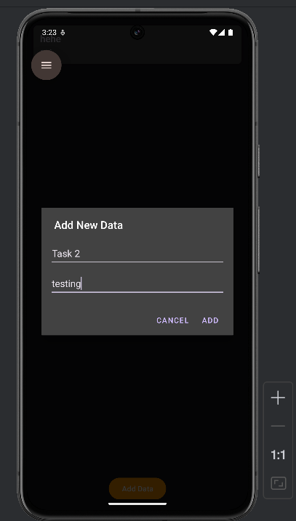

Reading data from firebase

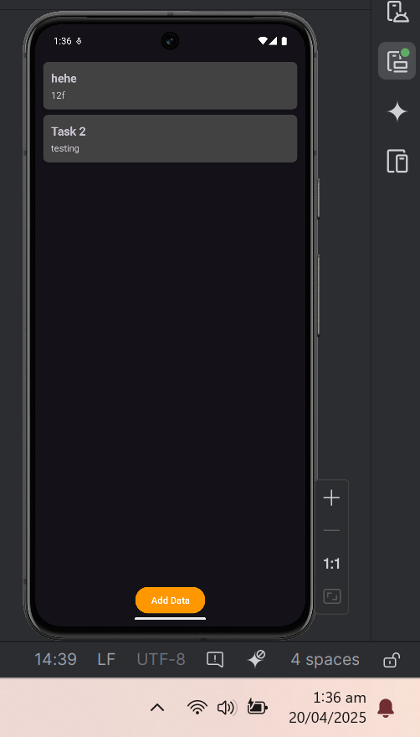

Data in firebase database

