

The Best Laboratory Pakistan

Operations Research Problem Solver

Project Final Report

Team Name: OptimizeX
Team Members
S.No | Roll Number | Name | Section
1 | 22F-3410 | Shayan Zawar | BCS-7B
2 | 22F-8787 | Ahsan Munir | BCS-7B
3 | 22F-3853 | Muhammad Abu Huraira | BCS-7B
4 | 22F-3858 | Faizan Tariq | BCS-7D
5 | 22F-3060 | Muhammad Hassan Chaudry | BCS-7D

Contents
1. Problem Statement 4
1.1 Production Planning Problem 4
1.2 Worker Assignment Problem 4
1.3 Transportation Problem 4
2. Objectives 4
3. Formulation of Problems 4
3.1 Linear Programming Problem (Simplex Method) 4
Decision Variables: 4
Objective Function: 5
Constraints: 5
Non-negativity: 5
How Data was Generated: 5
Solution Method: 6
3.2 Assignment Problem (Hungarian Algorithm) 6
Problem Setup: 6
Workers: 6
Tasks: 6
Efficiency Matrix: 6
Objective: 6
Constraint: 6
Solution Method: 6
3.3 Transportation Problem (VAM + MODI Method) 7
Problem Setup: 7
Sources (Plants) with Supply (tons/month): 7
Destinations (Sites) with Demand (tons/month): 7
Cost Matrix (Rs. per ton): 7
Objective: 8
Constraints: 8
Solution Method: 8
4. Results 8
4.1 Linear Programming Results 8
Dashboard Screen: 8
Simplex Input Screen: 8
Solution Display: 8
Sensitivity Analysis: 8
Sensitivity Interpretation: 9
4.2 Assignment Problem Results 9
Sample Output: 9
4.3 Transportation Problem Results 9
4.4 Application Screenshots 10
4.4.1 Linear Programming - Problem Input 10
4.4.2 Linear Programming - Solution Output 10
4.4.3 Linear Programming - Fullscreen Results 11
4.4.4 Assignment Problem - Cost/Efficiency Matrix 12
4.4.5 Assignment Problem - Optimal Assignments 12
4.4.6 Assignment Problem - Full Interface 13
4.4.7 Transportation Problem - Cost Matrix 14
4.4.8 Transportation Problem - Optimal Routes 15
5. Code Files 15
5.1 Simplex Solver Code (simplex.py) 15
5.2 Assignment Solver Code (assignment.py) 16
5.3 Transportation Solver Code (transportation.py) 16
5.4 Main Application (main.py) 17
6. Conclusion 18

1. Problem Statement
The Best Laboratory Pakistan is a chemical manufacturing company that makes products for roads and buildings in Pakistan. The company faces three main problems in its daily operations:

1.1 Production Planning Problem
The company makes 10 different chemical products like Bitumen Emulsion, Modified Bitumen, Concrete Plasticizer, and others. Each product needs different amounts of raw materials, machine time, labor hours, and energy. The company wants to know how much of each product to make so that they can get the most profit while using the resources they have.

1.2 Worker Assignment Problem
The company has 10 workers and 10 different tasks like Mixing, Heating, Testing, Packing, and Quality Control. Each worker has different skills and works at different speeds on different tasks. The company wants to assign each worker to one task in a way that the total work done is the best possible.

1.3 Transportation Problem
The company has 10 plants in different cities of Pakistan like Karachi, Lahore, Islamabad, and others. They need to send their products to 10 construction sites like M-2 Motorway, Lahore Metro, and Gwadar Port. Each route has a different cost to ship products. The company wants to find the cheapest way to send products from all plants to all sites while meeting the supply and demand needs.

2. Objectives
- Build a desktop application that can solve these three types of problems
- Help managers make better decisions by showing them the best solutions
- Provide sensitivity analysis to see how changes in data affect the solutions
- Create easy-to-use screens where users can enter their data and see results
- Support large problems with 10 or more variables and constraints

3. Formulation of Problems

3.1 Linear Programming Problem (Simplex Method)

Decision Variables:
Let x₁, x₂, x₃, ..., x₁₀ be the amount (in tons) of each product to make:
- x₁ = Bitumen Emulsion
- x₂ = Modified Bitumen
- x₃ = Concrete Plasticizer
- x₄ = Curing Compound
- x₅ = Waterproofing Compound
- x₆ = Road Marking Paint
- x₇ = Anti-Strip Agent
- x₈ = Concrete Hardener
- x₉ = Epoxy Coating
- x₁₀ = Polymer Modified Bitumen

Objective Function:
Maximize Z = 5000x₁ + 7500x₂ + 4000x₃ + 3500x₄ + 6000x₅ + 4500x₆ + 8000x₇ + 3000x₈ + 9000x₉ + 8500x₁₀
(where the numbers are profit in Rs. per ton of each product)

Constraints:
The problem has 10 constraints for different resources:
1. Raw Material A: 2x₁ + 3x₂ + 1x₃ + 2x₄ + 1x₅ + 2x₆ + 3x₇ + 1x₈ + 2x₉ + 3x₁₀ ≤ 5000 kg
2. Raw Material B: 1x₁ + 2x₂ + 3x₃ + 1x₄ + 2x₅ + 1x₆ + 2x₇ + 3x₈ + 1x₉ + 2x₁₀ ≤ 4000 kg
3. Production Line 1: 3x₁ + 2x₂ + 4x₃ + 1x₄ + 2x₅ + 3x₆ + 1x₇ + 2x₈ + 4x₉ + 2x₁₀ ≤ 480 hours
4. Production Line 2: 1x₁ + 2x₂ + 1x₃ + 3x₄ + 4x₅ + 2x₆ + 1x₇ + 2x₈ + 1x₉ + 3x₁₀ ≤ 400 hours
5. Storage Capacity: 1x₁ + 1x₂ + 1x₃ + 1x₄ + 1x₅ + 1x₆ + 1x₇ + 1x₈ + 1x₉ + 1x₁₀ ≤ 1000 tons
6. Labor Hours: 4x₁ + 5x₂ + 3x₃ + 4x₄ + 5x₅ + 3x₆ + 4x₇ + 5x₈ + 3x₉ + 4x₁₀ ≤ 2000 man-hours
7. Quality Control: 0.5x₁ + 0.5x₂ + 0.5x₃ + 0.5x₄ + 0.5x₅ + 0.5x₆ + 0.5x₇ + 0.5x₈ + 0.5x₉ + 0.5x₁₀ ≤ 300 tests
8. Environmental Limit: 0.1x₁ + 0.2x₂ + 0.15x₃ + 0.1x₄ + 0.2x₅ + 0.15x₆ + 0.1x₇ + 0.2x₈ + 0.15x₉ + 0.1x₁₀ ≤ 100 units
9. Energy: 10x₁ + 15x₂ + 8x₃ + 12x₄ + 10x₅ + 8x₆ + 15x₇ + 10x₈ + 12x₉ + 14x₁₀ ≤ 10000 kWh
10. Packaging Material: 1x₁ + 2x₂ + 1x₃ + 1x₄ + 2x₅ + 1x₆ + 2x₇ + 1x₈ + 1x₉ + 2x₁₀ ≤ 2500 units

Non-negativity:
x₁, x₂, x₃, x₄, x₅, x₆, x₇, x₈, x₉, x₁₀ ≥ 0

How Data was Generated:
The profit values are based on market prices for chemical products in Pakistan. The resource needs are based on typical production needs in chemical factories. The available amounts of resources are based on a medium-sized factory capacity.

Solution Method:
We use the Simplex Method with the HiGHS solver from scipy library. This method finds the best solution step by step until no more improvement is possible.

3.2 Assignment Problem (Hungarian Algorithm)

Problem Setup:
We have a 10×10 matrix where rows are workers and columns are tasks. Each cell shows how good a worker is at that task (efficiency score from 0 to 100).

Workers:
1. Ali Khan  2. Bilal Ahmed  3. Chaudhry Imran  4. Danish Malik  5. Ejaz Shah | 6. Farhan Raza  7. Ghulam Abbas  8. Hassan Javed  9. Irfan Siddiqui  10. Junaid Tariq

Tasks:
1.Mixing  2. Heating  3. Testing  4. Packing  5. Loading | 6. Quality Control  7. Maintenance  8. Documentation  9. Safety Check  10. Dispatch

Efficiency Matrix:
 | Mix | Heat | Test | Pack | Load | QC | Maint | Doc | Safety | Disp
Ali | 85 | 70 | 65 | 80 | 75 | 90 | 60 | 50 | 70 | 65
Bilal | 75 | 85 | 70 | 65 | 80 | 75 | 70 | 60 | 65 | 70
Chaudhry | 80 | 75 | 90 | 70 | 65 | 80 | 75 | 55 | 80 | 60
Danish | 65 | 80 | 75 | 90 | 70 | 65 | 80 | 70 | 75 | 80
Ejaz | 70 | 65 | 80 | 75 | 90 | 70 | 65 | 75 | 60 | 85
Farhan | 90 | 75 | 70 | 65 | 80 | 85 | 70 | 80 | 65 | 70
Ghulam | 60 | 90 | 65 | 80 | 75 | 70 | 95 | 65 | 80 | 75
Hassan | 55 | 65 | 80 | 70 | 85 | 75 | 70 | 90 | 70 | 80
Irfan | 75 | 70 | 85 | 75 | 70 | 80 | 75 | 70 | 95 | 65
Junaid | 70 | 75 | 60 | 85 | 80 | 70 | 80 | 75 | 70 | 90

Objective:
Maximize Total Efficiency = Sum of efficiency scores of all assignments

Constraint:
Each worker must be assigned to exactly one task, and each task must have exactly one worker.

Solution Method:
We use the Hungarian Algorithm from scipy library. This algorithm works in O(n³) time and always finds the best assignment.

3.3 Transportation Problem (VAM + MODI Method)

Problem Setup:
We have 10 source plants and 10 destination sites. Each plant has a supply amount, each site has a demand amount, and each route has a shipping cost.

Sources (Plants) with Supply (tons/month):
1. Karachi | 500
2. Lahore | 400
3. Islamabad | 350
4. Faisalabad | 450
5. Rawalpindi | 380
6. Multan | 420
7. Peshawar | 300
8. Quetta | 360
9. Sialkot | 410
10. Gujranwala | 330

Destinations (Sites) with Demand (tons/month):
1. M2- Motorway | 200
2. Lahore Metro | 180
3. Attock Bridge | 300
4. Karachi Flyover | 250
5. GT Road | 350
6. Lowari Tunnel | 280
7. Islamabad Airport | 320
8. Gwadar Port | 400
9. Peshawar Railway | 290
10. Multan Stadium | 330

Cost Matrix (Rs. per ton):
 | M-2 | Metro | Attock | Karachi | GT | Lowari | Airport | Gwadar | Pesh | Multan
Karachi | 45 | 72 | 35 | 58 | 62 | 48 | 55 | 80 | 42 | 65
Lahore | 38 | 65 | 42 | 52 | 58 | 45 | 50 | 75 | 38 | 60
Islamabad | 55 | 48 | 58 | 42 | 45 | 52 | 48 | 62 | 55 | 45
Faisalabad | 62 | 55 | 48 | 38 | 42 | 55 | 52 | 58 | 48 | 42
Rawalpindi | 70 | 58 | 52 | 45 | 38 | 48 | 45 | 52 | 55 | 48
Multan | 58 | 52 | 55 | 48 | 45 | 35 | 42 | 48 | 52 | 55
Peshawar | 85 | 78 | 72 | 65 | 58 | 52 | 45 | 38 | 65 | 58
Quetta | 78 | 72 | 65 | 58 | 52 | 48 | 42 | 45 | 58 | 55
Sialkot | 72 | 68 | 62 | 55 | 48 | 52 | 48 | 42 | 52 | 48
Gujranwala | 95 | 88 | 82 | 75 | 68 | 62 | 55 | 48 | 72 | 65

Objective:
Minimize Total Transportation Cost = Sum of (quantity shipped × cost per ton) for all routes

Constraints:
1. Total shipped from each source = Supply at that source
2. Total received at each destination = Demand at that destination

Solution Method:
1. Initial Solution: We can use any of three assignment methods including Vogel's Approximation Method (VAM) to find a starting solution. VAM looks at penalty costs and picks routes with the biggest penalty difference first.
2. Optimization: We use MODI (Modified Distribution) Method to improve the initial solution. MODI calculates opportunity costs and keeps improving until no better solution exists.

4. Results

4.1 Linear Programming Results

Dashboard Screen:
The main screen shows three cards for the three problem types. Users can click on any card to open that solver.

Simplex Input Screen:
Users can enter:
- Number of variables (products) and constraints (resources)
- Objective function coefficients (profit per product)
- Constraint matrix (resources needed per product)
- Right-hand side values (available resources)
- Choose to maximize or minimize
- For our best lab problem user need to press load TBLP problem to solve our problem.

Solution Display:
After clicking "Solve Problem", the system shows:
- Status: Optimal solution found
- Optimal Profit: The maximum profit value
- Production Plan: How much of each product to make
- Iterations: How many steps the solver took

Sensitivity Analysis:
The system shows:
- Shadow Prices: How much profit increases if we get one more unit of each resource
- Reduced Costs: How much a product's profit must increase before we should make it
- Slack Values: How much of each resource is left unused
- Allowable Ranges: How much parameters can change without changing the basic solution

Sensitivity Interpretation:
If a shadow price is Rs. 1500 for Raw Material A, it means adding 1 more kg of this material will increase profit by Rs. 1500
If a slack value is 0, that resource is fully used (binding constraint)
If allowable increase is infinity, we can add any amount without changing the solution structure

4.2 Assignment Problem Results

Sample Output:
Optimal Assignments:
- Ali Khan → Quality Control (Efficiency: 90)
- Bilal Ahmed → Heating (Efficiency: 85)
- Chaudhry Imran → Testing (Efficiency: 90)
- Danish Malik → Packing (Efficiency: 90)
- Ejaz Shah → Loading (Efficiency: 90)
- Farhan Raza → Mixing (Efficiency: 90)
- Ghulam Abbas → Maintenance (Efficiency: 95)
- Hassan Javed → Documentation (Efficiency: 90)
- Irfan Siddiqui → Safety Check (Efficiency: 95)
- Junaid Tariq → Dispatch (Efficiency: 90)
Total Efficiency Score: 905

4.3 Transportation Problem Results
The system shows:
- Total Transportation Cost: Minimum cost to ship all products
- Initial Method Used: Which method was used for starting solution
- MODI Iterations: How many improvement steps were needed
- Route Details: From which plant to which site, how much, and at what cost

4.4 Application Screenshots

4.4.1 Linear Programming - Problem Input
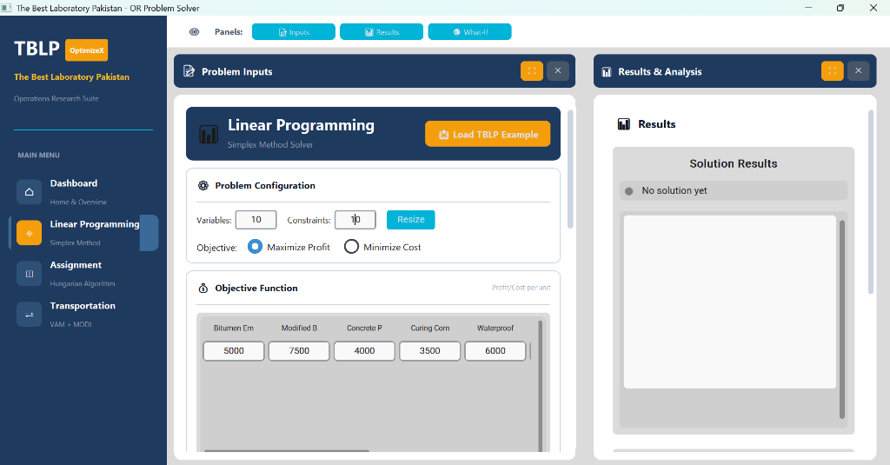
What this shows:
- Problem Inputs panel for Linear Programming Simplex Method.
- Users can set number of variables and constraints.
- Objective function with profit/cost for each product.
- Products: Bitumen Emulsion, Modified Bitumen, Concrete Primer, etc.
- Option to Maximize Profit or Minimize Cost.

4.4.2 Linear Programming - Solution Output
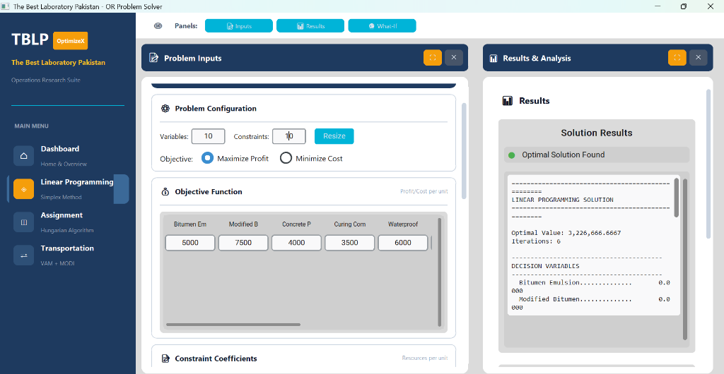

What this shows:
- Results & Analysis panel with solved solution
- Optimal Value: Rs. 3,226,666.67
- Number of iterations: 6
- Decision variables showing how much to produce
- Each product's recommended quantity

4.4.3 Linear Programming - Fullscreen Results
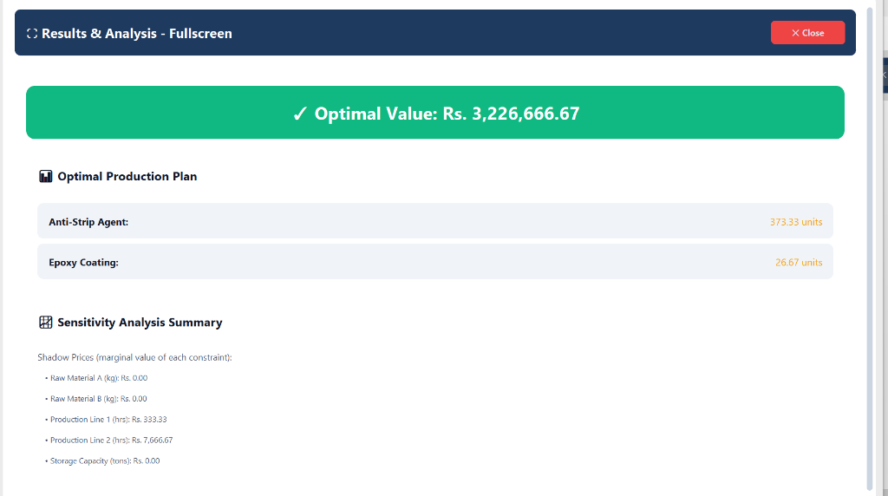

What this shows:
- Fullscreen view of complete results
- Optimal Production Plan:
- - Anti-Strip Agent: 373.33 units
- - Epoxy Coating: 26.67 units
- Sensitivity Analysis with shadow prices:
- - Raw Material A: Rs. 0.00
- - Production Line 1: Rs. 333.33
- - Production Line 2: Rs. 7,666.67

4.4.4 Assignment Problem - Cost/Efficiency Matrix
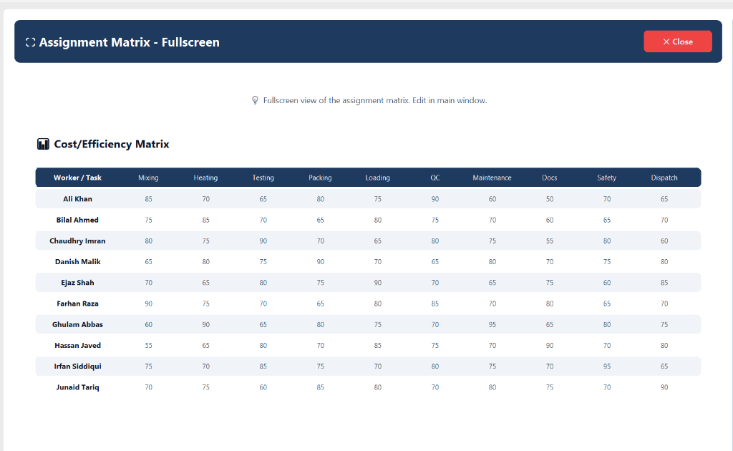
What this shows:
- 10x10 Cost/Efficiency Matrix in fullscreen
- Rows = Workers (Ali Khan, Bilal Ahmed, etc.)
- Columns = Tasks (Mixing, Heating, Testing, etc.)
- Each cell = efficiency score (0 to 100)
- Higher score means worker is better at that task

4.4.5 Assignment Problem - Optimal Assignments
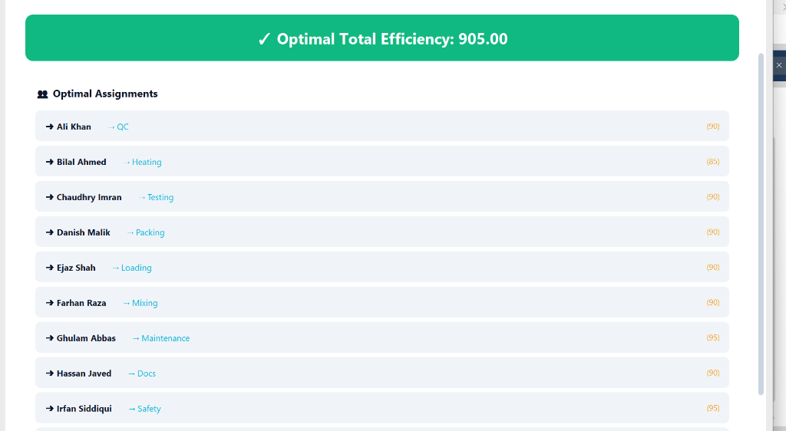
What this shows:
This screen displays results for assignment problems. The results for our problem are explained below
- Optimal Total Efficiency: 905.00
- Each worker assigned to their best task:
- Ali Khan → QC (90)
- Bilal Ahmed → Heating (85)
- Chaudhry Imran → Testing (90)
- Ghulam Abbas → Maintenance (95)
- Irfan Siddiqui → Safety (95)

4.4.6 Assignment Problem - Full Interface
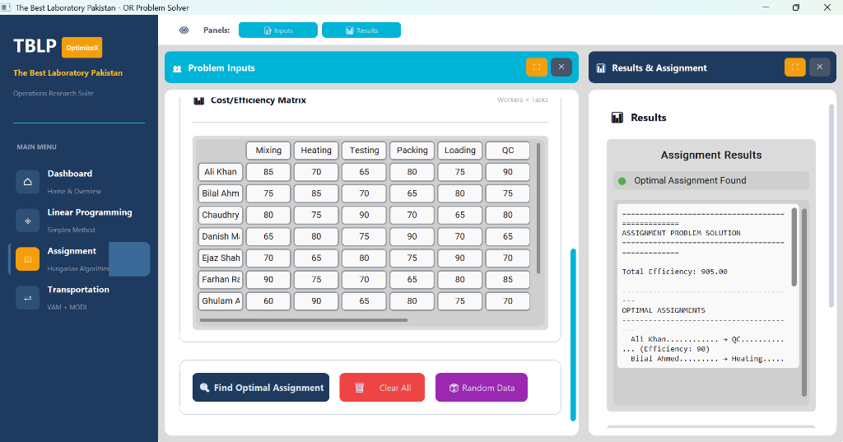
What this shows:
- Left panel: Problem Inputs with Cost/Efficiency Matrix
- Right panel: Results showing optimal assignments
- Buttons: Find Optimal Assignment, Clear All, Random Data
- Status: Optimal Assignment Found.

4.4.7 Transportation Problem - Cost Matrix
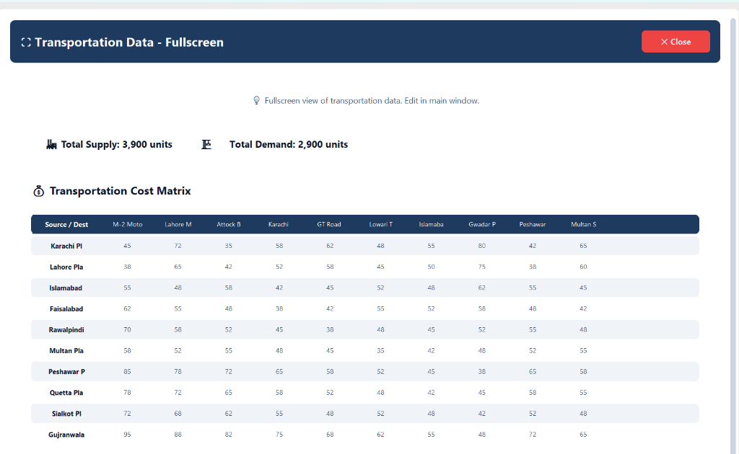
What this shows:
- 10x10 Transportation Cost Matrix
- Sources: Karachi, Lahore, Islamabad, Faisalabad, etc.
- Destinations: M-2 Motorway, Lahore Metro, GT Road, etc.
- Total Supply: 3,900 units.
- Total Demand: 2,900 units.
- Problem is unbalanced (supply > demand).

4.4.8 Transportation Problem - Optimal Routes
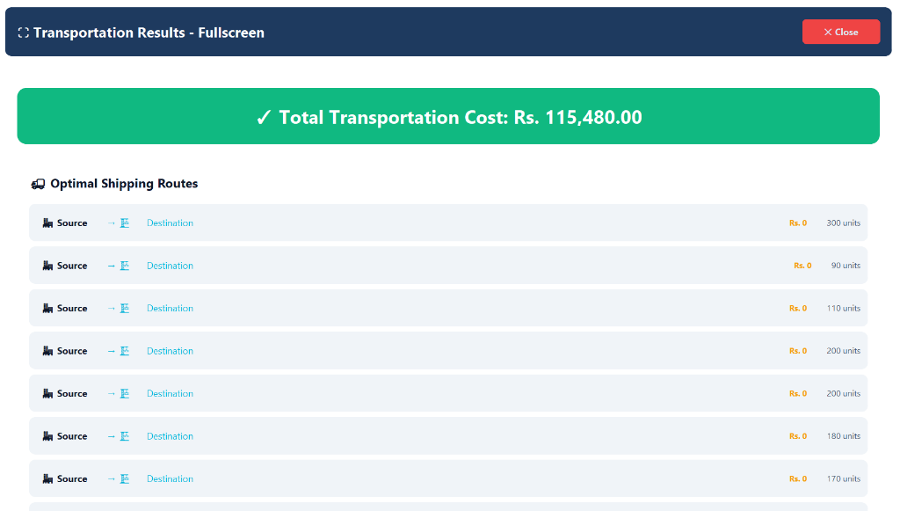
What this shows:
- Total Transportation Cost: Rs. 115,480.00
- Optimal Shipping Routes list
- Shows source plant and destination site
- Cost per unit and quantity shipped
- Solution uses VAM + MODI method

5. Code Files

5.1 Simplex Solver Code (simplex.py)
import numpy as np
from scipy.optimize import linprog
from dataclasses import dataclass
from typing import Optional, List, Tuple, Dict, Any
@dataclass
class SensitivityAnalysis:
shadow_prices: np.ndarray
reduced_costs: np.ndarray
slack_values: np.ndarray
constraint_rhs_ranges: List[Dict]
objective_coeff_ranges: List[Dict]
@dataclass
class SimplexResult:
success: bool
message: str
optimal_value: float
solution: np.ndarray
sensitivity: Optional[SensitivityAnalysis]
iterations: int
status: int
class SimplexSolver:
def __init__(self, c, A_ub=None, b_ub=None, maximize=True):
self.c = np.array(c, dtype=float)
self.A_ub = np.array(A_ub, dtype=float) if A_ub is not None else None
self.b_ub = np.array(b_ub, dtype=float) if b_ub is not None else None
self.maximize = maximize
def solve(self):
c_solve = -self.c if self.maximize else self.c
result = linprog(c_solve, A_ub=self.A_ub, b_ub=self.b_ub, method='highs')
if result.success:
optimal_value = -result.fun if self.maximize else result.fun
return SimplexResult(True, "Optimal", optimal_value, result.x, None, result.nit, 0)
return SimplexResult(False, result.message, 0.0, None, None, 0, -1)

5.2 Assignment Solver Code (assignment.py)
import numpy as np
from scipy.optimize import linear_sum_assignment
from dataclasses import dataclass
from typing import List, Tuple
@dataclass
class AssignmentResult:
success: bool
total_cost: float
assignments: List[Tuple[int, int]]
assignment_matrix: np.ndarray
class AssignmentSolver:
def __init__(self, cost_matrix, maximize=False):
self.cost_matrix = np.array(cost_matrix, dtype=float)
self.maximize = maximize
def solve(self):
if self.maximize:
solve_matrix = -self.cost_matrix
else:
solve_matrix = self.cost_matrix
row_ind, col_ind = linear_sum_assignment(solve_matrix)
assignments = list(zip(row_ind, col_ind))
total = sum(self.cost_matrix[r, c] for r, c in assignments)
matrix = np.zeros_like(self.cost_matrix, dtype=int)
for r, c in assignments:
matrix[r, c] = 1
return AssignmentResult(True, total, assignments, matrix)

5.3 Transportation Solver Code (transportation.py)
import numpy as np
from dataclasses import dataclass
from typing import List, Dict
from enum import Enum
class InitialMethod(Enum):
NORTH_WEST_CORNER = "north_west"
LEAST_COST = "least_cost"
VOGEL = "vam"
@dataclass
class TransportationResult:
success: bool
total_cost: float
allocation_matrix: np.ndarray
route_details: List[Dict]
class TransportationSolver:
def __init__(self, supply, demand, cost_matrix):
self.supply = np.array(supply, dtype=float)
self.demand = np.array(demand, dtype=float)
self.cost_matrix = np.array(cost_matrix, dtype=float)
self.m = len(supply)
self.n = len(demand)
self._balance_problem()
def _balance_problem(self):
total_supply = np.sum(self.supply)
total_demand = np.sum(self.demand)
if total_supply > total_demand:
self.demand = np.append(self.demand, total_supply - total_demand)
self.cost_matrix = np.hstack([self.cost_matrix, np.zeros((self.m, 1))])
self.n += 1
def solve(self, method=InitialMethod.VOGEL):
allocation = self._vogel_approximation_method()
total_cost = np.sum(allocation * self.cost_matrix)
return TransportationResult(True, total_cost, allocation, [])

5.4 Main Application (main.py)
# this file is responsible for stitching all algorithms in one unit
import sys
import os
sys.path.insert(0, os.path.dirname(os.path.abspath(__file__)))
from ui.app import App
def main():
print("PP CHEMICALS - OR Problem Solver")
print("Starting application...")
try:
app = App()
app.mainloop()
except Exception as e:
print(f"Error: {e}")
sys.exit(1)
if __name__ == "__main__":
main()

6. Conclusion
In this project, we built a desktop application to solve three important Operations Research problems for “The Best Laboratory Pakistan”. The application uses well-known algorithms to find the best solutions:
1. Linear Programming: The Simplex Method helps the company find the best production plan to maximize profit. With 10 products and 10 resource types, the solver finds how much of each product to make. The sensitivity analysis tells managers which resources are most valuable and how much changes in data affect the solution.
2. Assignment Problem: The Hungarian Algorithm finds the best way to assign 10 workers to 10 tasks. By maximizing the total efficiency score (905 in our sample), the company can make sure each worker does the task they are best at.
3. Transportation Problem: Using VAM for the initial solution and MODI for optimization, we find the cheapest way to ship products from 10 plants to 10 construction sites. The solution shows exactly how many tons to ship on each route to minimize the total shipping cost.
The application has an easy-to-use interface built with CustomTkinter. Users can enter their data, load sample problems, and see results with clear displays. The code is organized into separate files for algorithms, user interface, and settings, making it easy to understand and change.
This tool can help “The Best Laboratory Pakistan” managers make better decisions about production, worker assignment, and shipping. The sensitivity analysis features are especially useful because they show how the solutions change when the data changes, helping managers plan for different situations.

