
LAB REPORT COVER PAGE
Please print this page and attach it to the front of your lab report.
LAB NO.: | 05
SUBJECT: | CSC303 - Mobile Application Development
NAME: | Syed Muhammad Hur Ali
REGISTRATION: | FA23-BCE-008
SUBMITTED TO: | Dr Ali Raza Shahid
DATE:
Lab Assessment (to be completed by the lab instructor)
LAB ASSESSMENT
In-Lab Evaluation |  |  | / 7 | Awarded: __________
Lab Report | Data Analysis |  | / 1
 | Data Presentation |  | / 1
 | Writing Style |  | / 1
TOTAL |  |  | 10 | / 10
Comments:
Instructor Name: __________________________ |  | Instructor Signature: ______________________

LAB #05
JETPACK COMPOSE UI STATE VALIDATION AND ACCESSIBILITY
Task 1 - Create the Compose project
1. Create an Android Studio project named DeviceReadiness using the Empty Activity template and Kotlin. Store it in a lab05-device-readiness folder inside the laboratory repository.
2. Retain the Compose and Material 3 configuration generated by the template. Build and run the starter application before changing the UI.
3. Locate MainActivity.kt, the project theme package and res/values/strings.xml. Identify which code runs inside setContent.
4. Replace only the generated sample composables. Keep the project theme and enableEdgeToEdge setup unless the laboratory configuration requires otherwise.
class MainActivity : ComponentActivity() {
override fun onCreate(savedInstanceState: Bundle?) {
super.onCreate(savedInstanceState)
enableEdgeToEdge()
setContent {
DeviceReadinessTheme {
DeviceReadinessApp()
}
}
}
}

Project evidence: Show a clean build, the running starter and the Material theme files. Explain why this project uses a Compose template rather than an XML layout.

Output: -

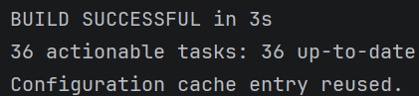
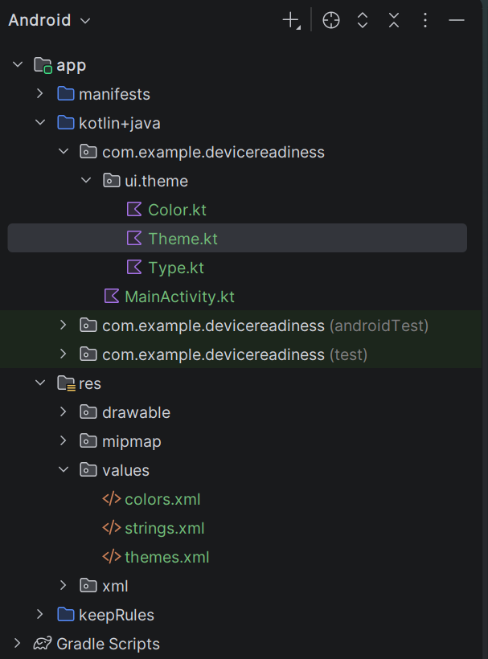
Task 2 - Define the validation and readiness rules
The completed form follows these rules:
Field or decision | Rule
Device name | Required after trimming; blank input is invalid.
Battery percentage | A whole number from 0 through 100; missing, non-numeric and out-of-range input is invalid.
Network available | Boolean selected through a Material Switch.
Ready | Valid form, battery at least 30 and network available.
Needs attention | Valid form but battery below 30 or network unavailable.
After input changes | Hide the previous result so it cannot describe stale values.

Record the rule table in the README before implementing it. The UI and tests must use the same boundaries.
Solution: -
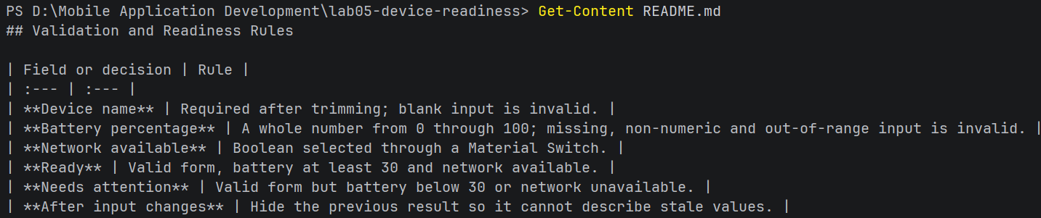

Task 3 - Add strings and formatted resources
Replace hard-coded interface text with entries in res/values/strings.xml. Add at least the following resources.
<resources>
<string name="app_name">Device Readiness</string>
<string name="screen_title">Device Readiness Checker</string>
<string name="screen_intro">Enter the device information and evaluate deployment readiness.</string>
<string name="device_name_label">Device name</string>
<string name="battery_label">Battery percentage</string>
<string name="battery_support">Enter a whole number from 0 to 100</string>
<string name="network_label">Network available</string>
<string name="evaluate">Evaluate</string>
<string name="clear">Clear</string>
<string name="error_device_name_required">Device name is required</string>
<string name="error_battery_invalid">Enter a valid battery percentage from 0 to 100</string>
<string name="result_ready">%1$s is ready for deployment.</string>
<string name="result_attention">%1$s requires attention before deployment.</string>
<string name="status_ready">Ready</string>
<string name="status_attention">Needs attention</string>
<string name="network_available">available</string>
<string name="network_unavailable">unavailable</string>
<string name="network_switch_description">Change network availability</string>
<string name="battery_progress_description">Battery level %1$d percent</string>
<string name="result_accessibility">Device %1$s. Battery %2$d percent. Network %3$s. Status %4$s.</string>
</resources>

Use stringResource for ordinary and formatted text in composable functions.
Do not construct accessibility descriptions by concatenating untranslated English fragments.
Keep field labels visible; a content description is not a replacement for a visible form label.

Solution: -
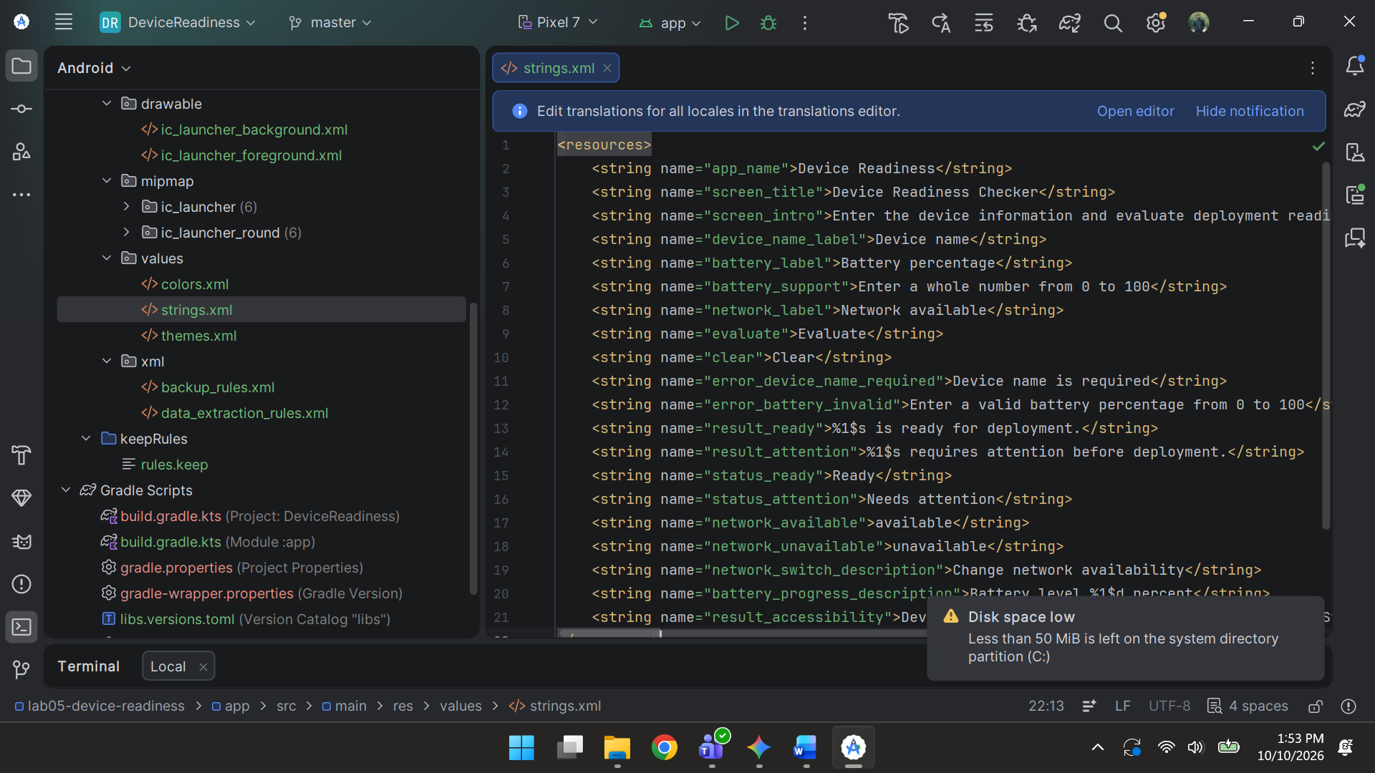

Task 4 - Create the stateful route and hoist screen state
DeviceReadinessApp owns small UI element state. The child screen receives current values and event callbacks, which makes the screen easier to preview and test.
@Composable
fun DeviceReadinessApp() {
var deviceName by rememberSaveable { mutableStateOf("") }
var batteryText by rememberSaveable { mutableStateOf("") }
var networkAvailable by rememberSaveable { mutableStateOf(true) }
var submitted by rememberSaveable { mutableStateOf(false) }
val battery = batteryText.toIntOrNull()
val nameError = submitted && deviceName.trim().isEmpty()
val batteryError = submitted &&
(battery == null || battery !in 0..100)
val valid = submitted && !nameError && !batteryError
val resultReady = if (valid) {
battery!! >= 30 && networkAvailable
} else {
null
}
DeviceReadinessScreen(
deviceName = deviceName,
batteryText = batteryText,
networkAvailable = networkAvailable,
nameError = nameError,
batteryError = batteryError,
resultReady = resultReady,
onDeviceNameChange = { deviceName = it; submitted = false },
onBatteryChange = { batteryText = it; submitted = false },
onNetworkChange = { networkAvailable = it; submitted = false },
onEvaluate = { submitted = true },
onClear = {
deviceName = ""
batteryText = ""
networkAvailable = true
submitted = false
}
)
}

Safety discussion: The battery!! expression is reached only after the valid condition proves that the parsed value is non-null and within range. Explain this guard. Do not introduce additional not-null assertions.

State and event map
State | Displayed by | Changed by
deviceName | Device name field and result | onDeviceNameChange and Clear
batteryText | Battery field, validation and result | onBatteryChange and Clear
networkAvailable | Switch and readiness decision | onNetworkChange and Clear
submitted | Error visibility and result visibility | Evaluate, any edit and Clear

Solution: -
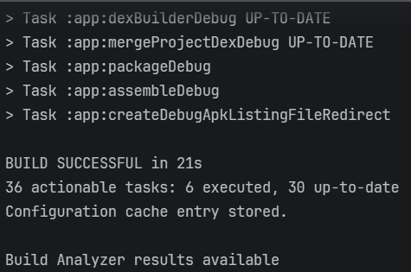

Task 5 - Build the stateless Material 3 screen
Add the screen signature first, then implement its content. Do not create new remember state inside this function for the four hoisted values.
Solution: -
@OptIn(ExperimentalMaterial3Api::class)
@Composable
fun DeviceReadinessScreen(
deviceName: String,
batteryText: String,
networkAvailable: Boolean,
nameError: Boolean,
batteryError: Boolean,
resultReady: Boolean?,
onDeviceNameChange: (String) -> Unit,
onBatteryChange: (String) -> Unit,
onNetworkChange: (Boolean) -> Unit,
onEvaluate: () -> Unit,
onClear: () -> Unit
) {
Scaffold(
topBar = {
TopAppBar(title = { Text(stringResource(R.string.screen_title)) })
}
) { innerPadding ->
Column(
modifier = Modifier
.padding(innerPadding)
.padding(24.dp)
.fillMaxSize()
.verticalScroll(rememberScrollState())
.imePadding(),
verticalArrangement = Arrangement.spacedBy(16.dp)
) {
Text(
text = stringResource(R.string.screen_intro),
style = MaterialTheme.typography.bodyLarge
)
// Add the fields, switch, buttons and result in Tasks 6-8.
}
}
}
Output: -
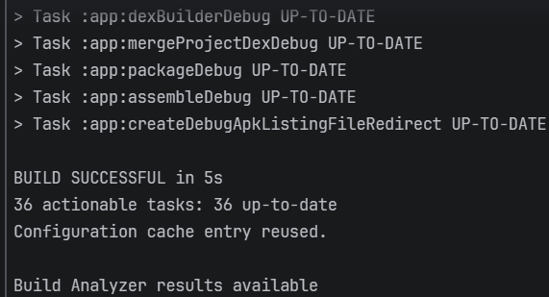
Task 6 - Add validated text fields
Place these fields inside the Column. The keyboard type is a hint; validation must still reject non-numeric input.
OutlinedTextField(
value = deviceName,
onValueChange = onDeviceNameChange,
label = { Text(stringResource(R.string.device_name_label)) },
singleLine = true,
isError = nameError,
supportingText = {
if (nameError) Text(stringResource(R.string.error_device_name_required))
},
modifier = Modifier.fillMaxWidth().testTag("deviceNameInput")
)
OutlinedTextField(
value = batteryText,
onValueChange = onBatteryChange,
label = { Text(stringResource(R.string.battery_label)) },
keyboardOptions = KeyboardOptions(keyboardType = KeyboardType.Number),
singleLine = true,
isError = batteryError,
supportingText = {
Text(
if (batteryError) stringResource(R.string.error_battery_invalid)
else stringResource(R.string.battery_support)
)
},
modifier = Modifier.fillMaxWidth().testTag("batteryInput")
)

Validation evidence: Demonstrate blank, text, -1, 0, 29, 30, 100 and 101 cases. Explain why boundary values are tested separately from typical values.

Output: -
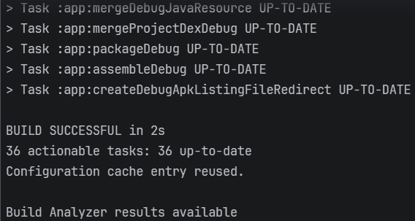
Task 7 - Add the switch and actions: -
Create a labelled switch row and two Material actions. The switch description comes from a resource.
Solution: -
val networkDescription = stringResource(R.string.network_switch_description)
Row(
modifier = Modifier.fillMaxWidth(),
verticalAlignment = Alignment.CenterVertically
) {
Text(
text = stringResource(R.string.network_label),
modifier = Modifier.weight(1f)
)
Switch(
checked = networkAvailable,
onCheckedChange = onNetworkChange,
modifier = Modifier
.semantics { contentDescription = networkDescription }
.testTag("networkSwitch")
)
}
Row(
modifier = Modifier.fillMaxWidth(),
horizontalArrangement = Arrangement.spacedBy(12.dp)
) {
Button(
onClick = onEvaluate,
modifier = Modifier.weight(1f).testTag("evaluateButton")
) { Text(stringResource(R.string.evaluate)) }
OutlinedButton(
onClick = onClear,
modifier = Modifier.weight(1f)
) { Text(stringResource(R.string.clear)) }
}
Use standard Material controls so focus, role and interaction semantics are available by default.
Keep controls large enough for reliable touch interaction and verify the layout with increased font size.
Do not use colour as the only indication of readiness or validation failure.
Output: -
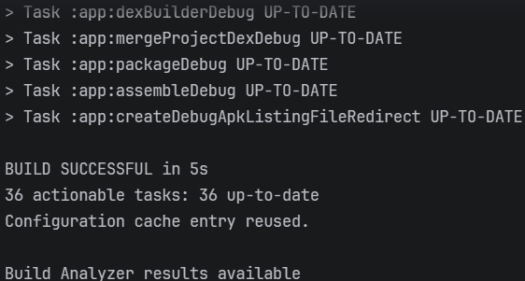

Task 8 - Display an accessible readiness result: -
Call ReadinessResultCard only when resultReady is not null and the parsed battery value is valid.
if (resultReady != null) {
ReadinessResultCard(
deviceName = deviceName.trim(),
batteryPercent = batteryText.toInt(),
networkAvailable = networkAvailable,
ready = resultReady
)
}

@Composable
fun ReadinessResultCard(
deviceName: String,
batteryPercent: Int,
networkAvailable: Boolean,
ready: Boolean
) {
val status = stringResource(
if (ready) R.string.status_ready else R.string.status_attention
)
val network = stringResource(
if (networkAvailable) R.string.network_available
else R.string.network_unavailable
)
val message = stringResource(
if (ready) R.string.result_ready else R.string.result_attention,
deviceName
)
val resultDescription = stringResource(
R.string.result_accessibility,
deviceName, batteryPercent, network, status
)
val batteryDescription = stringResource(
R.string.battery_progress_description, batteryPercent
)
Card(
modifier = Modifier
.fillMaxWidth()
.semantics(mergeDescendants = true) {
contentDescription = resultDescription
}
.testTag("resultCard")
) {
Column(
modifier = Modifier.padding(20.dp),
verticalArrangement = Arrangement.spacedBy(12.dp)
) {
Text(status, style = MaterialTheme.typography.titleLarge)
Text(message)
LinearProgressIndicator(
progress = { batteryPercent / 100f },
modifier = Modifier
.fillMaxWidth()
.semantics { contentDescription = batteryDescription }
)
}
}
}

Semantic design: The result includes visible status text and a complete spoken description. The progress indicator also exposes a battery description. Inspect the merged semantics tree and ensure information is not announced confusingly twice.

Output: -
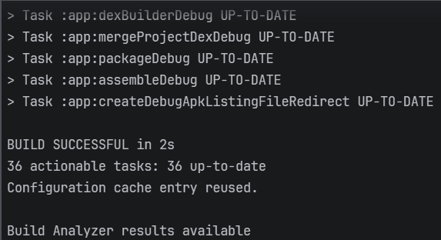

Task 9 - Add previews
Create previews for an empty form and a completed readiness result. Preview callbacks use empty lambdas because they do not change state.
Solution: -
@Preview(showBackground = true)
@Composable
fun DeviceReadinessEmptyPreview() {
DeviceReadinessTheme {
DeviceReadinessScreen(
deviceName = "",
batteryText = "",
networkAvailable = true,
nameError = false,
batteryError = false,
resultReady = null,
onDeviceNameChange = {},
onBatteryChange = {},
onNetworkChange = {},
onEvaluate = {},
onClear = {}
)
}
}

@Preview(showBackground = true)
@Composable
fun DeviceReadinessReadyPreview() {
DeviceReadinessTheme {
DeviceReadinessScreen(
deviceName = "Sensor-A",
batteryText = "68",
networkAvailable = true,
nameError = false,
batteryError = false,
resultReady = true,
onDeviceNameChange = {},
onBatteryChange = {},
onNetworkChange = {},
onEvaluate = {},
onClear = {}
)
}
}
Output: -
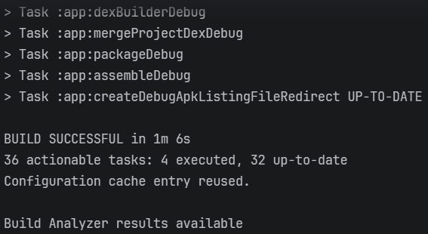

Task 10 - Verify state, validation and accessibility: -
Execute every row and record the actual result. Restore valid data after each invalid case.
ID | Input or action | Expected behaviour
T1 | Clean build and launch | Material 3 screen opens with labelled fields, switch and actions.
T2 | Evaluate blank form | Both visible validation messages appear; no result card is shown.
T3 | Battery text, -1 or 101 | Battery error appears and the form remains editable.
T4 | Battery 0, 29, 30 and 100 with network on | Boundaries are valid; 0/29 need attention and 30/100 are ready.
T5 | Battery 80; toggle network off | Result changes to needs attention only after Evaluate is selected again.
T6 | Evaluate valid values, then edit a field | The old result card disappears so stale information is not displayed.
T7 | Enter values and recreate the activity | Supported form values are restored through rememberSaveable.
T8 | Increase font size and use accessibility focus | Content remains reachable; labels, switch and result are announced meaningfully.

Solution: -
State and Validation Verification
Test | Action | Expected Outcome | Observed Result | Status
T1 | Launch application after clean build | Initial Material 3 UI renders with all form fields, switch, and buttons visible. | Application launches successfully, displaying the top bar, inputs, switch, and action buttons. | Pass
T2 | Submit blank form | Validation errors display; readiness result remains hidden. | Both fields activate isError. Text indicates missing name and invalid battery. No result card appears. | Pass
T3 | Input invalid battery data ("abc", -1, 101) | Battery error text displays; form accepts further edits. | Error message prompts for a valid percentage (0-100). Inputs remain fully functional. | Pass
T4 | Test battery thresholds (0, 29, 30, 100) with network ON | 0 and 29 trigger "Needs attention"; 30 and 100 trigger "Ready". | Values 0 and 29 display "Needs attention". Values 30 and 100 display "Ready". | Pass
T5 | Input 80 battery, toggle network OFF | Result updates to "Needs attention" only upon re-evaluation. | Toggling the network resets the submission state, hiding the current result. Re-evaluating displays "Needs attention". | Pass
T6 | Edit field after valid evaluation | Stale result card is removed from the screen. | Modifying the device name resets the submission flag, instantly hiding the outdated result card. | Pass
T7 | Trigger activity recreation | Input data persists using rememberSaveable. | Screen rotation maintains device name, battery input, network toggle, and submission state. | Pass
T8 | Enable accessibility focus and scale fonts | Elements remain accessible; screen reader provides meaningful context. | Scrollable column prevents clipping. TalkBack successfully announces the complete merged result description. | Pass
Accessibility Assessment
- Sequential Navigation: Focus shifts logically from top to bottom, moving through the app bar, intro text, inputs, switch, buttons, and finally the result card.
- Visual Independence: Fields maintain persistent visible labels. Error states are communicated via explicit supporting text rather than relying solely on color indicators.
- Component Semantics: The network switch correctly announces its checked state alongside the custom "Change network availability" description.
- Merged Output: The readiness result card utilizes mergeDescendants = true to combine the device status, battery percentage, and network availability into a single, cohesive screen reader announcement.
- Layout Resilience: Vertical scrolling and keyboard padding ensure all interface elements remain fully accessible and unclipped in landscape mode or at increased font scales.

Task 11 - Add focused Compose UI tests: -
Create DeviceReadinessScreenTest.kt under app/src/androidTest in the application package.
@RunWith(AndroidJUnit4::class)
class DeviceReadinessScreenTest {
@get:Rule
val composeRule = createAndroidComposeRule<MainActivity>()
@Test
fun blankForm_showsBothValidationMessages() {
val activity = composeRule.activity
composeRule.onNodeWithTag("evaluateButton").performClick()
composeRule.onNodeWithText(
activity.getString(R.string.error_device_name_required)
).assertIsDisplayed()
composeRule.onNodeWithText(
activity.getString(R.string.error_battery_invalid)
).assertIsDisplayed()
}
@Test
fun validForm_showsReadyResult() {
val activity = composeRule.activity
composeRule.onNodeWithTag("deviceNameInput")
.performTextInput("Sensor-A")
composeRule.onNodeWithTag("batteryInput")
.performTextInput("80")
composeRule.onNodeWithTag("evaluateButton").performClick()
composeRule.onNodeWithText(
activity.getString(R.string.result_ready, "Sensor-A")
).assertIsDisplayed()
}
}

Run both instrumented tests on the selected emulator or device and retain the successful result as evidence.
Use test tags for stable technical selection while keeping visible labels and semantics meaningful for users.
If a test cannot find a node, inspect the merged and unmerged semantics trees before changing the UI blindly.

