# LAB NO 2:

OBJECTIVE: To implement ArrayList and Vector.

TASK NO 1:

1-Write a program that initializes Vector with 10 integers in it. Display all the integers and sum of these integers

CODE:

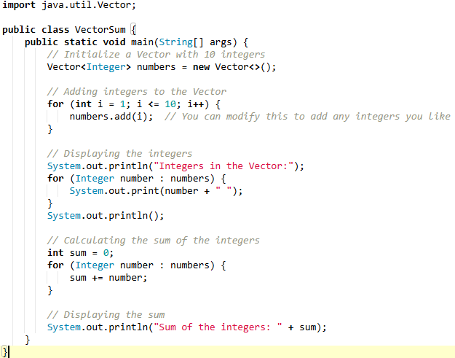

OUTPUT:



2; Create a Arraylist storing Employee details including Emp_id, Emp_Name, Emp_gender, Year_of_Joining (you can also add more attributes including these). Then sort the employees according to their joining year using Comparator and Comparable interfaces.

CODE:

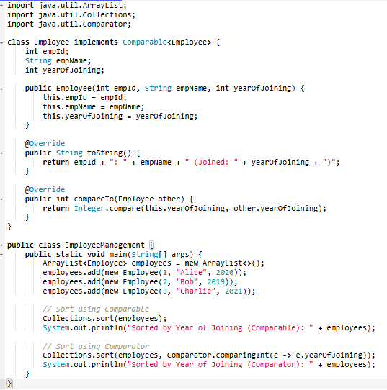

OUTPUT:

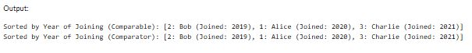

3: Write a program that initializes Vector with 10 integers in it.

• Display all the integers

• Sum of these integers.

• Find Maximum Element in Vector

CODE:

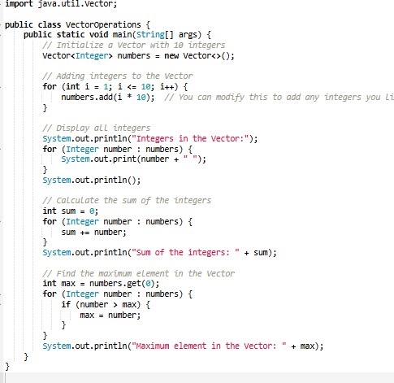

OUTPUT:

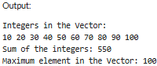

4: Find the k-th smallest element in a sorted ArrayList

CODE:

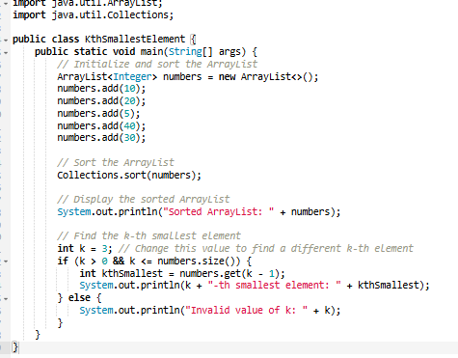

OUTPUT:

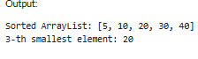

5; Write a program to merge two ArrayLists into one

CODE:

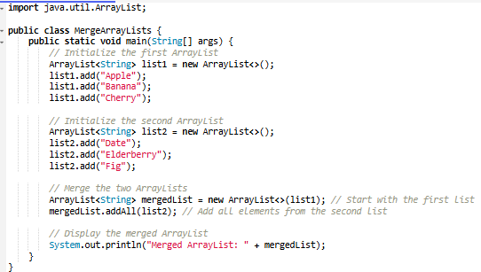

OUTPUT:



HOME TASK

1-Create a Vector storing integer objects as an input.

1. Sort the vector b.
2. Display largest number
3. Display smallest number

CODE:

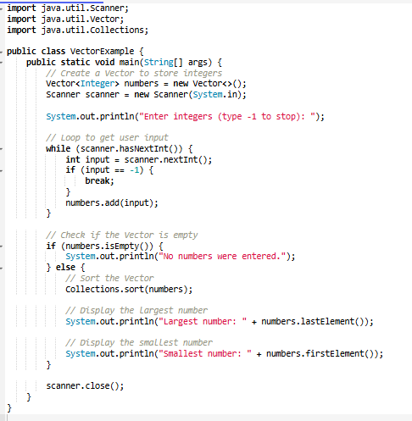

OUTPUT:

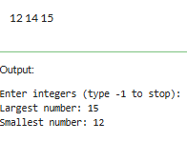

2-Write a java program which takes user input and gives hashcode value of those inputs using hashCode () method

CODE:

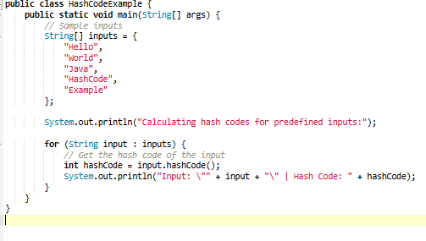

OUTPUT:

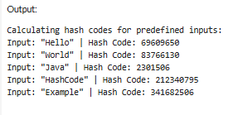

3-Create a Color class that has red, green, and blue values. Two colors are considered equal if their RGB values are the same

CODE:

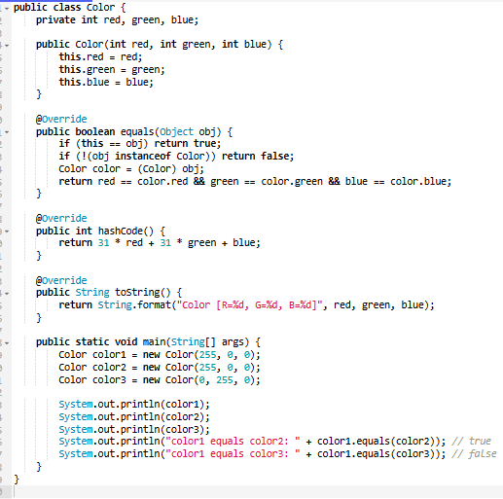

OUTPUT:

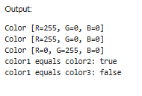

4-Create a java project, suppose you work for a company that needs to manage a list of employees. Each employee has a unique combination of a name and an ID. Your goal is to ensure that you can track employees effectively and avoid duplicate entries in your system. Requirements a. Employee Class: You need to create an Employee class that includes: • name: The employee's name (String). • id: The employee's unique identifier (int). • Override the hashCode() and equals() methods to ensure that two employees are considered equal if they have the same name and id. b. Employee Management: You will use a HashSet to store employee records. This will help you avoid duplicate entries. c. Operations: Implement operations to: • Add new employees to the record. • Check if an employee already exists in the records. • Display all employees.

CODE:

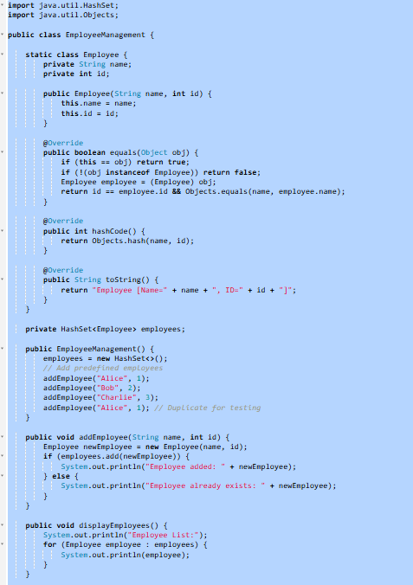

OUTPUT:

