Part 1:
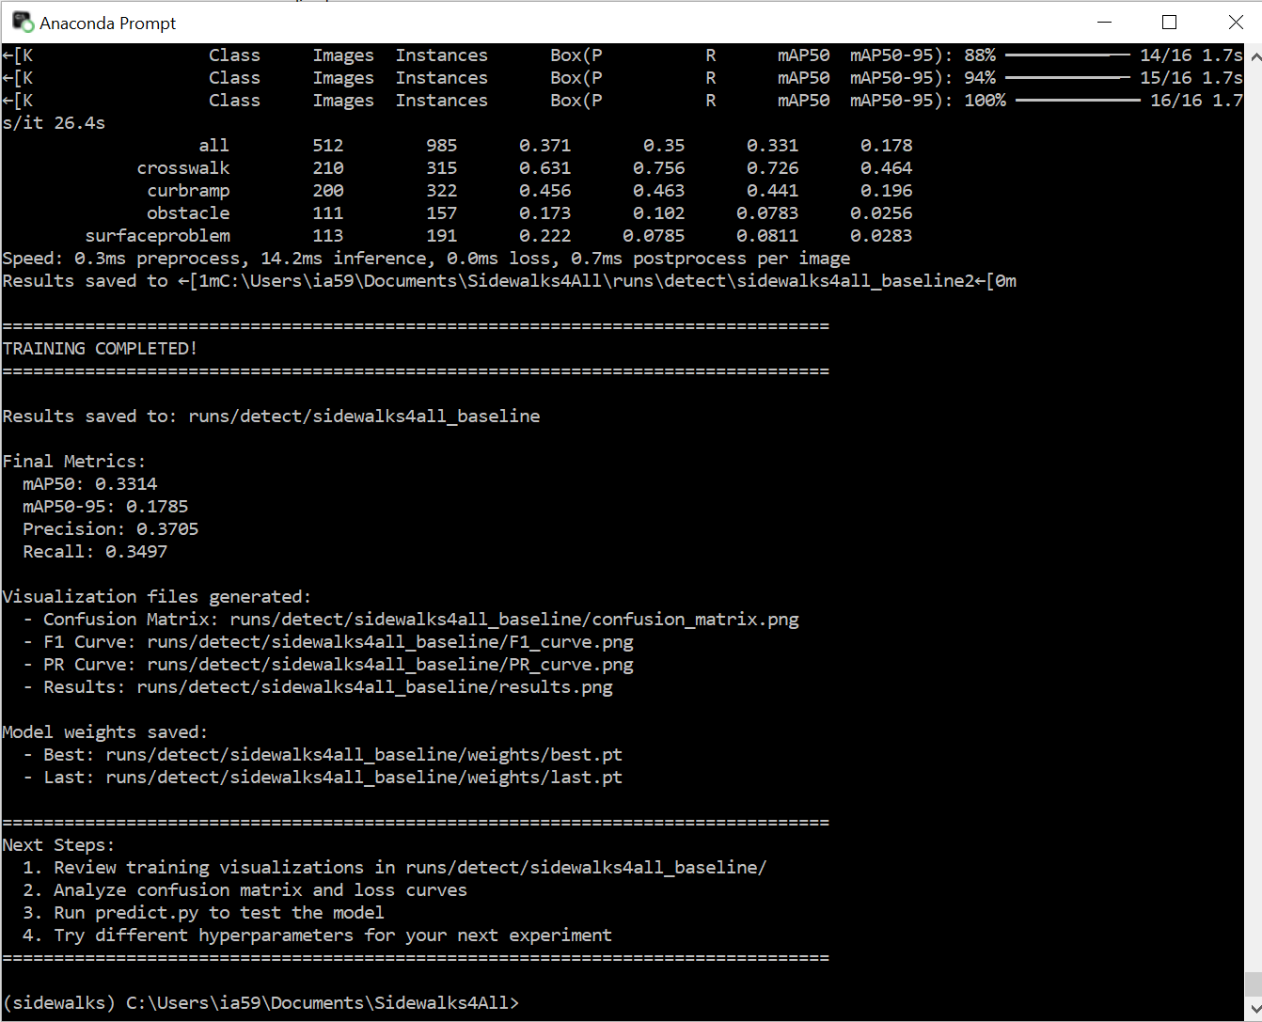
Metric | Value
mAP50 | 0.3314
mAP50-95 | 0.1785
Precision | 0.3705
Recall | 0.3497

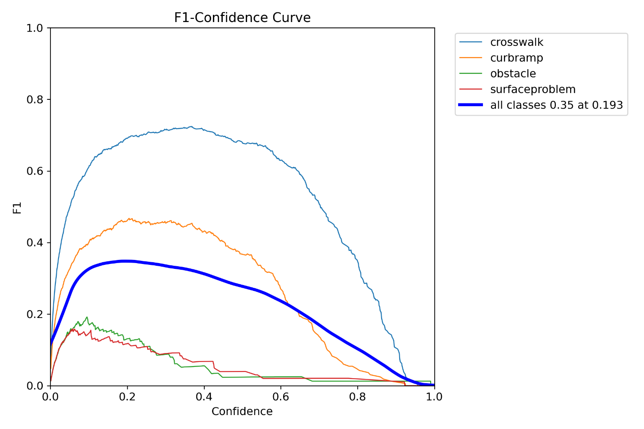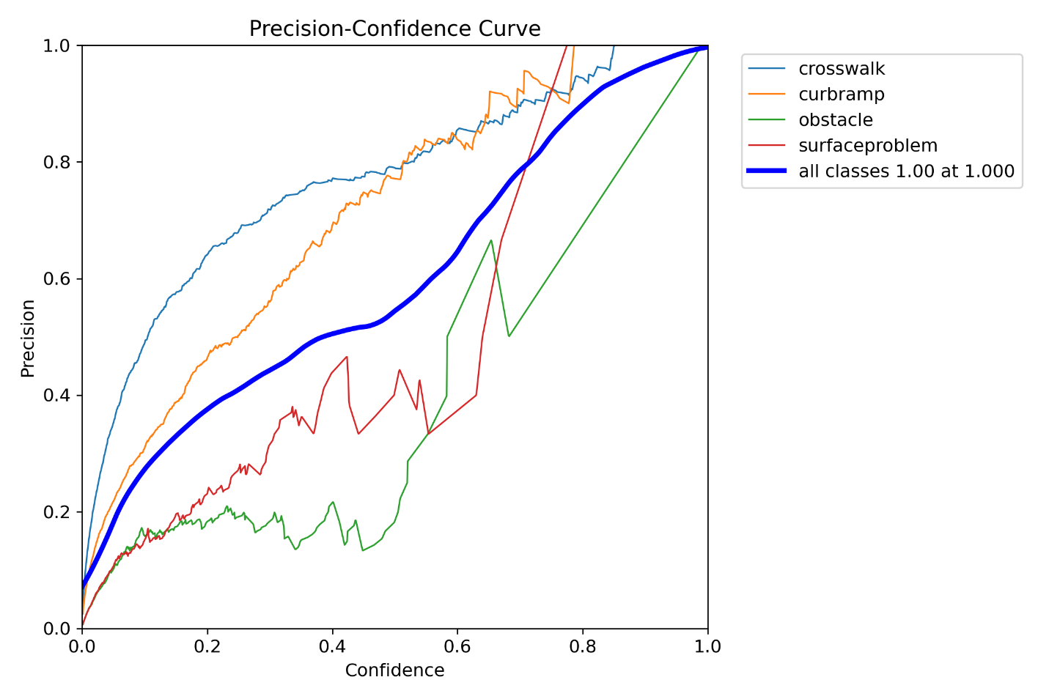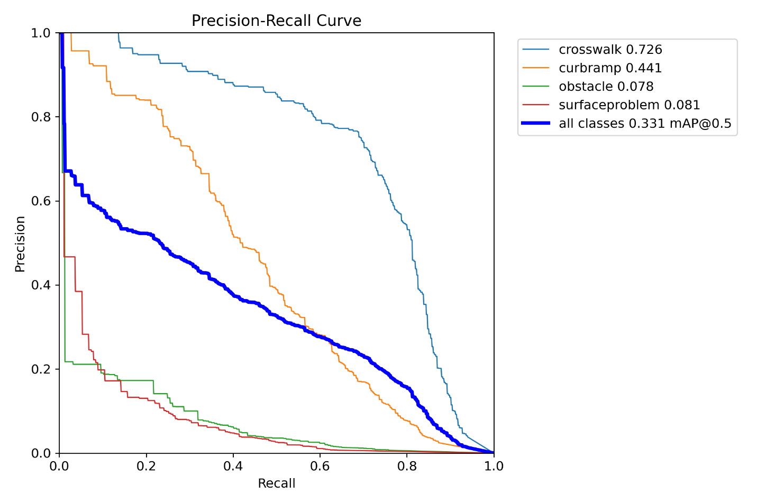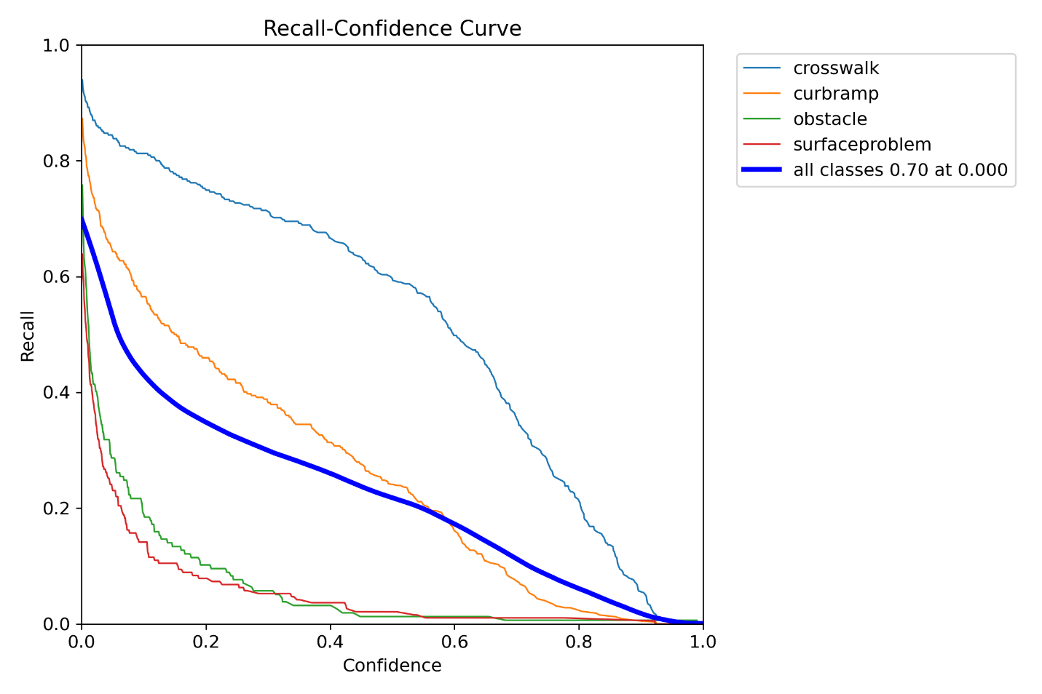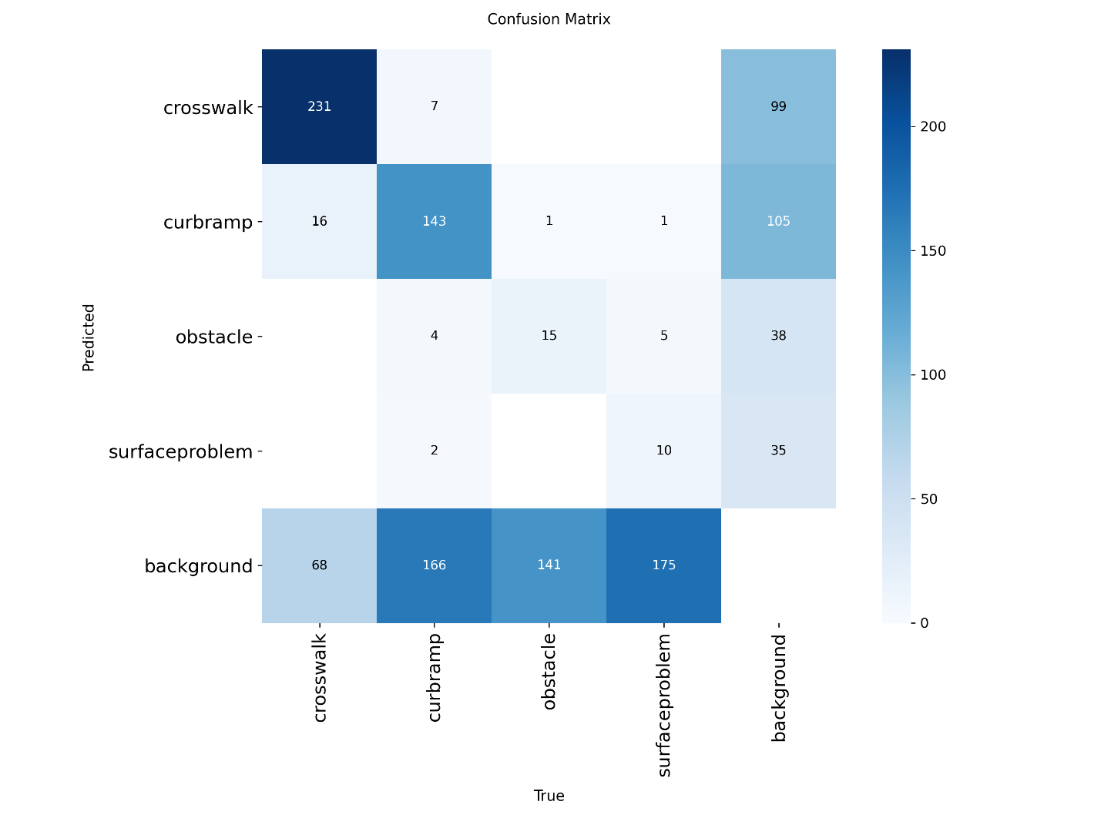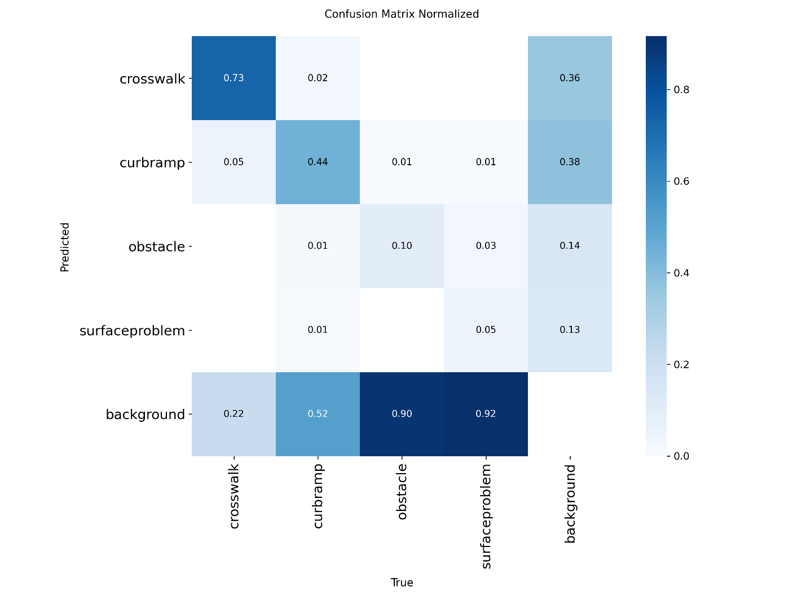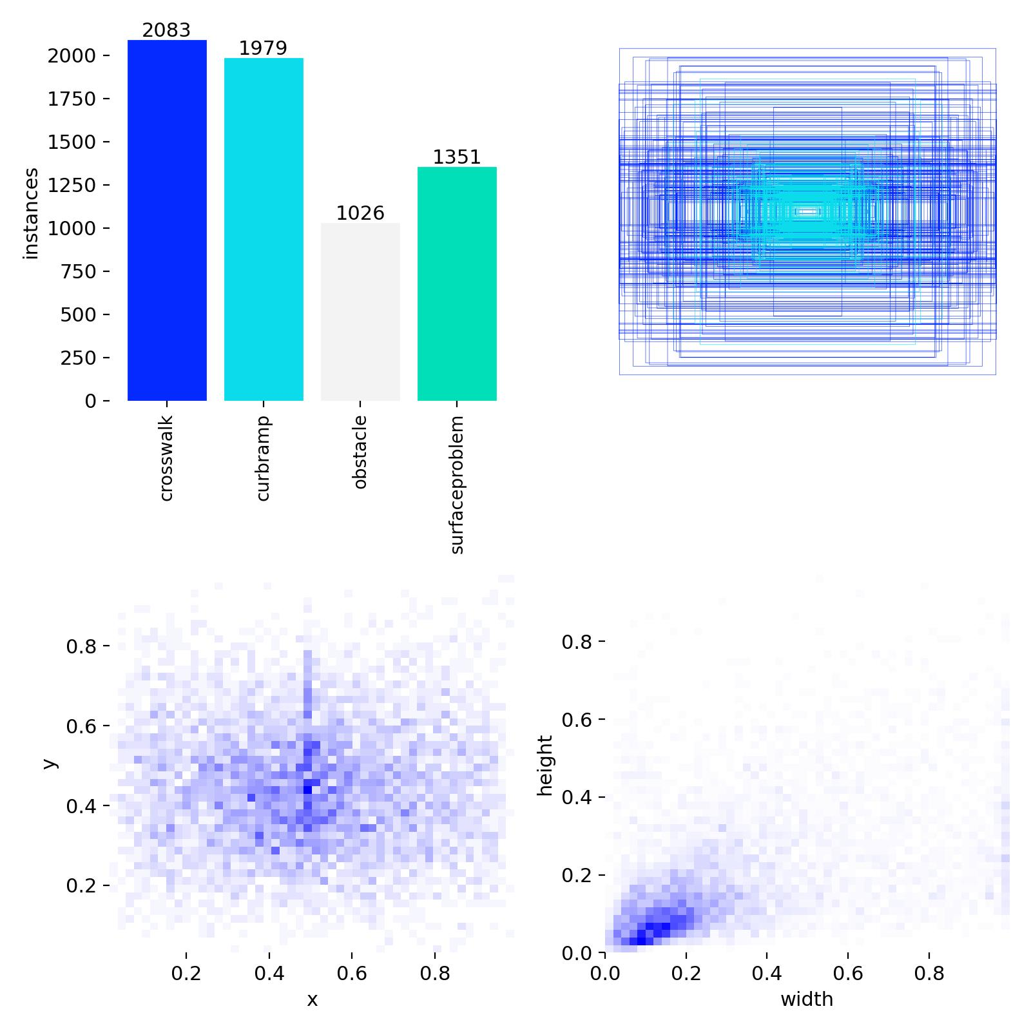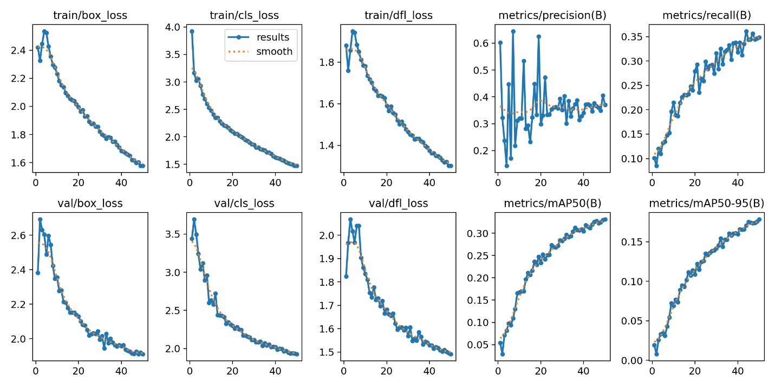

Part 2:
I disclose that I have in fact used AI.
modified train.py explaining hyperparameter choice:
"""
train.py - YOLOv8 Training Script for Sidewalks4All Project
CS 480 Machine Learning - University of Evansville
Dr. Maxwell Omwenga

This version includes modifications for Experiment 1, including:
- Reduced batch size for GPU memory limits
- Disabled caching to prevent RAM overload
- Workers set to 0 to avoid OpenCV multiprocessing crashes
- Custom augmentation and optimization hyperparameters
"""

import os
os.environ['KMP_DUPLICATE_LIB_OK'] = 'True'

from ultralytics import YOLO

if __name__ == '__main__':

# ========================================================================
# EXPERIMENT 1 CONFIGURATION
# ========================================================================

MODEL_NAME = 'yolov8n.pt'
DATA_CONFIG = 'data.yaml'

# 🔵 EXPERIMENT 1 HYPERPARAMETERS (MEMORY-SAFE VERSION)
# These values were chosen to prevent GPU/CPU memory crashes on a 2GB GPU.
EXPERIMENT_NAME = 'sidewalks4all_exp1'
EPOCHS = 100

BATCH_SIZE = 4 # Reduced from 16 → 8 → 4 to fit GPU VRAM
IMAGE_SIZE = 416 # Slightly smaller than 640 to reduce memory load

LEARNING_RATE = 0.001 # Standard YOLOv8 learning rate
FINAL_LR = 0.01 # Final LR for cosine decay scheduler

OPTIMIZER = 'SGD' # Using SGD for Experiment 1
MOMENTUM = 0.937
WEIGHT_DECAY = 0.0005

# Data augmentation settings for Experiment 1
MOSAIC = 0.0
MIXUP = 0.0
HSV_H = 0.015
HSV_S = 0.7
HSV_V = 0.4

DEGREES = 0.0
TRANSLATE = 0.1
SCALE = 0.5
SHEAR = 0.0
PERSPECTIVE = 0.0
FLIPUD = 0.0
FLIPLR = 0.5

DEVICE = '0'

WORKERS = 0 # Critical fix: prevents OpenCV memory crashes
PATIENCE = 50
SAVE_PERIOD = -1

# ========================================================================
# PRINT CONFIG
# ========================================================================

print("="*80)
print("SIDEWALKS4ALL - YOLOv8 TRAINING (EXPERIMENT 1)")
print("="*80)
print(f"Experiment Name: {EXPERIMENT_NAME}")
print(f"Epochs: {EPOCHS}")
print(f"Batch Size: {BATCH_SIZE}")
print(f"Image Size: {IMAGE_SIZE}")
print(f"Learning Rate: {LEARNING_RATE}")
print(f"Optimizer: {OPTIMIZER}")
print(f"Device: {DEVICE}")
print("="*80)

# ========================================================================
# TRAINING
# ========================================================================

model = YOLO(MODEL_NAME)

results = model.train(
data=DATA_CONFIG,
epochs=EPOCHS,
imgsz=IMAGE_SIZE,
batch=BATCH_SIZE,
lr0=LEARNING_RATE,
lrf=FINAL_LR,
optimizer=OPTIMIZER,
momentum=MOMENTUM,
weight_decay=WEIGHT_DECAY,
mosaic=MOSAIC,
mixup=MIXUP,
hsv_h=HSV_H,
hsv_s=HSV_S,
hsv_v=HSV_V,
degrees=DEGREES,
translate=TRANSLATE,
scale=SCALE,
shear=SHEAR,
perspective=PERSPECTIVE,
flipud=FLIPUD,
fliplr=FLIPLR,
device=DEVICE,
workers=WORKERS, # Prevents multiprocessing memory errors
patience=PATIENCE,
save_period=SAVE_PERIOD,
name=EXPERIMENT_NAME,
exist_ok=False,
pretrained=True,
verbose=True,
cache=False # Prevents RAM overload by disabling image caching
)

# ========================================================================
# RESULTS SUMMARY
# ========================================================================

print("\n" + "="*80)
print("TRAINING COMPLETED!")
print("="*80)
print(f"Results saved to: runs/detect/{EXPERIMENT_NAME}")

metrics = results.results_dict

print(f" mAP50: {metrics.get('metrics/mAP50(B)', 'N/A')}")
print(f" mAP50-95: {metrics.get('metrics/mAP50-95(B)', 'N/A')}")
print(f" Precision: {metrics.get('metrics/precision(B)', 'N/A')}")
print(f" Recall: {metrics.get('metrics/recall(B)', 'N/A')}")

print("\nVisualization files generated:")
print(f" - Confusion Matrix: runs/detect/{EXPERIMENT_NAME}/confusion_matrix.png")
print(f" - F1 Curve: runs/detect/{EXPERIMENT_NAME}/F1_curve.png")
print(f" - PR Curve: runs/detect/{EXPERIMENT_NAME}/PR_curve.png")
print(f" - Results: runs/detect/{EXPERIMENT_NAME}/results.png")

print("\nModel weights saved:")
print(f" - Best: runs/detect/{EXPERIMENT_NAME}/weights/best.pt")
print(f" - Last: runs/detect/{EXPERIMENT_NAME}/weights/last.pt")

print("="*80)
print("Next Steps:")
print(" 1. Start Experiment 2 after this finishes")
print(" 2. Run predictions on test set and your video")
print(" 3. Begin writing Part 1 & Part 2 of your report")
print("="*80)

Config | LR | Batch | Epochs | mAP50 | mAP50-95 | Precision | Recall
Baseline | 0.01 | 16 | 100 | 0.3314 | 0.1785 | 0.3705 | 0.3497
Exp 1 | 0.001 | 4 | 100 | 0.3523958085948193 | 0.19492191300133563 | 0.41170229222586785 | 0.36873544846198936
Exp 2 | 0.0005 | 8 | 30 | 0.3683632545263738 | 0.20023816533189115 | 0.3840404970999304 | 0.4006997419555879
Exp 3 | 0.01 | 4 | 20 | 0.2969375720888467 | 0.15585768740692832 | 0.33596286052266955 | 0.3236394961396085

Justification:
I modified the batch size to 4 because it reduces memory usage and prevents the likelihood of the program crashing when running. The computer I am using has a 2GB VRAM. A larger batch size would cause a out of memory crash so keeping it at this value prevents it. The workers are 0 because in an attempt to make sure crashes will not occur, parallelism has been set to 0. This is to make sure no crashes will occur. The cache is set to 0 to prevent memory errors because loading an entire dataset to RAM can cause an error leading to the training program to crash. As you may notice a lot of the changes I have made is to prevent crashes and that is pretty much it. My goal is to prevent crashes and the error messages I got each time were due too too much memory being used so I set it up to minimize its use.

The image size is 416 also because of me wanting to prevent memory issues but also because of the desire to maintain some accuracy while doing so and this seems to be best enough to do so as when using this I didn’t experience any crashes. So it is a good option for freeing up memory while maintaining accuracy. For now mosaic and mixup are off translate set to 0.1, fliplr set to 0.5, and scale set to 0.5 because these changes are moderate and for training without too much image distortion. The hsv is set to what it is because it is the default yolov8 recommendations, and unless I have a good reason to, the default should be good for using color in an image to recognize what its looking for. The optimizer is SGD because I want to see how SGD does compared to AdamW the baseline. The learning is 0.001 because it is the standard learning rate.
Exp 1
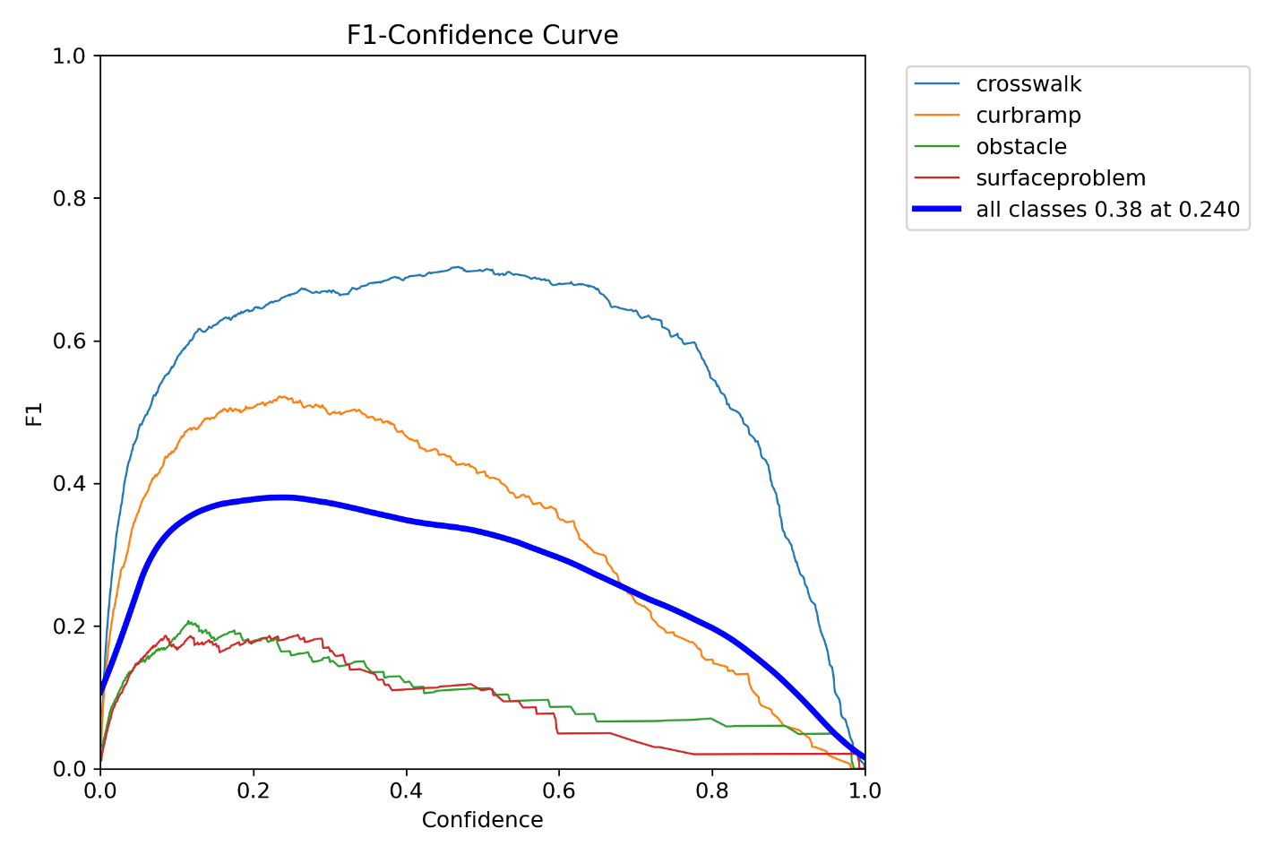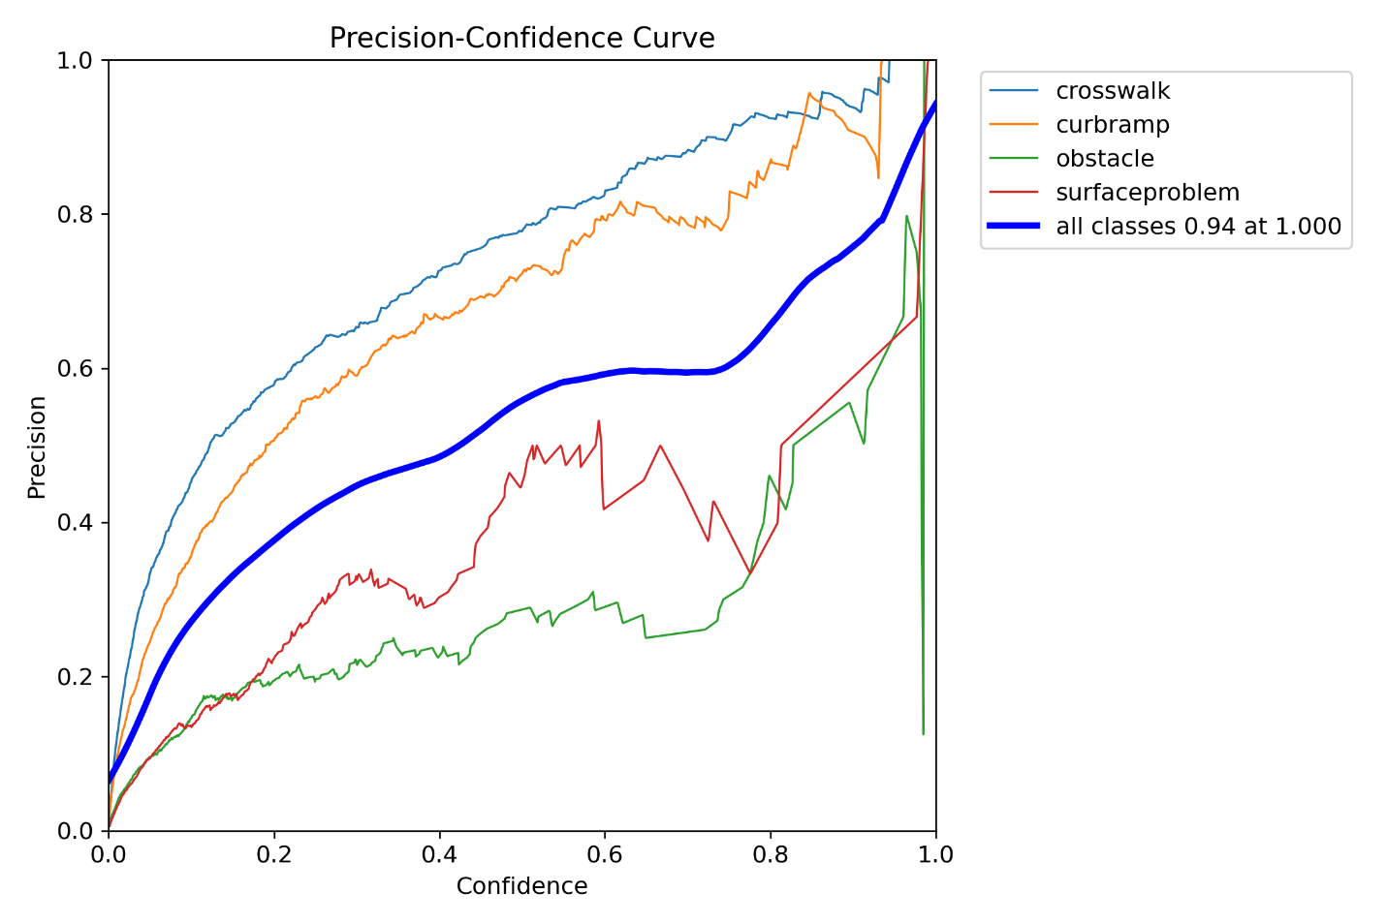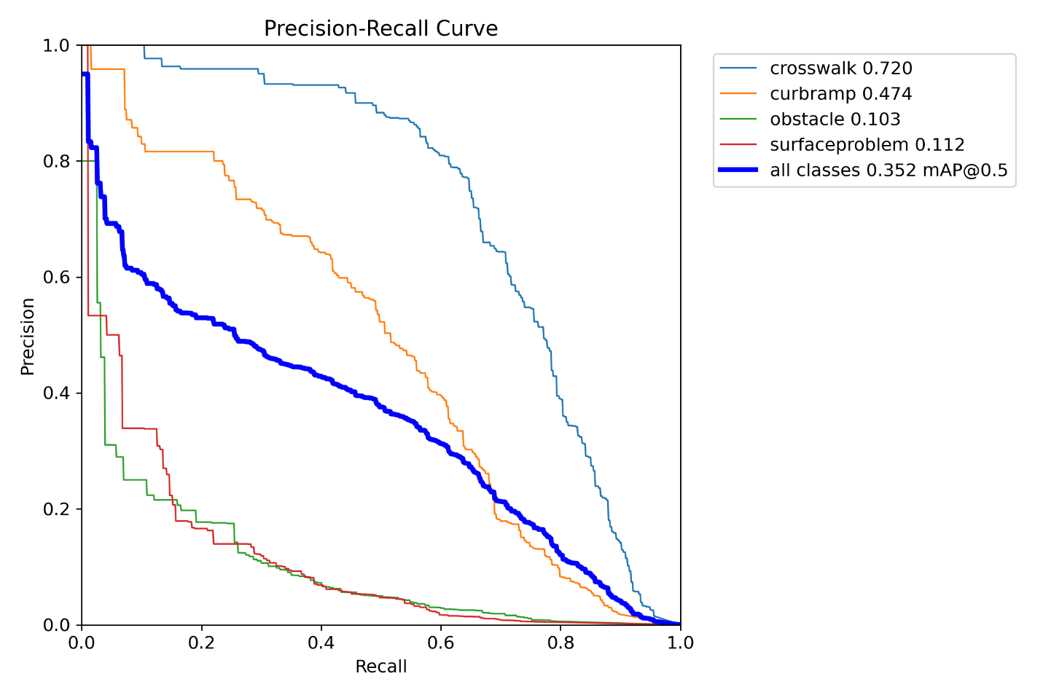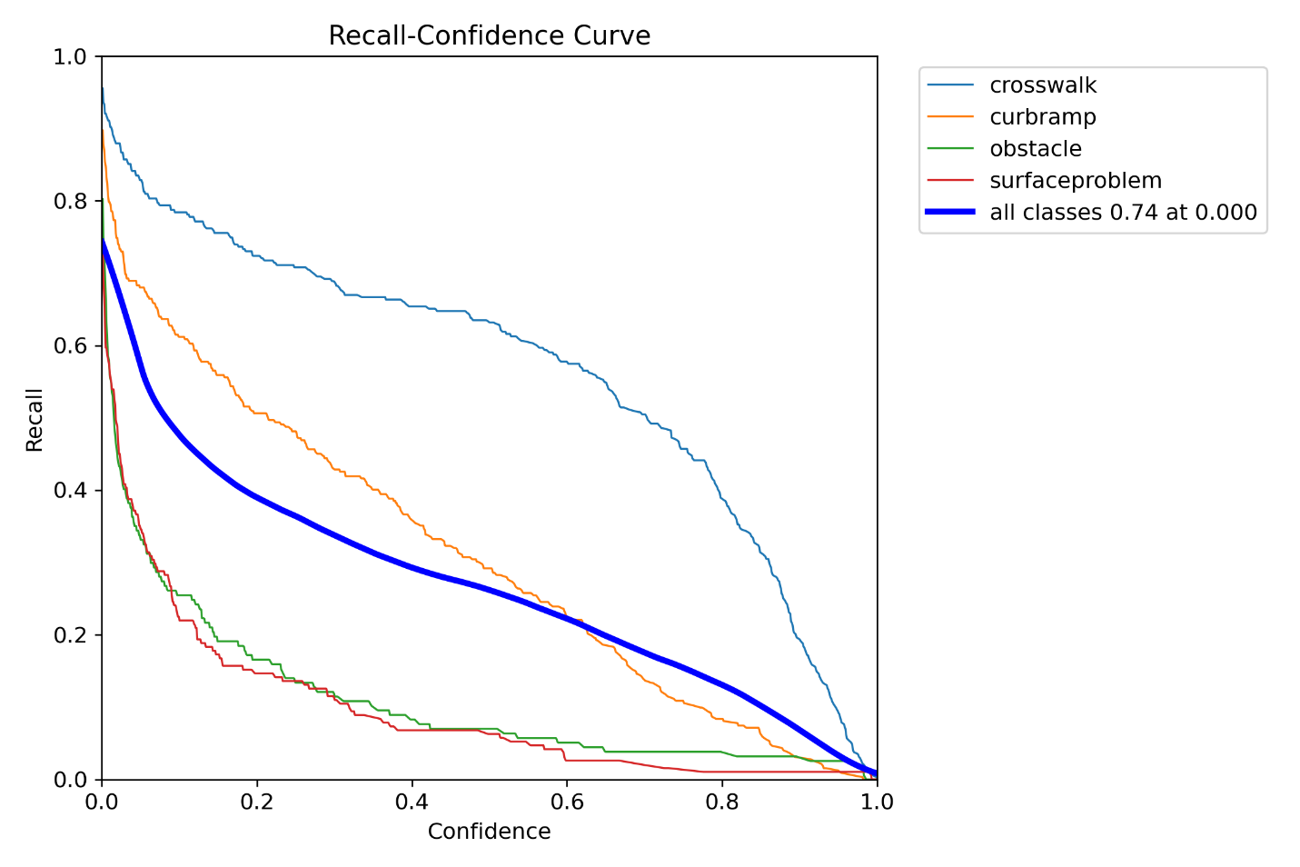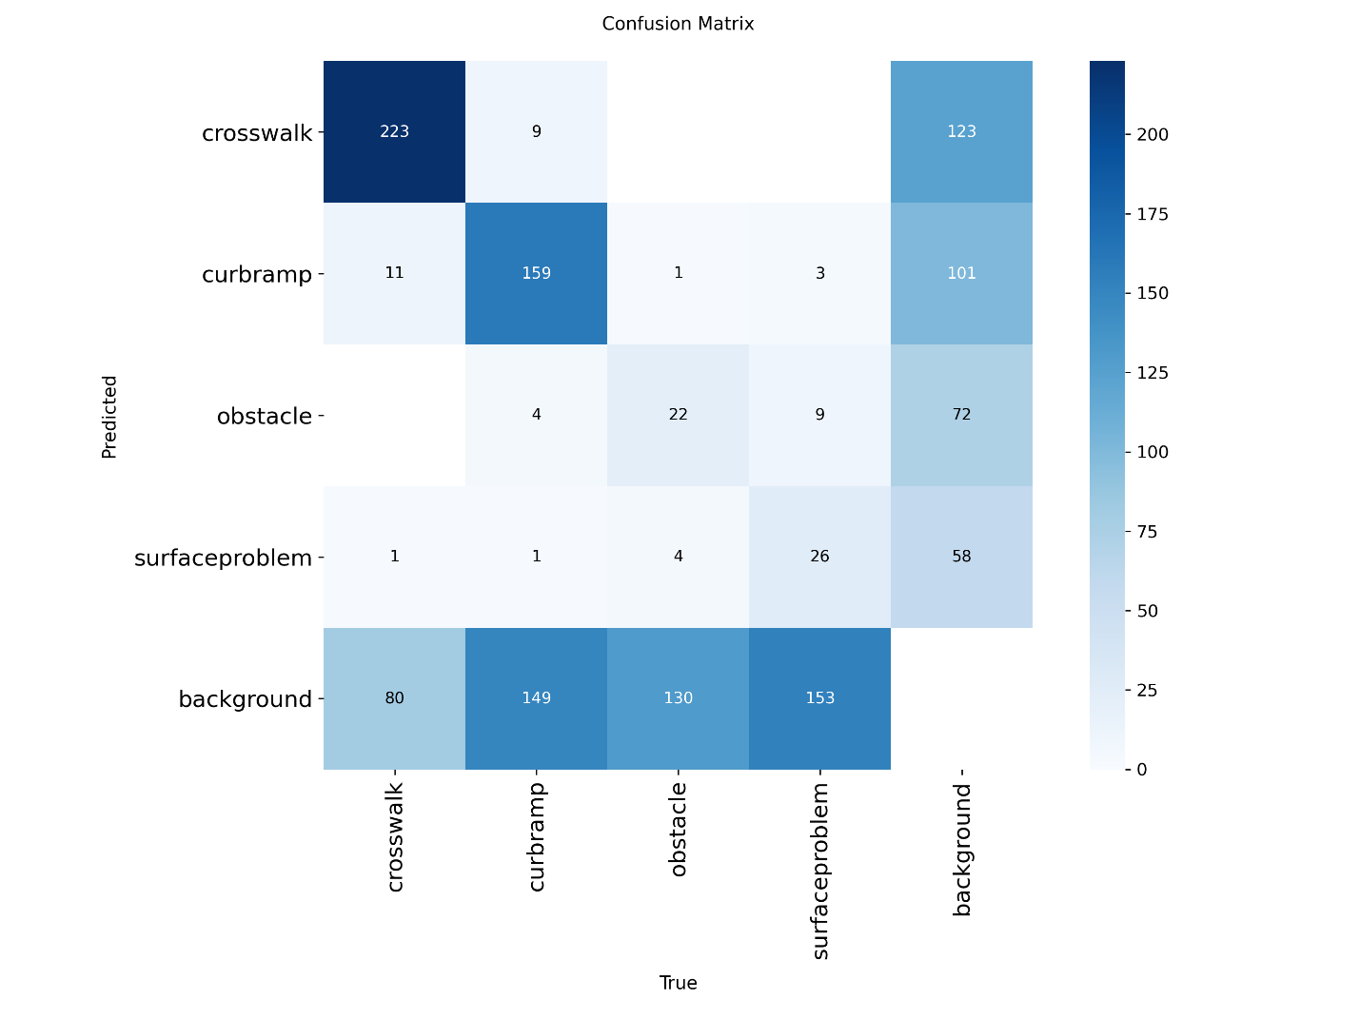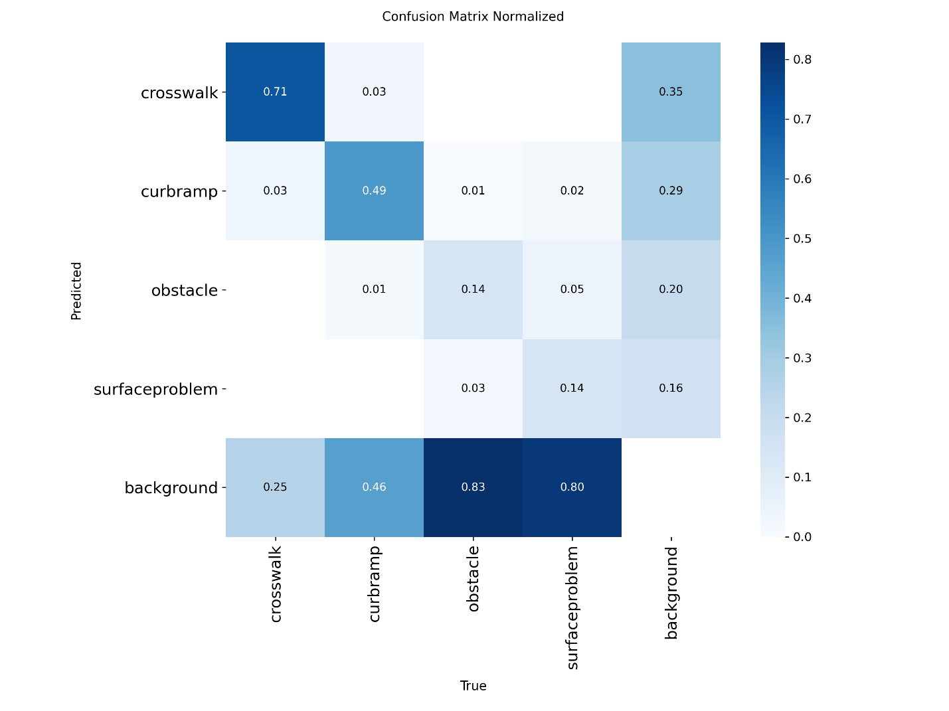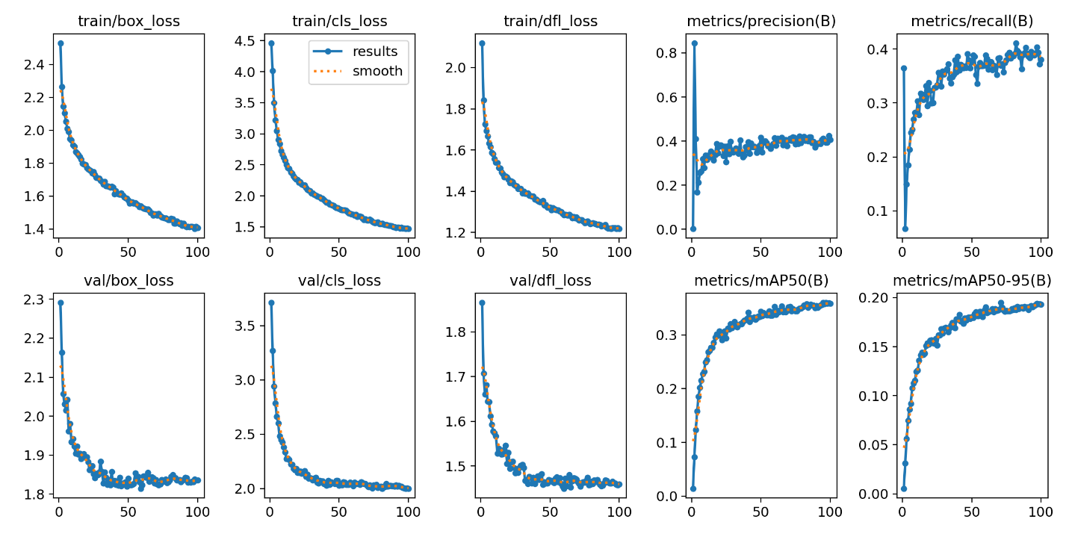
Exp 2
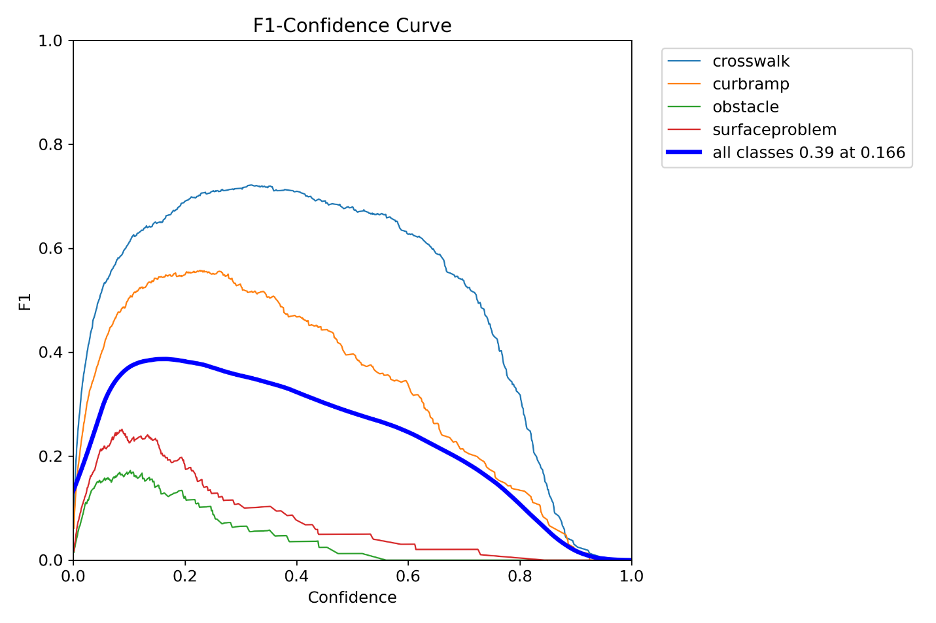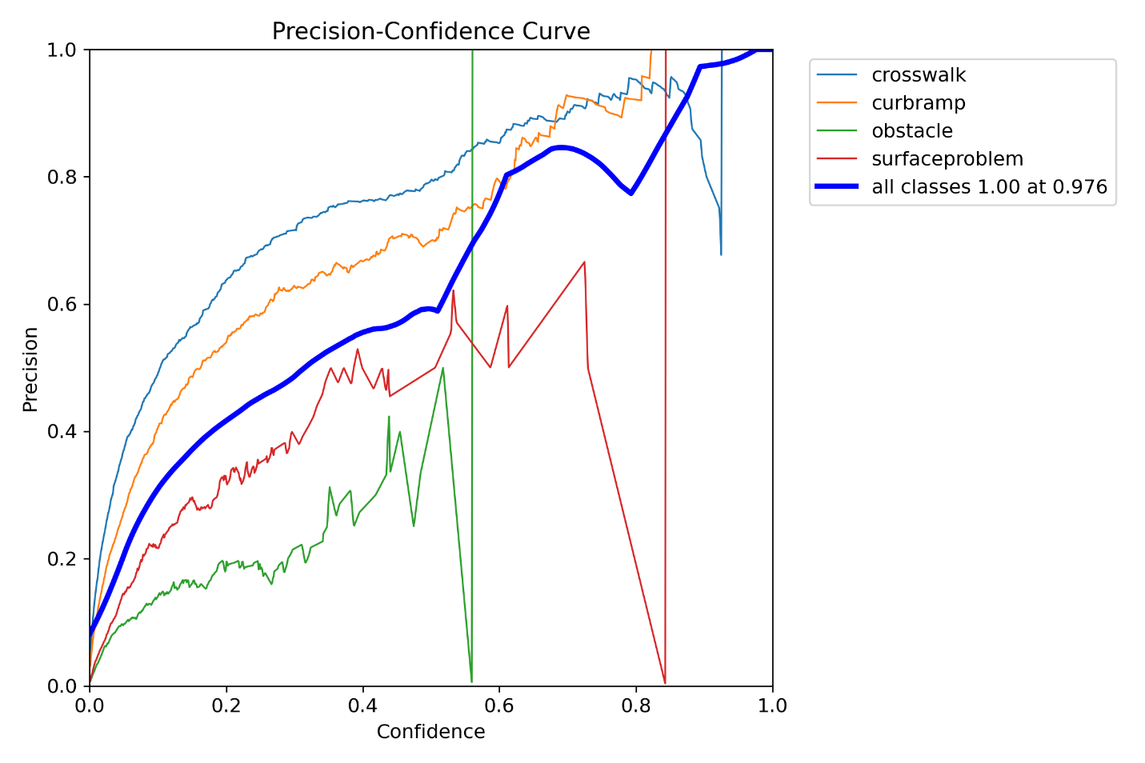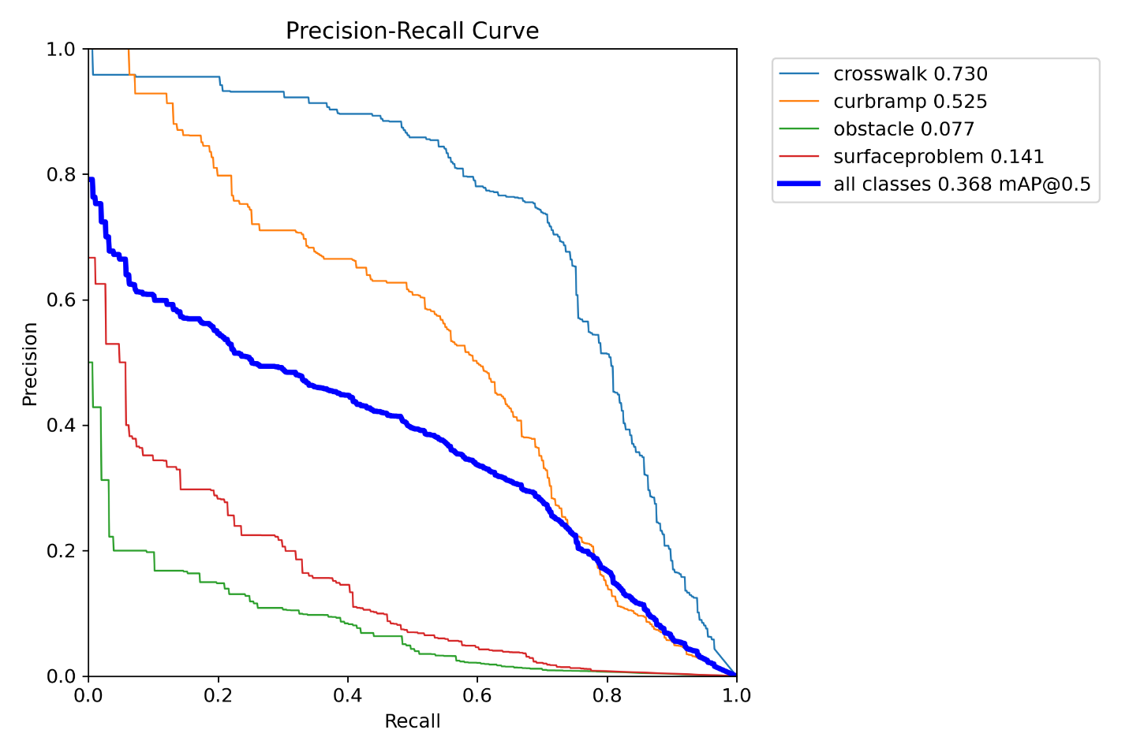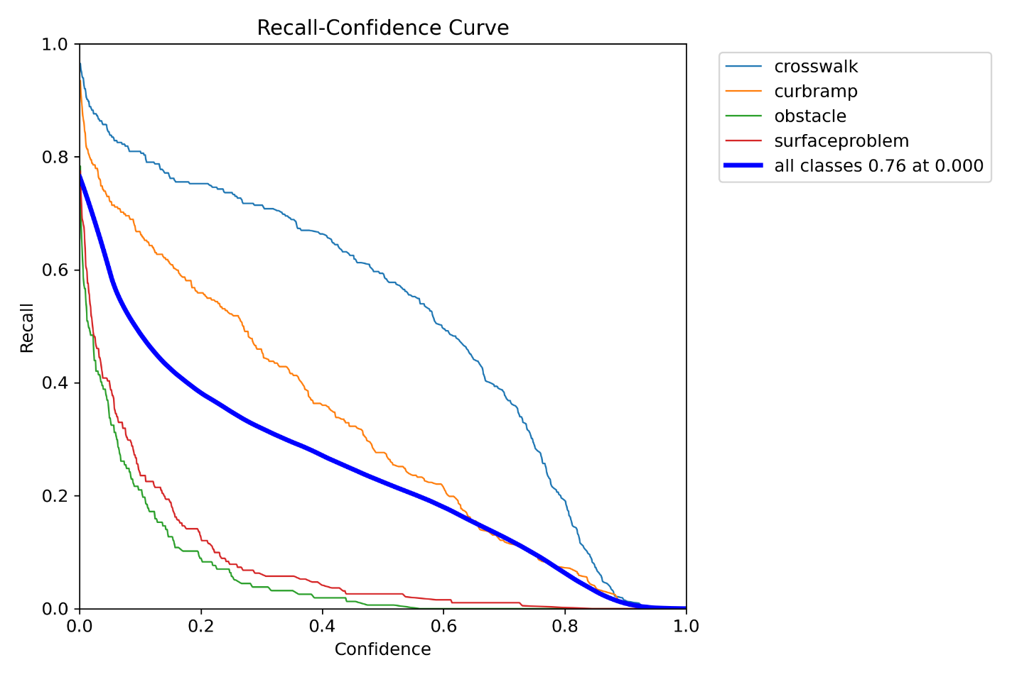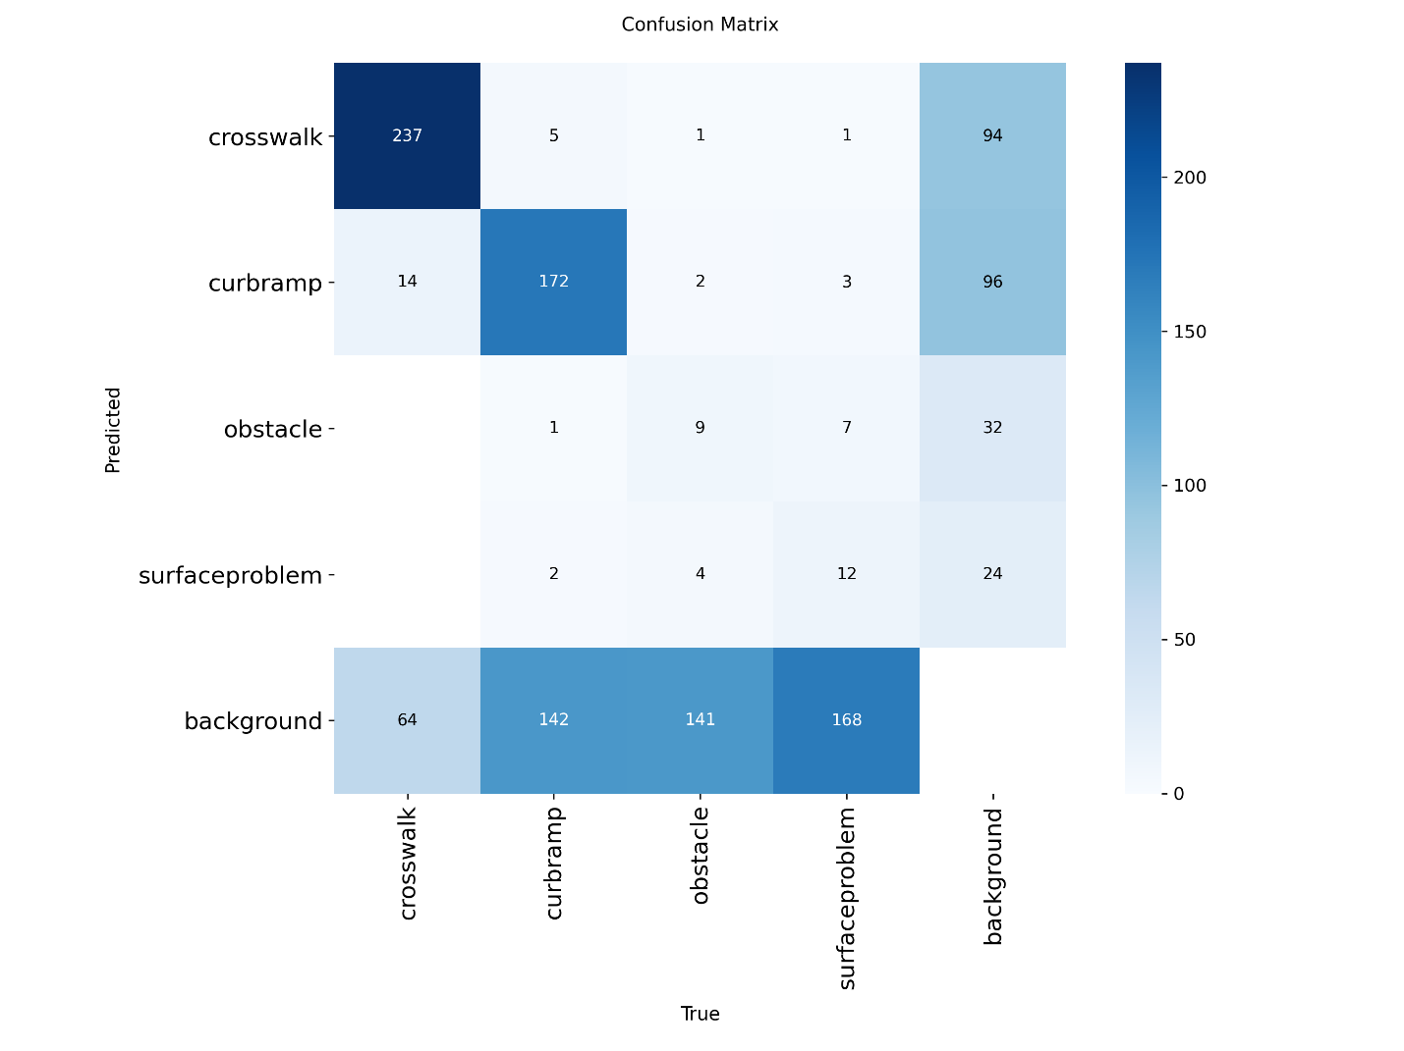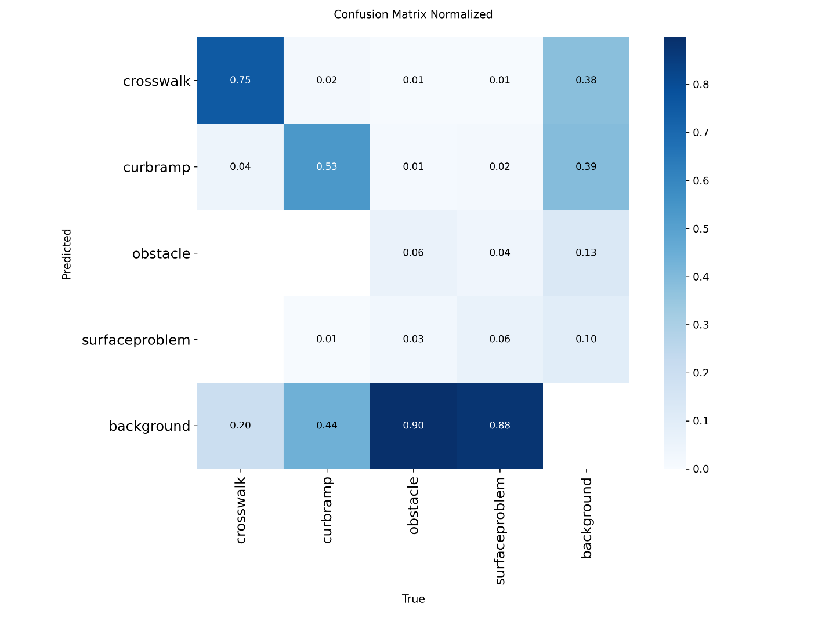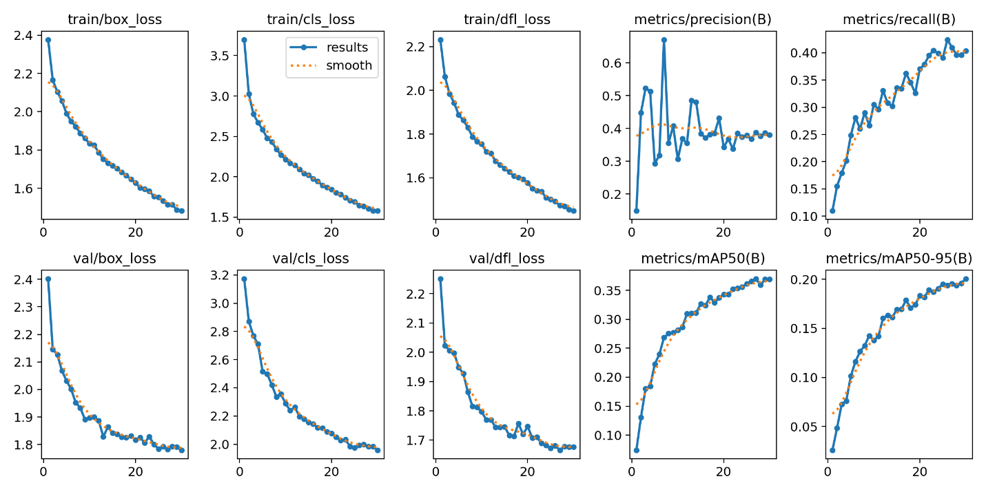
Exp 3
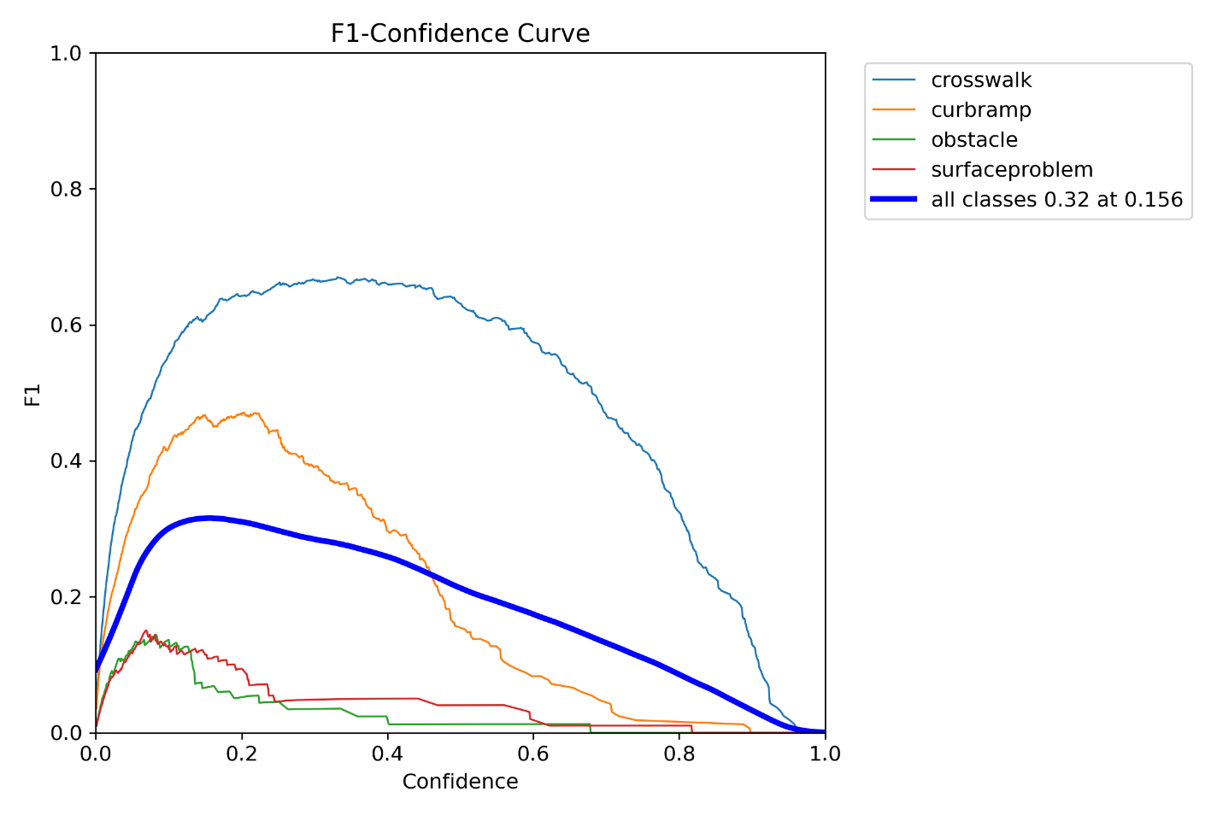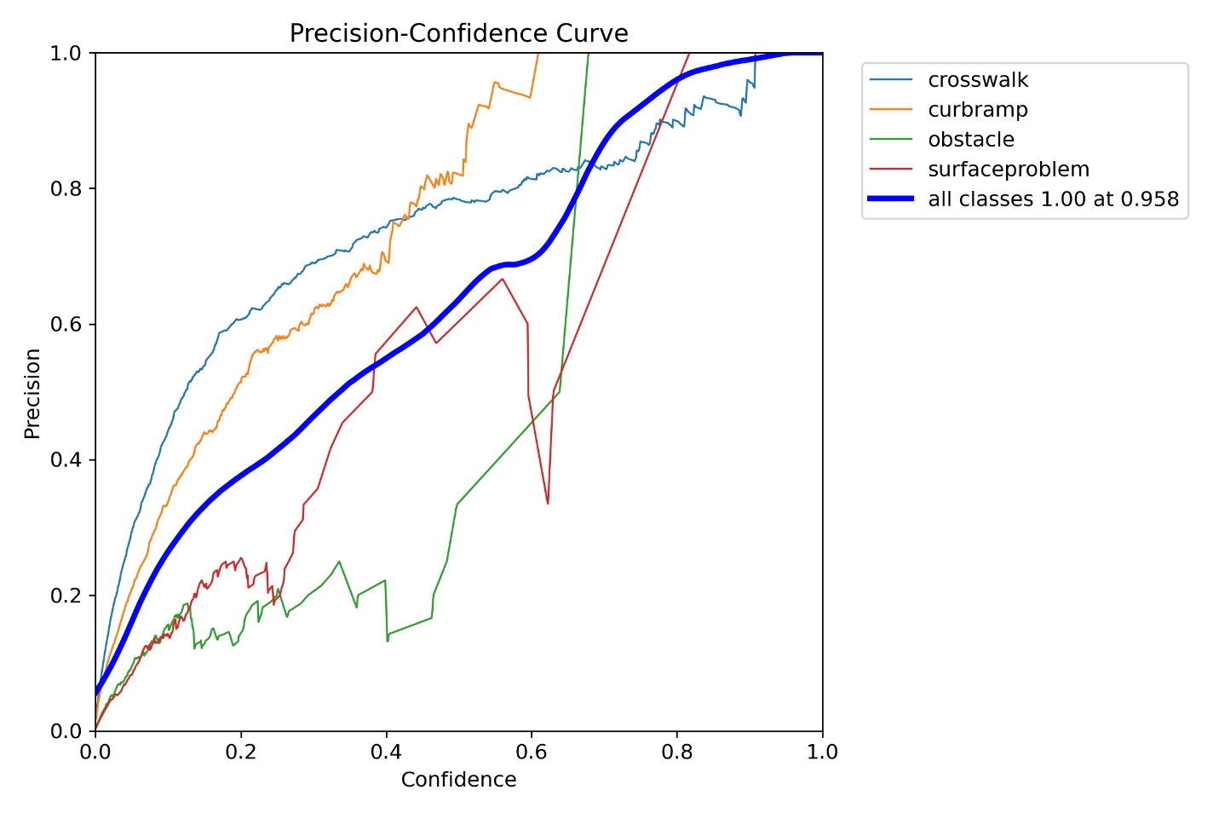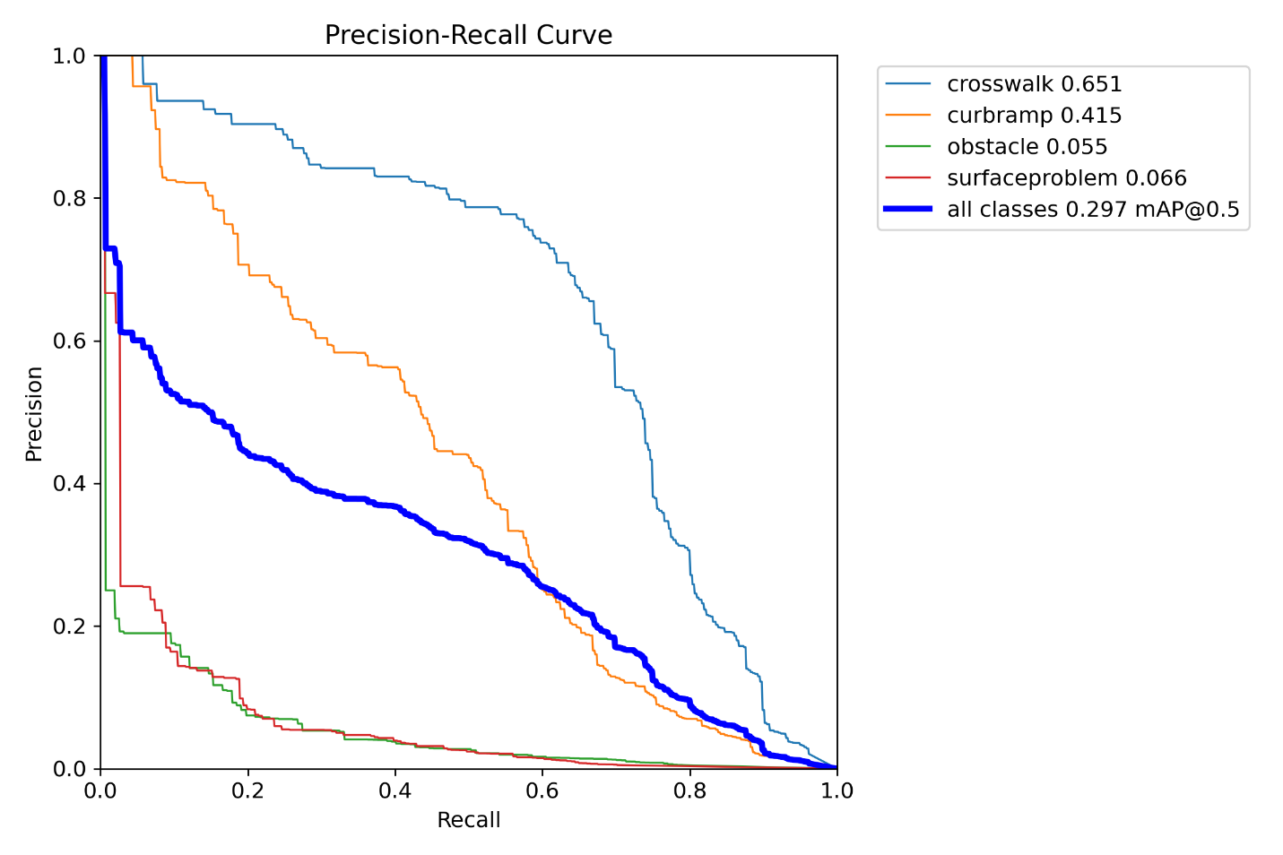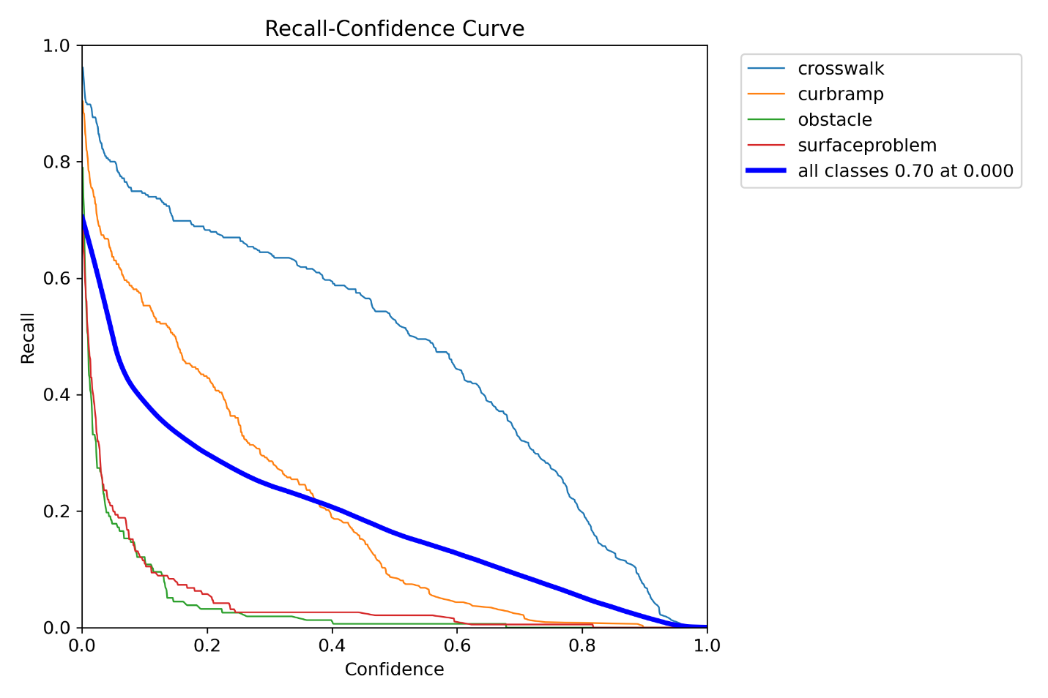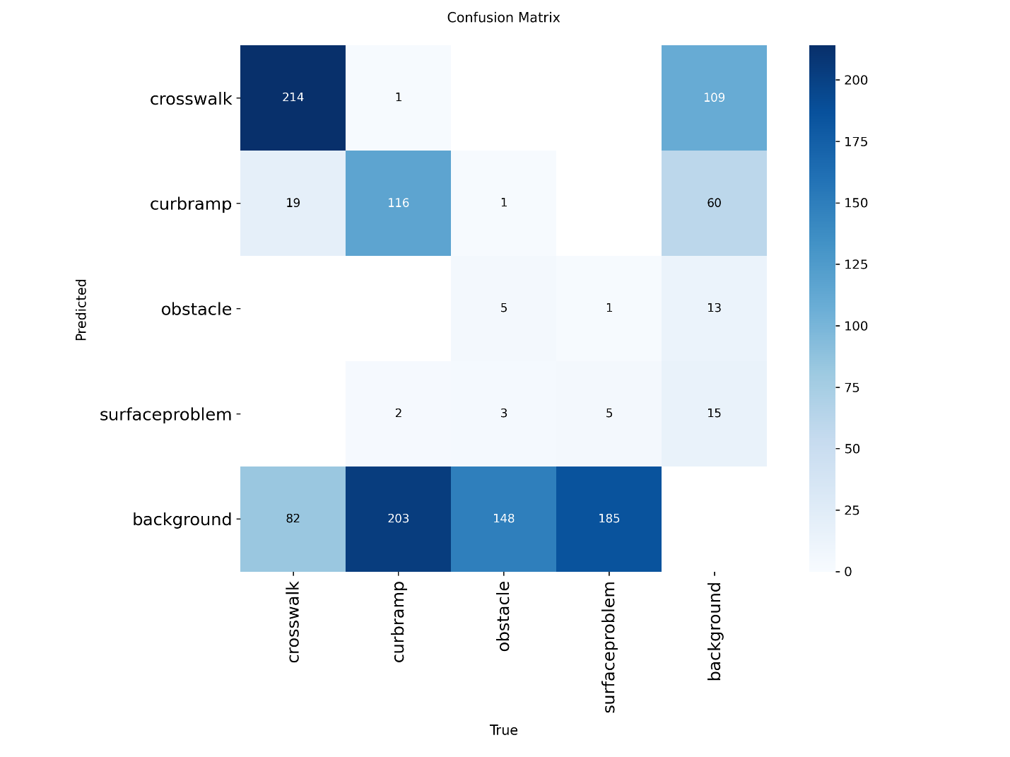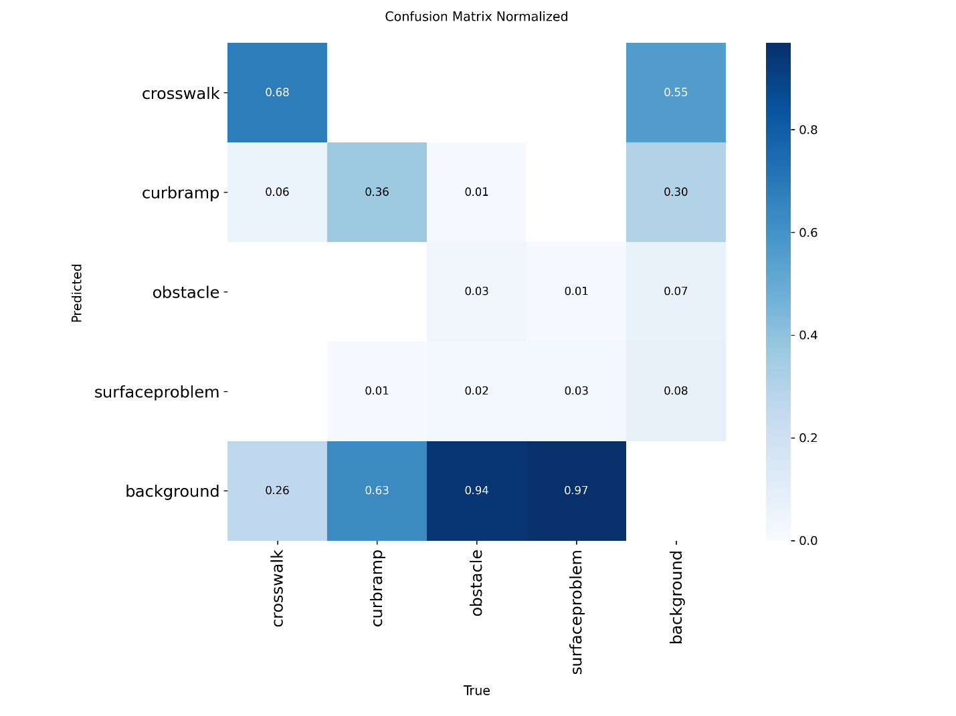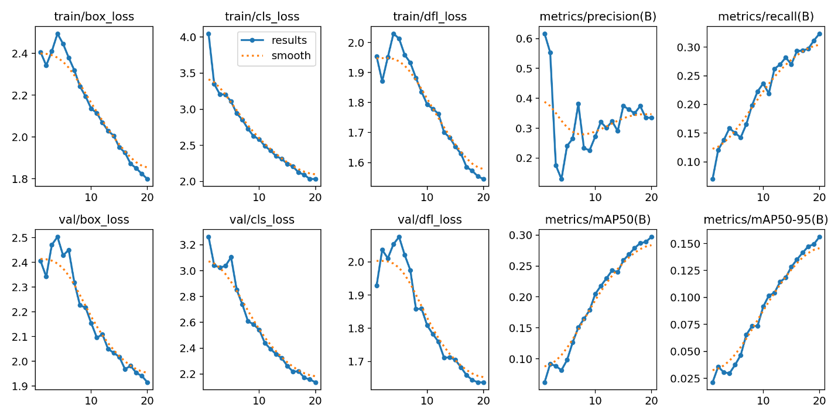
Part 3
The best model is exp 2. Using that model I will run predictions. 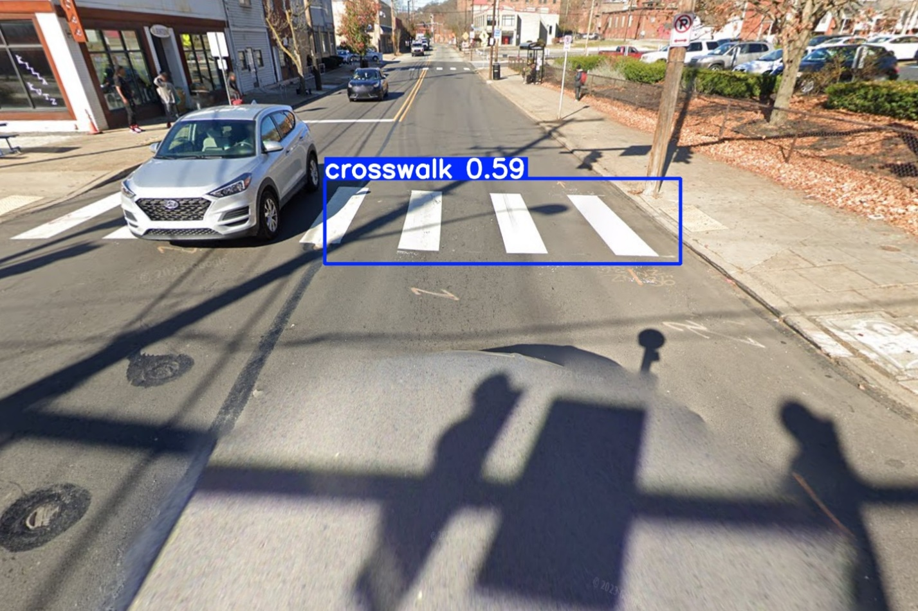
The image above shows that the model us able to detect sidewalks quite well. It did miss the curb ramps. However, the fact that a part of a cross walk being cut off by a car doesn’t hinder the model from detecting the sidewalk is impressive.
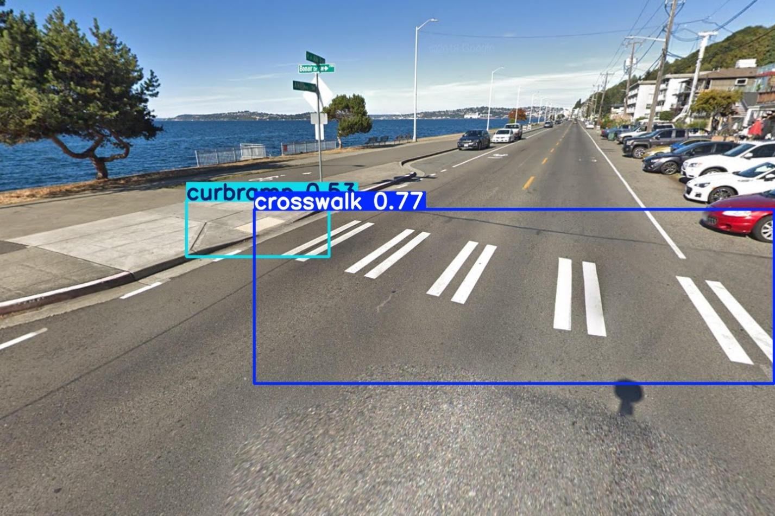
This image above shows the model successfully detecting a sidewak and curb ramp with high confidence and being correct showing that the model can identify those two categories quite well in images.
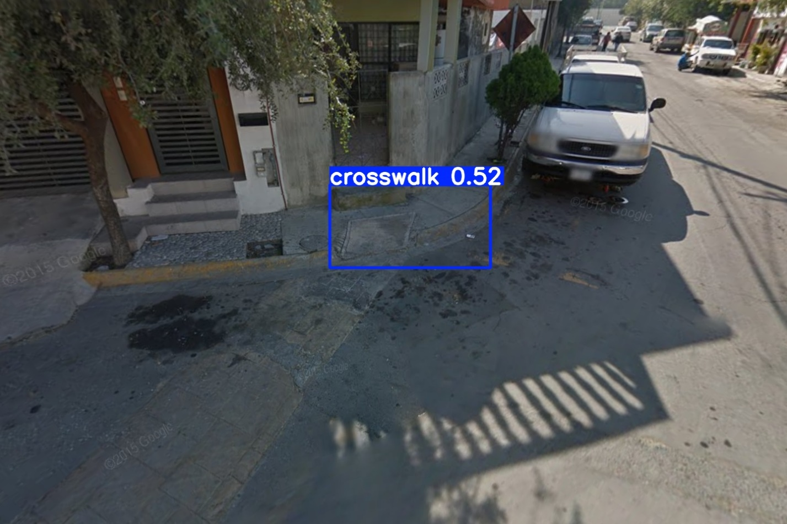
The model shows weakness in the image above as it identifies a curb ramp as a cross walk despite there being no white paint or white stripes showing. This shows a weakness in the model also confidently misclassifying curbramps as cross walks.
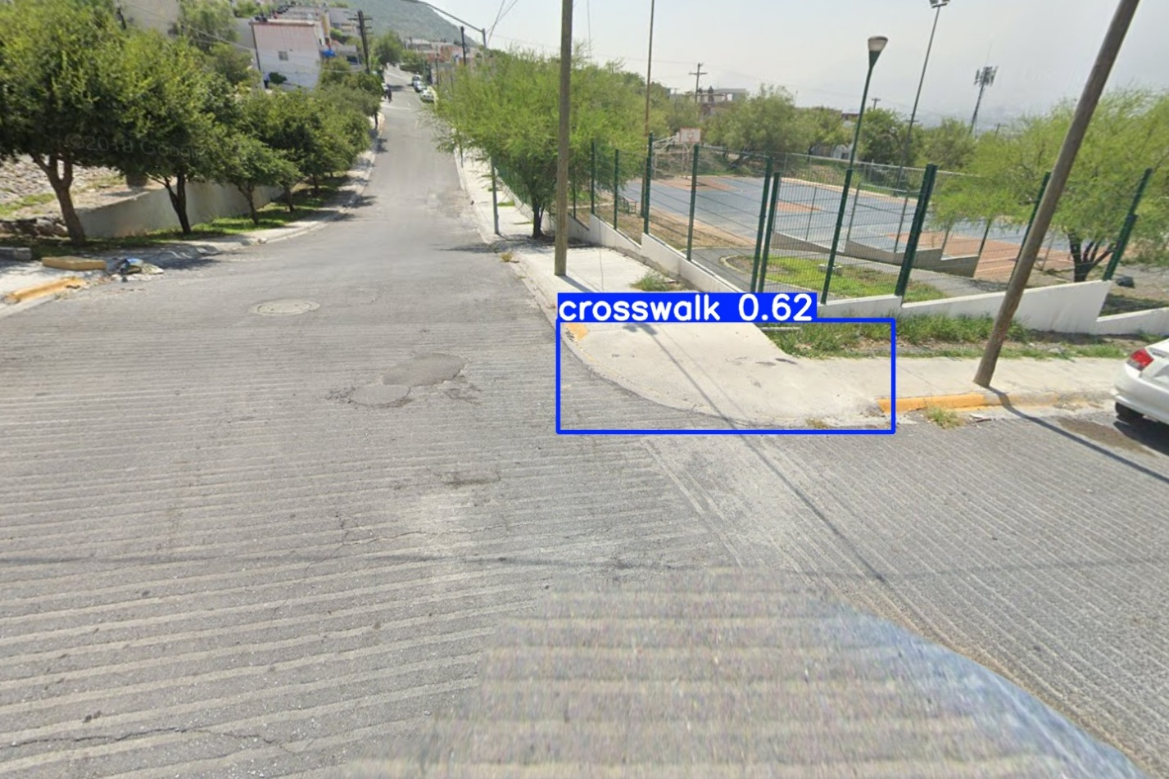
This image above is another piece of evidence that the model sometimes confidently misidentifies curb ramps as crosswalks. There is no signs of a crosswalk or anything mimicking a side walk, so whatever caused is misclassification is unclear but worrying.
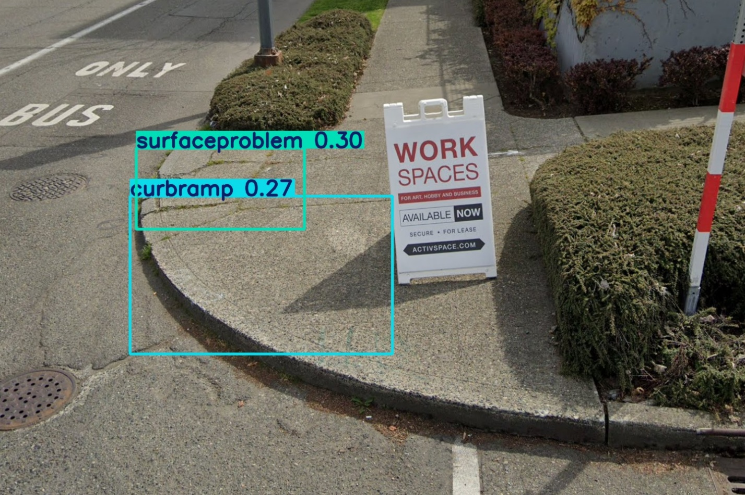
Now this is an interesting edge case shown in the image above. This is in fact a curb rampe and there are in facts cracks on the surface so it is right there is a surface problem. Two things that are in fact present in the image. Problem is it has low confidence. But it does acknowledge both and show them to the screen. Unfortunately, its low confidence means in edge cases it show what it thinks but also shows its unsure.

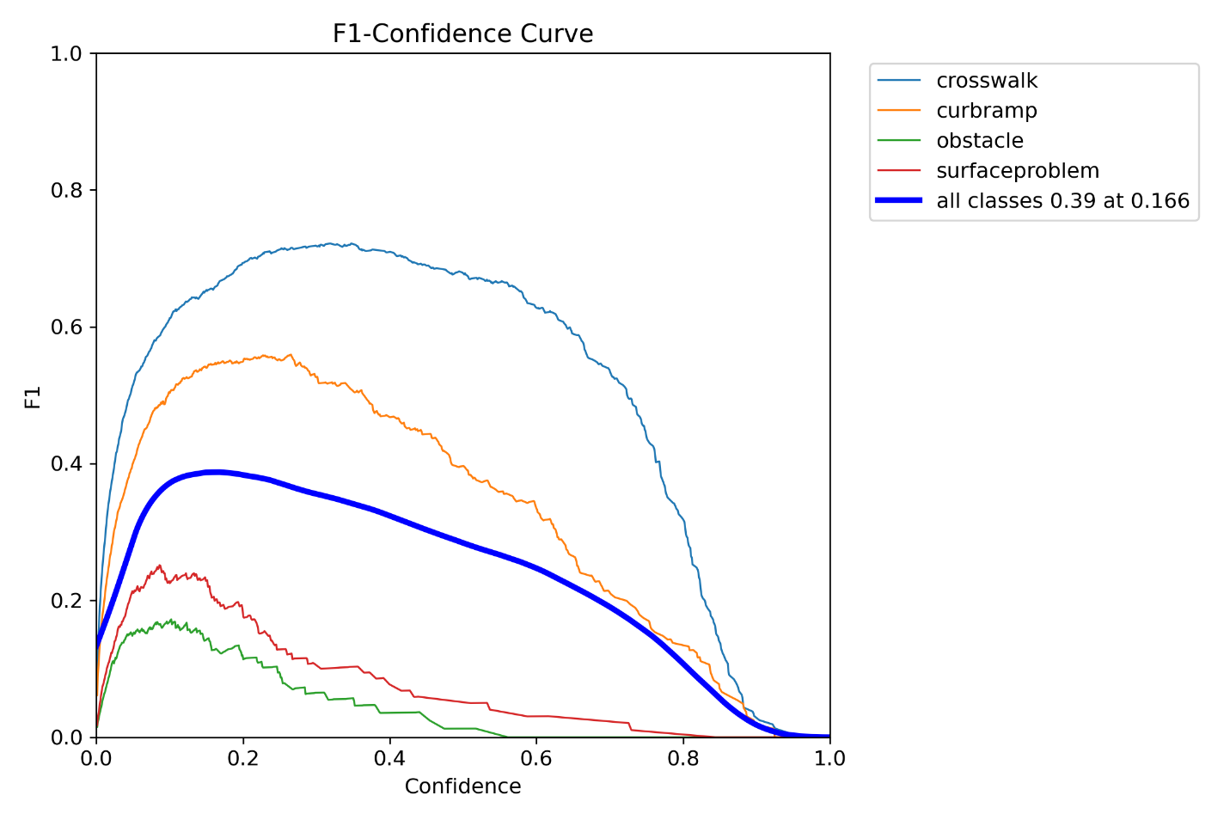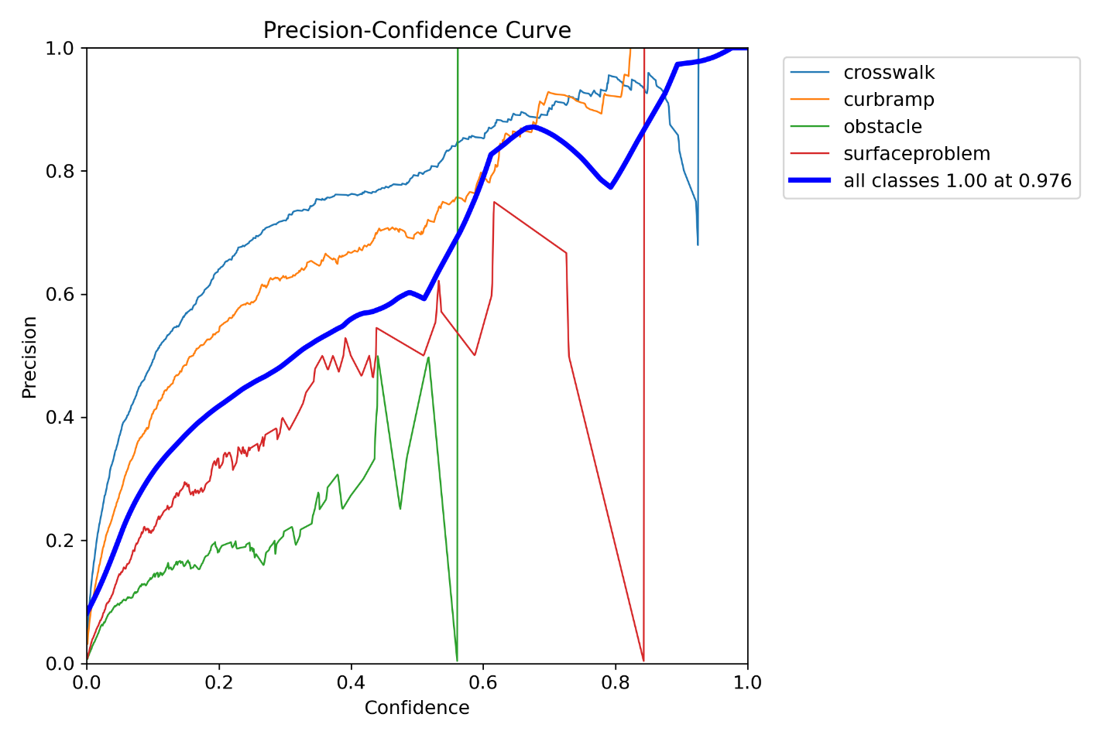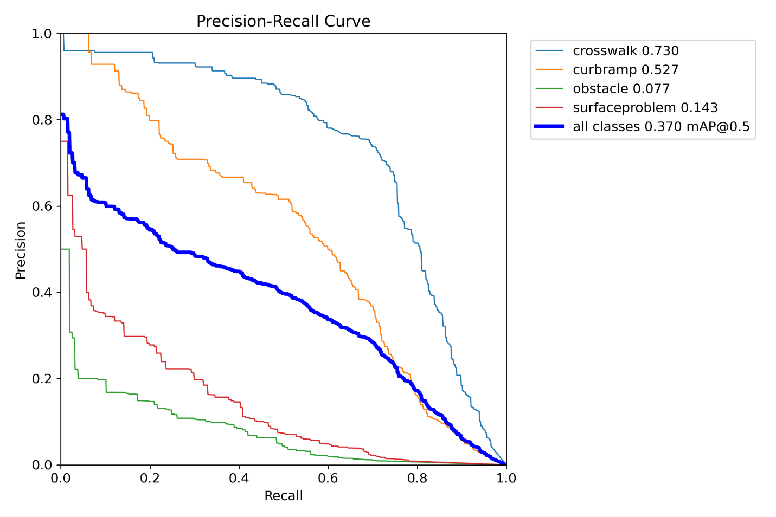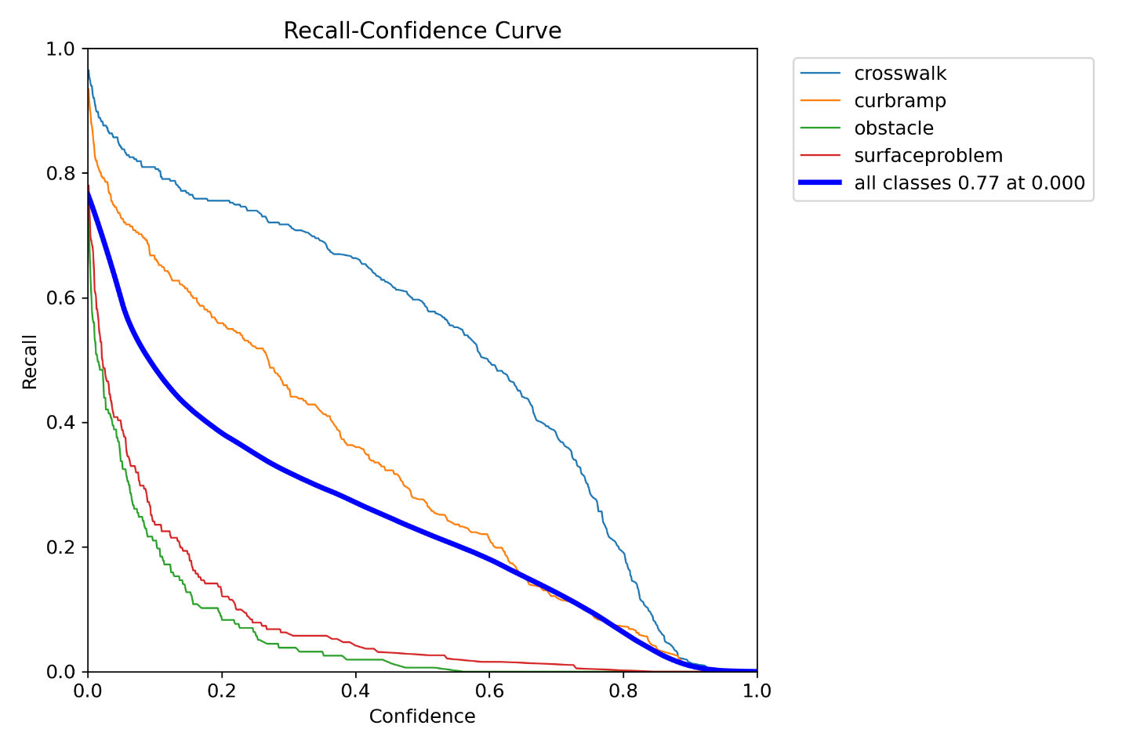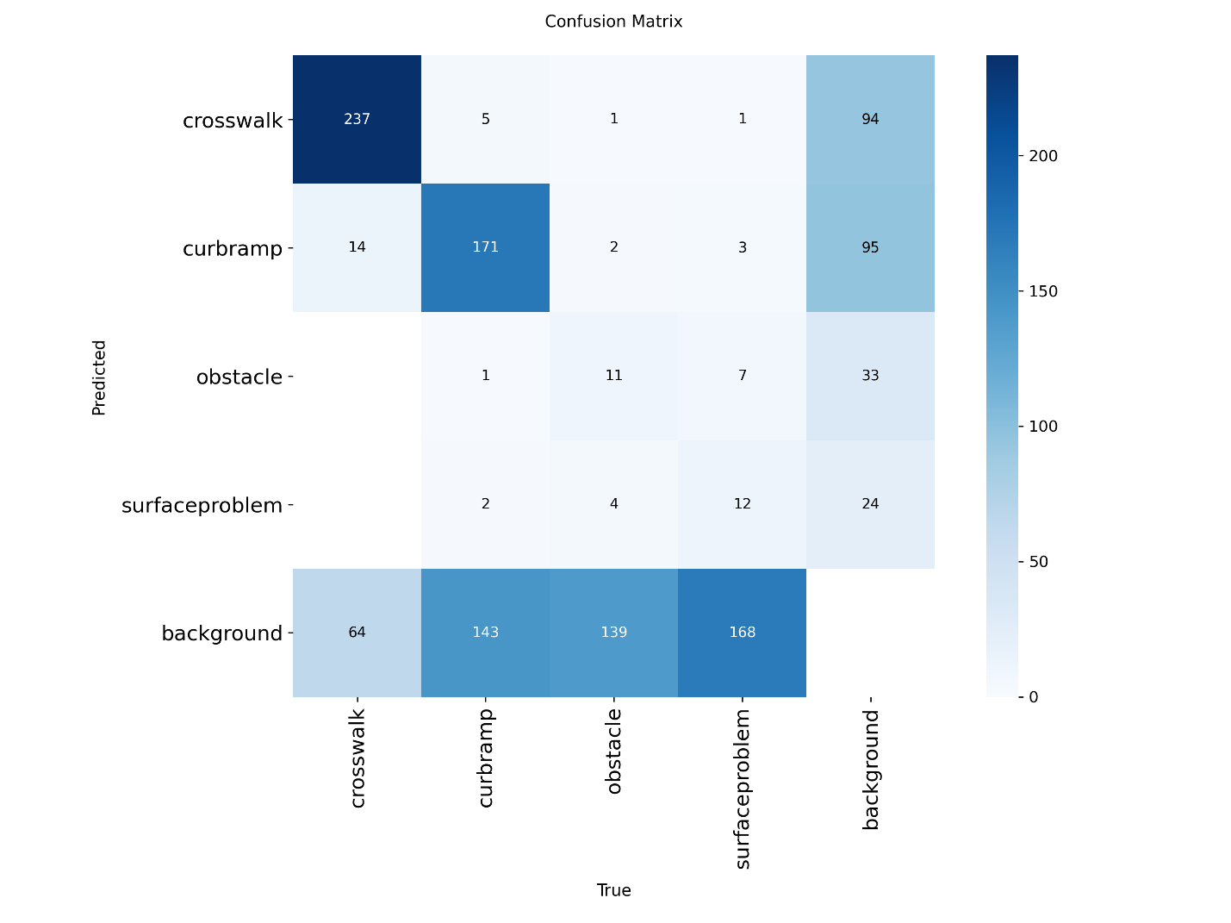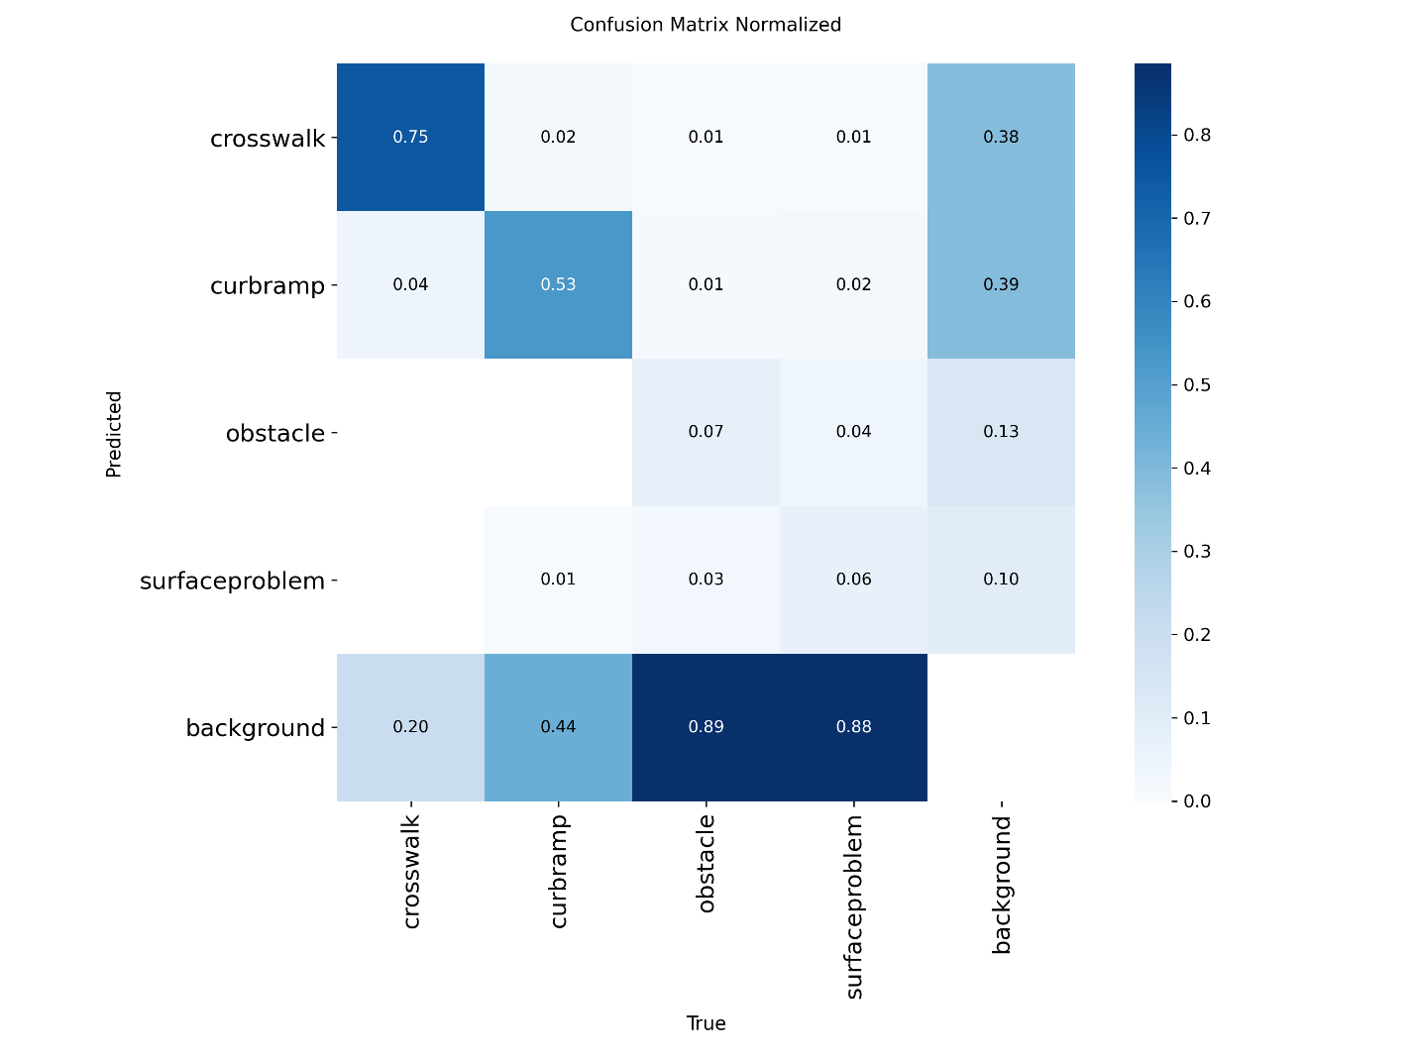
Test set performance summary table
Metric | Value
Precision | 0.384
Recall | 0.402
mAP50 | 0.370
mAP50-95 | 0.201
Images | 512
Instances | 985

Per class performance analysis
Looking through the images and reading the printed data printed after running predict.py. For crosswalks the model has a high precision of 0.589, highest recall of 0.759, mAP50 of 0.730, and mAP50-95 of 0.466. This is likely because of the fact that sidewalks are intended by design to be easily identifiable and recognizable. So it made annotating easy to mark it and study to identify its pattern leading to this being the highest performing class. Also sidewalks are practically almost the exact same in every country so that helps with identifying it.
The next best class is curbramp. The precision is 0.512, and the recall is 0.590. The mAP50-95 is a moderate 0.258. The reason for a lower score but better score than obstacle and surface problem is likely because curb ramps are standardizaed but the data including curbramps in a heavily deteriorated state and bad design from countries outside the USA means that identifying curbramps is slightly harder than crosswalks, but because of it being somewhat standardized it is easier to identify.
The second weakest class is surface problem. It had quite a low precision of 0.279, and recall of 0.152. It has a mAP50-95 of 0.051. Th cause of this is likely that the question of what amount of cracks in a surface makes it worth classifying a surface problem, and finding one is not standardized. Surface problems also come in different shapes and sizes. These two facts create uncertainity when annotating the data and tis leads to the model being uncertain when there is a surface problem and when there is not.
The worst performing class of all is obstacle.It scored the scareily low precision of 0.157, recall of 0.105, and mAP50-95 of 0.028. I would say the cause for this is the differences in how people label an obstacle. Only circle th obstacle? Or the sidewalk included with the obstacle. This misabeling by different people created this issue. As the model is unclear what constitutes a blockage and what doesn’t. This is also a real world problem leaking in. Sure a trash bin in the middle of a sidewak is an obstacle. But what about a lampopost that just happens to be beuilt in a manner it disrupts the sidewalk? It is part of the street so would it constitute a obstacle? After all none says a lamp post is an obstacle, but movable objects are considered obstacles. Is the objct itself an obstacle or its action on the sidewalk constitute an obstacle? Which is it? This unclear defitnition on the people who annotated the data was put into the model causing it to get a low score.
The trend is clear. The more strandardized, and easily identifiable something is the higher the score is. Cross walks and curbramps are standardized. On the other hand the opposite is true. The less standaedized and the hard to identify something is the low the idniification score is. What constitutes a surface problem? Is there a well defined definition? What constitutes an obstacle and what constitutes just a small negligible issue on a sidewalk that can be ignored? That is a gray area causing the low identification score beause it is unclear.

The strengths of the model is it can identify crosswalks and curb ramps with no issue. The problem is that it suffers when trying to identify the surface problems and curb ramps. I already explained above what is causing the strengths and weaknesses and I unfortunately have to repeat myself. The cause for the strangths in this model is thw good labeling of curb ramps and cross walks by the students like me. Which is directly the result of the fact that curb ramps and cross walks are made to be visually identifiable so that people can see them and know what they are for. This leads to the students labeling the data being able to label them well leading to the model to score so high in identifying those two classes In images. All a direct result of the nature of cross walks and curb ramps themselves.
On the other hand obstacle and surface problems are the opposite and it is no surprise that they scored low and become the wakness of the model in opposite of the models strength of identifying cross walks and curb ramps. To a human they might brush off certain surface issues either because they don’t seem to be a big problem, or because they don’t notice them. Most people won’t recognize the importance of small surface problems because they are not blind or wheel chair bound. But a blind person or a wheel chair bound person would. So this reults in the humans labeling the data not having the experience of the risk of surface problem for a person with mobility or vision issues not priotiriting the small surface problems unless they are big or noticeable enough in their shape and design. This results in ixed labeling sf some surface problem being label and some potentially not becaue the labeler just decided it isn’t big enough to be an issue or just didn’t notice even if it would mean the model ends up becoming less certain what constitutes a surface problem because it lacks proper data explain to it what it is. This causes its low score. Now the obstacle, the achille’s heel of thi model.
Why is the model is bad at identifying obstacle? So bad that it scored the lowest on it? Because of the unclear definition of what would constitue an obstacle when you label it. Sure when a trash bin or a car is directly on a sidewalk and so pushed into it that a person walking on the sidewalk who may even be blind would be drastically endgared should be considered a obstacle. But what about plant growing so much it leaks into the sidewalk? Would that constitute a obstacle? Afterall a blind person or a wheel chair bound individual can just walk over it with minimal issues. What about sidewalks from countries so badly designed that a lamp post which would constitute a obstacle. Would you even mark it because its unclear if it would even be used near that point because it sees there is a curb ramp just before it? But an blind person could end up hitting it accidentally from a turn just after getting of the sidewalk and onto the road via the curb ramp. That is the problem. There are several different types of obstacles. Some can be argued as extremely dangerous and some so little of a danger it can be lleft unlabeled. But the grey area of what it is makes it hard to defie leading to the model being unclear and uncertain just like the humans who labeled the data. After all the model is only as good as the data it is fed leading to it being as bad as it is because it is showing the how the humans who trained it see obstacles them selves.

Part 4
https://youtu.be/CeUJ9-gnrp0
 | Success | Fail
Curb ramp | 12 | 23
Crosswalk | 1 | 22
Obstacle | 0 | 1
Surface problem | 1 | 4
Above is the performance analysis table. The failure is the numer of times I found it misidentify something and mislabel something as soething else. The success is the total number of times something is labeled correctly.
My analysis of this is that the model did not generalize my neighborhood well. Look at the table aboce and watch the video. For the life of me I do not know why but it starts randomly labeling several curb ramps and random things as sidewalks. Wh? Maybe because some student drew the label for sidewalks too ig and cincluded uncessasary details? That is my best guess. It starts condering random things to be the sidewalk. Last but not least it completely missed several surface problems and only sucesfully detected one singular one. There was also a very easy simple example of a obstacle that it straight up missed. A big trash bin on the sidewalk that is completely blocking you unless you go around it. It missed it completely and did not label it as an obstacle at all which makes it worrying as it fails already in identify obstacles as mentioned earlier but it failing once again in real world data proves it truly is weak at finding obstacles.
The training data is either bad because the image is cut off, shows sidewalks and streets of completely different countries and not the us that have completely different standards for sidewalks, and have weird angles at times. Versus in the real world it would be in first person view and the sidewalks are more standardized.
I would say lighting and camera angles are the challenges encountered. The lighting might explain why it misidentified meaningless things that don’t even remotely look like a sidewalk as a sidewalk. Th camera angle also exacerbates the problem. The camera angles in the training data has several angles. But all a person has is a first person view of everything.
My recommendation for improving this model are two thigs. Firstly we need to redo this whole model training using only images of sidewalks and streets only of Evansville. I repeat images of streets and sidewalks only of Evansville. Using images of sidewalks and strees of other countries did not help the model. In fact I would go as far to say it made the model even worse. Because other counries will have compeletely different standards for sidewalks. So it would make the model confused on what to look at exactly unless it is taught only of Evansville sidewalk and street data, then it would better grasp the standards and the patterns it actually needs to look for and will be more confident and understand better. Lst but not least mak it so that people labeling the Evansville street and sidewalk data for themodel to train on, have clear and well defined definitions of what is a crosswalk, curbramp, surface problem, and obstacle! This way the images are labeled ina clearly defined and properly understood manner without little to no inconsistencies. Peventing the model from becoming confused and making it better understand what to look for exactly.

Part 5
Baseline

Exp 1

Exp 2

Exp 3

The baseline model shows moderate convergence but plateaus early. The loss curves flatten quickly, and the mAP50‑95 curve remains low throughout training. Precision and recall curves are also relatively weak. The confusion matrix shows many false negatives, especially for obstacle and surfaceproblem. This experiment serves as the reference point for evaluating improvements in later experiments.
Experiment 1 uses a lower learning rate and smaller batch size. The loss curves are smoother and more stable compared to the baseline. Precision, recall, and mAP curves all improve, indicating that the model benefits from the more conservative learning rate. The confusion matrix shows fewer missed detections and stronger diagonal values.
Experiment 2 shows the strongest performance across all visualizations. The loss curves converge quickly and stabilize without oscillation. Precision, recall, and mAP curves are the highest among all experiments. The PR and F1 curves show a good balance between precision and recall. The confusion matrix has the clearest diagonal, indicating strong per‑class performance.

These visualizations align with the validation and test metrics, confirming Experiment 2 as the best model.
Experiment 3 performs the worst among the tuned models. The high learning rate causes unstable and noisy loss curves. Precision, recall, and mAP curves are noticeably lower than in Experiments 1 and 2. The confusion matrix shows many false negatives and weaker diagonal values. This experiment highlights the negative The visualizations clearly show the effect of hyperparameter tuning:

Experiment 2 has the best curves and best overall performance. Experiment 1 improves over the baseline due to a lower learning rate. Experiment 3 underperforms because the learning rate was too high and training time too short. The visualization trends match the validation and test metrics, reinforcing the selection of Experiment 2 as the best model.impact of an overly aggressive learning rate and insufficient training time.
I admit to using AI to improve my writing of description and interpreting the graphs. As for improving the model I have to say. Use a lower learning rate. The smoother curves in Exp 1 and Exp 2 show that the model learns more reliably when the LR isn’t too aggressive. Train for more epochs. Exp 2 performed well even with fewer epochs, but the curves suggest the model hadn’t fully converged. More training time would likely boost mAP. Increase model size. YOLOv8n is very lightweight. A medium or large model would handle small objects and subtle classes better.
Improve class balance. The confusion matrices show weak performance on obstacle and surfaceproblem. Adding more examples of these classes would help.
Use stronger augmentation. The model struggles with lighting changes and small features. Augmentations like brightness shifts, blur, and random crops would improve robustness.
Increase image size. Higher‑resolution training would help detect small or low‑contrast objects that the current model misses.

