# Remote Program Control Demo Application

The Image below shows the example application and the various fields that are available as well as what they are used for. 1

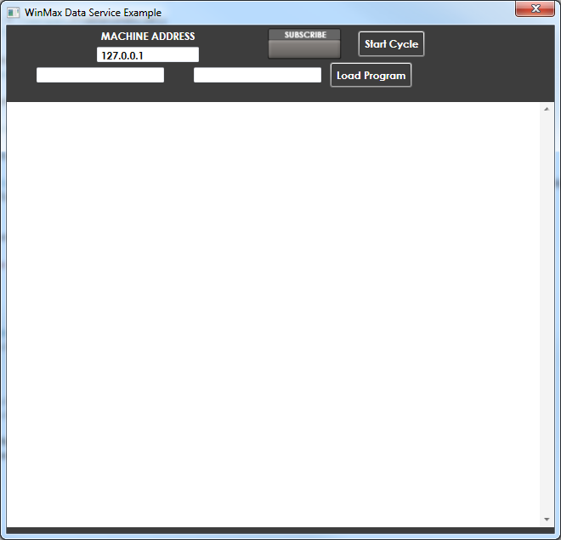

Start Cycle Button

Connects to Machine

Loads Program A

Path Program B

Path Program A

1. Enter machine address in place of “127.0.0.1”, unless running on control.
2. Enter path to Program A 2
3. Enter path to Program B 2
4. Click “Subscribe Button”
   1. Wait for connection
5. Click “Load Program” to initiate loading and running of Program A
6. If Program does not start immediately click “Start Cycle” to start it.

The Next Image is an example of the fields filled in as described above. The control will initially load and Execute Circle.hwm followed by Frame.hwm. After Frame.hwm is complete it will then load and run Circle.hwm again unless a new program path has been entered for program A. Following this it will repeat, loading and running program A, B, A, B until the demo application has been exited.

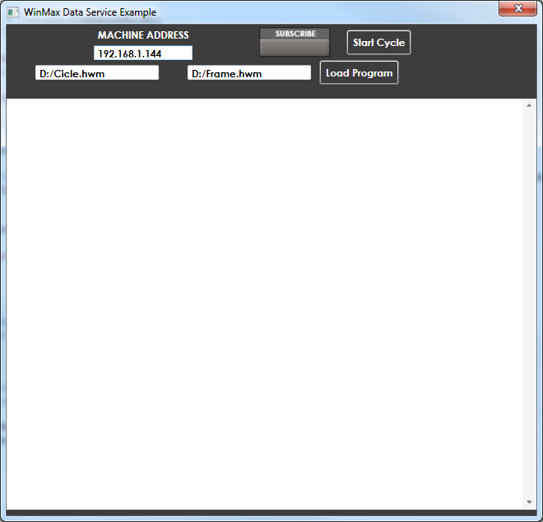

Notes:

1. The application is provided in source form without a VendorID or password you will need to enter your appropriate information and build the application.
2. These paths are relative to the control so you need to know the drive letter and path that the control can locate the files at