Figure S1. Gastrocnemius (GASTROC) weight following prevention and intervention study paradigms. (A, C) Total GASTROC weight and (B, D) GASTROC weight normalized to body weight were measured at study termination (26 wks of age) for both (A, B) prevention and (C, D) intervention study paradigms. Data represent mean ± std dev with each dot representing an individual animal. One-way ANOVA with Tukey’s post hoc test. *p<0.05, **p<0.01, ***p<0.001, ****p<0.0001. SD, standard diet; HFD, high-fat diet; KD, ketogenic diet; SDI, standard low-fat diet intervention; KDI, KD intervention; EXI, exercise intervention; KDI-EXI, combined KDI and EXI.

Figure S2. Energy expenditure and metabolism in prevention and intervention study paradigms. (A, C) Energy expenditure (EE) and (B, D) respiratory exchange ratio (RER) were measured in the (A, B) prevention and (C, D) intervention study paradigms over 48 hrs at 22 wks of age. Data represent mean ± std dev. One-way ANOVA with Tukey’s post hoc test. *p<0.05, **p<0.01, ***p<0.001, ****p<0.0001. SD, standard diet; HFD, high-fat diet; KD, ketogenic diet; SDI, standard low-fat diet intervention; KDI, KD intervention; EXI, exercise intervention; KDI-EXI, combined KDI and EXI.

Figure S3. Energy metabolism in the prevention study paradigm. (A) CO₂ production (VCO₂), (B) O₂ consumption (VO₂), (C) fat oxidation, and (D) glucose oxidation were measured over 48 hrs at 22 wks of age. Data represent mean ± std dev. SD, standard diet; HFD, high-fat diet; KD, ketogenic diet.

Figure S4. Liver pathology following prevention and intervention study paradigms. Histological evaluations including (A, E) steatosis scoring, (B, F) lobular inflammation scoring, (C, G) Non-alcoholic fatty liver disease (NAFLD) activity scoring (NAS), and (D, H) quantification of the number of fat droplets per tissue area, were performed at study termination (26 wks of age) for both prevention (A-D) and intervention (E-H) study paradigms. Data represent mean ± std dev with each dot representing an individual animal. One-way ANOVA with Tukey’s post hoc test. *p<0.05, **p<0.01, ***p<0.001. SD, standard diet; HFD, high-fat diet; KD, ketogenic diet; SDI, standard low-fat diet intervention; KDI, KD intervention; EXI, exercise intervention; KDI-EXI, combined KDI and EXI.

Figure S5. A high-fat diet (HFD) impairs nerve function. Baseline (A) motor and (B) sensory nerve conduction velocities (NCV) were measured at 18 wks of age. Data represent mean ± std dev with each dot representing an individual animal. One-way ANOVA with Tukey’s post hoc test. ****p<0.0001. SD, standard diet; KD, ketogenic diet.

Figure S6. Energy metabolism in the intervention study paradigm. (A) CO₂ production (VCO₂), (B) O₂ consumption (VO₂), (C) fat oxidation, and (D) glucose oxidation were measured over 48 hrs at 22 wks of age. Data represent mean ± std dev. SD, standard diet; HFD, high-fat diet; SDI, standard low-fat diet intervention; KDI, ketogenic diet intervention; EXI, exercise intervention; KDI-EXI, combined KDI and EXI.

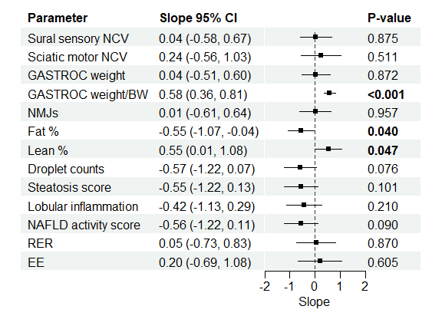
Figure S7. Impact of exercise adjusted for diet. Regression analysis of the impact of exercise (EX) on metabolic and peripheral neuropathy parameters adjusted for diet (high-fat diet [HFD] or ketogenic diet [KD]). Groups included mice granted access to a running wheel while maintained on a HFD (EXI) and mice granted access to a running wheel and placed on a KD (KDI-EXI).

Figure S8. Principal component analysis (PCA). PCA of transcriptomic profiles in (A) sciatic nerve (SCN) and (B) gastrocnemius (GASTROC) muscle for standard diet (SD), high-fat diet (HFD), ketogenic diet (KD), standard low-fat diet intervention (SDI), KD intervention (KDI), exercise intervention (EXI), and combined KDI and EXI (KDI-EXI) groups. Ellipses represent 95% confidence region.

Figure S9. Differentially expressed genes (DEGs) from the sciatic nerve (SCN) and gastrocnemius (GASTROC) muscle correlate with metabolic and neuropathy parameters. Spearman correlation analysis of (A) SCN and (B) GASTROC DEGs to metabolic and neuropathy parameters. Positive correlations are represented in red and negative correlations in blue. Significance was set at p<0.01. Insignificant correlations are gray. Plots present the top 25 statistically significant comparisons. BW, body weight; IENFD, intraepidermal nerve fiber densities; NCV, nerve conduction velocities; NMJ, neuromuscular junctions.

Figure S10. R-β-hydroxybutyrate (R-βHB) prevents palmitate (Palm)-induced reduction in ATP production in vitro. (A) Treatment timeline. Rat primary embryonic dorsal root ganglia (DRG) neurons were treated with either BSA, 0.5 mM R-βHB, or 62.5 µM Palm for 24 hrs or 0.5 mM R-βHB for 24 hrs and then switched to fresh media containing 62.5 µM Palm for 1.5 hrs. (B) ATP levels in DRG neurons (n = 7) treated with R-βHB and/or palmitate. Data represent mean ± std dev. One-way ANOVA with Tukey’s post hoc test. *p<0.05.

