A Comprehensive Analysis of Reaction Kinetics in Intracellular Environments with Macromolecular Crowding: Modified Fractal-like and Phenomenological Equation with Simulation Data

Junguk Hur¹⁾
1) School of Informatics, Indiana University Bloomington, 901 E. 10th St, Bloomington, IN 47404, USA ; Email: juhur@indiana.edu

Abstract
The kinetics of biochemical reactions in the cytoplasm do not follow the classical law of mass action due to the macromolecular crowding which take up to 40% of the intracellular volume. In order to solve the kinetics in the intracellular environment (in vivo), modified fractal-like kinetics has been proposed and validated by using lattice gas automata simulated data. In this paper, the modified fractal-like kinetic equation has been further analyzed with respect to each parameter in the equation. The meanings of each parameter were further confirmed by the simulated data but there still remain a few unclear relationships between parameters. Besides the equation, a new phenomenological equation, which is time-independent, has been tested by using a fitting script on the simulated data. These fitted data were also analyzed for the relationships with other parameters. However the amount of data was little and the fitting equation had a huge dependency on the initial values of the parameters when fitting. Thus it may not correctly model the current intracellular system and more simulated data is needed for further analysis.

- Introduction
In the fields of biology, especially biochemistry, a lot of biochemical properties of proteins, chemicals, and other biological molecules are mostly studied in vitro environment which has a great difference from the real world cytoplasmic environment. Hall and Minton (2003) characterized intracellular environments as a high total macromolecular content, simply known as macromolecular crowding. While the total macromolecular concentration is usually 1-10mg/ml in test tube conditions, it can be 50-400 mg/ml which may take up to 40% of the total cellular volume (Fulton, 1982; Lanni et al., 1985; Cayley et al., 1991). Macromolecular crowding is known to affect many aspects of the cell such as the thermodynamics, diffusion processes, phase separation, enhancement of protein association, and etc.
Kopelman (1986) has discovered that chemical reactions occurring in heterogeneous media, where reactants are spatially constrained on the microscopic levels, follow a fractal-like kinetics. He also proposed a new phenomenological description of non-homogeneous reaction dynamics called fractal-like kinetics. The rate coefficient k(t) is time-dependent where k_{o} is the initial rate coefficient and h is explained as a measure of the dimensionality of the system, which is often called “fractal parameter”.
Schnell et al (2004) have reviewed the evidences illustrating the fundamental differences between test tube (in vitro) and cytoplasmic (in vivo) biochemical kinetics and thermodynamics, and showing the breakdown of the law of mass action and power-law approximation in in vivo environment. From the Michalis-Menten reaction (Eq.2), they presented a modification (Eq.3) to fractal-like kinetics following the Zipf-Mandelbrot distribution (Zipf, 1949; Mandelbrot, 1982) which enables the modeling and analysis of biochemical reactions occurring in macromolecule crowded intracellular environments. The interpretation of the parameters involves renormalization group theory. The parameter 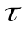can be explained physically as the critical time point from which the rate coefficients will be affected by the macromolecular crowding.
In this paper, the lattice gas automata simulation data from Schnell et al is analyzed for the Michalis-Menten reaction (Eq.2). Each parameter is assessed how they can be affected by the four environmental parameters; f (probability of forming complex[C] when substrate[S] and enzyme [E] interact), E (the concentration of enzyme), S (the concentration of substrate), 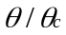 (obstacle density).
Another phenomenological equation (Eq.4) is analyzed for the simulated data of k₁ and [S] for each time point. These fitted equation are further analyzed according to the f, E, S and .

- Materials and Methods
  - Materials
Simulated data and the initial condition data were obtained from Schnell (2004) on the Michalis-Menten reaction and were used for analyses of relationship between parameters. Lattice gas automata simulation data was also provided for fitting equation (Eq.4).
  - Methods
    - Data analysis in the Excel
Graphs of relevant parameters were plotted together and the meaning of the parameters (, h, and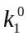) in accordance with the data were analyzed. This was done by selecting data in which one parameter varied while others remained constant.
    - Fitting parameters with MATLAB
A MATLAB script which implemented a non-linear square fitting algorithm was used for the data curve fitting to get values of equation (Eq.4). It should be noted that curve fitting results vary depending on the initial values of each parameter. In some cases, imaginary numbers are returned as fitting results. In order to avoid these imaginary number, the initial values for the [α, S₀, h] were set to [10, 1000, 0.5] that were confirmed to give real numbers after empirical searches. After curve fittings were completed, relation analyses same as section 2.2.1 were applied to the fitted data.

- Results
  - Modified Fractal-like Kinetic Equation
    - Effects of 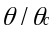 on , h, and
At f=1, E=0.01, and S=0.1, 26 data were available for varying . Even though there is a slightly increasing tendency of along with increasing , seems to be unrelated to in Fig.1a. By the definition of, it should be a constant value since it is the rate coefficient for ideal (homogeneous) solutions, where there is no obstacle.
From the Fig.1b and 1c, is linearly proportional to , while h is reversely related to . Fig.1b shows that decreases as increases. Schnell et al (2004) maintained that is physically understood as the critical time from which the rate coefficients will be driven by the effects of macromolecular crowding. The more obstacles exist in a solution, the earlier the rate coefficients may be affected by macromolecular crowding. As for the h, it increases as increases in Fig.1c. The h is understood as a measure of the dimensionality of the system, which is often called “fractal parameter”. As the increases, the heterogeneity of the reaction solution increase and thus h gets closer to 1.
    - Effects of substrate concentration [S] on , h , and
At f=1, E=0.01, = 0.859, 16 data were available for varying substrate concentration S. Fig.2a, b, c show the variance of , h, and respectively. Even though the scales of each graph are different, the overall patterns are strikingly similar to each other. Besides, the overall patterns imply that these parameters increase as the substrate concentration goes up, while the h can be said to rather constant.
Fig.3 shows a slightly different pattern from Fig.2a. In this Fig.3, data with same configuration were averaged. Even though there are too fee data points, the figure shows a tendency that the graph of gets flattened near S=0.1. This can be the case where the enzymes are saturated with substrates, thus there will not be an increase in the rate coefficient as the substrate concentrate is increased. The figure also shows there is not much increase from S=0.01 to S=0.02. This phenomenon can not be explained at the moment. Fig.2b indicates increases as the initial concentration of substrate increases. Since there are more available substrates around the enzymes in the cell, it will take more time for macromolecule crowding to take effect.
In case of h, it shows a very little increase along the substrate concentration. This may be explained by that newly produced products might be blocking the paths that substrates move in order to interact with enzymes, which results in increased heterogeneity or increased obstacles.
    - Effects of the probability f on , h , and
At E=0.01, S=0.1, =0.204, there were 15 data available for analysis of effects of probability f on the three parameters. One data at f=1 was removed due to it seemed to be an error point. Remaining data were used to calculate mean values of each parameter for given f values. Fig.4a shows that is linearly proportional to the f that is the probability of forming complex (C) when an enzyme and a substrate come in contact. If f gets higher (limit is 1), it means that E and S will more likely to produce C thus will increase the rate coefficient. Fig.4c shows that h increases along with the increasing f. This phenomenon may be derived from the fact that the higher f would reduce the amount of available substrate more quickly and produce more products of C, which cause the environment gets more heterogeneous in the macromolecular crowding. However Fig.4b can not be clearly explained.

  - Phenomenological Equation (Eq.4) Fitting
Initial values of [α, S₀, h] = [10, 1000, 0.5] were used in order to avoid imaginary numbers and these initial values enabled all the fittings of the 20 data sets to give the fitted values in real number. However it should be noted that the fitting itself is dependent much on the initial values meaning that the equation to be fitted might be not correct.
    - Effects of the given S₀ on the fitted α, S₀, and h
At f=1, E=0.01, =0.859, 5 data were available for varying substrate concentration S. Fig.5a, b shows that α and S₀ linearly increase as the given S₀ gets bigger. Fig.5c shows that h is independent of the concentration of substrate S. Fig.5d. shows what happens when the initial values of the parameters are changed. When α=1 is used, α of the fifth spot dramatically decreases.
    - Effect of on the fitted α, S₀, and h
At f=1, E=0.01, S=0.1, 5 data were available for varying. Fig.6a shows that α might be proportionally related (linearly) related to the. But the fourth spot (=0.8) seems to be an error or outlier. Its value dramatically changes as the initial values are changed (data not shown). Fig.6b implies that the fitted S₀ s are quite different from the original values that is S=0.1(1000). Except for the fifth spot (=1.0), the other fitted values are 20~35% greater than the original value. This also implies that the empirical equation might not be correct for modeling the intracellular reaction kinetics. From the Fig.6c, we can see that h shows a tendency to increase as the increases. This is in consistent with Section 3.1.1 where increased the fractal parameter h.
    - Effect of the probability f on the fitted α, S₀, and h
At E=0.01, S=0.1, =0.204, 10 data were available for varying f. They consist of duplicate data, which show quite close values to each other. In Fig.7a, the fitted α seems to be positively related to f. In Fig.7b, the fitted S₀s are quite different from the original values. But they don’t seem to have a clear tendency to increase as the f increases. Fig.7c shows that h has a tendency to increase as the f increases. This is same as in the Section 3.1.3 where the fractal parameter showed increment in the probability f.

- Discussion
The kinetics of biochemical reactions in the cytoplasm do not follow the classical law of mass action due to the macromolecular crowding which take up to 40% of the intracellular volume. This keeps reactants from freely diffusing and mixing. In order to solve the kinetics in the intracellular environment (in vivo), modified fractal-like kinetics has been proposed and validated by Schnell (2004) by using lattice gas automata simulated data. In this paper, the modified fractal-like kinetic equation (Eq.3) has been further analyzed with respect to each parameter in the equation. Furthermore, a new equation (Eq.4) has been tested by using MATLAB fitting script on the simulated data.
From the modified fractal-like kinetic equation (Eq.3), the meaning of and h could be further confirmed by plotting the fitted data against different initial parameters. In the Section 3.1, can be explained as the critical time point from which the rate coefficients will be driven by the effects of macromolecular crowding. Thus, the more such crowding exists in the cell, the smaller will be. On the other hand, h can imply the degree of heterogeneity. If h equals to 0, then it means the solution is completely homogeneous.
Even though most of the simulated results could be interpreted in the scope of the given parameters, some unexplainable phenomena were found. For example, in the Section 3.1.3, how increases along with the probability f could not be clearly understood. And in the Section 3.1.2, where the effects of substrate concentration was studied, it is not clear whether the enzymes are saturated around S=0.1. We need more data point to get better understanding how changes along with the S concentration.
For the Section 3.2, the phenomenological equation (Eq.4) fitting could be done with the initial values of the three parameters [α, S₀, h] = [10, 1000, 0.5]. As states in the section, it should be noted that the fitting itself is dependent greatly on the initial values. With different sets of initial values, one might get imaginary numbers sometimes. In fact, 13 out of 20 data sets resulted in imaginary numbers when the initially given values [α, S₀, h] = [1, 1000, 0.5] were used. This implies that the equation we are fitting may not represent the data well. If the equation models the system correctly, initial values are expected to have no or little influence on the fitted values.
From the real number results, α and h were found to be positively related to and to the probability f. h can be regarded as the fractal parameter and α may be regarded as a similar initial notion of in the equation (Eq.3). However, the fitted S₀ in both sections, S₀ are deviated from the original values.
Due to the limited number of data for fitting the equation (Eq.4), it can not be certainly concluded that this equation explains the intracellular kinetics well. Thus, more simulation data would be needed to give a better conclusion.

- Acknowledgements
I thank Dr. Santiago Schnell and Ms. Lalitha Viswanath for their continuous supports and in depth discussion.

- References
Cayley, S., Lewis, B.A., Guttman, H.J., Record, M.T., Jr, 1991. Characterization of the cytoplasm of Escherichia coli K-12 as a function of external osmolarity. Implications for protein-DNA interactions in vivo. Journal of Molecular Biology. 222, 281–300.
Fulton, A.B., 1982. How crowded is the cytoplasm? Cell 30, 345–347.
Hall, D., Minton, A.P., 2003. Macromolecular crowding: qualitative and semiquatitative successes, quantitative challenges. BBA-Protein Proteomics 1649, 127-139
Kopelman, R., 1986. Rate-processes on fractals—theory, simulations, and experiments. Journal of Statistical Physics. 42, 185–200.
Lanni, F., Waggoner, A.S., Taylor, D.L., 1985. Structural organization of interphase 3T3 fibroblasts studied by total internal reflection fluorescence microscopy. Journal of Cell Biology. 100, 1091–1102.
Mandelbrot, B.B., 1982. The Fractal Geometry of Nature. W.H. Freeman and Co., San Francisco, CA.
Schnell, S., Turnet, T.E., 2004. Reaction kinetics in intracellular environments with macromolecular crowding: simulations and rate laws. Progress in Biophysics and Molecular biology 85, 235-260.
Zipf, G.K., 1949. Human Behavior and the Principle of Least Effort. Addison-Wesley, Cambridge, MA.

- Appendix
(Eq.1) Time-dependent Fractal-like Kinetics of Kopelman
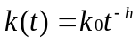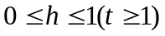
K_{o} : rate coefficient at t=0, h : fractal parameter
(Eq.2) Michalis-Menten reaction : Reversible reaction between an enzyme E and a substrate S, giving the enzyme-substrate complex C, which irreversibly yields product P
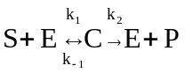
(Eq.3) Modified Fractal-like Kinetics: Zipf-Mandelbrot distribution
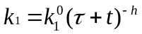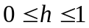
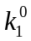: Initial rate coefficient, : Critical time delay of decaying k_{1,} h : fractal parameter
(Eq.4) Phenomenological equation
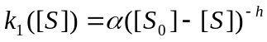
α : Positive constant S₀: Initial concentration of substrate, h : fractal parameter

- Figure Legends
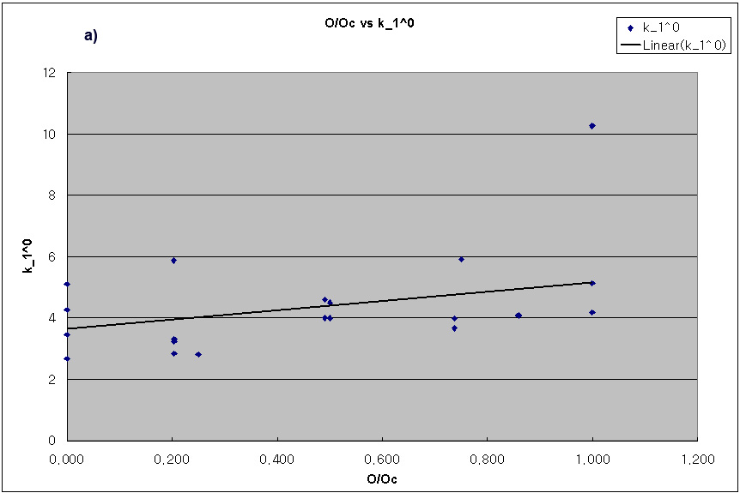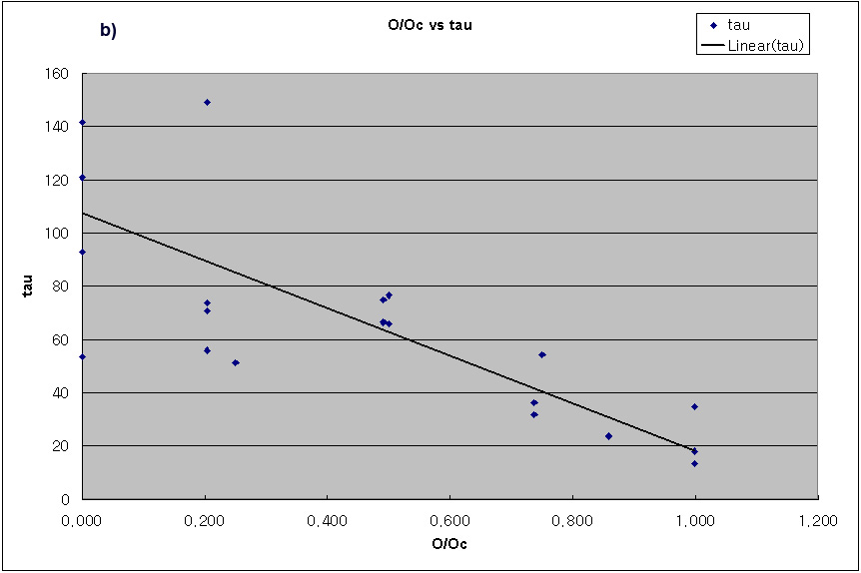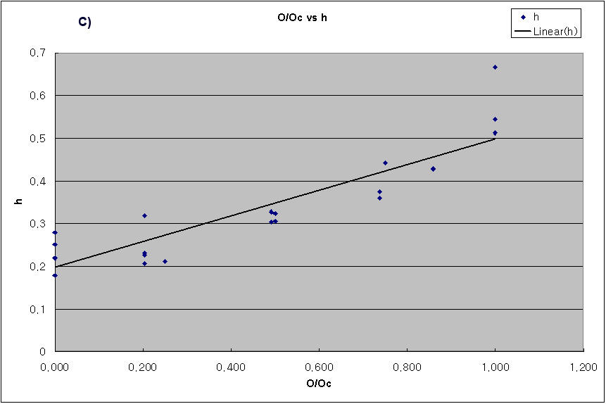
Fig.1 Effects of on , h, and
a) seems to be unrelated to . By definition, should be constant as it is the rate coefficient of time zero in homogeneous solution. b) decreases as increases. c) h increases as increases. b) and c) are well showing the effect in fractal-like kinetics.

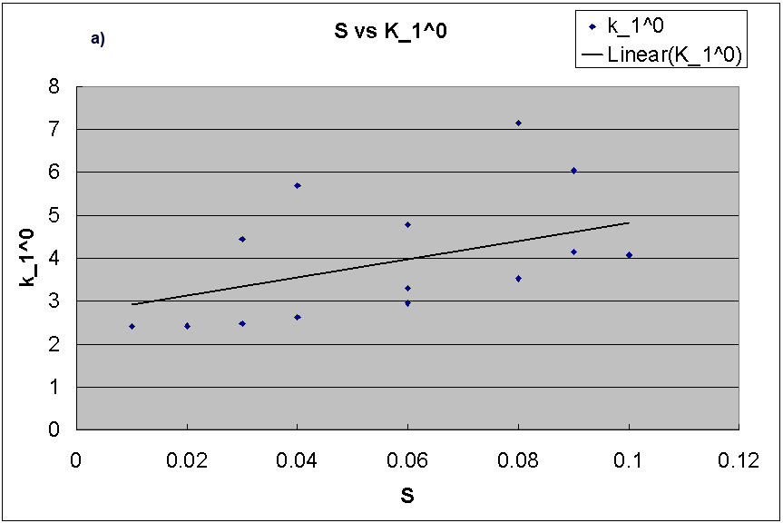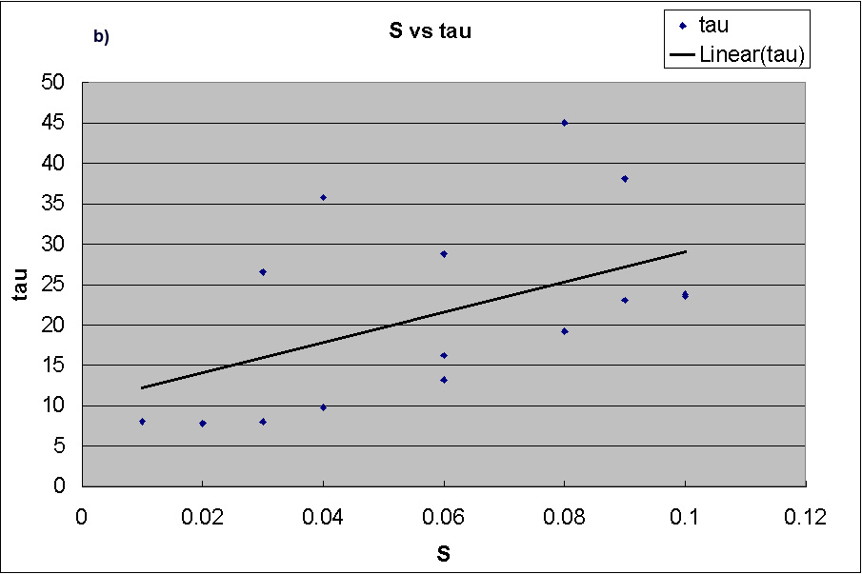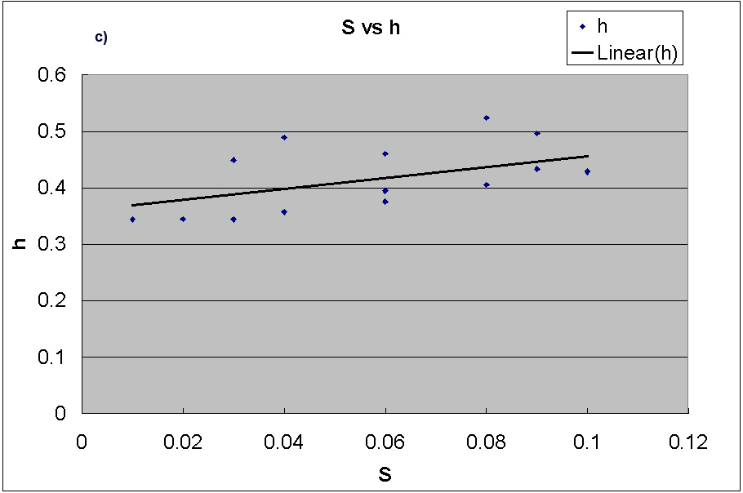
Fig.2 Effects of the concentration of substrate S on, h, and
Even though the scales of each graph are different, the spot patterns are strikingly similar to each other. Three parameters (, h, and ) seem to be increasing along with the increased concentration of substrate. a) increases along with S. b) increases along with S. c) h increases along with S.

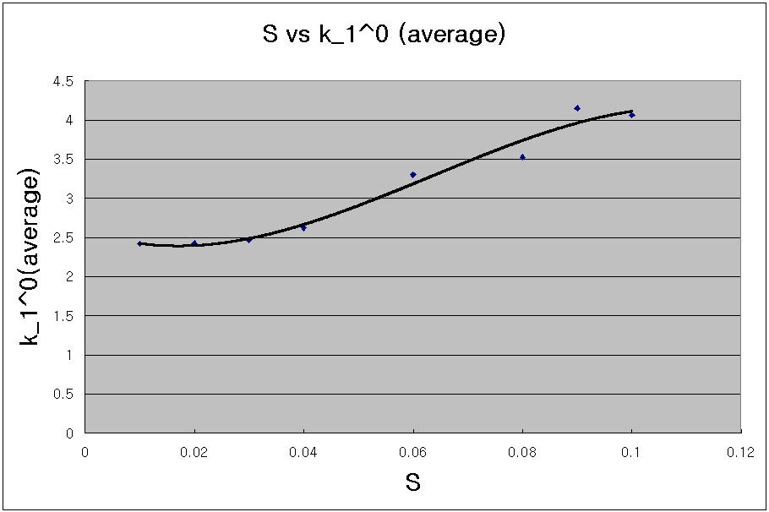
Fig.3 Averaged distribution along with the concentration of substrate S
If duplicate data are averaged, vs S graph is clearly showing increasing pattern of. Besides, as the S goes around 0.1, the slope seems to be flattened resulting in a s-shaped curve. This may imply that around this concentration of substrate, the whole enzymes in the solution are saturated. Thus increasing the concentration of substrate around this point will not results in linearly increasing.
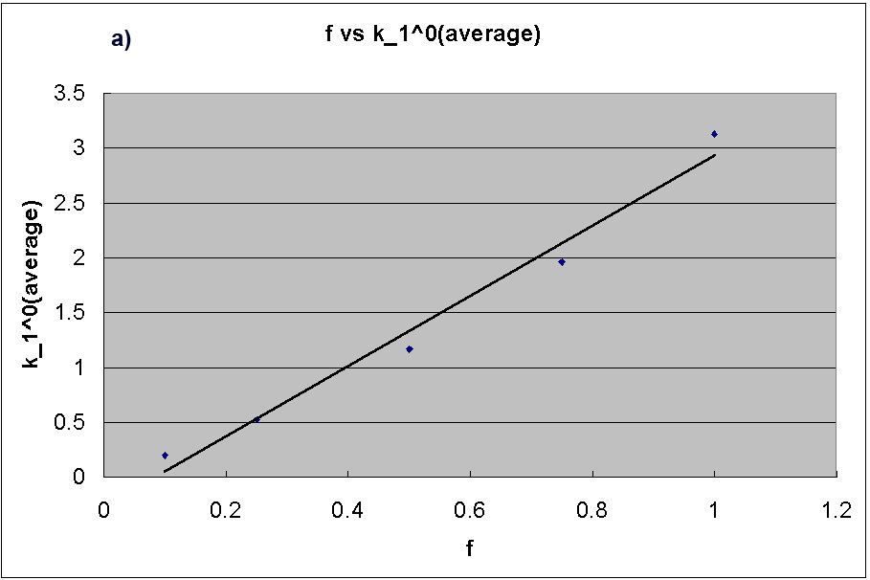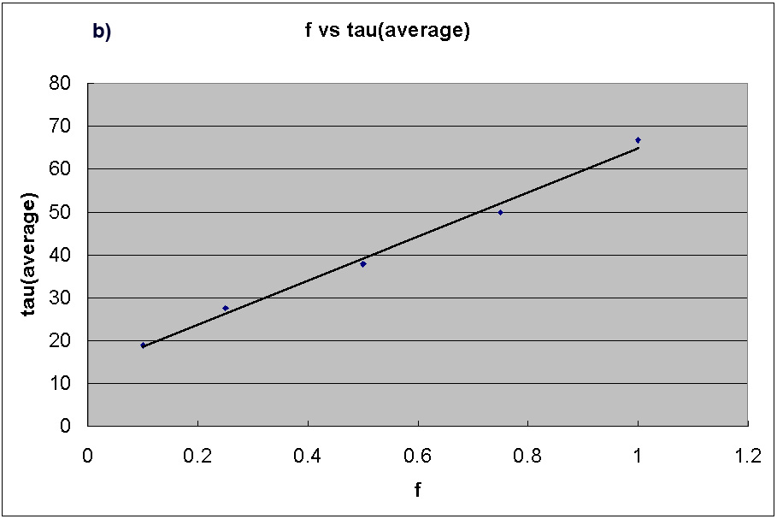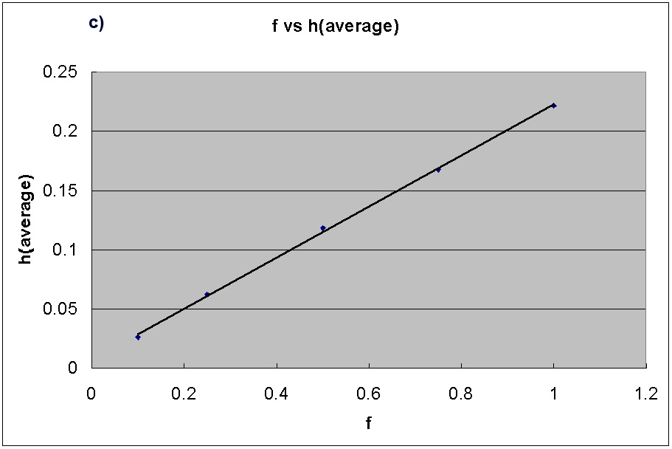
Fig.4 Effect of the probability f on, h, and
One data point at f=1 which seemed to be an error or outlier was removed and the remaining values were used to calculate mean values at each f point. a) is linearly proportional to the f that is the probability of forming complex (C) when an enzyme and an substrate contact. b) shows an tendency of linearly increasing along with the increasing f. c) h also increases linearly as the f increases.
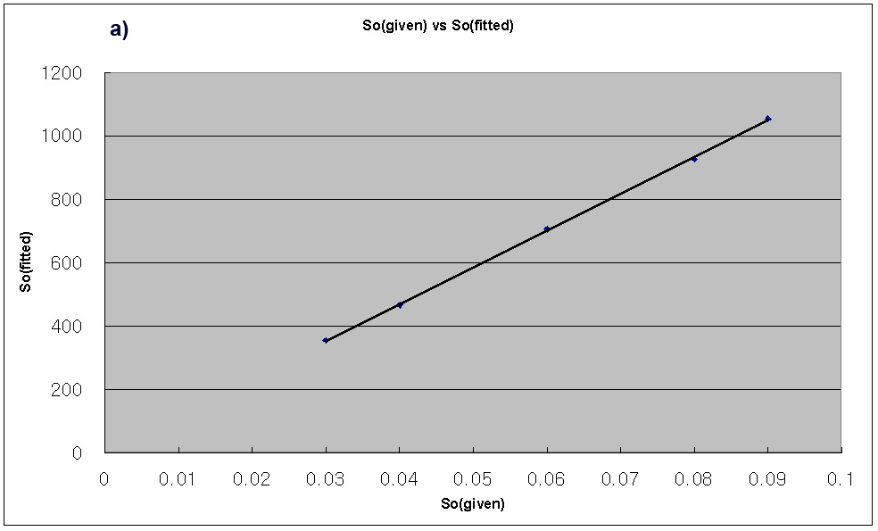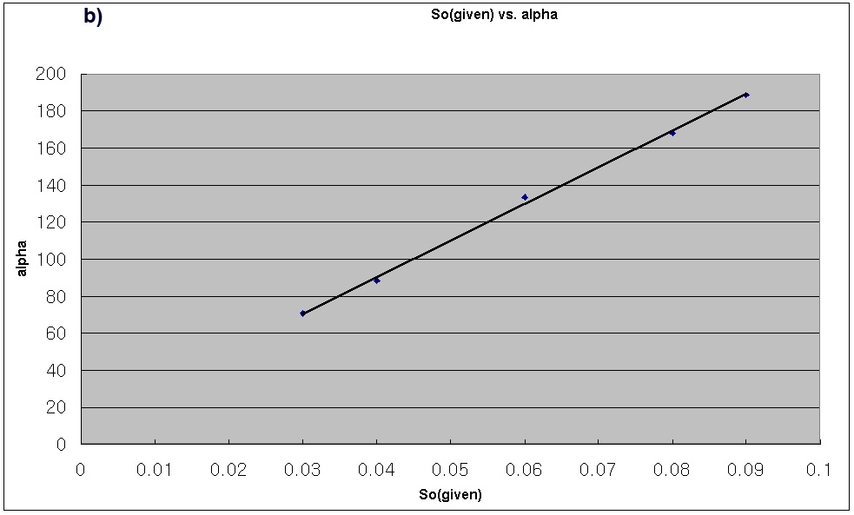
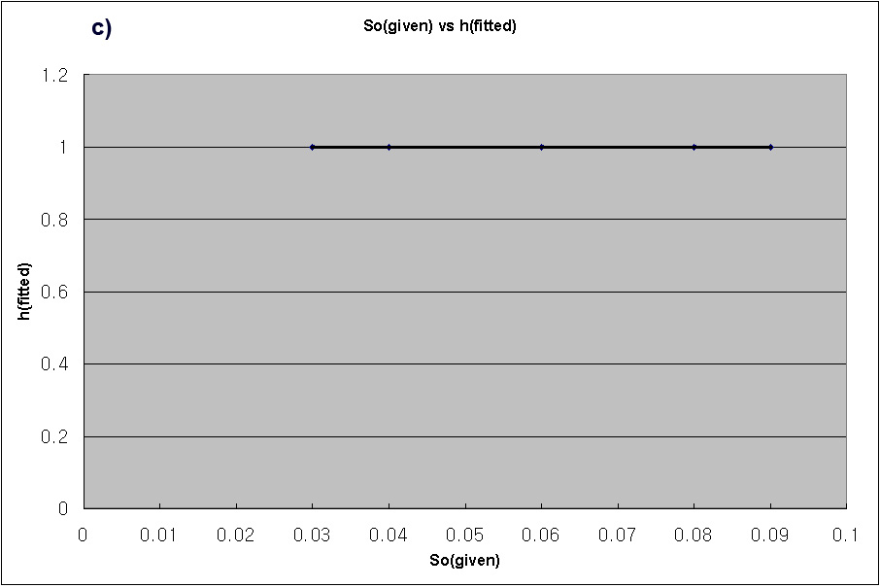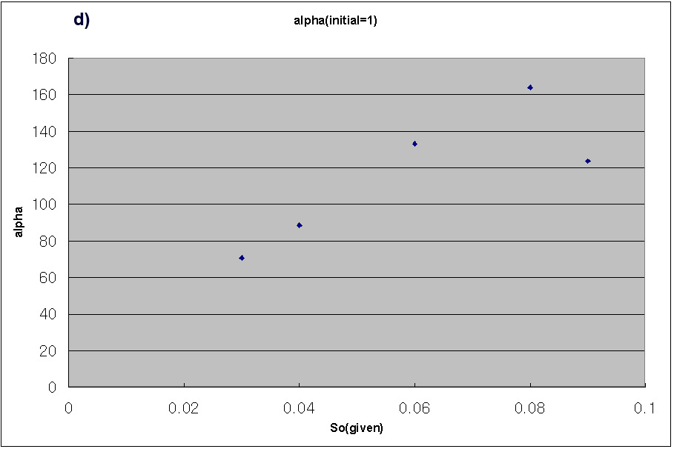
Fig.5 Effect of given S₀ on the fitted α, S₀, and h
a) Fitted S₀ is linearly increasing as the given S₀ increases. (note: 1000 fitted S₀ is same as 0.1 S₀) b) α is linearly increasing as the given S₀ increases. c) h remains 1 constantly. d) If the initial value of α is changed to 1 from 10, the overall shape and values of the fitted α will be different.

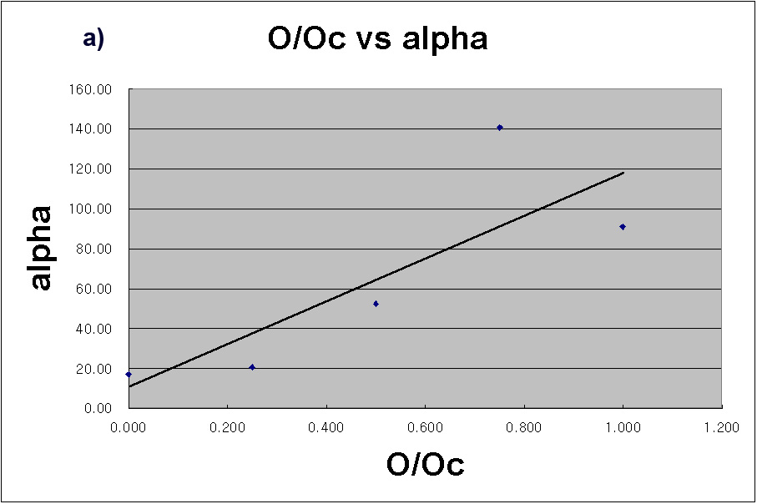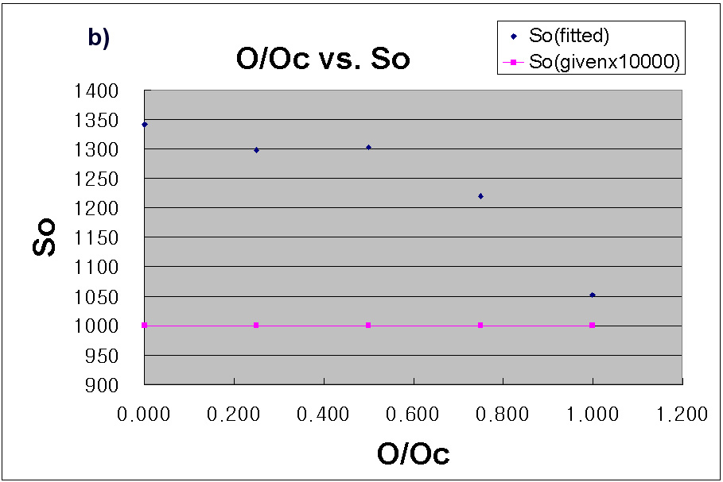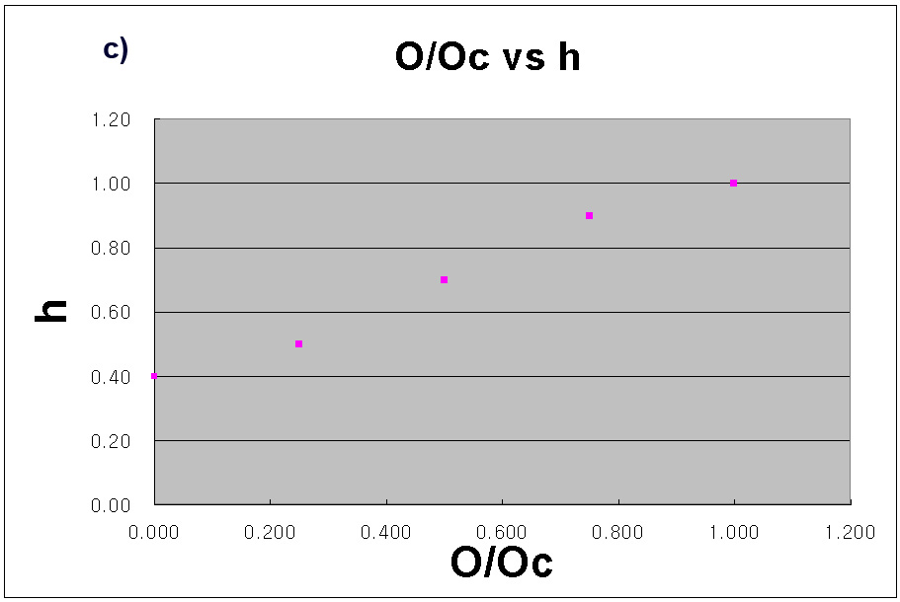
Fig.6 Effect of on the fitted α, S₀, and h
These figures shows how the is related to the parameters. a) α might be proportionally related to but the fourth spot at =0.8 seems to be an error spot. b) The fitted S₀ s are quite different from the original values. Except the fifth spot at =1.0 , the other fitted values are greater 20~35% than the original value. c) h shows a tendency to increase as the increases.
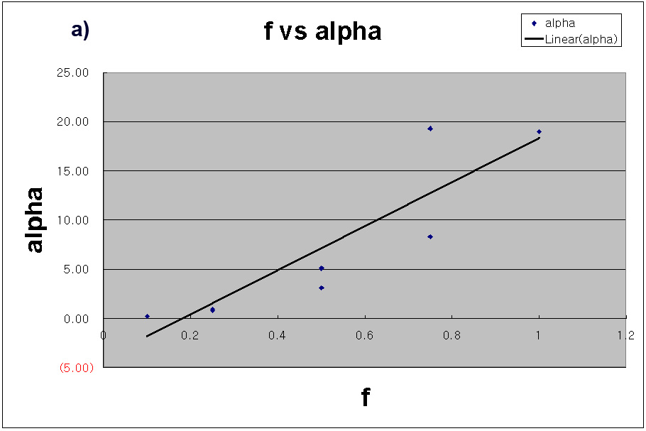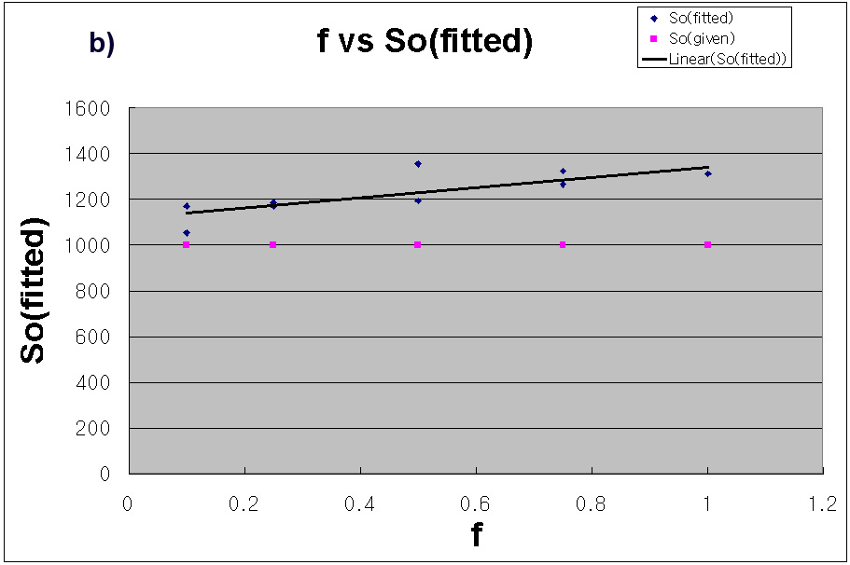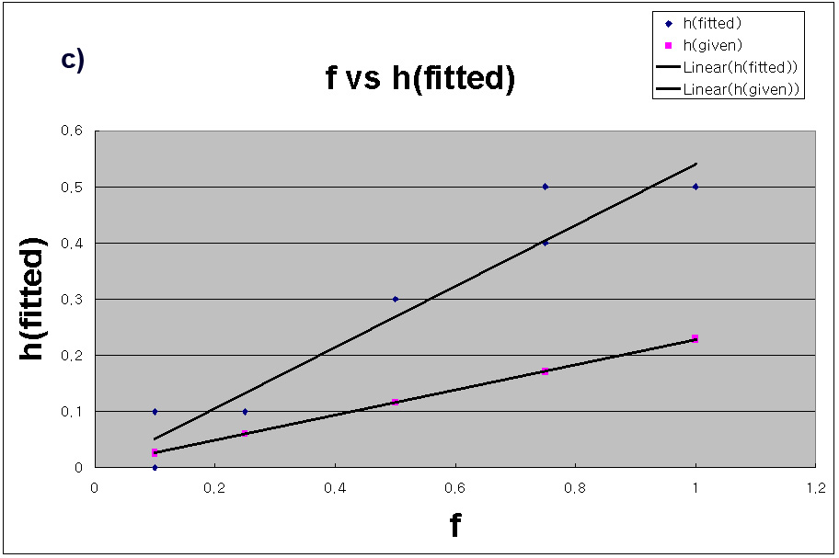
Fig.7 Effect of the probability f on the fitted α, S₀, and h
a) The fitted α might be proportionally related to f. b) The fitted S₀ s are quite different from the original values. but they doesn’t seem to have a clear tendency to increase as the f increases. c) h shows a tendency to increase as the f increases. This is same as in the Section 3.1.3. where the fractal parameter h showed incensement along the probability f.

