Genes for inflammation, fibrosis, senescence, DNL

Inflammation set
Pro-inflammatory Cytokines
IL-6, TNFa, IL1B, CCL2, NOS2
Macrophage marker
CD68, CD14, CD11c, f4/80,
(Our OVX mouse data)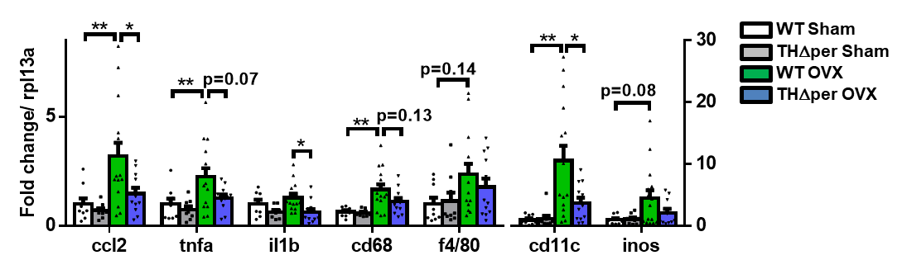
Pro-Fibrosis
COL1A1, COL3A1, COL4A1, COL5A1, COL5A2, COL6A1, COL6A2, COL6A3, COL14A1, COL15A1, COL16A1, FN1, ITGAX, ITGB2, LGALS3, LOX, LOXL2, MMP2, MMP3, MMP9, MMP12, MMP13, MMP14, MMP19, PCOLCE, PCOLCE2, PPARG, TGFB1, TIMP1, HIF1a

(Our OVX mouse data)
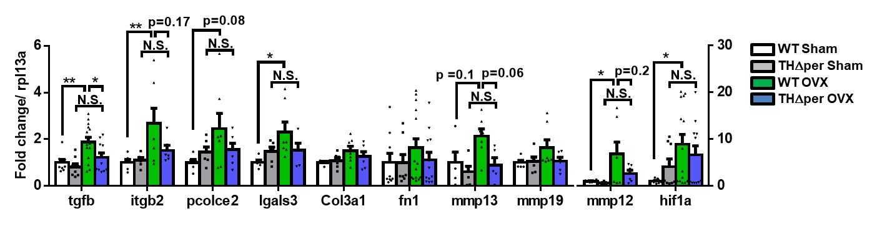
Senescence
CDKN1A (p21), CDKN2A (p16), gpnmb
(Our OVX mouse data)
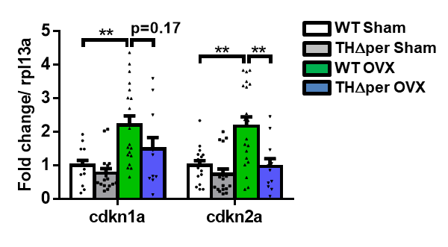
DNL
FASN, ACLY, ACACA (ACC1), SREBF1 (SREBP1c), MLXIPL (ChREBP), SCD1

CA resistance
It has been primarily described in obesity, while its presence in estrogen deficiency remains unclear.
Adrb3 is the key gene. Adrb1 and 2 may also be involved.
Adra2 (adrenergic alpha receptor) may be altered in the opposite direction.

