MATH 5037
Summary of Vector & Matrix Terminology

Term | Definition | Example
(1)scalar | a real number | 1 or 2.7 or π
(2)vector | an n-tuple of real numbers | (1,2,3) or (-5,2.4,√7,5)
(3)component of a vector | one of the entries in the n-tuple | 4 is the first component of the vector (4,5,9,3)
(4)equality of vectors | corresponding components equal | (3,1,2) and (1,2,3) are not equal vectors
(5)addition of vectors | (v1,v2,...,vn)+(u1,u2,...un)  =(v1+u1,v2+u2,...vn+un) | (2,3,1)+(5,-2,8)=(7,1,9)
(6)scalar multiple of vector | α(v1,v2,...,vn)=  (αv1,αv2,...αvn) | 3.1(4,1,2,0)=  (12.4,3.1,6.2,0)
(7)zero vector | vector all of whose components are zero | (0,0,0,0)
(8)geometrical vector | directed line segment in 2-space or 3 space | vector from (1,2) to (5,3) = (4,1)
(9)magnitude of vector  (Euclidean norm of vector) | ||v|| = √(v12+v22+...+vn2) | ||(1,-2,3)|| = √1+4+9 =  √14
(10)dot product of vectors | v.u= v1u1+v2u2+..+vnun | (4,1,5).(3,-1,2)= 21
(11)angle between vectors | 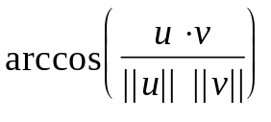 | angle between (1,4,3) and (2,1,5) = 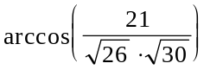=0.7198 radians
(12)matrix | rectangular array of numbers | 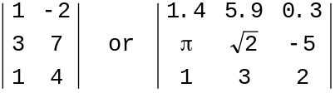
(13)row of matrix | horizontal lines in matrix | | 1 3 2| is the second row of 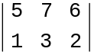
(14)column of matrix | vertical lines in matrix | 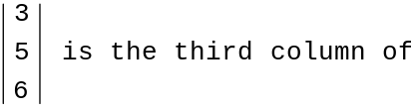  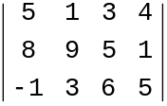
(15)size of matrix | number of rows & number of columns in matrix | 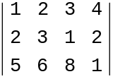 is a 3 × 4 matrix
(16)(i,j) entry in matrix | entry in row i, column j of matrix | (2,1) entry in 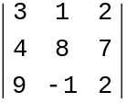 is 4
(17)equal matrices | corresponding entries equal | 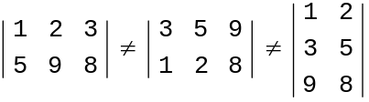
(18)transpose of matrix | (i,j) entry of transpose is (j,i) entry of original | 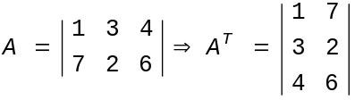
(19)scalar times matrix | matrix each of whose entries are multiplied by the scalar | 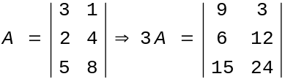
(20)sum of matrices | C=A+B is defined only if A and B are the same size, in which case cij=aij+bij | 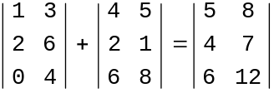
(21)product of matrices | C = AB is defined only if the number of columns in A = number of rows in B, in  which case cij = Σaikbkj | 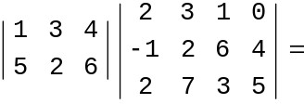  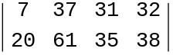
(22)square matrix | number of rows = number of columns | 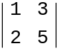 is square
(23)scalar matrix | diagonal matrix in which all diagonal elements are equal | 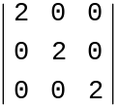 is scalar,
(24)identity matrix | scalar matrix whose diagonal entry is one | 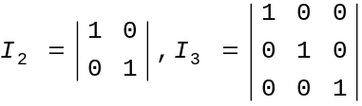
(25)invertible matrix  (nonsingular matrix) | there exists a matrix A-1 so that AA-1 = I = A-1A | 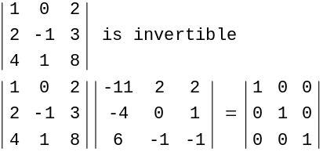
(26)determinant of a matrix | det(A) is a number associated with a square matrix. det(A) ≠ 0 if and only if A is invertible | 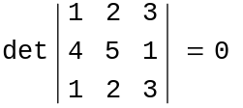  so matrix is not invertible

