Manual of Red2D

Developed by Ph.D. Xiang Li

Neutron Science laboratory, ISSP, The University of Tokyo

# Notes

* With this Igor package, you can easily reduce 2D tiff images to 1D I vs q profile with properly calculated error bars (using Poison distribution).
* 1D data can be further normalized by exposure time, transmittance, sample thickness, absolute intensity correction. Cell and solvent subtraction are also supported.
* For further data reduction, such as model fit, you need to use other software (e.g. SasView).
* This package requires Igor Pro 8 by WaveMetrics and should be compatible with Igor 6 and 7 (not confirmed). I only tested this package in MacOS but it should works on Windows as well.
* This package is free to use. It will be nice if you acknowledge me in your publications.
* If you find any bug, please contact me ([*x.li@issp.u-tokyo.ac.jp*](mailto:x.li@issp.u-tokyo.ac.jp)).

# How to install

* Copy and paste this folder into your local WaveMetrics folder:

Documents » Wavemetrics » Igor Pro 8 User Files » Igor Procedures

* Launch Igor Pro application, you will see a “Red2D” tab.

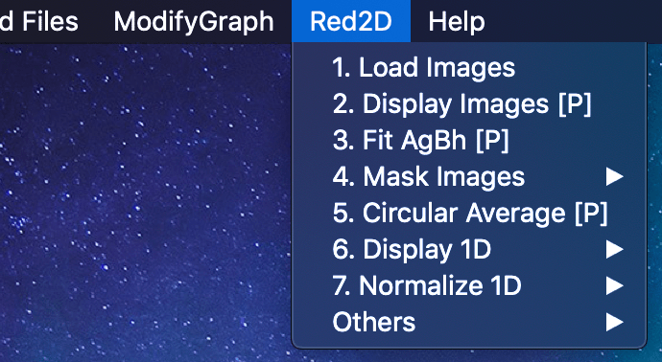

# How to use

**Common tips:**

1. Use data browser to organize your data.
2. Make different datafolders for different configurations (SDD, beam center, etc.).
3. Set datafolder to where the target data exist. The data in child folder will not be used.
   1. e.g. display images, mask image, circular average → set datafolder to where the images exist (e.g. SDD2m).
   2. Display 1D, normalization 1D → set datafolder to where1D data exist (Raw1D…).

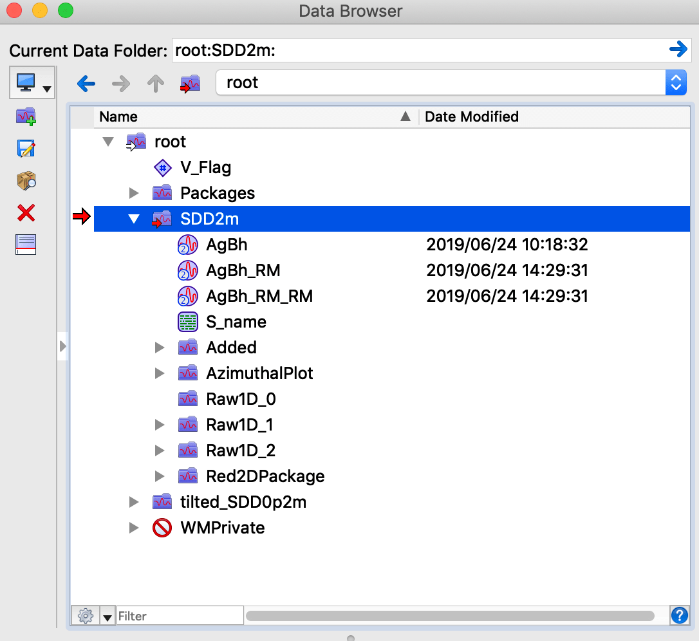

1. **Click “Load Images” and selected all the images you want to load.**

Tips:

1. The files are loaded in the order as you selected.
2. Image name rule: 1. starts from alphabet, 2. no space, 3. no symbol except underscore. 4. Concerning Igor Pro before version 8, make sure the file names shorter than 32 characters.
3. **Use “Display Images” to show 2D images.**

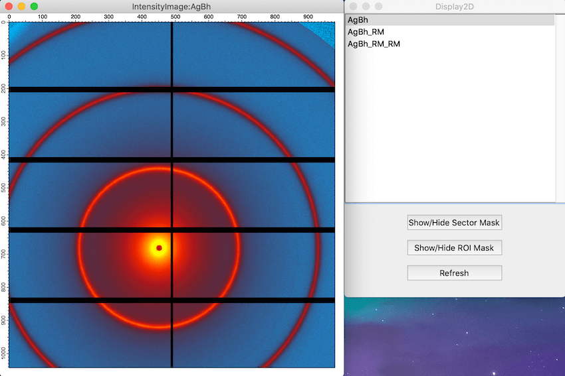

Tips:

1. Set datafolder to where the images exist.
2. Click “Refresh” button to refresh the list of images.
3. If sector mask or ROI mask is generated, you can show and hide the masks.
4. Fit AgBh to get beam center and SDD

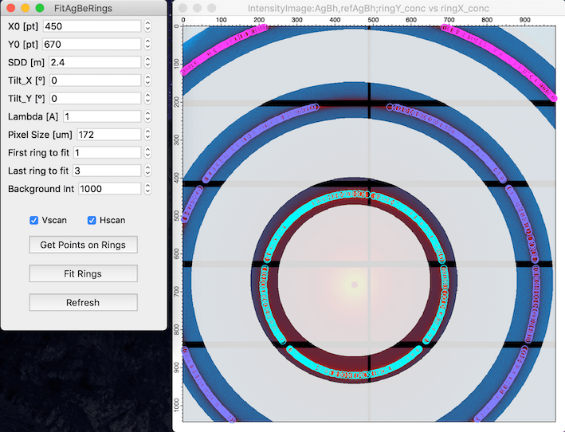

Tips:

1. Fill all the parameters. X0, Y0 and SDD are fit parameters. All the other parameters are independent variables and must be precise.
2. A white mask will appear based on the parameters you set.
   1. Only the non-masked pixels will be used to estimate beam center and SDD.
   2. Generally, fitting one ring is good enough.
3. Set background intensity to remove the noise and click “Get Points on Rings”.
   1. Colorful points appear on the rings.
   2. If the points are not on the rings, change the background intensity then click “Get Points on Rings” again. You can also try to check/uncheck Vscan (vertical peak scan) and Hscan (horizontal peak scan).
4. Click “Fit Rings” to do the fit.
   1. The fit result appears in the command window. X0, Y0 and SDD will be stored as global variables in a datafolder “Red2Dpacakge”.
5. You may want to remove the points and ring mask on the AgBh Image in the following data reduction. You can simply close the image and use the Display 2D to make a new image window.
6. Create and apply sector and ROI mask [optional]

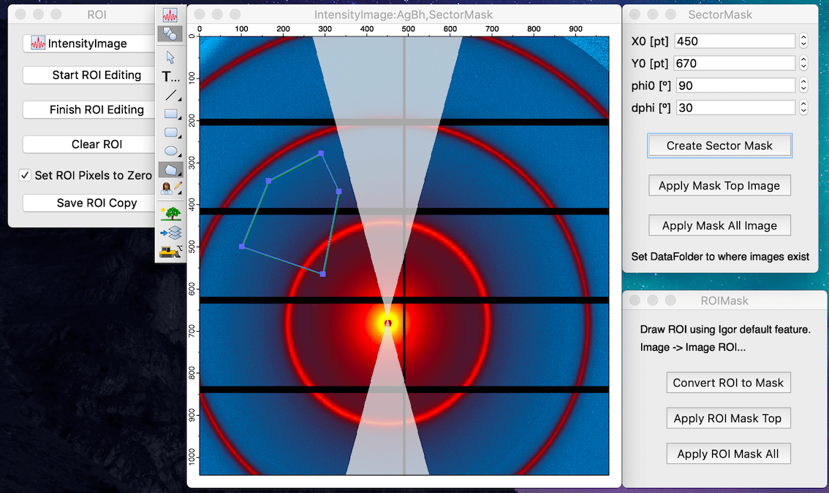

Tips:

1. Fill beam center position (X0, Y0) and fill the angle (phi0) and the range (dphi).
2. “Create Sector Mask” generates a sector mask.
3. “Apply Mask” creates masked images. The masked image will be saved in a separate datafolder. The original image will not be changed.
4. To use ROI mask, you need draw a ROI first by select “Image” ≫”Image ROI…” in the Igor menu bar. Then click convert ROI to Mask.
5. You can apply mask to the masked image.
6. The panel space (value = −1) will be automatically removed when performing circular average. You do not have make a mask for the panel space.
7. Circular Average [Panel]

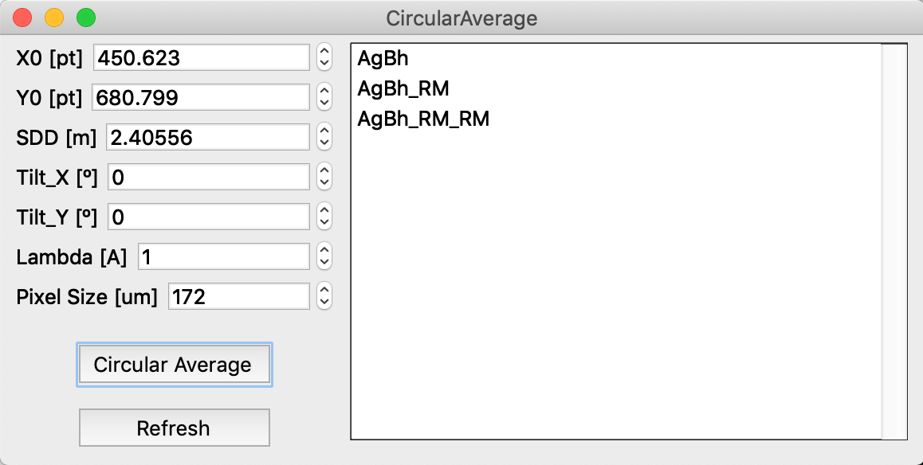

Tips:

1. Click refresh to update the image list and parameters when you changed the images or moved to other data folder.
2. Fill all the values then clicking circular average.
3. A new datafolder named “Raw1D”, which contains the reduced 1D data, will appear after the circular average.
4. **Click Display 1D and append 1D to show 1D data in a graph.**

Tips:

1. Set the datafolder to where the 1D data exist.
2. Error may occur for when the error bars are not found. You can ignore this.



1. **Normalize 1D data**

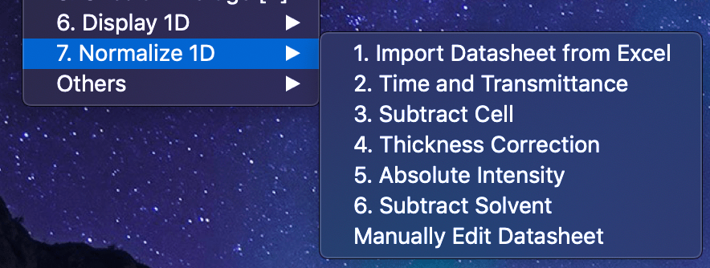

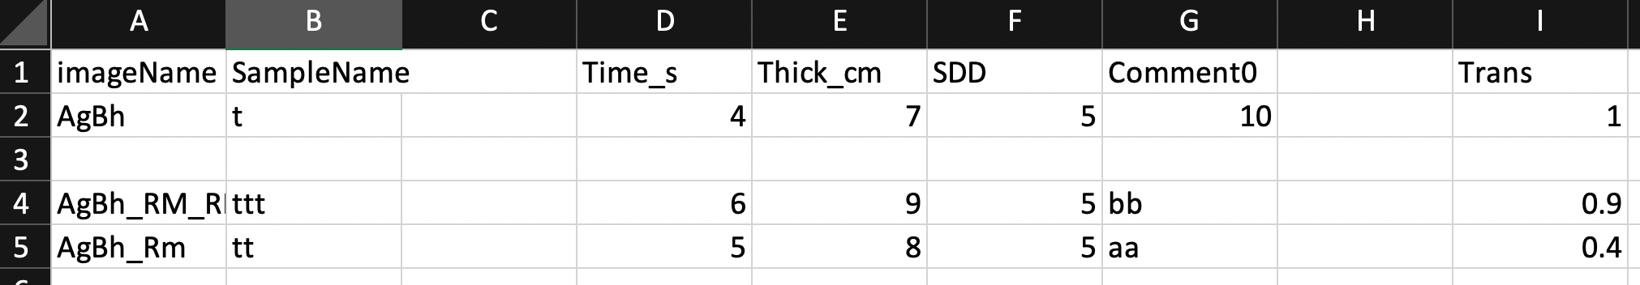

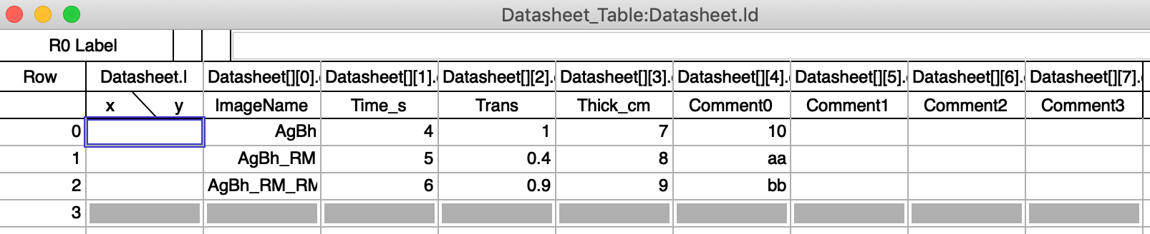

Tips:

1. Set the datafolder to where the 1D data exist.
2. Create a datasheet with Excel and import that using “Import Datasheet from Excel”.
   1. The first row in excel sheet is the header. Only the header named with ImageName, Time_s, Trans, Thick_cm and Comment0-3 will be imported.
   2. If the ImageName in the excel sheet does not exist in Igor, the ImageName and corresponding data will not be imported. This is very useful because you do not have to delete unnecessary data.
   3. Trans, Tims_s and Thcik_cm must be filled.
   4. If you want to skip normalization of any data, type 1 into the corresponding cell.
3. You can manually fill the datasheet if you want.
4. After you filled the datasheet, you can normalize the 1D data. If you understand what the normalizations do, you do not have to follow the index order in front of each normalization.
5. Note for absolute intensity correction:
6. Load calibration curve of glassy carbon by using “Others” ≫ “Load GC calibration curve”. The original data is downloaded from <https://www-s.nist.gov/srmors/view_detail.cfm?srm=3600>
7. Compare the intensity ratio of [your data]/[Calibration curve] at a proper q value.
8. Click “Absolute Intensity” and type the intensity ratio value.

# Appendix

**Red2Dpackage folder**

This datafolder will be automatically created in the directory where your images are stored. This datafolder stores global values and strings and waves used in background. You can edit these values by yourself when necessary.

**Others**

You can add multiple images into 1 image by using “Add 2D images”.

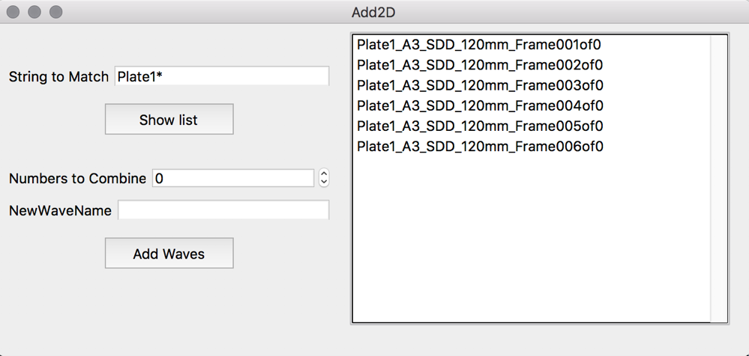

1. String to Match: type the common part of the image names. Use an asterisk (*) as a wildcard, e.g. “*abc*” matches “testabctest”.
2. Numbers to Combine: type the number of images to combine. e.g. If you have 10 images and Numbers to Combine = 2, then 5 combined images will be generated.
3. NewWaveName: when multiple images generated, a sequential number will be added at the end of the names.
4. Data will be saved in a datafolder “Added”.

You can use Azimuthal Plot to create an Azimuthal profile.