**WORD2VEC FOR ALL THE CHURCHES WITH CHURCH IDs**

**CONTENTS**

**1) IMPORTING NECESSARY LIBRARIES**

**2) LOADING THE DATA**

**3) PRE-PROCESSING THE TEXT DATA**

**4)LOADING THE FASTTEXT MODEL**

**5)COSINE SIMILARITY SCORE CALCULATIONS 6)OVERLAP OF METHODS**

**1) IMPORTING NECESSARY LIBRARIES**

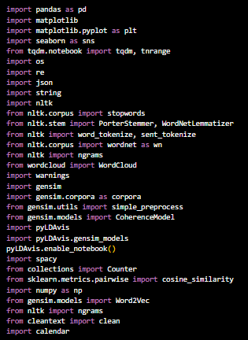

For explanation refer to fasttext test code documentation page number 2.

**2) LOADING THE DATA**

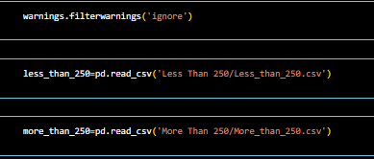

less_than_250

It contains all the data of churches which have

**3) PRE-PROCESSING THE TEXT DATA**

**I)**

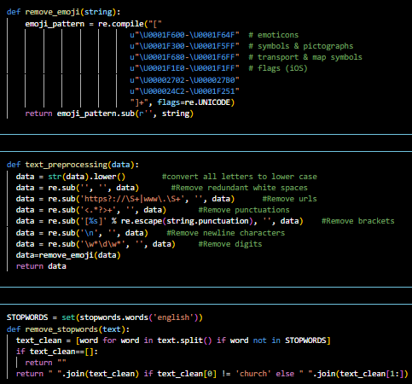

* + Convert to lowercase: Make all letters small.
  + Remove URLs: Deletes web addresses.
  + Remove HTML tags: Removes any HTML code.
  + Remove punctuation: Gets rid of symbols like ., !, and ?.
  + Remove newlines: Deletes line breaks.
  + Remove words with digits: Removes words that contain numbers.
  + Remove emojis: Deletes emojis
  + Load stopwords: Loads a list of common words to remove (like "and", "the").
  + Remove stopwords: Removes these common words from the text.
  + Special case for "church": If the cleaned text starts with "church", it removes this word

**II)**

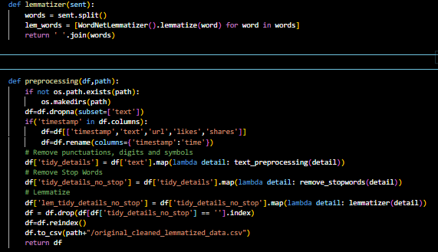

1. **Lemmatizer Function:**
   * lemmatizer(sent):
     + Splits the sentence into words.
     + Converts each word to its base form (lemma).
     + Joins the words back into a sentence.
2. **Preprocessing Function:**
   * preprocessing(df, path):
     + Create directory: Creates the directory if it doesn't exist.
     + Drop missing texts: Removes rows with missing 'text'.
     + Rename columns: If 'timestamp' exists, rename it to 'time' and select specific columns.
     + Clean text: Applies text_preprocessing to remove unwanted parts.
     + Remove stopwords: Applies remove_stopwords to eliminate common words.
     + Lemmatize: Applies lemmatizer to convert words to their base form.
     + Remove empty rows: Deletes rows where 'tidy_details_no_stop' is empty.
     + Reindex and save: Reindexes the DataFrame and saves it as a CSV file.
     + Return: Returns the processed DataFrame.

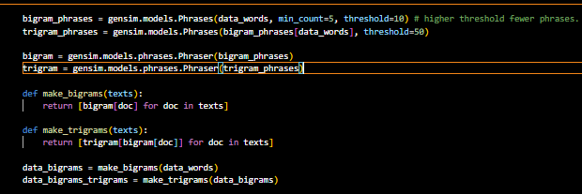

The code is using the `gensim` library to detect and generate bigram (two-word) and trigram (three-word) phrases from a given text corpus (`data_words`). This is a common preprocessing step in natural language processing tasks, as it helps capture multi-word expressions and can improve the quality of text representation.

1. **Generating Bigram and Trigram Phrases**:

- `gensim.models.Phrases` is used to detect and generate bigram and trigram phrases from the `data_words` corpus.

- `min_count=5` means only words appearing at least 5 times will be considered for phrase detection.

- `threshold=10` (for bigrams) and `threshold=50` (for trigrams) determine the scoring threshold for forming new phrases. Higher thresholds result in fewer phrases.

- Trigram phrases are generated from the previously generated bigram phrases.

2. **Applying Phrase Transformations**:

- `gensim.models.phrases.Phraser` is used to transform tokenized documents (lists of words) into lists of bigram or trigram phrases.

- `bigram` and `trigram` instances are created with the generated bigram and trigram phrases, respectively.

3. **Helper Functions**:

- `make_bigrams` and `make_trigrams` are custom functions to apply bigram and trigram phrase transformations to a list of tokenized documents (`texts`).

- `make_bigrams` applies the `bigram` transformation, while `make_trigrams` applies both `bigram` and `trigram` transformations.

4. **Applying Transformations to Data**:

- `data_bigrams` is a list of tokenized documents, where each document contains bigram phrases.

- `data_bigrams_trigrams` is a list of tokenized documents, where each document contains both bigram and trigram phrases.

The resulting `data_bigrams` and `data_bigrams_trigrams` can be used as input for further natural language processing tasks, such as topic modeling or text classification. By capturing multi-word expressions through bigram and trigram phrases, the text representation can be improved, potentially leading to better performance in downstream tasks.

**4) LOADING THE FASTTEXT MODEL**

**I**

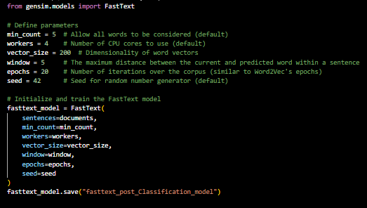

**For explanation of the Fasttext model and each of the parameters in detail refer to the BERT VS W2VEC documentation page number 11 onwards.**

fasttext_vocab = fasttext_model.wv.key_to_index

This above line of code extracts vocabulary information from two different word embedding models: `fasttext_model` `. Specifically, they are retrieving dictionaries that map words to their corresponding indices in the embedding spaces. The `key_to_index` attribute is likely provided by the word embedding models to allow for quick access to the indices of words in the vocabulary.

**II)**

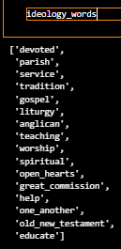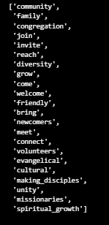

These lists contain the ideology and growth-related words that were present in the vocabulary of the whole text corpus after going through various analyses. The lists were initially predefined, and then each word was checked against the vocabulary of the text corpus. The words that were found in the vocabulary were retained in these final lists, effectively filtering out any words that were not present in the corpus.

These filtered word lists can be used for further analysis, such as examining the context and usage of these words in the text corpus, or as input features for machine learning models to classify or cluster documents based on their ideological or growth-related content.

**5)COSINE SIMILARITY SCORE CALCULATIONS**

**Refer to Fastext documentation page number 12 onwards for explanation of all of the code snippets in this section.**

**I)**

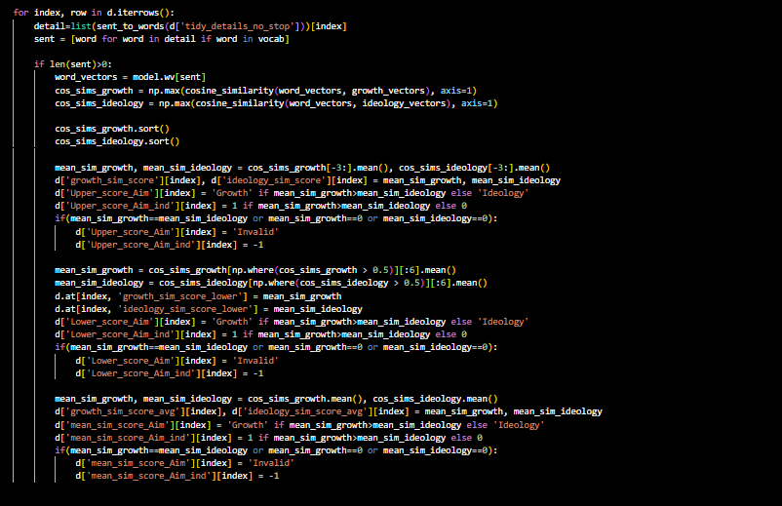

.

**II)**

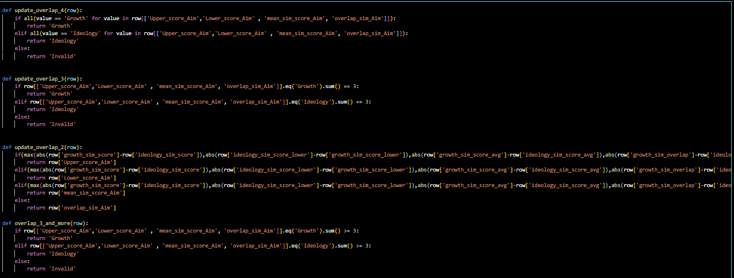

**III)**

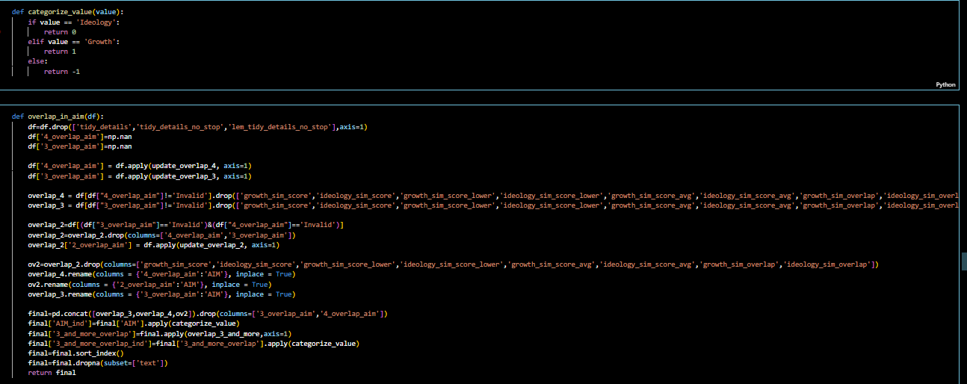

**6)OVERLAP OF METHODS**

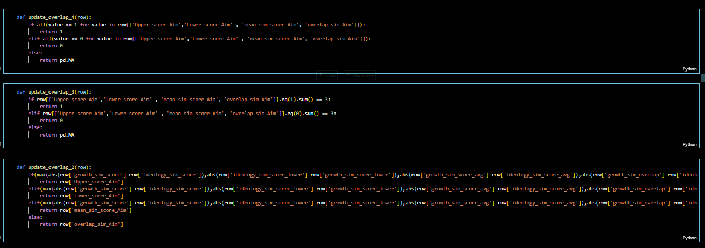

**The term "overlap of 4" refers to a scenario where all four similarity methods—mean similarity, lower bound similarity, upper bound similarity, and overlap similarity—yield the same result. In other words, when examining a dataset, if all four methods produce identical outcomes for a given set of keywords or concepts, it indicates a significant alignment across multiple measures of similarity.**

**Likewise, the concept of "overlap of 3" signifies that any three out of the four similarity methods lead to the same conclusion. This suggests a substantial degree of agreement among the majority of similarity metrics, further reinforcing the consistency in evaluating the relevance or association of keywords within the dataset.**

**Similarly, an "overlap of 2" implies that a pair of similarity methods among the four produce matching results. While not as comprehensive as an overlap of 3 or 4, this still indicates a notable level of concordance between specific pairs of similarity measures, highlighting areas of shared interpretation or relevance within the dataset.**

These are functions designed to update a column ('overlap_sim_Aim') in a DataFrame based on conditions involving other columns. Let's break down each function:

**1**. **update_overlap_4**: This function checks if all four specified columns have a value of 1. If they do, it returns 1. If all columns have a value of 0, it returns 0. Otherwise, it returns NA (null).

**2**. **update_overlap_3**: Similar to the previous function, but it only considers cases where exactly three out of the four columns have a value of 1. If this condition is met, it returns 1. If three columns have a value of 0, it returns 0. Otherwise, it returns NA.

**3**. **update_overlap_2**: This function is more complex. It calculates the absolute differences between pairs of values from various columns and selects the maximum difference. Based on which pair of columns has the maximum difference, it returns the corresponding value from another column ('Upper_score_Aim', 'Lower_score_Aim', 'mean_sim_score_Aim', or 'overlap_sim_Aim'). If there's a tie or no conditions are met, it returns the value from 'overlap_sim_Aim'.

**In simpler terms, these functions evaluate conditions involving multiple columns and update a specific column based on those conditions. They help to automate decision-making based on certain criteria within the DataFrame.**

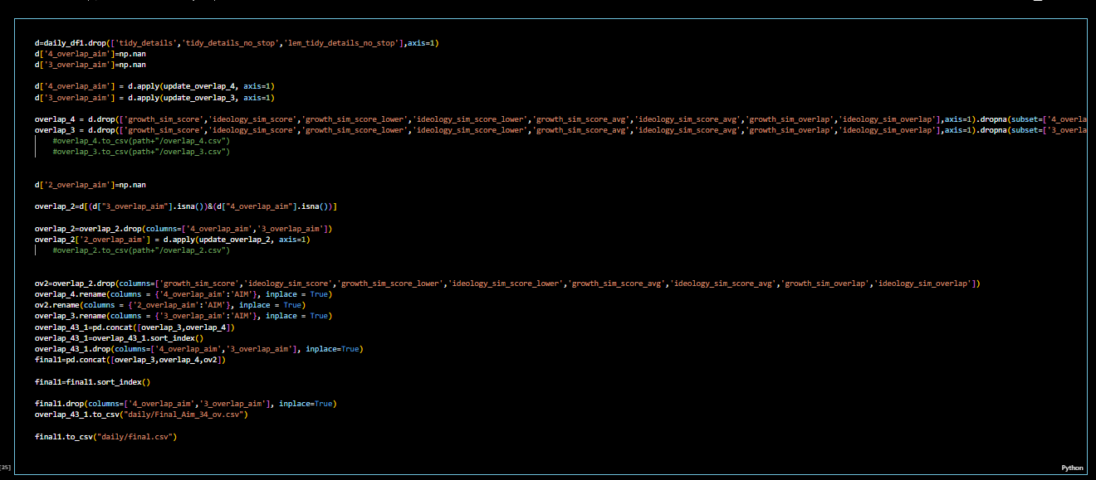

This script performs several operations on a DataFrame `daily_df1` to update and manipulate columns based on certain conditions. Let's break down each step in detail:

1. **Data Preparation**:

- The script first creates a new DataFrame `d` by dropping certain columns ('tidy_details', 'tidy_details_no_stop', 'lem_tidy_details_no_stop') from `daily_df1`.

- Two new columns, '4_overlap_aim' and '3_overlap_aim', are added to `d` with NaN (missing) values.

2. \*\***Updating '4_overlap_aim' and '3_overlap_aim**'**:

- The script applies the functions `update_overlap_4` and `update_overlap_3` row-wise to update the values in '4_overlap_aim' and '3_overlap_aim' columns, respectively.

- Two DataFrames, `overlap_4` and `overlap_3`, are created by dropping rows with NaN values in '4_overlap_aim' and '3_overlap_aim', respectively.

3. \*\***Updating '2_overlap_aim'**\*\*:

- A new column '2_overlap_aim' is added to `d` with NaN values.

- Rows with NaN values in both '4_overlap_aim' and '3_overlap_aim' are selected to update '2_overlap_aim' column.

- The function `update_overlap_2` is applied row-wise to update '2_overlap_aim' column.

4. \*\***Data Formatting**\*\*:

- Unnecessary columns related to similarity scores are dropped from `overlap_2` DataFrame.

- Column names are renamed to 'AIM' in `overlap_4`, `ov2`, and `overlap_3` DataFrames.

- `overlap_3` and `overlap_4` DataFrames are concatenated into `overlap_43_1` DataFrame and sorted by index.

- Duplicate columns '4_overlap_aim' and '3_overlap_aim' are dropped from `overlap_43_1` DataFrame.

- The final DataFrame `final1` is created by concatenating `overlap_3`, `overlap_4`, and `ov2` DataFrames, sorted by index, and duplicate columns dropped.

5. \*\***Data Expor**t**:

- `overlap_43_1` DataFrame is exported to a CSV file named "Final_Aim_34_ov.csv" in the "daily" directory.

- `final1` DataFrame is exported to a CSV file named "final.csv" in the "daily" directory.

In summary, this script updates and manipulates columns in the DataFrame `daily_df1` based on certain conditions, creates new DataFrames based on these updates, formats the data, and exports the final results to CSV files for further analysis.

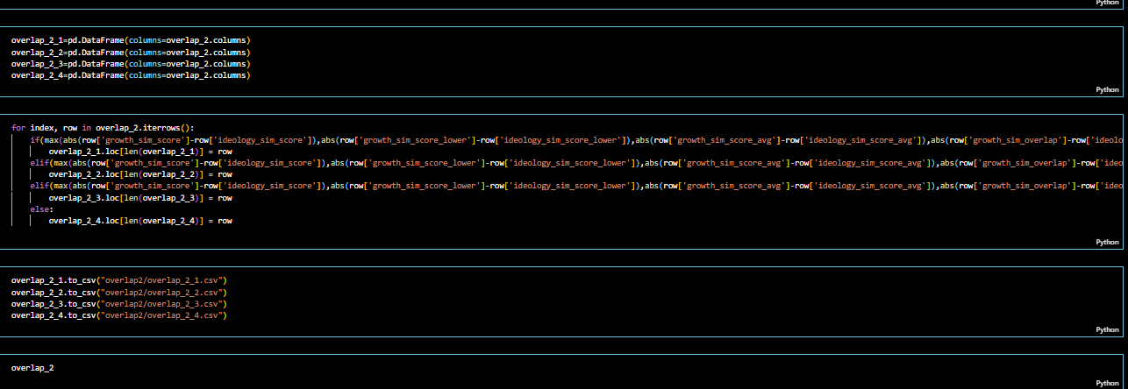

This code is performing filtering operations on a pandas DataFrame called overlap_3 and creating subsets based on specific conditions. It appears that overlap_3 contains columns related to similarity scores and overlap measures for some data. Here's a summary of what the code is doing:

1. **Filtering for Equal Scores**:
   * The code creates four new DataFrames: overlap_3_123, overlap_3_124, overlap_3_134, and overlap_3_234.
   * Each of these DataFrames is a subset of overlap_3 where certain columns have equal values.
   * For example, overlap_3_123 contains rows where the values in Upper_score_Aim, Lower_score_Aim, and mean_sim_score_Aim columns are all equal.
   * Similarly, overlap_3_124 contains rows where Upper_score_Aim, Lower_score_Aim, and overlap_sim_Aim have equal values.
   * The other two DataFrames (overlap_3_134 and overlap_3_234) filter for different combinations of equal values across these columns.
2. **Saving Filtered DataFrames to CSV**:
   * After creating the filtered DataFrames, the code saves them as separate CSV files using the to_csv method.
   * The file names follow a pattern like overlap_3_123.csv, overlap_3_124.csv, overlap_3_134.csv, and overlap_3_234.csv, where the numbers correspond to the columns that have equal values.
   * These files are saved in a directory called overlap3.
3. **Saving Original DataFrames**:
   * Finally, the code saves the original overlap_4 and overlap_3 DataFrames to CSV files named overlap_4.csv and overlap_3.csv, respectively.

The purpose of this code is to extract and save specific subsets of the overlap_3 DataFrame, where certain similarity score and overlap measure columns have equal values. These subsets may be useful for further analysis or processing in the broader context of the project. Additionally, the original DataFrames (overlap_4 and overlap_3) are also saved for reference or future use.

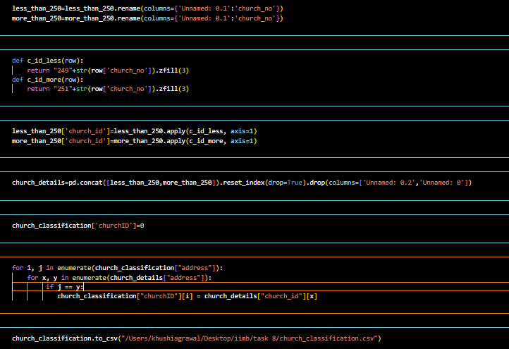

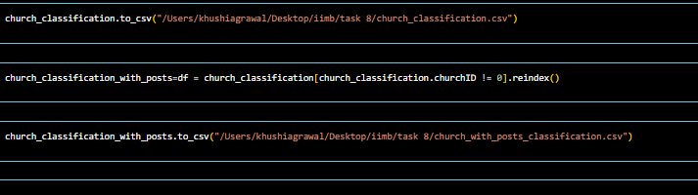

1. **Renaming Columns**:

- The code renames columns in the `overlap_4`, `ov2`, and `overlap_3` DataFrames.

- Specifically, it renames the columns `'4_overlap_aim'`, `'2_overlap_aim'`, and `'3_overlap_aim'` to `'AIM'`.

- Similarly, it renames the columns `'4_overlap_aim_ind'`, `'2_overlap_aim_ind'`, and `'3_overlap_aim_ind'` to `'AIM_ind'`.

- These rename operations are performed inplace, meaning the original DataFrames are modified.

2. **Concatenating DataFrames**:

- The code concatenates the `overlap_3`, `overlap_4`, and `ov2` DataFrames into a single DataFrame called `final`.

- The `pd.concat` function from pandas is used for this operation.

3. **Defining a Function for Overlap Calculation**:

- A function called `overlap_3_and_more` is defined.

- This function takes a row of data as input and checks if at least three of the columns `'Upper_score_Aim'`, `'Lower_score_Aim'`, `'mean_sim_score_Aim'`, and `'overlap_sim_Aim'` have the value 'Growth' or 'Ideology'.

- If at least three columns have the value 'Growth', it returns 'Growth'.

- If at least three columns have the value 'Ideology', it returns 'Ideology'.

- Otherwise, it returns 'Invalid'.

4. **Applying the Function to the DataFrame**:

- The `overlap_3_and_more` function is applied to each row of the `final` DataFrame using the `apply` method.

- The result is stored in a new column called `'3_and_more_overlap'`.

- Another column called `'3_and_more_overlap_ind'` is created by applying the `categorize_value` function to the `'3_and_more_overlap'` column.

5. **Dropping a Column**:

- The code drops the `"2_overlap_aim"` column from the `final` DataFrame.

6. **Merging DataFrames**:

- The code merges the `final_word2vec` and `final_fasttext` DataFrames based on the columns `'name'`, `'address'`, `'denomination'`, `'sub_denomination'`, `'contacts'`, `'web'`, `'size'`, `'details'`, `'link'`, `'facebook'`, `'instagram'`, `'twitter'`, `'youtube'`, `'state'`, `'region'`, and `'division'`.

- The resulting merged DataFrame is called `church_classification`.

- The `suffixes` parameter is used to handle overlapping column names by appending `'_W2V'` and `'_FT'` to the respective columns.

7. **Defining Functions for Church ID Assignment**:

- Two functions, `c_id_less` and `c_id_more`, are defined.

- These functions take a row of data as input and generate a `'church_id'` based on the `'church_no'` column.

- If `'church_no'` is less than 250, the `'church_id'` starts with "249" followed by the `'church_no'` padded with leading zeros to make it three digits.

- If `'church_no'` is greater than or equal to 250, the `'church_id'` starts with "251" followed by the `'church_no'` padded with leading zeros to make it three digits.

8. **Applying Functions to Assign Church IDs**:

- The `c_id_less` function is applied to the `less_than_250` DataFrame using the `apply` method, and the resulting `'church_id'` values are stored in a new column.

- Similarly, the `c_id_more` function is applied to the `more_than_250` DataFrame to assign `'church_id'` values.

9. **Updating Church IDs in the Merged DataFrame**:

- The code iterates over the `"address"` column in `church_classification` and the `"address"` column in `church_details`.

- If the addresses match, the corresponding `"churchID"` value in `church_classification` is updated with the `"church_id"` value from `church_details`.

10. **Saving the Final DataFrame**:

- Finally, the `final` DataFrame is saved to a CSV file named "Final_Aim.csv" using the `to_csv` method.

In summary, the code performs various operations such as renaming columns, concatenating DataFrames, applying custom functions, merging DataFrames, assigning church IDs based on specific conditions, updating church IDs in a merged DataFrame, and saving the final DataFrame to a CSV file.

**OUTPUTS:**

[**ALL METHODS AIM**](https://www.dropbox.com/scl/fi/gq9qulcto8pc7b43wizwn/all_methods_aim.csv?rlkey=aakc7yfixyu7gj8wgire02ljh&st=hkgowb9n&dl=0)

[**FINAL AIM**](https://www.dropbox.com/scl/fi/40h47pjrbqxyojstkdwg9/Final_Aim.csv?rlkey=wb44bgewmz65e22w68paqr2ex&st=92xlurwy&dl=0)