Your friend from Iowa, whose housing problem you solved, is now moving to Melbourne for a new assignment Down Under. As you have solved his Iowa housing problem so well, he wants you to solve his Melbourne housing problem too. Armed with your new-found expertise in regularization, let's work on the Melbourne housing data using regularized regression. Each observation is a different house attribute with various features, like the number of properties that exist in the suburb, land size, building size, governing council for the area, real estate agent, price of the house, etc.

**About the Dataset:**

Here's a snapshot of the data you will be work on :

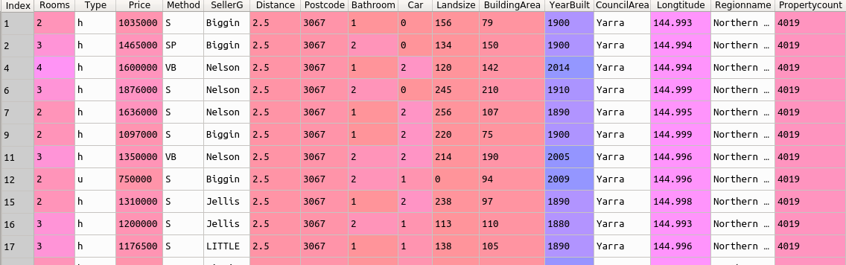

You can see that some of the features of Type, Method,SellerG,CouncilArea, and Regionname in the data are textual in nature. Don't worry, we have made things simple for you with some behind-the-scenes data preprocessing. You will learn about all these preprocessing techniques in a later concept. For now, let's concentrate on getting the Melbourne Housing data in your hands soon. :)

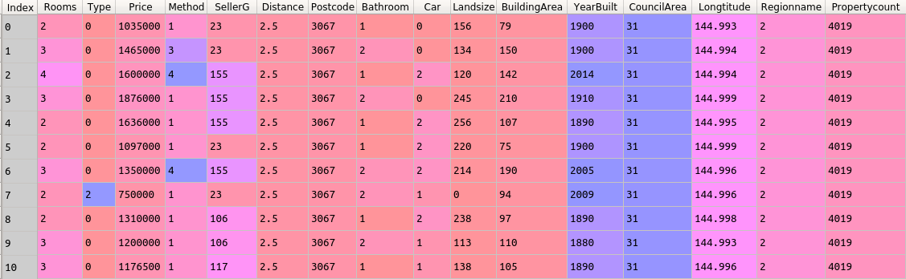

The dataset has details of 6830 house entries with the following 16 features

| **Feature** | **Description** |
| --- | --- |
| Rooms | Number of rooms |
| Type | Property type |
| Price | Price in dollars |
| Method | Property status |
| SellerG | Real Estate Agent |
| Distance | Distance from CBD |
| Postcode | Code of the area |
| Bathroom | Number of Bathrooms |
| Car | Number of carspots |
| Landsize | Land Size |
| BuildingArea | Building Size |
| YearBuilt | The year in which home was built |
| CouncilArea | Governing council for the area |
| Longtitude | The angular distance of a place east or west |
| Regionname | General Region (West, North West, North, Northeast …etc) |
| PropertyCount | Number of properties that exist in the suburb |

**Why solve this project?**

After completing this project, you will have a better understanding of how to build a regularized regression model. In this project, you will apply the following concepts.

* Train-test split
* Correlation between the features
* Linear Regression
* Polynomial Regressor
* Lasso Regressor
* Ridge Regressor
* R^2*R*2Evaluation Metrics