Since im working alone I wanted to work with a simple app so I had AI generate me an app I can work on for this project.

Starting app with one command
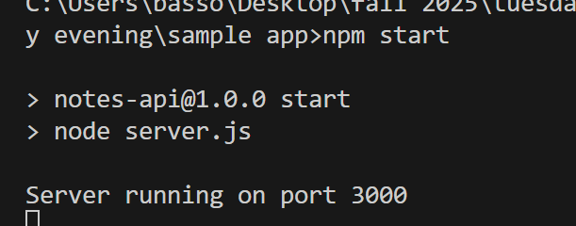

Docker
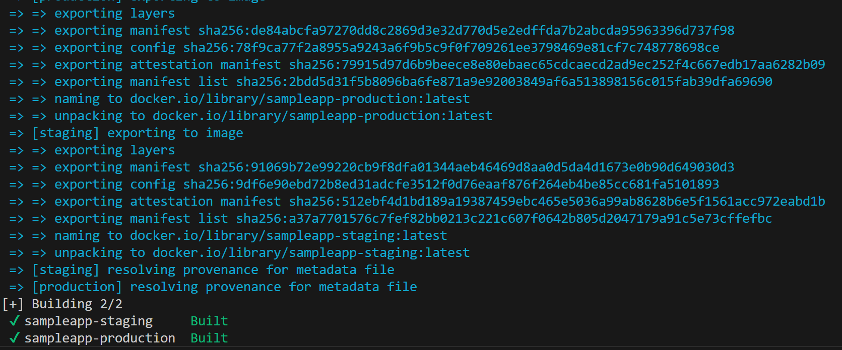
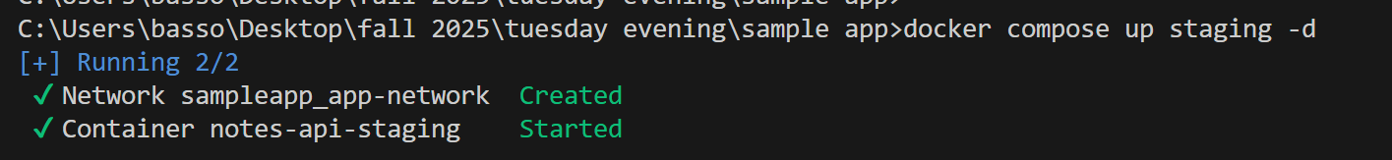
Running in browser
