Project Proposal

Name – Husandeep Singh Hayer

Submitted To – Vision College, Auckland

Student id – 3153190

Course – Software Development And Design

Level – 6

Table of Contents

PROJECT GOALS 2

Project objectives 3

Project Scope 3

Analysis Document 3

Log In page 3

Home Page 4

About Page 5

Contact Page 6

Employee page 7

Design Document (ScreenShots) 9

Login page 9

Home Page 10

About page 11

Contact page 11

Employee Page 12

User manual 12

Login Page 12

Home Page 13

About page 13

Contact page 14

Employee page 14

Hardware and software requirements 15

Resources need to complete the project 15

Project milestone 15

Project schedule 16

# PROJECT GOALS

Goals for this website is to manage employees like when ever there is any public holiday or other day off and something related to any celebration or over working hours. Staff and other like Mangers and company head will save time. As there is no need to contact other. So by this they will save their plenty of time.

# Project objectives

Principally, the main objective of this website is to save the time of the users like company managers and other head of the departments can easily publish the information through website. Rather than sending a lot of emails and contacting each other.

# Project Scope

In these website I have used web api web Api is an Application for either a web server or a web browser. It is a web development concept, usually limited to a web application client-side including any web framework being used and thus usually does not include web server or browser implementation details such as APIs unless publicly accessible by a remote web application.

Mainly this website is made to target companies and employers so they can manage there employees and save the data of there employees.

I focused to use WebApi and Mvc framework and c# and asp.net So with these website work more fast than usual I have not used other language like html, other frameworks, Java script, php etc because they may lack some times.

# Analysis Document

## Log In page

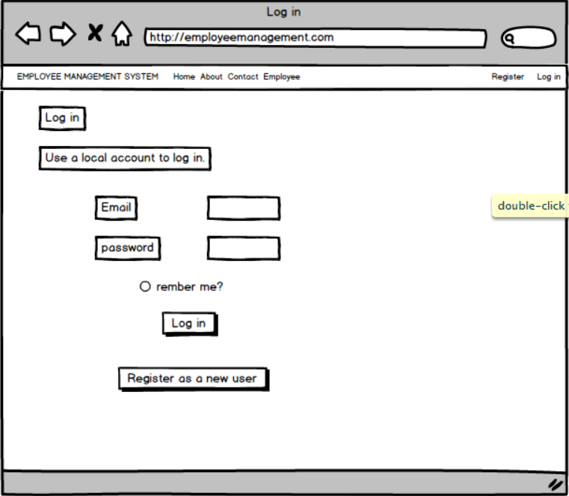

## Home Page

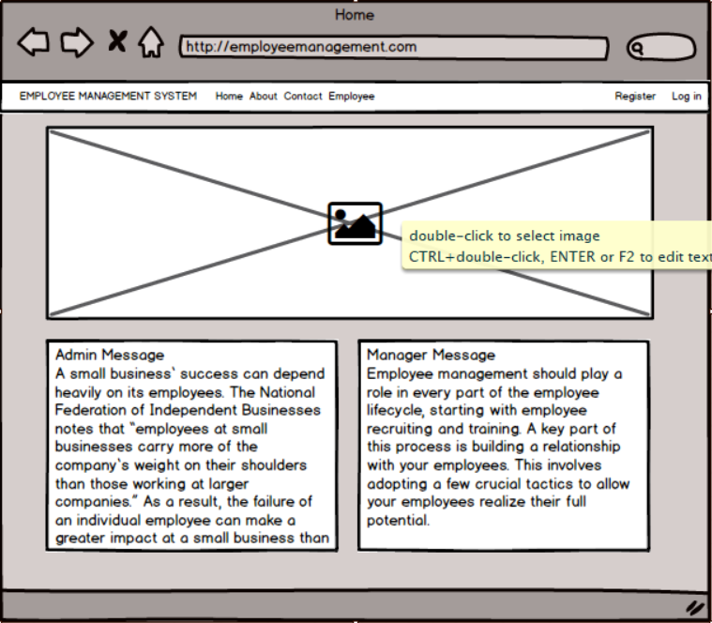

## About Page

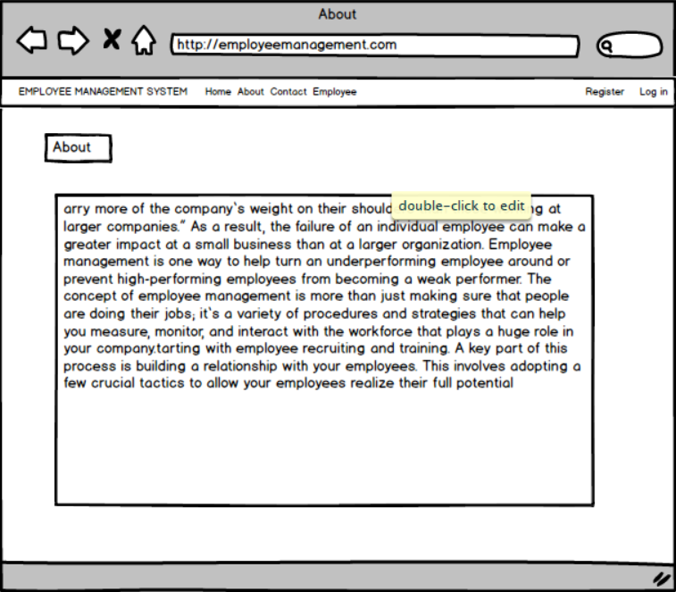

## Contact Page

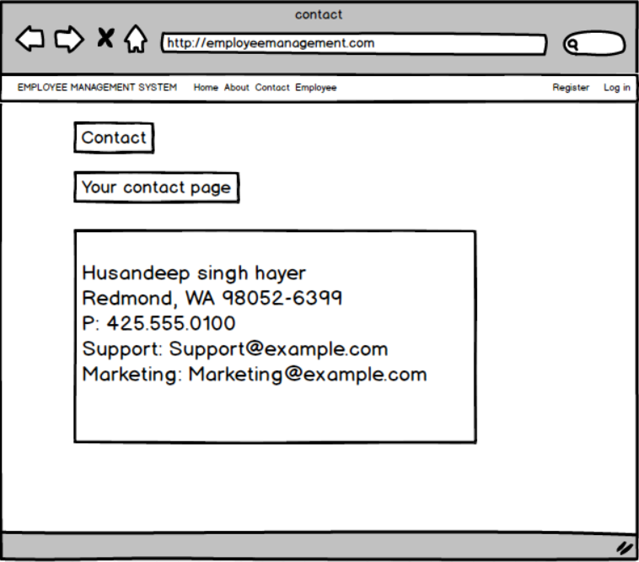

## Employee page

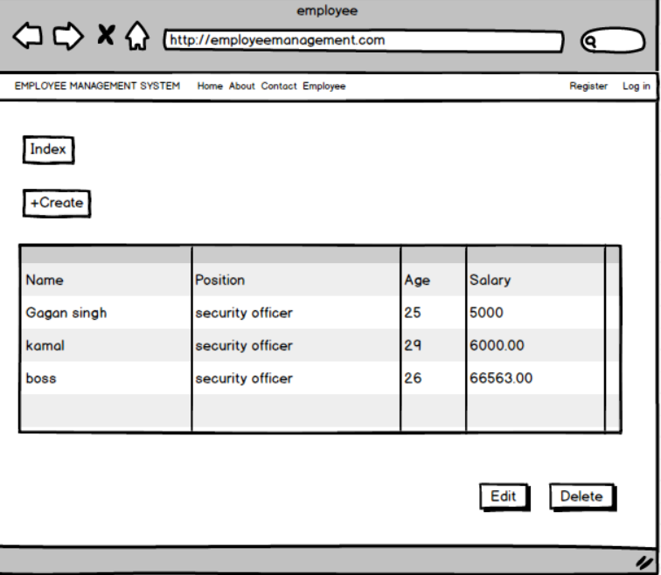

# **Design Document (ScreenShots)**

## Login page

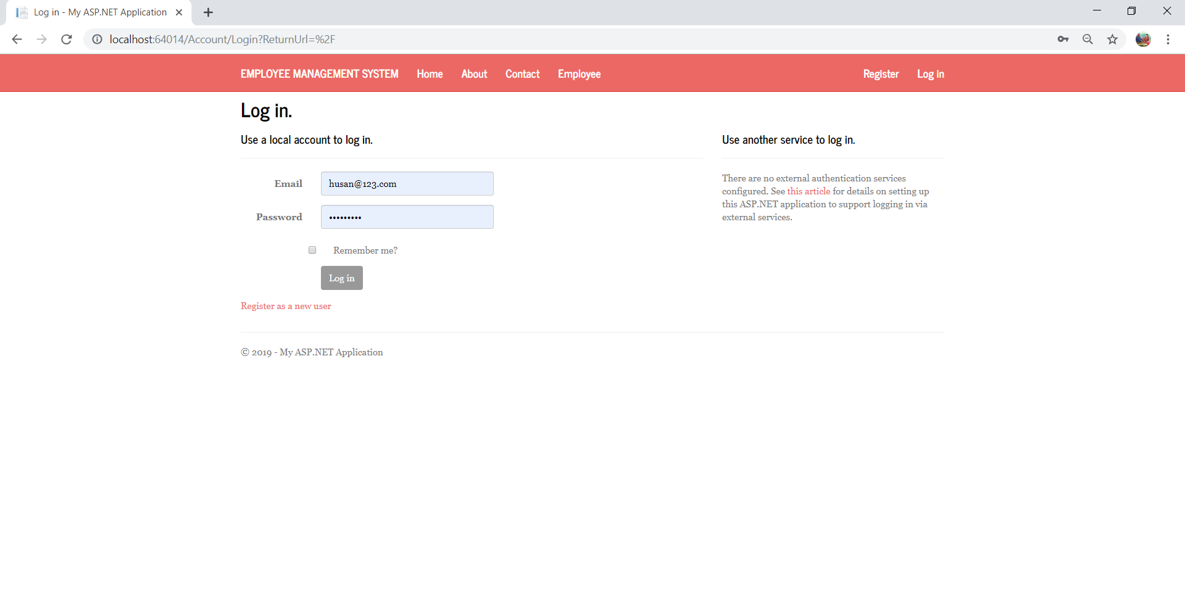

## Home Page

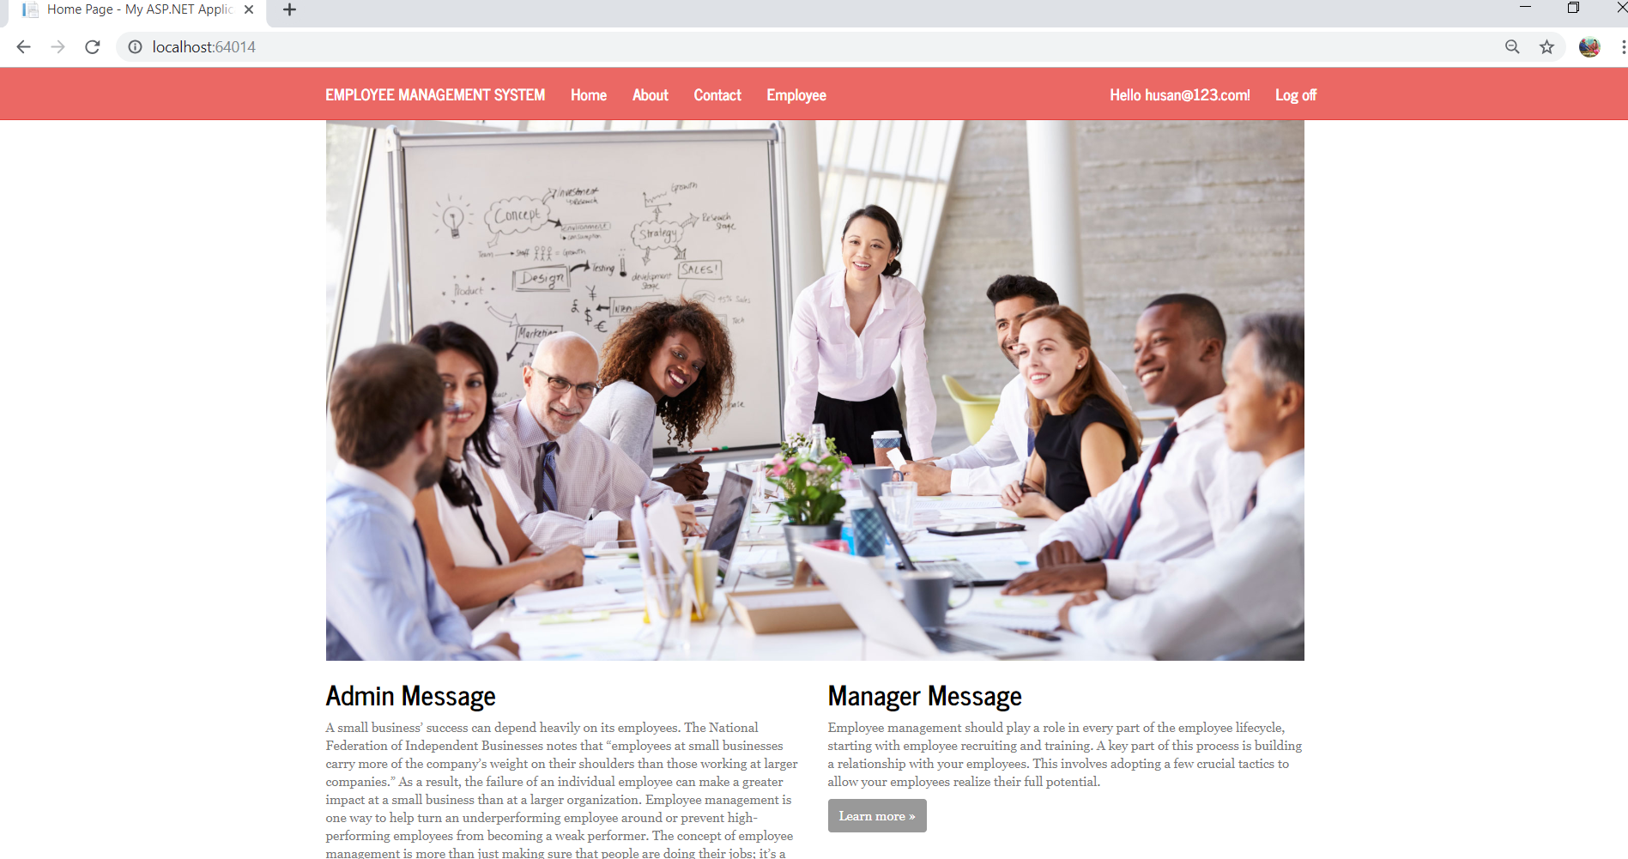

## About page

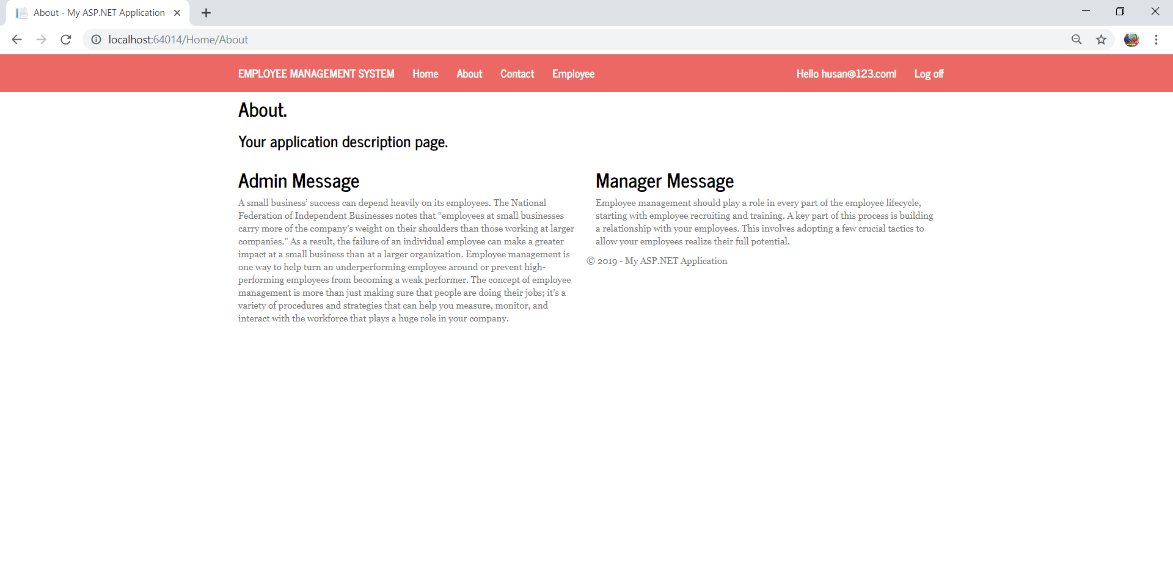

## Contact page

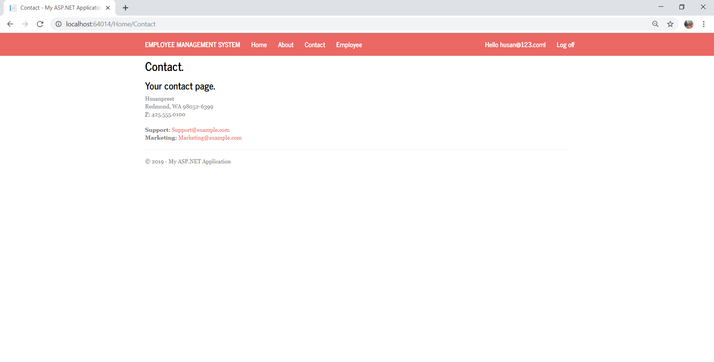

## Employee Page

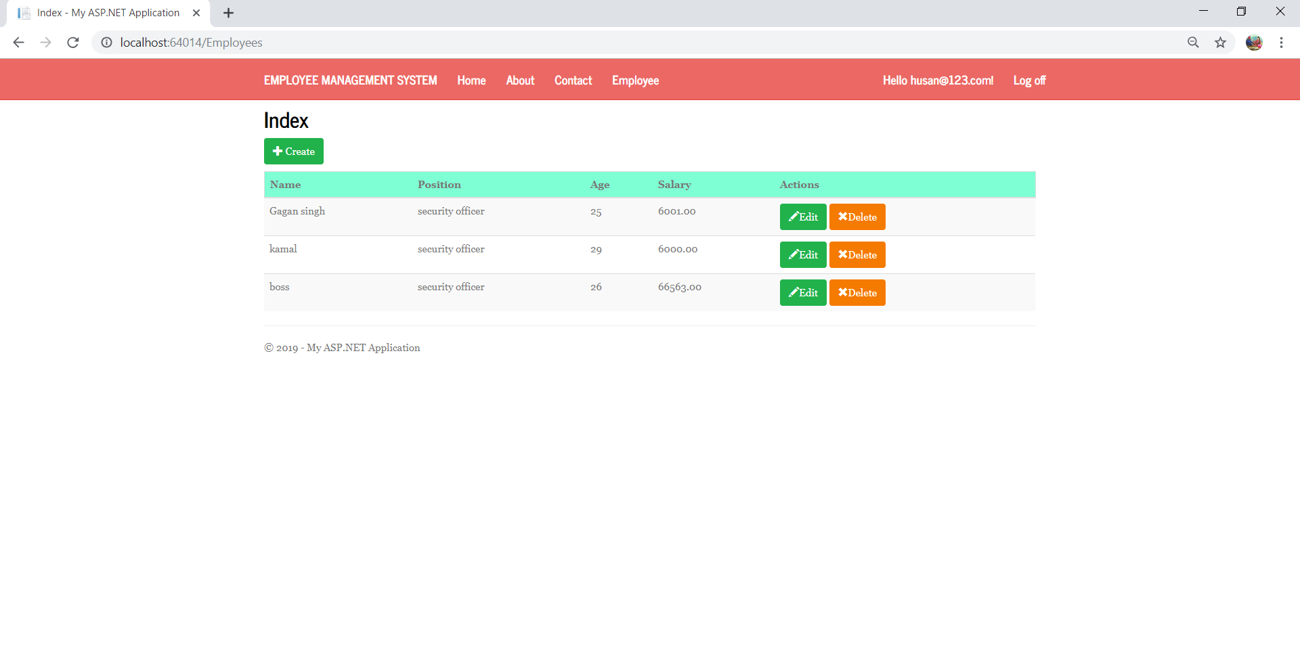

# User manual

## Login Page



Firstly user need to register a new user and then login while entering there details with these user will have access to application

## Home Page



These is a first page of application home page from here user and other people can read the information from here user can also go on other pages like contact about.

## About page



This is a about page about the company information is given here like some of admin message and manager message

## Contact page



These is a contact page here is a information about admin so any want to contact can easily contact from here with given information like phone numbers and email id

## Employee page

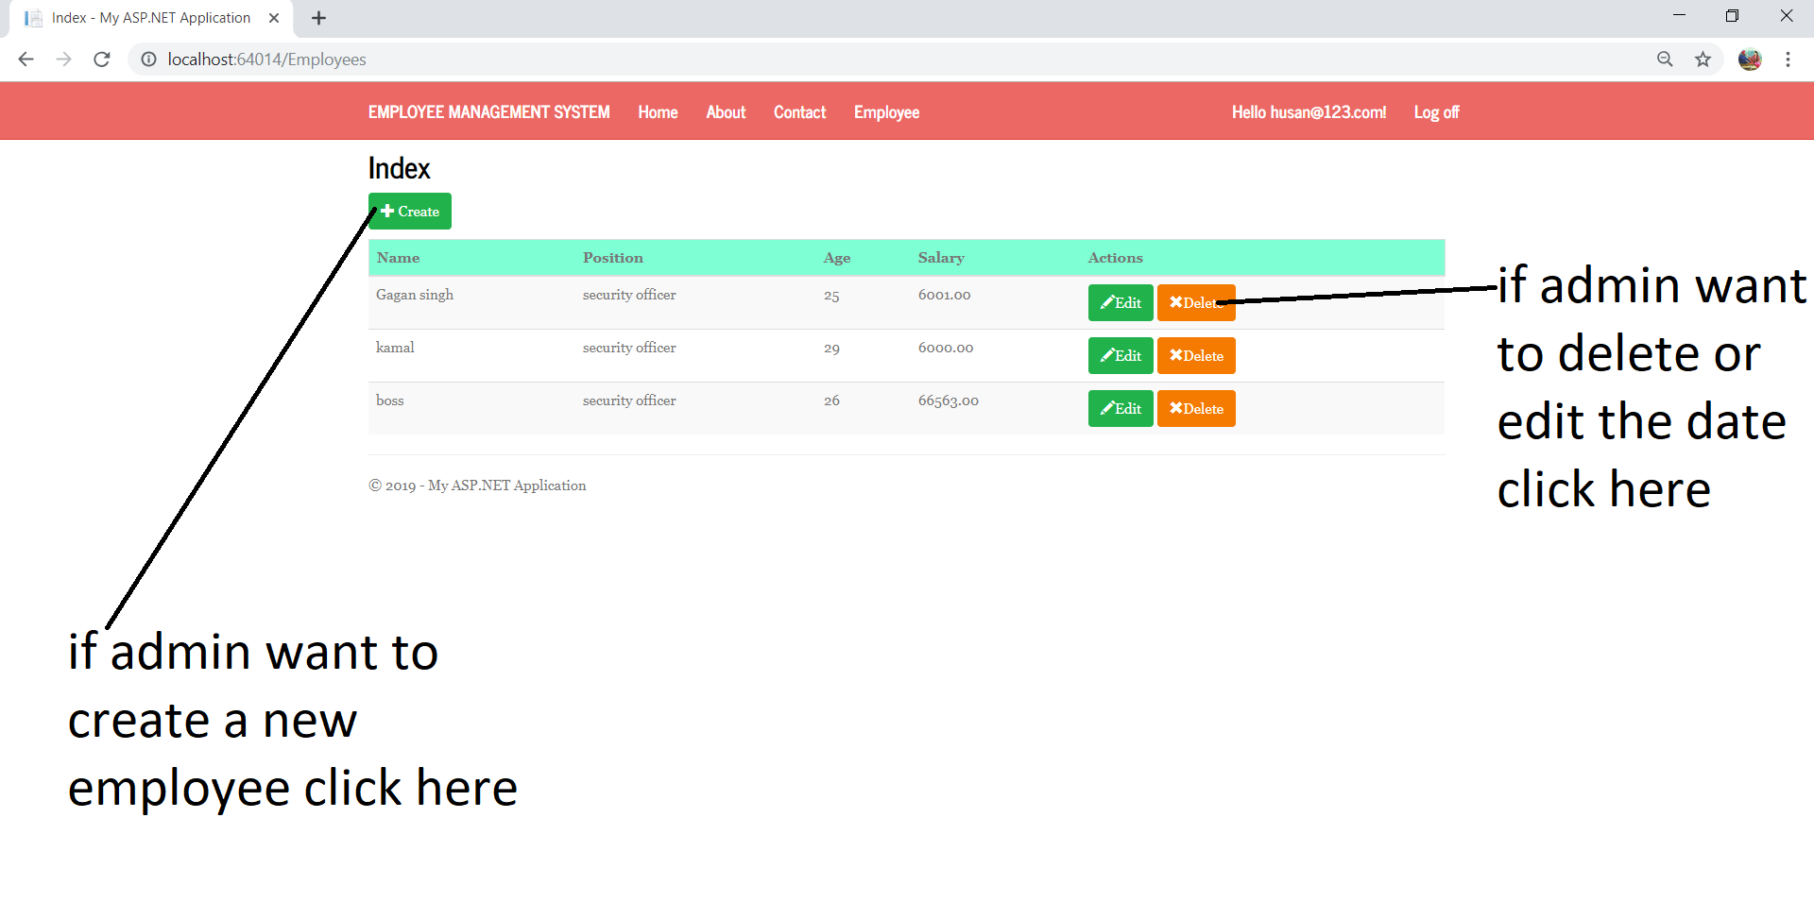

After click on create or edit these page will open you can just add the details.

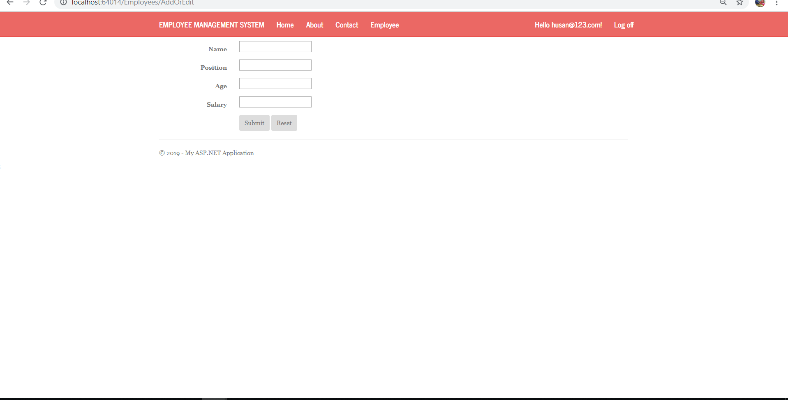

# Hardware and software requirements

* User need at lest 2015 visual studio
* user need i5 processer
* user need sql management system to manage database
* User need at lest 512 gb storage

# Resources need to complete the project

* Laptop
* Visual Studio 2015
* SQL Management System
* Balsmiq
* Internet

# Project milestone

|  |  |  |  |
| --- | --- | --- | --- |
| Planning | 5 Days | 02/03/2019 | 07/03/2019 |
| Coding | 10 Days | 08/03/2019 | 18/03/2019 |
| Monitoring | 2 Days | 20/03/2019 | 22/03/2019 |
| editing | 6 Days | 25/03/2019 | 31/03/2019 |
| Closing | 4 Days | 03/04/2019 | 07/04/2019 |

# Project schedule

|  |  |  |
| --- | --- | --- |
| Planning | 5 Days  2/3/19  3/3/19  4/3/19  5/3/19  6/3/19  7/3/19 | Hours  3  2  5  4  6  1 |
| Coding | 10 Days  8/3/19  9/3/19  10/3/19  11/3/19  12/3/19  13/3/19  14/3/19  15/3/19  16/3/19  17/3/19 | 2  5  2  3  4  6  6  8  9  5 |
| Monitoring | 2 Days  20/03/19  21/03/19 | 4  6 |
| editing | 6 Days  20/03/19  21/03/19  22/03/19  23/03/19  24/03/19  25/03/19 | 20/03/2019  3  5  5  6  7  5 |
| Closing | 4 Days  03/04/19  04/04/19  05/04/19  06/04/19 | 3  4  5  9 |