**Applications of DSP & Computing Vision**

Yifan Zhao, **Computer Vision Group Project**

Spring 2015

**Automatic real-time face detection and tracking**

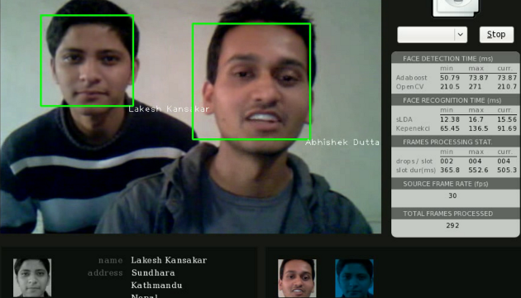

**Background**

Facial feature detection and tracking is being extensively studied in computer vision for a variety of applications which vary from surveillance to facial expression analysis. The increased interest in this field is evident by the quantity of literature written in this field and the IEEE and IEE workshops and conferences on human motion analysis and special journal issues that focus solely on gesture recognition, video surveillance and human motion analysis.

Real time face tracking and recognition refers to the task of locating human faces in a video stream and identifying the faces by matching them against the database of known faces.

**Project Outline**

You will be supplied with web cameras and required to develop a demonstration in C++ based on Visual Studio 2012/2013 with openCV. This prototype must address the following tasks:

1. Detection of single face and multi faces under various backgrounds, illumination (40%)
2. Recognize face of each member and have a name shown in screen (20%)
3. Tracking single face, multi faces (simple, complex background) (40%)

The methods to solve above problems are not limited. However, the working flow chart must be presented clearly in the report. Multiple solutions are welcomed.

Demonstration can run in the computer of the PC Lab.

**Project Deliverables**

**1. Conference paper with role description – part A:** A four-page conference paper comprising of abstract, introduction, prior work (literature review), methodology (possibly comprising of additional approach specific sub-sections), evaluation and discussion, conclusions and further work.

The literature review should be brief and detail current relevant computer vision research approaches in object tracking. This should be a “critical review” that evaluates prior research approaches and not simply just a “list or discussion of current approaches”. Figures, tables and graphs can be used as appropriate. The paper should follow the IEEE two-column layout in the following conference templates (format can be downloaded from internet). This paper aims to evaluate the performance of this system about successful rate, processing speed etc. and discuss the key advantages of the proposed method such as motion estimation, selection of invariant etc.

One page document is also required to clearly identify the role and contribution of each member.

**2. Demonstration – part B:** The demonstration will be a live demonstration of your developed system performing the tasks outlined in the project outline section. Students may decide upon the lighting conditions and background in which it is demonstrated.

**3. Presentation – Part C:** Your report will be additionally presented as a group presentation to the board of directors. The group presentation will last approximately 30 minutes with each group member presenting for ~5-6 minutes on their contribution with time for questions afterwards. It should cover the material detailed in the paper and the demonstration.

**Assessment**

This project will be assessed as a group and notwithstanding exceptional circumstances all students will be awarded the same “group mark”. Therefore, equal marks will be given to each member of the group for the group effort. The contribution from each group member for his/her role must be clearly identified in the report, and this will determine any exceptional variation in the marks. Note that the contribution from each member to this report will be examined in the presentation. In exceptional circumstances where a student has failed to make a significant contribution to the overall project or whose effort is identified as being significantly lesser than other group members a mark less than the overall “group mark” may be awarded to that individual.

All reports will be submitted (in electronic form) through the Cranfield University plagiarism detection system (Turnitin) by the student groups prior to final submission. This is the standard university-wide policy for the submission of all written assignments at Cranfield University. Plagiarism will be penalised.

**Deadline**

**Report:** 3th April 2014

(Submit to [CSTEAdmin@cranfield.ac.uk](mailto:CSTEAdmin@cranfield.ac.uk) as PDF or WORD)

**Presentation / Demonstration:** 6th March 2014

All source code, executables, testing videos or images and presentation files to be emailed as a zip file to CSTEAdmin@cranfield.ac.uk after the presentation / demonstrations have occurred.