Flipkart clone
Submitted by

Govind Kulkarni

2317081 MCA

St Aloysisus Institute of Management and Information

Technology (AIMIT) Mangalore

Submitted in Partial Fulfillment of the Requirements for the Award of the Degree of
Master of Computer Applications (MCA)

Under the guidance of

Dr. Rakesh Kumar Mr. Nagaraj Bhat
Assistant Professor & HOD Mentor, VRAIO
(Department of M.Sc. – BDA), Software Pvt Ltd
AIMIT, St Aloysius College, Bangalore. Mangalore.
Submitted to


ST. ALOYSIUS INSTITUTE OF MANAGEMENT AND

INFORMATION TECHNOLOGY (AIMIT)
ST ALOYSIUS COLLEGE (Deemed to be University)
MANGALURU, KARNATAKA

2025



ST ALOYSIUS INSTITUTE OF MANAGEMENT AND INFORMATION TECHNOLOGY

ST ALOYSIUS COLLEGE (AUTONOMOUS)
MANGALORE, KARNATAKA
CERTIFICATE
This is to certify that the project titled

Flipkart clone
Submitted by
Govind Kulkarni

2317081

MCA

St Aloysisus Institute of Management and Information

Technology (AIMIT) Mangalore
In partial fulfillment of the requirements for award of degree of Master of MCA of Mangalore University, is a bonafide record of the work carried out at

VRAIO Software Solutions Pvt Ltd
Bangalore
During the year
2025

Dr. Rakesh Kumar Assistant Professor & HOD
(Department of M.Sc. – BDA), AIMIT, St. Aloysius College,
Mangaluru-575 022.

Dr (Fr) Kiran Cotha SJ Director, St.
Aloysius College
Mangaluru-575022.

Dr Hemalata N
Dean, School of IT
PG Depts of Information Technology, AIMIT, St. Aloysius College,
Mangaluru-575 022.

Examiners
1.

2

ST ALOYSIUS INSTITUTE OF MANAGEMENT AND INFORMATION TECHNOLOGY
ST. ALOYSIUS COLLEGE (Deemed to be University)
BEERI, MANGALORE – 575 022
P G DEPT OF INFORMATION TECHNOLOGY & BIOINFORMATICS

PROFORMA OF PROJECT PROPOSAL

Note: The student has to fill this form and approval has to be sought from the Dean of the faculty before starting the Industry Internship.(January I week)

- Student Register Number: ______________________________________________
- Student Name : _______________________________________________________
- Title of the Project : ____________________________________________________
- Name & Address of the Organization : _____________________________________
______________________________________________________________________
- Telephone No. : ________________________________________________________
- E-mail : ______________________________________________________________
- Website / URL : ________________________________________________________
- Address of the Project Site : ______________________________________________
______________________________________________________________________
- Telephone No. : ________________________________________________________
- E-mail : ______________________________________________________________
- Residential Address of the Student : _______________________________________
______________________________________________________________________
- Telephone No : ________________________________________________________
- Mobile Number : _______________________________________________________
- E-mail : _______________________________________________________________
I hereby declare that the above furnished details are true to best of my knowledge and request you to permit me to join the Industry Internship for the Project work prescribed for MCA / MSc (Software Technology/Big Data Analytics/Data Science).

Signature of the Student

The Proposal for the project work has been accepted

Dean of the Faculty

CERTIFICATE OF AUTHENTICATED WORK

This is to certify that the project report is entitled

submitted to Aloysius Institute of Management and Information Technology (AIMIT), St Aloysius College, Mangalore affiliated to Mangalore University in partial fulfilment of the requirement for the award of the degree of MASTER OF COMPUTER APPLICATIONS (MCA)/ / MSc
(Software Technology/Big Data Analytics/Data Science is an original work carried out by Mr./Ms. Register no.
under my guidance. The matter embodied in this project is authentic and is genuine work done by the student and has not been submitted to this University, or to any other University / Institute for the fulfilment of the requirement of any course of study.

--------------------------------- -----------------------------------

Signature of the Student: Signature of the Guide Date: _______________ Date: _______________
Name and Address of the student Name, Designation and Address of
Govind Kulkarni the Guide:
Mangalore Dr. Rakesh Kumar
Register no:2317081 Assistant Professor & HOD
(Department of M.Sc. – BDA),
AIMIT, St. Aloysius College,
Mangaluru-575 022.

ABSTRACT

The Software Application named Flipkart Clone aims to streamline online retail operations and customer management. This application provides tools for product catalog management, order processing, payment integration, and comprehensive reporting. With a user-friendly interface, it simplifies e-commerce operations and improves service delivery through features like advanced product search and filtering, secure payment processing, real-time order tracking, and data analytics. By automating tasks and centralizing information, the application reduces errors, saves time, and enhances productivity while supporting sustainable practices by minimizing manual processes. The platform includes robust user management, shopping cart functionality, wishlist features, and an administrative dashboard for complete business oversight. Ultimately, it aims to improve operational workflow, increase customer satisfaction, and support the growth of online retail business through a comprehensive and scalable e-commerce solution
Project Proposal Report Synopsis
for
Flipkart clone

Govinda Kulkarni
2317081
MCA

St Aloysisus Institute of Management and Information

Technology (AIMIT) Mangalore

Under the guidance of

Dr. Rakesh Kumar Assistant Professor & HOD
Dept of M.Sc.- Big Data Analytics
St Aloysius Institute of Management and Information Technology
AIMIT (Deemed to be University),
Mangalore

Submitted to



ST ALOYSIUS INSTITUTE OF MANAGEMENT AND INFORMATION TECHNOLOGY (AIMIT)
ST ALOYSIUS COLLEGE (Deemed to be University)
MANGALORE, KARNATAKA

PROJECT PROPOSAL/SYNOPSIS
- Title of the Project
“Flipkart clone”

- Statement of the Problem
In the era of digitalization, online shopping has become an essential service for users. However, building a full-fledged e-commerce platform from scratch involves complex architecture and coordination between front-end, back-end, and database systems. The aim is to develop a fully functional, scalable, and user-friendly Flipkart-like e-commerce web application using modern technologies such as the MERN stack.

- Why this particular topic chosen?
• E-commerce is a trending and practical domain in the tech industry.
• It provides hands-on experience with real-world full-stack development.
• MERN stack is widely used in the industry for high-performance applications.
• The project helps in understanding the integration of different technologies and managing data flow efficiently between front-end and back-end.

- Objective and Scope
The primary objective of Flipkart Clone is to provide a comprehensive digital marketplace where customers can browse, purchase, and manage orders for a wide variety of products conveniently.
Key objectives include:
- Creating a seamless shopping experience for customers with advanced product discovery and filtering capabilities.
- Providing administrators with powerful tools to manage inventory, orders, users, and overall system operations efficiently.
- Implementing secure payment processing with multiple payment gateways (Razorpay, Stripe, COD) for enhanced user convenience.
- Building a robust user management system with role-based access control and profile management.
- Developing an intuitive order tracking and management system for both customers and administrators.
- Creating a responsive and modern UI/UX that works seamlessly across all devices.

The scope of this application covers:
- User Management: Registration, authentication, profile management, and role-based access control for customers and administrators.
- Product Management: Comprehensive product catalogs with detailed descriptions, images, specifications, reviews, and ratings. Advanced filtering, searching, and sorting capabilities.
- Shopping Experience: Shopping cart functionality, wishlist management, "Save for Later" feature, and seamless checkout process.
- Order Management: Order placement, payment processing, order tracking, and status updates throughout the delivery lifecycle.
- Payment Integration: Multiple payment options including Razorpay, Stripe, and Cash on Delivery (COD) with secure transaction handling.
- Admin Dashboard: Comprehensive administrative interface for managing products, orders, users, reviews, and system analytics with real-time data visualization.
- Inventory Management: Stock tracking, product availability management, and automated stock updates upon order placement.
- Review System: Product rating and review functionality with moderation capabilities for administrators.
- Responsive Design: Mobile-first approach ensuring optimal user experience across desktop, tablet, and mobile devices.
- Security Features: JWT authentication, secure payment processing, input validation, and data protection measures.

- Methodology
The project will follow the Agile methodology to ensure flexible, iterative development and quick adaptation to stakeholder feedback. This approach is ideal for complex e-commerce systems that require rapid updates and clear progress tracking. The tech stack includes React.js with Redux, Material-UI, Tailwind CSS, and React Router on the front end, and Node.js with Express, MongoDB with Mongoose, JWT authentication, and RESTful APIs on the backend. Payment options will include Razor pay, Stripe, and Cash on Delivery (COD). Development will be supported by Git version control, modular architecture, middleware, and strong error handling. Together, these technologies will enable the creation of a secure, scalable, and user-friendly e-commerce platform with robust admin tools.

- Process Description
The system is divided into several key modules to ensure smooth functionality and a great user experience:
- User Module: Handles user sign-up, login, profile management, and shopping cart. Built using React.js, Redux, Material-UI, and Tailwind CSS for a responsive and user-friendly interface.
- Product Management: Manages product listings, search, filtering, reviews, and inventory. Includes both customer views and admin controls for easy product management.
- Order Management: Covers everything from order placement to payment and tracking. Supports Razor pay, Stripe, and Cash on Delivery with secure order verification.
- Backend Development: Powered by Node.js and Express.js, this handles all server logic, APIs, authentication with JWT, file uploads, and error handling.
- Database Module: Uses MongoDB with Mongoose to store and manage data efficiently covering users, products, orders, payments, and reviews.
- Admin Dashboard: A powerful panel for admins to manage users, products, orders, and reviews. Includes role management, analytics, and system monitoring.

- Resources and Limitations
Languages used:
- Front-end: Tailwind CSS, React.js
- Back-end: Node.js
-Database: MongoDB
Hardware Interface:
- RAM: 4GB and above
- Hard Disk Utilization: 500MB and above
IDE:
-Visual Studio

Limitations:

- Scalability challenges with handling large product catalogs and high user traffic.
- Data security concerns requiring robust encryption and access control measures.
- Integration complexity with multiple payment gateways and external services.
- Performance optimization needed for real-time inventory and order processing.
- Mobile responsiveness challenges across different devices and screen sizes.
- Payment gateway dependencies and potential downtime risks from third-party services.
- Initial limited feature set requiring future enhancements and improvements.

- Testing Technologies used
Modules in this project will be tested using:
-Unit Testing
-Integration Testing
-Database Testing
-API Testing
-User Interface Testing
-Payment Gateway Testing
After developing each module, unit testing along with various test cases will be performed. Every module is integrated with every other module to define various module interdependent test cases. Various random test cases will be prepared beforehand depending upon the e-commerce platform requirements and hence by creating a testing environment for the various test cases.

- Conclusion
Flipkart Clone is designed to revolutionize the way consumers shop online by providing a reliable, convenient, and efficient e-commerce platform. By addressing the pain points of traditional online shopping, the application aims to offer superior quality and service through a comprehensive digital marketplace experience. The integration of multiple modules—user management, product catalog, order processing, payment integration, and admin dashboard—ensures a seamless operation from product discovery to order fulfillment. With thorough testing and continuous improvements based on user feedback, the platform is poised to become a leading solution in the e-commerce market, offering customers a modern, secure, and user-friendly shopping experience while providing administrators with powerful tools for platform management and business growth.

ACKNOWLEDGMENT

The satisfaction that accompanies the successful completion of any task would be impossible without mentioning the people who made it possible, whose constant guidance and encouragement crown all efforts with success. This project has been the most practical and exciting part of my learning experience during the final semester, which would be an asset for me in my future career.

I sincerely appreciate all those people who have been instrumental in making this project a success. I am very grateful to VRAIO Software Solutions Pvt Ltd Bangalore for having provided me with this project with the necessary facilities and a good environment.

I would also like to thank my External guide Mr. Nagaraj Bhat at VRAIO Software Solutions Pvt Ltd, for his guidance and the useful suggestions that helped me complete this project.

I would like to thank Rev. Dr. Praveen Martis SJ, Principal of St Aloysius College and Dr (Fr) Kiran Cotha SJ, Director of Aloysius Institute of Management and Technology (AIMIT) for their constant support and encouragement.

I am also highly obliged to Dr Hemalatha N, Dean Academics (IT), St Aloysius College for his help and instructions rendered me during my project work.

I would like to thank my Internal Guide Dr. Rakesh Kumar who has been very supportive throughout the project and who has provided me with all valuable inputs to put my efforts on the right track.

Finally, I place a deep sense of gratitude to my family members and my friends who have been a constant source of inspiration during the preparation of this project.

Table of Contents

CHAPTER 1: INTRODUCTION 12
  - Background 13
  - Objectives 13
  - Purpose, Scope and Applicability 13
    - Purpose 13
    - Scope 13
    - Applicability 13
  - Achievements 14
  - Organization of Report 14
CHAPTER 2: SURVEY OF TECHNOLOGIES 16
  - MongoDB 17
  - Node JS 17
  - React JS 18
  - Tailwind CSS 18
CHAPTER 3: REQUIREMENTS AND ANALYSIS 19
  - Problem Definition 20
  - Requirement Specification 20
    - Purpose 20
    - Document Convention 20
    - Intended Audience and Reading Suggestions 21
    - Project Scope 21
    - Overall Description 21
      - Product perspective 21
      - Product Features 22
      - User Classes and characteristics 22
      - Design and Implementation Constraints 22
      - User Documentation 23
      - Assumption and Dependencies 23
  - Software and hardware requirements 23
  - System Features 23
    - Functional requirements… 23
    - Non-Functional requirements 24
      - safety requirements 24
      - security requirements 24
  - Software quality attribute 25
  - planning and scheduling 25
  - Conceptual Model 27
    - Data Flow Diagram 27
    - Entity Relationship Diagram……………………………28

CHAPTER 4: SYSTEM DESIGN 33
  - Basic Models 34
  - Data Design Project Structure 34
    - Schema Design 34
    - Data Integrity and Constraints 36
  - Procedural Design… 36
    - Logic Diagrams 36
      - Use Case Diagram 37
      - Class Diagram 38
      - Sequence Diagram… 40
      - State chart Diagram 44
      - Activity Diagram 46
  - Security Issues 48
  - Test case design software testing 48
  - User interface design 50
CHAPTER 5: IMPLEMENTATION AND TESTING 57
  - Implementation Approaches 58
  - Coding Details and Code Efficiency 58
  - Testing Approach 59
    - Unit Testing 59
    - Integration Testing 60
    - User acceptance Testing 60
5.3.4 Performance Testing 60
CHAPTER 6: RESULTS AND DISCUSSION 61
6.1 Test Reports 62
CHAPTER 7: CONCLUSION 66
  - Conclusion 67
  - Limitations of the System 67
  - Future Scope of the project 67
REFERENCES 67
GLOSSARY 68

Table of Figures

Figure 1. Data Flow Diagram 28
Figure 2. Level 1 DFD for Admin 29
Figure 3. Level 1 DFD for User… 30
Figure 4. Use case Diagram 38
Figure 5: ER Diagram …………………………………………………………….44
Figure 6. Class Diagram 40
Figure 7. Sequence Diagram for login and registration 42
Figure 8. Sequence Diagram for Admin 42
Figure 9. Sequence Diagram for User. 43
Figure 11. Admin-State Chart Diagram… 45
Figure 12. User-State Chart Diagram… 45
Figure 14. Activity Diagram… 48
Figure 15: Home page 50
Figure 16: Product Description 50
Figure 17: Admin Dashboard 51
Figure 18: Add Product 51
Figure 19: Login Page 52
Figure 20: Customer Profile 52
Figure 21: Order page 53
Figure 22: Admin Order Update Status 54

List Of Tables
Table 1: Database Table for users 35
Table 2: Database Table for products… 35
Table 3: Database Table for orders. 36
Table 4: Database Table for payments. 36
Table 5: Database Table for Wishlist. 36

CHAPTER 1: INTRODUCTION

CHAPTER 1: INTRODUCTION

Background
Flipkart Clone is to develop a comprehensive software application to streamline and enhance the online shopping experience for customers. The software will include features for user authentication, profile management, product browsing and search, shopping cart functionality, order placement and tracking, secure payment processing, wishlist management, and a robust admin panel for efficient management of users, products, orders, and reviews.

Objectives
- Create an integrated and user-friendly e-commerce platform for online shopping.
- Optimize operational efficiency within the product catalogs and order management processes.
- Enhance order processing and payment management capabilities.
- Improve inventory control and stock management mechanisms.
- Facilitate seamless user interactions and engagement through modern UI/UX.

Purpose, Scope, and Applicability

Purpose
The purpose of this project is to design and implement a software application that facilitates seamless and efficient online shopping processes for customers, providing a comprehensive e-commerce platform with secure payment processing and robust administrative tools.

Scope
The scope of the project encompasses the development of both the customer-facing e-commerce application and the admin panel. Key functionalities include user registration and authentication, profile and address management, product browsing and search, shopping cart functionality, order placement and tracking, secure payment processing, and comprehensive admin capabilities for product, order, user, and review management.

Applicability
This software application is applicable to online shoppers and the administrative team managing the e-commerce platform. It is designed to enhance the efficiency and productivity of online retail operations, ensuring smooth and effective management of all related processes including inventory, orders, payments, and customer support

Achievements
Upon completion, the software application will provide a robust solution for managing online retail operations, resulting in improved operational efficiency, better user experience, enhanced data management and reporting capabilities, and a scalable platform for future growth and feature additions.

Organization of Report
This report is documented with an engineering approach to the solution of the problem being addressed. Following is the brief description of the remaining chapters of the report.

Chapter 1: Introduction
The system being developed is introduced in this chapter. A description of the background and context of the e-commerce project is specified. Concise statement of the aims and objectives of the project along with the purpose, scope and applicability are mentioned.

Chapter 2: Survey of technologies
This chapter provides details of all the technologies which are used to complete the project including React.js, Node.js, MongoDB, Express.js, Material-UI, Tailwind CSS, and payment gateways. This also demonstrates the awareness and understanding of the available technologies related to the topic of the project.

Chapter 3: Requirements and Analysis
The requirements that lead to the development of the e-commerce system are mentioned and analyzed in this chapter. This includes the problem definition, requirement specification and planning and scheduling. The details of the overall problem and the sub problems are provided in the problem definition phase. Planning for the purposes and the certain rules and constraints are specified in the planning and scheduling phase. The hardware requirements and software requirements are specified in the document. The hardware required to run the product in the system is clearly specified. The software requirements such as operating system and other software to link and install the software are listed in this section. The requirements and objectives of the new system, its functions and operations are given in the product description section. The conceptual models are built to understand the problem domain which describes the operations that can be performed and the allowable sequences of those operations.

Chapter 4: System Design
System Design describes the features and operations in detail, including the data design, functional and interface design, process diagrams, details description of functions and the test case design. The Basic Modules section briefly describes all the modules including user management, product catalog, order processing, payment integration, and admin dashboard. The next section is the Data Design which consists of how to organize, manage and manipulate the data. This section again has two Subsections-Schema design and Data Integrity and constraints. Schema design defines the structure and explanation of schemas. Data Integrity and constraints specifies all the validity checks and constraints.

Chapter 5: Implementation and testing
This chapter defines the plan of implementation and standards used in implementation, code efficiency, and testing approach, integrated testing, Modifications and improvements of project including unit testing, integration testing, API testing, and payment gateway testing.

Chapter 6: Results and Decisions
Here the test reports explain the test results and reports based on the test cases thereby showing that the software can face any problematic situation and that it works fine in different conditions. And the user documentation defines the working of the software. That is explaining its different functions, components with screen shots including user registration, product browsing, shopping cart, order placement, payment processing, and admin dashboard functionalities.

Chapter 7: Conclusions
This chapter summarizes the entire work. It explains all the points that have been made in the earlier chapters. It also includes the limitations of the system, listing all the criticism encountered during the demonstration of the software. It also proposes the future scope of the project i.e., new areas of investigation prompted by developments such as advanced analytics, recommendation systems, and multi-vendor support. It also explains the limitations of the system and the future possible enhancements of the system.

CHAPTER 2: SURVEY OF TECHNOLOGIES

CHAPTER 2: SURVEY OF TECHNOLOGIES

MongoDB
MongoDB is a leading NoSQL database known for its flexibility and scalability in managing unstructured and semi-structured data. Developed and maintained by MongoDB Inc., it stores data in BSON (Binary JSON) format, making it easy to handle complex data structures. MongoDB's document-based model allows for schema-less databases, enabling developers to iterate quickly and adapt to evolving data needs. It supports high availability with built-in replication and automatic partitioning with sharding.
As an open-source database, MongoDB fosters a vibrant community that contributes to its rich ecosystem of libraries, tools, and plugins. It is widely used in applications requiring real-time analytics, content management, and IoT data storage due to its horizontal scaling capabilities and robust performance. MongoDB’s language and aggregation framework provides powerful tools for data manipulation and analysis, making it a preferred choice for modern, data-intensive applications.

NodeJS
Node.js is a runtime environment that allows JavaScript to run on the server-side. Built on Chrome's V8 JavaScript engine and maintained by the Node.js Foundation, it enables developers to build scalable network applications using an event-driven, non-blocking I/O model. Node.js's lightweight architecture and single-threaded event loop facilitate high concurrency and efficient resource utilization.
Node.js's package ecosystem, NPM (Node Package Manager), hosts over a million packages, offering solutions for various functionalities from server frameworks like Express.js to utility libraries and database drivers. It's widely adopted for building APIs, real-time applications, and microservices due to its performance, scalability, and extensive community support. Node.js empowers developers to use JavaScript for both frontend and backend development, streamlining the development process and enhancing code reusability.

2.3 ReactJS
ReactJS, developed and maintained by Facebook, is a JavaScript library for building user interfaces. It utilizes component-based architecture where UIs are composed of reusable components that manage their state independently. Reacts virtual DOM optimizes rendering performance by only updating the necessary parts of the UI when data changes. This approach improves application speed and responsiveness, crucial for dynamic web applications. With a strong ecosystem and community support, ReactJS offers tools like React Router for handling navigation and Redux for managing application state. Its declarative syntax and efficient data binding simplify UI development, enabling developers to create complex interfaces with ease. ReactJS's popularity stems from its ability to build interactive and scalable frontend applications, making it a cornerstone of modern web development.

2.4 TAILWIND CSS
Tailwind CSS is a utility-first CSS framework that allows developers to rapidly build custom designs without writing traditional CSS. Developed and maintained by Tailwind Labs, it provides a set of low-level utility classes that directly apply styling to HTML elements. Tailwind CSS promotes a functional approach to styling, where designs are created by composing utility classes rather than writing custom CSS rules.
By focusing on utility classes, Tailwind CSS enables developers to maintain a consistent design system and quickly iterate on UI components. Its customizable configuration and plugin ecosystem further extends its functionality, catering to diverse design needs. Tailwind CSS's popularity stems from its ability to streamline the design process, improve developer productivity, and ensure a maintainable CSS codebase across projects.

CHAPTER 3: REQUIREMENTS AND ANALYSIS

CHAPTER 3: REQUIREMENTS AND ANALYSIS

Problem Definition
Flipkart Clone seeks to overcome manual e-commerce processes, inefficient inventory management, and limited customer engagement in online shopping. These issues lead to delays in order fulfillment, poor user experience, and suboptimal customer service. The project aims to develop a streamlined software solution that automates order processing, enhances inventory management, and improves customer interaction through a user-friendly interface and comprehensive administrative tools.

Requirements Specification

3.2.1 Purpose
The project aims to develop a comprehensive software application for online retail, designed to streamline and optimize e-commerce operations. This application includes features for user authentication, order placement and tracking, product management, and secure payment processing. It offers an admin panel for managing customers, products, orders, and reports, ensuring efficient oversight and decision-making. The scope covers the entire e-commerce process, from product listing to order delivery, including backend infrastructure for security, scalability, and performance optimization, ensuring the application meets the needs of both administrators and customers.

3.2.2 Document Conventions
- The document is justified with Line Spacing of 1.5
- Convention for Title
- Font face: Times New Roman
- Font style: Bold
- Font Size: 18
- Convention for Subtitle
- Font face: Times New Roman
- Font style: Bold
- Font Size: 14
- Convention for Body
- Font face: Times New Roman
- Font Size: 12

Intended Audience and Reading Suggestions
This document is intended to help the developer to understand what must be achieved throughout the development process. It also helps the developer to analyze whether the application being developed meets the requirement or not. The document should be viewed through the scope and system features to get an overview of the entire project.

Project Scope
This Software Application aims to optimize online retail operations with features for user authentication, profile management, product browsing, shopping cart functionality, order placement, payment processing, tracking, notifications, and robust administrative tools. The scope includes user onboarding, home navigation, product browsing, cart and checkout processes, order history, user profile management, notifications, search, and wishlist functionalities. Backend development covers user, product, cart, order, payment, search, wishlist management, notification system, performance optimization, and security. The admin panel will manage users, products, orders, reviews, and reports. The project will deliver a secure, scalable, and user-friendly e-commerce platform, enhancing operational efficiency and customer satisfaction.

Overall Description
This section of the SRS describes the general requirements that drive the design of the software system. The goal is not to state the specific requirements, but rather to provide context to make those requirements easier to understand.

Product Perspective
This Software Application is a standalone product designed to revolutionize online retail management. It serves as a platform integrating user-facing features like product browsing, shopping cart, order management, and secure payments, along with robust backend tasks such as user and product management, analytics, and infrastructure setup. This software acts as a centralized solution, replacing manual processes and enhancing efficiency for customers and administrators.

Product Features
The Flipkart Clone Software Application includes several key features:
- User management including login/signup, profile management, and password management.
- Product browsing with detailed product listings, descriptions, pricing information, reviews, and ratings.
- Shopping cart and checkout functionalities including cart management, item adjustments, delivery preferences, and order summary.
- Order processing features like placing orders, order history, order status tracking, and cancellation.
- Payment integration with multiple gateways (Razorpay, COD) for secure transactions.
- Wishlist and favourites management allowing users to add, remove, and view their favorite products.
- Admin panel with features for admin registration, login, dashboard, user and product management, order processing, and reporting.
- Backend infrastructure setup including server hosting, payment gateway integration, scalability planning, and database management.

User Classes and Characteristics
- Customers: Regular users, frequent online shopping, manage multiple addresses, track ongoing and delivered orders, and receive notifications.
- Administrators: Full access to admin panel functionalities for user and product management, order processing, review moderation, reports generation, and system administration.

Design and Implementation Constraints
The design and implementation constraints for the Flipkart Clone software application must integrate with existing systems and databases, use certain technologies and tools specified by the client (MERN stack), follow programming standards, and maintain security protocols for data protection and payment processing. Communication protocols and language requirements also need consideration, ensuring seamless interactions between users, devices, and the backend infrastructure while meeting performance and scalability demands.

User Documentation
As a part of the system itself user documentation is provided to the user which gives an overview of the system. It will include the full description of the application. The user will get the opportunity to use the system without having any trouble.

Assumptions and Dependencies
Assumptions made during the requirements gathering phase, such as availability of internet connectivity for system operation, and dependencies on external systems like payment gateways and cloud storage are documented to clarify project constraints and risks.

Software and Hardware Requirements:

Software Requirement:
- Front end: Tailwind CSS, React.js
- Back end: Node.js
- Database: MongoDB

Hardware Requirements:
- RAM: 4GB and above
- Processor: Intel core i5
- Hard Disk: 500MB or more

System Features
3.4.1 Functional Requirements
Admin:
- User logs in to access admin features.
- Admin views dashboard for system overview with analytics and reports.
- Admin manages user profiles, permissions, and roles.
- Admin monitors order history, manages products, reviews, and generates reports.
- Admin handles payment verification and order status updates.

Customer:

- User accesses welcome screen, login, or sign-up options.
- System verifies user credentials, either through standard login, social media login, or OTP verification.
- User navigates through home screen, product browsing, search, and filtering.
- User manages shopping cart, wishlist, and checkout process.
- System processes order, manages order history, and provides notifications on order status.
- Order processing, tracking, and status updates with payment confirmation.
- User can add product reviews and ratings.

3.4.2 Other Non-functional Requirements
The performance of the application shall depend on the hardware components of the user. MongoDB database has been used to save the data permanently. Cloudinary is used for image storage and management. Developing applications, the project has been implemented using ReactJS as well as NodeJS. To gain access effortlessly a quality system as well as internet speed will be required.

Safety Requirements
The information of the users should be safe, and only authorized users should be able to access the information and manipulate the data on the application. All the data is stored safely and is maintained securely on the database. Payment information is encrypted and processed through secure payment gateways.

Security Requirements
The user data is kept private and only authorized users can access the data. The users will be authenticated with username and password to access the application. JWT tokens are used for secure session management. The credentials that are provided to the admin or the users are not shared to safeguard the integrity. They can change password where jwt token link is shared with registered email address. Payment processing follows PCI DSS compliance standards.

Software Quality Attributes
The Quality of the database is maintained in such a way so that it can be very user friendly to users of the database
- Reliability: Good validation of user inputs will be done to avoid incorrect storage of records and ensure data integrity.
- Performance: The system should be able to handle all the users at a time using any of the web browsers with optimized loading times.
- Maintainability: During maintenance stage, the SRS can be referred for the validation and modular code structure enables easy updates.
- Portability: This system can be accessed from any device with internet connectivity and modern web browsers.
- Flexibility: The system keeps on updating the data according to the transactions that takes place and supports multiple payment methods.
- Timeliness: The system carries out all the operations with consumption of very less time, especially for payment processing and order confirmation.
- Scalability: The system can handle increased user load and product catalogs expansion without performance degradation.

Planning and Scheduling
Setting up milestones is an important and essential task in software development. Planning and scheduling will help to analyze and calculate the time required for project units to accomplish the goal. Some of the major milestones involved as part of the planning are described below:

No. | Milestone Name | Milestone Description | TimeLine (weeks/  days) | Remarks
1 | Skill Gap | Understanding of the  technology needed to be  Used in the project | 2 Week | Understanding the  technology is very  important to know how to  develop a system.

System layout | High level view of the system needs to be written or drawn using some use-cases, sequence  diagrams, etc. | 2 Week | The layouts must match the intended system to be developed.
SRS | The Phase is for completion of the System Requirement  Specification | 1 Week | Allowing to complete the necessary document that explains the system in  more detail.
Design | This Phase is regarding creating and placing layouts of the pages the way they need to be  designed. | 2 Weeks | This allows the System to developed as per the mentioned layouts and guidelines stated in  document.
Development | The necessary pages mentioned in the designs must be developed/coded in this phase. | 7 Weeks | The system should be able to function with all the required elements, fetch the required data from the database and display it to  the user.
Testing | The pages created in the development phase need to be tested with the  required validations. | 1 Weeks | The System is tested with multiple valid test cases.
Rollout | This phase involves deploying this system on all the required platforms | 1 Week | During the final deployment of the project, it is made sure that the application runs successfully on all the  required platforms.

Conceptual Models

Data Flow Diagram:
Data flow diagram (DFD) is a graphical representation of the “flow” of data through an information system it differs from the flowchart as it shows the data flow instead of the control flow of the program.
A data-flow diagram is a way of representing the flow of data through a process or a system (usually an information system). The DFD also provides information about the outputs and inputs of each entity and the process itself. A data-flow diagram has no control flow there are no decision rules and no loops. Specific operations based on the data can be represented by a flowchart.
A data flow diagram can also be used for the visualization of data processing. DFDs show the flow of data from external entities into the system, showing how the data moved from one process to another, as well as its logical storage. The basic notation used to create a DFD makes it easy to analyze and understand.

Basic Notations:

Symbol | Notation | Description
 | Source/Destination | Sources and destinations (sink) define the system’s boundaries. It is represented by a  rectangle.
 | Process | Represents an activity that changes, moves or otherwise transforms data. It is shown as a round-cornered rectangle/  oval.
 | Data store | Represents data at rest and implies that the data are held between processes. It is shown as an open-ended, horizontal  rectangle.
 | Flow of activity or control | Represents data in motion. It is depicted with an arrow.

Context Level DFD:

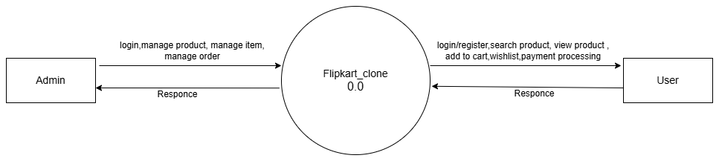

Fig 1: level 0 DFD diagram
DFD Level 1 for Admin:
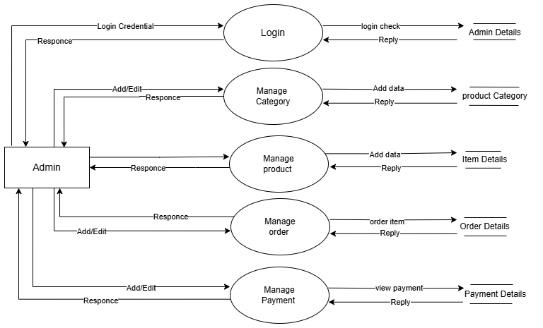

Fig 2: level 1 DFD for Admin

DFD Level 1 for User:

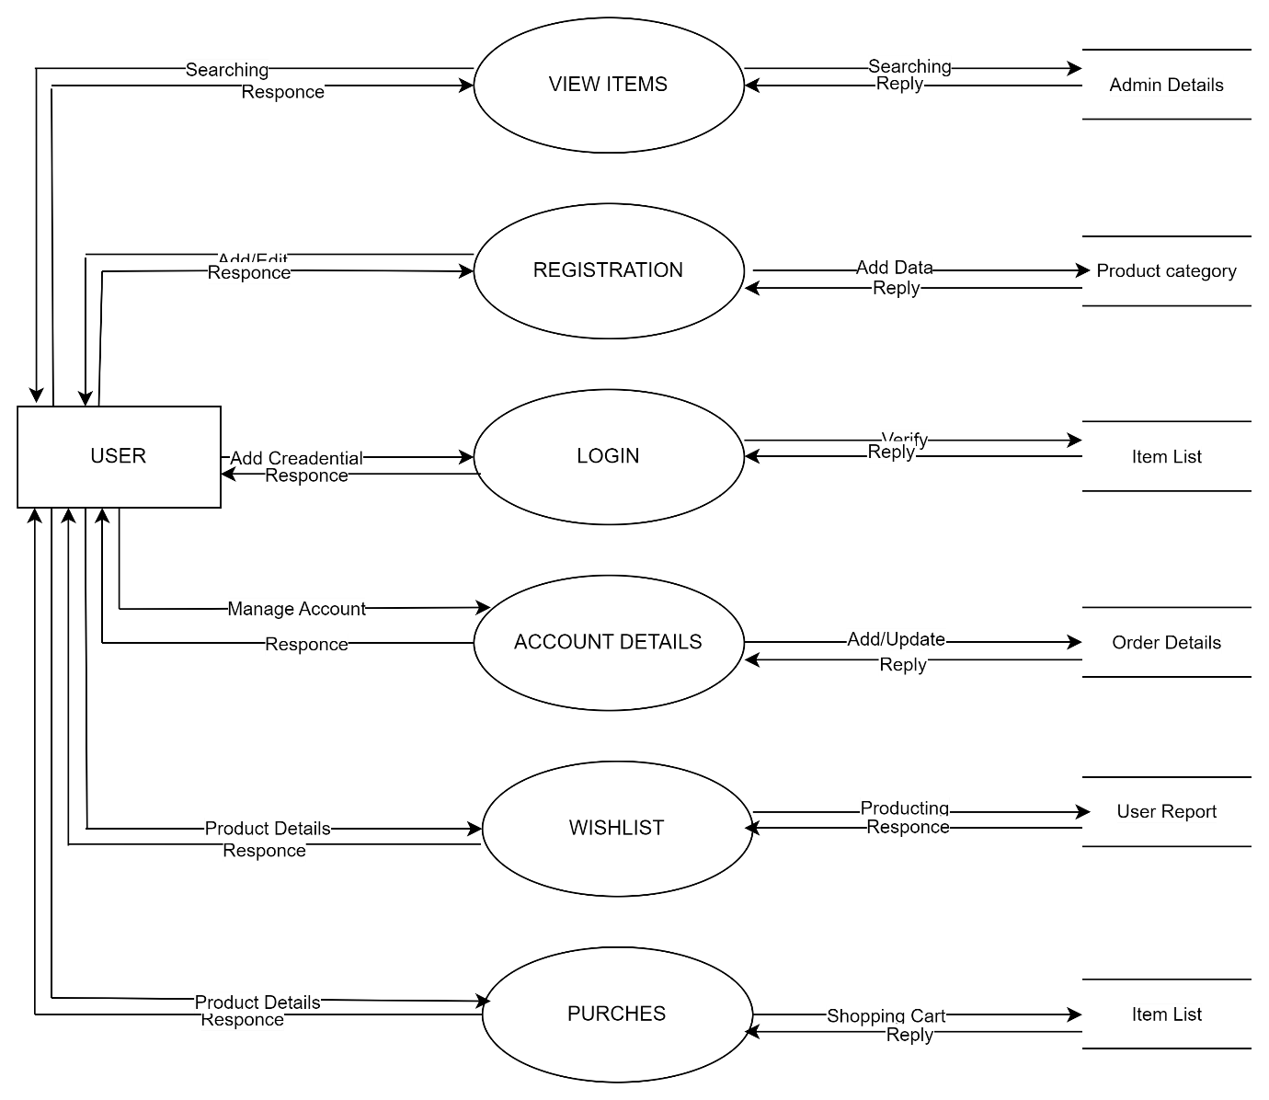

Fig 3: level 1 DFD for User

    - ER Diagram

An Entity-Relationship Diagram (ERD) for a Weapon Tracking System (WTS) visually represents the structure of the underlying data model, outlining key entities and the relationships among them. The primary entities include User, Trolley, Alarm Log, Location, and Asset. Users may have different roles such as administrators, operators, or security personnel, each with varying levels of access and responsibilities. Each Trolley is associated with one or more Assets and is tracked across defined Paths, Zones, and Floors within the facility. Alarm Logs record incidents or alerts triggered by certain events, including unauthorized movements or deviations from defined paths. These alarms are linked to specific trolleys, users, and timestamps. The Asset Configuration entity manages weapon details and assignment information. The system also includes modules for User Registration, Access Control, and Report Generation. The ERD helps to clearly define the relationships between these entities and ensures a well-structured and efficient database design for managing real-time tracking, alarms, and operational control within the WTS application.

Basic Notations

Symbol | Notation | Description
 | Entity | Represents a real-world object or concept. Each entity has a  set of attributes.
 | Attribute | Describes properties of an entity.
 | Relationship | Represents a relationship between entities.
 | Link | Links attribute to entity

ER Diagram

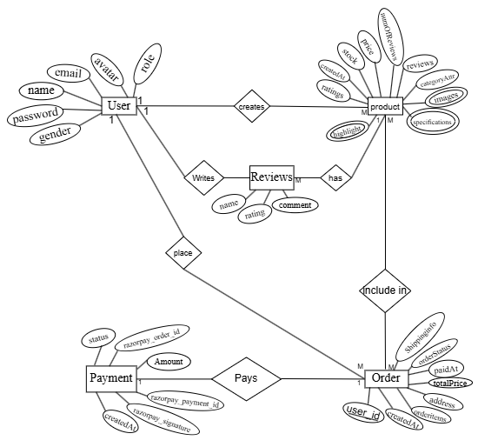

Fig 4: ER Diagram

CHAPTER 4: SYSTEM DESIGN

CHAPTER 4: SYSTEM DESIGN

  - Basic Modules

- Registration: User signup and create an account to avail services from the web application. Registration will be one time only and the customer should be verified by clicking the verification mail sent to user email.
- Login: There are two types of users using this software - admin and customers. Admin users have access to administrative functions while customers can browse products and place orders.
- Profile Details: Here user needs to update their profile details in order to continue using the website. This detail includes personal information, shipping addresses, and account preferences.
- Product Catalogs: Displays products with detailed information, images, pricing, reviews, and ratings. Includes search, filtering, and sorting capabilities for easy product discovery.
- Shopping Cart: Manages the selection and storage of products users wish to purchase. Allows quantity adjustments, item removal, and "Save for Later" functionality.
- Wishlist: Allows users to save products for future purchase consideration and manage their favorite items.
- Payment Processing: Processes transactions and manages multiple payment methods (Razor pay, COD) for completed orders with secure payment verification.
- Order Management: Allows administrators to oversee, process, and update customer orders. Includes order status tracking and delivery management.
- My Orders: Lets users view their order history and track the status of current orders with detailed order information and delivery updates.
- Admin Dashboard: Provides comprehensive administrative tools for managing users, products, orders, reviews, and generating analytics reports.

Data Design Project Structure

Schema Design
Table1: users

Field name | Data type | Constraint | Description
name | String | NOT NULL | Name of the user
email | String | NOT NULL | Email of the user
password | String | NOT NULL | Password of the user
avatar | Object |  | Upload user profile pic
role | String | NOT NULL | Role of the user
gender | String | NOT NULL | Gender of the user
Created At | Date | NOT NULL | User created date
updated at | Date | NOT NULL | User updated date

Table2: products

Field name | Data type | Constraint | Description
Name | String | NOT NULL | Name of the product
description | String | NOT NULL | Description of the product
highlights | Array | NOT NULL | Product highlights
specifications | Array | NOT NULL | Product specifications
description | String | NOT NULL | Description of the product
price | Number | NOT NULL | Price of the product
CuttedPrice | Number | NOT NULL | Selling price of the product
stock | Number | NOT NULL | Stock of the product
ratings | Number |  | Average rating
numofReviews | Number |  | Number of reviews
Warranty | Number |  | Warranty period
Image | Array | NOT NULL | Product image with public_id and URL
brand | object | NOT NULL | Brand details with name and logo
Reviews | Array |  | Product reviews
createdAt | Date | NOT NULL | Product created date
updatedAt | Date | NOT NULL | Product updated date

Field name | Data type | Constraint | Description
shippinginfo | object | NOT NULL | Shipping address details
orderitems | Array | NOT NULL | Ordered products details
user | objectid | NOT NULL | Reference to user
paymentinfo | object | NOT NULL | Payment details with id, status, and type
totalPrice | Number | NOT NULL | Total price of the order
orderStatus | Date | NOT NULL | Order status (processing, shipped, Delivered)
paidAt | Date |  | Payment completion date
deliveredAt | Date |  | Order delivery date
shippedAt | Date |  | Oder shipping date
createdAt | Date | NOT NULL | Order created date
updatedAt | Date | NOT NULL | Order updated date
Table3: orders

Table4: payments

Field name | Data type | Constraint | Description
razorpay_order_id | String | NOT NULL | Razorpay order id
razorpay_paym_id | String | NOT NULL | Razorpay payment id
razorpay_signature | String | NOT NULL | Razorpay signature
createdAt | Date | NOT NULL | Payment created date

Table5: wishlist

Field name | Data type | Constraint | Description
user | objectid | NOT NULL | Reference to user
product | objectid | NOT NULL | Reference to products
createdAt | Date | NOT NULL | Wishlist item created date

Data Integrity and constraints
Primary key: The primary key of a table uniquely identifies each record in the table, so that an individual record can be located without confusion.

Foreign Key: It is a key used to link two tables together. Primary key is the target which a foreign key can reference. Foreign key identifies a column or a set of columns in one table that refers to set of columns in another table.

NOT NULL constraint: It allows you to specify that a column may not contain NULL values.

Procedural design

Logic Diagrams

Use Case Diagrams
In the use case diagram, the representation of user's interaction with the system and specifications of a use case is done. It portrays the different types of users of a system and the various ways that they interact with the system. The main purpose of these diagrams is to help development teams in visualizing the functional requirements of the system, including the relationship of “actors” to essential processes, as well as the relationships among different use cases.

Basic Notation:

Shape | Notation | Description
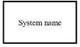 | Boundary | The scope of a system can be represented by a system (shape) or sometimes known as a system boundary. The use cases of the system are placed inside the system shape, while the actors who interact with the system are put outside the system. The use cases in the system make up the  total requirements of the system.
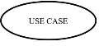 | Use Case | A use case is an external view of the system that represents some action the user might perform in order to complete a task. To show a use case on a use-case diagram, we draw an oval in the middle of the diagram and put the name of the use case  in the center of, or below, the oval.
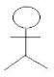 | Actor | Actors are the entities that interact with a system. Although in most cases, actors are used to represent the users of the system, actors can be anything that needs to exchange information with the system. Actors are typically drawn as stick figures on UML Use Case diagrams.
 | Relation | The relationship between the actor and the use case is shown with the help of an arrow. It indicates that there is a flow between the actors and the use case.

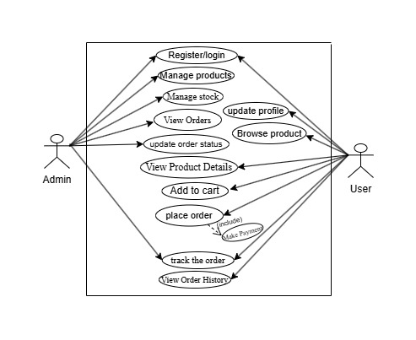

Fig 5: Use Case Diagram

Class Diagrams

Class diagrams are a type of UML (Unified Modeling Language) diagram used in software engineering to visually represent the structure and relationships of classes within a system i.e. used to construct and visualize object-oriented systems.

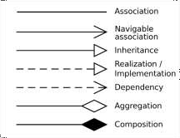

- Class Name: The name of the class is typically written in the top compartment of the class box and is centered and bold.
- Attributes: Attributes, also known as properties or fields, represent the data members of the class. They are listed in the second compartment of the class box and often include the visibility (e.g., public, private) and the data type of each attribute.
- Methods: Methods, also known as functions or operations, represent the behavior or functionality of the class. They are listed in the third compartment of the class box and include the visibility (e.g., public, private), return type, and parameters of each method.
- Visibility Notation: Visibility notations indicate the access level of attributes and methods. Common visibility notations include:
+ for public (visible to all classes)
- for private (visible only within the class) for protected (visible to subclasses)
~ for package or default visibility (visible to classes in the same package)

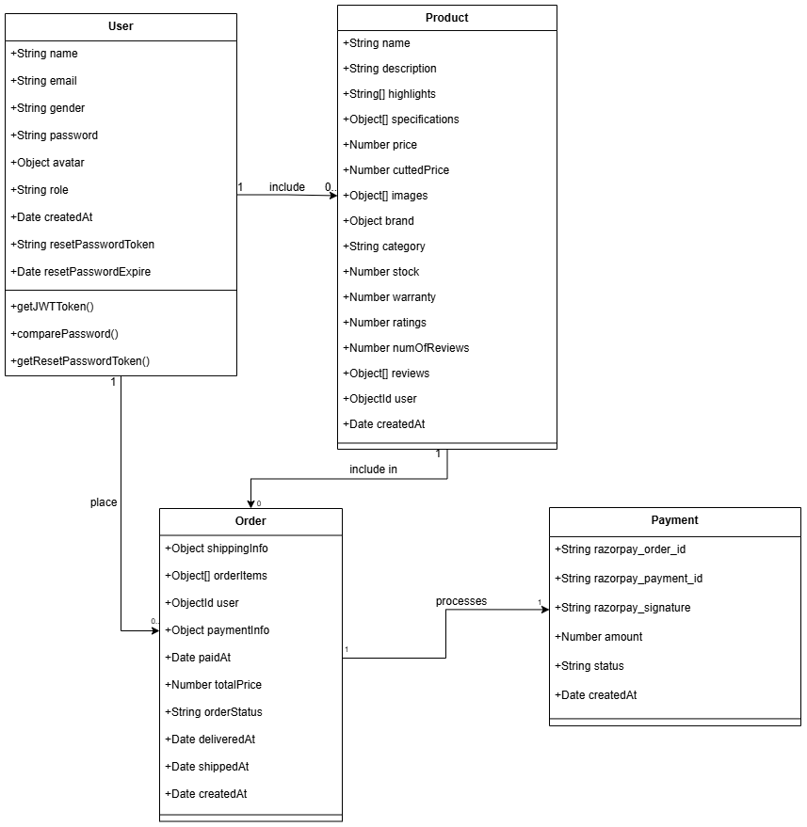

Fig 6: Class Diagram

Sequence Diagram
A Sequence Diagram in Unified Modelling Language (UML) is a kind of interaction diagram that shows how processes operate with one another and in what order. UML sequence diagrams model the flow of logic within your system in a visual manner, enabling you both to document and validate your logic, and are commonly used for both

analysis and design purposes. Sequence diagrams are the most popular UML artefact for dynamic modelling, which focuses on identifying the behavior within your system.

Basic Notations:

Shape | Notation | Description
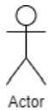 | Actor | They can communicate with the objects. Therefore, actors are placed in column
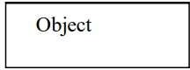 | Object | They are instances of classes and arranged horizontally.
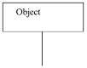 | Lifeline and Activation | Dashed indicates. | line | is | Lifeline | which
 | Activation or Execution Occurrence | Activation boxes represent the time an object needs to complete a task.

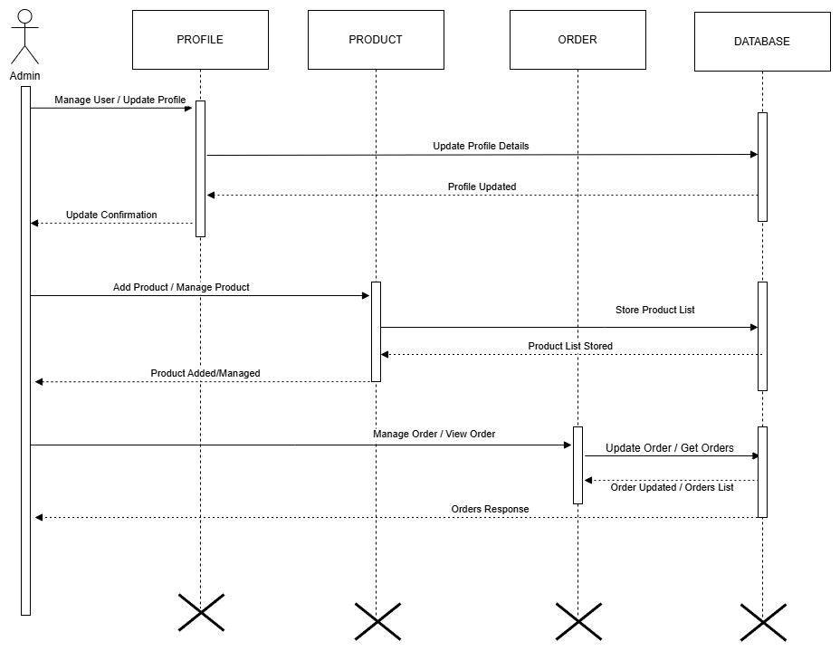

Fig 7: Sequence Diagram for Admin

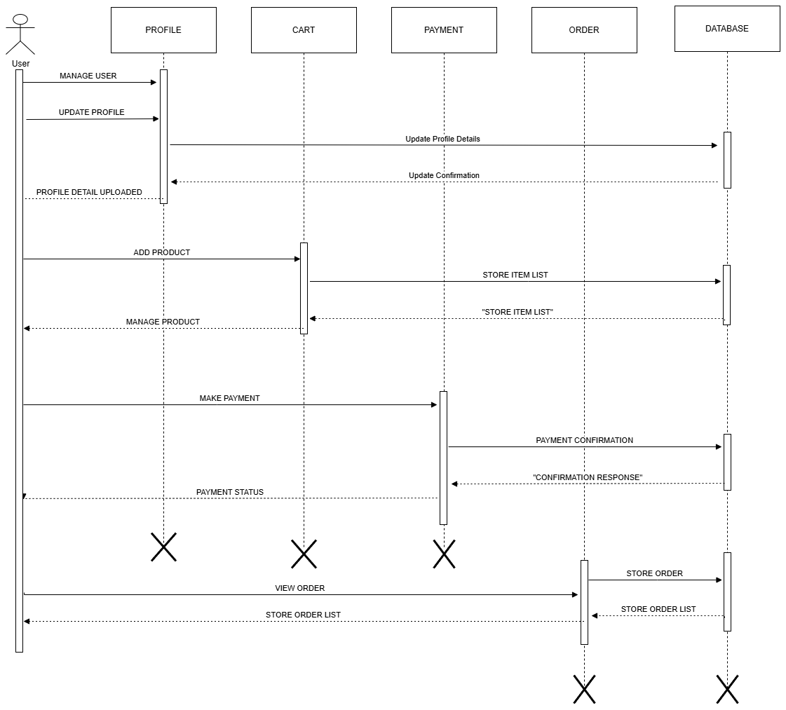
Fig 8: Sequence Diagram for User

State chart Diagrams
State diagrams depict the dynamic behavior of the entire system, or a sub-system, or even a single object in a system. State diagrams, which are also called State Chart diagrams, are used to help to better understand any complex/unusual functionalities or business flows of specialized areas of the system.

Basic Notations:

Shape | Notation | Description
 | Initial State | Denotes the starting point of the flow. It is shown by a solid circle.
 | Final State | Denotes the end of the state diagram. It is shown by a bull's eye symbol.
 | Intermediate State Changes | Represents the state of objects at an instant of time. It is denoted by a rounded rectangle.
 | Event and Action | Represents an event or action. It is a trigger that causes a transition to occur. It is represented as an arrow.

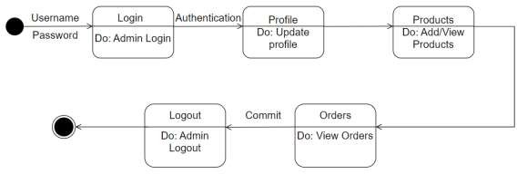

Fig 9: Admin - State Chart Diagram

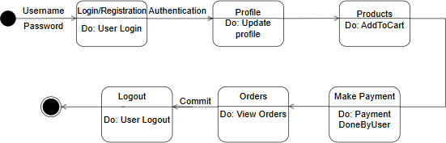

Fig 10: User - State Chart Diagram

Activity Diagrams
Activity diagrams are used to describe the operations of the system components in step-by-step workflows. It is a dynamic diagram that shows the activity and the event that causes the object to be in a particular state. It is a simple and intuitive illustration of what happens in a workflow, what activities can be done in parallel and whether there are alternative paths through the workflow.

Shape | Notation | Description
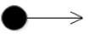 | Initial Activity | Represents the starting point or first activity of the flow. It is denoted by a  solid circle.
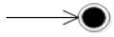 | Final Activity | Represents the end of the Activity  diagram, also called as a final activity. It is shown by a bull's eye symbol.
 | Activity | Represents an activity. It is shown by a rectangle with rounded (almost oval) edges.
 | Decision | Represents logic where a decision is to be made. It is shown by a diamond.
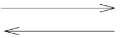 | Flow of Activity or Control | Shows the direction of the workflow in the activity diagram. It is depicted with an arrow.
Basic Notations:
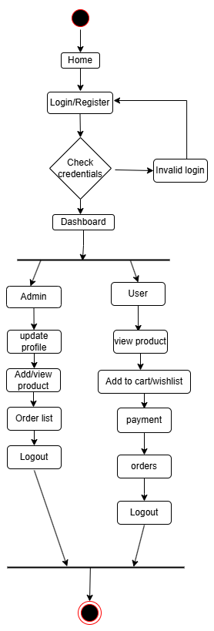

Fig 11: Activity Diagram

Security Issues

Administrator credentials are set for the admins, and they are not meant to be shared. This ensures that access to the data is by an authorized user and people without proper authentication cannot access the data or modify the data present in the system. This ensures that the data will be proper.

Test Case Design Software testing
It is a process used to identify the correctness, completeness and quality of developed computer software, i.e., software testing is to execute a software program with the intent of finding bugs.

Software Development Life Cycle:

• Requirements
• Analysis
• Design
• Coding
• Testing
• Maintenance Approaches to Testing:
• Black-Box Testing
• White-Box Testing

BLACK-BOX TESTING:

In black box testing the functional aspects of the system is considered and the internal structure of the system will not be taken care of. The desired functionalities retest cases are written based on the requirement specification of the module. The tester only needs to know about the inputs to the system and expected output from the system. In other words, the behavioral testing is made solely upon requirement or specification. The black box is also referred to as behavioral or functional testing.
WHITE-BOX TESTING:

White box testing is concerned with internal functionality. The aim of this testing approach is to test the implementation of the desired system that meets the specifications. White –box testing is also called structural testing. This testing model will not be much concentrated on inputs, but in some other means the inputs also fall into the test cases to verify the different data structures used in the implementation system. The test cases are constructed to exercise the programming structures based on the implementation of the program.

4.6. User interface design

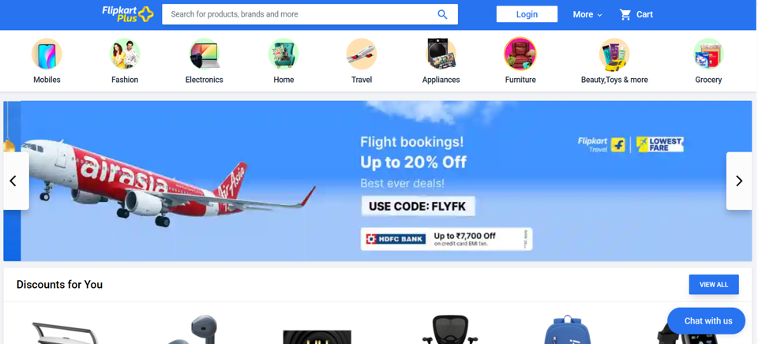

Fig 12: Home Page

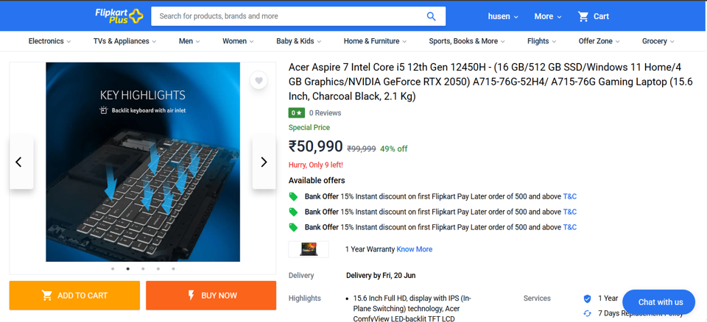

Fig 13: Product Description

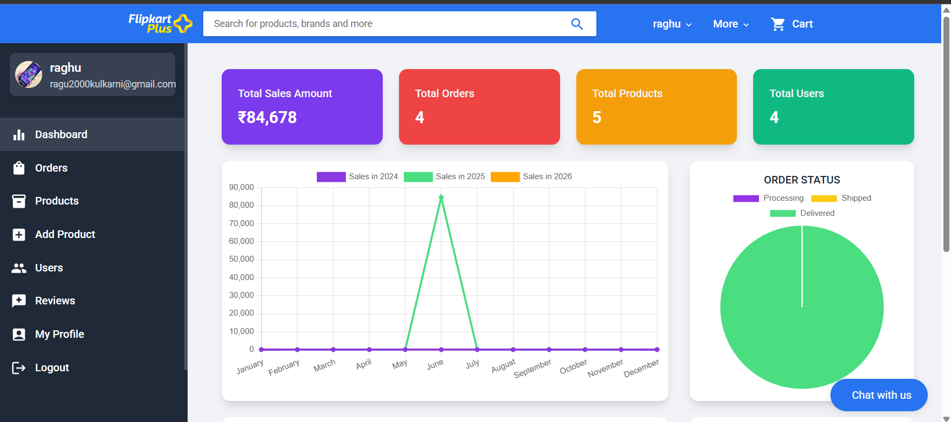

Fig 14: Admin Dashboard
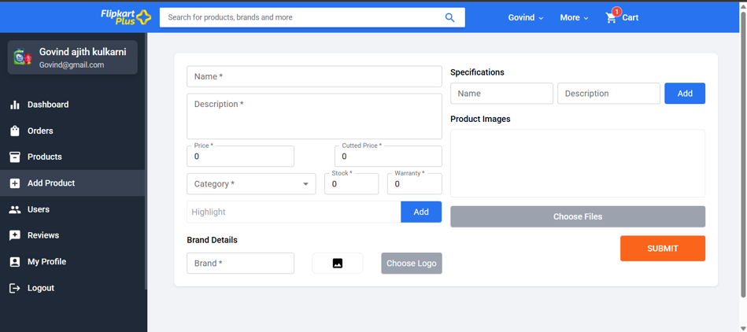

Fig 15: Add Product Page

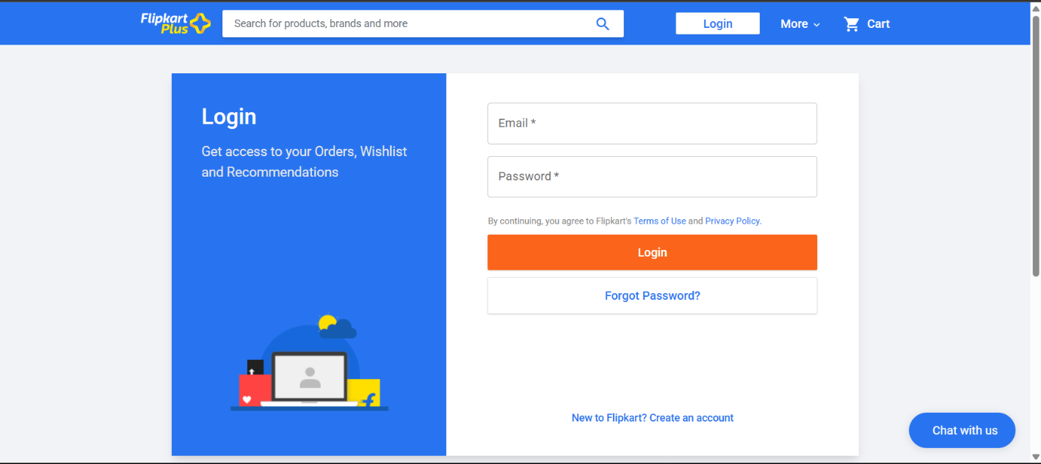

Fig 16: Login Page

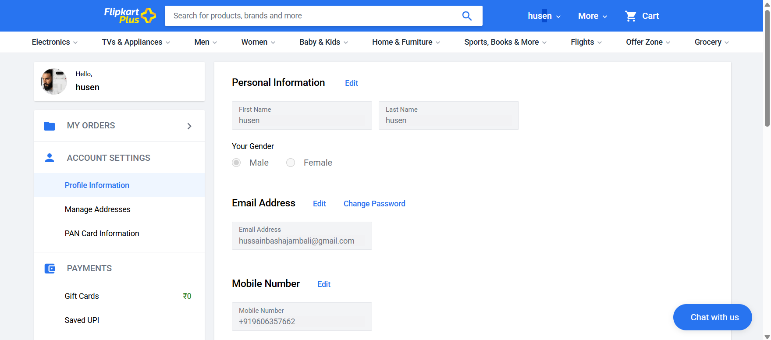

Fig 17: Customer Profile
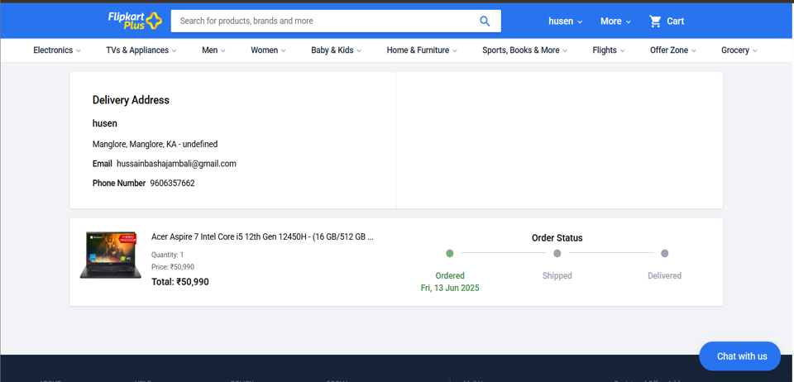

Fig 18: Order page

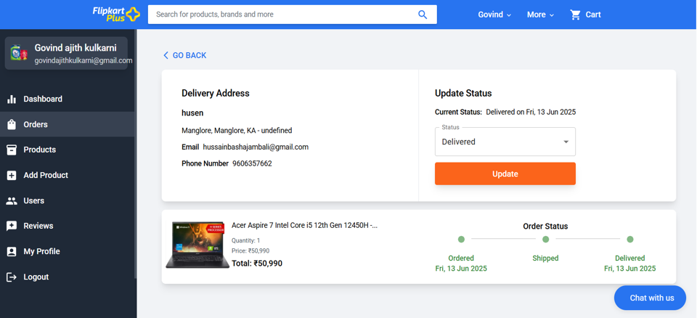

Fig 19: Admin Order Update Status

CHAPTER 5: IMPLEMENTATION AND TESTING

CHAPTER 5: IMPLEMENTATION AND TESTING

Implementation Approaches
Implementation is the phase where the system design is being started to be converted into actual system. It needs a systematic approach to implement the design into the actual working system, so that a keen investigation and planning should be made. That is it starts with an investigation on existing systems, planning the system and identifying implementation constraints of the system and identification of the methodologies to fulfil the desired system. The implementation phase is the stage where the actual proposed system is being implemented to achieve the desired working system without any catch. In other words, a completely functional e-commerce system is the outcome of the implementation phase. Apart from that user training is a task in this phase. User awareness is important because at the end they are going to use the system. So, they must be educated and trained to use the system. System analysis and modelling are directly proportional to the complexity of the system being implemented. Performance and quality of the proposed system is handled in the implementation phase. This phase is a step-by-step process that gradually builds the system according to the requirement and specification. This phase includes writing and reviewing the code, testing, configuring and integrating the system. The implementation phase includes:
- planning
- Identifying system constraints.
- Designing the functionality.
- User awareness.

Coding Details and Code Efficiency
For robust and efficient code, the MERN stack standards are followed. The code must be optimized and efficient. VS Code IDE is used to improve code efficiency since the IDE has inbuilt code efficiency tools. The following will be caught and rectified using the IDE:
- Unused methods and parameters
- Unused local variables
- Unreachable catch statements
- Empty conditions and loops
- Unused private methods
- Optimized statements
- React component optimization
- Redux state management efficiency
- API endpoint optimization
- Database query optimization
Code coverage tools in the IDE are used to check the code efficiency of coding standards.

Testing Approach

In software development life cycle testing is an important task. The quality of software is ensured in the testing phase. Based on the analysis possible test data is prepared and the system is tested for those set of data. The testing is performed to catch the bugs in the system. When performing the testing the errors are documented and rectified. The test data is a set of data that will cover all the edge condition inputs to the system. Users must be guided to use the product in order to test the acceptance of the product. Each functionality of the system is tested using the Unit testing approach. Unit testing is performed according to when each module is developed and then integrated. Integration testing approach is used to test the communication between the module is behaving as expected or not. In this testing the bugs are caught that have emerged with integration. These bugs must be noted and resolved. Finally, the system testing is performed on the integrated system. In system testing the system undergoes testing to check whether the specified requirements are fulfilled or not, in other words it will check for the behavioral expectations. So that the system testing falls under the black box testing, since the functionality of the system is tested regardless of the internal structure of the system. System testing is an approach under the assumption of all the internal parts of the system is correct. A series of testing approaches are used and conducted before the system undergoes for the user acceptance testing from the user perspective.
A good test should:
- Eliminate redundancy
- Catch almost all the bugs in the system
- Neither too simple nor too complex

Unit Testing

Unit testing is made on each individual unit of the module. It helps to ensure the quality of each module of the system. In the unit test all the validations are tested at the module level including user authentication, product management, order processing, and payment integration. The control flow of the information from input to the output is also tested here. All the edge conditions that are likely to have been tested to ensure that the module will operate on extreme conditions without any crash.

Integration Testing
The main catches in incremental software models are the communication between the modules since they are being developed at unit level and integrated to the system. The major concerns of integration testing are developing an incremental strategy that will limit the complexity of entire actions among components as they are added to the system. Developing a component as they are added to the system, developing an implementation and integration schedules that will make the modules available when needed, and designing test cases that will demonstrate the viability of the evolving system including API integration, payment gateway integration, and database connectivity.

User Acceptance Testing
User acceptance is probably the most important test phase of all as it is where we confirm that the system is fit for purpose. This includes testing the complete user journey from registration to order completion, payment processing, and order tracking.

Performance Testing
It is used to test at the user perspective to analyses throughput, stimulus response time or combination of these. This includes testing the application's performance under various load conditions, database query optimization, and frontend rendering performance.

CHAPTER 6: RESULTS AND DISCUSSION

CHAPTER 6: RESULTS AND DISCUSSION

Test Reports

Login Module

SL NO | Test Case | Expected Result | Test Result
1. | Email & Password left  empty | System will display validation  for empty fields | Pass
2. | Valid Email & Password, click Login | Users are authenticated and redirected to their account/dashboard | Pass
3. | Invalid Email or Password | The system displays "Invalid credentials" error. | Pass
4. | Click "Forgot Password" | Email input for password reset is shown | Pass
5. | Submit valid email for password reset | OTP is sent to email OTP input and new password fields are displayed | Pass
6. | Submit OTP and new password | Password is updated; users can log in with new password | Pass
7. | Click "Clear" on login form | All input fields are cleared | pass

    - Registration Module

SL NO | Test Case | Expected Result | Test Result
1. | All fields left empty | System will display validation  for empty fields | Pass
2. | Wrong Email | Email validations with “@”,”.” | Pass
3. | Passwords do not match | System displays "Passwords do not match" error | Pass
4. | Valid details, click Register | User is created, verification/approval message  shown | Pass
5. | Email already registered | System displays "Email already exists" error | Pass
6. | If admin rejects | Cannot login to the application | Pass

Admin Module

SL NO | Test Case | Expected Result | Test Result
1. | Update his profile details | Message as successful | Pass
2. | View all user | List of user accounts displayed with update/delete options | Pass
3. | Delete a user | User is removed from the system, confirmation shown | Pass
4. | Show all Products details with add, update and delete products Reports | Show the product added to application | Pass
5. | If the transaction is done by cash and select cash | Approved report with payment type cash | Pass
6. | If the transaction is done  by Razorpay | Payment successful and payment type Razorpay | Pass
7. | Show Orders details  Reports | Products ordered by all users | Pass

    - Customer Module

SL NO | Test Case | Expected Result | Test Result
1. | Update his profile details | Message as successful | Pass
2. | Add product to the cart to  order | Successful message | Pass

3. | Delete and update product added to cart | successful | Pass
4. | If transaction done By Razorpay, cash | Payment type will be displayed | Pass
5. | Orders of the user in their account after payment | Products ordered by the customer | Pass
6. | Add product to wishlist | Successful added to wishlist | pass
7. | Search and filter product | Product displayed based on search criteria | pass

Payment Module
SL NO | Test Case | Expected Result | Test Result
1. | Razorpay payment processing | Payment successful with confirmation | Pass
2. | Cash on Delivery(cod) | Order placed successfully with cod option | Pass
3. | Payment verification | Payment status update correctly | Pass
4. | Order confirmation | Order confirmation email sent to user | pass

CHAPTER 7: CONCLUSION

CHAPTER 7: CONCLUSION

Conclusion
The project focused on developing a software application named Flipkart Clone for online retail, aiming to improve efficiency and user experience in managing e-commerce operations and customer interactions. The application effectively tackled challenges such as product management, order processing, payment integration, and customer service. Utilizing modern technologies like React.js, Node.js, and MongoDB, we created a user-friendly interface that streamlines operations, reduces manual labor, and enhances customer satisfaction. The successful implementation highlights the potential for digital transformation in online retail businesses, promoting increased productivity and growth through a comprehensive e-commerce platform.

Limitation
Despite the achievements, the software application for Flipkart Clone has certain limitations:
- Scalability: The current application may experience performance issues if scaled to a larger user base or multiple product categories without significant modifications.
- Payment Integration: Integrating multiple payment gateways and ensuring seamless transaction processing posed challenges, and complete compatibility has not yet been achieved across all payment methods.
- Offline Functionality: The application relies heavily on internet connectivity, which can be a limitation in areas with poor network coverage, affecting real-time access and updates.
- User Training: Some users, particularly those less familiar with technology, may require additional training to effectively use the application features.
- Customization Flexibility: The current version offers limited customization options for specific business needs, which may restrict its adaptability for diverse operational requirements.
- Mobile Optimization: While responsive, the application may need further optimization for optimal performance on various mobile devices and screen sizes.

7.3 Future Scope of the project
In the future, the project can be developed further by improving scalability to support more users and product categories, adding advanced analytics and recommendation systems for better insights, and creating a dedicated mobile application for easier access. Enhancing offline capabilities will ensure reliable use in areas with poor internet connectivity. Integrating AI-powered features like chatbots and personal recommendations will streamline customer service and product discovery, while strengthen security measures and incorporate user feedback will help refine the application and address evolving business needs. These advancements will enhance the software's value and adaptability for the Flipkart Clone platform, making it a comprehensive solution for modern e-commerce operations.

REFERENCES
Books Referred
- Object-Oriented Analysis & Design with the Unified Process by Satzinger, Jackson, and Burd.
- An Integrated Approach to Software Engineering by Pankaj Jalote.
- Unified Modeling Language User Guide –Grady Booch, James Rumbaugh, Ivar Jacobson
- IEEE standard 10161998 recommended practice for software design descriptions
- Software Engineering, 5th Edition, Addison by Wesley – Ian Somerville.

Websites Referred
- UML Diagram Tutorial- https://www.tutorialspoint.com/uml/index.htm
- https://www.lucidchart.com/blog/types-of-UML-diagrams
- https://www.lucidchart.com/pages/ER-diagram-symbols-and-meaning
- https://www.geeksforgeeks.org/unified-modeling-language-uml-state-diagrams
- https://www.geeksforgeeks.org/unified-modeling-language-uml-sequence-diagrams
•https://app.diagrams.net/

GLOSSARY

- SDD: Software Design Document
- SRS: Software Requirement Specification
- DFD: Data Flow Diagram
- IoT: Internet of Things
- OTP: One-Time Password
- UI: User Interface
- DOM: Document Object Model
- CSS: Cascading Style Sheets
09. HTML: Hypertext Markup Language
- UML: Unified Modeling Language
- IDE: Integrated Development Environment

