Unlabeled Spectral Shift Predicts Which Target-Label Acquisition Strategy Works: A Multi-Task Study of Cross-Site MALDI-TOF Antimicrobial Resistance Prediction
Authors: [Author 1]¹, [Author 2]², [Author 3]¹
¹ Department of Biostatistics and Medical Informatics, Faculty of Medicine, Adıyaman University, Adıyaman, Türkiye
² Department of Biostatistics and Medical Informatics, Faculty of Medicine, İnönü University, Malatya, Türkiye
Correspondence: [e-mail]

Abstract
Background. Machine learning applied to MALDI-TOF mass spectra can flag antimicrobial resistance hours to days before conventional susceptibility testing, but models trained at one laboratory rarely keep their accuracy at another. What remains unclear is whether this failure can be repaired without target-site labels, and — when a small number of local susceptibility results can be obtained — how those results should be chosen.
Methods. We assembled 20 species–antibiotic cross-site transfer tasks from the DRIAMS collection, organised into seven source→target-by-species clusters. Splits were patient-aware wherever patient identifiers existed. After benchmarking a wide range of unsupervised harmonisation and adaptation techniques, we computed five shift descriptors that require no resistance labels at all, and asked whether they predict the relative benefit of two label-acquisition strategies (Random versus Hybrid) at budgets of 20, 30 and 50 target labels. A ridge model trained under leave-one-group-out cross-validation converted these descriptors into a deployment-time policy. Inference used cluster-aware bootstrapping and permutation testing.
Results. Source-only external PR-AUC spanned 0.144 to 0.914 across tasks, while source–target separability in the SVD representation was uniformly high (domain AUROC 0.985–1.000). No unsupervised method restored transportability consistently, and reducing domain separability was not accompanied by better resistance discrimination. Neither Random nor Hybrid acquisition was universally preferable. Five label-free descriptors were nonetheless associated with the Hybrid-minus-Random difference, the strongest being domain AUROC (Spearman ρ = −0.783, 95% CI −0.903 to −0.499). A leakage-free ridge policy produced small but consistent gains over both fixed strategies at every budget. Gains over Always-Random were +0.0023, +0.0037 and +0.0042 PR-AUC (10,000-permutation p = 0.0125, 0.0269 and 0.0219), gains over Always-Hybrid +0.0020, +0.0019 and +0.0022 (same p values), and the policy chose the better strategy in 80–85% of transfers. Cluster-aware bootstrap intervals for the Always-Random comparison excluded zero at all budgets, while the more conservative cluster-level permutation did not reach 0.05, reflecting the seven independent clusters available. Under nested leave-one-cluster-out validation the gains attenuated further and their intervals included zero.
Conclusions. Site identity is written into MALDI-TOF spectra so strongly that it cannot be removed by generic harmonisation, and removing it is not what makes transfer work. A more useful question is which adaptation strategy is most appropriate for a given deployment. Unlabeled spectral shift descriptors can inform that decision before local susceptibility labels are acquired, although their ability to extrapolate to entirely unseen species–site regimes remains uncertain.
Keywords: MALDI-TOF mass spectrometry; antimicrobial resistance; domain shift; external validation; label-efficient learning; clinical deployment

1. Introduction
Antimicrobial resistance was linked to an estimated 4.95 million deaths worldwide in 2019, of which 1.27 million were directly attributable to resistant infections [1]. Because delays in effective therapy carry measurable mortality costs [2–4], any diagnostic step that shortens the interval between sampling and a correct prescription has clinical value.
MALDI-TOF mass spectrometry occupies an unusual position here. It is already installed in most clinical microbiology laboratories, where it identifies organisms in minutes rather than hours [5–8]. The spectra it produces, however, contain more than taxonomic information. Weis and colleagues demonstrated that classifiers trained on more than 300,000 spectra linked to 750,000 susceptibility phenotypes could predict resistance directly, reporting AUROC values of 0.80 for Staphylococcus aureus, 0.74 for Escherichia coli and 0.74 for Klebsiella pneumoniae, and estimating in a retrospective case review that treatment would have changed beneficially in eight of nine patients [9]. Subsequent work extended this idea across species, platforms and algorithms [10–18], and a systematic review of forty studies found most reporting AUROC above 0.80 [19].
Reports of external performance are considerably less encouraging. In a German validation study using both local routine spectra and DRIAMS, predictive performance held up when training and test data were related, but deteriorated markedly when they were not; over 18 months of prospective observation, AUROC fell by 0.10 for S. aureus oxacillin, 0.19 for E. coli ciprofloxacin and 0.25 for K. pneumoniae piperacillin-tazobactam, leading the authors to conclude that classifiers must be trained locally and retrained regularly [20]. A recent benchmark of thirteen domain-adaptation methods across three public datasets reached a compatible conclusion from the opposite direction: unsupervised adaptation delivered improvements of only 0% to 6% over source-only baselines, whereas fine-tuning with target labels closed 92% to 97% of the domain gap [21].
The instinct behind unsupervised adaptation is intuitive — if source and target distributions can be aligned, the classifier should transfer. This instinct has been productive in neuroimaging, where scanner and site effects have driven a substantial harmonisation literature [22–24]. Whether it holds for mass spectra is a separate empirical question, and one that has not been examined systematically.
We approached the problem from a deployment perspective rather than an algorithmic one. A laboratory considering adoption faces three practical questions in sequence: will this model work here; if not, can it be fixed without local susceptibility data; and if local data are needed, how many results and which isolates. The first two questions have received attention. The third has not, and it is the one with immediate budgetary consequences.
Three commitments shaped the analysis. First, we required patient-aware splitting throughout, since exploratory work showed that isolate-level splits inflate discrimination when the same patient contributes several isolates. Second, we treated PR-AUC as the primary metric, because resistance prevalence varied widely across tasks and ROC curves can be visually reassuring in imbalanced settings while concealing poor positive predictive value [25]. Third, we insisted that any descriptor used to guide deployment decisions be computable without target resistance labels — otherwise the recommendation would be circular.
The study is reported in accordance with TRIPOD+AI [26].

2. Results

2.1. Cross-site transfer was heterogeneous, and site identity was almost perfectly detectable
Twenty species–antibiotic transfer tasks met eligibility criteria, spanning E. coli, S. epidermidis, S. aureus, K. pneumoniae and Proteus mirabilis, with transfers mostly from DRIAMS-A to DRIAMS-B or DRIAMS-C and one DRIAMS-B→DRIAMS-C transfer (Table 1; Figure 1). Source sample sizes ranged from 348 to 4,961 spectra and target sizes from 213 to 916. Resistance prevalence differed both between tasks and, for several tasks, between source and target sites — E. coli–amoxicillin-clavulanic acid transferred from a source prevalence of 0.244 to a target prevalence of 0.357 at DRIAMS-B, for instance.
Source-only external performance spread across almost the entire achievable range: PR-AUC from 0.144 (S. aureus–clindamycin, B→C) to 0.914 (S. epidermidis–ciprofloxacin, A→B), with AUROC from 0.508 to 0.913. This is not a benchmark with a single characteristic difficulty; it is a collection of deployment scenarios with genuinely different prospects.
Against that variation, one quantity was strikingly uniform. A classifier trained to distinguish source from target spectra in the SVD representation achieved domain AUROC between 0.985 and 1.000 in every task (Figure 2). Site membership is, in other words, encoded in these spectra far more legibly than resistance phenotype. The scatter in Figure 2 also makes clear that domain separability and source-only performance are not simply two views of the same thing — tasks with near-identical domain AUROC differ by more than 0.5 in external PR-AUC.

2.2. Unsupervised adaptation did not restore transportability, and alignment did not track performance
We evaluated a broad set of approaches before turning to the policy question: spectral band selection and wavelet subband analysis, nuisance-subspace projection, standard normal variate scaling, dimensionality reduction combined with subspace suppression, a MALDI-specific preprocessing chain (variance stabilisation, Savitzky–Golay smoothing, SNIP baseline correction, TIC normalisation, peak alignment), domain-adversarial training, CORAL, maximum mean discrepancy, batch-normalisation adaptation, domain-specific batch normalisation with residual adapters, physics-informed augmentation, pseudo-standard direct and piecewise direct standardisation, generalised least-squares weighting, external parameter orthogonalisation, PLS-based transfer, and entropic and class-regularised optimal transport. Detailed grids and task-level results are given in the Supplementary Materials.
The pattern across this benchmark was consistent enough to be worth stating plainly: no method improved external discrimination reliably across tasks, and several degraded it. Two observations proved more informative than the aggregate outcome.
The first concerns the relationship between alignment and performance. Entropic Sinkhorn transport reduced domain AUROC from 0.984 to 0.902 — the largest reduction achieved by any method — and simultaneously produced the largest loss in external PR-AUC (Δ −0.057 in one representative transfer, with all evaluated configurations negative in a second). A projection-based method reduced development-set domain AUROC from 0.998 to 0.991 without any corresponding gain in task performance (Δ −0.0096 in locked validation). Conversely, species-conditioned soft external parameter orthogonalisation left domain AUROC essentially untouched (0.993 → 0.988) yet produced small, reproducible PR-AUC gains under a target-blind protocol: +0.031 (95% CI +0.005 to +0.058) and +0.034 (+0.003 to +0.068) for S. aureus–oxacillin→C, and +0.020 (+0.007 to +0.032) and +0.049 (+0.029 to +0.066) for E. coli–ceftriaxone→D.
These results indicate that reducing source–target separability was neither necessary nor sufficient for improving cross-site predictive performance in our experiments. The two properties moved independently, and in the most aggressive alignment method they moved in opposite directions.
The second observation concerns preprocessing. Within the MALDI-specific chain, peak alignment was the single most useful step, raising external PR-AUC by roughly 15% at one target site, while a second application of total-ion-current normalisation to already-normalised binned data was harmful. This is a reminder that preprocessing chains borrowed wholesale can subtract as well as add.

2.3. Neither acquisition strategy dominated when target labels became available
Given that unsupervised repair was unreliable, we turned to the setting in which a laboratory can obtain a limited number of local susceptibility results. Two acquisition strategies were compared: Random selection of isolates for testing, and a Hybrid strategy combining uncertainty and diversity criteria.
In a single-task analysis on S. aureus–oxacillin, Hybrid appeared clearly superior, beating Random at every budget from 10 to 100 labels. Extending the comparison to all 20 transfer tasks with 50 repetitions under a locked protocol dissolved that impression. Mean differences were +0.00037, +0.00179 and +0.00200 PR-AUC at budgets of 20, 30 and 50, with 95% confidence intervals containing zero in each case, and Hybrid was the better choice in only 45%, 70% and 60% of transfers respectively. Certain A→C transfers showed substantial positive gains; several S. epidermidis A→B transfers showed the opposite.
We report this reversal deliberately. The single-task result would have supported an “always use Hybrid” recommendation that the multi-task analysis does not sustain, and the heterogeneity itself became the starting point for the remainder of the study.

2.4. Label-free shift descriptors were associated with the direction and size of adaptation benefit
If no strategy is universally best, the question becomes whether the right choice can be anticipated. We computed five descriptors from unlabeled spectra alone — SVD domain AUROC, centroid distance, covariance distance, source-to-target nearest-neighbour distance, and source internal diversity — and related them to the observed Hybrid-minus-Random difference averaged over the three budgets.
All five were associated with adaptation benefit (Table 2; Figure 3). Domain AUROC showed the strongest relationship (ρ = −0.783, 95% CI −0.903 to −0.499, p < 0.001): the more separable the two sites, the less Hybrid acquisition helped. Source internal diversity ran in the opposite direction (ρ = +0.709, +0.343 to +0.901, p < 0.001), consistent with the idea that a heterogeneous source model has more to gain from targeted sampling. Centroid distance (ρ = −0.656, p = 0.0017), covariance distance (ρ = −0.618, p = 0.0037) and nearest-neighbour distance (ρ = −0.594, p = 0.0058) followed the same pattern as domain AUROC. Source-only AUROC — which does require target labels, and is included only for comparison — was more weakly associated (ρ = −0.511, p = 0.021).
Combining the five label-free descriptors in a ridge model evaluated by leave-one-group-out cross-validation gave RMSE 0.0079, Pearson r = 0.687 and Spearman ρ = 0.597 between predicted and observed benefit, with a permutation test yielding p = 0.00020. Simple threshold rules on individual descriptors classified the direction of benefit with 80–90% accuracy.

2.5. A leakage-free selective policy outperformed both fixed strategies at every budget
An earlier prototype of the policy used source-only target AUROC among its inputs. Because that quantity is estimated from target labels, it introduces indirect leakage into a decision that is meant to precede labelling, and the prototype was discarded. We report this here rather than in the Supplementary Materials because the distinction is easy to miss and materially changes what the policy claims to do.
The final policy uses only the five label-free descriptors (Figure 4). In an outer leave-one-transfer-out loop the test transfer never contributes to policy training, and the ridge penalty is selected in an inner leave-one-transfer-out loop restricted to training transfers. When the predicted ΔPR-AUC exceeds zero the policy recommends Hybrid; otherwise Random.
Across budgets, the policy landed between the two fixed strategies and close to the oracle (Table 3; Figure 5A). At 20 labels, mean PR-AUC was 0.5481 for Always-Random, 0.5485 for Always-Hybrid, 0.5504 for the policy and 0.5507 for the oracle. At 30 labels the corresponding values were 0.5517, 0.5535, 0.5553 and 0.5561; at 50 labels, 0.5577, 0.5597, 0.5619 and 0.5629. Gains over Always-Random were +0.0023, +0.0037 and +0.0042, and the policy identified the better strategy in 80%, 85% and 80% of transfers. Mean regret relative to the oracle was 0.00031, 0.00080 and 0.00097 PR-AUC.
Predicted and observed benefit are plotted against each other in Figure 6; overall direction accuracy was 82%.

2.6. The advantage survived permutation, cluster-aware and species-exclusion analyses
Because the same policy assignment underlies both comparisons, we tested the observed gains against a transfer-level null in which the policy’s strategy assignments were randomly permuted across transfers (10,000 permutations). The gain over Always-Random exceeded the null at all three budgets: +0.0023 (p = 0.0125) at 20 labels, +0.0037 (p = 0.0269) at 30, and +0.0042 (p = 0.0219) at 50 (Table 4). The gain over Always-Hybrid was likewise separated from null at every budget (+0.0020, +0.0019 and +0.0022; p = 0.0125, 0.0269 and 0.0219). Mean regret relative to the oracle fell below the null at all budgets with the same p values.
Directional accuracy told a slightly softer story. Observed accuracies of 80%, 85% and 80% exceeded null means of 51%, 65% and 58%, reaching p = 0.0178 at 20 labels and p = 0.0352 at 50, but only p = 0.0571 at 30 labels. We report this as it stands rather than emphasising the budgets that cleared the threshold.
The 20 tasks are not independent. Different antibiotics tested on the same species at the same site pair share underlying isolates, so we defined clusters as source→target by species — seven clusters — and resampled at that level (Figure 5B). The policy-minus-Random difference remained above zero throughout: +0.0023 (95% CI +0.0004 to +0.0048), +0.0037 (+0.0008 to +0.0083) and +0.0042 (+0.0015 to +0.0110). Under this framework the comparison against Always-Hybrid was less secure; the interval excluded zero at 20 labels but included it at 30 and 50.
We also ran permutation at cluster rather than transfer level. Observed gains exceeded null means at all budgets, but empirical p values were 0.052, 0.106 and 0.102. With seven clusters this test has little power, and its implementation resizes donor vectors when cluster sizes differ; we therefore treat it as sensitivity rather than primary inference and report it here rather than burying it in the Supplement.
Leaving out one species at a time produced 15 scenarios across five species and three budgets. The policy-minus-Random difference was positive in all 15. Excluding E. coli gave gains of +0.00086, +0.00324 and +0.00501; excluding S. epidermidis gave +0.00301, +0.00658 and +0.00714. The result is therefore not carried by a single dominant species.

2.7. Sensitivity analysis: extrapolation to unseen species–site transfer clusters
The analyses above hold out individual transfers. A harder question is whether the policy survives when an entire transfer regime — every antibiotic task sharing a species and site pair — is removed from policy development. We therefore ran nested leave-one-cluster-out (LOCO) validation.
Under this protocol the policy retained a positive mean PR-AUC difference over Always-Random at all three budgets, but the effect shrank considerably: +0.0001, +0.0018 and +0.0020 at 20, 30 and 50 labels. These are task-weighted means across all 20 transfers; per-cluster values, which weight the seven clusters equally regardless of how many antibiotic tasks each contains, are given in Supplementary Table S11. Cluster-bootstrap 95% confidence intervals were −0.0034 to +0.0034, −0.0040 to +0.0097 and −0.0037 to +0.0117, including zero throughout. Direction accuracy was 50%, 70% and 60%. At the two larger budgets the LOCO policy recommended Hybrid acquisition for every held-out task and therefore collapsed to the Always-Hybrid strategy. The advantage observed in the primary analysis does not, on this evidence, extend cleanly to entirely unseen species–site regimes.
Auditing the individual clusters identified one dominant failure. In the A→B S. epidermidis cluster, Hybrid acquisition was actually worse than Random by −0.0071 and −0.0075 PR-AUC at 30 and 50 labels, while the LOCO policy predicted positive Hybrid benefit (+0.0096 and +0.0086); direction accuracy in that cluster was 14.3% at both budgets. This cluster fell outside the training-cluster range on all five shift descriptors, with a standardised nearest-cluster distance of 2.76 — clear descriptor-space extrapolation. Descriptor distance did not, however, explain policy error in general: its Spearman association with regret was weak and inconsistent across budgets (ρ = 0.09, 0.20 and −0.09). Extrapolation was an important individual failure mode, not a sufficient general account.
Per-cluster LOCO results are given in Supplementary Table S11.

Table 1. Cross-site transfer characteristics and source-only performance for the 20 species–antibiotic tasks. R denotes resistance prevalence; domain AUC is computed in the SVD representation and quantifies source–target separability.
Source | Target | Species | Antibiotic | Source n | Target n | Source R | Target R | AUROC | PR-AUC | Domain AUC
A | B | E. coli | Amoxicillin-clavulanic acid | 4826 | 213 | 0.244 | 0.357 | 0.633 | 0.506 | 0.994
A | B | S. epidermidis | Amoxicillin-clavulanic acid | 4262 | 220 | 0.705 | 0.586 | 0.714 | 0.797 | 0.999
A | B | S. epidermidis | Cefepime | 4261 | 220 | 0.705 | 0.586 | 0.716 | 0.798 | 0.999
A | B | S. epidermidis | Ciprofloxacin | 4679 | 220 | 0.574 | 0.427 | 0.913 | 0.914 | 0.999
A | B | S. epidermidis | Clindamycin | 4192 | 216 | 0.507 | 0.412 | 0.669 | 0.614 | 1.000
A | B | S. epidermidis | Erythromycin | 4232 | 216 | 0.612 | 0.449 | 0.610 | 0.548 | 0.999
A | B | S. epidermidis | Fusidic acid | 4589 | 218 | 0.525 | 0.463 | 0.721 | 0.676 | 0.999
A | B | S. epidermidis | Oxacillin | 4664 | 220 | 0.713 | 0.586 | 0.719 | 0.797 | 0.999
A | C | E. coli | Amoxicillin-clavulanic acid | 4826 | 902 | 0.244 | 0.255 | 0.577 | 0.343 | 0.994
A | C | E. coli | Cefepime | 4890 | 622 | 0.172 | 0.203 | 0.667 | 0.424 | 0.992
A | C | E. coli | Ceftazidime | 4822 | 915 | 0.181 | 0.160 | 0.637 | 0.306 | 0.992
A | C | E. coli | Ceftriaxone | 4961 | 916 | 0.219 | 0.165 | 0.659 | 0.350 | 0.994
A | C | E. coli | Ciprofloxacin | 4911 | 889 | 0.299 | 0.215 | 0.814 | 0.681 | 0.993
A | C | E. coli | Cotrimoxazole | 4888 | 896 | 0.326 | 0.339 | 0.592 | 0.418 | 0.993
A | C | E. coli | Norfloxacin | 1488 | 446 | 0.262 | 0.274 | 0.778 | 0.696 | 0.994
A | C | K. pneumoniae | Cotrimoxazole | 2854 | 366 | 0.212 | 0.202 | 0.580 | 0.287 | 0.993
A | C | P. mirabilis | Cotrimoxazole | 915 | 220 | 0.291 | 0.364 | 0.545 | 0.430 | 0.985
A | C | S. aureus | Clindamycin | 3575 | 651 | 0.145 | 0.121 | 0.577 | 0.196 | 0.992
A | C | S. aureus | Penicillin | 3553 | 738 | 0.735 | 0.741 | 0.733 | 0.893 | 0.991
B | C | S. aureus | Clindamycin | 348 | 651 | 0.106 | 0.121 | 0.508 | 0.144 | 0.992

Table 2. Confirmatory associations between unlabeled shift descriptors and adaptation benefit (ΔPR-AUC, Hybrid − Random, averaged over budgets of 20, 30 and 50 labels; n = 20 transfers).
Predictor | Spearman ρ | 95% CI | p
Domain AUROC (SVD) | −0.783 | −0.903 to −0.499 | < 0.001
Source internal diversity | +0.709 | +0.343 to +0.901 | < 0.001
Centroid distance (SVD) | −0.656 | −0.840 to −0.278 | 0.0017
Covariance distance (SVD) | −0.618 | −0.804 to −0.244 | 0.0037
Source→target NN distance | −0.594 | −0.801 to −0.161 | 0.0058
Source-only AUROCª | −0.511 | −0.760 to −0.116 | 0.021
ª Requires target labels; shown for comparison only and excluded from the deployment policy.
Multivariable prediction using the five label-free descriptors (ridge regression, leave-one-group-out): α = 10; RMSE = 0.0079; Pearson r = 0.687; Spearman ρ = 0.597; permutation p = 0.00020.

Table 3. External PR-AUC by target-label acquisition strategy. Budgets of 20, 30 and 50 labels represent low, intermediate and higher pilot-labelling scenarios; none was designated primary.
Target labels | Always Random | Always Hybrid | Selective policy | Oracle | Δ Policy − Random | Direction accuracy
20 | 0.5481 | 0.5485 | 0.5504 | 0.5507 | +0.0023 | 80%
30 | 0.5517 | 0.5535 | 0.5553 | 0.5561 | +0.0037 | 85%
50 | 0.5577 | 0.5597 | 0.5619 | 0.5629 | +0.0042 | 80%

Table 4. Robustness of the selective policy. Permutation tests used 10,000 transfer-level permutations of the policy’s strategy assignments; cluster-aware confidence intervals were obtained by resampling seven species–site clusters.
Target labels | Comparison | Δ PR-AUC | Null mean | Permutation p | Cluster-aware 95% CI
20 | Policy − Always-Random | +0.00233 | +0.00034 | 0.0125 | +0.0004 to +0.0048
20 | Policy − Always-Hybrid | +0.00196 | −0.00003 | 0.0125 | —
20 | Direction accuracy | 80% | 51% | 0.0178 | —
30 | Policy − Always-Random | +0.00365 | +0.00159 | 0.0269 | +0.0008 to +0.0083
30 | Policy − Always-Hybrid | +0.00187 | −0.00019 | 0.0269 | —
30 | Direction accuracy | 85% | 65% | 0.0571 | —
50 | Policy − Always-Random | +0.00422 | +0.00176 | 0.0219 | +0.0015 to +0.0110
50 | Policy − Always-Hybrid | +0.00222 | −0.00024 | 0.0219 | —
50 | Direction accuracy | 80% | 58% | 0.0352 | —
Mean regret relative to the oracle was 0.00031, 0.00080 and 0.00097 PR-AUC at the three budgets, in each case below the permutation null (p = 0.0125, 0.0269 and 0.0219). Cluster-level permutation, restricted by the small number of clusters, gave p = 0.052, 0.106 and 0.102 and is reported as sensitivity analysis.

3. Discussion
Three findings emerged from this analysis, and they fit together more tidily than we expected when we began.
The first is that site identity is present in MALDI-TOF spectra with a clarity that dwarfs the resistance signal. Domain AUROC exceeded 0.985 in every transfer task, and in supplementary analyses this separability persisted when species, acquisition year and resistance status were each held fixed. Whatever this signature reflects — and it is almost certainly a composite of instrument state, calibration, sample preparation, workflow, patient mix, circulating lineages and local testing policy — it is not a nuisance layer sitting on top of the biology that can be peeled away.
The second is that removing that signature was neither necessary nor sufficient for better transfer. This is the observation we find most consequential, because it runs against the intuition motivating much of the domain-adaptation literature. Optimal transport achieved the largest reduction in domain separability we obtained and produced the largest loss in external PR-AUC. A projection method reduced separability without any performance gain. The method that did produce reproducible gains barely moved domain AUROC at all. If alignment and task performance can move in opposite directions, then the degree of alignment is not a safe surrogate for transportability, and reporting it as evidence of successful harmonisation is unwarranted.
The third is that the heterogeneity of adaptation benefit is itself predictable. Descriptors computable from unlabeled spectra explained a substantial share of the variance in Hybrid-versus-Random benefit, and a leakage-free policy built on them improved on both fixed strategies at every budget, with transfer-level permutation p values between 0.0125 and 0.0269. In deployment terms this changes the sequence of decisions: a laboratory can characterise its own spectral distance from the source, obtain an estimate of which acquisition strategy suits its situation, and only then commit susceptibility-testing capacity.

3.1. Relation to prior work
Our findings agree with the German validation study in the essentials — cross-site and temporal degradation are real and substantial — while adding the observation that the size of that degradation is not uniform and can be anticipated [20]. The thirteen-method benchmark reported that unsupervised adaptation gains 0–6% while fine-tuning closes 92–97% of the gap [21]. Our unsupervised results align with that first figure. Our supervised results do not reproduce the second: warm-started gradient boosting and low-learning-rate neural fine-tuning were both neutral or harmful in our hands, whereas pooling source and target data was reliably beneficial. Design differences plausibly explain part of the discrepancy — that benchmark varied target labels as a fraction of available data (10% to 75%), while we worked at fixed small absolute budgets of 20 to 50 labels, a regime closer to what a laboratory would realistically commit to at the outset.
The broader domain-adaptation literature in neuroimaging has grappled with the same tension between harmonisation and information preservation [22–24]. Our results suggest the mass-spectrometry case may be less favourable than the imaging case, plausibly because the resistance signal occupies narrow, position-specific spectral features — the PSM-mec-associated region near 2,408 Da being the canonical example [27,28] — that are readily disturbed by transformations designed to equalise global distributions. Consistent with this, the marker region ranked 11th of 6,000 bins in our S. aureus–oxacillin model and 297th to 320th in ciprofloxacin models, indicating that the models were attending to biologically appropriate features rather than to arbitrary correlates.

3.2. Clinical implications
For a laboratory considering deployment, three practical points follow.
Do not rely on unsupervised harmonisation to make a source model work locally. Across a wide range of methods, it did not, and some approaches were actively harmful.
If a modest number of local susceptibility results can be obtained, pool them with the source data rather than discarding the source. Target-only models trained on comparable budgets were substantially weaker.
Recalibrate before using predicted probabilities for threshold-based decisions. Platt scaling stabilised calibration slope when roughly 100 samples with at least 10 positives were available, but was unstable below that. This matters because decision-curve analysis at a 0.10 threshold showed that a model with apparently moderate discrimination did not exceed a treat-all strategy at one target site — a discrepancy that discrimination metrics alone would not have revealed [29–31], and that poor calibration compounds [32].

3.3. What the policy does and does not generalise across
An important qualification emerged from the cluster-held-out analysis. Although the policy showed statistically supported advantages in the transfer-level analyses, those gains were markedly attenuated once an entire species–site regime was excluded from development. The mean advantage over Random acquisition stayed positive at every budget, but cluster-level intervals included zero, and at the two larger budgets the policy reduced in practice to an Always-Hybrid decision. The evidence therefore supports strategy selection among transfer settings represented by related shift regimes more strongly than extrapolation to genuinely novel species–site combinations.
The A→B S. epidermidis failure is instructive. That cluster fell outside the training range on all five descriptors, which suggests descriptor-space extrapolation can serve as a warning sign that a policy decision is unreliable. But the absence of a consistent relationship between descriptor distance and regret across budgets indicates that a simple out-of-distribution threshold would not resolve the problem on its own.
In deployment terms, the descriptors are better read as decision-support signals than as a transportable rule. A laboratory–species configuration poorly represented in the descriptor space of previously characterised transfers may warrant conservative acquisition or a small pilot labelling round rather than automatic reliance on the predicted strategy.
Three levels of validation should be kept distinct when reading these results. The leakage-free selective policy is the primary analysis and shows a supported advantage. Permutation, cluster-aware bootstrapping and leave-one-species-out analysis constitute robustness checks and are broadly supportive. Nested LOCO is a stress test, and it is where the evidence weakens: confidence intervals include zero and generalisation to entirely new species–site regimes is not established.

3.4. Limitations
The absolute gains from the selective policy are small: 0.002 to 0.004 PR-AUC. They are statistically consistent under cluster-aware resampling and species exclusion, but we have not demonstrated a corresponding clinical effect, and readers should weigh the finding as a proof of principle for shift-guided deployment planning rather than as a directly actionable improvement in patient outcomes.
The two inference frameworks we used do not agree completely. Transfer-level permutation with 10,000 iterations supported the policy’s advantage over both fixed strategies at every budget, and cluster-aware bootstrap intervals for the Always-Random comparison excluded zero. Cluster-level permutation, however, gave p values of 0.052 to 0.106. With seven clusters that test has little power, and its implementation resizes donor vectors when cluster sizes differ; both are reasons to read it as sensitivity rather than as a contradiction. Readers who prefer the most conservative reading should treat the cluster-level result as the binding constraint, in which case the finding is suggestive rather than confirmed. Directional accuracy also fell short of 0.05 at the 30-label budget (p = 0.0571).
Patient identifiers were unavailable at one site, so splitting there was isolate-level and the corresponding estimates may be slightly optimistic. The binned representation we used had already undergone vendor preprocessing, so our preprocessing chain was applied on top of existing processing. Neural network baselines underperformed gradient boosting at these sample sizes, which limits what our architecture-dependent results can support. Finally, all data originate from four Swiss laboratories using related instrumentation; whether the descriptors behave similarly across manufacturers or in settings with different resistance epidemiology remains to be established.
The policy analysis rests on 20 transfer tasks grouped into seven species–site clusters, with substantial imbalance in the number of antibiotic tasks per cluster. Cluster-held-out estimates are therefore imprecise, as their wide confidence intervals show. Nested LOCO validation and cluster-balanced fitting reduce information sharing across related tasks, but independent confirmation across additional laboratories, species, instruments and antimicrobial agents will be needed before the acquisition policy can be considered broadly transportable.

3.5. Future directions
Two extensions seem worth pursuing. Self-supervised pretraining designed for mass spectra has shown promise on downstream prediction tasks [33], and whether shift descriptors computed in such a learned representation carry more information than those computed in an SVD basis is an open question. Separately, our results suggest a concrete recommendation for multicentre study design: if participating laboratories each measured a shared reference strain panel, classical calibration-transfer methods — which failed here for want of paired standards — would become applicable.

4. Materials and Methods

4.1. Study design and data
This was a retrospective multicentre computational study using the DRIAMS collection of MALDI-TOF mass spectra linked to antimicrobial susceptibility testing results [9]. Transfer tasks were defined by a source site, a target site, a bacterial species and an antimicrobial agent. The final analysis comprised 20 transfer tasks grouped into seven source→target-by-species clusters.
Spectra were represented on a fixed m/z axis from approximately 2,000.11 to 19,999.69 Da as 6,000 intensity bins of approximately 3 Da. Absolute m/z position was retained rather than normalised away, because narrow resistance-associated peaks carry position-specific information.

4.2. Outcome and task construction
The outcome was binary non-susceptibility/resistance as encoded in the harmonised DRIAMS susceptibility labels. Candidate tasks required both outcome classes and sufficient observations for repeated group-aware evaluation: at least 300 source spectra, 150 target spectra, 20 source positives and 10 target positives. Candidates were drawn from A→B, A→C and B→C where eligible, with a maximum of 20 tasks retained.
Where patient identifiers were available, all splitting was group-aware so that observations from one patient could not appear in both adaptation and evaluation partitions. This was prespecified after exploratory analyses showed that isolate-level splitting inflated internal AUROC by 0.026 to 0.079 across five pilot tasks.

4.3. Prediction model
The supervised backbone was LightGBM with a binary objective: 31 leaves, 300 estimators, learning rate 0.05, column subsampling 0.30, row subsampling 0.80 with frequency 1. Random states were fixed for reproducibility.
Performance was summarised by AUROC and PR-AUC, with PR-AUC treated as primary because resistance prevalence varied across tasks and resistant isolates were sometimes uncommon [25]. Brier score and calibration slope were computed where probability calibration was relevant [32].

4.4. Adaptation benchmark
Before constructing the policy we evaluated spectral signal-processing and representation approaches, domain-adversarial learning, optimal-transport alignment, generalised least-squares weighting and external parameter orthogonalisation, direct and piecewise direct standardisation, PLS-based transfer, projection methods, and target-label recalibration and pooling. These served as a methodological benchmark rather than a search for a favourable algorithm; grids and task-level results are in the Supplementary Materials.
For each method we recorded both external task performance and a source–target domain classifier AUROC computed in the same representation, which allowed us to examine whether alignment and performance moved together.

4.5. Target-label budget and acquisition strategies
Target data were repeatedly partitioned into an adaptation pool and an untouched held-out test set by stratified group-aware splitting, with a target test fraction of 0.5. Within each repetition the same partition was used for every acquisition strategy, so Random and Hybrid were always compared on identical evaluation data. Budgets of 20, 30 and 50 labels represent low, intermediate and higher pilot-labelling scenarios; none was designated as primary.
Random acquisition sampled the required number of spectra uniformly without replacement from the adaptation pool.
Hybrid acquisition combined predictive uncertainty with spectral diversity. A LightGBM model fitted to the source data generated class probabilities p_{i} for every unlabeled spectrum in the target adaptation pool. Uncertainty was defined as u_{i} = 1 − 2|p_{i} − 0.5| and min–max normalised to [0,1], so that predictions closest to 0.5 received the highest score. Diversity was computed in a 100-component randomized-SVD representation fitted on the source spectra alone; source and target adaptation spectra were projected into this space and standardised using scaling parameters estimated from the source representation only. The first spectrum was selected as the one with maximum uncertainty. For each subsequent step, the diversity score of a candidate was its minimum Euclidean distance to any already-selected spectrum; these minimum distances were min–max normalised at each iteration and combined with uncertainty as H_{i} = αu_{i} + (1 − α)d_{i}, with α fixed at 0.5 before evaluation. The highest-scoring unselected candidate was added and the minimum-distance vector updated, until the budget was exhausted.
Two features of this procedure differ from conventional active learning and are worth making explicit, since they affect how the results should be read. Source-model probabilities were computed once and held fixed throughout acquisition — there is no query–retrain–query loop. And the prediction model was refitted a single time, after the complete batch had been selected and its susceptibility results revealed, on the source data pooled with the selected target examples; that model was then evaluated on the untouched target test partition. The design is therefore batch acquisition with fixed uncertainty scores and iteratively updated diversity, not sequential active learning.
Both strategies shared the same budgets, adaptation pool, refitting procedure and evaluation partition. The multi-task validation used 50 repetitions per task and budget.

4.6. Shift descriptors
Five descriptors were computed from unlabeled spectra alone. None uses resistance labels from either site. All were calculated in a common reduced representation obtained by 100-component randomized singular value decomposition after mean-centring; source and target spectra were projected onto the same basis.
Domain AUROC. A LightGBM classifier was trained to distinguish source from target spectra in the reduced representation, using balanced subsamples of the two sites and stratified cross-validation, with patient-aware grouping where identifiers were available. The reported value is the mean cross-validated AUROC. Values near 1.0 indicate that the two sites are almost perfectly separable.
Centroid distance. The Euclidean distance between site means, ‖μ_{S} − μ_{T}‖₂, computed in the reduced representation.
Covariance distance. The Frobenius norm of the difference between site covariance matrices, ‖Σ_{S} − Σ_{T}‖_{F}, in the same representation.
Source-to-target nearest-neighbour distance. For each target spectrum, the Euclidean distance to its nearest source spectrum; the descriptor is the mean over target spectra.
Source internal diversity. The mean pairwise Euclidean distance among source spectra, quantifying the spread of the training distribution independently of the target.
Because domain AUROC was the strongest single predictor in the policy, the exact configuration used to compute it — number of retained components, classifier hyperparameters, subsampling and cross-validation scheme — is reported in full in the Supplementary Methods and implemented in the accompanying code.

4.7. Selective adaptation policy
A ridge regression predicting ΔPR-AUC (Hybrid − Random) from the five descriptors was trained in an outer leave-one-transfer-out loop, with the ridge penalty selected in an inner leave-one-transfer-out loop restricted to training transfers. Where predicted ΔPR-AUC exceeded zero the policy chose Hybrid, otherwise Random. An earlier prototype that included source-only target performance among its inputs was excluded from the final analysis because that quantity requires target labels.
Policy performance was compared against Always-Random, Always-Hybrid and an oracle that always selects the better observed strategy.

4.8. Leave-one-cluster-out policy validation
As a stringent sensitivity analysis of extrapolation to previously unseen transfer settings, we performed nested leave-one-cluster-out validation, with clusters defined by source-to-target site pair and bacterial species. In each outer iteration all antibiotic-specific transfer tasks belonging to one species–site cluster were withheld simultaneously. The policy was fitted only on the remaining clusters, using the same five target-label-free descriptors, and the ridge penalty was selected by an inner leave-one-cluster-out procedure restricted to training clusters — so the held-out cluster contributed neither to coefficient estimation nor to hyperparameter selection. Inverse cluster-size weighting was applied during fitting to prevent clusters containing many antibiotic tasks from dominating. Performance was summarised by mean PR-AUC gain relative to Always-Random and Always-Hybrid, direction accuracy, regret, and cluster-level bootstrap confidence intervals. We additionally recorded, for each held-out cluster, how many of the five descriptors fell outside the training-cluster range and the standardised distance to the nearest training cluster.

4.9. Statistical analysis
Associations between descriptors and adaptation benefit were quantified by Spearman correlation with bootstrap confidence intervals. Multivariable prediction was assessed by leave-one-group-out cross-validation with RMSE, Pearson and Spearman correlation, and a 5,000-iteration permutation test.
Because tasks sharing a species and site pair are not independent, dependence-aware uncertainty estimation used cluster-aware bootstrapping with clusters defined as source→target by species (seven clusters), resampling antibiotic tasks together with their cluster. Transfer-level permutation testing used 10,000 permutations of the policy’s strategy assignments across transfers, evaluating mean gain over Always-Random and Always-Hybrid, directional accuracy, and mean regret relative to the oracle. Cluster-level permutation (500 permutations) and leave-one-species-out sensitivity analysis across five species and three budgets were performed as supporting analyses.
Tests across descriptors, budgets and comparison strategies were treated as complementary analyses of prespecified quantities rather than as independent confirmatory hypotheses. No multiplicity adjustment was applied; p values should therefore be read together with effect sizes, confidence intervals and the sensitivity analyses rather than in isolation.
Analyses were performed in Python 3.11 using scikit-learn, LightGBM, PyTorch, POT and SciPy.

4.10. Data and code availability
DRIAMS is publicly available through Dryad (doi:10.5061/dryad.bzkh1899q). Analysis code is available at https://github.com/huseyinKutlu/maldi-shift, archived at Zenodo under doi:10.5281/zenodo.XXXXXXX.

5. Conclusions
Cross-site failure in MALDI-TOF resistance prediction is severe and heterogeneous, and none of the unsupervised adaptation approaches we evaluated consistently restored transportability. More surprisingly, the degree to which a method aligns source and target distributions bears no dependable relationship to how well it transfers — the most aggressive aligner in our benchmark was also the most damaging. Limited target supervision does help, but which acquisition strategy helps depends on the deployment, and no fixed choice was universally correct. What we can offer instead is a way to make that choice before committing resources: five descriptors computed from unlabeled spectra predicted the direction of benefit in 80–85% of transfers, and a leakage-free policy built on them improved over both fixed acquisition strategies at every budget tested. That advantage attenuated when whole species–site regimes were withheld, so the descriptors are best used as decision support within characterised shift regimes rather than as a universal rule. For a laboratory weighing adoption, that is a decision that can now be informed rather than guessed.

References
- Antimicrobial Resistance Collaborators. Global burden of bacterial antimicrobial resistance in 2019: a systematic analysis. Lancet 2022, 399, 629–655. doi:10.1016/S0140-6736(21)02724-0
- Timbrook, T.T.; Morton, J.B.; McConeghy, K.W.; Caffrey, A.R.; Mylonakis, E.; LaPlante, K.L. The effect of molecular rapid diagnostic testing on clinical outcomes in bloodstream infections: a systematic review and meta-analysis. Clin. Infect. Dis. 2017, 64, 15–23. doi:10.1093/cid/ciw649
- Banerjee, R.; Teng, C.B.; Cunningham, S.A.; Ihde, S.M.; Steckelberg, J.M.; Moriarty, J.P.; Shah, N.D.; Mandrekar, J.N.; Patel, R. Randomized trial of rapid multiplex polymerase chain reaction-based blood culture identification and susceptibility testing. Clin. Infect. Dis. 2015, 61, 1071–1080. doi:10.1093/cid/civ447
- Bandy, S.M.; Jackson, C.B.; Black, C.A.; Godinez, W.; Gawrys, G.W.; Lee, G.C. Molecular rapid diagnostics improve time to effective therapy and survival in patients with vancomycin-resistant Enterococcus bloodstream infections. Antibiotics 2023, 12, 210. doi:10.3390/antibiotics12020210
- Seng, P.; Abat, C.; Rolain, J.M.; Colson, P.; Lagier, J.C.; Gouriet, F.; Fournier, P.E.; Drancourt, M.; La Scola, B.; Raoult, D. Identification of rare pathogenic bacteria in a clinical microbiology laboratory: impact of matrix-assisted laser desorption ionization-time of flight mass spectrometry. J. Clin. Microbiol. 2013, 51, 2182–2194. doi:10.1128/JCM.00492-13
- Kohlmann, R.; Hoffmann, A.; Geis, G.; Gatermann, S. MALDI-TOF mass spectrometry following short incubation on a solid medium is a valuable tool for rapid pathogen identification from positive blood cultures. Int. J. Med. Microbiol. 2015, 305, 469–479. doi:10.1016/j.ijmm.2015.04.004
- Intra, J.; Sarto, C.; Tiberti, N.; Besana, S.; Savarino, C.; Brambilla, P. Genus-level identification of dermatophytes by MALDI-TOF MS after 2 days of colony growth. Lett. Appl. Microbiol. 2018, 67, 136–143. doi:10.1111/lam.12997
- Klugherz, I.; Kölli, B.; Reinmüller, M.; Willinger, B.; Leitner, E.; Steinmetz, I.; Dichtl, K. Identification of filamentous fungi: an evaluation of three MALDI-TOF mass spectrometry systems. Mycoses 2025, 68, e70078. doi:10.1111/myc.70078
- Weis, C.; Cuénod, A.; Rieck, B.; Dubuis, O.; Graf, S.; Lang, C.; Oberle, M.; Brackmann, M.; Søgaard, K.K.; Osthoff, M.; Borgwardt, K.; Egli, A. Direct antimicrobial resistance prediction from clinical MALDI-TOF mass spectra using machine learning. Nat. Med. 2022, 28, 164–174. doi:10.1038/s41591-021-01619-9
- Weis, C.; Horn, M.; Rieck, B.; Cuénod, A.; Egli, A.; Borgwardt, K. Topological and kernel-based microbial phenotype prediction from MALDI-TOF mass spectra. Bioinformatics 2020, 36, i30–i38. doi:10.1093/bioinformatics/btaa429
- Wang, W.Y.; Chiu, C.F.; Tsao, S.M.; Lee, Y.L.; Chen, Y.H. Accurate prediction of antimicrobial resistance and genetic marker of Staphylococcus aureus clinical isolates using MALDI-TOF MS and machine learning — across DRIAMS and Taiwan database. Int. J. Antimicrob. Agents 2024, 64, 107329. doi:10.1016/j.ijantimicag.2024.107329
- Ren, M.; Chen, Q.; Zhang, J. Repurposing MALDI-TOF MS for effective antibiotic resistance screening in Staphylococcus epidermidis using machine learning. Sci. Rep. 2024, 14, 24139. doi:10.1038/s41598-024-75044-6
- Rocchi, E.; Nicitra, E.; Calvo, M.; Cento, V.; Peiretti, L.; Asif, Z.; Menchinelli, G.; Posteraro, B.; Sala, C.; Colosimo, C.; et al. Combining mass spectrometry and machine learning models for predicting Klebsiella pneumoniae antimicrobial resistance: a multicenter experience from clinical isolates in Italy. BMC Microbiol. 2026, 26, 40. doi:10.1186/s12866-025-04657-2
- Rodriguez-Temporal, D.; Gutiérrez-Pareja, M.; Gordy, G.G.; Nahkala, E.M.; Rodríguez-Sánchez, B.; Patel, R. Prediction of KPC-producing Klebsiella pneumoniae by MALDI-TOF MS, ensemble learning, and spectral peak annotation. J. Clin. Microbiol. 2026, 64, e0146625. doi:10.1128/jcm.01466-25
- Versmessen, N.; Mispelaere, M.; Vanstokstraeten, R.; Teixeira, M.; Boelens, J.; Hermans, C.; Vandekerckhove, M.; Vranckx, K.; Hulpiau, P.; Demuyser, T.; et al. Machine learning-based prediction of antimicrobial resistance from MALDI-TOF mass spectrometry data. Diagnostics 2026, 16, 2103. doi:10.3390/diagnostics16132103
- Ren, J.; Zhang, M.; Wu, J.; Li, Y.; Liu, C.; Li, S.; Cao, W. MALDI-TOF mass spectrometry and SHAP guided machine learning for multicenter antibiotic resistance prediction in Pseudomonas aeruginosa. J. Antimicrob. Chemother. 2026, 81, dkag259. doi:10.1093/jac/dkag259
- Fordham, S.M.E. The evaluation of machine learning models using MALDI-TOF-MS spectra for the prediction of antibiotic resistance in Klebsiella pneumoniae. MicrobiologyOpen 2026, 15, e70257. doi:10.1002/mbo3.70257
- Duroux, D.; Yang, Y.; Sattler, J.; Krauthammer, M.; Egli, A. Early antifungal resistance prediction based on MALDI-TOF mass spectrometry and machine learning. Sci. Rep. 2026, 16, 18624. doi:10.1038/s41598-026-53519-y
- López-Cortés, X.A.; Manríquez-Troncoso, J.M.; Kandalaft-Letelier, J.; Cuadros-Orellana, S. Machine learning and matrix-assisted laser desorption/ionization time-of-flight mass spectra for antimicrobial resistance prediction: a systematic review of recent advancements and future development. J. Chromatogr. A 2024, 1734, 465262. doi:10.1016/j.chroma.2024.465262
- Wiesmann, N.; Enders, D.; Westendorf, A.; Koch, R.; Schaumburg, F. Prediction of antimicrobial resistance from MALDI-TOF mass spectra using machine learning: a validation study. J. Clin. Microbiol. 2025, 63, e0118625. doi:10.1128/jcm.01186-25
- Chen, M.I.; Hsu, Y.L.; Chen, Y.H. Benchmarking domain adaptation methods for cross-site antimicrobial resistance prediction from MALDI-TOF mass spectrometry data. Comput. Biol. Chem. 2026, 124, 109097. doi:10.1016/j.compbiolchem.2026.109097
- Guan, H.; Liu, Y.; Yang, E.; Yap, P.T.; Shen, D.; Liu, M. Multi-site MRI harmonization via attention-guided deep domain adaptation for brain disorder identification. Med. Image Anal. 2021, 71, 102076. doi:10.1016/j.media.2021.102076
- Bento, M.; Fantini, I.; Park, J.; Rittner, L.; Frayne, R. Deep learning in large and multi-site structural brain MR imaging datasets. Front. Neuroinform. 2022, 15, 805669. doi:10.3389/fninf.2021.805669
- Adkinson, B.D.; Rosenblatt, M.; Dadashkarimi, J.; Tejavibulya, L.; Jiang, R.; Noble, S.; Scheinost, D. Brain-phenotype predictions of language and executive function can survive across diverse real-world data: dataset shifts in developmental populations. Dev. Cogn. Neurosci. 2024, 70, 101464. doi:10.1016/j.dcn.2024.101464
- Saito, T.; Rehmsmeier, M. The precision-recall plot is more informative than the ROC plot when evaluating binary classifiers on imbalanced datasets. PLoS ONE 2015, 10, e0118432. doi:10.1371/journal.pone.0118432
- Cohen, J.F.; Bossuyt, P.M.M. TRIPOD+AI: an updated reporting guideline for clinical prediction models. BMJ 2024, 385, q824. doi:10.1136/bmj.q824
- Rhoads, D.D.; Wang, H.; Karichu, J.; Richter, S.S. The presence of a single MALDI-TOF mass spectral peak predicts methicillin resistance in staphylococci. Diagn. Microbiol. Infect. Dis. 2016, 86, 257–261. doi:10.1016/j.diagmicrobio.2016.08.001
- Alksne, L.; Makarova, S.; Avsejenko, J.; Cibrovska, A.; Trofimova, J.; Valciņa, O. Determination of methicillin-resistant Staphylococcus aureus and Staphylococcus epidermidis by MALDI-TOF MS in clinical isolates from Latvia. Clin. Mass Spectrom. 2020, 16, 33–39. doi:10.1016/j.clinms.2020.03.001
- Vickers, A.J.; Elkin, E.B. Decision curve analysis: a novel method for evaluating prediction models. Med. Decis. Making 2006, 26, 565–574. doi:10.1177/0272989X06295361
- Vickers, A.J.; Van Calster, B.; Steyerberg, E.W. Net benefit approaches to the evaluation of prediction models, molecular markers, and diagnostic tests. BMJ 2016, 352, i6. doi:10.1136/bmj.i6
- Vickers, A.J.; van Calster, B.; Steyerberg, E.W. A simple, step-by-step guide to interpreting decision curve analysis. Diagn. Progn. Res. 2019, 3, 18. doi:10.1186/s41512-019-0064-7
- Van Calster, B.; McLernon, D.J.; van Smeden, M.; Wynants, L.; Steyerberg, E.W. Calibration: the Achilles heel of predictive analytics. BMC Med. 2019, 17, 230. doi:10.1186/s12916-019-1466-7
- De Waele, G.; Menschaert, G.; Vandamme, P.; Waegeman, W. Pre-trained Maldi Transformers improve MALDI-TOF MS-based prediction. Comput. Biol. Med. 2025, 186, 109695. doi:10.1016/j.compbiomed.2025.109695
- De Angeli, K.; Gao, S.; Alawad, M.; Yoon, H.J.; Schaefferkoetter, N.; Wu, X.C.; Durbin, E.B.; Doherty, J.; Stroup, A.; Coyle, L.; et al. Deep active learning for classifying cancer pathology reports. BMC Bioinformatics 2021, 22, 113. doi:10.1186/s12859-021-04047-1
- Debray, T.P.A.; Vergouwe, Y.; Koffijberg, H.; Nieboer, D.; Steyerberg, E.W.; Moons, K.G.M. A new framework to enhance the interpretation of external validation studies of clinical prediction models. J. Clin. Epidemiol. 2015, 68, 279–289. doi:10.1016/j.jclinepi.2014.06.018
- López-Cortés, X.A.; Manríquez-Troncoso, J.M.; Sepúlveda, A.Y.; Soto, P.S. Integrating machine learning with MALDI-TOF mass spectrometry for rapid and accurate antimicrobial resistance detection in clinical pathogens. Int. J. Mol. Sci. 2025, 26, 1140. doi:10.3390/ijms26031140
- Feucherolles, M.; Nennig, M.; Becker, S.L.; Martiny, D.; Losch, S.; Penny, C.; Cauchie, H.M.; Ragimbeau, C. Combination of MALDI-TOF mass spectrometry and machine learning for rapid antimicrobial resistance screening: the case of Campylobacter spp. Front. Microbiol. 2022, 12, 804484. doi:10.3389/fmicb.2021.804484
- Thai, T.D.; Nithimongkolchai, N.; Kaewseekhao, B.; Samarnjit, J.; Sukkasem, C.; Wonglakorn, L.; Sirichoat, A.; Nithichanon, A.; Faksri, K. MALDI-TOF mass spectrometry discriminates drug-susceptible and -resistant strains in Mycobacterium abscessus. PLoS ONE 2025, 20, e0319809. doi:10.1371/journal.pone.0319809
- Campion, M.; Scully, G. Antibiotic use in the intensive care unit: optimization and de-escalation. J. Intensive Care Med. 2018, 33, 647–655. doi:10.1177/0885066618762747

Figure Legends
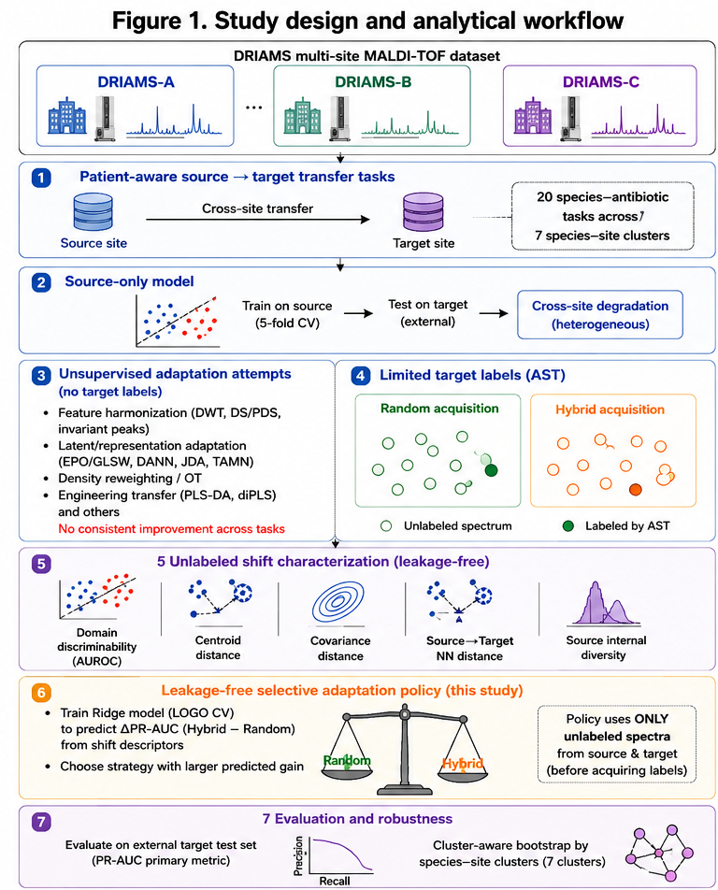
Figure 1. Study design and analytical workflow. Twenty species–antibiotic transfer tasks across seven species–site clusters were constructed from the DRIAMS collection with patient-aware splitting. Source-only models were trained by five-fold cross-validation and tested externally. Unsupervised adaptation was benchmarked without target labels; limited target labels were then acquired under Random or Hybrid strategies. Five label-free shift descriptors fed a leave-one-group-out ridge model that selected the acquisition strategy before any labels were obtained. Evaluation used external target test sets with cluster-aware bootstrapping.
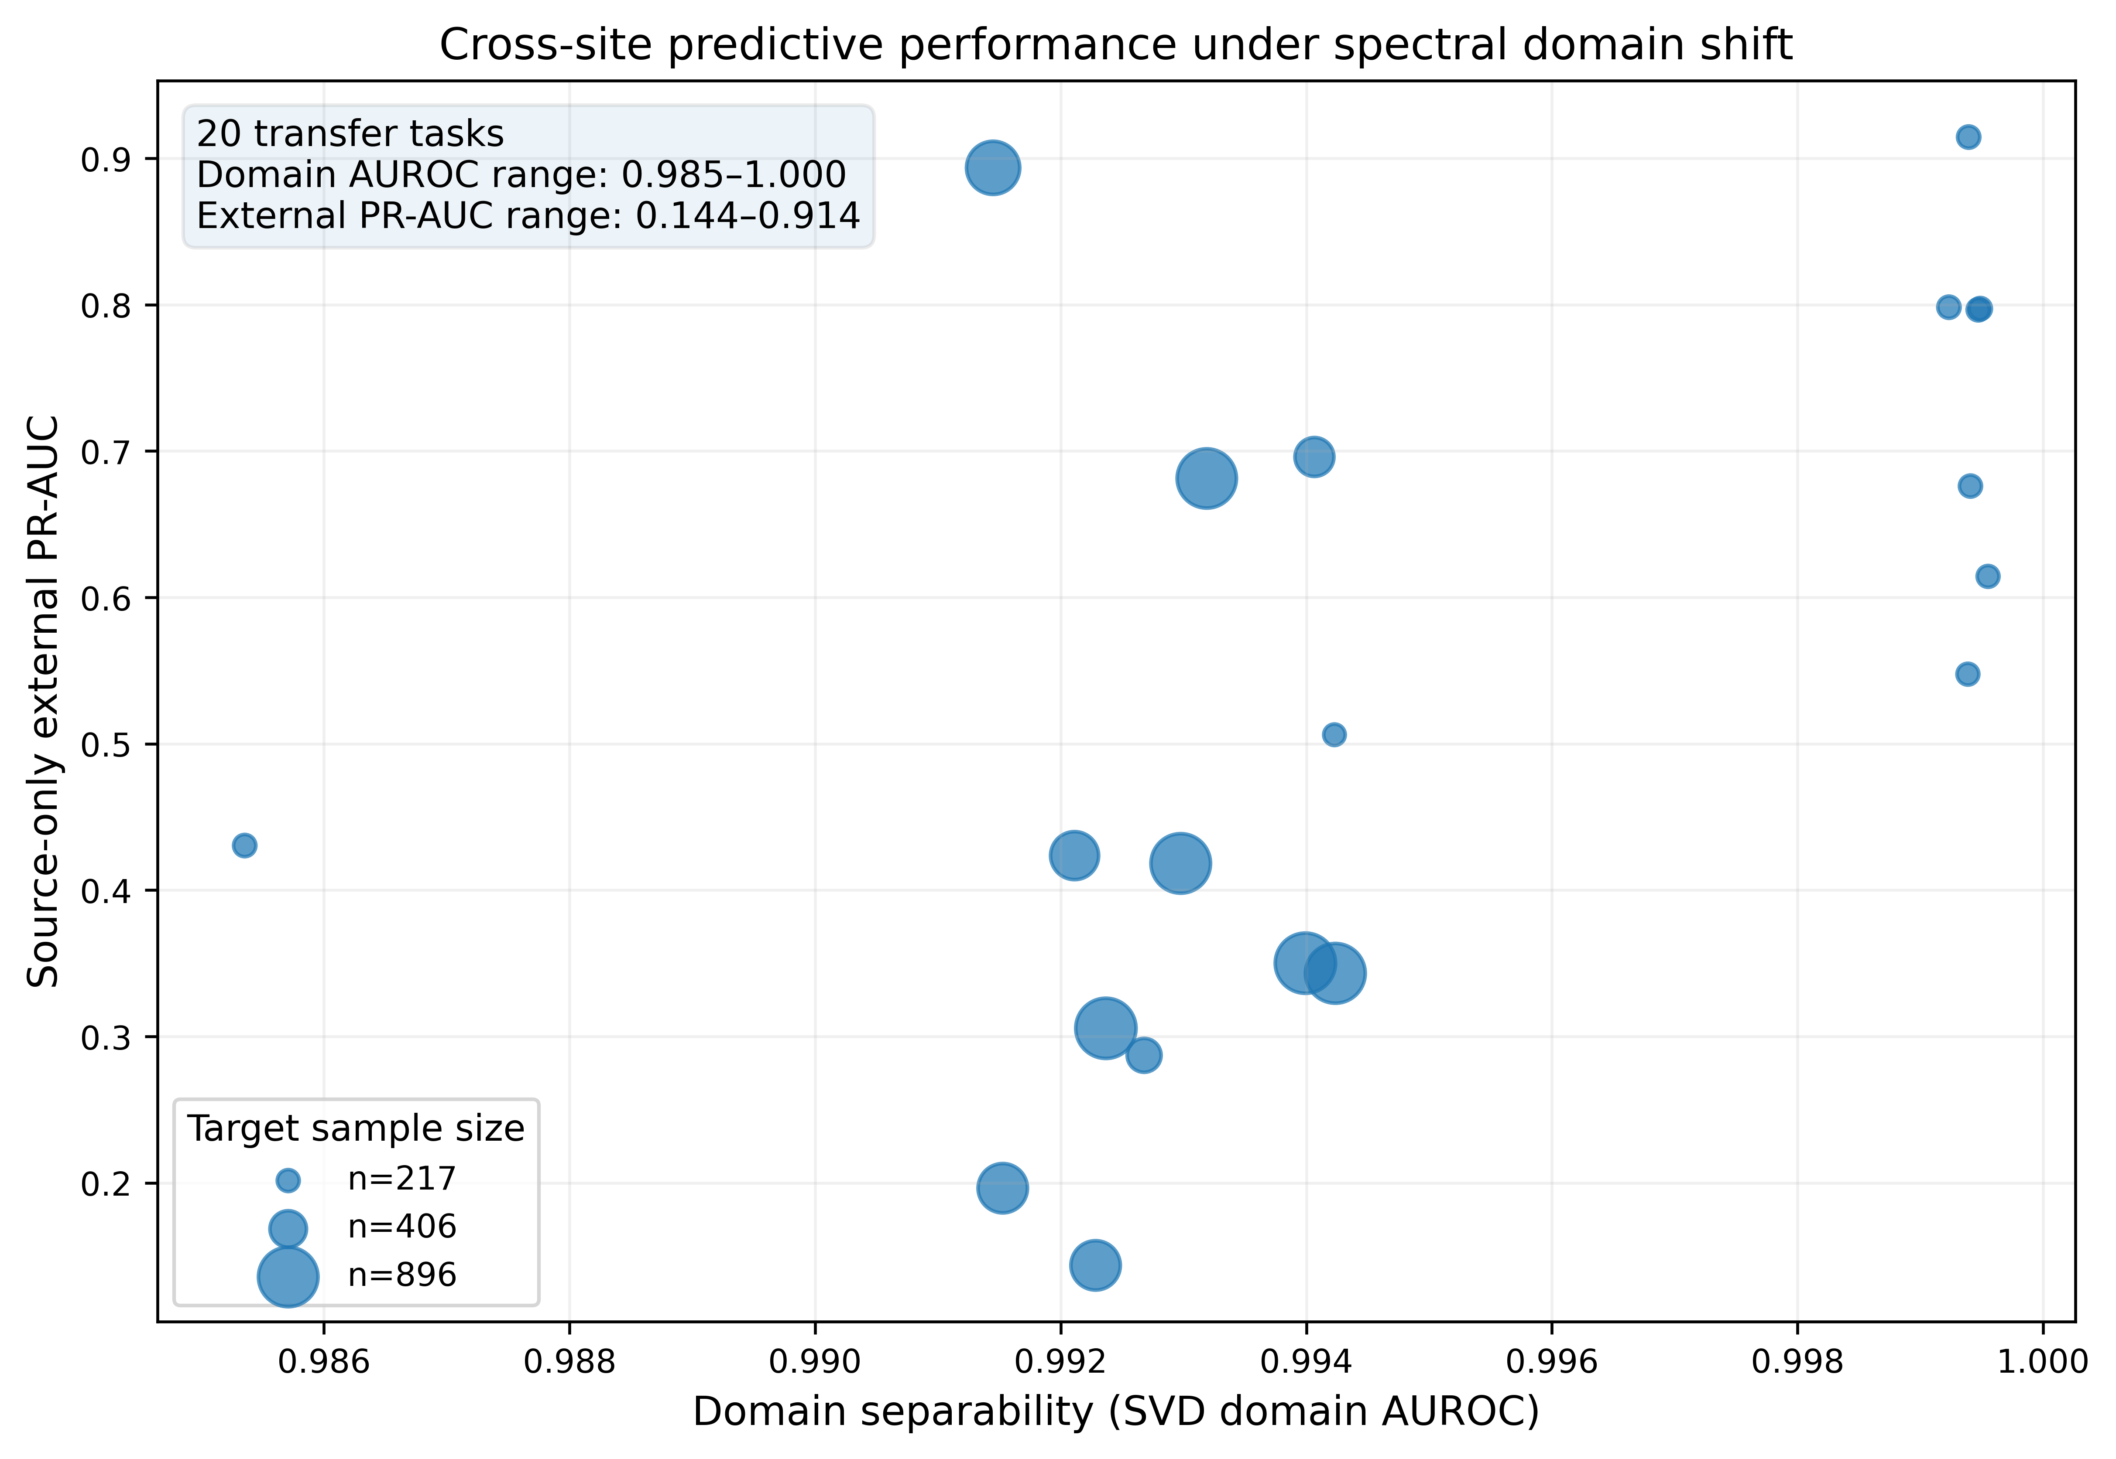
Figure 2. Cross-site predictive performance under spectral domain shift. Each point is one transfer task; marker area is proportional to target sample size. Source–target separability was uniformly high (domain AUROC 0.985–1.000) while source-only external PR-AUC ranged from 0.144 to 0.914.
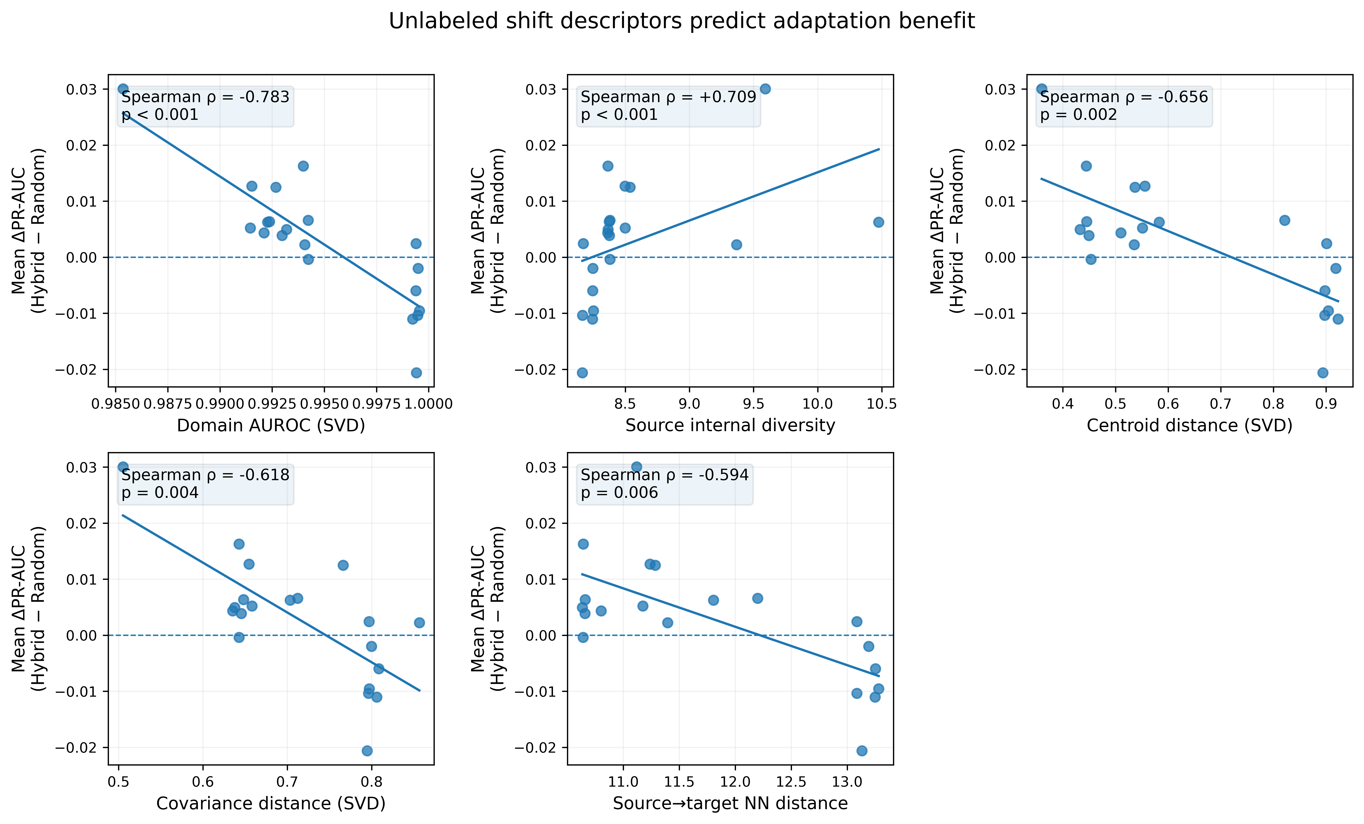
Figure 3. Unlabeled shift descriptors predict adaptation benefit. Mean ΔPR-AUC (Hybrid − Random) plotted against each of five label-free descriptors across 20 transfers, with Spearman coefficients and p values.
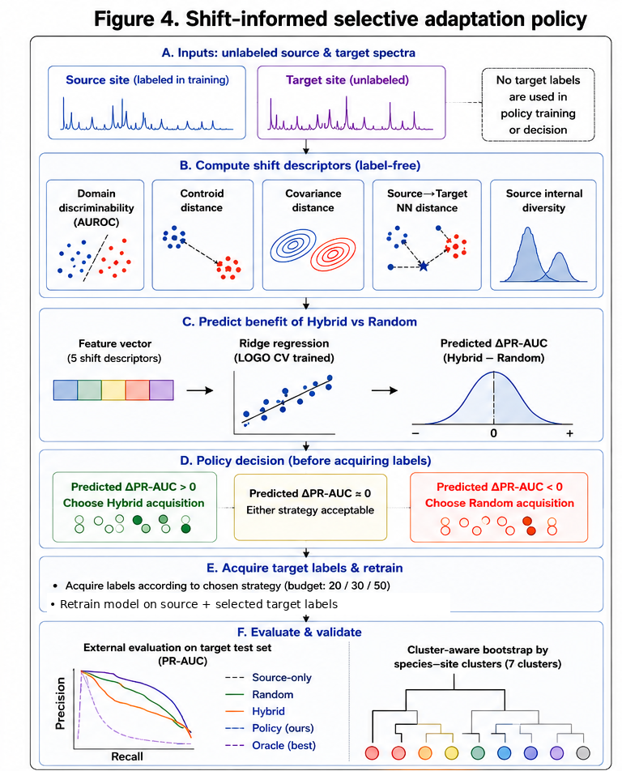
Figure 4. Shift-informed selective adaptation policy. (A) Inputs are unlabeled source and target spectra. (B) Five label-free descriptors are computed. (C) A ridge model trained under leave-one-group-out cross-validation predicts ΔPR-AUC. (D) The strategy with larger predicted gain is selected before labels are acquired. (E) Labels are obtained under the chosen strategy and the model retrained on source plus target. (F) Evaluation on an external target test set with cluster-aware bootstrapping.
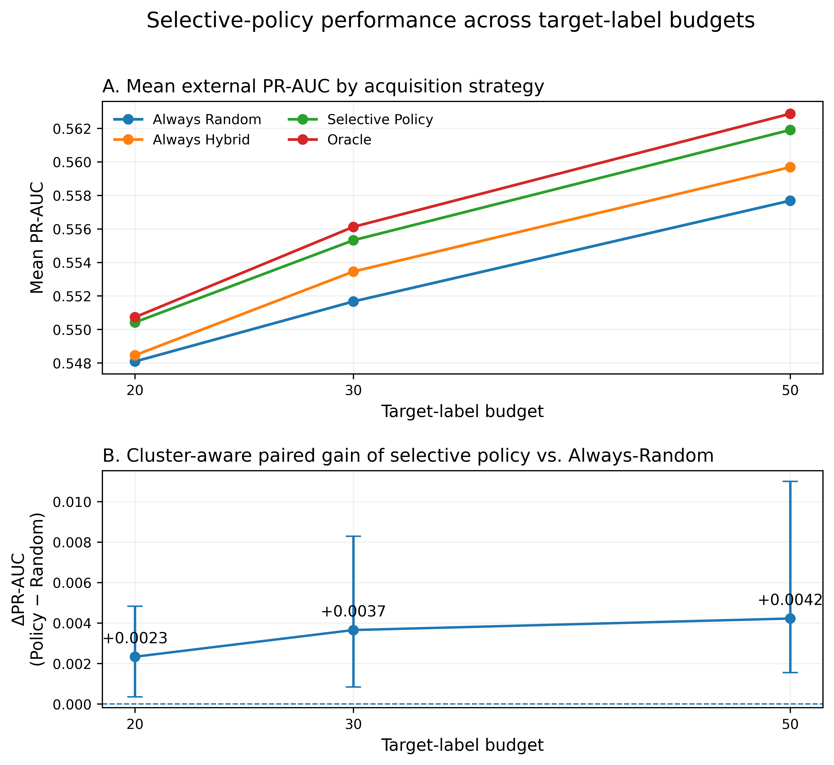
Figure 5. Selective-policy performance across target-label budgets. (A) Mean external PR-AUC for Always-Random, Always-Hybrid, the selective policy and the oracle. (B) Cluster-aware paired gain of the selective policy over Always-Random, with 95% confidence intervals.
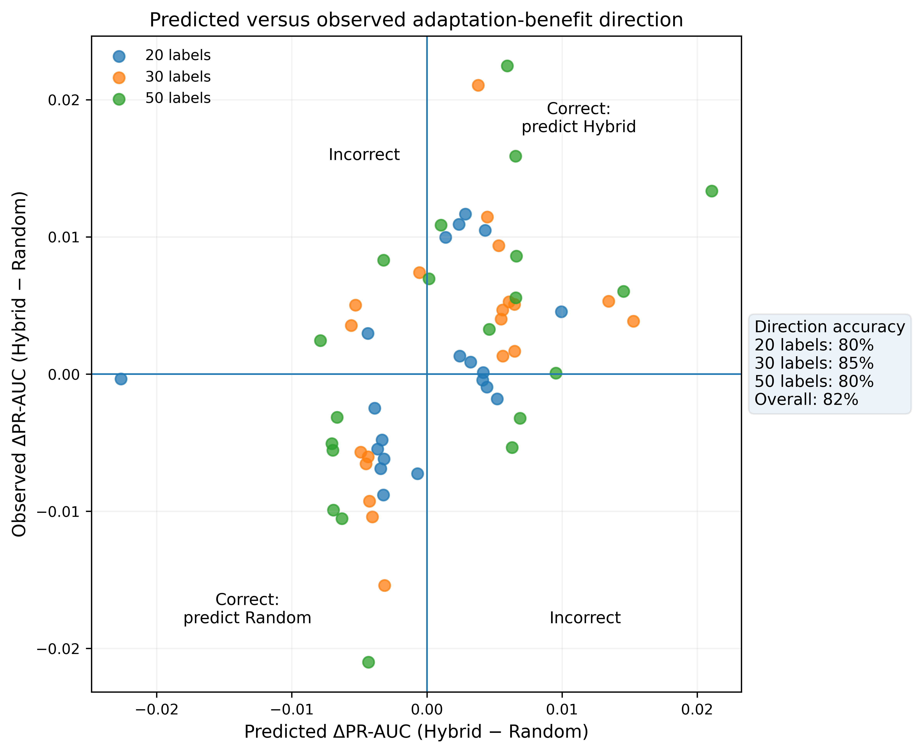
Figure 6. Predicted versus observed adaptation-benefit direction. Each point is one transfer at one budget. Points in the upper-right and lower-left quadrants represent correct directional predictions; overall accuracy was 82%.

Supplementary Materials: Supplementary Methods (adaptation-benchmark algorithms and grids; nested LOCO algorithm); Supplementary Tables S1–S11, including S11 (per-cluster leave-one-cluster-out validation of the selective acquisition policy: held-out cluster, number of tasks, observed and predicted ΔPR-AUC, direction accuracy, gain versus Random, regret, number of out-of-range descriptors, and standardised nearest-cluster distance).
Author Contributions: Conceptualization, [ ]; methodology, [ ]; software, [ ]; validation, [ ]; formal analysis, [ ]; data curation, [ ]; writing—original draft preparation, [ ]; writing—review and editing, [ ]; visualization, [ ]; supervision, [ ]. All authors have read and agreed to the published version of the manuscript.
Funding: This research received no external funding.
Institutional Review Board Statement: Not applicable. The study used publicly available, de-identified data.
Informed Consent Statement: Not applicable.
Data Availability Statement: DRIAMS is publicly available at doi:10.5061/dryad.bzkh1899q. Analysis code is available at https://github.com/huseyinKutlu/maldi-shift and archived at Zenodo under doi:10.5281/zenodo.XXXXXXX.
Conflicts of Interest: The authors declare no conflict of interest.

