**All operation screenshots of Todo RESTful API.**

POST /api/todo

Creates a new ToDo item.

**Request**:

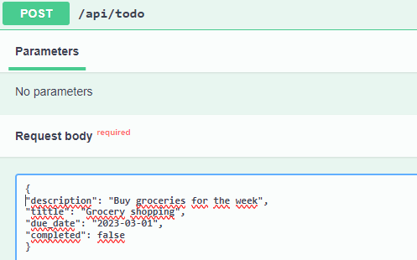

**Response**:

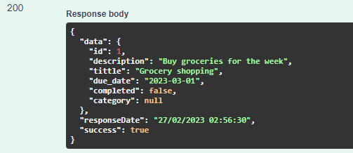

GET /api/todo

Returns a list of all ToDo items.

**Response**:

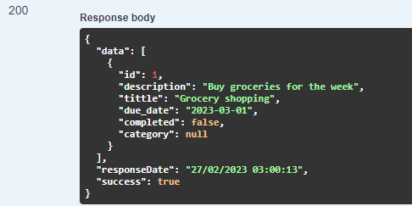

GET /api/todo/{id}

Returns a single ToDo item with the specified ID.

**Request**:

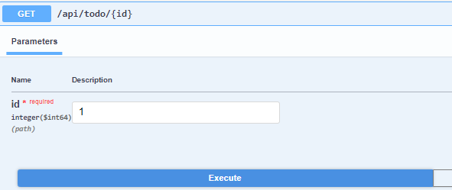

**Response**:

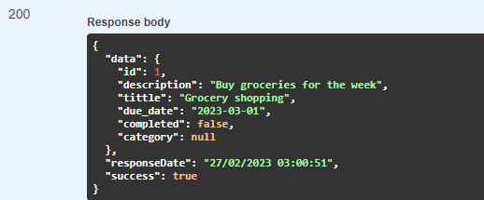

PUT /api/todo/{id}

Updates an existing ToDo item with the specified ID.

**Request**:

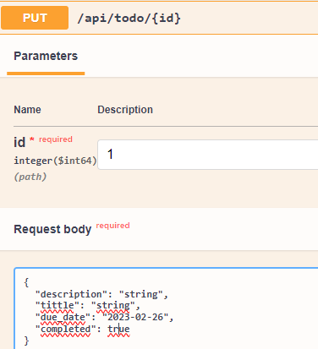

**Response**:

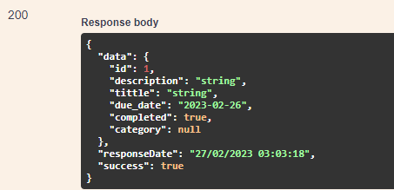

DELETE /api/todo/{id}

Deletes an existing ToDo item with the specified ID.

**Request**:

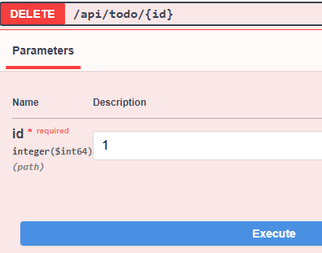

**Response**:

