**E-Commerce Data and Customer Retention Analysis with SQL**

_________________________________________________________

An e-commerce organization demands some analysis of sales and shipping processes. Thus, the organization hopes to be able to predict more easily the opportunities and threats for the future.

Acording to this scenario, You are asked to make the following analyzes consistant with following the instructions given.

/* Analyze the data by finding the answers to the questions below:

1.Find the top 3 customers who have the maximum count of orders.

*/

SELECT

TOP 3 *

FROM(

SELECT

DISTINCT B.cust_id, first_name, last_name,

COUNT(ord_id) OVER(PARTITION BY B.cust_id) AS cnt_order

FROM

customer.customer_table AS A,

[order].order_table AS B

WHERE

A.cust_id = B.cust_id

) AS Subquery

ORDER BY cnt_order DESC

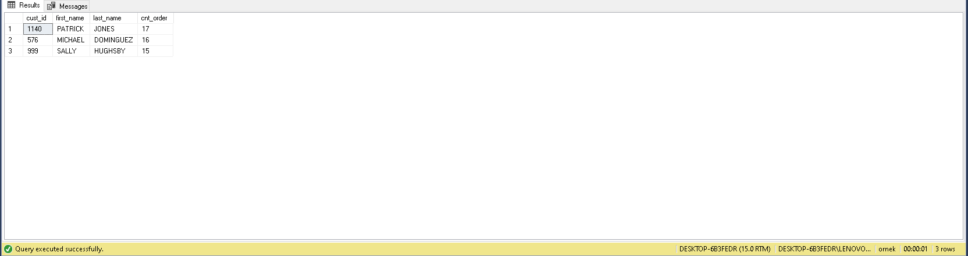

/* 2. Find the customer whose order took the maximum time to get shipping. */

WITH T1 AS(

SELECT

A.first_name,

A.last_name,

C.days_taken_for_shipping

FROM

customer.customer_table AS A

INNER JOIN [order].order_table AS B ON B.cust_id = A.cust_id

INNER JOIN customer.ship_table AS C ON C.ship_id = B.ship_id)

SELECT

TOP 1 *

FROM

T1

ORDER BY

days_taken_for_shipping DESC

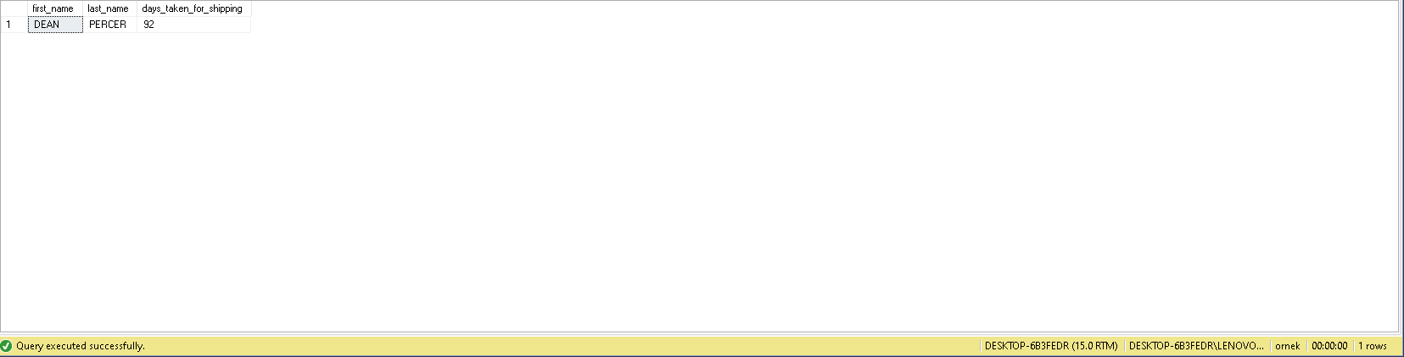

/* 3. Count the total number of unique customers in January and how many of them came back every month over the entire year in 2011 */

WITH T1 AS(

SELECT

A.*,

DATENAME(MONTH, B.order_date) AS month_name

FROM

customer.customer_table AS A

INNER JOIN [order].order_table AS B ON B.cust_id = A.cust_id

WHERE

YEAR(B.order_date) = 2011 AND

A.cust_id IN(

SELECT

DISTINCT A.cust_id

FROM

customer.customer_table AS A

INNER JOIN [order].order_table AS B ON B.cust_id = A.cust_id

WHERE

YEAR(B.order_date) = 2011 AND MONTH(B.order_date) = 1 ))

SELECT

SUM(CASE WHEN month_name = 'January' THEN 1 ELSE 0 END) AS January,

SUM(CASE WHEN month_name = 'February' THEN 1 ELSE 0 END) AS February,

SUM(CASE WHEN month_name = 'March' THEN 1 ELSE 0 END) AS March,

SUM(CASE WHEN month_name = 'April' THEN 1 ELSE 0 END) AS April,

SUM(CASE WHEN month_name = 'May' THEN 1 ELSE 0 END) AS May,

SUM(CASE WHEN month_name = 'June' THEN 1 ELSE 0 END) AS June,

SUM(CASE WHEN month_name = 'July' THEN 1 ELSE 0 END) AS July,

SUM(CASE WHEN month_name = 'August' THEN 1 ELSE 0 END) AS August,

SUM(CASE WHEN month_name = 'September' THEN 1 ELSE 0 END) AS September,

SUM(CASE WHEN month_name = 'October' THEN 1 ELSE 0 END) AS October,

SUM(CASE WHEN month_name = 'November' THEN 1 ELSE 0 END) AS November,

SUM(CASE WHEN month_name = 'December' THEN 1 ELSE 0 END) AS December

FROM

T1

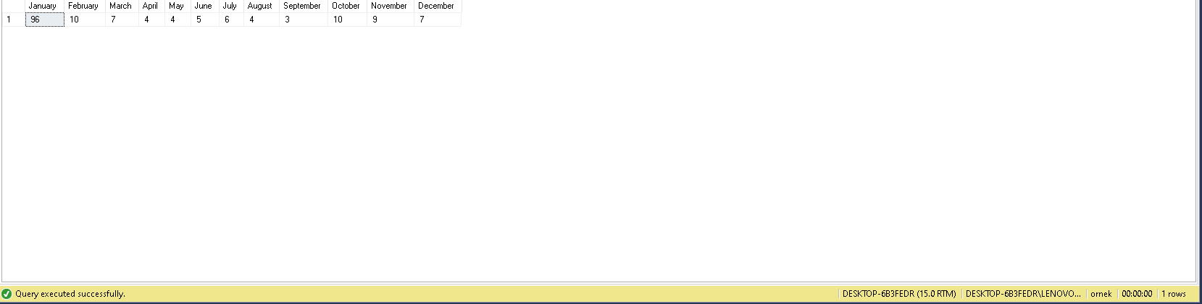

/* 4. Write a query to return for each user the time elapsed between the first purchasing and the third purchasing, in ascending order by Customer ID. */

SELECT

*,

DATEDIFF(DAY, first_purchasing, third_purchasing) AS difference_first_and_third_purchase

FROM(

SELECT

A.cust_id,

order_date AS first_purchasing,

LEAD(order_date, 2) OVER(PARTITION BY A.cust_id ORDER BY B.order_date) AS third_purchasing

FROM

customer.customer_table AS A

INNER JOIN [order].order_table AS B ON B.cust_id = A.cust_id) AS subquery

WHERE

third_purchasing IS NOT NULL

ORDER BY

cust_id;

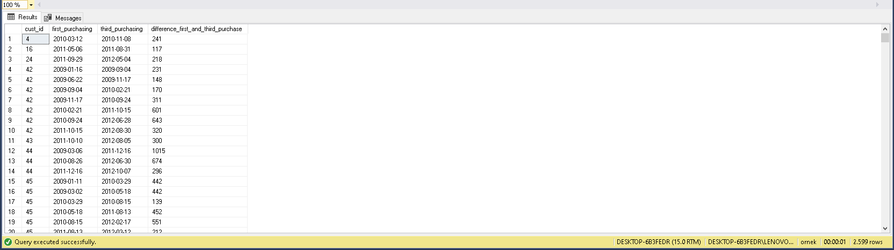

/* 5 . Write a query that returns customers who purchased both product 11 and product 14, as well as the ratio of these products to the total number of products purchased by the customer. */

GO

WITH T1 AS (

SELECT

DISTINCT A.cust_id,

SUM(C.order_quantity) OVER(PARTITION BY A.cust_id) AS prod_id_11,

A.first_name,

A.last_name

---CASE WHEN C.prod_id = 11 AND C.order_quantity ! = 0 THEN SUM(order_quantity) OVER(PARTITION BY A.cust_id) ELSE 0 END AS prod_id_11

FROM

customer.customer_table AS A

INNER JOIN [order].order_table AS B ON B.cust_id = A.cust_id

INNER JOIN [order].order_item AS C ON C.ord_id = B.ord_id

WHERE

C.prod_id = 11

), T2 AS(

SELECT

DISTINCT A.cust_id,

SUM(C.order_quantity) OVER(PARTITION BY A.cust_id) AS prod_id_14,

A.first_name,

A.last_name

---CASE WHEN C.prod_id = 14 AND C.order_quantity ! = 0 THEN SUM(order_quantity) OVER(PARTITION BY A.cust_id) ELSE 0 END AS prod_id_14

FROM

customer.customer_table AS A

INNER JOIN [order].order_table AS B ON B.cust_id = A.cust_id

INNER JOIN [order].order_item AS C ON C.ord_id = B.ord_id

WHERE

C.prod_id = 14

), T3 AS(

SELECT

DISTINCT A.cust_id,

SUM(C.order_quantity) OVER(PARTITION BY A.cust_id) AS sum_quantity,

A.first_name,

A.last_name

---CASE WHEN C.prod_id = 14 AND C.order_quantity ! = 0 THEN SUM(order_quantity) OVER(PARTITION BY A.cust_id) ELSE 0 END AS prod_id_14

FROM

customer.customer_table AS A

INNER JOIN [order].order_table AS B ON B.cust_id = A.cust_id

INNER JOIN [order].order_item AS C ON C.ord_id = B.ord_id

)

SELECT

T1.cust_id,

T1.first_name,

T1.last_name,

T3.sum_quantity,

T1.prod_id_11,

CAST(T1.prod_id_11 * 1.0 / T3.sum_quantity * 1.0 AS DECIMAL(3,2)) AS ratio_of_product_11,

T2.prod_id_14,

CAST(T2.prod_id_14 * 1.0 / T3.sum_quantity * 1.0 AS DECIMAL(3,2)) AS ratio_of_product_14

FROM

T1

INNER JOIN T2 ON T1.cust_id = T2.cust_id

INNER JOIN T3 ON T3.cust_id = T2.cust_id

ORDER BY

T1.cust_id

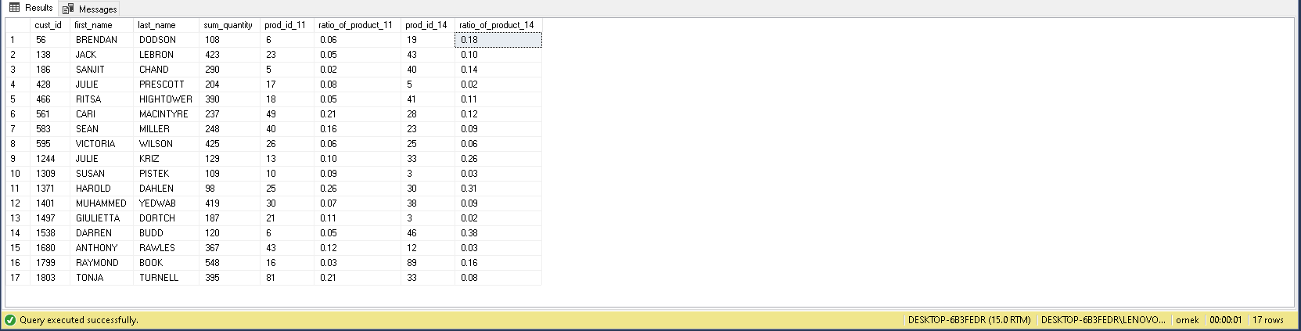

**Customer Segmentation**

**Categorize customers based on their frequency of visits. The following steps will guide you. If you want, you can track your own way.**

/* 1. Create a “view” that keeps visit logs of customers on a monthly basis. (For each log, three field is kept: Cust_id, Year, Month) */

GO

;CREATE VIEW vw_visit_logs AS(

SELECT

DISTINCT cust_id,

YEAR(order_date) AS 'year',

MONTH(order_date) AS 'month'

FROM

[order].order_table)

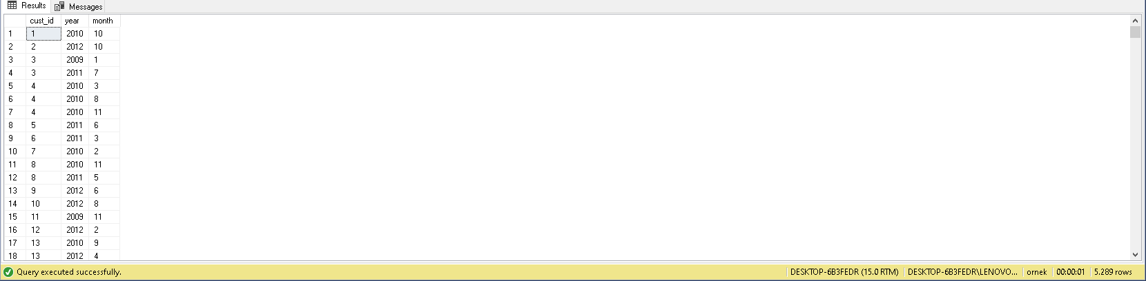

/* 2. Create a “view” that keeps the number of monthly visits by users. (Show separately all months from the beginning business) */

CREATE VIEW vw_number_of_visits AS(

SELECT

cust_id,

[2009_January], [2009_February], [2009_March], [2009_April], [2009_May], [2009_June], [2009_July],[2009_August], [2009_September], [2009_October], [2009_November], [2009_December],

[2010_January], [2010_February], [2010_March], [2010_April], [2010_May], [2010_June], [2010_July],[2010_August], [2010_September], [2010_October], [2010_November], [2010_December],

[2011_January], [2011_February], [2011_March], [2011_April], [2011_May], [2011_June], [2011_July],[2011_August], [2011_September], [2011_October], [2011_November], [2011_December],

[2012_January], [2012_February], [2012_March], [2012_April], [2012_May], [2012_June], [2012_July],[2012_August], [2012_September], [2012_October], [2012_November], [2012_December]

FROM (

SELECT

cust_id,

CONCAT(YEAR(order_date), '_', DATENAME(MONTH, order_date)) AS YearMonth

FROM

[order].order_table

) AS subquery

PIVOT (

COUNT(YearMonth)

FOR YearMonth IN (

[2009_January], [2009_February], [2009_March], [2009_April], [2009_May], [2009_June], [2009_July],[2009_August], [2009_September], [2009_October], [2009_November], [2009_December],

[2010_January], [2010_February], [2010_March], [2010_April], [2010_May], [2010_June], [2010_July],[2010_August], [2010_September], [2010_October], [2010_November], [2010_December],

[2011_January], [2011_February], [2011_March], [2011_April], [2011_May], [2011_June], [2011_July],[2011_August], [2011_September], [2011_October], [2011_November], [2011_December],

[2012_January], [2012_February], [2012_March], [2012_April], [2012_May], [2012_June], [2012_July],[2012_August], [2012_September], [2012_October], [2012_November], [2012_December]

)

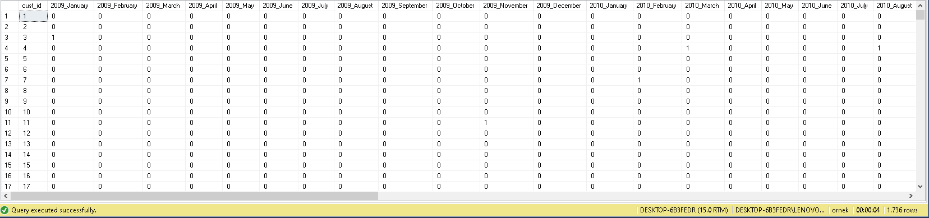) AS pivot_table);

/* 3. For each visit of customers, create the next month of the visit as a separate column. */

SELECT

DISTINCT cust_id,

order_date AS [1_visit],

LEAD(order_date) OVER(PARTITION BY cust_id ORDER BY order_date) [2_visit],

LEAD(order_date, 2) OVER(PARTITION BY cust_id ORDER BY order_date) [3_visit],

LEAD(order_date,3) OVER(PARTITION BY cust_id ORDER BY order_date) [4_visit],

LEAD(order_date, 4) OVER(PARTITION BY cust_id ORDER BY order_date) [5_visit],

LEAD(order_date, 5) OVER(PARTITION BY cust_id ORDER BY order_date) [6_visit],

LEAD(order_date, 6) OVER(PARTITION BY cust_id ORDER BY order_date) [7_visit],

LEAD(order_date, 7) OVER(PARTITION BY cust_id ORDER BY order_date) [8_visit],

LEAD(order_date, 8) OVER(PARTITION BY cust_id ORDER BY order_date) [9_visit],

LEAD(order_date, 9) OVER(PARTITION BY cust_id ORDER BY order_date) [10_visit],

LEAD(order_date, 10) OVER(PARTITION BY cust_id ORDER BY order_date) [11_visit],

LEAD(order_date, 11) OVER(PARTITION BY cust_id ORDER BY order_date) [12_visit],

LEAD(order_date, 12) OVER(PARTITION BY cust_id ORDER BY order_date) [13_visit],

LEAD(order_date, 13) OVER(PARTITION BY cust_id ORDER BY order_date) [14_visit],

LEAD(order_date, 14) OVER(PARTITION BY cust_id ORDER BY order_date) [15_visit],

LEAD(order_date, 15) OVER(PARTITION BY cust_id ORDER BY order_date) [16_visit],

LEAD(order_date, 16) OVER(PARTITION BY cust_id ORDER BY order_date) [17_visit]

FROM

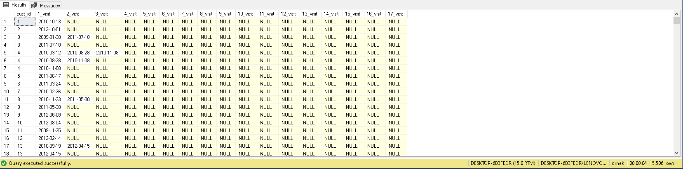 [order].order_table

/* 4. Calculate the monthly time gap between two consecutive visits by each customer. */

WITH CTE AS (

SELECT

DISTINCT cust_id,

0 AS [1_visit],

DATEDIFF(MONTH ,order_date, LEAD(order_date) OVER(PARTITION BY cust_id ORDER BY order_date)) AS [1_gap],

DATEDIFF(MONTH , LEAD(order_date) OVER(PARTITION BY cust_id ORDER BY order_date), LEAD(order_date, 2) OVER(PARTITION BY cust_id ORDER BY order_date)) AS [2_gap],

DATEDIFF(MONTH , LEAD(order_date, 2) OVER(PARTITION BY cust_id ORDER BY order_date), LEAD(order_date, 3) OVER(PARTITION BY cust_id ORDER BY order_date)) AS [3_gap],

DATEDIFF(MONTH , LEAD(order_date, 3) OVER(PARTITION BY cust_id ORDER BY order_date), LEAD(order_date, 4) OVER(PARTITION BY cust_id ORDER BY order_date)) AS [4_gap],

DATEDIFF(MONTH , LEAD(order_date, 4) OVER(PARTITION BY cust_id ORDER BY order_date), LEAD(order_date, 5) OVER(PARTITION BY cust_id ORDER BY order_date)) AS [5_gap],

DATEDIFF(MONTH , LEAD(order_date, 5) OVER(PARTITION BY cust_id ORDER BY order_date), LEAD(order_date, 6) OVER(PARTITION BY cust_id ORDER BY order_date)) AS [6_gap],

DATEDIFF(MONTH , LEAD(order_date, 6) OVER(PARTITION BY cust_id ORDER BY order_date), LEAD(order_date, 7) OVER(PARTITION BY cust_id ORDER BY order_date)) AS [7_gap],

DATEDIFF(MONTH , LEAD(order_date, 7) OVER(PARTITION BY cust_id ORDER BY order_date), LEAD(order_date, 8) OVER(PARTITION BY cust_id ORDER BY order_date)) AS [8_gap],

DATEDIFF(MONTH , LEAD(order_date, 8) OVER(PARTITION BY cust_id ORDER BY order_date), LEAD(order_date, 9) OVER(PARTITION BY cust_id ORDER BY order_date)) AS [9_gap],

DATEDIFF(MONTH , LEAD(order_date, 9) OVER(PARTITION BY cust_id ORDER BY order_date), LEAD(order_date, 10) OVER(PARTITION BY cust_id ORDER BY order_date)) AS [10_gap],

DATEDIFF(MONTH , LEAD(order_date, 10) OVER(PARTITION BY cust_id ORDER BY order_date), LEAD(order_date, 11) OVER(PARTITION BY cust_id ORDER BY order_date)) AS [11_gap],

DATEDIFF(MONTH , LEAD(order_date, 11) OVER(PARTITION BY cust_id ORDER BY order_date), LEAD(order_date, 12) OVER(PARTITION BY cust_id ORDER BY order_date)) AS [12_gap],

DATEDIFF(MONTH , LEAD(order_date, 12) OVER(PARTITION BY cust_id ORDER BY order_date), LEAD(order_date, 13) OVER(PARTITION BY cust_id ORDER BY order_date)) AS [13_gap],

DATEDIFF(MONTH , LEAD(order_date, 13) OVER(PARTITION BY cust_id ORDER BY order_date), LEAD(order_date, 14) OVER(PARTITION BY cust_id ORDER BY order_date)) AS [14_gap],

DATEDIFF(MONTH , LEAD(order_date, 14) OVER(PARTITION BY cust_id ORDER BY order_date), LEAD(order_date, 15) OVER(PARTITION BY cust_id ORDER BY order_date)) AS [15_gap],

DATEDIFF(MONTH , LEAD(order_date, 15) OVER(PARTITION BY cust_id ORDER BY order_date), LEAD(order_date, 16) OVER(PARTITION BY cust_id ORDER BY order_date)) AS [16_gap]

FROM

[order].order_table

)

SELECT TOP 1 WITH TIES *

FROM CTE

ORDER BY RANK() OVER (PARTITION BY cust_id ORDER BY CASE WHEN [1_gap] IS NULL THEN 1 ELSE 0 END + CASE WHEN [2_gap] IS NULL THEN 1 ELSE 0 END + CASE WHEN [3_gap] IS NULL THEN 1 ELSE 0 END +CASE WHEN [4_gap] IS NULL THEN 1 ELSE 0 END +CASE WHEN [5_gap] IS NULL THEN 1 ELSE 0 END +CASE WHEN [6_gap] IS NULL THEN 1 ELSE 0 END +CASE WHEN [7_gap] IS NULL THEN 1 ELSE 0 END +CASE WHEN [8_gap] IS NULL THEN 1 ELSE 0 END +CASE WHEN [9_gap] IS NULL THEN 1 ELSE 0 END +CASE WHEN [10_gap] IS NULL THEN 1 ELSE 0 END + CASE WHEN [11_gap] IS NULL THEN 1 ELSE 0 END + CASE WHEN [12_gap] IS NULL THEN 1 ELSE 0 END + CASE WHEN [13_gap] IS NULL THEN 1 ELSE 0 END + CASE WHEN [14_gap] IS NULL THEN 1 ELSE 0 END + CASE WHEN [15_gap] IS NULL THEN 1 ELSE 0 END + CASE WHEN [16_gap] IS NULL THEN 1 ELSE 0 END + 0) ASC;

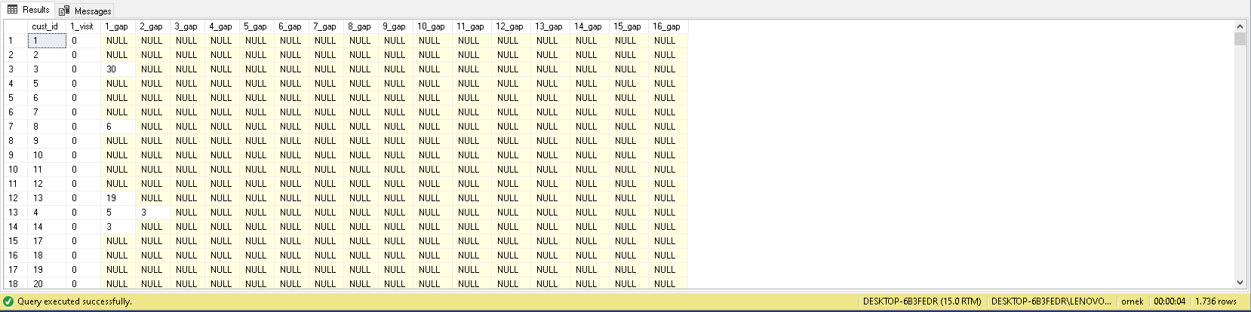

/* 5. Categorise customers using average time gaps. Choose the most fitted labeling model for you. */

--create a table with 'total_gaps_non_null' name

WITH CTE AS (

SELECT

DISTINCT cust_id,

0 AS [1_visit],

DATEDIFF(MONTH ,order_date, LEAD(order_date) OVER(PARTITION BY cust_id ORDER BY order_date)) AS [1_gap],

DATEDIFF(MONTH , LEAD(order_date) OVER(PARTITION BY cust_id ORDER BY order_date), LEAD(order_date, 2) OVER(PARTITION BY cust_id ORDER BY order_date)) AS [2_gap],

DATEDIFF(MONTH , LEAD(order_date, 2) OVER(PARTITION BY cust_id ORDER BY order_date), LEAD(order_date, 3) OVER(PARTITION BY cust_id ORDER BY order_date)) AS [3_gap],

DATEDIFF(MONTH , LEAD(order_date, 3) OVER(PARTITION BY cust_id ORDER BY order_date), LEAD(order_date, 4) OVER(PARTITION BY cust_id ORDER BY order_date)) AS [4_gap],

DATEDIFF(MONTH , LEAD(order_date, 4) OVER(PARTITION BY cust_id ORDER BY order_date), LEAD(order_date, 5) OVER(PARTITION BY cust_id ORDER BY order_date)) AS [5_gap],

DATEDIFF(MONTH , LEAD(order_date, 5) OVER(PARTITION BY cust_id ORDER BY order_date), LEAD(order_date, 6) OVER(PARTITION BY cust_id ORDER BY order_date)) AS [6_gap],

DATEDIFF(MONTH , LEAD(order_date, 6) OVER(PARTITION BY cust_id ORDER BY order_date), LEAD(order_date, 7) OVER(PARTITION BY cust_id ORDER BY order_date)) AS [7_gap],

DATEDIFF(MONTH , LEAD(order_date, 7) OVER(PARTITION BY cust_id ORDER BY order_date), LEAD(order_date, 8) OVER(PARTITION BY cust_id ORDER BY order_date)) AS [8_gap],

DATEDIFF(MONTH , LEAD(order_date, 8) OVER(PARTITION BY cust_id ORDER BY order_date), LEAD(order_date, 9) OVER(PARTITION BY cust_id ORDER BY order_date)) AS [9_gap],

DATEDIFF(MONTH , LEAD(order_date, 9) OVER(PARTITION BY cust_id ORDER BY order_date), LEAD(order_date, 10) OVER(PARTITION BY cust_id ORDER BY order_date)) AS [10_gap],

DATEDIFF(MONTH , LEAD(order_date, 10) OVER(PARTITION BY cust_id ORDER BY order_date), LEAD(order_date, 11) OVER(PARTITION BY cust_id ORDER BY order_date)) AS [11_gap],

DATEDIFF(MONTH , LEAD(order_date, 11) OVER(PARTITION BY cust_id ORDER BY order_date), LEAD(order_date, 12) OVER(PARTITION BY cust_id ORDER BY order_date)) AS [12_gap],

DATEDIFF(MONTH , LEAD(order_date, 12) OVER(PARTITION BY cust_id ORDER BY order_date), LEAD(order_date, 13) OVER(PARTITION BY cust_id ORDER BY order_date)) AS [13_gap],

DATEDIFF(MONTH , LEAD(order_date, 13) OVER(PARTITION BY cust_id ORDER BY order_date), LEAD(order_date, 14) OVER(PARTITION BY cust_id ORDER BY order_date)) AS [14_gap],

DATEDIFF(MONTH , LEAD(order_date, 14) OVER(PARTITION BY cust_id ORDER BY order_date), LEAD(order_date, 15) OVER(PARTITION BY cust_id ORDER BY order_date)) AS [15_gap],

DATEDIFF(MONTH , LEAD(order_date, 15) OVER(PARTITION BY cust_id ORDER BY order_date), LEAD(order_date, 16) OVER(PARTITION BY cust_id ORDER BY order_date)) AS [16_gap]

FROM

[order].order_table

)

SELECT TOP 1 WITH TIES *,

COALESCE([1_gap], 0) + COALESCE([2_gap], 0) + COALESCE([3_gap], 0) + COALESCE([3_gap], 0) + COALESCE([4_gap], 0) + COALESCE([5_gap], 0) + COALESCE([6_gap], 0) + COALESCE([7_gap], 0) + COALESCE([8_gap], 0) + COALESCE([9_gap], 0) + COALESCE([10_gap], 0) + COALESCE([11_gap], 0) + COALESCE([12_gap], 0) + COALESCE([13_gap], 0) + COALESCE([14_gap], 0) + COALESCE([15_gap], 0) + COALESCE([16_gap], 0) AS total_gap,

CASE WHEN [1_gap] IS NOT NULL THEN 1 ELSE 0 END +

CASE WHEN [2_gap] IS NOT NULL THEN 1 ELSE 0 END +

CASE WHEN [3_gap] IS NOT NULL THEN 1 ELSE 0 END +

CASE WHEN [4_gap] IS NOT NULL THEN 1 ELSE 0 END +

CASE WHEN [5_gap] IS NOT NULL THEN 1 ELSE 0 END +

CASE WHEN [6_gap] IS NOT NULL THEN 1 ELSE 0 END +

CASE WHEN [7_gap] IS NOT NULL THEN 1 ELSE 0 END +

CASE WHEN [8_gap] IS NOT NULL THEN 1 ELSE 0 END +

CASE WHEN [9_gap] IS NOT NULL THEN 1 ELSE 0 END +

CASE WHEN [10_gap] IS NOT NULL THEN 1 ELSE 0 END +

CASE WHEN [11_gap] IS NOT NULL THEN 1 ELSE 0 END +

CASE WHEN [12_gap] IS NOT NULL THEN 1 ELSE 0 END +

CASE WHEN [13_gap] IS NOT NULL THEN 1 ELSE 0 END +

CASE WHEN [14_gap] IS NOT NULL THEN 1 ELSE 0 END +

CASE WHEN [15_gap] IS NOT NULL THEN 1 ELSE 0 END +

CASE WHEN [16_gap] IS NOT NULL THEN 1 ELSE 0 END AS non_null_count

INTO total_gaps_non_null

FROM CTE

ORDER BY RANK() OVER (PARTITION BY cust_id ORDER BY CASE WHEN [1_gap] IS NULL THEN 1 ELSE 0 END +

CASE WHEN [2_gap] IS NULL THEN 1 ELSE 0 END +

CASE WHEN [3_gap] IS NULL THEN 1 ELSE 0 END +

CASE WHEN [4_gap] IS NULL THEN 1 ELSE 0 END +

CASE WHEN [5_gap] IS NULL THEN 1 ELSE 0 END +

CASE WHEN [6_gap] IS NULL THEN 1 ELSE 0 END +

CASE WHEN [7_gap] IS NULL THEN 1 ELSE 0 END +

CASE WHEN [8_gap] IS NULL THEN 1 ELSE 0 END +

CASE WHEN [9_gap] IS NULL THEN 1 ELSE 0 END +

CASE WHEN [10_gap] IS NULL THEN 1 ELSE 0 END +

CASE WHEN [11_gap] IS NULL THEN 1 ELSE 0 END +

CASE WHEN [12_gap] IS NULL THEN 1 ELSE 0 END +

CASE WHEN [13_gap] IS NULL THEN 1 ELSE 0 END +

CASE WHEN [14_gap] IS NULL THEN 1 ELSE 0 END +

CASE WHEN [15_gap] IS NULL THEN 1 ELSE 0 END +

CASE WHEN [16_gap] IS NULL THEN 1 ELSE 0 END +

1. ASC

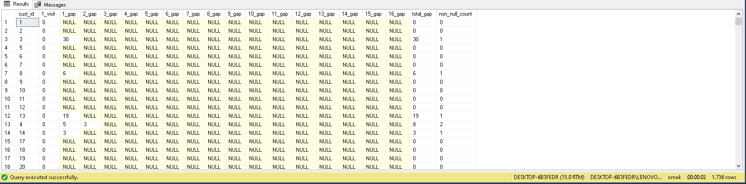SELECT

cust_id,

CASE WHEN avg_gap = 0 THEN 'Churn'

WHEN avg_gap = 1 THEN 'Regular'

WHEN avg_gap BETWEEN 2 AND 10 THEN 'Very Good'

WHEN avg_gap BETWEEN 11 AND 20 THEN 'Good'

WHEN avg_gap BETWEEN 21 AND 30 THEN 'Medium'

WHEN avg_gap BETWEEN 31 AND 40 THEN 'Bad'

ELSE 'Very Bad' END AS category_visitors

FROM

(

SELECT

*,

total_gap / CASE WHEN non_null_count = 0 THEN 1 ELSE non_null_count END avg_gap

FROM

total_gaps_non_null) AS subquery

ORDER BY

cust_id

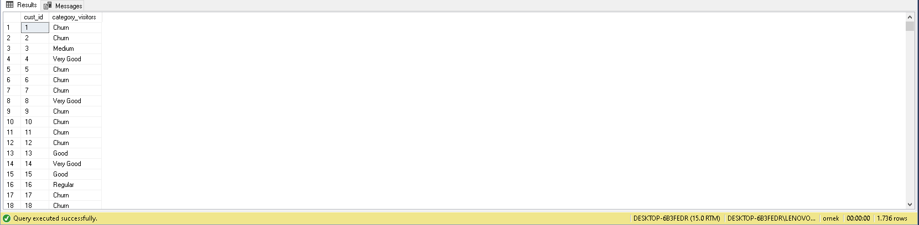

**Month-Wise Retention Rate**

**Find month-by-month customer retention rate*i* since the start of the business.**

CREATE VIEW vw_month_wise AS(

SELECT

cust_id,

CASE WHEN [2009_January] = 1 AND [2009_February] = 1 THEN 1 ELSE 0 END AS [2009_Jan_Feb],

CASE WHEN [2009_February] = 1 AND [2009_March] = 1 THEN 1 ELSE 0 END AS [2009_Feb_Mar],

CASE WHEN [2009_March] = 1 AND [2009_April] = 1 THEN 1 ELSE 0 END AS [2009_Mar_Apr],

CASE WHEN [2009_April] = 1 AND [2009_May] = 1 THEN 1 ELSE 0 END AS [2009_Apr_May],

CASE WHEN [2009_May] = 1 AND [2009_June] = 1 THEN 1 ELSE 0 END AS [2009_May_Jun],

CASE WHEN [2009_June] = 1 AND [2009_July] = 1 THEN 1 ELSE 0 END AS [2009_Jun_July],

CASE WHEN [2009_July] = 1 AND [2009_August] = 1 THEN 1 ELSE 0 END AS [2009_July_Aug],

CASE WHEN [2009_August] = 1 AND [2009_September] = 1 THEN 1 ELSE 0 END AS [2009_Aug_Sep],

CASE WHEN [2009_September] = 1 AND [2009_October] = 1 THEN 1 ELSE 0 END AS [2009_Sep_Oct],

CASE WHEN [2009_October] = 1 AND [2009_November] = 1 THEN 1 ELSE 0 END AS [2009_Oct_Nov],

CASE WHEN [2009_November] = 1 AND [2009_December] = 1 THEN 1 ELSE 0 END AS [2009_Nov_Dec],

CASE WHEN [2009_December] = 1 AND [2010_January] = 1 THEN 1 ELSE 0 END AS [2009_Dec_Jan],

CASE WHEN [2010_January] = 1 AND [2010_February] = 1 THEN 1 ELSE 0 END AS [2010_Jan_Feb],

CASE WHEN [2010_February] = 1 AND [2010_March] = 1 THEN 1 ELSE 0 END AS [2010_Feb_Mar],

CASE WHEN [2010_March] = 1 AND [2010_April] = 1 THEN 1 ELSE 0 END AS [2010_Mar_Apr],

CASE WHEN [2010_April] = 1 AND [2010_May] = 1 THEN 1 ELSE 0 END AS [2010_Apr_May],

CASE WHEN [2010_May] = 1 AND [2010_June] = 1 THEN 1 ELSE 0 END AS [2010_May_Jun],

CASE WHEN [2010_June] = 1 AND [2010_July] = 1 THEN 1 ELSE 0 END AS [2010_Jun_July],

CASE WHEN [2010_July] = 1 AND [2010_August] = 1 THEN 1 ELSE 0 END AS [2010_July_Aug],

CASE WHEN [2010_August] = 1 AND [2010_September] = 1 THEN 1 ELSE 0 END AS [2010_Aug_Sep],

CASE WHEN [2010_September] = 1 AND [2010_October] = 1 THEN 1 ELSE 0 END AS [2010_Sep_Oct],

CASE WHEN [2010_October] = 1 AND [2010_November] = 1 THEN 1 ELSE 0 END AS [2010_Oct_Nov],

CASE WHEN [2010_November] = 1 AND [2010_December] = 1 THEN 1 ELSE 0 END AS [2010_Nov_Dec],

CASE WHEN [2010_December] = 1 AND [2011_January] = 1 THEN 1 ELSE 0 END AS [2010_Dec_Jan],

CASE WHEN [2011_January] = 1 AND [2011_February] = 1 THEN 1 ELSE 0 END AS [2011_Jan_Feb],

CASE WHEN [2011_February] = 1 AND [2011_March] = 1 THEN 1 ELSE 0 END AS [2011_Feb_Mar],

CASE WHEN [2011_March] = 1 AND [2011_April] = 1 THEN 1 ELSE 0 END AS [2011_Mar_Apr],

CASE WHEN [2011_April] = 1 AND [2011_May] = 1 THEN 1 ELSE 0 END AS [2011_Apr_May],

CASE WHEN [2011_May] = 1 AND [2011_June] = 1 THEN 1 ELSE 0 END AS [2011_May_Jun],

CASE WHEN [2011_June] = 1 AND [2011_July] = 1 THEN 1 ELSE 0 END AS [2011_Jun_July],

CASE WHEN [2011_July] = 1 AND [2011_August] = 1 THEN 1 ELSE 0 END AS [2011_July_Aug],

CASE WHEN [2011_August] = 1 AND [2011_September] = 1 THEN 1 ELSE 0 END AS [2011_Aug_Sep],

CASE WHEN [2011_September] = 1 AND [2011_October] = 1 THEN 1 ELSE 0 END AS [2011_Sep_Oct],

CASE WHEN [2011_October] = 1 AND [2011_November] = 1 THEN 1 ELSE 0 END AS [2011_Oct_Nov],

CASE WHEN [2011_November] = 1 AND [2011_December] = 1 THEN 1 ELSE 0 END AS [2011_Nov_Dec],

CASE WHEN [2011_December] = 1 AND [2012_January] = 1 THEN 1 ELSE 0 END AS [2011_Dec_Jan],

CASE WHEN [2012_January] = 1 AND [2012_February] = 1 THEN 1 ELSE 0 END AS [2012_Jan_Feb],

CASE WHEN [2012_February] = 1 AND [2012_March] = 1 THEN 1 ELSE 0 END AS [2012_Feb_Mar],

CASE WHEN [2012_March] = 1 AND [2012_April] = 1 THEN 1 ELSE 0 END AS [2012_Mar_Apr],

CASE WHEN [2012_April] = 1 AND [2012_May] = 1 THEN 1 ELSE 0 END AS [2012_Apr_May],

CASE WHEN [2012_May] = 1 AND [2012_June] = 1 THEN 1 ELSE 0 END AS [2012_May_Jun],

CASE WHEN [2012_June] = 1 AND [2012_July] = 1 THEN 1 ELSE 0 END AS [2012_Jun_July],

CASE WHEN [2012_July] = 1 AND [2012_August] = 1 THEN 1 ELSE 0 END AS [2012_July_Aug],

CASE WHEN [2012_August] = 1 AND [2012_September] = 1 THEN 1 ELSE 0 END AS [2012_Aug_Sep],

CASE WHEN [2012_September] = 1 AND [2012_October] = 1 THEN 1 ELSE 0 END AS [2012_Sep_Oct],

CASE WHEN [2012_October] = 1 AND [2012_November] = 1 THEN 1 ELSE 0 END AS [2012_Oct_Nov],

CASE WHEN [2012_November] = 1 AND [2012_December] = 1 THEN 1 ELSE 0 END AS [2012_Nov_Dec]

FROM

vw_number_of_visits)

SELECT

*

FROM

vw_month_wise

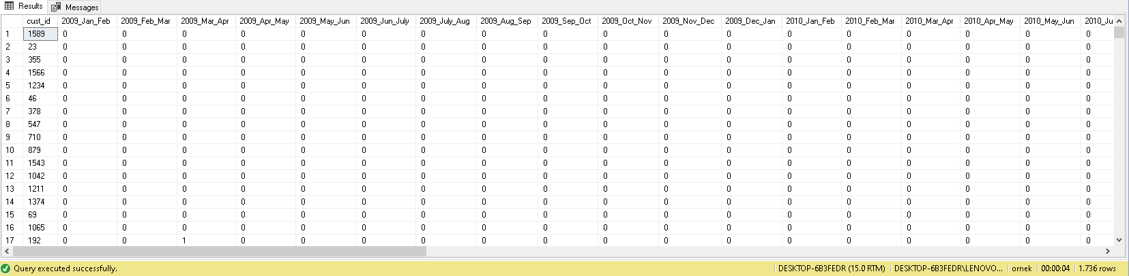 CREATE VIEW vw_consecutive_months AS(

SELECT

cust_id,

CASE WHEN [2009_Jan_Feb] = 1 THEN '2009_Jan_Feb'

WHEN [2009_Feb_Mar] = 1 THEN '2009_Feb_Mar'

WHEN [2009_Mar_Apr] = 1 THEN '2009_Mar_Apr'

WHEN [2009_Apr_May] = 1 THEN '2009_Apr_May'

WHEN [2009_May_Jun] = 1 THEN '2009_May_Jun'

WHEN [2009_Jun_July] = 1 THEN '2009_Jun_July'

WHEN [2009_July_Aug] = 1 THEN '2009_July_Aug'

WHEN [2009_Aug_Sep] = 1 THEN '2009_Aug_Sep'

WHEN [2009_Sep_Oct] = 1 THEN '2009_Sep_Oct'

WHEN [2009_Oct_Nov] = 1 THEN '2009_Oct_Nov'

WHEN [2009_Nov_Dec] = 1 THEN '2009_Nov_Dec'

WHEN [2009_Dec_Jan] = 1 THEN '2009_Dec_Jan'

WHEN [2010_Jan_Feb] = 1 THEN '2010_Jan_Feb'

WHEN [2010_Feb_Mar] = 1 THEN '2010_Feb_Mar'

WHEN [2010_Mar_Apr] = 1 THEN '2010_Mar_Apr'

WHEN [2010_Apr_May] = 1 THEN '2010_Apr_May'

WHEN [2010_May_Jun] = 1 THEN '2010_May_Jun'

WHEN [2010_Jun_July] = 1 THEN '2010_Jun_July'

WHEN [2010_July_Aug] = 1 THEN '2010_July_Aug'

WHEN [2010_Aug_Sep] = 1 THEN '2010_Aug_Sep'

WHEN [2010_Sep_Oct] = 1 THEN '2010_Sep_Oct'

WHEN [2010_Oct_Nov] = 1 THEN '2010_Oct_Nov'

WHEN [2010_Nov_Dec] = 1 THEN '2010_Nov_Dec'

WHEN [2010_Dec_Jan] = 1 THEN '2010_Dec_Jan'

WHEN [2011_Jan_Feb] = 1 THEN '2011_Jan_Feb'

WHEN [2011_Feb_Mar] = 1 THEN '2011_Feb_Mar'

WHEN [2011_Mar_Apr] = 1 THEN '2011_Mar_Apr'

WHEN [2011_Apr_May] = 1 THEN '2011_Apr_May'

WHEN [2011_May_Jun] = 1 THEN '2011_May_Jun'

WHEN [2011_Jun_July] = 1 THEN '2011_Jun_July'

WHEN [2011_July_Aug] = 1 THEN '2011_July_Aug'

WHEN [2011_Aug_Sep] = 1 THEN '2011_Aug_Sep'

WHEN [2011_Sep_Oct] = 1 THEN '2011_Sep_Oct'

WHEN [2011_Oct_Nov] = 1 THEN '2011_Oct_Nov'

WHEN [2011_Nov_Dec] = 1 THEN '2011_Nov_Dec'

WHEN [2011_Dec_Jan] = 1 THEN '2011_Dec_Jan'

WHEN [2012_Jan_Feb] = 1 THEN '2012_Jan_Feb'

WHEN [2012_Feb_Mar] = 1 THEN '2012_Feb_Mar'

WHEN [2012_Mar_Apr] = 1 THEN '2012_Mar_Apr'

WHEN [2012_Apr_May] = 1 THEN '2012_Apr_May'

WHEN [2012_May_Jun] = 1 THEN '2012_May_Jun'

WHEN [2012_Jun_July] = 1 THEN '2012_Jun_July'

WHEN [2012_July_Aug] = 1 THEN '2012_July_Aug'

WHEN [2012_Aug_Sep] = 1 THEN '2012_Aug_Sep'

WHEN [2012_Sep_Oct] = 1 THEN '2012_Sep_Oct'

WHEN [2012_Oct_Nov] = 1 THEN '2012_Oct_Nov'

WHEN [2012_Nov_Dec] = 1 THEN '2012_Nov_Dec'

ELSE NULL

END AS consecutive_months

FROM

vw_month_wise

WHERE

[2009_Jan_Feb] = 1 OR [2009_Feb_Mar] = 1 OR [2009_Mar_Apr] = 1 OR [2009_Apr_May] = 1 OR [2009_May_Jun] = 1 OR [2009_Jun_July] = 1 OR [2009_July_Aug] = 1 OR [2009_Aug_Sep] = 1 OR [2009_Sep_Oct] = 1 OR [2009_Oct_Nov] = 1 OR [2009_Nov_Dec] = 1 OR [2009_Dec_Jan] = 1 OR [2010_Jan_Feb] = 1 OR [2010_Feb_Mar] = 1 OR [2010_Mar_Apr] = 1 OR [2010_Apr_May] = 1 OR [2010_May_Jun] = 1 OR [2010_Jun_July] = 1 OR [2010_July_Aug] = 1 OR [2010_Aug_Sep] = 1 OR [2010_Sep_Oct] = 1 OR [2010_Oct_Nov] = 1 OR [2010_Nov_Dec] = 1 OR [2010_Dec_Jan] = 1 OR [2011_Jan_Feb] = 1 OR [2011_Feb_Mar] = 1 OR [2011_Mar_Apr] = 1 OR [2011_Apr_May] = 1 OR [2011_May_Jun] = 1 OR [2011_Jun_July] = 1 OR [2011_July_Aug] = 1 OR [2011_Aug_Sep] = 1 OR [2011_Sep_Oct] = 1 OR [2011_Oct_Nov] = 1 OR [2011_Nov_Dec] = 1 OR [2011_Dec_Jan] = 1 OR [2012_Jan_Feb] = 1 OR [2012_Feb_Mar] = 1 OR [2012_Mar_Apr] = 1 OR [2012_Apr_May] = 1 OR [2012_May_Jun] = 1 OR [2012_Jun_July] = 1 OR [2012_July_Aug] = 1 OR [2012_Aug_Sep] = 1 OR [2012_Sep_Oct] = 1 OR [2012_Oct_Nov] = 1 OR [2012_Nov_Dec] = 1)

SELECT

*,

ROW_NUMBER() OVER(PARTITION BY consecutive_months ORDER BY consecutive_months)

FROM

vw_consecutive_months

GROUP BY

consecutive_months,

cust_id

ORDER BY

2

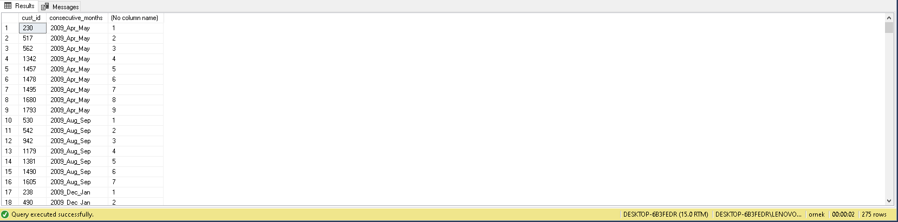

CREATE VIEW vw_year_month_consecutive AS(

SELECT

*,

CASE WHEN consecutive_months IN ('2009_Apr_May', '2009_Mar_Apr', '2009_Aug_Sep', '2009_Dec_Jan', '2009_Feb_Mar', '2009_Jan_Feb', '2009_July_Aug', '2009_Jun_July', '2009_Mar_Apr', '2009_May_Jun', '2009_Nov_Dec', '2009_Oct_Nov', '2009_Sep_Oct' ) THEN '2009'

WHEN consecutive_months IN ('2010_Apr_May' , '2010_Aug_Sep', '2010_Dec_Jan', '2010_Feb_Mar', '2010_Jan_Feb', '2010_July_Aug', '2010_Jun_July', '2010_Mar_Apr', '2010_May_Jun', '2010_Nov_Dec', '2010_Oct_Nov', '2010_Sep_Oct') THEN '2010'

WHEN consecutive_months IN ('2011_Apr_May', '2011_Aug_Sep', '2011_Dec_Jan', '2011_Feb_Mar', '2011_Jan_Feb', '2011_July_Aug', '2011_Jun_July' ,'2011_Mar_Apr', '2011_May_Jun' , '2011_Nov_Dec', '2011_Oct_Nov', '2011_Sep_Oct') THEN'2011' ELSE '2012' END AS year_date,

CASE WHEN SUBSTRING(consecutive_months, CHARINDEX('_', consecutive_months, CHARINDEX('_', consecutive_months) + 1) + 1 ,LEN(consecutive_months)) = 'May' THEN 5

WHEN SUBSTRING(consecutive_months, CHARINDEX('_', consecutive_months, CHARINDEX('_', consecutive_months) + 1) + 1 ,LEN(consecutive_months)) = 'Sep' THEN 9

WHEN SUBSTRING(consecutive_months, CHARINDEX('_', consecutive_months, CHARINDEX('_', consecutive_months) + 1) + 1 ,LEN(consecutive_months)) = 'Jan' THEN 1

WHEN SUBSTRING(consecutive_months, CHARINDEX('_', consecutive_months, CHARINDEX('_', consecutive_months) + 1) + 1 ,LEN(consecutive_months)) = 'Mar' THEN 3

WHEN SUBSTRING(consecutive_months, CHARINDEX('_', consecutive_months, CHARINDEX('_', consecutive_months) + 1) + 1 ,LEN(consecutive_months)) = 'Feb' THEN 2

WHEN SUBSTRING(consecutive_months, CHARINDEX('_', consecutive_months, CHARINDEX('_', consecutive_months) + 1) + 1 ,LEN(consecutive_months)) = 'Aug' THEN 8

WHEN SUBSTRING(consecutive_months, CHARINDEX('_', consecutive_months, CHARINDEX('_', consecutive_months) + 1) + 1 ,LEN(consecutive_months)) = 'July' THEN 7

WHEN SUBSTRING(consecutive_months, CHARINDEX('_', consecutive_months, CHARINDEX('_', consecutive_months) + 1) + 1 ,LEN(consecutive_months)) = 'Apr' THEN 4

WHEN SUBSTRING(consecutive_months, CHARINDEX('_', consecutive_months, CHARINDEX('_', consecutive_months) + 1) + 1 ,LEN(consecutive_months)) = 'Jun' THEN 6

WHEN SUBSTRING(consecutive_months, CHARINDEX('_', consecutive_months, CHARINDEX('_', consecutive_months) + 1) + 1 ,LEN(consecutive_months)) = 'Dec' THEN 12

WHEN SUBSTRING(consecutive_months, CHARINDEX('_', consecutive_months, CHARINDEX('_', consecutive_months) + 1) + 1 ,LEN(consecutive_months)) = 'Nov' THEN 11

WHEN SUBSTRING(consecutive_months, CHARINDEX('_', consecutive_months, CHARINDEX('_', consecutive_months) + 1) + 1 ,LEN(consecutive_months)) = 'Oct' THEN 10

ELSE 0 END AS month_date

FROM

vw_consecutive_months)

SELECT

*

FROM

vw_year_month_consecutive

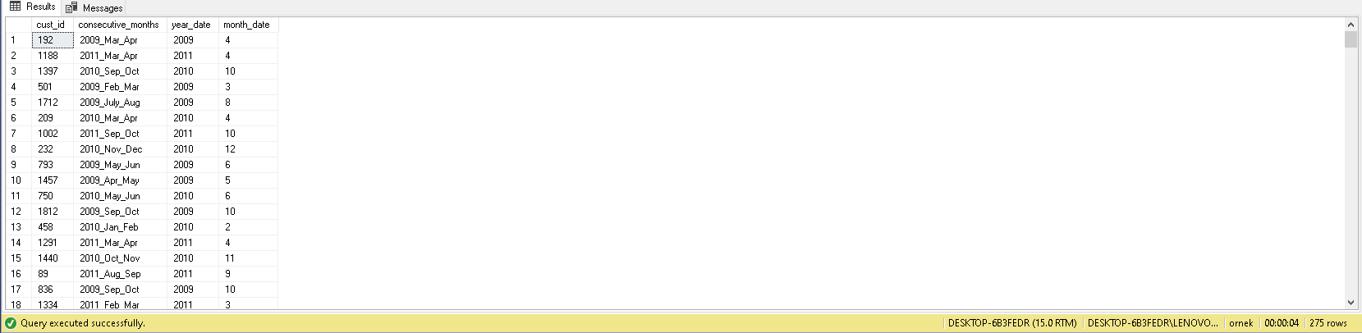

SELECT

DISTINCT

A.year_date,

A.month_date,

COUNT(cust_id) OVER(ORDER BY A.year_date,A.month_date) cnt_consecutive,

B.cnt_total,

CAST(1.0 * COUNT(cust_id) OVER(ORDER BY A.year_date,A.month_date) / B.cnt_total AS DECIMAL(5,2)) AS month_wise_retention_rate

FROM

vw_year_month_consecutive AS A

INNER JOIN (

SELECT

DISTINCT YEAR(order_date) as year_date,

MONTH(order_date) as month_date,

COUNT(cust_id) OVER(PARTITION BY YEAR(order_date), MONTH(order_date) ORDER BY YEAR(order_date), MONTH(order_date)) cnt_total

FROM

[order].order_table

) AS B ON A.year_date = B.year_date AND A.month_date = B.month_date

ORDER BY

1,2

