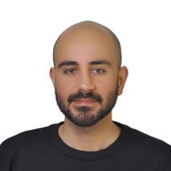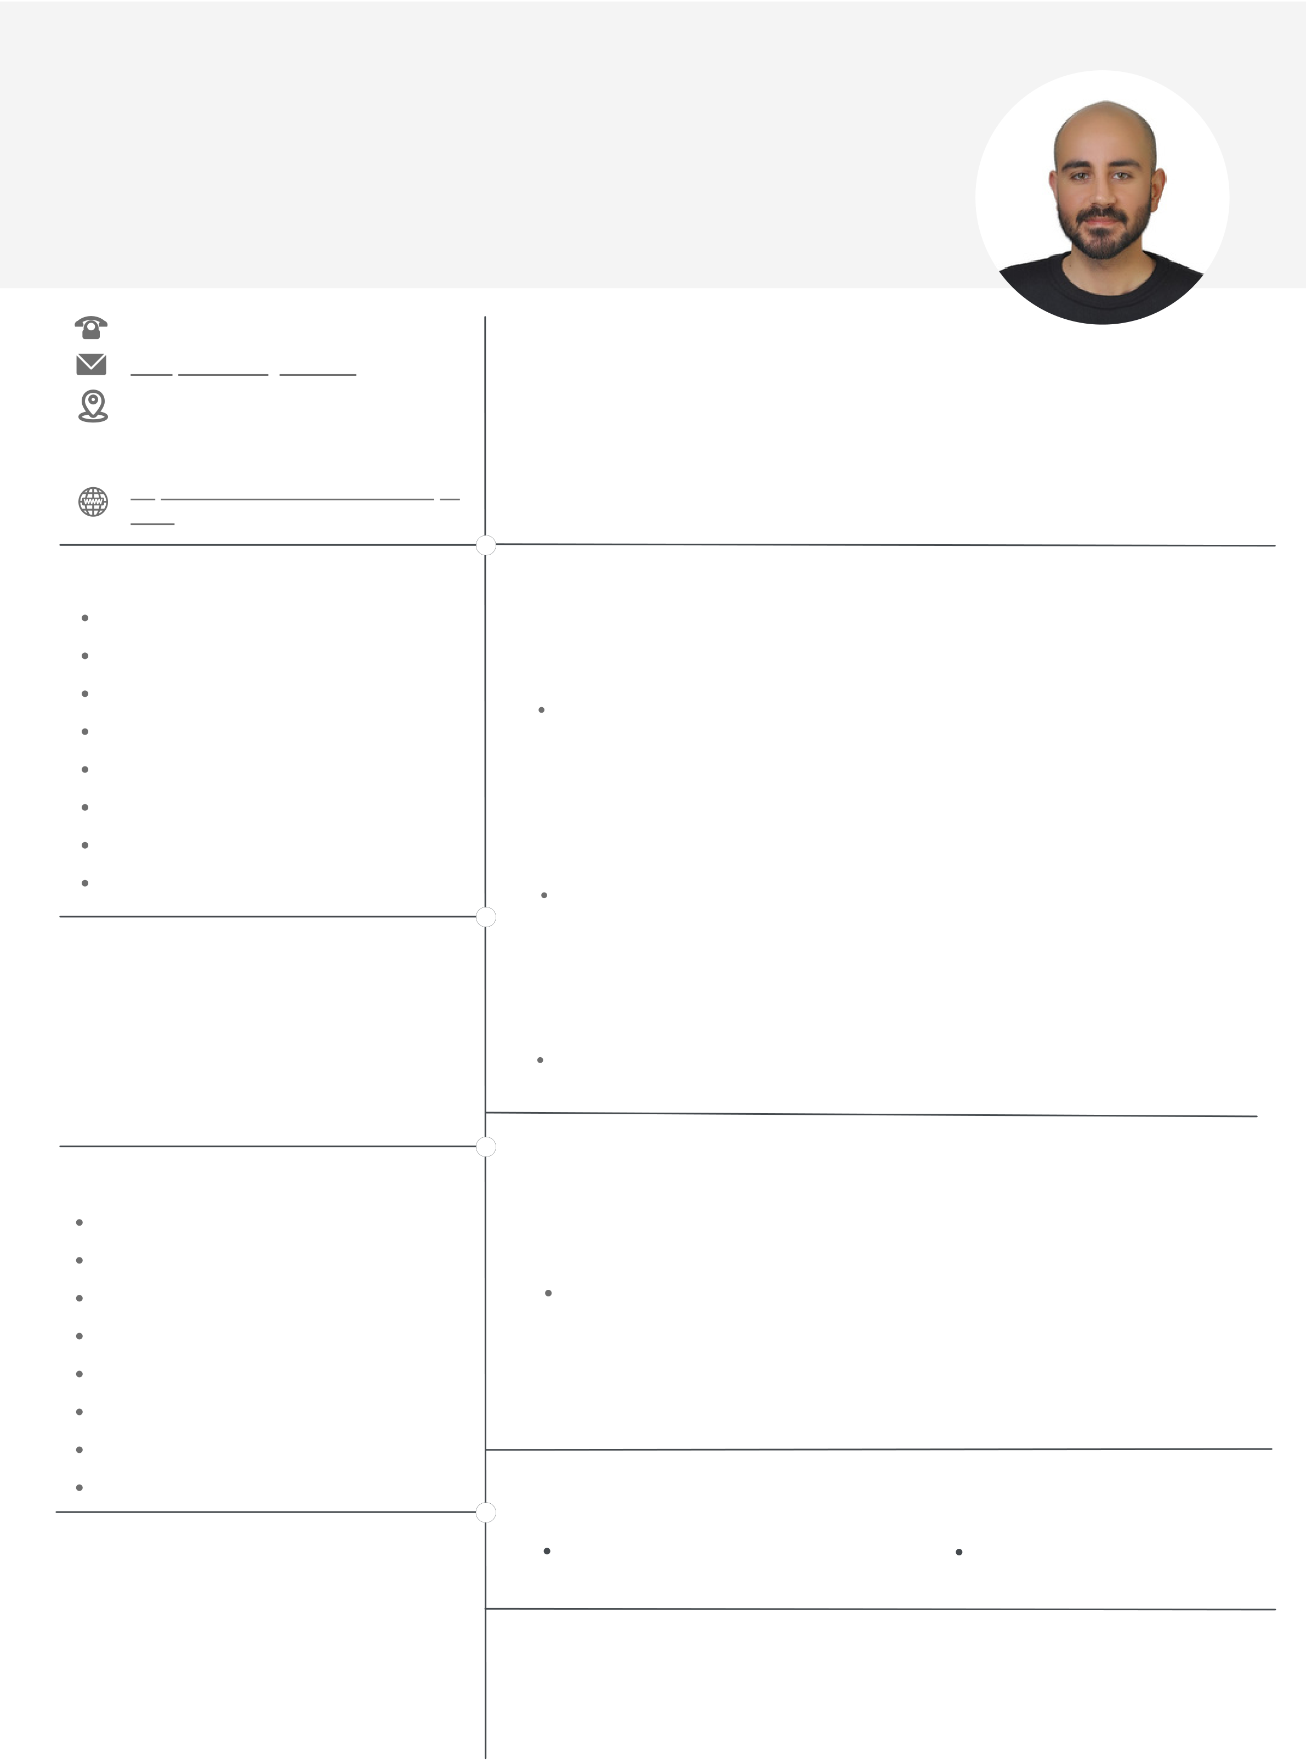

HÜSEYİN **ŞANAL**   
E L E C T R I C A L A N D E L E C T R O N I C S E N G I N E E R

+90 538 326 8480   
[huseyinnsanal@gmail.com](mailto:huseyinnsanal@gmail.com)

|  |  |  |  |
| --- | --- | --- | --- |
| Pınar | Mahallesi | 74039 | Sokak |

Sanrıkent 2 Sitesi B Blok K:4/D:7

A B O U T M E   
I am a 4th year student at Çukurova University departmant of Electrical and Electronics Engineering. I am a person who is open to improvement and I want to gain work experience in my field. I am a quick learner, I can

Seyhan/Adana easily adapt to teamwork and I have high individual productivity. I trust

[https://www.linkedin.com/in/huseyin sanal](https://www.linkedin.com/in/huseyinsanal/)

my communication skills, I believe that I can put extras on the expected efficiency in the studies which I participate in and the jobs I receive.

|  |  |
| --- | --- |
| S K I L L S  LTspice  Visual Studio(C++)  CST Microwave Studio Suite Code Composer Studio(C) AutoCAD  Microsoft Office PowerPoint Microsoft Office Word  Microsoft Office Excel  L A N G U A G E S K I L L S | W O R K E X P E R I E N C E  **PERSONNEL**  Zeplin Plastik İnşaat İç ve Dış Ticaret Limited Şirketi  June 2021 - August 2022   Mostly, I was dealing with the logistics of the company. I was responsible from storage, stock control, material and quality control, preparation for shipment and tracking. I also created price quotes and income statements in MS Excel.  **PART TIME SUPPORT WORKER**  Ç.Ü. Sağlık Kültür ve Spor Daire Başkanlığı Özgelirler  December 2019 - April 2020   I worked about maintenance and control of technical equipments such as microphones, smart boards and computers which are used for the lessons.  **FRONT FIELD SALESPERSON**  Şanal Petrol Ticaret Limited Şirketi |

English - I graduated from the college of foreign languages with a B2 level English and I am studying 100% English.

June 2017 - October 2017   
I was offering technical services such as refueling the vehicle, checking the battery, radiator, glass and engine water and completing it to the required level.

|  |  |  |  |
| --- | --- | --- | --- |
| H O B B I E S  Basketball  Football  Reading Books  Swimming  Riding Bike  Playing Darts  Playing Tennis  New Technologies  E D U C A T İ O N  **Çukurova University** | P R O J E C T S  **ROCKET ENGINE TEST STAND**  1.5 Adana Rocketary Team  September 2021 - January 2022   I was the electronic member of the team and I took part in the R&D and hardware design of the electronic board which we designed with load cell to draw the thrust-time graph of the solid fuel rocket engine which we will produce. Also, I took part in the design of the wireless ignition system to provide security of people.  A C T I V I T I E S | | |
| October 2019 - January 2023 | October 2013 - June 2018 | |
| **Faculty of Engineering** | | **GSİM Basketball Club** |
| **Basketball Team** | | |

Electrical Electronics Engineering 2018 - 2024

**İsmail Safa Özler Anatolian High School**

R E F E R E N C E   
**Ahmet İRTEŞ**   
Zeplin Plastik Construction General Manager

2013 - 2017 +90 532 100 2194