Veri Yapıları ve Algoritmalar-Ödev6

1-) Binary Search Algrithm

- Eşit Dağılımlı

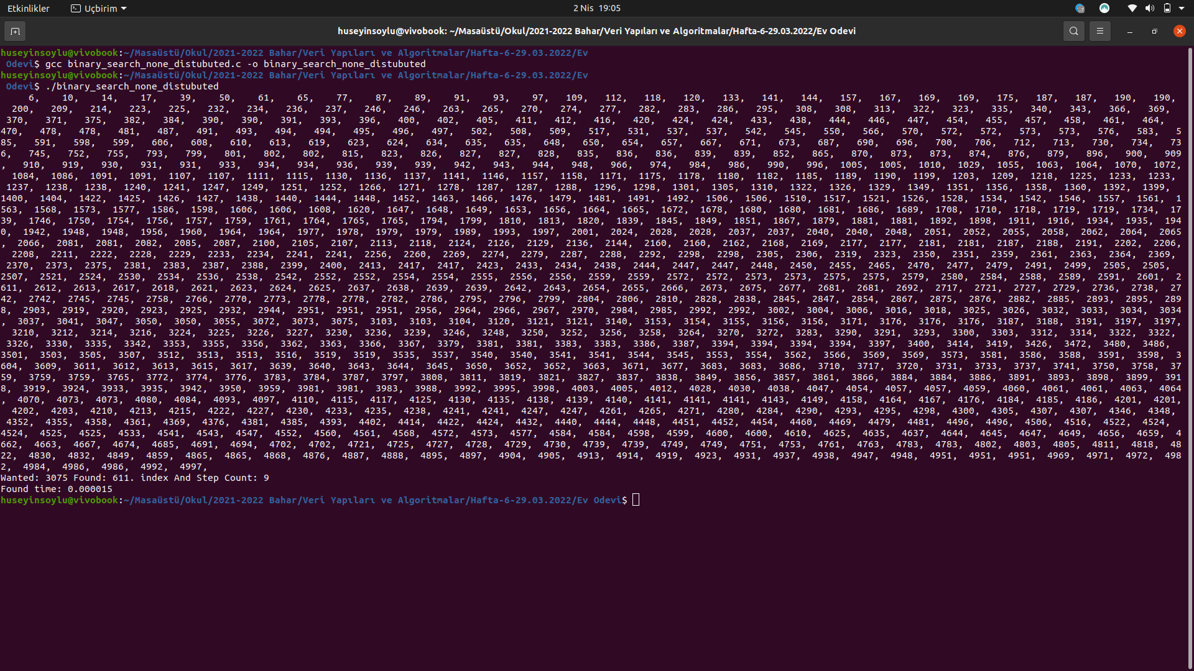

- Eşit Dağılımsız

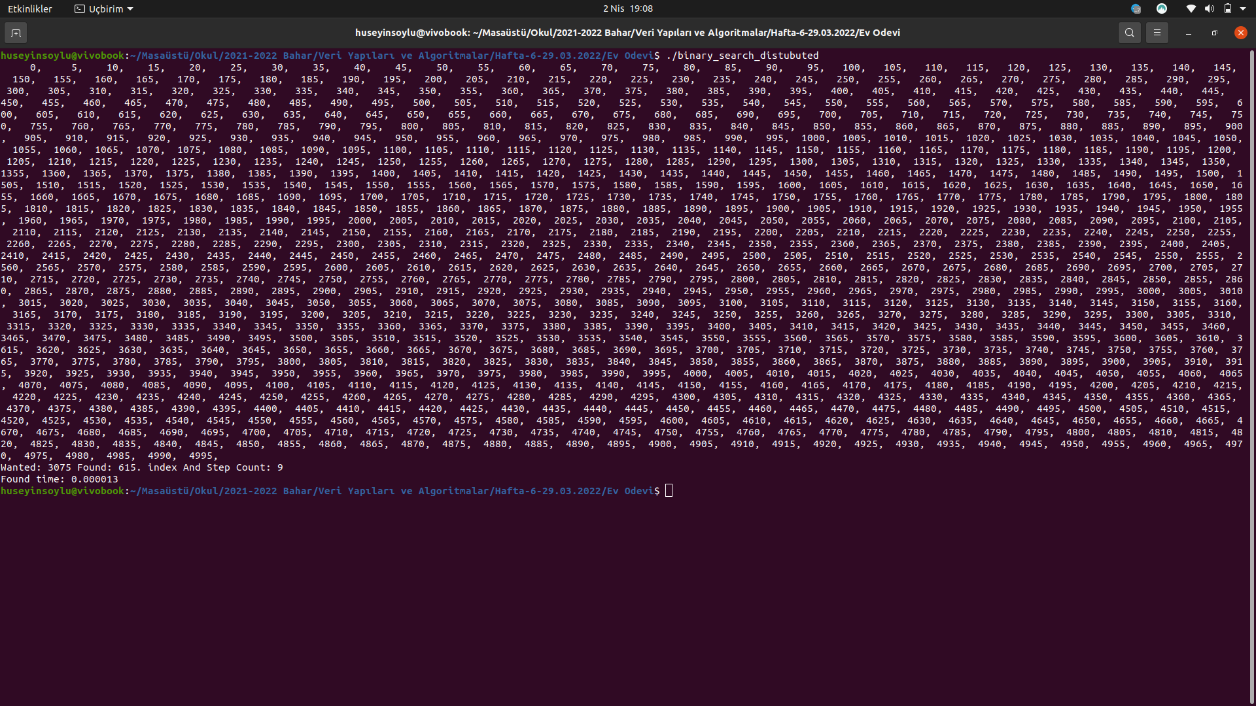
- Aramada 1000 Elemanlı bir sıralı dizi kullanılmıştır. 612 numaralı eleman toplam 9 iterasyonda bulunmuştur. Bulunma süresi 0.000013 – 0.000017 arasında değişmektedir.
- Algoritmanın zaman analizi O(Log(n))’dir.
- Algoritma dizinin eşit dağılımlı olup olmamasına bağlı değildir.

2-) İnterpolasyon Search Algorithm

- Eşit Dağılımlı
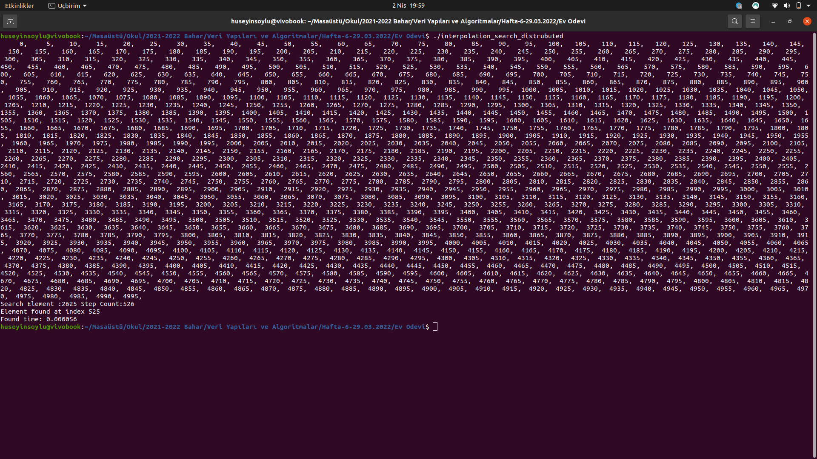
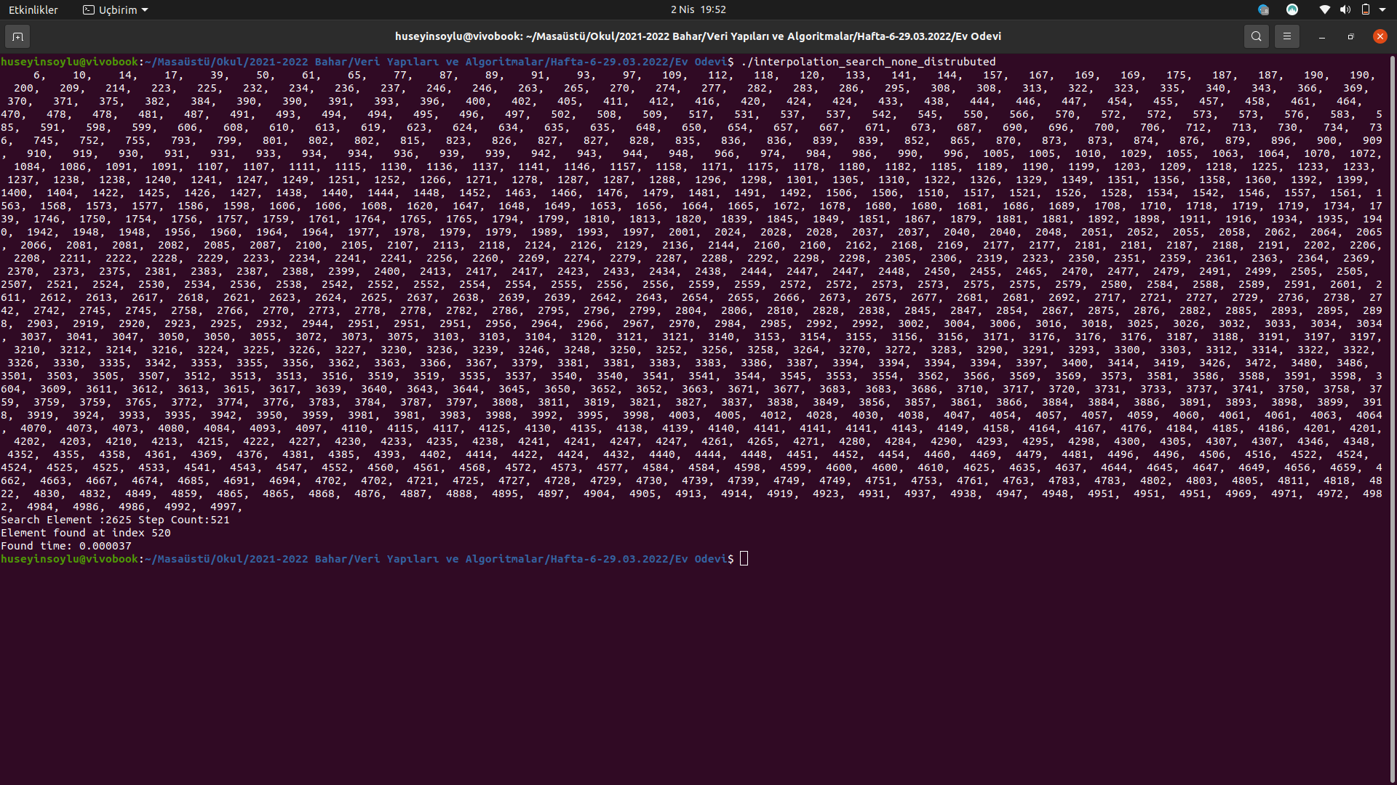
- Eşit Dağılımsız
- Aramada 1000 Elemanlı bir sıralı dizi kullanılmıştır.
- Sabit dağılımlı dizi ile sabit aralıksız dizi arasında çok büyük bir fark gözlemlenmememiştir.
- Sabit dağılımlı dizi 0.000056 saniyede çözüme ulaşmıştır.
- Sabit dağılımsız dizi 0.000060 saniyede çözüme ulaşmıştır.(Birkaç kez çalıştırıldı)
- Çok fazla kez çalıştırırsak aralarında fark olmadığını gözlemleriz
- Algoritmanın çalışma zamanı O(Log(n))’ dir.

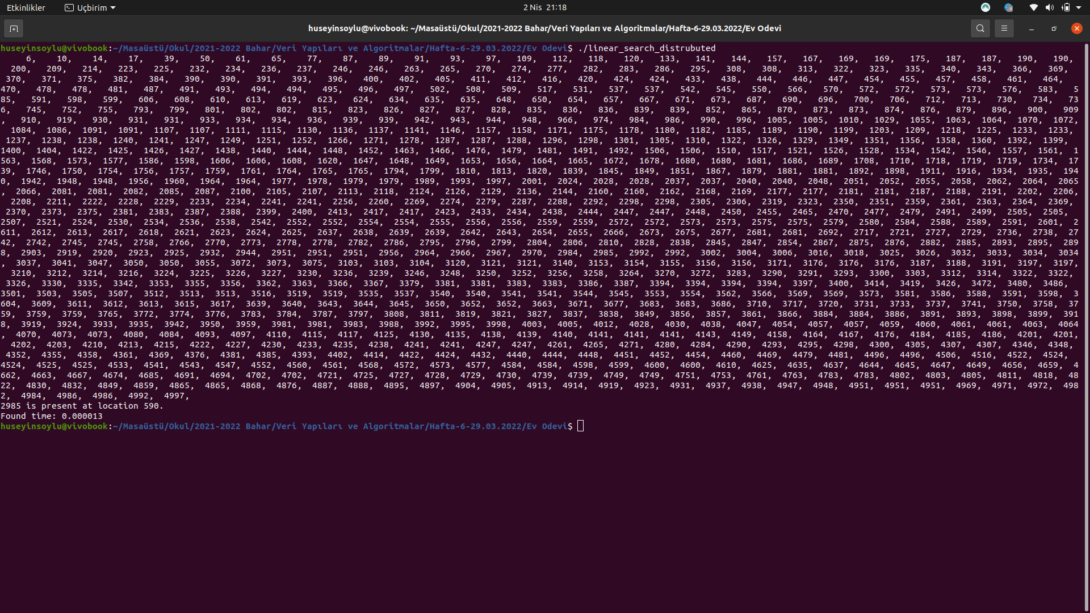
- 3-) Sequential Search Algorithm
- Aramada 1000 Elemanlı bir sıralı dizi kullanılmıştır.
- Bu arama türünde herhangi bir şekilde dağılımlı ya da dağılımsız diye ayrım yapmak doğru olmayacaktır. Çünkü aranan değer her nerde ise oraya kadar bir döngü yardımı ile gitmek zorundayız.
- Algoritmanın çalışma zamanı O(N)’dir. Çünkü alternatif bir yol yoktur arama yaparken. Tek tek gezilmek zorundadır.
- Bulunan index: 590.
- Bulunma Zamanı: 0.000013 saniye.

Buraya kadar yapmış olduğum tüm algoritmalar durumu bilinmeyen algoritmalar olarak literatürde geçmektedir. Bundan sonraki vereceğim iki örnek ise durumu bilinen algoritmalar olarak literatürde geçmektedir.

4-) Prims - Kruskal Search Algorithm
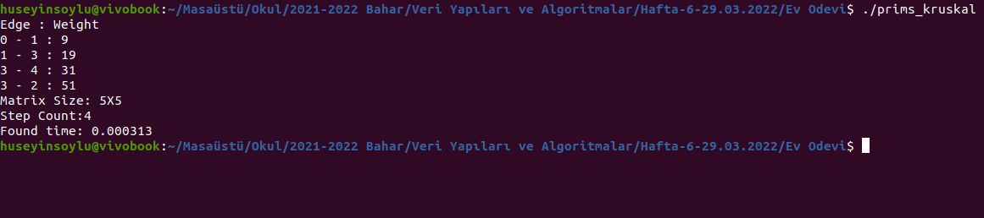
- Algoritma için 5X5 matris kullanılmıştır.
- Adım Sayısı : 4
- Çalışma Zamanı: 0.000313 Saniye.

Karşılaştırma Tablosu

Algoritma | Çalışma Zamanı | Karmaşıklık | Adım Sayısı
Binary Search | 0.000013 – 0.000017 | O(Log(n)) | 612. İndex–9 Adım
İnterpolation Search | 0.000056 - 0.000060 | O(Log(n)) | 520.İndex–521 Adım
Prims - Kruskal | 0.000313 | Değişmekte - O(n^2) | 4. Adımda buldu.
Sequration Search | 0.000013 | O(n) | n. indis için n

*1000 Elemanlı dizi ve 5X5 matris kullanılmıştır.

KAYNAK KODLAR

1-)Binary Search
______________________________________________________________________
#include <stdio.h>
#include <time.h>
#include <stdlib.h>
#include <time.h>

void print_array(int array[],int num){

for(int i=0;i<num;i++){
printf("%6d,",array[i]);
}
printf("\n");

}
int main()
{
int array[1000]={0, 5, 10, 15, 20, 25, 30, 35, 40, 45, 50, 55, 60, 65, 70, 75, 80, 85, 90, 95, 100, 105, 110, 115, 120, 125, 130, 135, 140, 145, 150, 155, 160, 165, 170, 175, 180, 185, 190, 195, 200, 205, 210, 215, 220, 225, 230, 235, 240, 245, 250, 255, 260, 265, 270, 275, 280, 285, 290, 295, 300, 305, 310, 315, 320, 325, 330, 335, 340, 345, 350, 355, 360, 365, 370, 375, 380, 385, 390, 395, 400, 405, 410, 415, 420, 425, 430, 435, 440, 445, 450, 455, 460, 465, 470, 475, 480, 485, 490, 495, 500, 505, 510, 515, 520, 525, 530, 535, 540, 545, 550, 555, 560, 565, 570, 575, 580, 585, 590, 595, 600, 605, 610, 615, 620, 625, 630, 635, 640, 645, 650, 655, 660, 665, 670, 675, 680, 685, 690, 695, 700, 705, 710, 715, 720, 725, 730, 735, 740, 745, 750, 755, 760, 765, 770, 775, 780, 785, 790, 795, 800, 805, 810, 815, 820, 825, 830, 835, 840, 845, 850, 855, 860, 865, 870, 875, 880, 885, 890, 895, 900, 905, 910, 915, 920, 925, 930, 935, 940, 945, 950, 955, 960, 965, 970, 975, 980, 985, 990, 995, 1000, 1005, 1010, 1015, 1020, 1025, 1030, 1035, 1040, 1045, 1050, 1055, 1060, 1065, 1070, 1075, 1080, 1085, 1090, 1095, 1100, 1105, 1110, 1115, 1120, 1125, 1130, 1135, 1140, 1145, 1150, 1155, 1160, 1165, 1170, 1175, 1180, 1185, 1190, 1195, 1200, 1205, 1210, 1215, 1220, 1225, 1230, 1235, 1240, 1245, 1250, 1255, 1260, 1265, 1270, 1275, 1280, 1285, 1290, 1295, 1300, 1305, 1310, 1315, 1320, 1325, 1330, 1335, 1340, 1345, 1350, 1355, 1360, 1365, 1370, 1375, 1380, 1385, 1390, 1395, 1400, 1405, 1410, 1415, 1420, 1425, 1430, 1435, 1440, 1445, 1450, 1455, 1460, 1465, 1470, 1475, 1480, 1485, 1490, 1495, 1500, 1505, 1510, 1515, 1520, 1525, 1530, 1535, 1540, 1545, 1550, 1555, 1560, 1565, 1570, 1575, 1580, 1585, 1590, 1595, 1600, 1605, 1610, 1615, 1620, 1625, 1630, 1635, 1640, 1645, 1650, 1655, 1660, 1665, 1670, 1675, 1680, 1685, 1690, 1695, 1700, 1705, 1710, 1715, 1720, 1725, 1730, 1735, 1740, 1745, 1750, 1755, 1760, 1765, 1770, 1775, 1780, 1785, 1790, 1795, 1800, 1805, 1810, 1815, 1820, 1825, 1830, 1835, 1840, 1845, 1850, 1855, 1860, 1865, 1870, 1875, 1880, 1885, 1890, 1895, 1900, 1905, 1910, 1915, 1920, 1925, 1930, 1935, 1940, 1945, 1950, 1955, 1960, 1965, 1970, 1975, 1980, 1985, 1990, 1995, 2000, 2005, 2010, 2015, 2020, 2025, 2030, 2035, 2040, 2045, 2050, 2055, 2060, 2065, 2070, 2075, 2080, 2085, 2090, 2095, 2100, 2105, 2110, 2115, 2120, 2125, 2130, 2135, 2140, 2145, 2150, 2155, 2160, 2165, 2170, 2175, 2180, 2185, 2190, 2195, 2200, 2205, 2210, 2215, 2220, 2225, 2230, 2235, 2240, 2245, 2250, 2255, 2260, 2265, 2270, 2275, 2280, 2285, 2290, 2295, 2300, 2305, 2310, 2315, 2320, 2325, 2330, 2335, 2340, 2345, 2350, 2355, 2360, 2365, 2370, 2375, 2380, 2385, 2390, 2395, 2400, 2405, 2410, 2415, 2420, 2425, 2430, 2435, 2440, 2445, 2450, 2455, 2460, 2465, 2470, 2475, 2480, 2485, 2490, 2495, 2500, 2505, 2510, 2515, 2520, 2525, 2530, 2535, 2540, 2545, 2550, 2555, 2560, 2565, 2570, 2575, 2580, 2585, 2590, 2595, 2600, 2605, 2610, 2615, 2620, 2625, 2630, 2635, 2640, 2645, 2650, 2655, 2660, 2665, 2670, 2675, 2680, 2685, 2690, 2695, 2700, 2705, 2710, 2715, 2720, 2725, 2730, 2735, 2740, 2745, 2750, 2755, 2760, 2765, 2770, 2775, 2780, 2785, 2790, 2795, 2800, 2805, 2810, 2815, 2820, 2825, 2830, 2835, 2840, 2845, 2850, 2855, 2860, 2865, 2870, 2875, 2880, 2885, 2890, 2895, 2900, 2905, 2910, 2915, 2920, 2925, 2930, 2935, 2940, 2945, 2950, 2955, 2960, 2965, 2970, 2975, 2980, 2985, 2990, 2995, 3000, 3005, 3010, 3015, 3020, 3025, 3030, 3035, 3040, 3045, 3050, 3055, 3060, 3065, 3070, 3075, 3080, 3085, 3090, 3095, 3100, 3105, 3110, 3115, 3120, 3125, 3130, 3135, 3140, 3145, 3150, 3155, 3160, 3165, 3170, 3175, 3180, 3185, 3190, 3195, 3200, 3205, 3210, 3215, 3220, 3225, 3230, 3235, 3240, 3245, 3250, 3255, 3260, 3265, 3270, 3275, 3280, 3285, 3290, 3295, 3300, 3305, 3310, 3315, 3320, 3325, 3330, 3335, 3340, 3345, 3350, 3355, 3360, 3365, 3370, 3375, 3380, 3385, 3390, 3395, 3400, 3405, 3410, 3415, 3420, 3425, 3430, 3435, 3440, 3445, 3450, 3455, 3460, 3465, 3470, 3475, 3480, 3485, 3490, 3495, 3500, 3505, 3510, 3515, 3520, 3525, 3530, 3535, 3540, 3545, 3550, 3555, 3560, 3565, 3570, 3575, 3580, 3585, 3590, 3595, 3600, 3605, 3610, 3615, 3620, 3625, 3630, 3635, 3640, 3645, 3650, 3655, 3660, 3665, 3670, 3675, 3680, 3685, 3690, 3695, 3700, 3705, 3710, 3715, 3720, 3725, 3730, 3735, 3740, 3745, 3750, 3755, 3760, 3765, 3770, 3775, 3780, 3785, 3790, 3795, 3800, 3805, 3810, 3815, 3820, 3825, 3830, 3835, 3840, 3845, 3850, 3855, 3860, 3865, 3870, 3875, 3880, 3885, 3890, 3895, 3900, 3905, 3910, 3915, 3920, 3925, 3930, 3935, 3940, 3945, 3950, 3955, 3960, 3965, 3970, 3975, 3980, 3985, 3990, 3995, 4000, 4005, 4010, 4015, 4020, 4025, 4030, 4035, 4040, 4045, 4050, 4055, 4060, 4065, 4070, 4075, 4080, 4085, 4090, 4095, 4100, 4105, 4110, 4115, 4120, 4125, 4130, 4135, 4140, 4145, 4150, 4155, 4160, 4165, 4170, 4175, 4180, 4185, 4190, 4195, 4200, 4205, 4210, 4215, 4220, 4225, 4230, 4235, 4240, 4245, 4250, 4255, 4260, 4265, 4270, 4275, 4280, 4285, 4290, 4295, 4300, 4305, 4310, 4315, 4320, 4325, 4330, 4335, 4340, 4345, 4350, 4355, 4360, 4365, 4370, 4375, 4380, 4385, 4390, 4395, 4400, 4405, 4410, 4415, 4420, 4425, 4430, 4435, 4440, 4445, 4450, 4455, 4460, 4465, 4470, 4475, 4480, 4485, 4490, 4495, 4500, 4505, 4510, 4515, 4520, 4525, 4530, 4535, 4540, 4545, 4550, 4555, 4560, 4565, 4570, 4575, 4580, 4585, 4590, 4595, 4600, 4605, 4610, 4615, 4620, 4625, 4630, 4635, 4640, 4645, 4650, 4655, 4660, 4665, 4670, 4675, 4680, 4685, 4690, 4695, 4700, 4705, 4710, 4715, 4720, 4725, 4730, 4735, 4740, 4745, 4750, 4755, 4760, 4765, 4770, 4775, 4780, 4785, 4790, 4795, 4800, 4805, 4810, 4815, 4820, 4825, 4830, 4835, 4840, 4845, 4850, 4855, 4860, 4865, 4870, 4875, 4880, 4885, 4890, 4895, 4900, 4905, 4910, 4915, 4920, 4925, 4930, 4935, 4940, 4945, 4950, 4955, 4960, 4965, 4970, 4975, 4980, 4985, 4990, 4995};
//print_randoms_array(array,0,5000,1000);
//bubble_short_array(array,1000);

clock_t start_t, end_t;

print_array(array,1000);
int low = 0;
int high = 1000;
int flag = 0;
int s = 3075;
int search_step=0;

start_t = clock();

while(low <= high){
search_step++;
int index = low+(high-low)/2;
if(array[index] == s){
flag = 1;
printf("Wanted: %d Found: %d. index And Step Count: %d \n",s,index,search_step);
break;
}
else if(array[index] < s){
low = index+1;
}
else{
high = index-1;
}
}
if(flag == 0){
printf("Not Found!\n");
}
end_t = clock();
printf("Found time: %f\n", (double)(end_t - start_t) / CLOCKS_PER_SEC);
return 0;
}
______________________________________________________________________

1-)İnterpolation Search
______________________________________________________________________
#include <stdio.h>
#include <time.h>
#include <stdlib.h>
#include <time.h>

void print_array(int array[],int num){

for(int i=0;i<num;i++){
printf("%6d,",array[i]);
}
printf("\n");

}

/*int interpolationSearch(int arr[], int lo, int hi, int x)
{
int pos;
// Since array is sorted, an element present
// in array must be in range defined by corner
if (lo <= hi && x >= arr[lo] && x <= arr[hi]) {
// Probing the position with keeping
// uniform distribution in mind.
pos = lo
+ (((double)(hi - lo) / (arr[hi] - arr[lo]))
* (x - arr[lo]));

// Condition of target found
if (arr[pos] == x)
return pos;

// If x is larger, x is in right sub array
if (arr[pos] < x)
return interpolationSearch(arr, pos + 1, hi, x);

// If x is smaller, x is in left sub array
if (arr[pos] > x)
return interpolationSearch(arr, lo, pos - 1, x);
}
return -1;
}*/

int interpol_search(int arr[], int lb, int ub, int x)
{
int step_count=0;
while ((arr[lb] != arr[ub]) && (x <= arr[ub]) && (x >= arr[lb])) {
step_count++;
int pos = lb + (((ub - lb) / (arr[ub] - arr[lb])) * (x - arr[lb]));
if (arr[pos] == x){
printf("Search Element :%d Step Count:%d\n",x,step_count);
return pos;
}

if (arr[pos] < x)
lb = pos + 1;
else
ub = pos - 1;
}
return -1;
}

int main()
{
int arr[]={0, 5, 10, 15, 20, 25, 30, 35, 40, 45, 50, 55, 60, 65, 70, 75, 80, 85, 90, 95, 100, 105, 110, 115, 120, 125, 130, 135, 140, 145, 150, 155, 160, 165, 170, 175, 180, 185, 190, 195, 200, 205, 210, 215, 220, 225, 230, 235, 240, 245, 250, 255, 260, 265, 270, 275, 280, 285, 290, 295, 300, 305, 310, 315, 320, 325, 330, 335, 340, 345, 350, 355, 360, 365, 370, 375, 380, 385, 390, 395, 400, 405, 410, 415, 420, 425, 430, 435, 440, 445, 450, 455, 460, 465, 470, 475, 480, 485, 490, 495, 500, 505, 510, 515, 520, 525, 530, 535, 540, 545, 550, 555, 560, 565, 570, 575, 580, 585, 590, 595, 600, 605, 610, 615, 620, 625, 630, 635, 640, 645, 650, 655, 660, 665, 670, 675, 680, 685, 690, 695, 700, 705, 710, 715, 720, 725, 730, 735, 740, 745, 750, 755, 760, 765, 770, 775, 780, 785, 790, 795, 800, 805, 810, 815, 820, 825, 830, 835, 840, 845, 850, 855, 860, 865, 870, 875, 880, 885, 890, 895, 900, 905, 910, 915, 920, 925, 930, 935, 940, 945, 950, 955, 960, 965, 970, 975, 980, 985, 990, 995, 1000, 1005, 1010, 1015, 1020, 1025, 1030, 1035, 1040, 1045, 1050, 1055, 1060, 1065, 1070, 1075, 1080, 1085, 1090, 1095, 1100, 1105, 1110, 1115, 1120, 1125, 1130, 1135, 1140, 1145, 1150, 1155, 1160, 1165, 1170, 1175, 1180, 1185, 1190, 1195, 1200, 1205, 1210, 1215, 1220, 1225, 1230, 1235, 1240, 1245, 1250, 1255, 1260, 1265, 1270, 1275, 1280, 1285, 1290, 1295, 1300, 1305, 1310, 1315, 1320, 1325, 1330, 1335, 1340, 1345, 1350, 1355, 1360, 1365, 1370, 1375, 1380, 1385, 1390, 1395, 1400, 1405, 1410, 1415, 1420, 1425, 1430, 1435, 1440, 1445, 1450, 1455, 1460, 1465, 1470, 1475, 1480, 1485, 1490, 1495, 1500, 1505, 1510, 1515, 1520, 1525, 1530, 1535, 1540, 1545, 1550, 1555, 1560, 1565, 1570, 1575, 1580, 1585, 1590, 1595, 1600, 1605, 1610, 1615, 1620, 1625, 1630, 1635, 1640, 1645, 1650, 1655, 1660, 1665, 1670, 1675, 1680, 1685, 1690, 1695, 1700, 1705, 1710, 1715, 1720, 1725, 1730, 1735, 1740, 1745, 1750, 1755, 1760, 1765, 1770, 1775, 1780, 1785, 1790, 1795, 1800, 1805, 1810, 1815, 1820, 1825, 1830, 1835, 1840, 1845, 1850, 1855, 1860, 1865, 1870, 1875, 1880, 1885, 1890, 1895, 1900, 1905, 1910, 1915, 1920, 1925, 1930, 1935, 1940, 1945, 1950, 1955, 1960, 1965, 1970, 1975, 1980, 1985, 1990, 1995, 2000, 2005, 2010, 2015, 2020, 2025, 2030, 2035, 2040, 2045, 2050, 2055, 2060, 2065, 2070, 2075, 2080, 2085, 2090, 2095, 2100, 2105, 2110, 2115, 2120, 2125, 2130, 2135, 2140, 2145, 2150, 2155, 2160, 2165, 2170, 2175, 2180, 2185, 2190, 2195, 2200, 2205, 2210, 2215, 2220, 2225, 2230, 2235, 2240, 2245, 2250, 2255, 2260, 2265, 2270, 2275, 2280, 2285, 2290, 2295, 2300, 2305, 2310, 2315, 2320, 2325, 2330, 2335, 2340, 2345, 2350, 2355, 2360, 2365, 2370, 2375, 2380, 2385, 2390, 2395, 2400, 2405, 2410, 2415, 2420, 2425, 2430, 2435, 2440, 2445, 2450, 2455, 2460, 2465, 2470, 2475, 2480, 2485, 2490, 2495, 2500, 2505, 2510, 2515, 2520, 2525, 2530, 2535, 2540, 2545, 2550, 2555, 2560, 2565, 2570, 2575, 2580, 2585, 2590, 2595, 2600, 2605, 2610, 2615, 2620, 2625, 2630, 2635, 2640, 2645, 2650, 2655, 2660, 2665, 2670, 2675, 2680, 2685, 2690, 2695, 2700, 2705, 2710, 2715, 2720, 2725, 2730, 2735, 2740, 2745, 2750, 2755, 2760, 2765, 2770, 2775, 2780, 2785, 2790, 2795, 2800, 2805, 2810, 2815, 2820, 2825, 2830, 2835, 2840, 2845, 2850, 2855, 2860, 2865, 2870, 2875, 2880, 2885, 2890, 2895, 2900, 2905, 2910, 2915, 2920, 2925, 2930, 2935, 2940, 2945, 2950, 2955, 2960, 2965, 2970, 2975, 2980, 2985, 2990, 2995, 3000, 3005, 3010, 3015, 3020, 3025, 3030, 3035, 3040, 3045, 3050, 3055, 3060, 3065, 3070, 3075, 3080, 3085, 3090, 3095, 3100, 3105, 3110, 3115, 3120, 3125, 3130, 3135, 3140, 3145, 3150, 3155, 3160, 3165, 3170, 3175, 3180, 3185, 3190, 3195, 3200, 3205, 3210, 3215, 3220, 3225, 3230, 3235, 3240, 3245, 3250, 3255, 3260, 3265, 3270, 3275, 3280, 3285, 3290, 3295, 3300, 3305, 3310, 3315, 3320, 3325, 3330, 3335, 3340, 3345, 3350, 3355, 3360, 3365, 3370, 3375, 3380, 3385, 3390, 3395, 3400, 3405, 3410, 3415, 3420, 3425, 3430, 3435, 3440, 3445, 3450, 3455, 3460, 3465, 3470, 3475, 3480, 3485, 3490, 3495, 3500, 3505, 3510, 3515, 3520, 3525, 3530, 3535, 3540, 3545, 3550, 3555, 3560, 3565, 3570, 3575, 3580, 3585, 3590, 3595, 3600, 3605, 3610, 3615, 3620, 3625, 3630, 3635, 3640, 3645, 3650, 3655, 3660, 3665, 3670, 3675, 3680, 3685, 3690, 3695, 3700, 3705, 3710, 3715, 3720, 3725, 3730, 3735, 3740, 3745, 3750, 3755, 3760, 3765, 3770, 3775, 3780, 3785, 3790, 3795, 3800, 3805, 3810, 3815, 3820, 3825, 3830, 3835, 3840, 3845, 3850, 3855, 3860, 3865, 3870, 3875, 3880, 3885, 3890, 3895, 3900, 3905, 3910, 3915, 3920, 3925, 3930, 3935, 3940, 3945, 3950, 3955, 3960, 3965, 3970, 3975, 3980, 3985, 3990, 3995, 4000, 4005, 4010, 4015, 4020, 4025, 4030, 4035, 4040, 4045, 4050, 4055, 4060, 4065, 4070, 4075, 4080, 4085, 4090, 4095, 4100, 4105, 4110, 4115, 4120, 4125, 4130, 4135, 4140, 4145, 4150, 4155, 4160, 4165, 4170, 4175, 4180, 4185, 4190, 4195, 4200, 4205, 4210, 4215, 4220, 4225, 4230, 4235, 4240, 4245, 4250, 4255, 4260, 4265, 4270, 4275, 4280, 4285, 4290, 4295, 4300, 4305, 4310, 4315, 4320, 4325, 4330, 4335, 4340, 4345, 4350, 4355, 4360, 4365, 4370, 4375, 4380, 4385, 4390, 4395, 4400, 4405, 4410, 4415, 4420, 4425, 4430, 4435, 4440, 4445, 4450, 4455, 4460, 4465, 4470, 4475, 4480, 4485, 4490, 4495, 4500, 4505, 4510, 4515, 4520, 4525, 4530, 4535, 4540, 4545, 4550, 4555, 4560, 4565, 4570, 4575, 4580, 4585, 4590, 4595, 4600, 4605, 4610, 4615, 4620, 4625, 4630, 4635, 4640, 4645, 4650, 4655, 4660, 4665, 4670, 4675, 4680, 4685, 4690, 4695, 4700, 4705, 4710, 4715, 4720, 4725, 4730, 4735, 4740, 4745, 4750, 4755, 4760, 4765, 4770, 4775, 4780, 4785, 4790, 4795, 4800, 4805, 4810, 4815, 4820, 4825, 4830, 4835, 4840, 4845, 4850, 4855, 4860, 4865, 4870, 4875, 4880, 4885, 4890, 4895, 4900, 4905, 4910, 4915, 4920, 4925, 4930, 4935, 4940, 4945, 4950, 4955, 4960, 4965, 4970, 4975, 4980, 4985, 4990, 4995};

clock_t start_t, end_t;

print_array(arr,1000);

int n = sizeof(arr) / sizeof(arr[0]);

start_t = clock();

int search_element = 2625;
int index = interpol_search(arr, 0, n - 1, search_element);

end_t = clock();

if (index != -1)
printf("Element found at index %d\n", index);
else
printf("Element not found.\n");

printf("Found time: %f\n", (double)(end_t - start_t) / CLOCKS_PER_SEC);

return 0;

}
______________________________________________________________________

3-)Sequration Search
______________________________________________________________________

#include <stdio.h>
#include <time.h>
#include <stdlib.h>

void print_array(int array[],int num){

for(int i=0;i<num;i++){
printf("%6d,",array[i]);
}
printf("\n");

}

int linear_search(int *pointer, int n, int find)
{
int c;

for ( c = 0 ; c < n ; c++ )
{
if ( *(pointer+c) == find )
return c;
}

return -1;
}

int main()
{
int array[]={6, 10, 14, 17, 39, 50, 61, 65, 77, 87, 89, 91, 93, 97, 109, 112, 118, 120, 133, 141, 144, 157, 167, 169, 169, 175, 187, 187, 190, 190, 200, 209, 214, 223, 225, 232, 234, 236, 237, 246, 246, 263, 265, 270, 274, 277, 282, 283, 286, 295, 308, 308, 313, 322, 323, 335, 340, 343, 366, 369, 370, 371, 375, 382, 384, 390, 390, 391, 393, 396, 400, 402, 405, 411, 412, 416, 420, 424, 424, 433, 438, 444, 446, 447, 454, 455, 457, 458, 461, 464, 470, 478, 478, 481, 487, 491, 493, 494, 494, 495, 496, 497, 502, 508, 509, 517, 531, 537, 537, 542, 545, 550, 566, 570, 572, 572, 573, 573, 576, 583, 585, 591, 598, 599, 606, 608, 610, 613, 619, 623, 624, 634, 635, 635, 648, 650, 654, 657, 667, 671, 673, 687, 690, 696, 700, 706, 712, 713, 730, 734, 736, 745, 752, 755, 793, 799, 801, 802, 802, 815, 823, 826, 827, 827, 828, 835, 836, 836, 839, 839, 852, 865, 870, 873, 873, 874, 876, 879, 896, 900, 909, 910, 919, 930, 931, 931, 933, 934, 934, 936, 939, 939, 942, 943, 944, 948, 966, 974, 984, 986, 990, 996, 1005, 1005, 1010, 1029, 1055, 1063, 1064, 1070, 1072, 1084, 1086, 1091, 1091, 1107, 1107, 1111, 1115, 1130, 1136, 1137, 1141, 1146, 1157, 1158, 1171, 1175, 1178, 1180, 1182, 1185, 1189, 1190, 1199, 1203, 1209, 1218, 1225, 1233, 1233, 1237, 1238, 1238, 1240, 1241, 1247, 1249, 1251, 1252, 1266, 1271, 1278, 1287, 1287, 1288, 1296, 1298, 1301, 1305, 1310, 1322, 1326, 1329, 1349, 1351, 1356, 1358, 1360, 1392, 1399, 1400, 1404, 1422, 1425, 1426, 1427, 1438, 1440, 1444, 1448, 1452, 1463, 1466, 1476, 1479, 1481, 1491, 1492, 1506, 1506, 1510, 1517, 1521, 1526, 1528, 1534, 1542, 1546, 1557, 1561, 1563, 1568, 1573, 1577, 1586, 1598, 1606, 1606, 1608, 1620, 1647, 1648, 1649, 1653, 1656, 1664, 1665, 1672, 1678, 1680, 1680, 1681, 1686, 1689, 1708, 1710, 1718, 1719, 1719, 1734, 1739, 1746, 1750, 1754, 1756, 1757, 1759, 1761, 1764, 1765, 1765, 1794, 1799, 1810, 1813, 1820, 1839, 1845, 1849, 1851, 1867, 1879, 1881, 1881, 1892, 1898, 1911, 1916, 1934, 1935, 1940, 1942, 1948, 1948, 1956, 1960, 1964, 1964, 1977, 1978, 1979, 1979, 1989, 1993, 1997, 2001, 2024, 2028, 2028, 2037, 2037, 2040, 2040, 2048, 2051, 2052, 2055, 2058, 2062, 2064, 2065, 2066, 2081, 2081, 2082, 2085, 2087, 2100, 2105, 2107, 2113, 2118, 2124, 2126, 2129, 2136, 2144, 2160, 2160, 2162, 2168, 2169, 2177, 2177, 2181, 2181, 2187, 2188, 2191, 2202, 2206, 2208, 2211, 2222, 2228, 2229, 2233, 2234, 2241, 2241, 2256, 2260, 2269, 2274, 2279, 2287, 2288, 2292, 2298, 2298, 2305, 2306, 2319, 2323, 2350, 2351, 2359, 2361, 2363, 2364, 2369, 2370, 2373, 2375, 2381, 2383, 2387, 2388, 2399, 2400, 2413, 2417, 2417, 2423, 2433, 2434, 2438, 2444, 2447, 2447, 2448, 2450, 2455, 2465, 2470, 2477, 2479, 2491, 2499, 2505, 2505, 2507, 2521, 2524, 2530, 2534, 2536, 2538, 2542, 2552, 2552, 2554, 2554, 2555, 2556, 2556, 2559, 2559, 2572, 2572, 2573, 2573, 2575, 2575, 2579, 2580, 2584, 2588, 2589, 2591, 2601, 2611, 2612, 2613, 2617, 2618, 2621, 2623, 2624, 2625, 2637, 2638, 2639, 2639, 2642, 2643, 2654, 2655, 2666, 2673, 2675, 2677, 2681, 2681, 2692, 2717, 2721, 2727, 2729, 2736, 2738, 2742, 2742, 2745, 2745, 2758, 2766, 2770, 2773, 2778, 2778, 2782, 2786, 2795, 2796, 2799, 2804, 2806, 2810, 2828, 2838, 2845, 2847, 2854, 2867, 2875, 2876, 2882, 2885, 2893, 2895, 2898, 2903, 2919, 2920, 2923, 2925, 2932, 2944, 2951, 2951, 2951, 2956, 2964, 2966, 2967, 2970, 2984, 2985, 2992, 2992, 3002, 3004, 3006, 3016, 3018, 3025, 3026, 3032, 3033, 3034, 3034, 3037, 3041, 3047, 3050, 3050, 3055, 3072, 3073, 3075, 3103, 3103, 3104, 3120, 3121, 3121, 3140, 3153, 3154, 3155, 3156, 3156, 3171, 3176, 3176, 3176, 3187, 3188, 3191, 3197, 3197, 3210, 3212, 3214, 3216, 3224, 3225, 3226, 3227, 3230, 3236, 3239, 3246, 3248, 3250, 3252, 3256, 3258, 3264, 3270, 3272, 3283, 3290, 3291, 3293, 3300, 3303, 3312, 3314, 3322, 3322, 3326, 3330, 3335, 3342, 3353, 3355, 3356, 3362, 3363, 3366, 3367, 3379, 3381, 3381, 3383, 3383, 3386, 3387, 3394, 3394, 3394, 3394, 3397, 3400, 3414, 3419, 3426, 3472, 3480, 3486, 3501, 3503, 3505, 3507, 3512, 3513, 3513, 3516, 3519, 3519, 3535, 3537, 3540, 3540, 3541, 3541, 3544, 3545, 3553, 3554, 3562, 3566, 3569, 3569, 3573, 3581, 3586, 3588, 3591, 3598, 3604, 3609, 3611, 3612, 3613, 3615, 3617, 3639, 3640, 3643, 3644, 3645, 3650, 3652, 3652, 3663, 3671, 3677, 3683, 3683, 3686, 3710, 3717, 3720, 3731, 3733, 3737, 3741, 3750, 3758, 3759, 3759, 3759, 3765, 3772, 3774, 3776, 3783, 3784, 3787, 3797, 3808, 3811, 3819, 3821, 3827, 3837, 3838, 3849, 3856, 3857, 3861, 3866, 3884, 3884, 3886, 3891, 3893, 3898, 3899, 3918, 3919, 3924, 3933, 3935, 3942, 3950, 3959, 3981, 3981, 3983, 3988, 3992, 3995, 3998, 4003, 4005, 4012, 4028, 4030, 4038, 4047, 4054, 4057, 4057, 4059, 4060, 4061, 4061, 4063, 4064, 4070, 4073, 4073, 4080, 4084, 4093, 4097, 4110, 4115, 4117, 4125, 4130, 4135, 4138, 4139, 4140, 4141, 4141, 4141, 4143, 4149, 4158, 4164, 4167, 4176, 4184, 4185, 4186, 4201, 4201, 4202, 4203, 4210, 4213, 4215, 4222, 4227, 4230, 4233, 4235, 4238, 4241, 4241, 4247, 4247, 4261, 4265, 4271, 4280, 4284, 4290, 4293, 4295, 4298, 4300, 4305, 4307, 4307, 4346, 4348, 4352, 4355, 4358, 4361, 4369, 4376, 4381, 4385, 4393, 4402, 4414, 4422, 4424, 4432, 4440, 4444, 4448, 4451, 4452, 4454, 4460, 4469, 4479, 4481, 4496, 4496, 4506, 4516, 4522, 4524, 4524, 4525, 4525, 4533, 4541, 4543, 4547, 4552, 4560, 4561, 4568, 4572, 4573, 4577, 4584, 4584, 4598, 4599, 4600, 4600, 4610, 4625, 4635, 4637, 4644, 4645, 4647, 4649, 4656, 4659, 4662, 4663, 4667, 4674, 4685, 4691, 4694, 4702, 4702, 4721, 4725, 4727, 4728, 4729, 4730, 4739, 4739, 4749, 4749, 4751, 4753, 4761, 4763, 4783, 4783, 4802, 4803, 4805, 4811, 4818, 4822, 4830, 4832, 4849, 4859, 4865, 4865, 4868, 4876, 4887, 4888, 4895, 4897, 4904, 4905, 4913, 4914, 4919, 4923, 4931, 4937, 4938, 4947, 4948, 4951, 4951, 4951, 4969, 4971, 4972, 4982, 4984, 4986, 4986, 4992, 4997};

print_array(array,1000);
clock_t start_t, end_t;

int search, c, position;

start_t = clock();
position = linear_search(array, 1000, 2985);
end_t = clock();

if ( position == -1 )
printf("%d is not present in array.\n", 2985);
else
printf("%d is present at location %d.\n", 2985, position+1);

printf("Found time: %f\n", (double)(end_t - start_t) / CLOCKS_PER_SEC);

return 0;

}
______________________________________________________________________

4-)Prim-Kruskal Search
______________________________________________________________________

#include<stdio.h>
#include<stdbool.h>
#include <time.h>
#include <string.h>

#define INF 9999999

// number of vertices in graph
#define V 5

// create a 2d array of size 5x5
//for adjacency matrix to represent graph
int G[V][V] = {
{0, 9, 75, 0, 0},
{9, 0, 95, 19, 42},
{75, 95, 0, 51, 66},
{0, 19, 51, 0, 31},
{0, 42, 66, 31, 0}};

int main() {
clock_t start_t, end_t;
start_t = clock();
int no_edge; // number of edge

// create a array to track selected vertex
// selected will become true otherwise false
int selected[V];

// set selected false initially
memset(selected, false, sizeof(selected));

// set number of edge to 0
no_edge = 0;

// the number of egde in minimum spanning tree will be
// always less than (V -1), where V is number of vertices in
//graph

// choose 0th vertex and make it true
selected[0] = true;

int x; // row number
int y; // col number

// print for edge and weight
printf("Edge : Weight\n");

int step_count =0;

while (no_edge < V - 1) {

step_count++;

//For every vertex in the set S, find the all adjacent vertices
// , calculate the distance from the vertex selected at step 1.
// if the vertex is already in the set S, discard it otherwise
//choose another vertex nearest to selected vertex at step 1.

int min = INF;
x = 0;
y = 0;

for (int i = 0; i < V; i++) {
if (selected[i]) {
for (int j = 0; j < V; j++) {
if (!selected[j] && G[i][j]) { // not in selected and there is an edge
if (min > G[i][j]) {
min = G[i][j];
x = i;
y = j;
}
}
}
}
}
printf("%d - %d : %d\n", x, y, G[x][y]);
selected[y] = true;
no_edge++;
}
end_t = clock();
printf("Matrix Size: 5X5\n");
printf("Step Count:%d\n",step_count);
printf("Found time: %f\n", (double)(end_t - start_t) / CLOCKS_PER_SEC);
return 0;
}

