

Bilkent Universtity

Department of Computer Engineering

CS 319 Term Project

Group 1D  
Wars & Warriors  
Iteration 1

Final Report

Project Group Members:

Samet DEMIR  
Ahmet MALAL  
Mahammad SHIRINOV  
İbrahim MAMMADOV  
Huseyn ALLAHYAROV  

Supervisor: Eray TUZUN

Table of Contents

1 Introduction 3

2 Design Changes 3

3 Lessons Learnt 4

4 User’s Guide 4

4.1 System Requirement and Installation 4

4.2 How to use 4

# Introduction

Priority in this first iteration was given to establishing main structures and logic of the game, with relatively little attention given to aesthetics. The basic logic of Walls and Warriors and its fundamental rules and gameplay has been implemented. A sample map is included and is playable, with red and blue soldiers and wall shapes needed to complete the. Game checks for the wall placements and game state if the game has been ended or not. Wall placement attempts require verification by the game manager to make sure no overlapping occurs using the coordinates. Game checks for the game state for the whole gameplay, and if the player completes the level, it stops the game, prints a message and plays a sound indicating that the player has won.

Sound effects have been added for the wall placements, victory and background music. Background music can be muted during the game. It is a loop of a simple media file. Every wall placement that is approved will be accompanied with a sound effect. At the end of the game when the player wins, game will play a victory sound.

Main menu is implemented for the fundamental functions with a simple style and design. For the demo, all the screens have appropriate information as has been depicted in the mockups. How to play menu displays basis user guidelines to play the game. Credits displays the information about group members. Settings menu is in the implementation state. It will be implemented and added to the menu when all the necessary settings can be configured.

For the demo, we have only one level demonstrating the gameplay by interacting with the fundamental objects, such as walls, soldiers and the map. Among the additional functionalities of the game, the size of the map is made to be changeable. All other additional functionalities will be implemented in the next iteration. We also intend to change the design of the game and settings menu and controls in the next iteration.

# Design Changes

Firstly, we decided as a group not to use the slick libraries as we had first intended to. Slick libraries are used for games with more advanced maps and graphics. Considering the basic functionalities of Walls & Warriors, slick libraries were too advanced for such a low-profile game. We decided to stick with the Java’s swing and awt libraries.

Other than that, we made all screens to be a part of the same cardLayout in the GameView, instead of creating a view for each case. They are kept as different panels as card instances in the cardLayout, and the game switches between different cards as needed.

# Lessons Learnt

* This project made us realize the importance of certain things pertaining to project management:
* Time Management and Work Distribution: Arranging meetings, and more importantly, spending the meeting time efficiently turned out to be a nontrivial task. We learnt that working on the project at different times by different groups of members (whoever is available) is quite effective.
* Communication: This project made us realize the importance of communication and breaking down of decisions and problems to be handled, and also their documentation.
* UML diagrams: These were an effective way of storing decisions made by the group and referring back to them whenever needed. Also, they were helpful to see the “big picture”.

# User’s Guide

## System Requirement and Installation

* Walls & Warriors is a Java based game. Thus, Java Run Environment (JRE) must be installed on the computer in order to start the game. No installation is needed, as the game will be created into and distributed via a .jar file.

## How to Play

At the start of the game, the game menu is displayed, with 5 buttons as below.

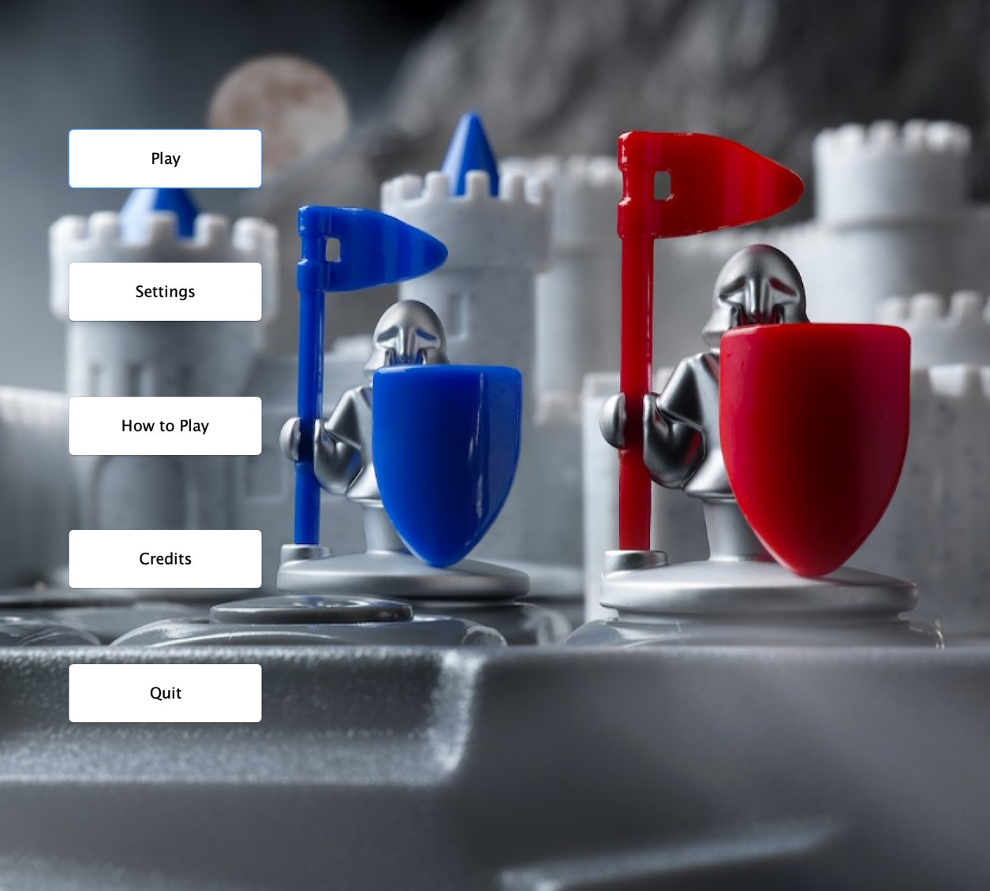

The How To Play and Credits buttons display information about the gameplay and creators. Settings button opens the settings menu, and Quick button exits the game. Finally, the Play button takes the player to the Level Menu, where the player selects a level and starts playing.

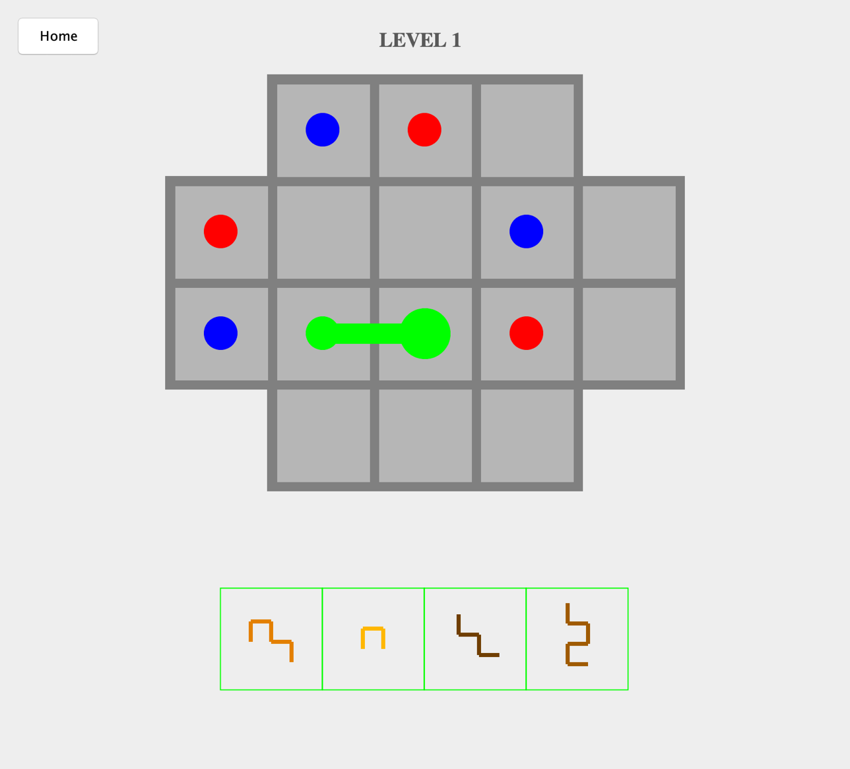

In the game screen, the board and the available walls are displayed. The user can select the walls from the panel and drag them onto the map. The wall displays a clicking sound if the placing is successful. The walls can be rotated while in the panel by right clicking. When the level is completed, a victory sound is played and the player has two options to select from a popped up window: go to the next level and return to menu.