**Introduction**

In modern life it is important to design projects before handle with them or mange them. All business projects need management systems to be managed effectively and increase productivity.

Supermarkets handle with management systems contains customer details, received, and bought products, employee details and depo information. All these information is stored in databases and these databases are designed in different platforms.

**General information**

As a database I used oracle database and SQL developer. Firstly, I created ER diagram of all entities and relations. I used insert, create, alter, update, create view

, join, drop commands on my project.

**Explanation:**

**Customer** table describes all customers’ information. **Sales** table describes information about customers’ shopping details like sales date. **Products** table illustrates all information about the products including price, brand etc. **Categories** table describes categories of products. **Depo** shows which categories stored in which depo. **Market account** shows all transactions hold in market doing by employees. **Payment details** table described customers’ payment methods and linked to products table. **Employees** table shows information about employees.

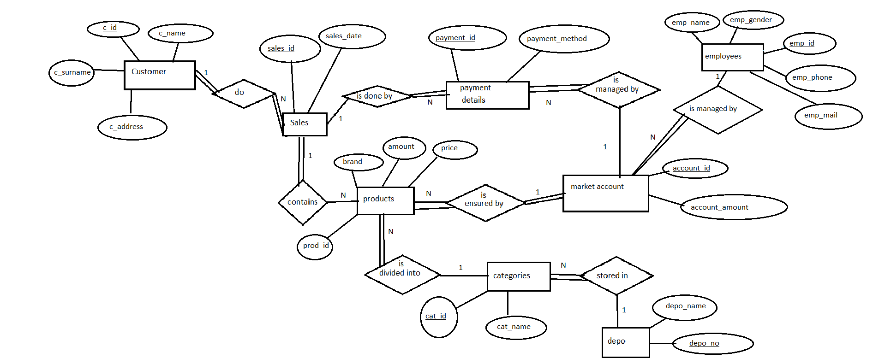

**Comments:**

I add some constraints like not null, primary key. I used alter commands and create view. I also used some select commands for multiple tasks.

**Code:**

CREATE SEQUENCE dept_seq START WITH 100;

create table customer(

c_name varchar2(50) not null,

c_surname varchar2(50) not null,

c_address varchar2(50),

c_id number primary key

);

alter table customer

modify c_address varchar2(50) not null;

create table sales(

sales_id number primary key,

sales_date date not null,

fk_sal_customer_id references customer(c_id)

);

create table products(

prod_id number primary key,

brand varchar2(50) not null,

price decimal not null,

amount decimal not null,

total decimal not null,

fk_sal_prod_id references sales(sales_id),

fk_cat_prod_id references categories(cat_id),

fk_mar_prod_id references market_account(account_id)

);

alter table products

modify price float;

alter table products

modify amount float;

alter table products

modify total float;

CREATE SEQUENCE dept_seq START WITH 100;

create table categories(

cat_name varchar2(50) NOT NULL,

cat_id number default dept_seq.nextval not null

);

alter table categories

add constraint cat_pk primary key(cat_id);

create table depo(

depo_name varchar2(50) not null,

depo_no number primary key

);

alter table depo

add fk_depo_cat_pk references categories(cat_id);

CREATE SEQUENCE acc_seq START WITH 201;

create table market_account(

account_amount number not null,

account_id number default acc_seq.nextval not null

);

alter table market_account

add constraint acc_pk primary key(account_id);

alter table market_account

add fk_markt_pay_id references payment_details(payment_id);

alter table market_account

add fk_markt_emp_id references employees0(emp_id);

alter table market_account

modify account_amount decimal;

create table payment_details(

payment_method varchar2(50) check (payment_method = 'cash' or payment_method='card'),

payment_id number primary key,

fk_prod_id references products(prod_id)

);

alter table payment_details

drop column fk_prod_id;

alter table payment_details

add fk_sal_pay_id references sales(sales_id);

create table employees0(

emp_name varchar2(50) not null,

emp_gender varchar2(30) check (emp_gender = 'female' or emp_gender='male'),

emp_id number primary key,

emp_phone number not null,

emp_mail varchar2(100) not null

);

alter table employees0

add emp_surname varchar2(30) not null;

insert into Customer values('Kylian','Mbappe','Paris',102101);

insert into Customer values('Lionel','Messi','Buenos-aires',102102);

insert into Customer values('Neymar','Jr','Lion',102103);

insert into Customer values('Ali','Mammadzade','Baku',102104);

insert into Customer values('Aykhan','Huseynli','Saatli',102105);

insert into Customer values('Vusal','Rustamov','Baku',102106);

insert into Customer values('Ilham','Aliyev','Moscow',102107);

insert into Customer values('Ali','Karimli','Saatli',102108);

insert into Customer values('Kerim','Babacanov','Shamkir',102109);

insert into Customer values('Azer','Suleymanov','Moscow',102110);

select * from customer;

insert into categories values('meat',101);

insert into categories values('diary',102);

insert into categories values('vegetable',103);

insert into categories values('cooking',104);

insert into categories values('drinks',105);

insert into categories values('cleaning',106);

insert into categories values('candy',107);

insert into categories values('fast meals',108);

insert into categories values('for home',109);

insert into categories values('alcoholic drinks',110);

select*from categories;

insert into sales values(4567,'12 December 2022',102105);

insert into sales values(4568,'13 December 2022',102102);

insert into sales values(4569,'13 December 2022',102106);

insert into sales values(4570,'14 December 2022',102110);

insert into sales values(4571,'15 December 2022',102108);

insert into sales values(4572,'16 December 2022',102107);

insert into sales values(4573,'16 December 2022',102104);

insert into sales values(4574,'16 December 2022',102103);

insert into sales values(4575,'17 December 2022',102101);

insert into sales values(4576,'17 December 2022',102109);

select*from sales;

insert into depo values('depo1',049,107);

insert into depo values('depo1',050,103);

insert into depo values('depo1',051,105);

insert into depo values('depo1',052,104);

insert into depo values('depo1',053,102);

insert into depo values('depo1',054,101);

insert into depo values('depo1',055,108);

insert into depo values('depo1',056,107);

select*from depo;

insert into employees0 values('Narmina','female',1309092,994557007710,'narmina@gmail.com','Namazova');

insert into employees0 values('Azer','male',1309093,994557007711,'azer@gmail.com','Suleymanov');

insert into employees0 values('Azad','male',1309094,994557007712,'azad@gmail.com','Suleymanov');

insert into employees0 values('Tural','male',1309095,994557007713,'tural@gmail.com','Rustamli');

insert into employees0 values('Aysel','female',1309096,994557007714,'aysel@gmail.com','Isayeva');

insert into employees0 values('Narmin','female',1309097,994557007715,'narmin@gmail.com','Zeynalova');

insert into employees0 values('Nureddin','male',1309098,994557007716,'nureddin@gmail.com','Aliyev');

insert into employees0 values('Orxan','male',1309099,994557007717,'orxan@gmail.com','Kerimov');

insert into employees0 values('Nicat','male',1309100,994557007718,'nicat@gmail.com','Bagirov');

insert into employees0 values('Senan','male',1309101,994557007719,'senan@gmail.com','Mammadov');

select*from employees0;

insert into payment_details values('cash',20510,4568);

insert into payment_details values('cash',20511,4570);

insert into payment_details values('cash',20512,4567);

insert into payment_details values('card',20513,4573);

insert into payment_details values('cash',20514,4574);

insert into payment_details values('card',20515,4571);

insert into payment_details values('card',20516,4572);

insert into payment_details values('cash',20517,4569);

insert into payment_details values('cash',20518,4575);

insert into payment_details values('card',20519,4576);

select*from payment_details;

insert into market_account values(19300,201,20510,1309092);

insert into market_account values(20059,202,20511,1309093);

insert into market_account values(13434,203,20512,1309094);

insert into market_account values(17560,204,20513,1309095);

insert into market_account values(1934,205,20514,1309096);

insert into market_account values(3004,206,20515,1309097);

insert into market_account values(1423,207,20516,1309098);

insert into market_account values(34234,208,20517,1309099);

insert into market_account values(1122,209,20518,1309100);

insert into market_account values(34443,210,20519,1309101);

select*from market_account;

insert into products values(999001,'Coca-cola',0.70,2,1.40,4567,105,201);

insert into products values(999010,'Beef',12.0,2,24.0,4568,101,202);

insert into products values(999020,'Azersud milk',1.73,1,1.73,4569,102,203);

insert into products values(999030,'Potato Celilabad',0.69,2,1.38,4570,103,204);

insert into products values(999040,'Bine bread',0.70,3,2.10,4571,104,205);

insert into products values(999050,'Shampoo H and S',3.58,1,3.58,4572,106,206);

insert into products values(999060,'Turk pakhlava',25.0,0.200,5.0,4573,107,207);

insert into products values(999070,'Pizza',14.0,1,14.0,4574,108,208);

insert into products values(999080,'window cleaner',2.90,1,2.90,4575,109,209);

insert into products values(999090,'Mamedoff klassik araq',14.50,1,14.50,4576,110,210);

--creating views--

--details about producst--

create view products_view

as select prod_id,brand,price from products;

select*from products_view;

--details about categories and products together--

create view prod_categories

as select products.brand,categories.cat_name from products

left join categories

on categories.cat_id=products.fk_cat_prod_id;

select*from prod_categories;

select*from products;

update products

set total=14.50

where prod_id=999090;

-- select command for multiple tasks--

--category id based on category name--

select cat_id from categories

where cat_name='drinks';

--product id based on product name--

select prod_id from products

where brand='Bine bread';

--getting products and prices--

select brand,price from products;

--getting categories name ordered--

select * from categories order by cat_name;

--getting sales when 13 december 2022--

select sales.sales_id,products.brand from sales

left join products

on products.fk_sal_prod_id=sales.sales_id

where sales.sales_date='13 December 2022';

--getting employees--

select emp_id,emp_name| |' '||emp_surname as full_name from employees0;

--updating customer address--

update customer

set c_address='Baku'

where c_id=102107;

--getting total sales on 14-17 december 2022--

select sum(total) from products

left join sales

on sales.sales_id=fk_sal_prod_id

where sales_date between '14 December 2022' and '17 December 2022';

--change the date 12 december to 13 december--

update sales

set sales_date=to_date('13 December 2022','DD-MON-YYYY')

where sales_date=to_date('12 December 2022');

-- select all products with 15% discount--

select brand,price as old_price,price-price*0.15 as discount_price from products;

-- show which customer buys which products--

create view customer_sales

as select sales.sales_id,customer.c_name ||' '|| customer.c_surname as c_fullname from customer

left join sales

on sales.fk_sal_customer_id=customer.c_id;

select*from customer_sales;

create view customer_product

as select customer_sales.c_fullname,products.brand from customer_sales

left join products

on products.fk_sal_prod_id=customer_sales.sales_id;

select*from customer_product;

--order products by price--

select price from products

order by price desc;

--select top 5 expensive products--

select brand,price from products

order by price desc

fetch first 5 rows only;

-- select employee names oredred by alphabet--

select emp_name||' '||emp_surname from employees0

order by emp_name;