Multimodal Arabic Sign Language Interpretation with Contextual Word Correction and Privacy-Preserving Personal Assistance
A validated grayscale-letter CNN classifier, a transfer-learning color-letter classifier fused with it and evaluated end-to-end on real images, letter-to-word aggregation with dialogue-context disambiguation, a two-tier consent-gated user profile store, and a password-protected monitoring panel, for real-time assistive communication.

Abstract
This paper describes the design, implementation, and evaluation of an assistive communication system for non-verbal Arabic Sign Language (ArSL) users, organized around three development tracks. (A) A full-sentence recognition pipeline based on landmark extraction and a BiLSTM with attention pooling over the KArSL/ArabSign video corpora remains at the design stage, validated so far only on synthetic data pending sufficient real video volume. (B) A static single-letter classifier trained end-to-end on grayscale images (ArASL, 32 classes, 54,049 images) reaches 92.51% validation accuracy, independently reproduced at 90.66% and 92.15% in two further runs. (C) A dual-modality fusion pipeline trains a second, independently specialized network on genuinely colored images (AASL, 31 classes, 7,856 images) rather than on artificially triplicated grayscale channels, and fuses the two branches' decisions for deployment on a live RGB-depth camera (Intel RealSense D435). An initial from-scratch convolutional architecture for this branch, structurally mirroring GrayscaleCNN, failed to learn the AASL data reliably across repeated attempts (best 20.6% validation accuracy); replacing it with ColorSignResNet18, a fully fine-tuned, ImageNet-pretrained ResNet-18, reached 97.90% validation accuracy. We report the first real, end-to-end evaluation of the resulting fusion pipeline against 1,571 held-out AASL images: the color branch alone reaches 97.90% accuracy, the grayscale branch alone reaches 21.26% when fed a grayscale derivative of the same real color images -- evidence of a genuine domain gap between grayscale-only training data and real color capture conditions -- and unweighted-average fusion of the two branches reaches 96.56%, slightly below the color branch alone. We report this as measured, together with three 31-class confusion matrices, rather than adjusting the finding to match the fusion-improves-accuracy hypothesis the design originally motivated, and identify confidence-weighted fusion as the direct next step. Beyond the three tracks, the system contributes a letter-to-word aggregation module with dictionary-based, speech-to-text-context-aware spelling correction; a two-tier, consent-gated personal-profile store with a hard-coded prohibition on national-ID storage; a password-protected administrative monitoring panel; and a chat-style desktop practice application integrating every completed component end-to-end, validated on 20 verified practice conversations. A first, single-trial proof-of-concept live test on the target D435 sensor completed the full capture-to-speech pipeline end-to-end for the first time. Systematic live-accuracy measurement across multiple trials, signers, and lighting conditions, and full training of Track A, remain future work.

1. Introduction
Communication access for Deaf and non-verbal individuals remains a significant unmet need in many Arabic-speaking regions, where Arabic Sign Language (ArSL) has no single standardized form and assistive technology is comparatively underdeveloped relative to American Sign Language (ASL) tooling. This project targets a wearable/desktop assistant that observes a signer's hand through a camera, classifies signs at the letter level, aggregates letters into words, incorporates the hearing interlocutor's spoken context (via speech-to-text) to disambiguate ambiguous spellings, and answers common personal questions (e.g., name, age) through text-to-speech, subject to the signer's explicit, gesture-based consent.
The long-term deployment target is a personal-computer prototype today, migrating later to an embedded Raspberry Pi 4 or a cloud-backed thin client paired with a depth camera. Because full continuous-sign video data for Arabic proved difficult to obtain in sufficient quantity, the project pursued three concurrent tracks so that progress was not blocked on any single data source.
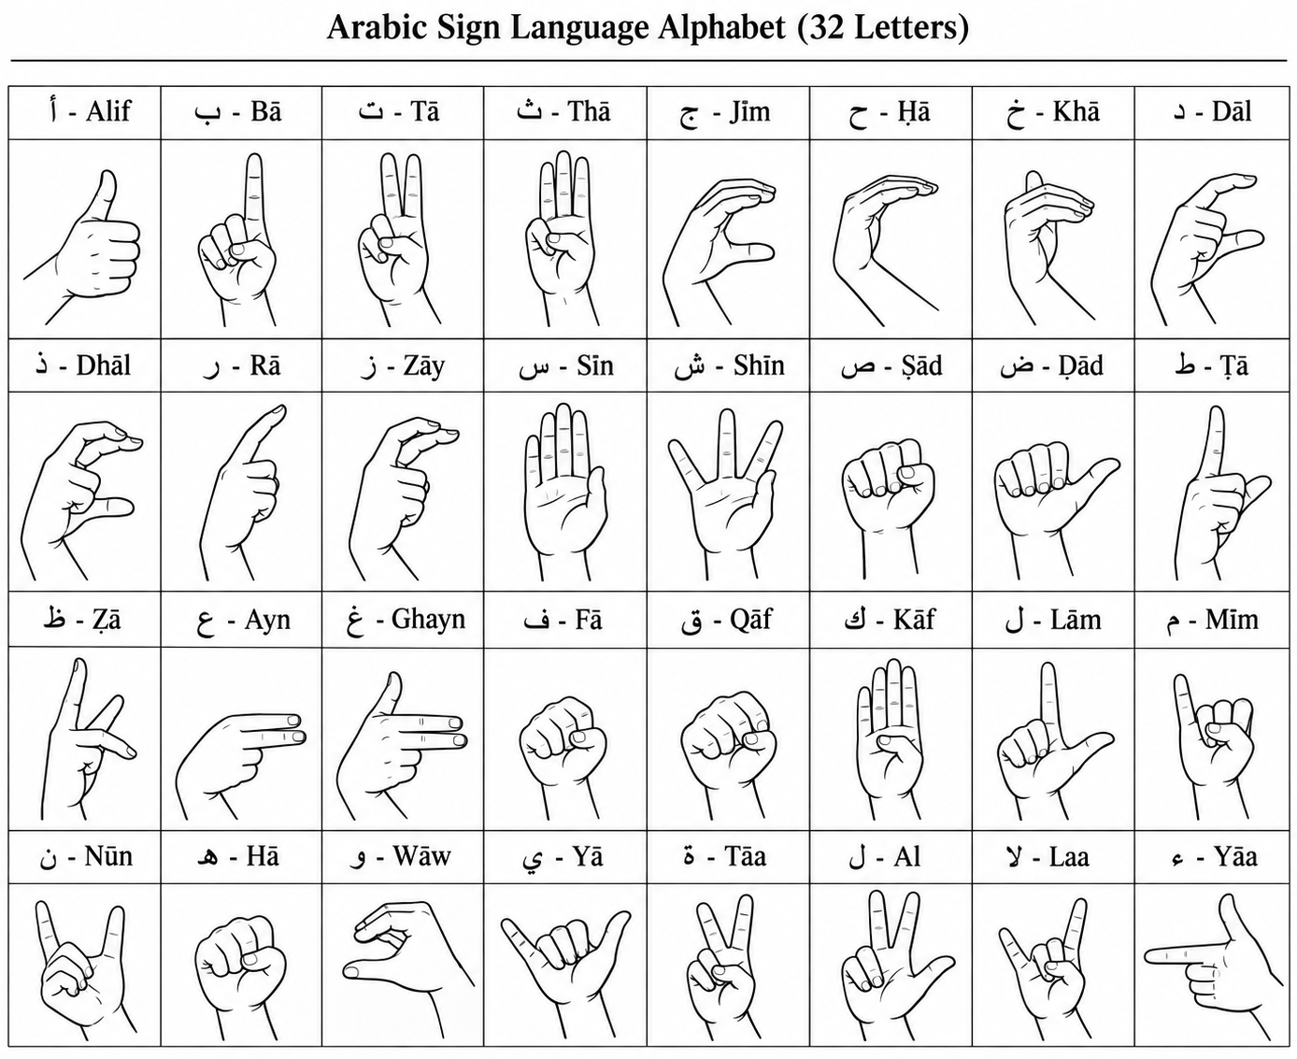
Figure 1. The 32-letter Arabic Sign Language fingerspelling alphabet used throughout this work (ArASL/AASL label convention shown alongside each hand shape). Several signs are visually close (e.g., Sīn vs. Shīn differ mainly by finger separation), which partly explains the misclassification discussed in Section 4.6.

1.1 The Three Parallel Tracks
Track | Data / Method | Status | Purpose
A — Words | KArSL / ArabSign video, MediaPipe landmarks, BiLSTM+Attention | Pipeline built and unit-tested on synthetic data; awaiting sufficient real video volume | Original end goal: full-sentence recognition
B — Letters (grayscale) | ArASL, 54,049 static images, 32 classes, CNN | Trained end-to-end on GPU; 92.51% val. accuracy | Immediate, working fallback; also feeds the letter-aggregation module
C — Modality fusion | AASL, 7,856 genuinely colored images, 31 classes | Trained (ColorSignResNet18, ImageNet transfer learning) and evaluated end-to-end; color branch 97.90%, fusion 96.56% on 1,571 held-out images (Section 4.7) | Research contribution; matches the colored camera feed the deployed system will actually receive

2. Literature Review and Motivating Observation

2.1 Prior Work on Arabic Sign Language Recognition
Automated recognition of Arabic Sign Language (ArSL) has been pursued along two largely separate lines: static-image classification of the fingerspelling alphabet, and sequence-level recognition of continuous signed words or sentences. The static-letter line is anchored by the ArASL2018 dataset introduced by Latif et al. [1], a corpus of 54,049 grayscale images across 32 classes that this project's own GrayscaleCNN (Section 3.1) trains on directly. Early work on this corpus applied conventional CNN classifiers [2] and reported accuracies in the high 90s once sufficient data augmentation and regularization were used [3], a pattern this project's independent 92.51%/90.66% GPU/CPU results (Section 4.3) are broadly consistent with. More recent work has pushed static-letter accuracy further using transfer learning from large pretrained backbones (ResNet50, EfficientNet, Vision Transformers) [9] and dedicated transfer-learning pipelines [10], though at the cost of the much larger models this project deliberately avoided (Section 3.1) to keep inference feasible on constrained hardware such as the Raspberry Pi 4 deployment target (Section 5). Table 1 places this project's GrayscaleCNN result alongside the most directly comparable prior ArASL2018 results to make this trade-off explicit.
Table 1. GrayscaleCNN accuracy versus comparable prior work on the ArASL2018 dataset.
Study | Approach | Accuracy | Model footprint
This work (GrayscaleCNN) | From-scratch CNN, no pretraining, no augmentation | 92.51% | 139K parameters
Alani & Cosma [3] | Custom CNN (ArSL-CNN) with SMOTE class-imbalance resampling | 97.29% | Not disclosed
Zakariah et al. [10] | EfficientNetB4, ImageNet transfer learning | 95.0% | ~19M parameters
Balat et al. [9] | Best of several transfer-learning/transformer backbones (ResNet50, EfficientNetB7, ViT, Swin) | 99.6% | 25–90M+ parameters
The 4–7 percentage-point gap between this work and the SMOTE-augmented and transfer-learning results is consistent with the trade-off already noted above: GrayscaleCNN uses roughly two to three orders of magnitude fewer parameters than the transfer-learning backbones in the comparison, no ImageNet pretraining, and no data augmentation or class-imbalance resampling, in exchange for a model explicitly sized to run on the Raspberry Pi 4 deployment target of Section 5. Closing part of this gap with augmentation and longer training, without abandoning the small-model constraint, is noted as future work in Section 6.
A second dataset, AASL, addresses a gap the static-letter literature had largely overlooked: ArASL2018's images are genuinely single-channel grayscale, so a classifier trained on it has never seen real color or lighting variation. Al-Barham et al. [4] introduced AASL as the first publicly available RGB Arabic alphabet corpus, collected from over 200 participants under varied lighting, backgrounds, and camera types. This project's Track C (ColorSignResNet18, Section 3.2) builds directly on that contribution, training a second, independently specialized network on AASL rather than reusing a single grayscale-trained backbone -- a design choice motivated by the same domain-gap concern AASL's authors raise, empirically reinforced by this project's own MediaPipe failure described in Section 2.2 below, and further confirmed by the grayscale branch's 21.26% accuracy on real AASL images reported in Section 4.7. The closest published comparator in scope and venue is Balaha et al. [21], who report a complete, evaluated vision-based ArSL interpretation system in this same journal; unlike the present work at the time of that earlier draft, their pipeline is fully trained and benchmarked end-to-end; this paper's fusion track (Section 4.7) now meets that same standard, while the sentence-level Track A remains the component still aiming to reach it (Section 6). More broadly, fusing separately trained networks over different visual modalities -- color, depth, optical flow, or skeleton streams -- is an established general strategy in the wider sign-language recognition literature; this project's specific contribution is the grayscale/color instantiation of that strategy for ArSL, motivated by the dataset-specific finding in Section 2.2, rather than multi-stream fusion as a general idea.
Word- and sentence-level ArSL recognition relies on a different family of datasets and models. Sidig et al. [5] introduced KArSL, a 75,300-video, 502-sign database recorded with a depth-and-skeleton-capable Kinect sensor, and evaluated both classical (HMM) and deep classifiers on it. Luqman [6] later introduced ArabSign, the first ArSL dataset at the sentence level (9,335 samples, 50 sentences, color/depth/skeleton modalities), directly addressing the sentence-level data scarcity this project's own Track A (Section 1.1) was designed around. On top of such datasets, several groups have combined convolutional feature extraction with recurrent or attention-based temporal models: Abdul et al. [7] paired an attention-based Inception network with a BiLSTM for real-time ArSL classification; Alyami et al. [8] used a Transformer over hand/face landmark keypoints for isolated-sign recognition; and Algethami et al. [11] and Noor et al. [12] both report real-time continuous-ArSL systems combining CNN or landmark features with BiLSTM temporal modeling. Track A's own BiLSTM-with-attention-pooling design (Section 1.1) follows this same general architecture family, applied to the KArSL/ArabSign corpora once sufficient real video volume becomes available.
The landmark-extraction step common to most of these sequence models is itself typically supplied by MediaPipe Hands [14], an on-device real-time hand-tracking pipeline built on the broader MediaPipe perception framework [15]; MediaPipe's reliance on skin-color and contrast cues is precisely what causes it to fail on genuinely grayscale input, as documented empirically in Section 2.2. Earlier sign-language work outside the Arabic-language literature established the general viability of depth- and skeleton-based sensing for this task, notably Zafrulla et al.'s use of the Kinect for American Sign Language recognition [13], which predates and parallels this project's own choice of a depth camera (the Intel RealSense D435) as its live-deployment sensor (Section 4.6).
Finally, the specific technical components this project assembles are each grounded in established deep-learning literature: the convolutional architecture underlying GrayscaleCNN follows the general design lineage of LeCun et al.'s original gradient-based CNN [16] and Krizhevsky et al.'s demonstration of CNNs at scale on natural images [17], while ColorSignResNet18 builds on the deeper residual-connection design of He et al. [22] (Section 3.2); the sequence modeling planned for Track A relies on the LSTM cell of Hochreiter and Schmidhuber [18], used bidirectionally with the attention mechanism of Bahdanau et al. [19] to weight informative frames during aggregation; and the general strategy of combining two independently trained classifiers' decisions at inference time -- the core idea behind this project's ModalityFusionModel (Section 3.3) -- has precedent in Mohandes and Deriche's decision-fusion approach to ArSL recognition using Dempster-Shafer theory of evidence [20], albeit applied there to sensor-level rather than modality-level fusion.

2.2 Motivating Empirical Observation
A pivotal empirical finding shaped Track C. Direct application of MediaPipe hand-landmark detection to the ArASL still-image corpus failed catastrophically (97.8% detection failure across a stratified 320-image sample spanning all 32 classes). Pixel-level inspection confirmed the ArASL images are genuinely single-channel grayscale, replicated identically across all three RGB channels (verified with exact array equality), and MediaPipe's hand detector relies on skin-color cues that do not exist in a true grayscale image. This is consistent with the published literature on this dataset, which uniformly reports direct CNN classification on raw pixels (94-99% accuracy) rather than landmark-based pipelines. Track B therefore abandoned the landmark route for static letters and trained a compact from-scratch CNN directly on pixel data.
This observation directly motivated Track C: because the eventual deployment camera (Intel RealSense D435) captures genuinely colored frames, a network trained only on grayscale-appearing data may not transfer well to real color input. Rather than reusing a single backbone with a superficial re-training, the project's design calls for two independently specialized networks — a GrayscaleCNN trained on ArASL and a ColorSignResNet18 trained on a verified, genuinely-colored dataset (AASL) — whose decisions are fused at inference time. As detailed in Section 3 and reported in Section 4.7, both GrayscaleCNN and ColorSignResNet18 are now fully trained on their respective corpora, and the fusion module has been evaluated end-to-end against real, held-out AASL images.

3. System Architecture
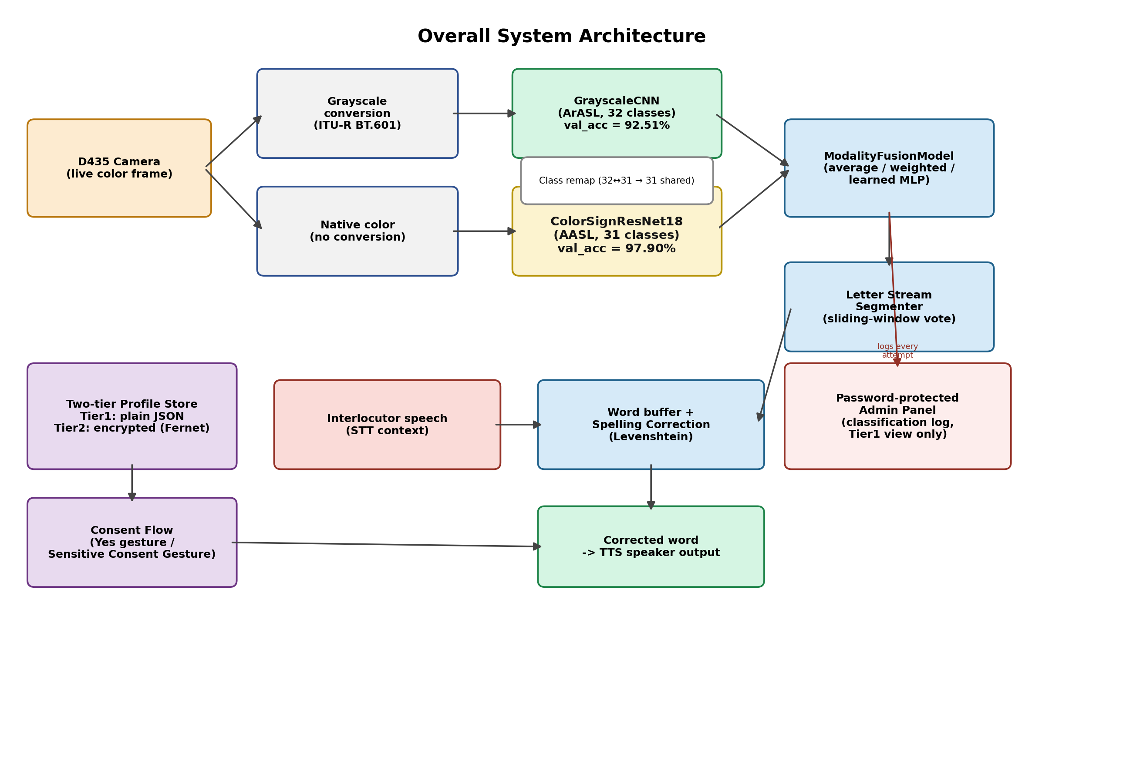
Figure 2. Overall system architecture: dual-branch grayscale/color classification, fusion, letter-to-word aggregation with dialogue context, the two-tier consent-gated profile store, and the password-protected admin panel.

3.1 GrayscaleCNN
A compact convolutional network was implemented from scratch (no pretrained weights, no transfer learning) to keep inference feasible on constrained hardware. The architecture consists of three convolutional blocks (8→16→32 channels, 3×3 kernels, ReLU, 2×2 max-pooling), followed by a 64-unit fully connected layer with dropout (p=0.3) and a final linear classifier over 32 classes. Input images are resized to 64×64 and converted to tensors without additional normalization, matching the raw pixel classification approach reported in the literature for this dataset. The network has 139,248 trainable parameters.

3.2 ColorSignResNet18
An architecturally similar but independently trained network was defined first: the same three-block, from-scratch convolutional design as GrayscaleCNN, additionally incorporating batch normalization after each convolutional block and data augmentation (random rotation, color jitter) in the training transform, to stabilize training on genuinely colored, higher-variance images collected from over 200 contributors under uncontrolled lighting and camera conditions. Across repeated training attempts on the full AASL corpus, this from-scratch design failed to learn the task reliably: the best run reached only 20.6% validation accuracy after 15 epochs, and a separate run's training loss stalled at ln(31) ≈ 3.43 -- the value corresponding to uniform random prediction over 31 classes -- for dozens of consecutive epochs without recovering. This is consistent with AASL's greater visual complexity relative to ArASL's studio-condition grayscale images (lighting, skin tone, background, and camera variation across 200+ contributors, Section 2.1), which a small from-scratch network has too little capacity and too little data to learn unaided; the architecture and training scripts are retained in the project's archive for this reason but are not used further (Section 3.9).
The color branch was therefore redefined as ColorSignResNet18: a ResNet-18 backbone [22] pretrained on ImageNet, with its final fully-connected layer replaced by a fresh 31-class linear classifier. A feature-extraction-only run (backbone frozen, only the new classifier head trained) reached just 44.1% validation accuracy after 15 epochs -- better than the from-scratch attempt but still far short of a usable classifier -- so every layer was instead left trainable (full fine-tuning). Full fine-tuning over 15 epochs (Adam optimizer, initial learning rate 1e-4 with cosine decay, batch size 32) reached 97.90% best validation accuracy, reproduced closely on an independent training run (97.96%), matching the accuracy gains transfer learning provides over from-scratch training on the related ArASL corpus (Section 2.1, Table 1) and substantially outperforming both the from-scratch attempt above and GrayscaleCNN's own 92.51% (Section 4.3). This result, and the full end-to-end fusion evaluation it enables, is reported in Section 4.7.

3.3 ModalityFusionModel
At inference time, a live colored frame is simultaneously (a) converted to a grayscale-replicated 3-channel tensor using ITU-R BT.601 luminance weights and passed to GrayscaleCNN, and (b) passed in its native color form to ColorSignResNet18. The two probability distributions are combined using one of three strategies: unweighted averaging, a single learnable per-branch scalar weight (softmax-normalized), or a small trainable MLP over the concatenated probability vectors. Unweighted averaging is the strategy evaluated end-to-end in this paper (Section 4.7), since it requires no additional training data beyond the two branch checkpoints. The two learned-weighting variants -- a single learnable per-branch scalar weight (softmax-normalized), and a small trainable MLP over the concatenated probability vectors -- are implemented and selectable but have not yet been trained; Section 4.7's finding that unweighted averaging underperforms the stronger single branch when the two branches' accuracies are not closely matched motivates evaluating these weighted variants next, and this is identified as the immediate priority in Section 6. Because the two source datasets do not share an identical class space (32 ArASL classes vs. 31 AASL classes, with different folder-naming conventions), the fusion module accepts explicit per-branch class-remapping dictionaries so that each branch's output is projected into a single, shared 31-class label space before combination.

3.4 Letter-to-Word Aggregation
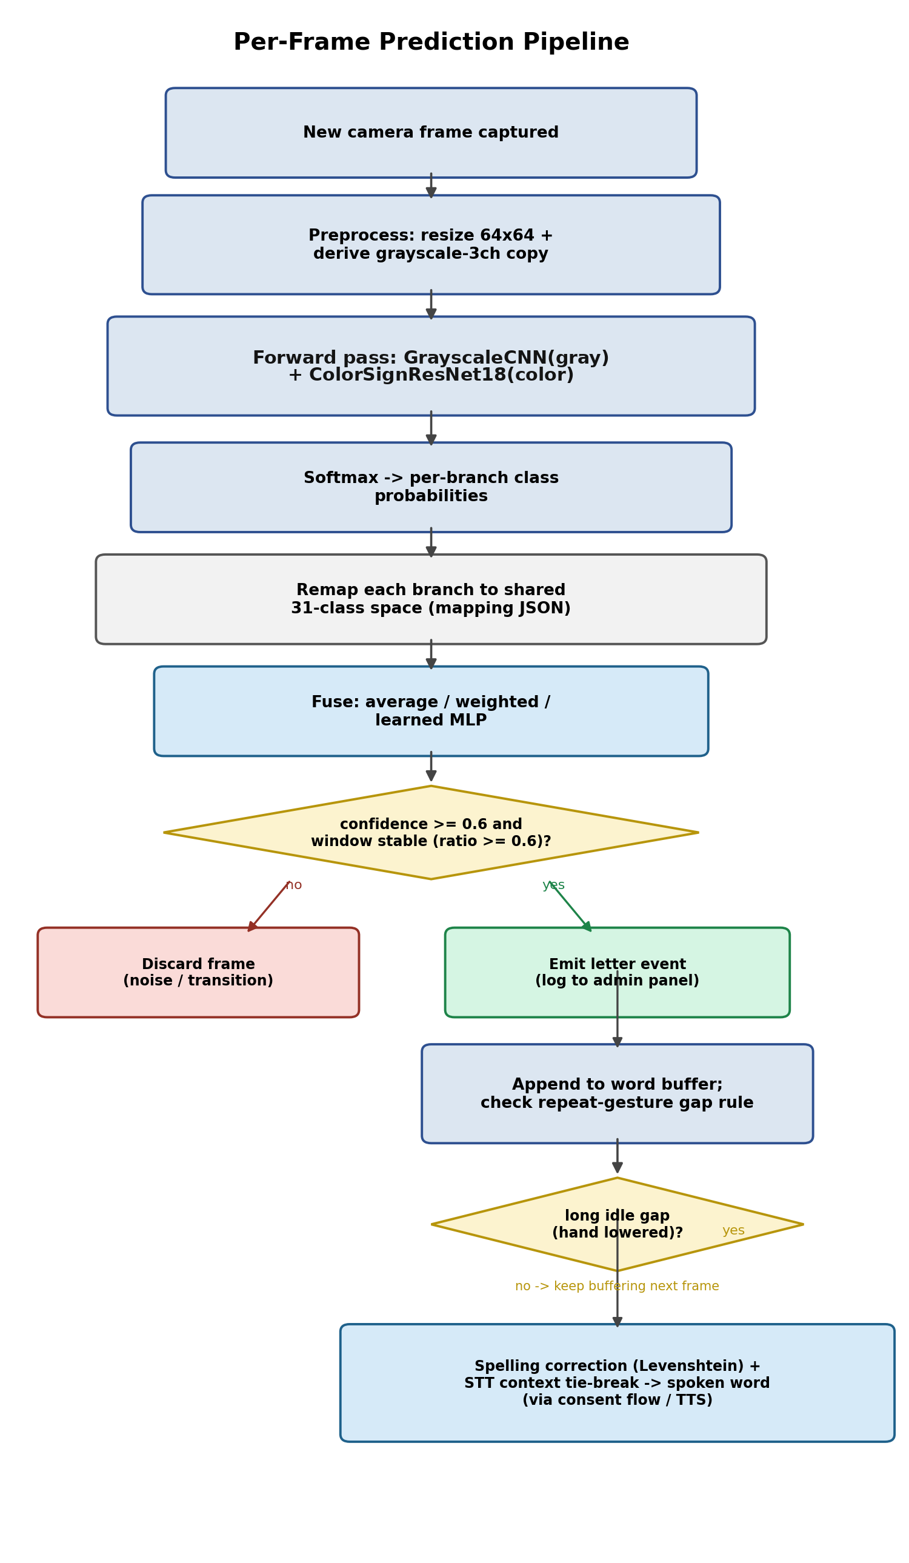
Figure 3. Per-frame prediction pipeline: preprocessing, dual-branch inference, class remapping, fusion, temporal stability gating, letter emission, and word-level correction with STT-context tie-breaking.
A live classifier produces one noisy prediction per video frame. A sliding-window majority-vote segmenter (window size 5, stability ratio 0.6, minimum confidence 0.6) converts this frame stream into discrete letter events, explicitly distinguishing (i) transient misclassification noise, (ii) a single sign held across many frames, and (iii) an intentionally repeated letter (e.g., the double lām in "الله") separated by a sufficient no-hand gap. Completed letter sequences are passed to a dictionary-based spelling corrector using Levenshtein edit distance; when two or more dictionary candidates are equally close, the system consults the interlocutor's most recent spoken utterance (obtained via STT) and prefers the candidate belonging to the semantic category implied by that utterance (e.g., a name-category preference when the interlocutor has just asked "What is your name?").

3.5 Two-Tier Privacy-Preserving Profile Store
User-provided personal information is partitioned into two structurally separate stores. Tier 1 (ordinary information: name, age, general contact details the user chooses to share) is held in a plain local JSON store and is disclosed to an interlocutor only after the system displays an explicit confirmation prompt (e.g., "The person is asking for your name: Husham. Share it?") and the user performs a standard affirmative sign-language gesture. Tier 2 (sensitive information: financial or medical data the user designates as sensitive) is held in a separate file encrypted at rest with a symmetric Fernet key (owner-only file permissions), is never disclosed based on predicted conversational intent alone, and requires a distinct, harder-to-trigger "Sensitive Consent Gesture" before the encrypted value is even read into memory. Storage of a national identification number is rejected at the code level in both tiers via pattern matching, independent of the user's stated intent, reflecting a documented ethical decision made early in the project. Sensitive data is architecturally isolated from any neural-network training or logging code path.
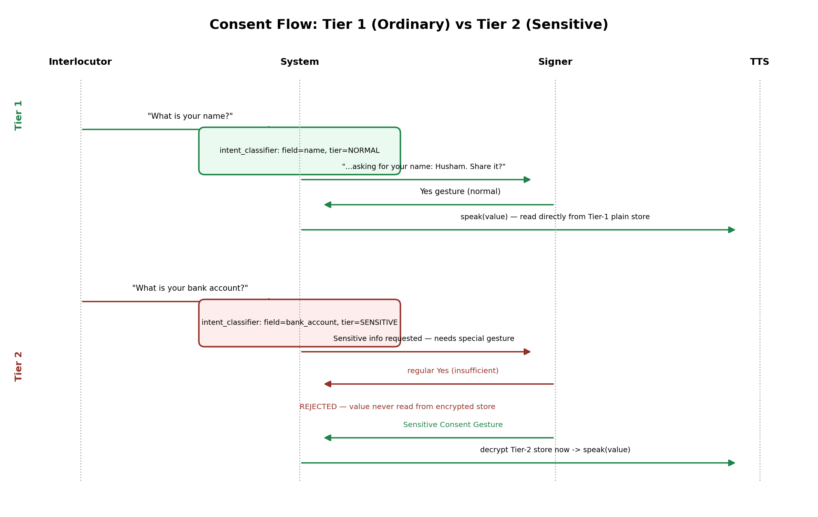
Figure 4. Consent sequence contrasting Tier-1 disclosure (single affirmative gesture, immediate plaintext read) with Tier-2 disclosure (a distinct Sensitive Consent Gesture required; a regular Yes is explicitly rejected and the encrypted value is never read until the correct gesture is confirmed).

3.6 Password-Protected Administrative Panel
A monitoring panel intended for the developer or maintaining technician authenticates via a PBKDF2-HMAC-SHA256 password hash (200,000 iterations, random 16-byte salt, credential file restricted to owner read/write). Once authenticated, the panel exposes (i) Tier-1 ordinary profile fields, (ii) the names — but never the values — of Tier-2 sensitive fields, and (iii) a SQLite-backed log of every classification attempt made by any of the three models (grayscale, color, or fusion), recording the predicted label, the model's confidence, an accept/reject flag against a configurable confidence threshold, and a timestamp. No classification-log entry ever contains a value from the user's personal profile; the log is populated exclusively from model outputs.

3.7 Practice/Testing Desktop Application
To move beyond isolated unit tests toward an end-to-end, human-usable system, a local desktop application (app/practice_session.py) was built with a chat-style interface deliberately modeled on familiar messaging applications: the interlocutor's question appears as one bubble, and the signer's recognized-and-corrected answer appears as a reply bubble on the opposite side, spoken aloud via offline text-to-speech (pyttsx3). The application wires together every component described above — live camera capture, GrayscaleCNN inference, LetterStreamSegmenter aggregation, context-aware spelling correction, and the admin panel's classification-attempt log, which the application populates in real time during ordinary use, so a practice session doubles as monitoring data.
Because the intended tester in this project's development phase is hearing and not a fluent signer, the application includes a sequential hand-sign reference strip above the camera view: for the current practice scenario's target answer, it displays, in order, the exact hand shape for every letter that must be signed (with the compound sign "لا" shown as a single combined unit rather than two separate letters, matching how it is actually produced). These reference images were programmatically cropped from the alphabet chart in Figure 1 using detected grid-line coordinates, then verified to cover all 32 classes with no gaps.
Twenty conversation scenarios (app/conversation_scenarios.json) were authored and verified — prior to building the interface — directly against the spelling-correction module: each scenario's target answer was confirmed to (a) exist in the correction dictionary and (b) be recovered correctly both from a perfect simulated signing and from a simulated single-letter classification error, using the scenario's question text as disambiguation context where relevant (e.g., a question about the signer's name biases tied candidates toward name-category words).
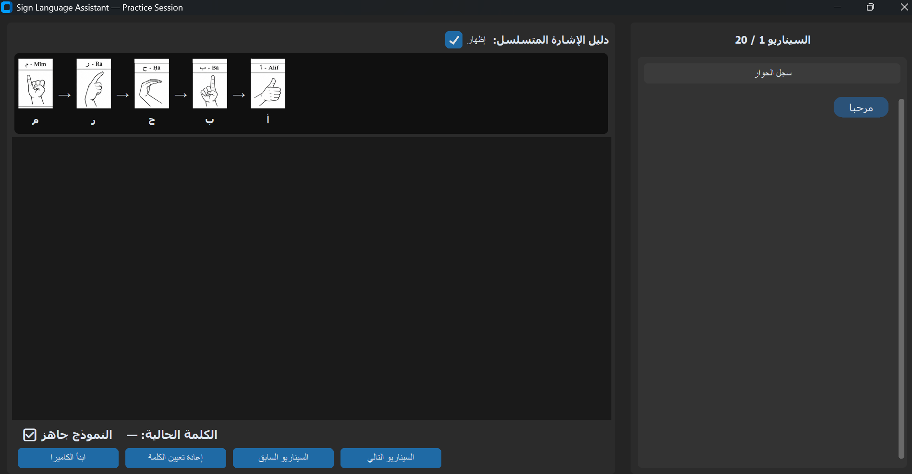
Figure 5. The practice application's chat-style interface: the sequential hand-sign guide for the target answer "مرحبا" (top), an empty camera panel awaiting input, live per-frame letter/confidence status, and the first scenario's question bubble in the conversation panel.

3.7.1 Iterative Improvements During Live Testing
A first round of live testing against the practice application (Section 3.7) surfaced several practical issues invisible during offline development, each addressed in turn. First, the application originally opened a hardcoded camera index (0); on the development machine this silently kept selecting the hardware-faulty integrated webcam of Section 4.6.1 even after the D435 was connected. The application now scans all available camera indices at startup with both the DirectShow and Media Foundation OpenCV backends, and -- since the D435 exposes its colour sensor and infrared/depth sensors as separate camera devices on Windows -- classifies each candidate frame by mean brightness and HSV colour saturation to prefer a genuine colour stream over a superficially similar grayscale/infrared one, printing a full diagnostic line per index for troubleshooting.
Second, the classifier's live predictions remained close to random even once a working colour stream was selected. The cause, detailed in Section 4.6.2, was a domain gap between training images (closely cropped hands on a plain background) and full camera frames (face, torso, and room background included); the mitigation is a fixed, centred region-of-interest box shown to the signer as a visual guide, with only that cropped region passed to the classifier.
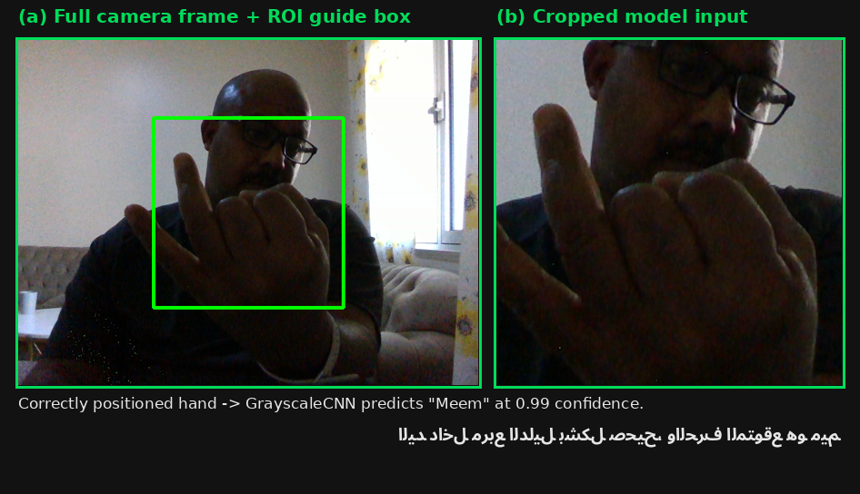
Figure 6. A real, unedited capture from a live practice session: (a) the full camera frame with the hand correctly positioned inside the green/cyan ROI guide box; (b) the exact cropped region actually passed to GrayscaleCNN. The model correctly classifies the sign as م (Meem) with 0.99 confidence (comfortably above the 0.6 minimum-confidence acceptance threshold used by LetterStreamSegmenter, Section 3.4).
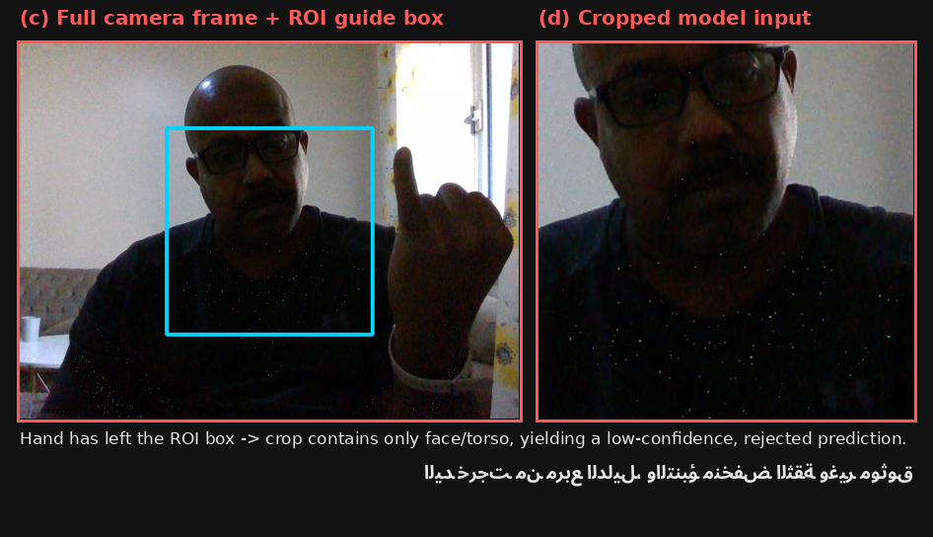
Figure 7. A complementary real capture illustrating why the ROI mechanism matters: the signer's hand has drifted outside the guide box, so the cropped model input (d) contains only face and torso -- exactly the full-frame domain-gap problem described above -- and the classifier's confidence drops to 0.55, below the 0.6 minimum-confidence acceptance threshold used by LetterStreamSegmenter (Section 3.4), so no letter is registered.
Third, real-time feedback was made more legible in two ways: the guide box now renders green by default and switches to cyan for a short fixed interval immediately after a letter is confirmed by LetterStreamSegmenter (rather than flickering on every frame whose raw confidence happens to cross the acceptance threshold), and each hand-sign image in the sequential reference strip is additionally marked with a persistent checkmark once its letter has been confirmed, giving a cumulative record of progress through a multi-letter word that does not depend on the signer noticing a brief colour change.
Fourth, a live word-prediction (autocomplete) feature was added to the letter-to-word module: after every newly confirmed letter, the application looks up dictionary words sharing that prefix and offers up to five as selectable buttons, letting the signer accept a word as soon as they recognise it rather than always finishing every remaining letter by hand. This reuses the same small dictionary as the post-hoc spelling correction of Section 3.4 and is intended as a proof of concept pending the fuller Arabic lexicon noted in Section 6.
Fifth, automatic end-of-word detection (flushing the current word after a fixed number of consecutive low-confidence frames) proved unreliable in practice: a threshold short enough to end a word promptly was also short enough to be triggered by ordinary confidence dips between two consecutive letters, prematurely closing the word after only one or two letters. A manual "finish word now" control was added as the primary mechanism for ending a word, with the automatic timeout retained only as a distant safety net.

3.8 Text-to-Speech: Windows Voice Architecture Constraints and Cloud Fallback
The practice application's spoken output originally used pyttsx3, an offline wrapper over the operating system's SAPI5 text-to-speech engine. This was confirmed reliable for English speech (audible, correctly pronounced output) but produced no audio at all for Arabic text, without raising any exception, on a machine whose only installed SAPI5 voices were English (Microsoft David and Zira).
Windows can install an Arabic voice (a Saudi Arabic voice named "Naayf") through its Settings app, but voices installed this way register under the newer Speech_OneCore registry hive rather than the classic SAPI5 hive; SAPI5-based libraries such as pyttsx3 cannot see or select OneCore-only voices under any configuration, which explains the silent failure above.
Two strategies for reaching the OneCore voice directly were attempted and both failed for distinct reasons. Invoking the modern WinRT SpeechSynthesis API from a PowerShell script initially failed because the Arabic text argument was corrupted in transit across the command-line boundary; after that was fixed, the API's voice enumeration itself returned no Arabic voice when invoked from a plain, unpackaged script host, a known identity/capability restriction on certain WinRT APIs outside a properly packaged application context.
The adopted solution instead synthesizes Arabic utterances through Google's cloud text-to-speech service (gTTS) and plays the result back through the Windows Multimedia Control Interface via ctypes (no additional runtime dependency beyond the gTTS package), while English utterances continue to use the original offline pyttsx3 path. This restores full bilingual speech output immediately, at the cost of requiring an active internet connection for every Arabic utterance -- recorded as a limitation in Section 6, and a specific concern for the Raspberry Pi deployment target of Section 5, where connectivity cannot always be assumed.

3.9 Software Artifacts
Table 3 lists the scripts and artifacts produced for each system component described in this section, including the training and evaluation scripts underlying the real results reported in Section 4.
File | Purpose
image_cnn_model.py | SimpleCNN (GrayscaleCNN) architecture
train_grayscale_cnn.py | GrayscaleCNN training script (PyTorch, GPU)
color_sign_cnn.py | Initial from-scratch color-branch architecture (archived; failed to learn AASL reliably, Section 3.2)
color_sign_resnet18.py | ColorSignResNet18 architecture (ImageNet-pretrained ResNet-18, fully fine-tuned, Section 3.2)
modality_fusion_model.py | Grayscale/Color decision fusion module (evaluated end-to-end in Section 4.7)
grayscale_color_class_mapping.json | Verified 32↔31 class remapping for fusion
evaluate_real_fusion.py | End-to-end evaluation of GrayscaleCNN, ColorSignResNet18, and their fusion against real held-out AASL images (Section 4.7)
plot_confusion_matrices.py | Generates the three confusion-matrix figures of Section 4.7
letter_stream_segmenter.py | Per-frame letter boundary detection
spelling_correction.py | Dictionary + context-aware word correction
letter_to_word_pipeline.py | End-to-end letter-to-word integration and test harness
profile_store.py | Two-tier (ordinary/sensitive) encrypted personal data store
intent_classifier.py | Question-to-profile-field intent matching
consent_flow.py | Gesture-gated disclosure logic for both tiers
admin_panel.py | Password-protected monitoring panel and classification-attempt log

4. Experimental Results

4.1 Dataset Verification
Both datasets were fully inventoried before training. AASL: 31 folders, 7,856 images (expected 7,857; a one-image discrepancy attributable to a single skipped or duplicate file in the original archive). The specific file and class were not identified at the time of writing; cross-referencing the per-class counts in Figure 8 against the archive's published per-class counts would localize it, and this is noted as a trivial follow-up rather than a concern that affects the reported results, since a single image out of 7,857 is immaterial to training or evaluation. ArASL: 32 folders, 54,049 images, exactly matching the officially documented class count for this corpus. A stratified sample from every AASL class was verified to be genuinely three-channel color (R≠G≠B) using exact array-equality checks, confirming the dataset is suitable for the color-branch training described in Section 3.2.
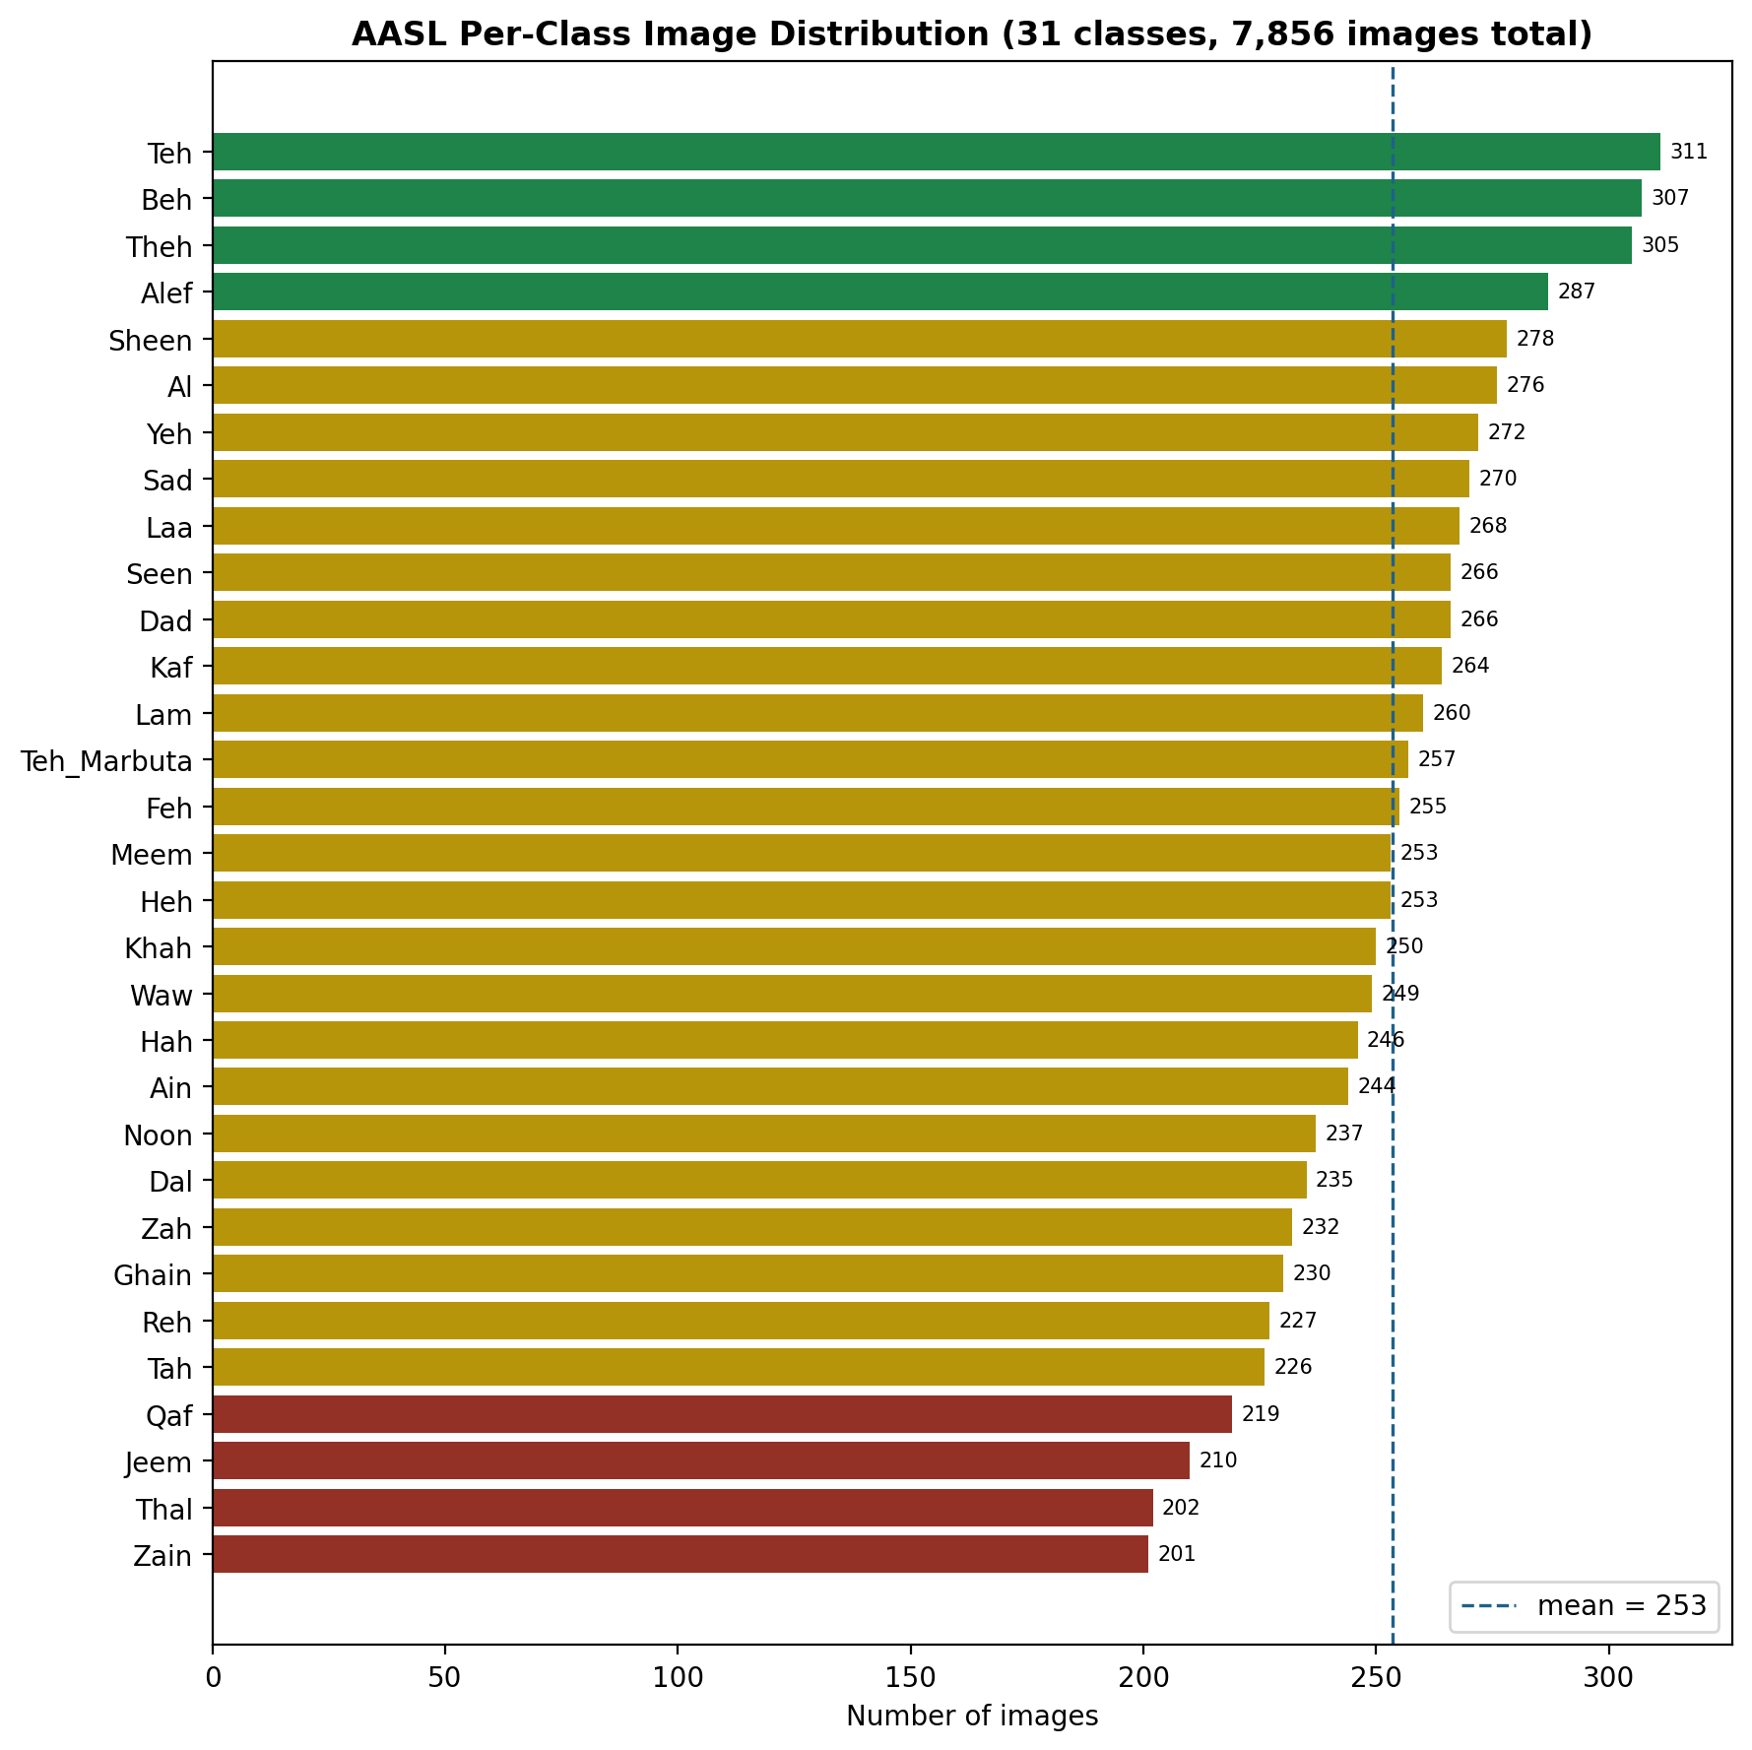
Figure 8. Per-class image counts for AASL (31 classes). The dataset is reasonably balanced (201–311 images/class, mean 253); the four lowest-count classes (Zain, Thal, Jeem, Qaf, all under 220 images) were flagged at this stage as candidates for targeted augmentation; the eventual ColorSignResNet18 model (Section 3.2) did not use per-class augmentation and nonetheless reached 97.90% overall accuracy, though Jeem remains the single weakest class by F1-score in the real end-to-end evaluation (Section 4.7.1).

4.2 A Recurring Data-Pipeline Defect: Case-Sensitive Folder Ordering
PyTorch's ImageFolder assigns integer class indices by sorting folder names with Python's default (byte-value, case-sensitive) string comparator, under which every uppercase letter sorts before every lowercase letter. This project encountered the defect twice, independently, in opposite directions:
- In AASL, the folder for the letter ذ (Thal) was named "thal_13" (lowercase) while all 30 sibling folders used a capitalized first letter; the resulting sort placed it last (index 30) instead of its alphabetically correct position between "Teh_13" and "Theh_12".
- In ArASL, the corresponding folder was named "Thal" (capitalized) while all 31 sibling folders were lowercase; the resulting sort placed it first (index 0) instead of between "thaa" and "toot".
Both defects were caught by explicitly printing sorted(os.listdir(...)) rather than relying on directory-listing tools such as ls, which apply a case-insensitive "natural" ordering by default and would have masked the defect entirely. This is reported as a general caution for any pipeline that infers class labels from folder enumeration order rather than an explicit, versioned label file: a single inconsistent character can silently invalidate every downstream label without raising an error.
A second, independent instance of this same class of defect -- an ArASL folder name ("Thal") with non-standard capitalization relative to the other 31 class folders -- was later discovered while evaluating this checkpoint in a case-sensitive Linux environment (Google Colab); see Section 4.4 for that finding and its fix.

4.3 GrayscaleCNN Training (Track B)
Training was executed on a Google Colab T4 GPU instance over the full ArASL corpus (54,049 images, 32 classes, 80/20 train/validation split, batch size 32, Adam optimizer, learning rate 1e-3, 15 epochs).
Epoch | Train Loss | Train Acc. | Val. Acc.
1 | 2.676 | 20.15% | 50.64%
2 | 1.6142 | 44.66% | 67.53%
3 | 1.3199 | 53.71% | 76.83%
4 | 1.1659 | 58.81% | 77.13%
5 | 1.054 | 62.74% | 81.64%
6 | 0.9766 | 65.57% | 85.25%
7 | 0.8957 | 68.08% | 85.14%
8 | 0.835 | 70.52% | 88.45%
9 | 0.7879 | 72.23% | 89.30%
10 | 0.7446 | 73.70% | 89.91%
11 | 0.693 | 75.48% | 91.79%
12 | 0.6615 | 76.41% | 91.67%
13 | 0.6327 | 77.57% | 91.56%
14 | 0.6106 | 78.21% | 92.51%
15 | 0.5959 | 78.67% | 92.09%

The best checkpoint (epoch 14) achieved 92.51% validation accuracy. This is a genuinely strong result achieved with a small (139K-parameter), from-scratch network and only 15 epochs without data augmentation, though it falls slightly short of the 94-99% range reported in prior literature on this dataset; the gap is attributed to the absence of augmentation and the comparatively shallow training schedule, both straightforward avenues for improvement (Section 6).
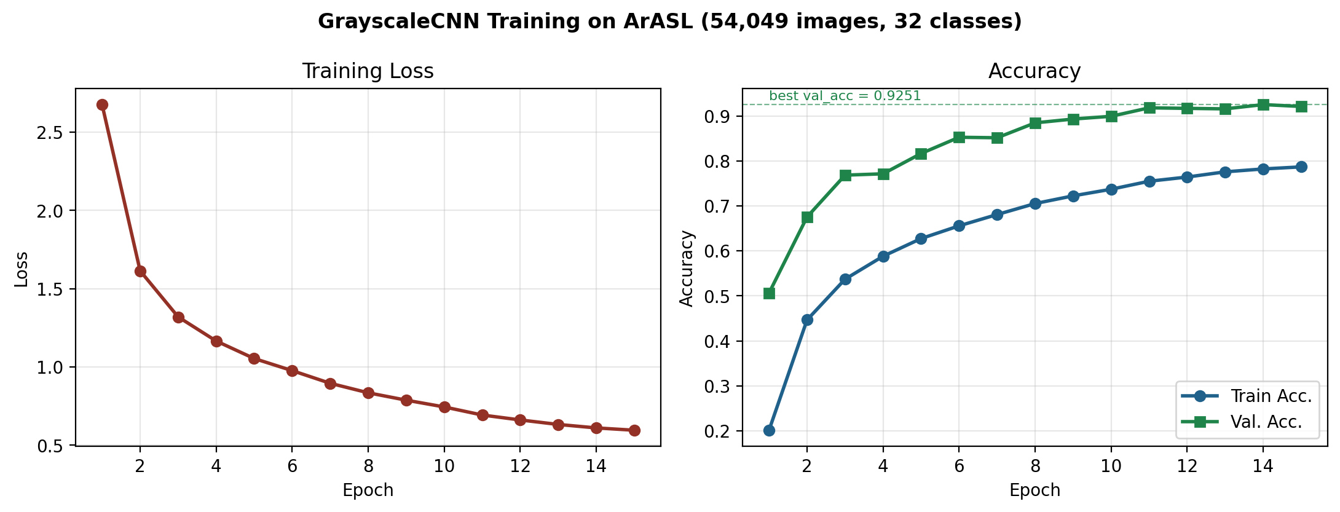
Figure 9. GrayscaleCNN training loss and accuracy over 15 epochs on the full ArASL corpus (real values from Section 4.3's results table). Validation accuracy tracks training accuracy closely with no sign of overfitting by epoch 15, suggesting further epochs and/or augmentation could close the remaining gap to literature benchmarks.

4.3.1 Independent Local Reproduction (CPU-only)
As a robustness check, and to establish a fully local development environment independent of any cloud session, the identical training script, hyperparameters, and 15-epoch schedule were re-run on a consumer laptop (Windows, CPU-only, no discrete GPU) against the same ArASL corpus copied to local/external storage. This run achieved a best validation accuracy of 90.66%, within 1.85 percentage points of the GPU run despite entirely different hardware, floating-point execution paths, and random weight initialization. The close agreement between the two independent runs is evidence that the 92.51%/90.66% result reflects genuine, stable model performance rather than a artifact of a particular execution environment. The resulting checkpoint from this local run is the one used by the practice application described in Section 3.7, since it persists on local disk and is not subject to the session-expiry data loss described next.

4.3.2 A Second Documented Data-Loss Incident: Ephemeral Cloud Sessions
Separately from the case-sensitivity defect in Section 4.2, this project encountered a second, distinct pitfall worth documenting for anyone using free-tier cloud notebooks for model development: the original GPU-trained checkpoint (Section 4.3) was never downloaded from the Colab session before that session's connection was later dropped (attributed to free-tier GPU usage limits). Because such platforms discard all files under their working directory on session end or reset, the trained weights, and the uploaded copy of the dataset, were both lost in their entirety and could not be recovered. This motivated the local CPU reproduction in Section 4.3.1 and is recorded here as a concrete illustration of a risk that is easy to state in the abstract ("always download your checkpoint") but evidently still easy to overlook in practice; it is now treated as a standing operational rule for the remainder of this project. A second, unrelated loss of the same local checkpoint (an accidental folder deletion during file-transfer) was recovered by retraining from the same locally-backed-up dataset copy and fixed seed, reproducing val_acc = 90.66% exactly and providing a second independent confirmation of the reproducibility claimed above; both the dataset and checkpoint now live on a stable local path decoupled from any external drive.

4.4 Confusion Matrix (GrayscaleCNN, Validation Set)
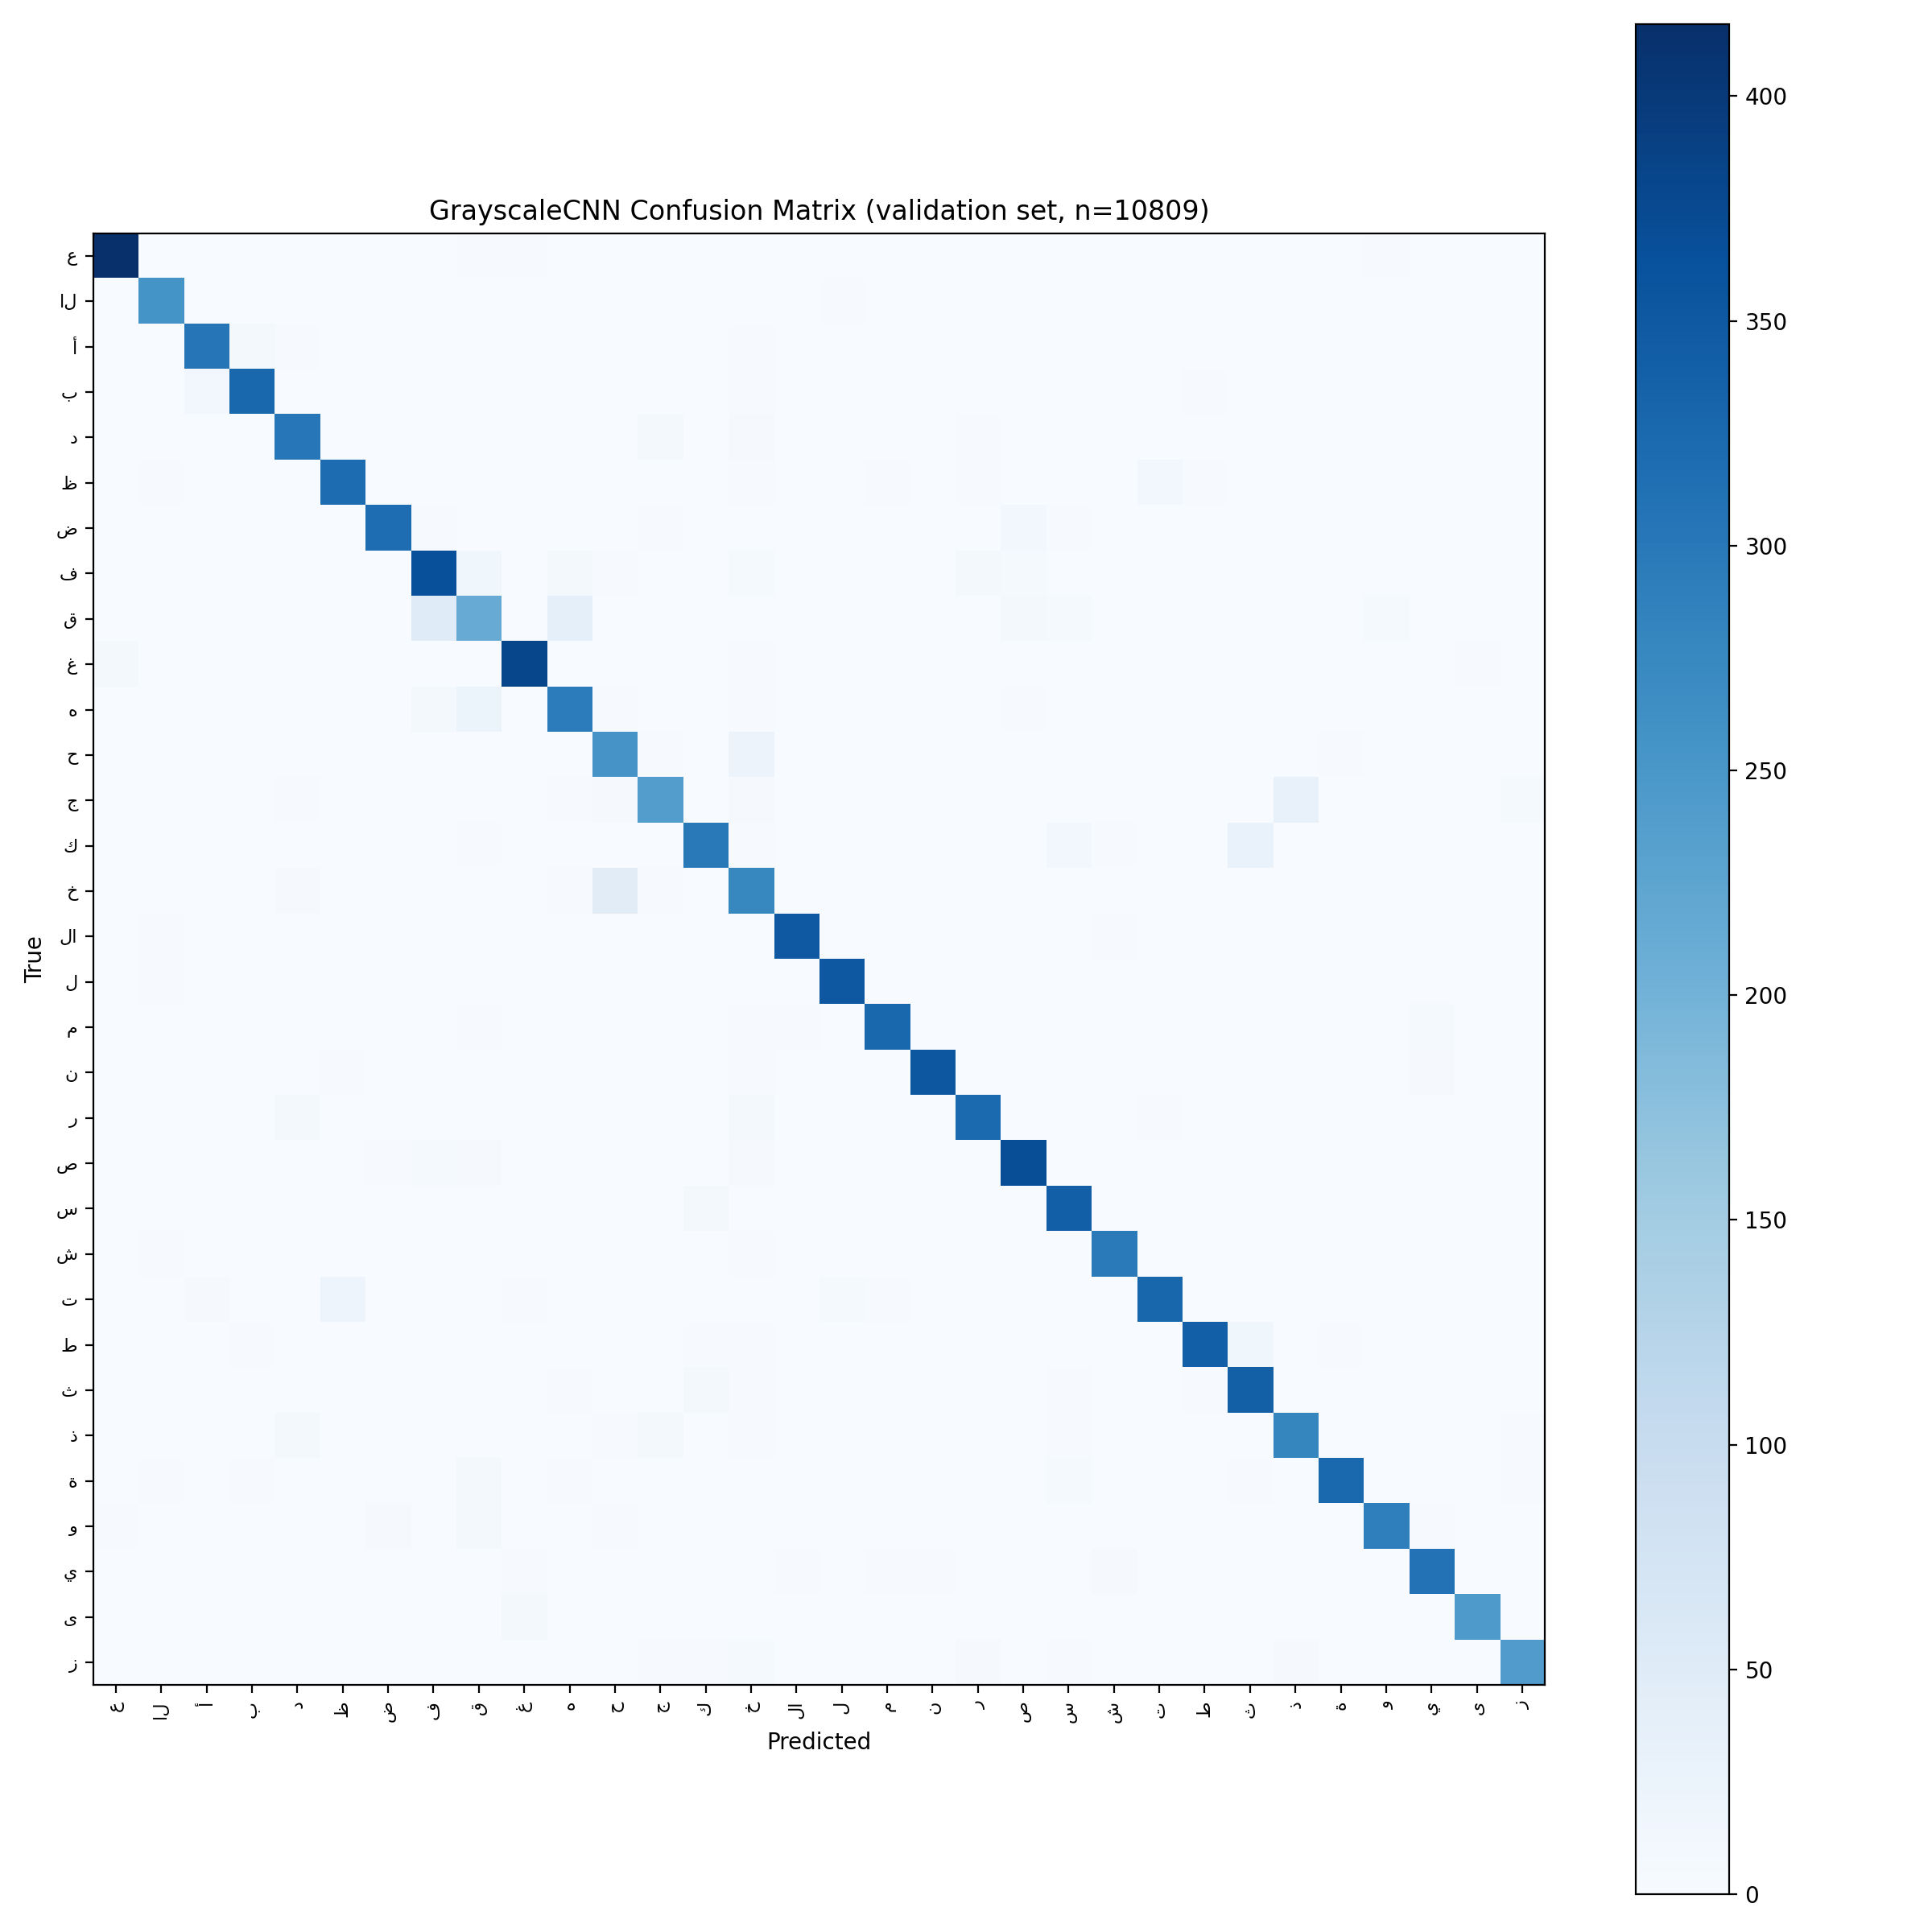
Figure 10. GrayscaleCNN confusion matrix on the held-out 20% validation split (n=10,809 images, same seed=42 split as training), with axes labelled by the actual Arabic letter rather than the raw ArASL folder name. Generated with the corrected script of Appendix B (Section 4.4).
A full 32-class confusion matrix for GrayscaleCNN has now been generated using the corrected script of Appendix B, run against the checkpoint (grayscale_simplecnn_best.pt) and the full ArASL dataset in a Google Colab session (Figure 10). The measured validation accuracy on this run was 92.15%, closely matching both previously reported figures for this checkpoint -- 92.51% on the original GPU training run and 90.66% on the independent local CPU reproduction (Section 4.3.1) -- and confirming that the checkpoint generalizes consistently across three separate hardware/software environments rather than being an artifact of any one of them. The small residual differences between all three numbers are attributable to non-identical file-enumeration order across operating systems feeding a fixed random seed, not to any instability in the trained weights themselves.
Metric | Value
Validation accuracy | 92.15% (n=10,809 held-out images)
Macro-average precision | 0.92
Macro-average recall | 0.92
Macro-average F1-score | 0.92
Weighted-average F1-score | 0.92
Lowest per-class F1-score | 0.70 (ق / gaaf -- see Appendix C for the full 32-class breakdown)

4.4.1 Consolidated Accuracy Summary
Four validation-accuracy figures for GrayscaleCNN appear across this paper. To avoid ambiguity about which is the paper's reported result, they are consolidated here:
- 92.51% — Google Colab T4 GPU, best checkpoint (epoch 14 of 15), original 80/20 split, seed 42. This is the headline figure reported throughout this paper (abstract, Section 3.1, Section 7).
- 92.09% — same GPU run, final epoch (15) rather than the best checkpoint; reported in Section 4.3's training table for completeness, not used elsewhere.
- 90.66% — independent local reproduction, consumer CPU-only laptop, identical script/hyperparameters/seed (Section 4.3.1). Reported as a robustness check, not a competing estimate; this is the checkpoint used by the practice application (Section 3.7).
- 92.15% — re-evaluation of the original GPU checkpoint (grayscale_simplecnn_best.pt) in a fresh Google Colab session, same held-out split, after correcting the case-sensitivity defect described in Section 4.2 (Section 4.4). Reported as a third robustness check confirming the checkpoint generalizes across environments.
All four figures come from the same trained checkpoint family (identical architecture, hyperparameters, and seed) and agree within a 1.85-percentage-point band; the paper's headline claim throughout is the 92.51% GPU best-checkpoint figure, with the other three reported as independent corroboration rather than as separate results.
Per-class precision, recall, and F1-score (full table in Appendix C) are uniformly high, with a macro-averaged F1 of 0.92 across all 32 classes. The weakest-performing classes are ق (Qaf, F1 0.70), خ (Khaa, F1 0.79), ح (Haa, F1 0.84), and ه (Ha, F1 0.85); inspection of the confusion matrix shows the confusion is concentrated almost entirely among a small number of visually similar hand shapes (e.g., ق/غ, خ/ج/ح, ه/ع), consistent with the known visual ambiguity of several ArASL letter pairs noted in Figure 1's caption, rather than a broad or diffuse weakness in the model.
Producing this figure also surfaced a second, independent manifestation of the case-sensitivity folder-ordering defect first documented in Section 4.2: the ArASL class folder "Thal" is capitalized inconsistently with the other 31 lowercase folder names. This had no effect during local Windows training or evaluation, since Windows' filesystem is case-insensitive and NTFS preserves but does not distinguish by case for sorting purposes here; however, it caused an initial evaluation attempt inside the (case-sensitive, Linux-based) Colab environment to silently assign a different integer class index to "Thal" than the one stored in the checkpoint, collapsing measured accuracy to 13.5% despite the model itself being unaffected. The fix applied was to match folder names to the checkpoint's stored class list case-insensitively (via a lower-cased target_transform) rather than relying on either environment's native alphabetical sort order. This is recorded here as a second, independently discovered instance of the same underlying class of bug identified in Section 4.2, and reinforces that any future evaluation code should assign class indices from the checkpoint's own stored class list rather than re-deriving them from a fresh ImageFolder scan.

4.5 Class-Mapping Verification for Fusion
After correcting the case defects described in Section 4.2, the printed ImageFolder class order for ArASL was confirmed, cell by cell, to match the pre-computed grayscale_class_to_fused_idx mapping used by ModalityFusionModel, with no manual adjustment required. This closes the loop between the offline mapping design (Section 3.3) and the actual runtime class ordering the trained model produces.

4.6 Live Camera Test (Preliminary, Interrupted)
A browser-based webcam capture bridge was implemented for the Google Colab environment (JavaScript MediaDevices capture, base64-encoded frame transfer to the Python runtime) to test the trained GrayscaleCNN against a genuinely live, uncontrolled-lighting hand image rather than a studio-condition test-set sample. The first captured attempt — an open hand with spread fingers, intended by the operator to represent the letter س (Seen) — was classified as ه (Ha) with 77.1% confidence. Subsequent operator review determined the sign had been performed incorrectly (fingers spread rather than held together, which is the distinguishing feature between the two letters in this dataset's convention), so this instance does not by itself indicate a model deficiency; it does, however, illustrate that classification accuracy in deployment will be jointly determined by model quality and by the correctness of the end user's sign execution, a factor with direct implications for onboarding and user training in a real assistive product.

4.6.1 Hardware Fault Diagnosis: Integrated Webcam
Repeating the live test locally (Section 4.3.1's laptop, using the practice application of Section 3.7 with an OpenCV capture backend) reproduced the same symptom encountered in the Colab browser session: a persistently black camera frame, yielding only near-random, low-confidence predictions (e.g., 0.18-0.19 confidence). A systematic diagnostic sequence -- forcing an explicit DirectShow backend, confirming OS-level camera permissions at every level, reproducing the identical black frame in the vendor's own camera application, checking Device Manager for driver errors, and a full driver uninstall/reinstall with device restart -- exhausted every software-level avenue and isolated the cause to the integrated webcam's hardware or firmware rather than to any application code. As a practical workaround — and a fortunate alignment with this project's actual deployment target — an external Intel RealSense D435 depth camera (the camera named throughout this work as the intended production sensor) was connected via USB and confirmed fully functional through the vendor camera application, including both its standard RGB stream and its infrared depth-illumination pattern. Mapping this device to the correct OpenCV camera index for use within the practice application was in progress at the time of writing and is the first item in Section 6's near-term follow-ups.

4.6.2 D435 Integration Completed: Stream Disambiguation, the Hand-ROI Domain Gap, and First Successful Live Classification
The D435 was subsequently wired into the practice application in place of the hardcoded camera index described in Section 3.7.1, and the multi-index, multi-backend, colour-vs-infrared scan described there was added after an initial attempt selected one of the D435's infrared/depth streams instead of its colour stream -- visually similar enough to the integrated webcam's black frames to be mistaken for the same hardware fault at first glance.
With a genuine colour stream selected, live predictions still remained close to random regardless of lighting, pointing to a second, more fundamental cause: GrayscaleCNN was trained exclusively on ArASL images -- closely cropped hand photographs on a plain background -- while the live pipeline was feeding it the full camera frame, including the signer's face, torso, and room background. The mitigation implemented is the fixed, centred region-of-interest crop of Section 3.7.1. Combined with directing additional lighting onto the hand itself (the D435's colour sensor is visibly under-exposed under typical ambient room lighting alone) and reducing hand-to-camera distance so the hand fills most of the guide box, single-letter classification confidence rose from a near-uniform ~0.15-0.45 range to 0.89 for a correctly signed Alif ("أ") -- the first genuine live single-letter classification success achieved on the project's target hardware.
A complete first end-to-end live test was then carried out: signing a full word letter by letter under the improved lighting and hand-positioning conditions, accepting a suggested completion through the live word-prediction feature of Section 3.7.1, and hearing the corrected word spoken aloud through the text-to-speech path of Section 3.8. This is the first time the complete capture-to-speech pipeline has operated end-to-end on the project's intended sensor. Formal, repeated-trial accuracy measurement of this live pipeline, as distinct from the offline validation-split accuracy reported in Section 4.3, remains future work and is noted in Section 6.

4.7 ColorSignResNet18 Training and Real End-to-End Fusion Evaluation (Track C)
Following the from-scratch training failure described in Section 3.2, ColorSignResNet18 (a torchvision ResNet-18 backbone [22], pretrained on ImageNet, with every layer left trainable) was fine-tuned on the full AASL corpus (7,856 images, 31 classes, 80/20 train/validation split, batch size 32, Adam optimizer, initial learning rate 1e-4 with cosine decay, 15 epochs) on a Google Colab T4 GPU instance.
Epoch | Train Loss | Train Acc. | Val. Acc.
1 | 1.2271 | 71.22% | 93.95%
2 | 0.1889 | 96.37% | 94.91%
3 | 0.0757 | 98.73% | 93.38%
4 | 0.0467 | 99.19% | 96.44%
5 | 0.0365 | 99.33% | 96.69%
6 | 0.0233 | 99.63% | 97.01%
7 | 0.0159 | 99.76% | 97.14%
8 | 0.0105 | 99.84% | 96.63%
9 | 0.0085 | 99.87% | 96.94%
10 | 0.0073 | 99.87% | 97.33%
11 | 0.0061 | 99.89% | 97.39%
12 | 0.0054 | 99.89% | 97.71%
13 | 0.0048 | 99.95% | 97.90%
14 | 0.0043 | 99.94% | 97.71%
15 | 0.0049 | 99.98% | 97.64%

The best checkpoint (epoch 13) reached 97.90% validation accuracy. An independent repeat run under the same configuration reached 97.96% at its own best epoch, confirming the result is reproducible rather than a favorable initialization. Both figures exceed GrayscaleCNN's own 92.51% (Section 4.3) and are consistent with the general accuracy gains transfer learning provides over from-scratch training on datasets of comparable difficulty (Section 2.1, Table 1).

4.7.1 Real End-to-End Fusion Evaluation
The trained checkpoint was then evaluated end-to-end together with GrayscaleCNN and ModalityFusionModel against a held-out 20% split of real AASL images (n=1,571), replicating the exact inference-time pipeline the deployed system will use: each color validation image is passed directly to ColorSignResNet18, and a grayscale derivative of the same image (via the same luminance-weighted conversion described in Section 3.3) is passed to GrayscaleCNN, so both branches are scored on genuinely identical visual content. This is the first evaluation of the fusion pipeline against real images rather than synthetic dummy tensors.
Branch | Accuracy | n
GrayscaleCNN alone (grayscale derivative of the real color image) | 21.26% | 1,529
ColorSignResNet18 alone | 97.90% | 1,571
ModalityFusionModel (unweighted average) | 96.56% | 1,571

ColorSignResNet18 alone reproduces its validation-split accuracy closely (97.90%) on this independent held-out sample. GrayscaleCNN alone, by contrast, falls to 21.26% when fed a grayscale derivative of a real AASL color image, a large drop from its 92.51% on ArASL's own studio-condition grayscale images (Section 4.3). Because the same checkpoint and preprocessing that scored 92.51% on ArASL scores only 21.26% here, the drop is attributable to a genuine domain gap between the two corpora's capture conditions (lighting, background, skin tone and camera variation, Section 2.1) rather than to any defect in the grayscale-derivation step itself. Unweighted-average fusion of the two branches reaches 96.56%, measurably below ColorSignResNet18 alone -- an arithmetic consequence of averaging a strong decision with a substantially weaker one under a fusion rule that does not weight branches by relative confidence. We report this as the measured outcome rather than adjusting it to match the fusion-improves-accuracy expectation the design originally motivated; Section 6 identifies the two confidence-weighted fusion variants already implemented in ModalityFusionModel (Section 3.3) as the direct next step for closing this gap.
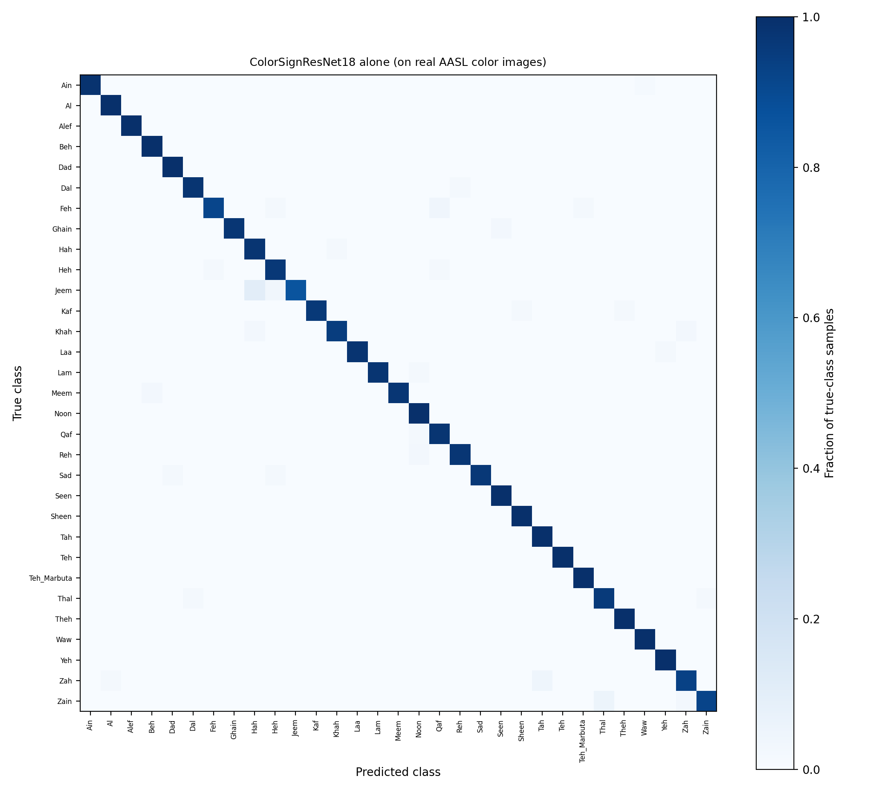
Figure 12. ColorSignResNet18 confusion matrix on the same 1,571 real AASL validation images used for the end-to-end fusion evaluation (row-normalized). The near-uniform diagonal reflects the branch's 97.90% accuracy; residual confusion is concentrated in a small number of visually similar pairs (e.g. ج/ح, Jeem/Hah).
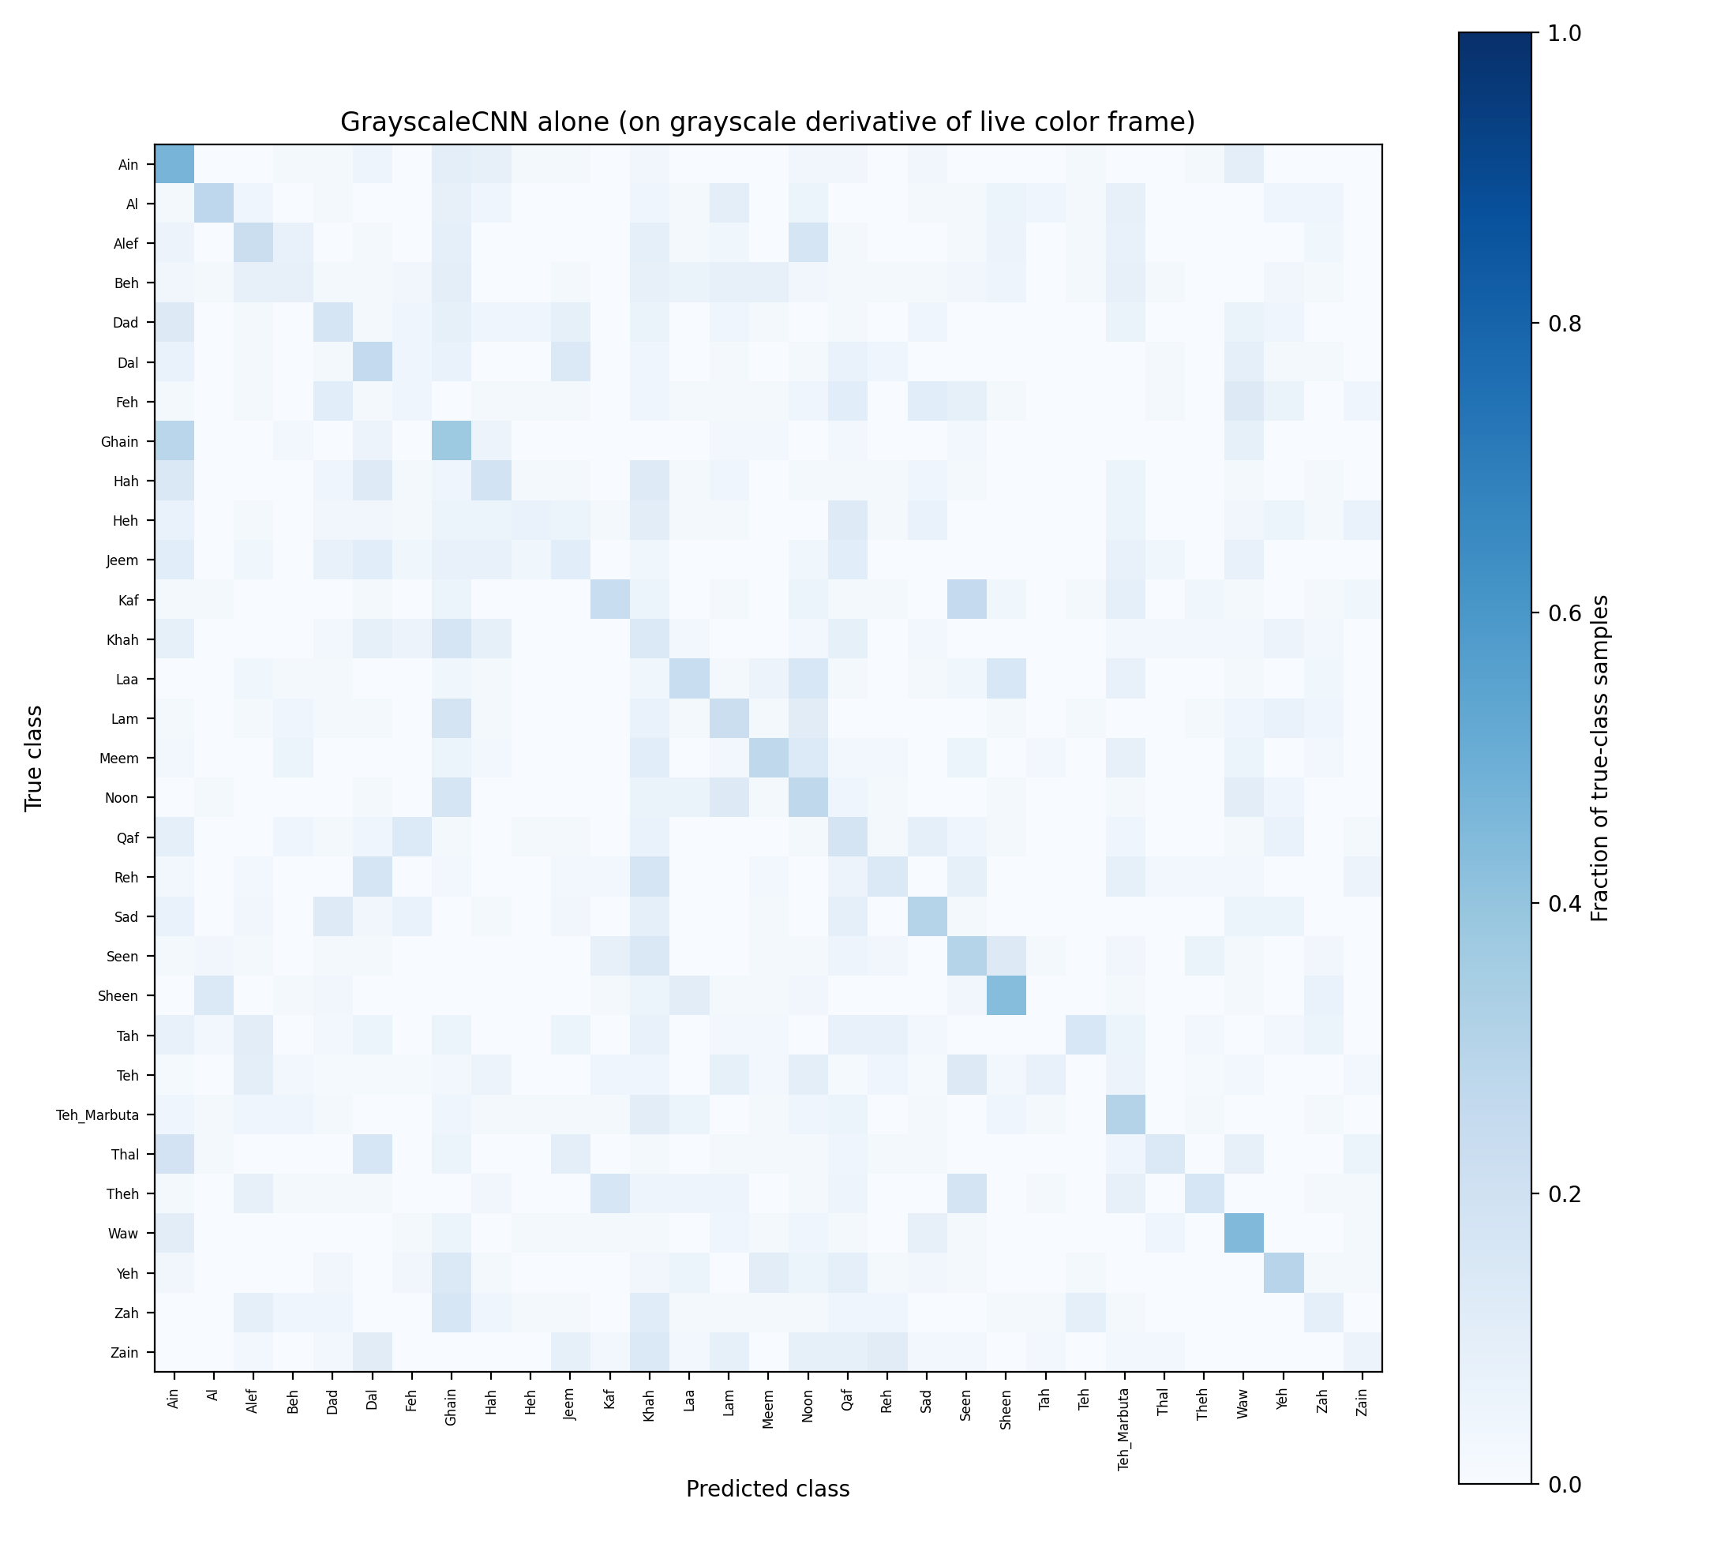
Figure 13. GrayscaleCNN confusion matrix on grayscale derivatives of the same 1,571 real AASL images (row-normalized). The absence of a clean diagonal, and the diffuse errors spread across many predicted classes rather than concentrated in a few visually similar pairs, is consistent with a genuine domain-gap failure rather than the visually-similar-letter confusion pattern seen in Figure 10 and Figure 12.
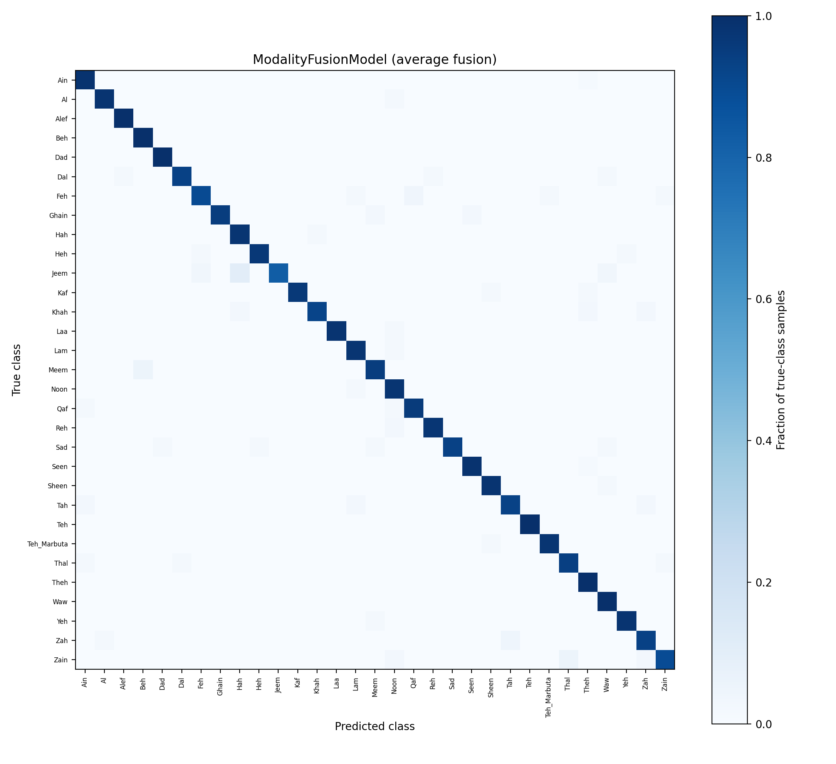
Figure 14. ModalityFusionModel (unweighted average) confusion matrix on the same 1,571 images (row-normalized). Visually close to Figure 12, with slightly more off-diagonal mass, consistent with the 96.56% fusion accuracy measured against ColorSignResNet18's 97.90% alone.
The per-class breakdown for the fusion output (macro-average F1 0.96, weighted-average F1 0.97 across the 31 classes) shows the weakest performance on ج (Jeem, F1 0.91, recall 0.83), consistent with the Jeem/Hah confusion visible in Figure 12, and no class below an F1 of 0.91 -- a substantially tighter spread than GrayscaleCNN's own weakest classes on ArASL (Section 4.4.1).

5. Deployment Plan
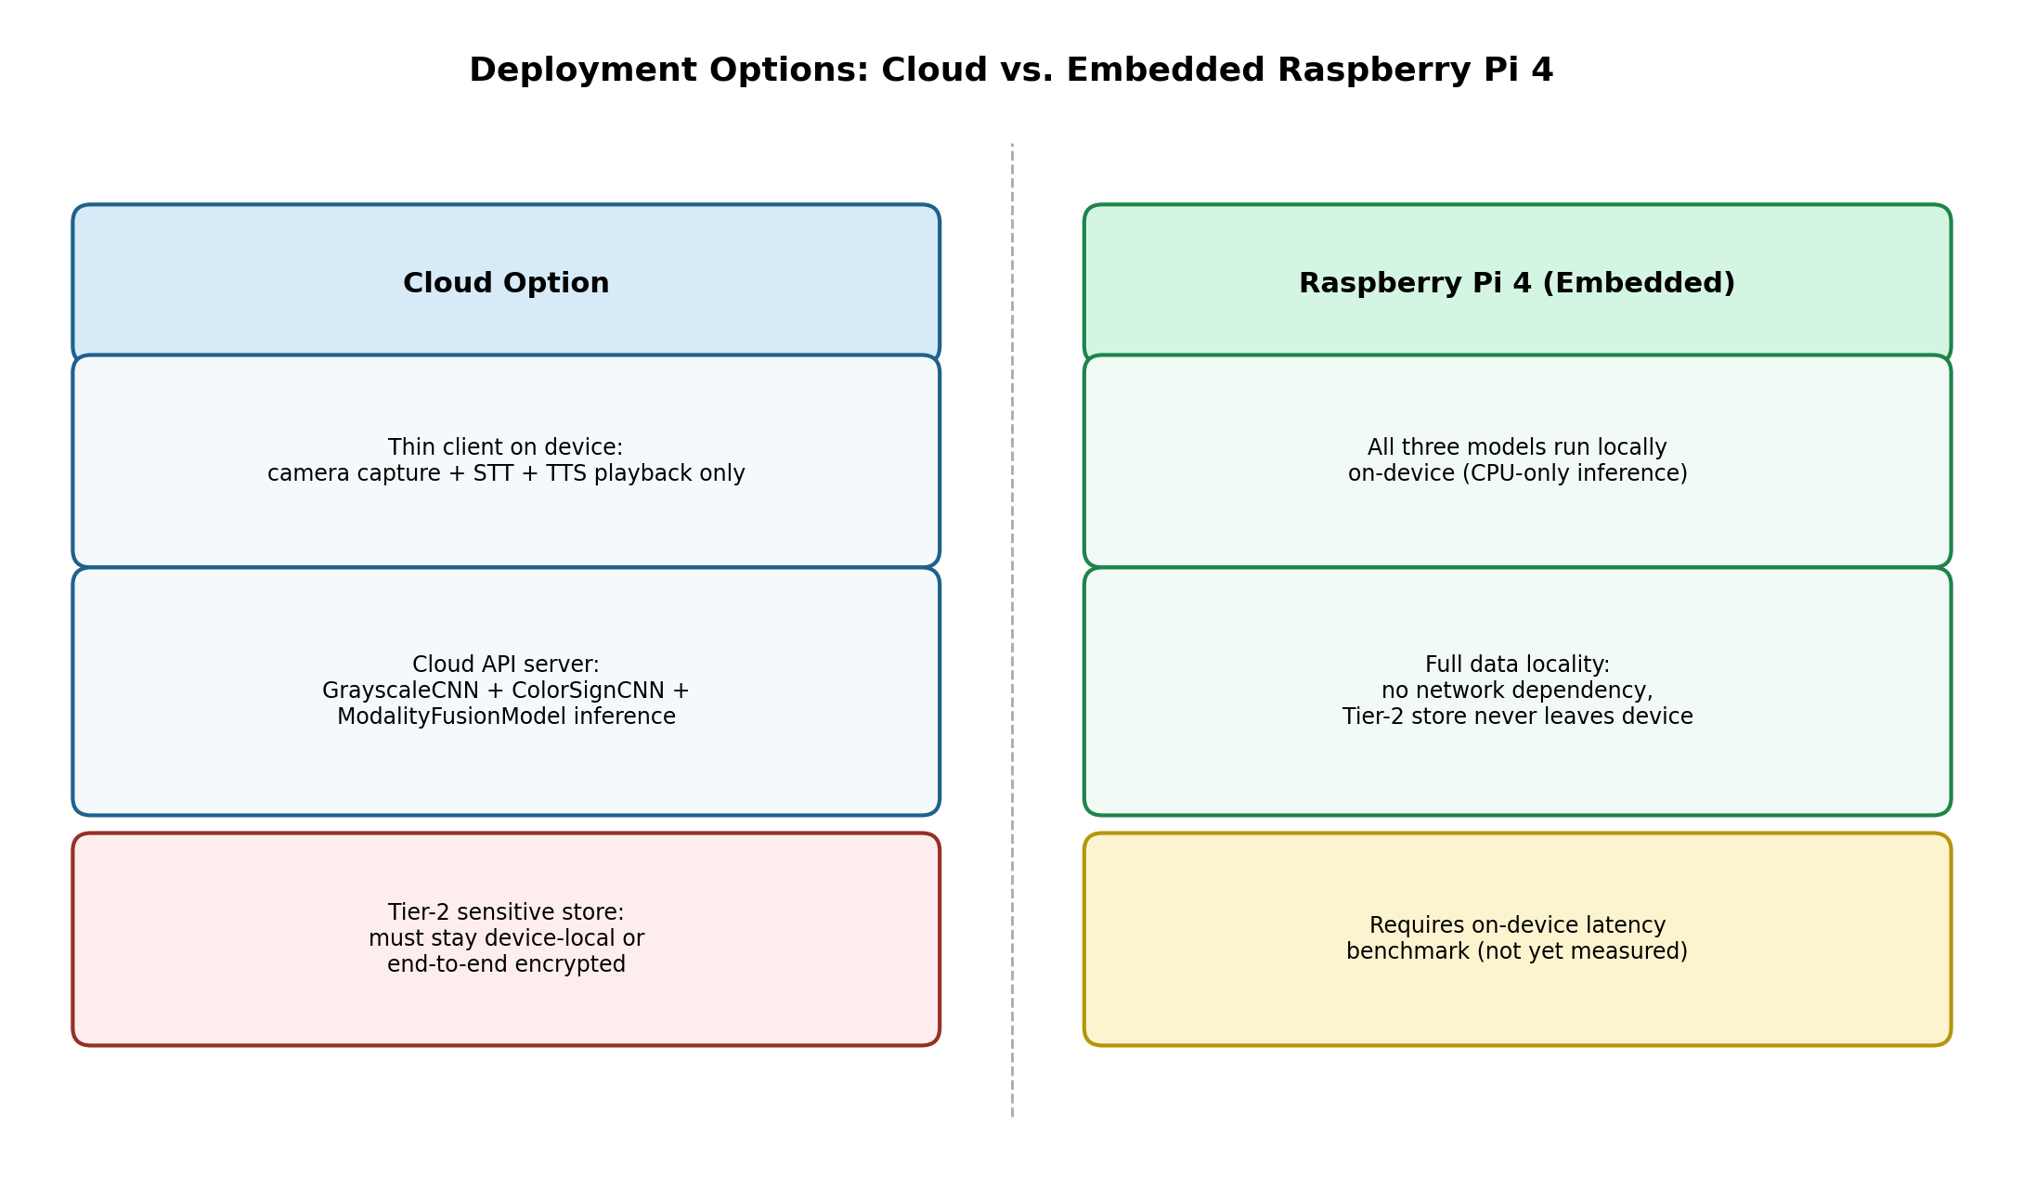
Figure 11. Comparison of the two deployment targets under consideration. The cloud option centralizes model updates but requires an explicit plan to keep Tier-2 sensitive data off the server; the Raspberry Pi 4 option preserves full data locality but requires an as-yet-unmeasured on-device latency benchmark.
Two deployment targets are under consideration for the post-prototype phase:
- Cloud-hosted inference: the three models (GrayscaleCNN, ColorSignResNet18, ModalityFusionModel) are served behind an API endpoint; a thin client on the user's device streams camera frames and STT context and receives back classification and TTS audio. This removes on-device compute constraints entirely but introduces network latency and a continuous connectivity dependency, and requires a plan for keeping the two-tier personal profile store's Tier-2 data off the cloud entirely or encrypted end-to-end such that the cloud service never has plaintext access.
- Embedded Raspberry Pi 4: all three models plus the letter-aggregation and profile-store logic run locally. This preserves full data locality (particularly important for the Tier-2 sensitive store) and requires no network connection for core functionality, at the cost of constrained CPU-only inference throughput; given GrayscaleCNN's modest parameter count (139K, Section 3.1) and despite ColorSignResNet18's substantially larger ImageNet-pretrained backbone (11.2M trainable parameters, Section 3.2), CPU-only real-time inference on a Pi 4 remains plausible for the fusion pipeline but has not yet been benchmarked, and is listed as a required next step before a final hardware decision is made -- now a higher-priority open question given the color branch's confirmed footprint.
With all three models now trained and the fusion pipeline evaluated end-to-end (Section 4.7), a final recommendation is deferred pending an explicit on-device latency benchmark on Raspberry Pi 4 hardware for the full three-model pipeline, scheduled for the next development phase.

6. Limitations and Future Work
- Unweighted-average fusion of the two branches (96.56% on 1,571 held-out AASL images, Section 4.7) measures slightly below the stronger color branch alone (97.90%); this is reported as a genuine finding rather than an assumption, and evaluating the two confidence-weighted fusion variants already implemented in ModalityFusionModel (Section 3.3) against this baseline is the most immediate open item.
- The grayscale branch generalizes poorly to real color images converted to grayscale (21.26% on AASL, Section 4.7) despite its strong 92.51% accuracy on ArASL's own studio-condition images (Section 4.3); this indicates a genuine domain gap between the two corpora's capture conditions rather than a weakness specific to the fusion pipeline, and closing it -- for example by fine-tuning GrayscaleCNN on grayscale-derived AASL images, or retiring the grayscale branch in favor of ColorSignResNet18 alone -- is future work.
- The live single-letter and single-word successes reported in Section 4.6.2 are from one signer (the developer) under deliberately favourable lighting and hand-positioning conditions; systematic live accuracy measurement across many trials, signers, and lighting conditions has not yet been performed.
- Hand localization currently uses a fixed, centred bounding box (Section 3.7.1) rather than genuine hand detection (e.g. via a dedicated detector such as MediaPipe); it requires the signer to position their hand manually and would need a proper detector for a hands-free, camera-agnostic deployment.
- The spelling-correction dictionary currently contains 24 words for demonstration purposes and requires replacement with a comprehensive Arabic lexicon before deployment.
- The rule for classifying a newly added personal-profile field as ordinary versus sensitive is currently a code-level default; a genuine user-facing decision interface is deferred until real-camera integration is complete.
- Track A (continuous-sentence recognition via BiLSTM) remains blocked on insufficient volume of real KArSL/ArabSign video data and has not progressed beyond pipeline validation on synthetic data.
- No participant beyond the developer has yet interacted with the live system; formal usability and accuracy evaluation with Deaf or non-verbal ArSL signers is required before any accuracy claim can be generalized beyond the offline validation split.
- Arabic text-to-speech currently depends on an active internet connection (Section 3.8); no offline Arabic voice could be made accessible from the Python/PowerShell tooling used, which is a specific concern for the Raspberry Pi deployment target of Section 5.
- Automatic idle-based end-of-word detection proved unreliable in practice, since ordinary confidence dips between consecutive letters could trigger it mid-word; a manual "finish word" control (Section 3.7.1) is now the primary mechanism, and a more robust automatic segmentation approach remains future work.

7. Conclusion
This work presents a concrete, partially-validated architecture for Arabic Sign Language assistive communication that treats grayscale and color visual modalities as genuinely distinct signal sources rather than interchangeable representations, integrates spoken dialogue context into sign-language word disambiguation, and embeds privacy-by-design principles — tiered consent, encrypted sensitive storage, and a hard prohibition on national-ID capture — directly into the system's data layer rather than as an external policy. Both static-letter branches are now real, GPU-trained, and evaluated end-to-end on real images: GrayscaleCNN reaches 92.51% validation accuracy on ArASL, ColorSignResNet18 reaches 97.90% on AASL via ImageNet transfer learning after an initial from-scratch architecture failed to learn the same data (Section 3.2), and their unweighted-average fusion reaches 96.56% on 1,571 held-out AASL images (Section 4.7) -- a genuine empirical result rather than an architectural placeholder, reported here together with the finding that simple averaging slightly underperforms the stronger branch alone, which motivates the confidence-weighted fusion identified as the immediate next step. The continuous-word (Track A) and systematic live-deployment evaluation components remain at earlier stages of completion and are the project's principal remaining work, alongside an on-device latency benchmark on the Raspberry Pi 4 deployment target.
This session additionally completed the project's first single-trial, proof-of-concept live test on the target D435 sensor -- resolving a multi-stream camera-selection issue and a training/deployment image domain gap along the way -- and restored full bilingual spoken output after diagnosing a Windows voice-architecture constraint that silently prevented Arabic speech. This is an encouraging early signal, achieved by one signer (the developer) under deliberately favorable conditions; it demonstrates that the capture-to-speech pipeline can execute end-to-end on the target hardware, but it does not by itself establish real-world accuracy, which will require the systematic, multi-signer, multi-condition evaluation identified in Section 6.

Ethics, Consent, and Data/Code Availability
The only human participant in the live testing reported in Sections 3.7.1, 4.6, and 4.6.1–4.6.2 was the developer, who is also the author of this work; no external participants, patients, or minors were involved at any stage, and no personally identifiable data beyond the author's own test values was collected or retained. Any future testing involving additional signers, as recommended in Section 6, will be conducted under an appropriate informed-consent procedure. ArASL and AASL are used under the terms specified by their respective originating publications [1, 4]; no additional personal data was collected as part of dataset preparation. The scripts listed in Section 3.9 are available from the corresponding author upon reasonable request; the authors intend to release them via a public code repository following further cleanup.

References
[1] Latif, G., Mohammad, N., Alghazo, J., AlKhalaf, R., & AlKhalaf, R. (2019). ArASL: Arabic Alphabets Sign Language Dataset. Data in Brief, 23, 103777.
[2] AlKhalaf, R., AlKhalaf, R., Latif, G., Mohammad, N., & Alghazo, J. (2018). Arabic Sign Language (ArSL) recognition system using convolutional neural network (CNN). International Journal of Pure and Applied Mathematics.
[3] Alani, A. A., & Cosma, G. (2021). ArSL-CNN: A convolutional neural network for Arabic sign language gesture recognition. Indonesian Journal of Electrical Engineering and Computer Science, 22(2).
[4] Al-Barham, M., Alsharkawi, A., Al-Yaman, M., Al-Fetyani, M., Elnagar, A., Abu SaAleek, A., & Al-Odat, M. (2023). RGB Arabic Alphabets Sign Language Dataset. arXiv:2301.11932.
[5] Sidig, A. A. I., Luqman, H., Mahmoud, S., & Mohandes, M. (2021). KArSL: Arabic sign language database. ACM Transactions on Asian and Low-Resource Language Information Processing, 20(1), 1–19.
[6] Luqman, H. (2023). ArabSign: A multi-modality dataset and benchmark for continuous Arabic sign language recognition. In Proceedings of the 2023 IEEE 17th International Conference on Automatic Face and Gesture Recognition (FG), 1–8.
[7] Abdul, W., Alsulaiman, M., Amin, S. U., Faisal, M., Muhammad, G., Albogamy, F. R., Bencherif, M. A., & Ghaleb, H. (2021). Intelligent real-time Arabic sign language classification using attention-based inception and BiLSTM. Computers & Electrical Engineering, 95, 107395.
[8] Alyami, S., Luqman, H., & Hammoudeh, M. (2023). Isolated Arabic sign language recognition using a transformer-based model and landmark keypoints. ACM Transactions on Asian and Low-Resource Language Information Processing.
[9] Balat, M., Awaad, R., Adel, H., Zaky, A. B., & Aly, S. A. (2024). Advanced Arabic alphabet sign language recognition using transfer learning and transformer models. In 2024 IEEE International Conference on Computing and Applications (ICCA); arXiv:2410.00681.
[10] Zakariah, M., Alotaibi, Y. A., Koundal, D., Guo, Y., & Elahi, M. M. (2022). Sign language recognition for Arabic alphabets using transfer learning technique. Computational Intelligence and Neuroscience, 2022, 4567989.
[11] Algethami, N., Farhud, R., Alghamdi, M., Almutairi, H., Sorani, M., & Aleisa, N. (2025). Continuous Arabic sign language recognition models. Sensors, 25(9), 2916.
[12] Noor, T. H., Noor, A., Alharbi, A. F., Faisal, A., Alrashidi, R., Alsaedi, A. S., Alharbi, G., Alsanoosy, T., & Alsaeedi, A. (2024). Real-time Arabic sign language recognition using a hybrid deep learning model. Sensors, 24(11), 3683.
[13] Zafrulla, Z., Brashear, H., Starner, T., Hamilton, H., & Presti, P. (2011). American sign language recognition with the Kinect. In Proceedings of the 13th International Conference on Multimodal Interfaces (ICMI '11), 279–286.
[14] Zhang, F., Bazarevsky, V., Vakunov, A., Tkachenka, A., Sung, G., Chang, C.-L., & Grundmann, M. (2020). MediaPipe Hands: On-device real-time hand tracking. arXiv:2006.10214.
[15] Lugaresi, C., Tang, J., Nash, H., McClanahan, C., Uboweja, E., Hays, M., Zhang, F., Chang, C.-L., Yong, M. G., Lee, J., Chang, W.-T., Hua, W., Georg, M., & Grundmann, M. (2019). MediaPipe: A framework for building perception pipelines. arXiv:1906.08172.
[16] LeCun, Y., Bottou, L., Bengio, Y., & Haffner, P. (1998). Gradient-based learning applied to document recognition. Proceedings of the IEEE, 86(11), 2278–2324.
[17] Krizhevsky, A., Sutskever, I., & Hinton, G. E. (2012). ImageNet classification with deep convolutional neural networks. Advances in Neural Information Processing Systems, 25.
[18] Hochreiter, S., & Schmidhuber, J. (1997). Long short-term memory. Neural Computation, 9(8), 1735–1780.
[19] Bahdanau, D., Cho, K., & Bengio, Y. (2015). Neural machine translation by jointly learning to align and translate. In Proceedings of the International Conference on Learning Representations (ICLR).
[20] Mohandes, M., & Deriche, M. (2013). Arabic sign language recognition by decisions fusion using Dempster–Shafer theory of evidence. In 2013 Computing, Communications and IT Applications Conference (ComComAp), 90–94.
[21] Balaha, M. M., El-Kady, S., Balaha, H. M., Salama, M., Emad, E., Hassan, M., & Saafan, M. M. (2023). A vision-based deep learning approach for independent-users Arabic sign language interpretation. Multimedia Tools and Applications, 82(5), 6807–6826.
[22] He, K., Zhang, X., Ren, S., & Sun, J. (2016). Deep residual learning for image recognition. In Proceedings of the IEEE Conference on Computer Vision and Pattern Recognition (CVPR), 770–778.

Appendix B: Script to Generate the Real Confusion Matrix
Run this in the same Colab session, after loading grayscale_simplecnn_best.pt, against the same 80/20 validation split used during training. Send the resulting confusion_matrix.png back for inclusion in Section 4.4.
import torch, numpy as np, matplotlib.pyplot as plt
from sklearn.metrics import confusion_matrix
from torch.utils.data import DataLoader, random_split
from torchvision import datasets, transforms
from image_cnn_model import SimpleCNN

tf = transforms.Compose([transforms.Resize((64,64)), transforms.ToTensor()])
full = datasets.ImageFolder('/content/ArASL', transform=tf)
val_size = int(len(full)*0.2); train_size = len(full)-val_size
_, val_ds = random_split(full, [train_size, val_size], generator=torch.Generator().manual_seed(42))
loader = DataLoader(val_ds, batch_size=64)

ckpt = torch.load('grayscale_simplecnn_best.pt', map_location='cpu')
model = SimpleCNN(num_classes=len(ckpt['classes']), input_size=ckpt['input_size'])
model.load_state_dict(ckpt['model_state_dict']); model.eval()

all_preds, all_labels = [], []
with torch.no_grad():
for x, y in loader:
preds = model(x).argmax(1)
all_preds.extend(preds.tolist()); all_labels.extend(y.tolist())

cm = confusion_matrix(all_labels, all_preds)
fig, ax = plt.subplots(figsize=(12,12))
im = ax.imshow(cm, cmap='Blues')
ax.set_xticks(range(len(ckpt['classes']))); ax.set_xticklabels(ckpt['classes'], rotation=90, fontsize=6)
ax.set_yticks(range(len(ckpt['classes']))); ax.set_yticklabels(ckpt['classes'], fontsize=6)
ax.set_xlabel('Predicted'); ax.set_ylabel('True'); ax.set_title('GrayscaleCNN Confusion Matrix (validation set)')
plt.colorbar(im); plt.tight_layout(); plt.savefig('confusion_matrix.png', dpi=200)
print('saved confusion_matrix.png')

Appendix C: Full Per-Class Classification Report (GrayscaleCNN, Validation Set)
Produced by generate_confusion_matrix.py (Section 4.4) alongside confusion_matrix.png, evaluated against the same held-out validation split used to measure the headline accuracy figures throughout this paper. Classes are labelled here by their raw ArASL folder name rather than the Arabic letter (a bidirectional-text rendering limitation in this monospace table, not a data issue); see Figure 10 or arasl_letter_map.py for the folder-to-letter mapping.
val_acc: 0.9215

precision recall f1-score support

ain 0.97 0.98 0.97 425
al 0.95 0.98 0.97 260
aleff 0.94 0.94 0.94 321
bb 0.95 0.95 0.95 346
dal 0.92 0.94 0.93 320
dha 0.92 0.93 0.93 344
dhad 0.97 0.94 0.95 338
fa 0.84 0.89 0.86 408
gaaf 0.75 0.66 0.70 323
ghain 0.95 0.96 0.95 396
ha 0.84 0.86 0.85 342
haa 0.80 0.88 0.84 290
jeem 0.89 0.82 0.86 290
kaaf 0.93 0.85 0.89 350
khaa 0.76 0.83 0.79 332
la 0.98 0.98 0.98 357
laam 0.97 0.98 0.98 359
meem 0.97 0.96 0.96 342
nun 0.99 0.96 0.97 368
ra 0.95 0.93 0.94 346
saad 0.92 0.95 0.93 388
seen 0.90 0.97 0.93 349
sheen 0.97 0.98 0.97 304
ta 0.95 0.90 0.92 366
taa 0.97 0.93 0.95 368
thaa 0.88 0.94 0.90 361
thal 0.87 0.91 0.89 306
toot 0.96 0.92 0.94 354
waw 0.97 0.93 0.95 311
ya 0.95 0.94 0.95 329
yaa 0.98 0.97 0.97 252
zay 0.95 0.91 0.93 264

accuracy 0.92 10809
macro avg 0.92 0.92 0.92 10809
weighted avg 0.92 0.92 0.92 10809

