Short User Guide
Personal Assistant for Arabic Sign Language
This is the English companion version of the original Arabic booklet (user_booklet_ar.docx), included for developers and reviewers browsing this repository. The actual end user of the device — a non-verbal Arabic Sign Language signer — should be given the Arabic version, since that matches the language they and their interlocutors actually speak.

1. What is this device?
This device helps you communicate with anyone around you without needing an interpreter. You show your sign in front of the camera, the device understands it, forms it into a word, and speaks it aloud to the other person.
The device uses a camera to watch your hand, and makes use of what the other person says (which it hears) to understand your signing more accurately — especially when more than one word could match the same letters.
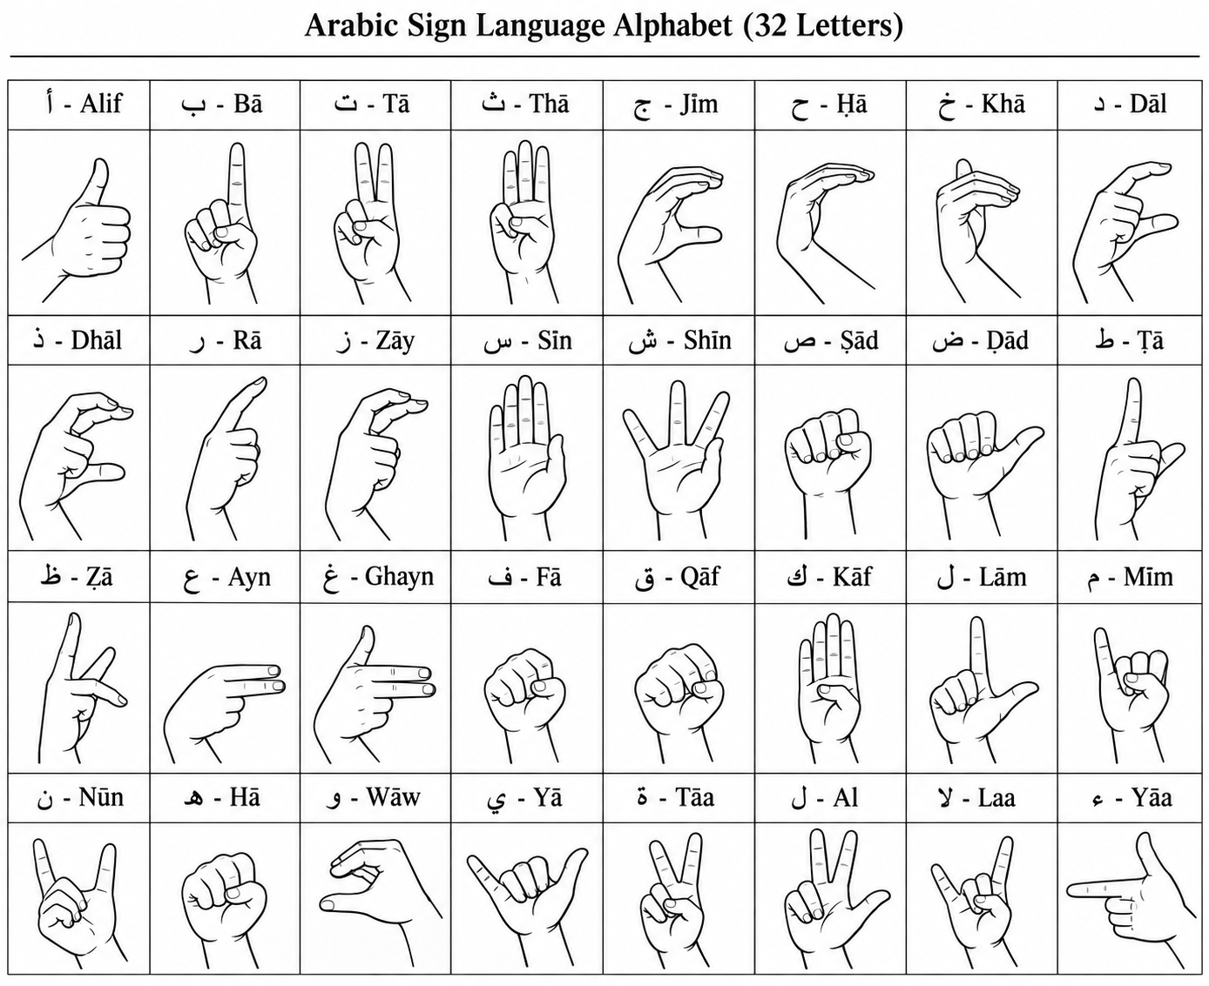
The Arabic Sign Language alphabet — the 32 letters the device recognizes

2. Before you start
- Make sure the lighting around you is good — not too dark, and no strong light directly behind you.
- Keep your hand clearly visible in front of the camera, about one meter away, with no other moving objects behind you.
- Try simple signs (single letters) first before forming full words, to get a feel for how the device responds.
Important note: the device's accuracy depends on how precisely you perform the sign itself, in the standard way. If a sign is unclear or performed slightly differently, it may be misunderstood.
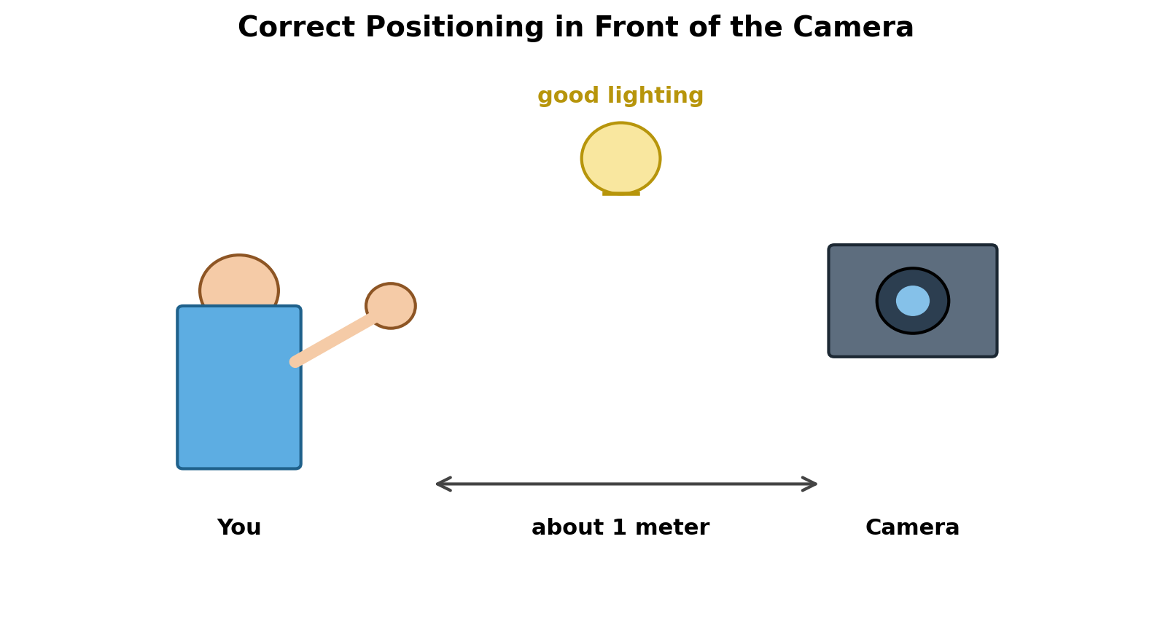
Correct positioning: a reasonable distance and good lighting

3. How to form a word
Show each letter for one or two seconds, keeping your hand in a clear, steady position. The device gathers the letters automatically. When you finish the word, lower your hand for a few seconds — this tells the device the word is complete and ready to be spoken.
If you need to repeat the same letter twice in a row within the same word (like the double lām in "الله"), make sure to raise your hand briefly between the two letters before repeating the same sign, so the device understands it as two separate letters.

4. When someone asks you for information about yourself
If the other person asks a normal question (such as "What's your name?" or "How old are you?"), the device shows you a confirmation message on screen before answering, such as:
"The person is asking for your name: Husham. Share it?"
If you agree, perform the normal 'Yes' gesture, and the device speaks the answer aloud immediately. If you don't perform any gesture, or perform a decline gesture, the device says nothing.

5. Sensitive information — an extra safeguard
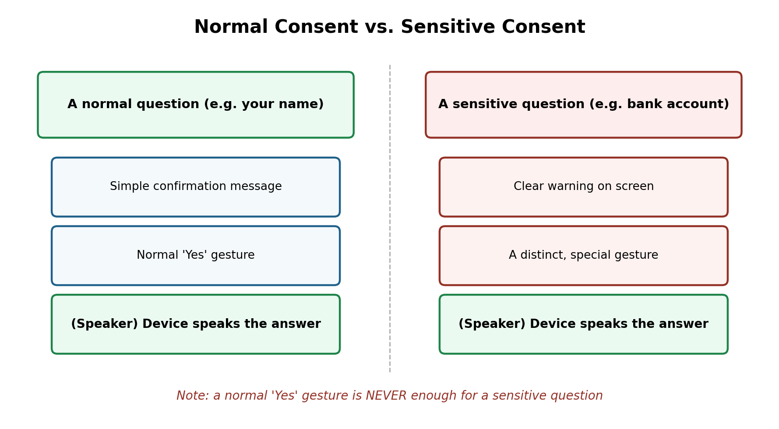
The difference between normal consent and sensitive consent
If the other person asks about sensitive information (such as your bank account or medical condition), the device will never answer with just a normal 'Yes' gesture. It will specifically ask for a different, harder-to-repeat-by-accident gesture called the "Sensitive Consent Gesture".
This is intentional: so nothing sensitive about you is revealed by mistake or in haste. You must perform this special gesture fully consciously every time.
Your sensitive information is stored fully encrypted, completely separate from the rest of the device's data, and no part of the system can access it except after your explicit consent at that exact moment.
Important: this device never stores your national ID number under any circumstance, even if you try to enter it yourself — this is a fixed security decision built into the device's design.

6. Common problems and solutions
- The device isn't responding to your signs: make sure your hand fully appears in the camera and there is enough light.
- Results are wrong repeatedly: check that you are performing the exact correct hand shape for the intended letter (small details like fingers together vs. apart make a difference).
- The screen is completely black and no video appears: this is usually a camera-hardware issue — make sure there's no cover on the lens, and restart the device.
- No sound plays after consent: make sure the speaker is connected and its volume is turned up.

7. A reminder
This device is an assistive tool, and its accuracy improves over time. If you notice repeated errors or have a suggestion, please record it so it can be used to improve the device later.

