Voiceprint-guided three-dimensional acoustic localization of drones with a six-microphone rigid spherical array: rotor silence windows and reference subtraction
Husham Saied^{a,*}
ªPrince Sultan Military College of Health Sciences, Dhahran, Saudi Arabia
*Corresponding author. E-mail: hushamfarouk@gmail.com

Abstract
We study three-dimensional acoustic localization of drones with a 160 mm rigid sphere carrying six microphones on its poles, in simulation and with real single-channel drone recordings propagated synthetically to the array. The simulator models rigid-sphere scattering, ISO 9613-1 absorption, distributed rotor noise, rotor spin-down and hardware errors. In an active mode the target emits a 3–6 kHz chirp; with 0.2 s rotor silence windows, matched filtering and sphere-steered SRP-PHAT, 25/30 closed-loop approaches from 80 m succeeded, against 0/30 with motors running and 8/30 with an ego-noise reference canceller; an optimistic coherent-rotor model raises the last figure to 29/30, so whether the windows are needed depends on a measurable reference coherence. In a passive mode a station locates the arriving drone from its own rotor noise: reference subtraction, a blade-passing-frequency drone-type signature and sphere-steered, harmonic-weighted SRP-PHAT gave a median direction error of 1.13° over 30 randomized approaches. Leakage-free evaluation lowered signature accuracy from 98% (random split) to 94% (by recording) and, on real clips, to 72% across recording campaigns. On real drone-embedded recordings (DREGON, eight-microphone array, free flight at signal-to-noise ratios near −12 dB), the same steered-response-power estimator with subtraction of the average noise cross-spectra located a broadband loudspeaker within 10° in 182/217 segments (median 3.4°), whereas in-flight speech was not localized. Validation of the spherical sensor itself is in progress.
Keywords: Drone audition; Sound source localization; Spherical microphone array; SRP-PHAT; Ego-noise; Reference cancellation

1. Introduction
Multirotor drones used for weather monitoring are limited by battery capacity, and landing to replace the battery interrupts the measurement series. Two remedies motivate this work: a supply drone that reaches the monitoring drone in the air to exchange its battery, and a ground battery-swap station that guides an arriving drone to land. Both require locating the other drone in three dimensions without relying on visual contact.
Acoustic localization from and around drones is difficult because rotor ego-noise is close to the microphones and much louder than distant sounds [6]–[11], and because a station places the microphones next to transformers, fans and actuators whose tones overlap the drone band. Recent work combines drone-embedded arrays with ego-noise reduction and validates on real recordings [9], [10], [14]–[18]; a 2025 review counts 49 such studies [19].
This paper studies a six-microphone spherical sensor for this problem under deliberately realistic assumptions: it (i) models the sensor as a rigid sphere with hardware errors instead of a free-field array, (ii) compares rotor silence windows against matched-filter detection, known-RPM harmonic notching and reference ego-noise cancellation, and (iii) evaluates every learned component without data leakage. The contributions, stated element by element, are:
- Periodic in-flight rotor silence windows (0.2 s every 2 s with a compensating pre-climb) for a cooperative acoustic beacon, with a spin-down and energy model, and a quantitative map of the ego-noise conditions in which they are needed versus reference cancellation.
- A voiceprint-guided 3D sound meter: SRP-PHAT steered with the rigid-sphere response and weighted by the harmonic comb of the drone's blade-passing frequency (BPF), with refinement that removes the grid floor, and range from the calibrated harmonic level.
- An analysis of reference subtraction at a station (acoustic and vibration references, fixed, gated-adaptive and re-calibrated filters) under wind, moving machinery, sensor drift and target leakage.
- Hardware requirements derived from simulation (common sampling clock, sub-millimetre microphone positioning) and open tools for validation on real array recordings, applied here to the in-flight recordings of DREGON [12] (Section 7.6) and usable with SP Cup 2019 [13] or the physical sensor, with code and data archived [40], [41].
Section 2 reviews related work, Section 3 the sensor model, Sections 4–5 the two modes, Section 6 the data and setup, Section 7 the results, including real drone-embedded recordings, and Section 8 the discussion and the remaining validation.

2. Related work and novelty
Localization with arrays. GCC-PHAT [1] and its steered-response-power extension SRP-PHAT [3] are the standard time-difference estimators; subspace methods such as MUSIC [2] trade complexity for resolution. Robot audition systems [4], [5] brought these methods to mobile platforms, and spherical arrays are usually modeled with rigid-sphere scattering [27].
Drone-embedded audition. Basiri et al. [6] localized emergency signals from micro air vehicles; Furukawa et al. [7] estimated ego-noise correlation matrices; Wang and Cavallaro reduced ego-noise with time-frequency spatial filtering [8], [9] and sensed acoustic sources from a multirotor [10]; Hioka et al. [11] enhanced speech with a UAV-mounted array. Salvati et al. [14] used a 19-microphone spherical array on a drone to localize a flying target drone with spherical-harmonic diagonal-unloading beamforming and ego-noise reduction, on real recordings — the closest prior work to our sensor. Manamperi et al. [15] modeled drone-related transfer functions and subtracted the noise angular spectrum; Hoshiba et al. [16] proposed a MUSIC histogram method with outdoor recordings; Wu et al. [18] combined beamforming and deep filtering and validated on DREGON [12]. DREGON and the SP Cup 2019 [12], [13] provide real drone-embedded recordings with ground truth.
Reference-based ego-noise reduction. Adaptive noise cancelling [21] and spectral subtraction [20] are the foundations. Tengan et al. [17] placed reference microphones near the propellers and used a prior-knowledge multichannel Wiener filter; a patent describes Wiener cancellation driven by rotor RPM sensors [36]. Our station canceller is the same least-squares idea with acoustic and vibration references; the contribution claimed here is the analysis of when each reference and each adaptation policy works, not the filter itself.
Silencing the source. Turning motors off to improve acoustic SNR has been described for an inspection drone after landing [37]. We did not find periodic in-flight silence windows on a multirotor.
Acoustic drone recognition. BPF and harmonic signatures are well established [22]–[26]; Shulman [25] released an open pipeline with BPF estimation, GCC/SRP-PHAT and tracking and documented session-level leakage in the DroneAudioDataset [22], which we also observe. We use the BPF signature mainly to weight localization; the term "voiceprint" denotes a drone-type signature, not the identity of an individual unit (Section 7.6).

3. Spherical sensor and signal model
Six microphones sit at ±x, ±y and ±z on a rigid sphere of radius r = 80 mm (Fig. 1a). A capsule with directivity α has the free-field gain
$g(θ)=(1−α)+α\frac{1+cos θ}{2}$ (1)
where θ is the angle between its axis and the source. On the rigid body the pressure at a surface microphone for a plane wave arriving at angle Θ from its normal is given by Rayleigh's series [27]
H(ka,Θ)=1(ka)2n=0∞in+1(2n+1)Pn(cos Θ)hn′(ka) (2)
normalized to the free-field pressure at the centre, with k the wavenumber, P_{n} Legendre polynomials and h_{n}′ the derivative of the spherical Hankel function. Eq. (2) produces up to +6 dB on the illuminated side and a frequency-dependent shadow (Fig. 1b), and it lengthens the opposite-pair delay from the free-field value 2r/c = 0.47 ms to between the low-frequency limit 3r/c and the high-frequency limit (r/c)(π/2 + 1) ≈ 0.60 ms (Fig. 4). The array signals are modeled as
$y_{m}(t)=\sum_{s}{g_{m} {(h}_{m,s}∗x_{s})((1+ε_{m})(t−τ_{m}))}+n_{m}(t)$ (3)
where h_{m,s} contains delay, spreading, absorption and Eq. (2) evaluated at the true (perturbed) microphone position, and the hardware errors are the gain g_{m}, timing offset τ_{m} and clock skew ε_{m} of channel m. The sensor housing is a two-part print with a hollow mounting stem (Fig. 2); Fig. 3 shows the pickup lobes of cardioid capsules.
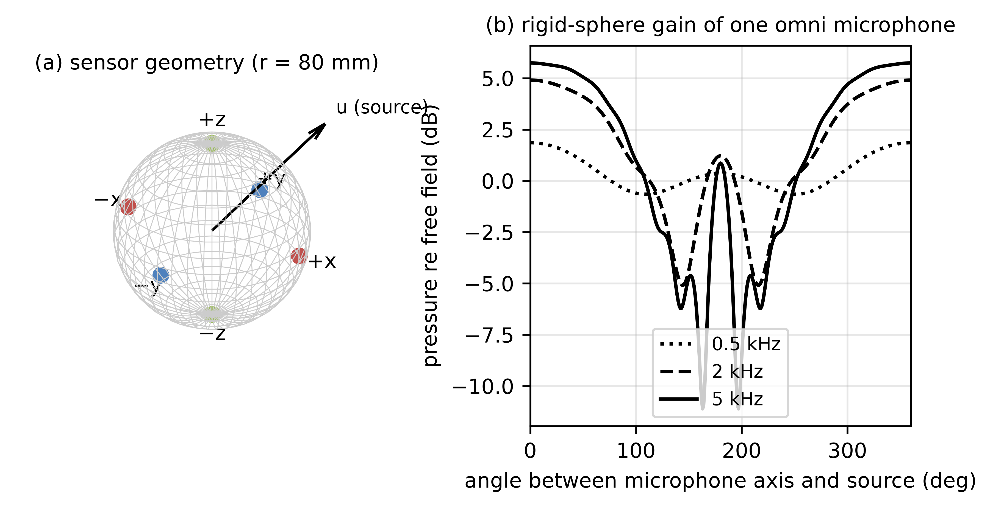
Fig. 1. (a) Sensor geometry; (b) gain of one omnidirectional microphone on the rigid sphere versus angle at 0.5, 2 and 5 kHz, Eq. (2).
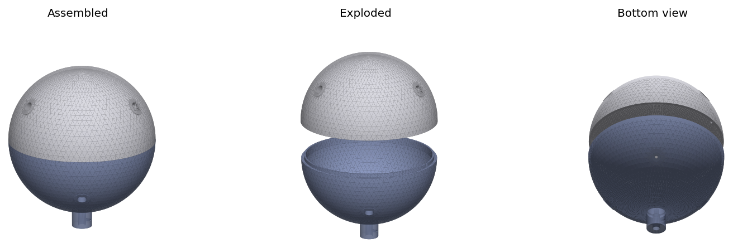
Fig. 2. Sensor housing (D = 160 mm): assembled, exploded (two hemispheres) and bottom view with the mounting stem. CAD renders by the author.
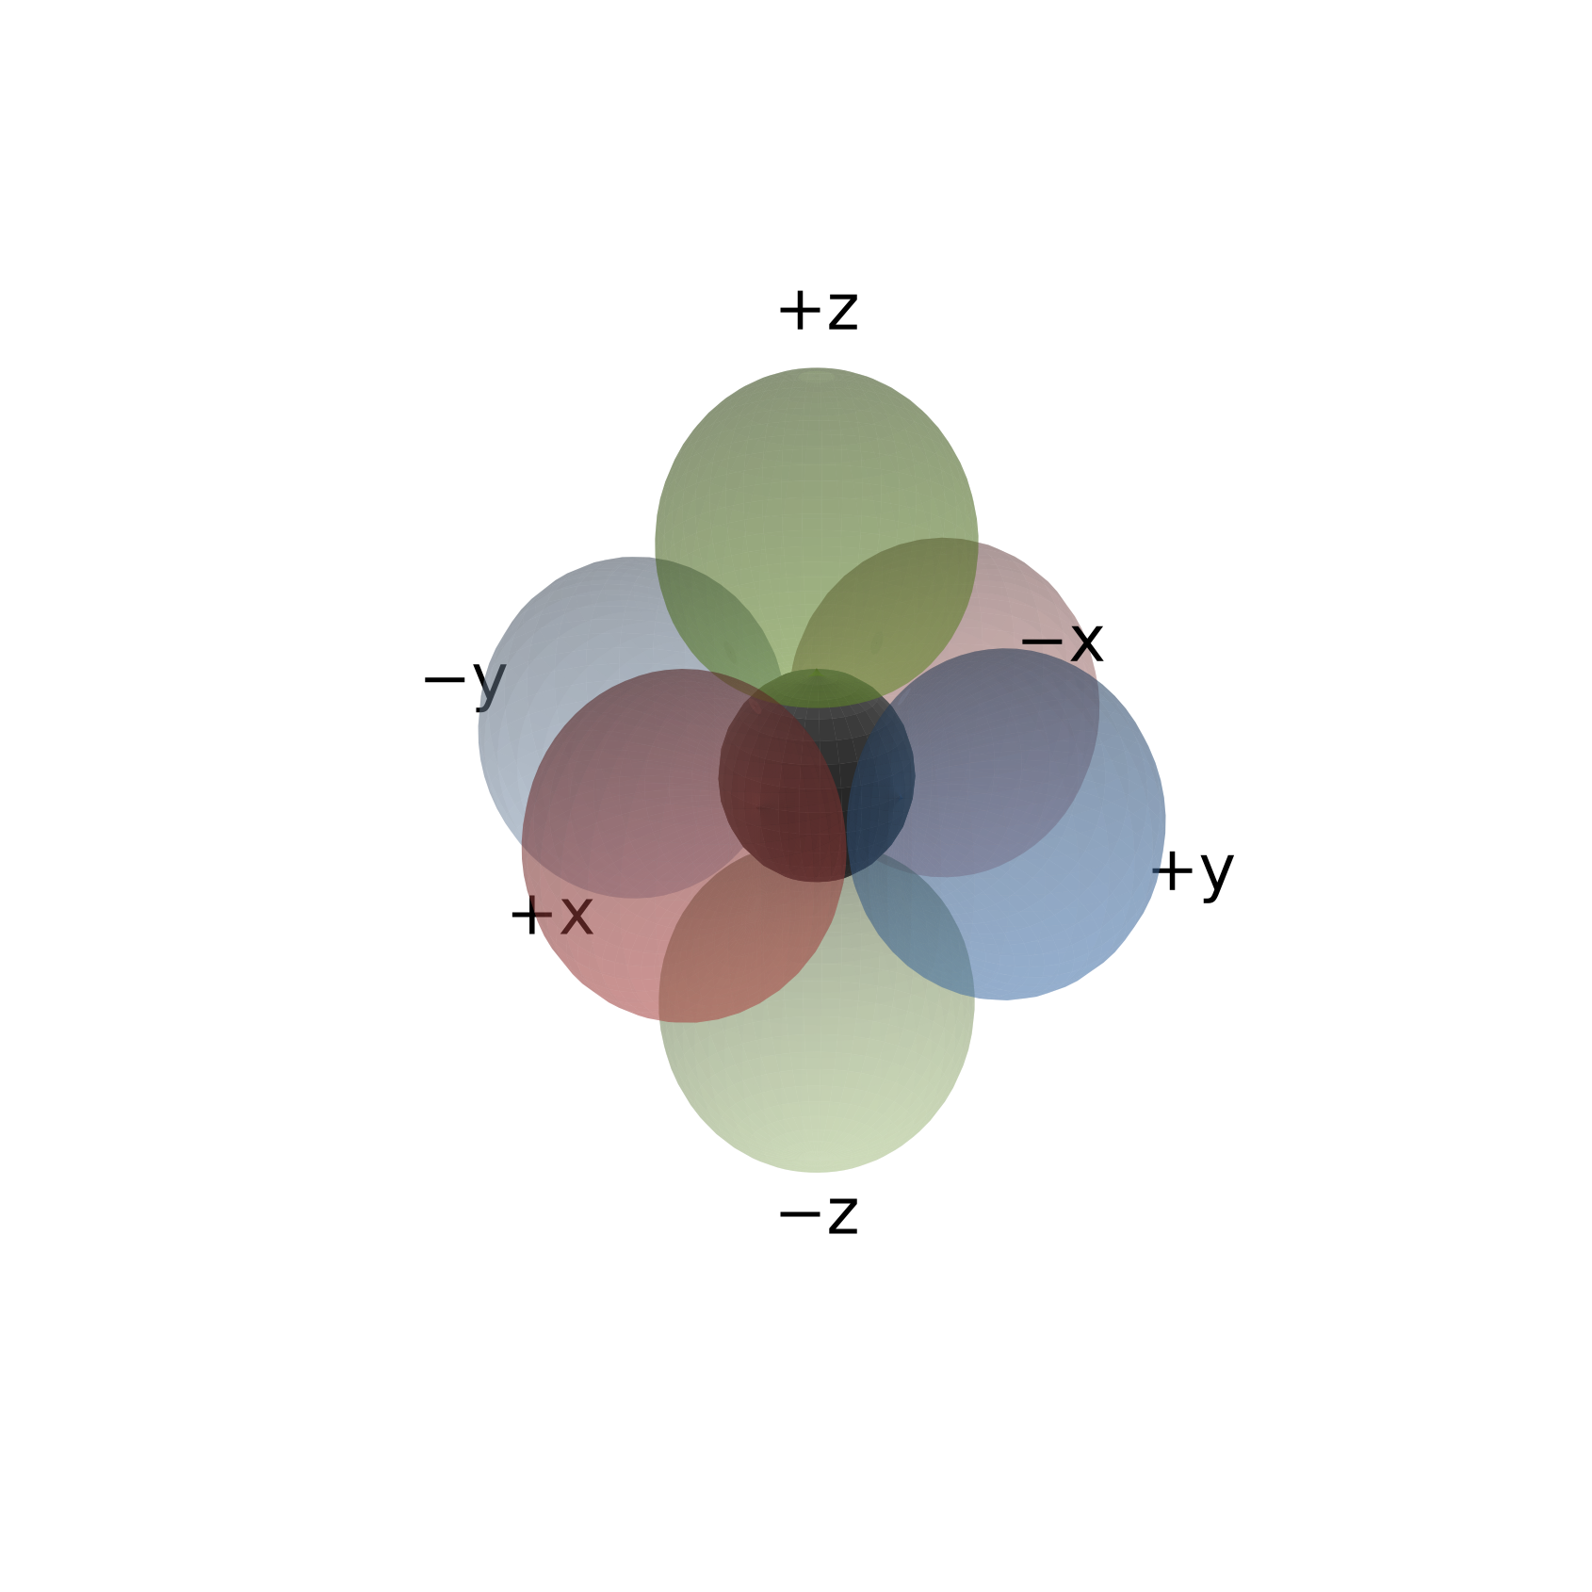
Fig. 3. Cardioid pickup lobes of the six capsules; opposite pairs share a hue.
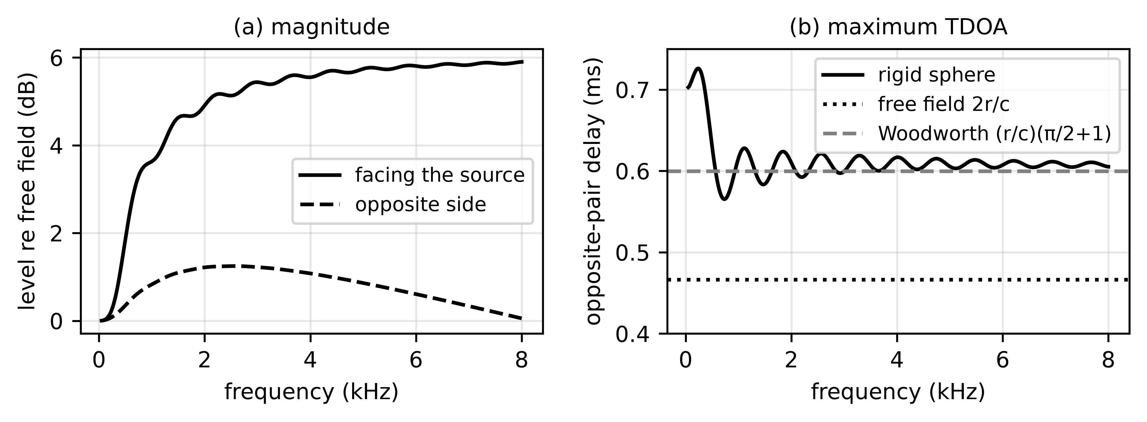
Fig. 4. Rigid-sphere effect on (a) the level at the facing and opposite microphones and (b) the maximum opposite-pair delay, compared with the free-field value and the Woodworth approximation.

4. Active mode: beacon homing
The supply drone carries the sphere on a 0.30 m mast above its four rotors and listens for a cooperative beacon on the monitoring drone (Fig. 5a). The beacon is a 50 ms linear chirp from 3 to 6 kHz, repeated continuously, with a design source level L_{b} = 100 dB SPL at 1 m. The received level at distance d is
$L(f,d)=L_{b}−20 \log_{10}d−α(f) d$ (4)
with α(f) the ISO 9613-1 absorption coefficient [28] (0.018, 0.037 and 0.062 dB/m at 3, 4.5 and 6 kHz for 20 °C and 50% relative humidity). The monitoring drone's own rotor noise arrives from the same direction and is included.
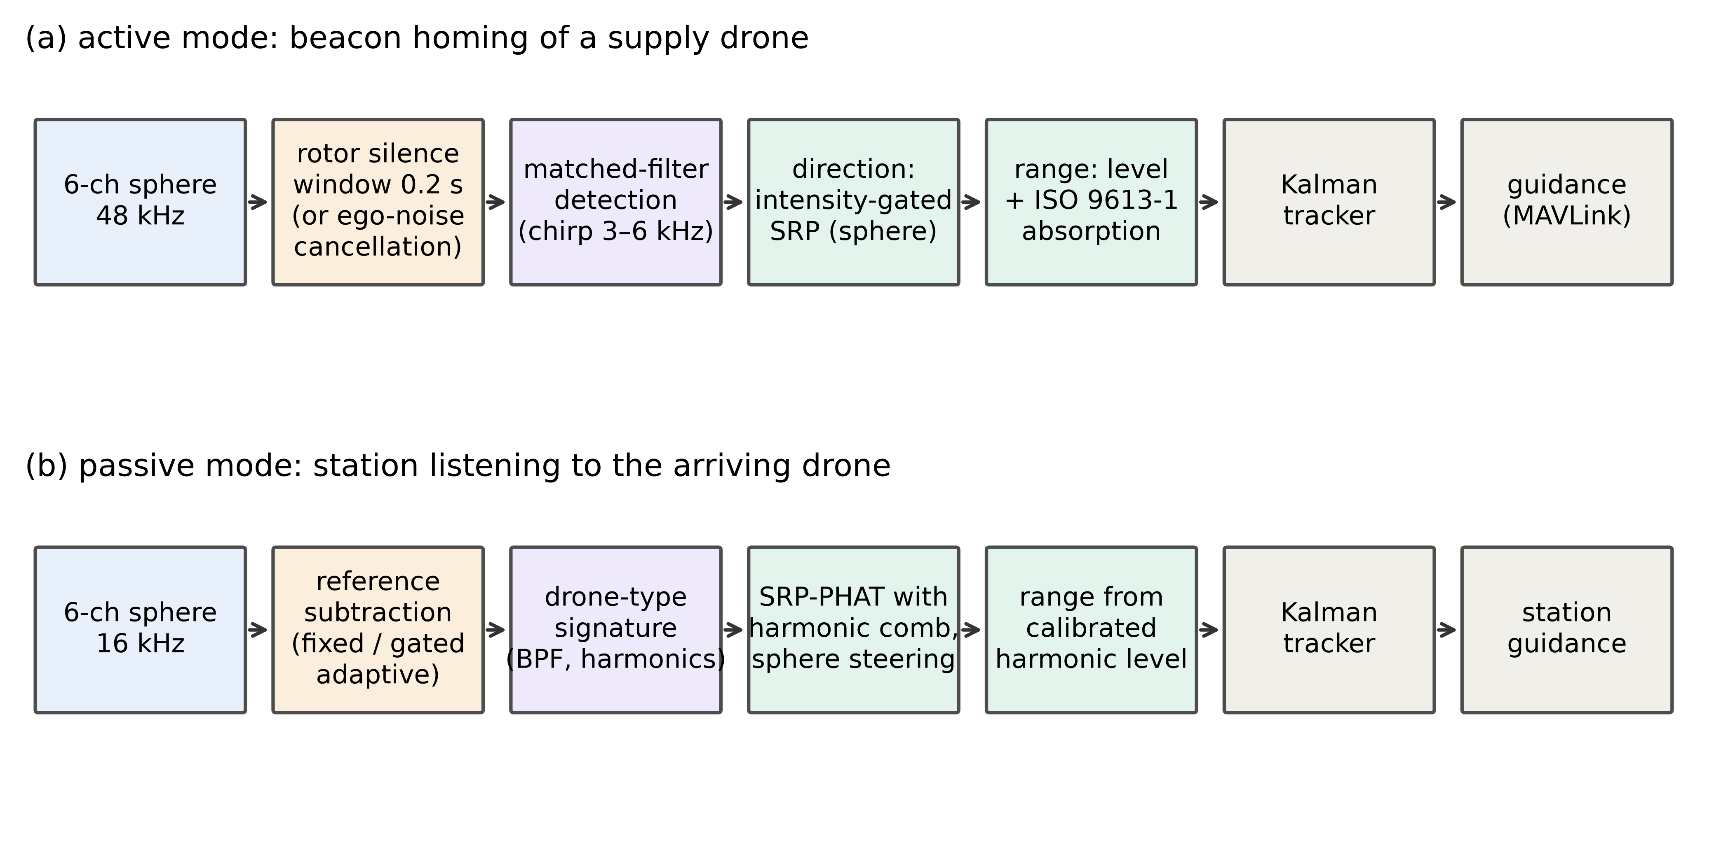
Fig. 5. Processing chains of (a) the active and (b) the passive mode.

4.1. Silence windows: dynamics and energy
Every 2 s the drone pre-climbs for 0.3 s at 1.5 m/s, brakes its rotors actively for 0.1 s and listens for 0.2 s (Fig. 6). With rotor inertia I, hover speed ω₀ and braking torque τ_{b}, the rotor stops after t_{stop} = I ω₀/τ_{b}, and the rotor noise amplitude is taken proportional to (ω/ω₀)^{2.5}:
$ω(t)=ω_{0} max(0, 1−t/t_{stop})$ (5)
The energy overhead of one cycle, relative to hover power P_{h} = (mg)^{3/2}/(FM √(2ρA)), is
$ΔE=\frac{4·½ I ω_{0}^{2}}{η_{m}}+\frac{½ m v_{r}^{2}}{FM}+\frac{m g Δh}{FM}−P_{h}{ t}_{off}$ (6)
where v_{r} is the vertical speed when thrust returns, Δh the pre-climb height and t_{off} = 0.3 s the unpowered time. Table 6 evaluates the model for a 3 kg quadrotor with 15-inch propellers; I and τ_{b} are design values to be measured on the bench (Section 8).
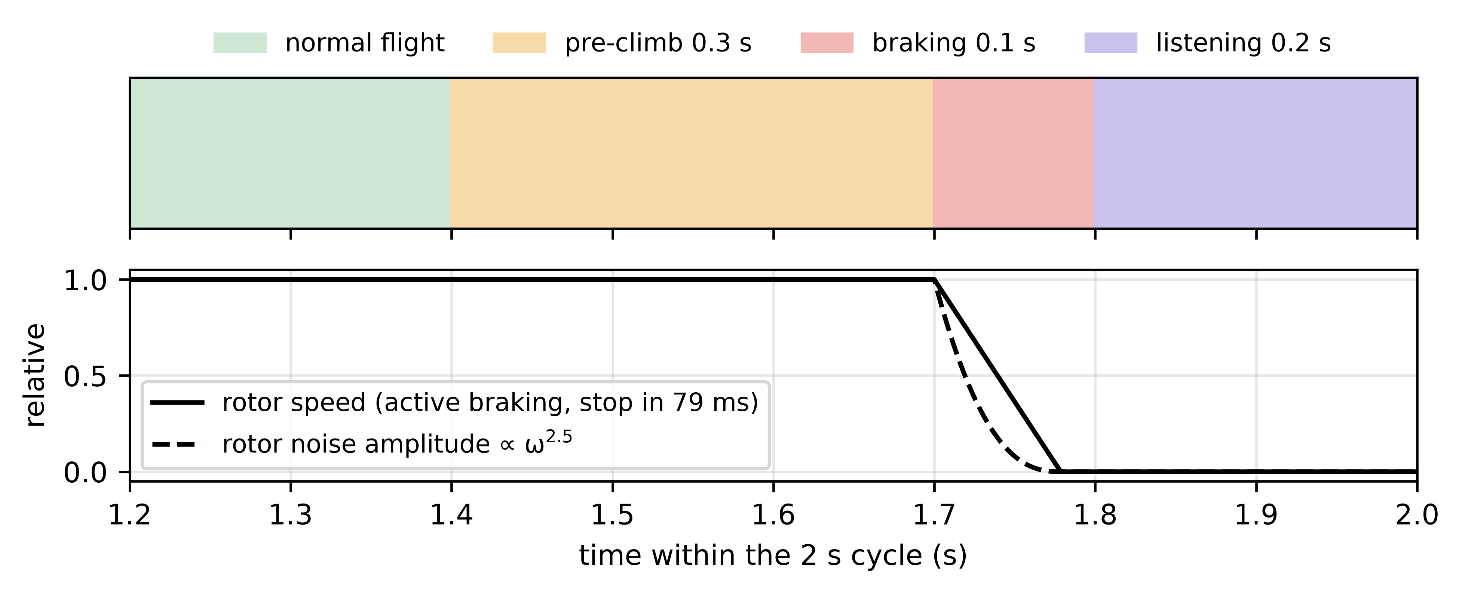
Fig. 6. Listening cycle: phases within the 2 s cycle and rotor speed with active braking; the noise amplitude follows (ω/ω₀)^{2.5}.

4.2. Detection, ego-noise suppression and direction
Detectors. The baseline band-energy detector compares the 3–6 kHz band with a beacon-free 7–10 kHz band (threshold 6 dB). The matched filter correlates each channel with the known chirp and uses
$Λ=\frac{\max_{τ}\sum_{m}{|(y_{m}⋆c)(τ)|^{2}}}{median (_{τ}·)}$ (7)
with the threshold set for a false-alarm probability of 1% from beacon-free windows of the same condition. Ego-noise suppression with motors running uses either a notch at every multiple of each rotor's shaft rate, with the RPM taken from ESC telemetry, or a least-squares reference canceller (Eq. (10)) driven by four microphones placed 5 cm below the rotors and trained on a beacon-free flight segment. Rotor noise model. Each rotor radiates its tonal part from the hub and its broadband turbulence from six independent points on a 0.15 m ring; a coherent point-source variant is used as an optimistic bound.
Direction estimators. The six-pair intensity vector is
$v_{I}=[E(+x)−E(−x), E(+y)−E(−y), E(+z)−E(−z)]$ (8)
and the opposite-pair GCC-PHAT vector uses the free-field mapping s_{x} = −cΔτ_{x}/(2r). They are fused either with heuristic fixed weights (0.4/0.6) or by inverse-variance weighting,
$u=\frac{û_{I}/σ_{I}^{2}+û_{T}/σ_{T}^{2}}{‖û_{I}/σ_{I}^{2}+û_{T}/σ_{T}^{2}‖}$ (9)
with σ_{I}, σ_{T} the RMS errors of each estimator calibrated offline as functions of the matched-filter SNR. The proposed estimator is SRP-PHAT with rigid-sphere steering (Eq. (16)); an intensity-gated variant restricts its search to 40° around v_{I}. Range follows from the in-band energy relative to its 1 m calibration, solving Eq. (4) including absorption. Tracking and guidance follow Section 5.4.

5. Passive mode: voiceprint-guided localization at a station

5.1. Reference subtraction
At the station the interference is observed by R reference sensors x_{r}: an acoustic microphone 7 cm from the machinery and a vibration sensor on its frame, all sampled on the same clock as the array. From a drone-free calibration window the canceller learns, per frequency, the least-squares transfer (M × R)
$H(f)=R_{yx}(f){(R_{xx}(f)+λI)}^{−1}$ (10)
$E(f,t)=Y(f,t)−H(f) X(f,t)$ (11)
where R_{yx} (M × R) and R_{xx} (R × R) are cross- and auto-spectral matrices from a 2048-point STFT with 512-sample hop at 16 kHz (7.8 Hz resolution) and λ is a diagonal loading of 10⁻³ of the mean reference power. A gated adaptive variant tracks slow changes with a normalized LMS update [39]
$W←W+μ \frac{e x^{H}}{{‖x‖}^{2}+δ_{f}}, only if {‖x‖}^{2}≥κ P_{cal}(f)$ (12)
with μ = 0.2, δ_{f} = P_{cal}(f) and κ = 0.1: a bin adapts only while its references are dominated by the interference they were installed to observe. A re-calibration policy instead re-fits Eq. (10) whenever the drone-type signature reports no drone.

5.2. Drone-type signature ("voiceprint")
The fundamental of a multirotor signature is the blade-passing frequency
$BPF=\frac{RPM}{60}·B$ (13)
with B blades. It is estimated by a harmonic sum,
f̂0=arg maxf0k=1Kwk log(1+P(k f0)P̃) (14)
with K = 8, w_{k} = 1 − 0.03k, P̃ the median spectral level and a search range of 0.7–1.35 times the nominal BPF. Each 1 s segment yields 57 level-independent features (40 normalized log-mel bands, 12 relative harmonic levels, BPF, salience, centroid, flatness, roll-off) classified by a random forest [31].

5.3. Voiceprint-guided 3D sound meter
The BPF defines the harmonic comb
$W(f)=\max_{k} exp(−\frac{{(f−k {f̂}_{0})}^{2}}{2σ_{k}^{2}})$ (15)
with σ_{k} = max(6 Hz, 0.03 k f̂₀) up to 4 kHz. With G_{ij} the cross-spectra of the 15 microphone pairs, the steered response power is
$SRP(u)=\sum_{i<j}{\sum_{f}{W(f) Re\{\frac{G_{ij}}{|G_{ij}|} Φ_{i}^{*}(f,u)Φ_{j}(f,u)\}}}$ (16)
where Φ_{m} = H_{m}/|H_{m}| is the phase of Eq. (2) for microphone m (rigid-sphere steering) or exp(j2πf p_{m}·u/c) (free-field steering). SRP is evaluated on 3,000 Fibonacci directions with elevation ≥ −30°, which excludes the ground image below the horizon, and then on a local cap of radius 8° around the peak, so the estimate is not limited by the grid spacing. With a 16 cm aperture the low harmonics (aperture/λ ≈ 0.07 at 150 Hz) contribute little resolution; the comb therefore relies mainly on harmonics between 1 and 4 kHz. The range follows from the harmonic level L (noise floor removed by a 41-bin running median) and the level L_{1m} calibrated with the sensor:
$r={10}^{(L_{1m}−L)/20}$ (17)
A 1 dB error in L_{1m} therefore causes a 12% range bias, which is why L_{1m} is measured with the physical sensor rather than taken from nominal SPL values (Table 2 lists the nominal values used to synthesize sources).

5.4. Tracking and guidance
A constant-velocity Kalman filter [29] fuses the measurements with covariance
$R=σ_{r}^{2} uu^{T}+{(r σ_{θ})}^{2}(I−uu^{T})$ (18)
with σ_{θ} and the relative range deviation σ_{r}/r set from the measured errors of each mode (active: 6° and 0.13 decades; passive: 3° and 0.12 decades), a χ² gate of 16.27 (3 degrees of freedom, 99.9%) [30] and re-initialization after repeated rejections. Guidance commands v_{cmd} = clip(k(d̂ − d_{s}))u + v̂_{target} with k = 0.8, d_{s} = 2 m and 8 m/s maximum.

6. Data and experimental setup
Drone sound library. Seven synthetic rotor-noise models (Table 2) generate BPF harmonics with model-specific patterns, per-rotor RPM offsets, shaft and motor-whine lines, thrust-control fluctuation and broadband turbulence; units of a model differ by ±1.5 dB harmonic gains and rotor offsets. Parrot models were tuned to the BPFs measured in the DroneAudioDataset [22] (Fig. 7). Real data sources are listed in Table 1.
Table 1. Data sources.
Source | Content | Use in this work
Synthetic library (this work) [40] | 7 drone models, 5 units each, rotor-noise model | Training and all simulations
DroneAudioDataset [22] | 1 s mono clips: Parrot Bebop (666 clips, 134 sessions), Mambo (666, 178) | Model tuning; leakage-free signature tests; source signals
Drone-detection dataset [23] | Drone, helicopter and background audio | Additional signature data (not used for results)
ESC-50 [24] | 2,000 environmental clips | Interference library (not used for results)
DREGON [12], SP Cup 2019 [13] | Drone-embedded 8-mic recordings with ground truth | Real-array evaluation (Section 7.6)

Table 2. Nominal parameters of the synthetic drone models (SPL values are design assumptions, not measurements).
Model | Rotors × blades | Hover RPM | BPF (Hz) | SPL at 1 m (dB)
DJI Mini (sub-250 g) | 4 × 2 | 9600 | 320 | 70
DJI Mavic class | 4 × 2 | 6600 | 220 | 76
DJI Phantom 4 | 4 × 2 | 5400 | 180 | 80
Parrot Bebop 2 | 4 × 3 | 7900 | 395 | 75
Parrot Mambo (toy) | 4 × 2 | 18400 | 613 | 68
DJI Matrice 300 (heavy) | 4 × 2 | 3300 | 110 | 88
Battery-swap hexacopter (custom) | 6 × 2 | 4500 | 150 | 84

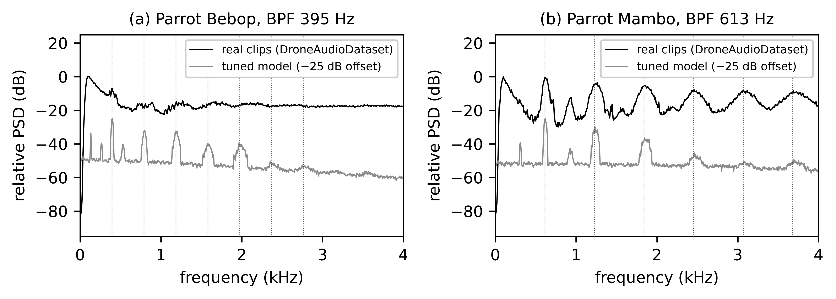
Fig. 7. Averaged spectra of real Parrot clips (DroneAudioDataset [22]) and of the tuned synthetic models; dotted lines mark BPF harmonics.
Simulations. Passive scenes use 16 kHz, rigid-sphere scattering, a moving source with Doppler and a ground reflection (coefficient 0.5), station machinery 0.75 m from the array (68–80 dB at 1 m), incoherent gusty wind (35–50 dB) and hardware errors of a calibrated common-clock build (1 mm, 0.5 dB, 5 µs) unless stated. Active windows use 48 kHz and the elements of Section 4. Statistics. Medians are reported with 95% bootstrap intervals and proportions with Wilson intervals [38]; n is given in each table. The active-mode window study combines two runs with different seeds (ego-noise −30 and −20 dB from the first). All code, seeds and raw results are archived [40], [41].
Definitions. Detection rate: fraction of frames whose signature probability for the target is ≥ 0.5. Voiceprint accuracy: out-of-fold classification accuracy. Successful arrival: three consecutive seconds in the Terminal state with a true distance of 1–4 m; false arrival: the same declaration at a true distance outside 1–4 m; trials end after 60 s.

7. Results

7.1. Sensor model and hardware errors
Table 3. Passive direction finding at 60 random positions (3–40 m) under increasingly realistic sensor models.
 | Simulation / estimator | Median error [95% CI] | 90th pct. | Range error
A | free-field simulation, lag-domain SRP (fixed grid) | 0.95° [0.75, 1.12] | 2.20° | 19%
B | free-field simulation, phase SRP with local refinement | 0.39° [0.31, 0.50] | 2.06° | 19%
C | rigid-sphere simulation, free-field steering (model mismatch) | 0.95° [0.73, 1.28] | 3.41° | 20%
D | rigid-sphere simulation, rigid-sphere steering | 0.55° [0.43, 0.72] | 2.42° | 20%
E | D + hardware errors, common clock (1 mm, 0.5 dB, 5 us) | 1.13° [0.93, 1.37] | 2.32° | 20%
F | D + larger hardware errors, common clock (2 mm, 1 dB, 20 us) | 2.19° [2.02, 2.38] | 3.15° | 20%
G | E + 20 ppm clock skew (separate ADC clocks) | 87.75° [69.72, 107.10] | 139.92° | 41%

Refining the SRP peak locally removed the grid floor of a fixed-grid estimator (A → B). On a rigid sphere, free-field steering became biased (C: 0.95°, 90th percentile 3.41°), and rigid-sphere steering recovered most of the loss (D: 0.55°). Millimetre-level hardware errors on a common clock cost about 0.5–1.5° (E, F), but a 20 ppm skew between independent clocks destroyed the reference subtraction and with it localization (G: 87.7°). Hence all array and reference channels must share one sampling clock.

7.2. Active mode: when are silence windows needed?
Table 4. Median direction error (deg) at 80 m and nominal ego-noise (0 dB), 40 windows per cell, and detection probability of the band-energy and matched-filter detectors (P_{FA} = 1% for the matched filter).
Estimator | silence window | running | running + notch | running + ref. canc.
SRP, sphere | 0.29 | 107.21 | 93.88 | 96.96
SRP, free field | 0.77 | 83.19 | 73.91 | 80.71
SRP, intensity-gated | 0.29 | 65.70 | 73.83 | 93.67
GCC pairs | 1.42 | 86.18 | 77.48 | 92.89
fixed fusion | 2.16 | 89.80 | 88.98 | 91.45
inv.-var. fusion | 1.70 | 87.96 | 82.36 | 90.75
six-pair intensity | 3.29 | 79.97 | 86.06 | 89.72
three loudest | 5.40 | 77.97 | 75.74 | 73.28
P_{D} matched filter | 40/40 | 40/40 | 38/40 | 40/40
P_{D} band energy | 40/40 | 21/40 | 20/40 | 15/40

During silence windows every estimator worked, and sphere-steered SRP was the most accurate (0.29° at 80 m). On the rigid sphere the six-pair intensity vector is no longer exact (3.29°) and is comparable to the three-loudest-microphones rule (5.40°); inverse-variance fusion improved on the fixed weights but not on GCC-PHAT alone, and gating SRP with the intensity estimate was harmful whenever the intensity estimate was wrong. We therefore no longer claim the intensity estimator as a contribution and use ungated sphere-steered SRP. With motors running, the band-energy detector fired regardless of the beacon, which explains the 0/30 result of the baseline chain, whereas the matched filter kept detecting; the direction, not the detection, failed at long range. Fig. 8 maps this boundary over the ego-noise level: known-RPM notching did not help because the four rotors' harmonic combs and broadband turbulence fill the beacon band (the notch also removed about 60% of the beacon energy), and the reference canceller helped only at moderate ego-noise under the distributed rotor model.
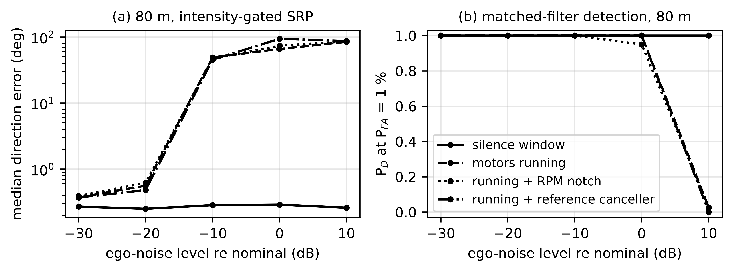
Fig. 8. Active mode at 80 m versus ego-noise level relative to nominal: (a) median direction error of sphere-steered SRP and (b) matched-filter detection probability, for silence windows and three motors-running chains.
Table 5. Closed-loop approaches from 80 m (30 randomized trials per policy; distributed rotor-noise model unless marked).
Policy | Arrivals [95% CI] | False | Mean time | Dir. error
silence windows, energy detector, fixed fusion (baseline) | 24/30 [0.63, 0.90] | 6 | 19.7 s | 1.85°
motors running, energy detector, fixed fusion | 0/30 [0.00, 0.11] | 0 | — | 132.05°
motors running, matched filter, SRP-sphere | 0/30 [0.00, 0.11] | 0 | — | 119.02°
motors running, matched filter + RPM notch, SRP-sphere | 0/30 [0.00, 0.11] | 1 | — | 121.69°
motors running, matched filter + reference canceller, SRP-sphere | 8/30 [0.14, 0.44] | 1 | 22.1 s | 121.73°
silence windows, matched filter, SRP-sphere (proposed) | 25/30 [0.66, 0.93] | 5 | 19.4 s | 0.28°
motors running, energy detector, fixed fusion (coherent rotor model) | 0/30 [0.00, 0.11] | 0 | — | 133.83°
motors running, matched filter, SRP-sphere (coherent rotor model) | 0/30 [0.00, 0.11] | 0 | — | 121.35°
motors running, matched filter + RPM notch, SRP-sphere (coherent rotor model) | 0/30 [0.00, 0.11] | 0 | — | 114.09°
motors running, matched filter + reference canceller, SRP-sphere (coherent rotor model) | 29/30 [0.83, 0.99] | 1 | 14.2 s | 0.43°

Table 5 confirms the window study in closed loop: the proposed silence-window chain reached the hand-over zone in 25/30 trials, the baseline silence-window chain (energy detector, fixed fusion) in 24/30 (indistinguishable at n = 30, but with the median final-direction error reduced from 1.85° to 0.28° and 5 instead of 6 false arrivals), and motors-running chains in 0/30 (matched filter) and 8/30 (reference canceller); under the coherent rotor model the reference canceller reached 29/30. Whether silence windows are necessary therefore hinges on the coherence between the rotor reference microphones and the array, which bounds any linear canceller by −10 log₁₀(1 − γ²) dB and is measured by the first hardware test (Section 8). Table 6 gives the cost of the windows.
Table 6. Silence-window budget for a 3 kg quadrotor (model of Section 4.1; I = 1.5×10⁻⁴ kg m², τ_{b} = 0.9 N m, FM = 0.6).
Quantity | Value
Hover power | 252 W
Rotor stop time with active braking | 79 ms
Vertical speed when thrust returns | -1.44 m/s
Net height change per cycle (with pre-climb) | +0.01 m
Rotor spin-up energy | 83 J
Net energy overhead per 2 s cycle | 35 J (7.0% of hover)

7.3. Reference subtraction at the station
Table 7. Reference-subtraction ablation: positions localized within 5° (of 30), interference reduction and target-to-distortion ratio (TDR) with the drone 3 m away.
Policy / references | stationary | +20 dB wind on ref. | moving machinery | 3 dB ref. gain drift
none | 1 | 0.0 dB | — dB | 1 | 0.0 dB | — dB | 2 | 0.0 dB | — dB | 1 | 0.0 dB | — dB
fixed/acoustic | 30 | 25.3 dB | 19 dB | 30 | 25.2 dB | 19 dB | 3 | -0.7 dB | 20 dB | 9 | 7.9 dB | 16 dB
fixed/vibration | 17 | 21.0 dB | 99 dB | 17 | 21.0 dB | 99 dB | 3 | -0.8 dB | 99 dB | 17 | 21.0 dB | 99 dB
fixed/both | 30 | 25.3 dB | 19 dB | 30 | 25.2 dB | 19 dB | 3 | -0.7 dB | 20 dB | 9 | 7.8 dB | 16 dB
adaptive/both | 30 | 19.1 dB | 8 dB | 30 | 19.1 dB | 8 dB | 8 | 7.9 dB | 8 dB | 30 | 17.9 dB | 7 dB
recalibrated/both | 30 | 24.2 dB | 19 dB | 30 | 24.1 dB | 19 dB | 3 | 0.8 dB | 23 dB | 30 | 24.2 dB | 19 dB
Each cell: positions within 5° | reduction | TDR.

The acoustic reference alone carried the subtraction in the stationary and windy scenes; strong wind on the reference microphone did not degrade it because wind energy lies below the drone comb. The vibration reference alone missed the airborne high-frequency components (17/30 within 5°) but was immune to a gain drift of the acoustic reference, which reduced the fixed acoustic filter to 9/30; re-calibrating on a drone-free window restored 30/30. The gated adaptive filter also tracked the drift (30/30) but cancelled part of the drone through its leakage into the reference (TDR 8 dB versus 19 dB for the fixed filter), so we use the fixed filter during approaches and re-calibrate between them. No policy handled machinery moving by ±0.15 m (at best 8/30): time-varying paths require a reference mounted on the moving part. We consequently dropped "multimodal" from the title; the vibration sensor is retained as a drift-robust fallback.

7.4. Drone-type signature without leakage
Table 8. Signature accuracy with leakage-free splits (95% Wilson intervals).
Evaluation | Accuracy | n
Synthetic, random 1 s segments (conventional, leaks across recordings) | 98% [97%, 99%] | 960
Synthetic, split by recording | 94% [92%, 95%] | 960
Synthetic, unseen physical unit | 91% [88%, 93%] | 576
RPM offset ±0%, trained ±12% / ±30% | 98% / 90% | 336
RPM offset ±10%, trained ±12% / ±30% | 84% / 83% | 336
RPM offset ±20%, trained ±12% / ±30% | 54% / 83% | 336
RPM offset ±30%, trained ±12% / ±30% | 23% / 79% | 336
Five units of one model (chance 20%) | 63% [59%, 67%] | 480
Real Bebop vs Mambo, random split (1332 clips) | 96% | 1332
Real, split by session (257 sessions) | 92% | 1332
Real, leave-one-campaign-out | 72% | 1332

Random segment splits overstated accuracy for both synthetic and real data, in line with the leakage reported by Shulman [25]. A classifier trained on ±12% RPM collapsed outside that range (23% at ±30%), whereas training on ±30% kept 79% at a small cost at nominal RPM; we adopt the wide range. Distinguishing individual units of one model reached 63% under our assumed manufacturing variation, so we use "voiceprint" only for the drone type.

7.5. Passive mode: Monte Carlo approaches
Table 9. Passive pipeline over 30 randomized approaches (trajectory, machinery 68–80 dB, wind 35–50 dB, hardware errors); medians across runs with 95% bootstrap intervals.
Metric | Median [95% CI]
Array SNR before subtraction | -4.5 dB [-6.6, -3.4]
Array SNR after subtraction | 19.1 dB [18.5, 20.0]
Detection rate | 94% [91, 97]
Direction error, per-run median | 1.13° [0.88, 1.35]
Direction error, per-run 90th percentile | 1.77° [1.60, 1.87]
Range error, per-run median | 20% [19, 22]
Track position error, per-run median | 4.05 m [3.03, 4.75]
Final track error at the end of the approach | 0.52 m [0.42, 0.62]

Across approaches, sphere-steered harmonic SRP stayed near 1.1°, while the range estimate remained the weak link (20% median error) and the detection rate varied strongly between runs, which delayed the tracker in some approaches. Figs. 9 and 10 show one approach with the realistic sensor model.
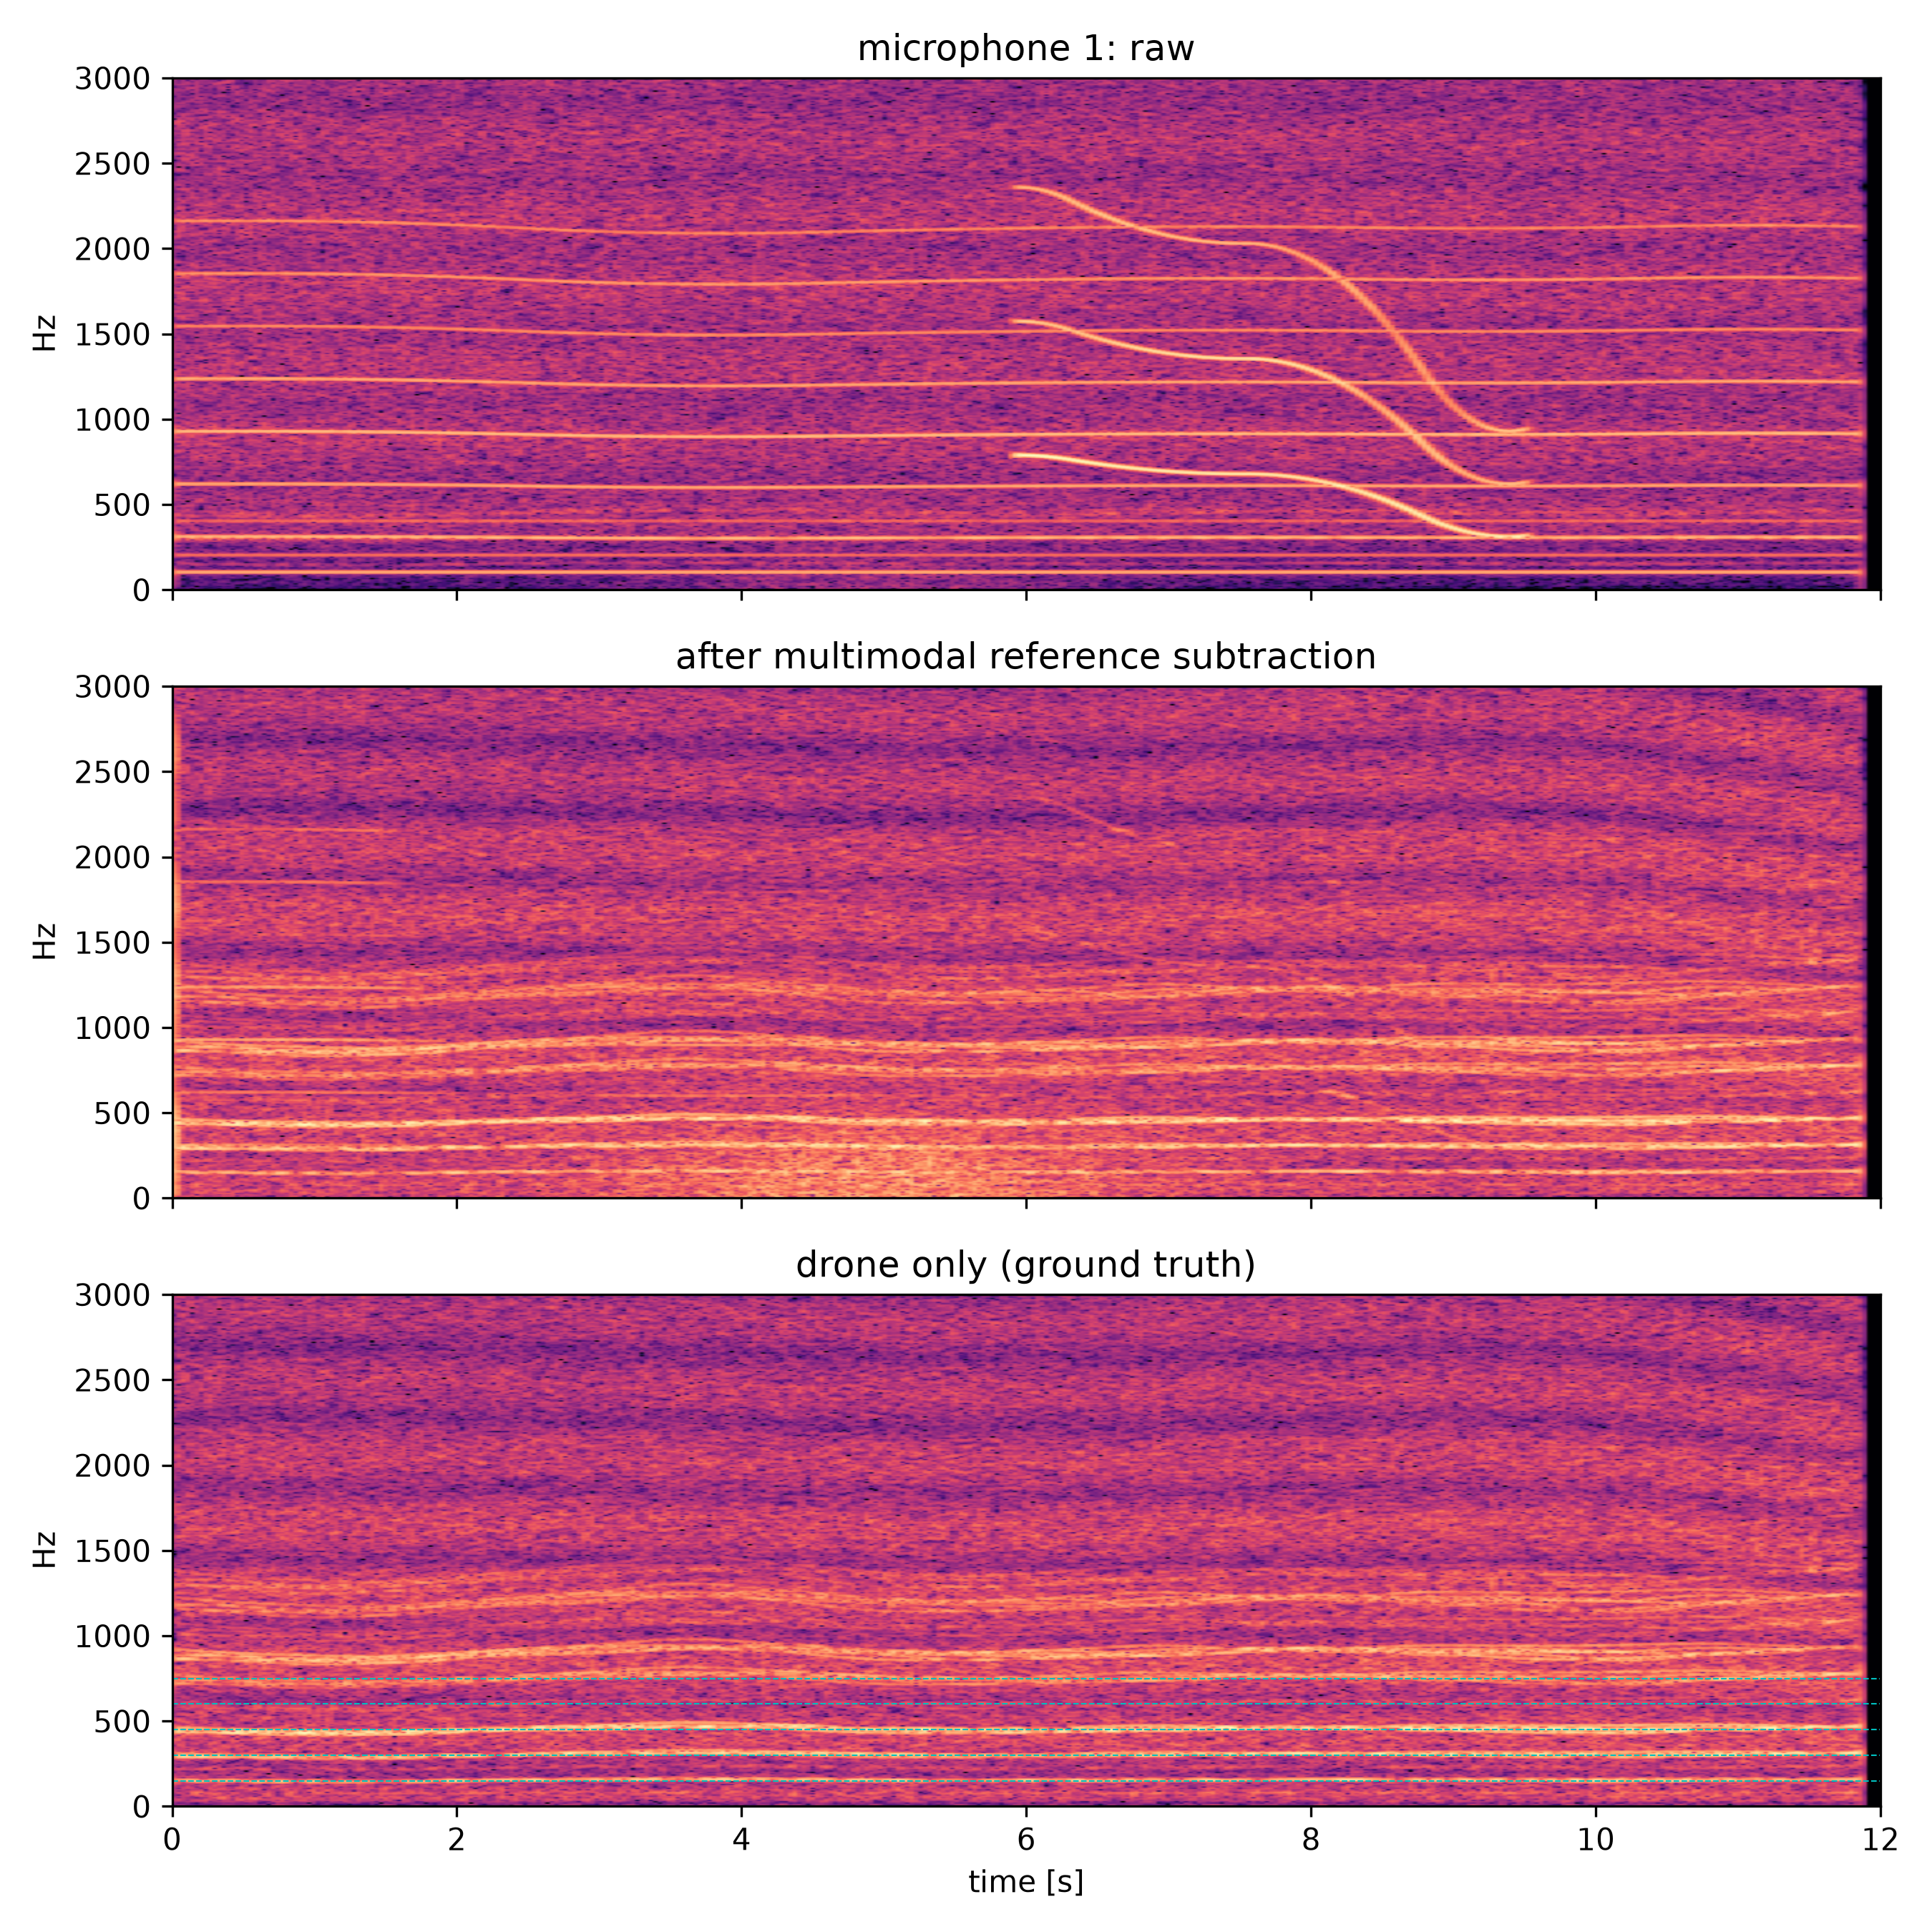
Fig. 9. One passive approach (realistic sensor model): spectrograms at microphone 1 before and after reference subtraction and of the drone alone; dashed lines mark BPF harmonics.
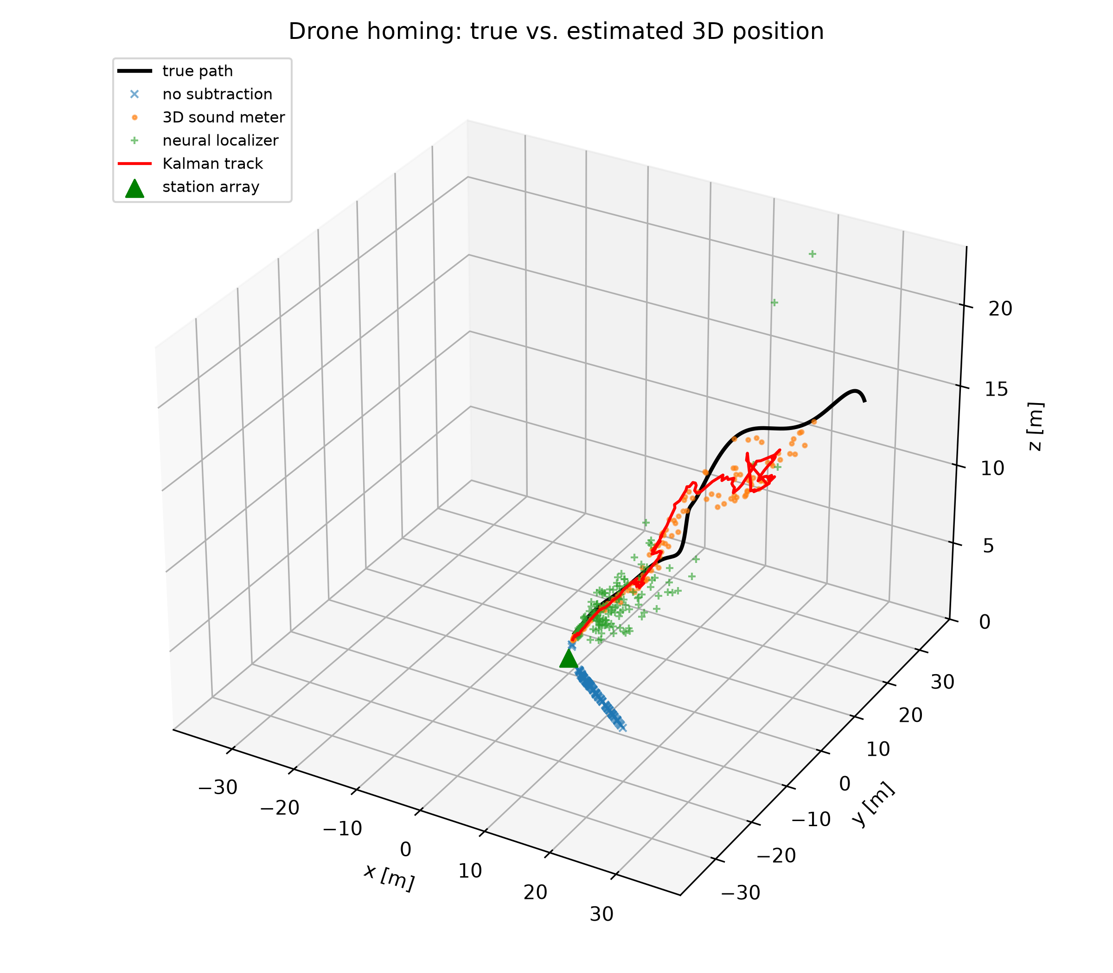
Fig. 10. True path and estimates for the approach of Fig. 9; the triangle marks the station array.

7.6. Real drone-embedded recordings (DREGON)
To test the direction estimator on real array data, it was applied without modification to the five in-flight source recordings of DREGON [12]: an eight-microphone cube array (12.3 cm edge) beneath a quadrotor, a loudspeaker emitting white noise or speech at two levels in a large indoor room, and the source direction in the UAV frame from a Vicon system. The recordings were resampled to 16 kHz and cut into 0.5 s segments, the true direction being interpolated at the centre of each segment from the per-sample timestamps (synchronisation error below 0.1 s [12]). Steering was free-field, since the cube is not a sphere; the band was fixed by the source type (300–7000 Hz for white noise, 300–4000 Hz for speech) and no parameter was tuned on these data. Two variants were run: no pre-processing, and subtraction of the average noise cross-spectra of a separate noise-only free flight in the same room before PHAT weighting, analogous to the noise statistics used by the Wiener filter of [12]. The error is the great-circle angle between estimated and true directions, which is stricter than the separate azimuth and elevation errors of [12]. Among sign and 90° conventions for azimuth and elevation, the one used (that of the dataset) gave by far the lowest error, which excludes a frame mismatch.
Table 10. Direction error on the DREGON in-flight recordings [12] (0.5 s segments; median with 95% bootstrap interval; segments within 10°). Noise subtraction uses a separate noise-only free flight.
Recording | Segments | No pre-processing: median | ≤ 10° | Noise subtracted: median | ≤ 10°
Motors off, white noise (low) | 139 | 2.7° [2.6, 3.2] | 125/139 | 3.2° [2.5, 3.8] | 124/139
Free flight, white noise (high) | 105 | 3.5° [2.9, 3.9] | 85/105 | 3.0° [2.7, 3.4] | 102/105
Free flight, white noise (low) | 112 | 74.5° [62.5, 79.5] | 32/112 | 3.9° [3.4, 4.9] | 80/112
Free flight, speech (high) | 94 | 111.1° [95.9, 118.2] | 5/94 | 57.4° [39.1, 73.4] | 18/94
Free flight, speech (low) | 111 | 101.8° [82.2, 112.9] | 7/111 | 47.1° [38.8, 68.4] | 8/111
In-flight white noise, pooled | 217 | 5.8° [4.2, 50.3] | 117/217 | 3.4° [3.1, 3.6] | 182/217

With a broadband source in flight, subtracting the noise cross-spectra raised the share of segments within 10° from 117/217 to 182/217 (Wilson 95% interval 0.78–0.88); in the louder recording (−11.8 dB) 102/105 segments were within 10°, the three exceptions falling in the take-off transient (Fig. 11). Without pre-processing, 99% of the in-flight segments with errors above 20° pointed more than 30° above the array, i.e. towards the rotors of a drone whose array is mounted beneath the body. Successful segments carried a median offset of -1.8° in azimuth and 0.2° in elevation, consistent with a small yaw between the array and the Vicon frame; it was not corrected. With the motors off, 125/139 segments were within 10°, and all failures fell in the first seconds of the recording, before the loudspeaker started (the recording includes a period of room silence [12]); with the source active, 125/127 segments were within 10° (median 2.7°). Fixed subtraction slightly degraded these motors-off segments and failed on the pre-take-off segments of the low-level flight, because it removes noise that is not present; the subtraction must follow the motor state, and a version scaled by the rotor-band power is included in the released code. In-flight speech was not localized (at most 18/94 segments within 10°), in line with [12], where speech localization in flight remained a challenge even after removing the noisiest channels and restricting the search grid: speech has pauses and most of its energy below 1 kHz, where the rotor harmonics dominate.
These data test the estimator and the noise subtraction on a real drone-mounted array with a broadband cooperative source, the situation of the active mode with motors running; they do not test the rigid-sphere sensor, the harmonic (voiceprint) weighting or a drone target, which require the measurements listed in Section 8.
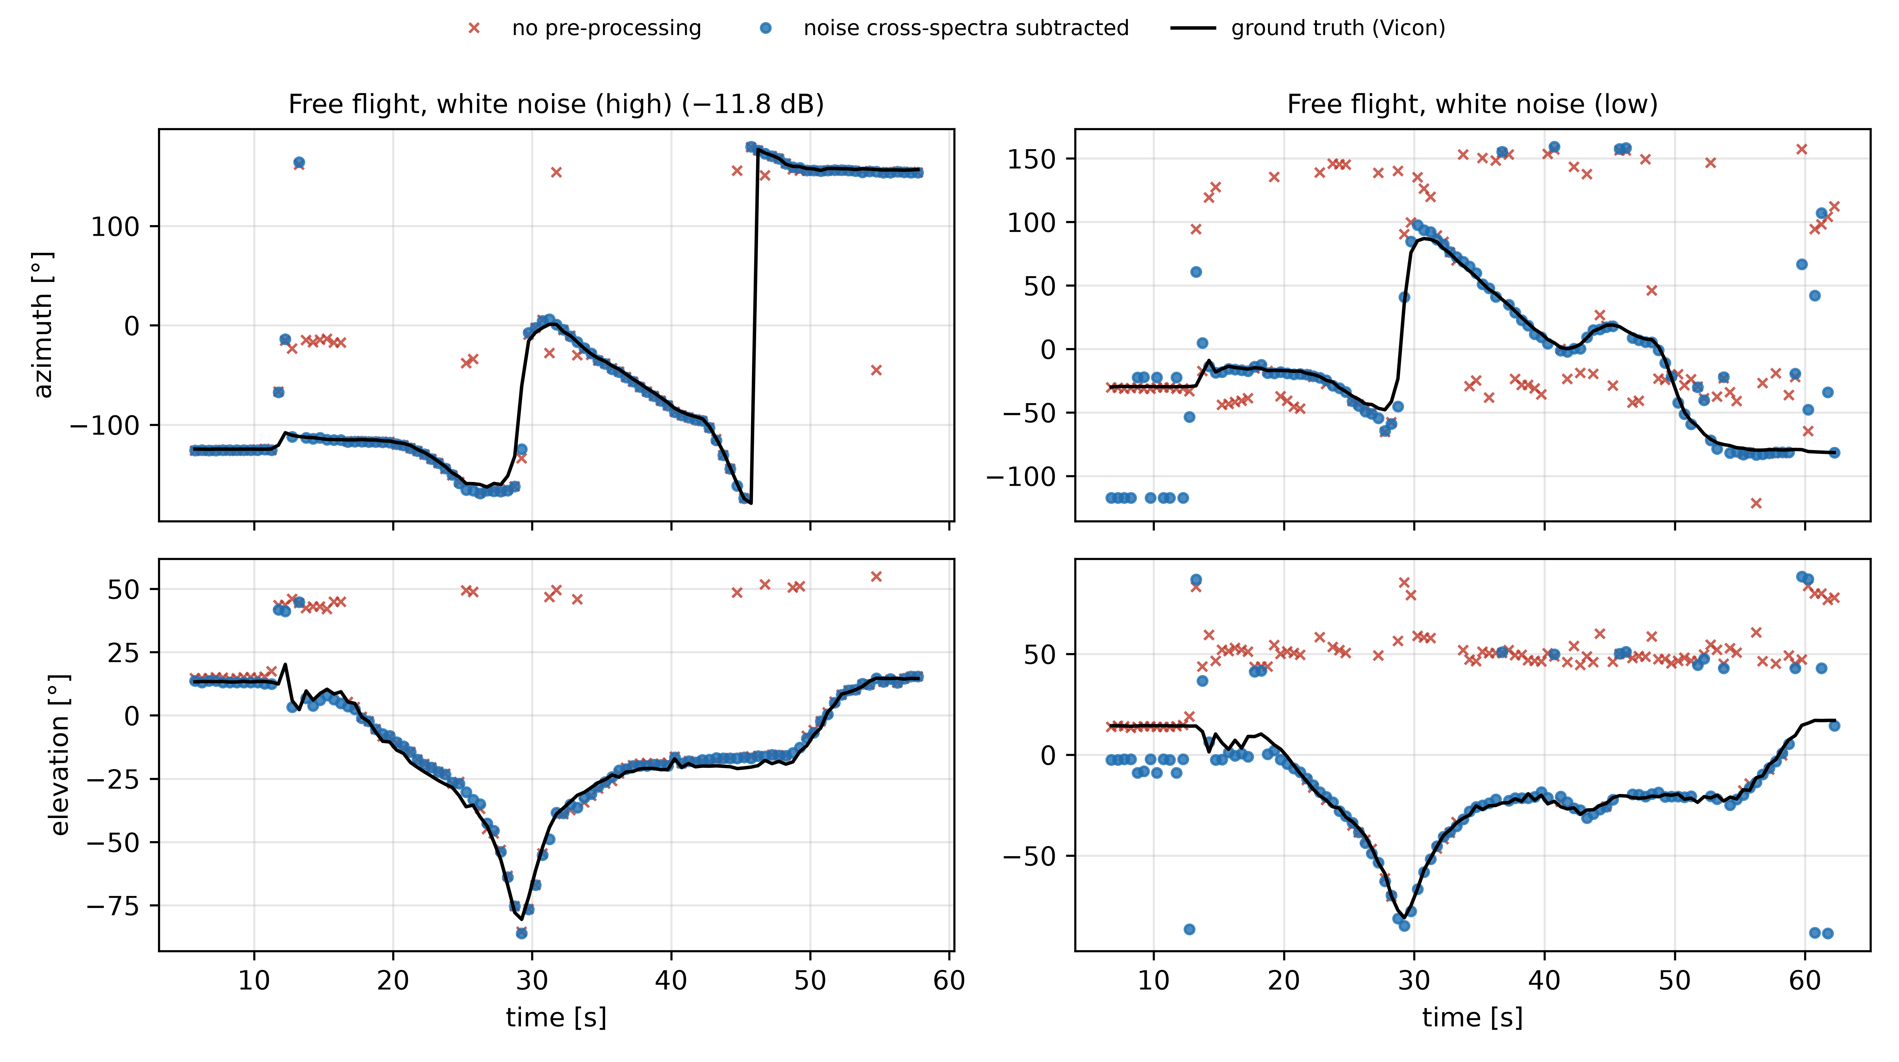
Fig. 11. Estimated and true (Vicon) azimuth and elevation for the two in-flight white-noise recordings of DREGON [12], without pre-processing and with noise cross-spectra subtracted.

8. Discussion, limitations and validation plan
Effect of realistic modelling. Modelling the sensor body, hardware errors, distributed rotor noise and leakage-free evaluation lowered the accuracy obtained under an idealised free-field model, showed no advantage of the six-pair intensity estimator or of a vibration reference in benign conditions, and made the silence-window result conditional. The elements that remain are the periodic silence-window concept, the voiceprint-guided sphere-steered SRP, the reference-subtraction policy (fixed during approach, re-calibrated between approaches) and the derived hardware requirements.
Limitations. The array signals of Sections 7.1–7.5 are simulated, and the "real" drone clips used there are single-channel recordings propagated synthetically to the array; the real-array evidence of Section 7.6 comes from a cube array with a loudspeaker source, not from the proposed sphere or a drone target. The rotor-noise coherence, the spin-down dynamics, the ground effect and the 1 m levels are model inputs. Moving interference at the station is not handled. Stopping motors in flight is not a standard PX4/ArduPilot function [33], and each window costs about 7% of hover energy per cycle under our assumptions.
Table 11. Validation with real recordings (tools released with the code).
Test | Measurement | Decides
DREGON / SP Cup 2019 [12], [13] | Direction error of SRP-PHAT on drone-embedded 8-mic recordings with ground truth | Done (Section 7.6): broadband source localized in flight; speech not
Bench, loudspeaker grid | Error of sphere vs free-field steering on the physical 160 mm sensor | Rigid-sphere model and hardware errors
Rotor coherence in flight / on a stand | Multiple coherence between rotor reference microphones and the array, 3–6 kHz | Whether silence windows are needed
Braking test on a thrust stand | Stop time, residual noise in the window, recovery thrust, energy | Feasibility and cost of the windows
Calibrated drone recordings | L_{1m} and signature data over RPM, distance and sessions | Range accuracy and signature generalization

Apart from the DREGON evaluation (Section 7.6), these tests are being prepared with the hardware specified in the released build guide; until they are completed, the results of Sections 7.1–7.5 should be read as simulation results.

9. Conclusions
A rigid-sphere model, realistic hardware errors and fair baselines change the picture of six-microphone drone localization substantially. Sphere-steered, harmonic-weighted SRP-PHAT is the accurate direction estimator (1.13° median in passive Monte Carlo); silence windows are necessary at long range only if rotor noise is poorly coherent with on-board references; reference subtraction at a station works with a fixed filter re-calibrated between approaches but not with moving interference; and drone-type signatures must be evaluated across recordings. All channels must share one sampling clock. On real in-flight recordings, steered response power with noise cross-spectra subtraction localized a broadband source within 10° in 182 of 217 segments, while speech was not localized. The next step is the measurement campaign of Table 11 with the spherical sensor.

CRediT authorship contribution statement
Husham Saied: Conceptualization, Methodology, Software, Validation, Formal analysis, Investigation, Data curation, Writing – original draft, Writing – review & editing, Visualization.

Declaration of competing interest
The author declares no known competing financial interests or personal relationships that could appear to influence the work reported in this paper.

Funding
This research did not receive any specific grant from funding agencies in the public, commercial, or not-for-profit sectors.

Data availability
Code, data download scripts, experiment and figure scripts that regenerate every result, the aggregated results (docs/revision/results_summary.json) and the per-segment DREGON results (docs/revision/dregon) are available at https://github.com/husham-eng/Multimodal-Reference-Subtraction-Voiceprint-and-Three-Dimensional-Sound-Meter-for-Drone-Localization (accessed 4 October 2026) and archived on Zenodo (doi: 10.5281/zenodo.23122228) under the MIT license [40], [41]. Public datasets are available from their sources [12], [13], [22]–[24].

Declaration of generative AI and AI-assisted technologies in the writing process
During the preparation of this work the author used an AI assistant (Claude, Anthropic) to help implement the simulation software and to draft and edit the manuscript. All figures were generated from the released code and data with matplotlib, except Fig. 2, which shows CAD renders by the author; no figure was produced with a generative image model. The author reviewed and edited all content and takes full responsibility for it.

References
[1] C.H. Knapp, G.C. Carter, The generalized correlation method for estimation of time delay, IEEE Trans. Acoust. Speech Signal Process. 24 (4) (1976) 320–327. https://doi.org/10.1109/TASSP.1976.1162830
[2] R.O. Schmidt, Multiple emitter location and signal parameter estimation, IEEE Trans. Antennas Propag. 34 (3) (1986) 276–280. https://doi.org/10.1109/TAP.1986.1143830
[3] J.H. DiBiase, H.F. Silverman, M.S. Brandstein, Robust localization in reverberant rooms, in: M. Brandstein, D. Ward (Eds.), Microphone Arrays, Springer, Berlin, 2001, pp. 157–180.
[4] J.-M. Valin, F. Michaud, J. Rouat, D. Létourneau, Robust sound source localization using a microphone array on a mobile robot, in: Proc. IEEE/RSJ IROS, 2003.
[5] K. Nakadai, T. Takahashi, H.G. Okuno, H. Nakajima, Y. Hasegawa, H. Tsujino, Design and implementation of robot audition system 'HARK', Adv. Robot. 24 (5–6) (2010) 739–761.
[6] M. Basiri, F. Schill, P.U. Lima, D. Floreano, Robust acoustic source localization of emergency signals from micro air vehicles, in: Proc. IEEE/RSJ IROS, 2012.
[7] K. Furukawa, K. Okutani, K. Nagira, T. Otsuka, K. Itoyama, K. Nakadai, H.G. Okuno, Noise correlation matrix estimation for improving sound source localization by multirotor UAV, in: Proc. IEEE/RSJ IROS, 2013.
[8] L. Wang, A. Cavallaro, Ear in the sky: Ego-noise reduction for auditory micro aerial vehicles, in: Proc. IEEE AVSS, 2016, pp. 152–158.
[9] L. Wang, A. Cavallaro, Microphone-array ego-noise reduction algorithms for auditory micro aerial vehicles, IEEE Sens. J. 17 (8) (2017) 2447–2455. https://doi.org/10.1109/JSEN.2017.2669262
[10] L. Wang, A. Cavallaro, Acoustic sensing from a multi-rotor drone, IEEE Sens. J. 18 (11) (2018) 4570–4582. https://doi.org/10.1109/JSEN.2018.2825879
[11] Y. Hioka, M. Kingan, G. Schmid, K.A. Stol, Speech enhancement using a microphone array mounted on an unmanned aerial vehicle, in: Proc. IWAENC, 2016.
[12] M. Strauss, P. Mordel, V. Miguet, A. Deleforge, DREGON: Dataset and methods for UAV-embedded sound source localization, in: Proc. IEEE/RSJ IROS, 2018. Data: http://dregon.inria.fr
[13] A. Deleforge, D. Di Carlo, M. Strauss, R. Serizel, L. Marcenaro, Audio-based search and rescue with a drone: Highlights from the IEEE Signal Processing Cup 2019 student competition, IEEE Signal Process. Mag. 36 (5) (2019) 138–144.
[14] D. Salvati, C. Drioli, G.L. Foresti, Spherical harmonic diagonal unloading beamforming with ego-noise reduction for DOA estimation from autonomous systems, in: Proc. IEEE WASPAA, 2021, pp. 216–220.
[15] W. Manamperi, T.D. Abhayapala, J. Zhang, P.N. Samarasinghe, Drone audition: Sound source localization using on-board microphones, IEEE/ACM Trans. Audio Speech Lang. Process. 30 (2022) 508–519. https://doi.org/10.1109/TASLP.2022.3140550
[16] K. Hoshiba, I. Komatsuzaki, N. Iwatsuki, Proposal of practical sound source localization method using histogram and frequency information of spatial spectrum for drone audition, Drones 8 (4) (2024) 159.
[17] E. Tengan, T. Dietzen, S. Ruiz, M. Alkmim, J. Cardenuto, T. van Waterschoot, Speech enhancement using ego-noise references with a microphone array embedded in an unmanned aerial vehicle, in: Proc. 24th Int. Congr. Acoustics, 2022. arXiv:2211.02690
[18] Y. Wu, Y. Chiu, M. Anthony, M.R. Bai, Egonoise resilient source localization and speech enhancement for drones using a hybrid model and learning-based approach, arXiv:2508.06310, 2025.
[19] S.F. Chevtchenko et al., Drone-based sound source localization: A systematic literature review, IEEE Access 13 (2025) 94256–94274. https://doi.org/10.1109/ACCESS.2025.3572478
[20] S.F. Boll, Suppression of acoustic noise in speech using spectral subtraction, IEEE Trans. Acoust. Speech Signal Process. 27 (2) (1979) 113–120. https://doi.org/10.1109/TASSP.1979.1163209
[21] B. Widrow et al., Adaptive noise cancelling: Principles and applications, Proc. IEEE 63 (12) (1975) 1692–1716. https://doi.org/10.1109/PROC.1975.10036
[22] S. Al-Emadi, A. Al-Ali, A. Mohammad, A. Al-Ali, Audio based drone detection and identification using deep learning, in: Proc. IWCMC, 2019, pp. 459–464. Data: https://github.com/saraalemadi/DroneAudioDataset (accessed 4 October 2026).
[23] F. Svanström, F. Alonso-Fernandez, C. Englund, A dataset for multi-sensor drone detection, Data Brief 39 (2021) 107521. https://doi.org/10.1016/j.dib.2021.107521
[24] K.J. Piczak, ESC: Dataset for environmental sound classification, in: Proc. 23rd ACM Int. Conf. Multimedia, 2015, pp. 1015–1018. https://doi.org/10.1145/2733373.2806390
[25] D. Shulman, EchoHawk: A reproducible acoustic pipeline for drone detection, classification, and direction-finding, with a cautionary study of session-level data leakage, arXiv:2606.29589, 2026.
[26] R. Chatterjee, S. Chakrabarty, T. Acharjee, D. Mishra, AUDRON: A deep learning framework with fused acoustic signatures for drone type recognition, in: Proc. IEEE INDICON, 2025. arXiv:2512.20407
[27] R.O. Duda, W.L. Martens, Range dependence of the response of a spherical head model, J. Acoust. Soc. Am. 104 (5) (1998) 3048–3058. https://doi.org/10.1121/1.423886
[28] ISO 9613-1:1993, Acoustics — Attenuation of sound during propagation outdoors — Part 1: Calculation of the absorption of sound by the atmosphere, International Organization for Standardization, Geneva, 1993.
[29] R.E. Kalman, A new approach to linear filtering and prediction problems, J. Basic Eng. 82 (1) (1960) 35–45. https://doi.org/10.1115/1.3662552
[30] Y. Bar-Shalom, X.R. Li, T. Kirubarajan, Estimation with Applications to Tracking and Navigation, Wiley, New York, 2001.
[31] L. Breiman, Random forests, Mach. Learn. 45 (1) (2001) 5–32. https://doi.org/10.1023/A:1010933404324
[32] F. Pedregosa et al., Scikit-learn: Machine learning in Python, J. Mach. Learn. Res. 12 (2011) 2825–2830.
[33] L. Meier, D. Honegger, M. Pollefeys, PX4: A node-based multithreaded open source robotics framework for deeply embedded platforms, in: Proc. IEEE ICRA, 2015.
[34] E. Olson, AprilTag: A robust and flexible visual fiducial system, in: Proc. IEEE ICRA, 2011.
[35] K.A.O. Suzuki, P. Kemper Filho, J.R. Morrison, Automatic battery replacement system for UAVs: Analysis and design, J. Intell. Robot. Syst. 65 (2012) 563–586.
[36] Intel Corp., Systems, apparatus, and methods for drone audio noise reduction, U.S. Patent 10,290,293 B2, 2019.
[37] Data- and model-driven inspection of autonomous aircraft using an unmanned aerial vehicle, U.S. Patent 11,203,445, 2021.
[38] E.B. Wilson, Probable inference, the law of succession, and statistical inference, J. Am. Stat. Assoc. 22 (158) (1927) 209–212. https://doi.org/10.1080/01621459.1927.10502953
[39] S. Haykin, Adaptive Filter Theory, 5th ed., Pearson, 2014.
[40] H. Saied, Multimodal reference subtraction, voiceprint and three-dimensional sound meter for drone localization, GitHub repository, 2026. https://github.com/husham-eng/Multimodal-Reference-Subtraction-Voiceprint-and-Three-Dimensional-Sound-Meter-for-Drone-Localization (accessed 4 October 2026).
[41] H. Saied, Multimodal Reference Subtraction, Drone Voiceprint and Three-Dimensional Sound Meter for Drone Localization (software, v2.0.1 and later), Zenodo, 2026. https://doi.org/10.5281/zenodo.23122228

