A Three-Dimensional Acoustic Guidance and Localization System for Drones
Six-Microphone Spherical Array, Rotor Silence Windows, Multimodal Reference Subtraction, Drone Voiceprint and a 3D Sound Meter
Combined Report — Phase One (Beacon Homing) and Phase Two (Passive Voiceprint Localization)
Version 2 — Phase Two with training data, results and the public code repository
Prepared by: Dr. Husham Saied
Prince Sultan Military College of Health Sciences, Dhahran, Saudi Arabia
October 2026
Source code and data scripts:
https://github.com/husham-eng/Multimodal-Reference-Subtraction-Voiceprint-and-Three-Dimensional-Sound-Meter-for-Drone-Localization
(branch: main)
Archived on Zenodo (cite all versions):
DOI: 10.5281/zenodo.23122228
Version 2.0.0: DOI: 10.5281/zenodo.23122229

Contents

(Right-click the table of contents and choose “Update Field” if page numbers are not shown.)

Document History
Version | Date | Content | Software release
1 | October 2026 | Phase One report: beacon homing with rotor silence windows (simulation) | Phase One scripts (not archived)
2 | October 3, 2026 | Phase Two added: drone sound library and training data, multimodal reference subtraction, drone voiceprint, 3D sound meter; report reorganized; Zenodo archive | v2.0.0 (GitHub release, Zenodo DOI 10.5281/zenodo.23122229)
2.1 | October 2026 | Final report: affiliation, document history, project identifiers, MIT license | v2.0.1 (GitHub release, Zenodo; same all-versions DOI)

Abstract
Weather-monitoring drones operate for long periods, but battery capacity limits their time aloft. This project develops the acoustic perception needed to bring a second drone, or a battery-swap station, to such a drone without visual contact. The core sensor is a sphere of 160 mm diameter carrying six directional microphones on its six poles (±x, ±y, ±z). Two complementary operating modes are studied.
Phase One (active beacon homing). The target emits a 3–6 kHz chirp beacon; the supply drone stops its rotors during 0.2 s silence windows every two seconds to avoid ego-noise, fuses six-pair intensity differences with GCC-PHAT time differences to estimate direction, estimates distance from the known beacon level, tracks the target with a Kalman filter and steers toward it. In closed-loop simulation from 80 m the drone reached the hand-over zone in 28 of 30 randomized trials (mean 18.2 s, median direction error 2.5°), whereas all 30 trials failed when listening with the motors running (median error 97.8°).
Phase Two (passive voiceprint localization, new in this version). No beacon is required: the array listens to the drone's own rotor sound. Interference from equipment near the array is removed by a trained multimodal reference subtraction (an acoustic reference microphone plus a vibration sensor), the drone is identified by its voiceprint (blade-passing frequency and harmonic signature) and located by a 3D sound meter that combines voiceprint-guided SRP-PHAT direction with range from the calibrated harmonic sound level. A drone sound library of seven synthetic drone models and public datasets (DroneAudioDataset, Drone-detection dataset, ESC-50; DREGON and SP Cup 2019 for validation) was assembled for training. In a 40 s simulated landing approach of a battery-swap hexacopter, reference subtraction reduced interference by 26.8 dB and raised the array SNR from -7.1 dB to 19.7 dB; the voiceprint classifier reached 97.9% held-out accuracy over 8 classes; and the median direction error fell from 54.9° without subtraction to 0.8° with it (median position error 1.75 m after Kalman tracking).
Keywords: sound direction finding, spherical microphone array, drones, rotor ego-noise, reference subtraction, drone voiceprint, blade-passing frequency, GCC-PHAT, SRP-PHAT, Kalman filter, autonomous guidance, in-flight battery replacement.

What Is New in Version 2
The first version of this report covered Phase One only, used synthetic signals exclusively and listed the reference-subtraction classifier as future work. This version implements that classifier and extends the system to passive localization. Table 1 summarizes every change; the new material is in Sections 3.2–3.3, 5, 6, 7.2, 8.7–8.10 and Appendix A.2–A.3.
Table 1: Summary of changes relative to the previous version of the report.
Item | Version 1 | Version 2
Classification stage | Simplified SNR test in the beacon band (placeholder) | Drone voiceprint classifier (BPF, harmonics, log-mel; Random Forest), 8 classes, 97.9% accuracy
Reference subtraction | Proposed as future work | Implemented and trained: multichannel Wiener canceller with acoustic + vibration references, 26.8 dB interference reduction
Training data | Synthetic beacon and rotor noise only | Drone sound library: 7 synthetic drone models + 5 public datasets; Parrot models calibrated on real recordings
Localization | Beacon intensity + GCC-PHAT fusion | Additionally: passive voiceprint-guided SRP-PHAT, level-based range, neural localizer
Sensor hardware | Concept: radius 8 cm | Enclosure design (D = 160 mm, two hemispheres, mast mount) and pickup-lobe visualization
Software | Phase-one scripts | Python package droneloc with command-line interface, unit tests and a public GitHub repository
Archiving and citation | None | GitHub release v2.0.0 archived on Zenodo (DOI 10.5281/zenodo.23122228); CITATION.cff and .zenodo.json metadata [25]
Report organization | Notes and figures partly outside the main structure | Data reorganized into tables; notes converted to Section 3.3 and Appendix B; references 17–25 added

1. Introduction

1.1 Problem Background
Drones are widely used for weather monitoring and atmospheric data collection, but their flight time is limited by battery capacity, and landing to replace the battery interrupts the measurement series and costs time and energy. The project proposes a supply drone that carries a charged battery, reaches the weather drone in the air and replaces its battery without landing, and, as a ground alternative, a battery-swap station that guides an arriving drone to land.
Both cases begin with the same question: where exactly is the other drone in three-dimensional space? Most current applications can hear a sound, and some can classify it, but they do not know where it comes from or which drone produced it. This project addresses that gap: hearing the target, recognizing it, determining its direction and distance, and using this to guide the approach.

1.2 Proposed Idea
Six microphones are mounted on the poles of a sphere, and the sphere is mounted on a mast above the drone body (or on the station). A sound is first cleaned and classified with the subtractive-reference technique from the researcher's previous work; the six channels are then analyzed to obtain the direction vector and the distance, and the course is adjusted toward the source. Two modes are considered:
- Active mode (Phase One): the target emits a known chirp beacon; the listener silences its own rotors briefly while listening.
- Passive mode (Phase Two): the target's own rotor sound is used; the drone is recognized by its acoustic voiceprint, and known interferers near the array are removed with reference sensors.

1.3 Objectives
Table 2: Project objectives and their status.
# | Objective | Phase | Status
1 | Determine the direction of a sound source in 3D with a six-element spherical array | 1, 2 | Done (simulation)
2 | Address rotor ego-noise in a practical way (silence windows) | 1 | Done (simulation)
3 | Estimate distance and track position over time | 1, 2 | Done (simulation)
4 | Guide the drone up to the hand-over distance | 1 | Done (simulation)
5 | Remove interference with multimodal reference subtraction | 2 | Done (simulation) — new
6 | Identify the target drone by its acoustic voiceprint | 2 | Done (synthetic + real recordings) — new
7 | Assemble a drone sound library and training data | 2 | Done — new
8 | Validate on real hardware and real flights | 3 | Planned

1.4 Scope of the Report
The report covers direction finding, recognition and guidance up to about two meters from the target. The mechanical docking and hot-swapping of power are addressed in a separate complementary project. All results are from simulation; Phase Two additionally uses real single-microphone drone recordings as source signals.

2. Literature Review and Previous Studies

2.1 Sound Source Localization with Arrays
Direction-of-arrival (DOA) methods fall into three families. Time-difference methods rest on the generalized cross-correlation of Knapp and Carter [1] and its phase-transform variant GCC-PHAT, which is robust to reverberation and colored noise; summing GCC-PHAT over all microphone pairs for each candidate direction gives the steered response power SRP-PHAT [21]. Subspace methods such as MUSIC [2] are more accurate but computationally heavier. Intensity-difference methods are the simplest and rely on microphone directivity or the acoustic shadow of the carrying body. In robotics, Valin et al. [3] localized sources with an array on a mobile robot, and Nakadai et al. introduced the open-source HARK robot audition system [4].

2.2 Drone-Mounted Hearing and Ego-Noise
Rotor and motor noise is the main obstacle to hearing on drones because it is close to the microphones and much louder than distant sounds. Basiri et al. [5] localized emergency signals from micro air vehicles, Furukawa et al. [6] estimated noise correlation matrices for a multirotor, Wang and Cavallaro [7] reduced ego-noise for auditory micro aerial vehicles, and Hioka et al. [8] enhanced speech with a drone-mounted array. The DREGON dataset [9] and the IEEE Signal Processing Cup 2019 [20] provide real drone-embedded recordings with ground-truth directions. These works handle ego-noise by filtering, subtraction and noise statistics; this project adds a complementary approach: silencing the source itself while listening.

2.3 Noise Subtraction
Noise subtraction goes back to spectral subtraction by Boll [10] and to adaptive noise cancellation with a noise reference by Widrow et al. [11]. The subtractive-reference technique of the researcher's previous work builds on this idea; here it is generalized to several reference sensors of different modalities (acoustic and vibration).

2.4 Tracking, Guidance and Autonomous Flight
The Kalman filter [12] fuses noisy measurements with a motion model, and tracking references such as Bar-Shalom et al. [13] describe the outlier-rejection tests used here. PX4 [14] provides an open flight-control platform that accepts velocity commands over MAVLink, and visual markers such as AprilTag [15] are used for precise docking.

2.5 Drone Battery Replacement
Suzuki et al. [16] studied automatic battery replacement at ground stations. In-flight replacement remains an open challenge and is the subject of the complementary project.

2.6 Acoustic Drone Detection and Public Datasets
Al-Emadi et al. [17] detected and identified drones from audio with deep learning and released the DroneAudioDataset (Parrot Bebop and Mambo). Svanström et al. [18] published a multi-sensor drone detection dataset with audio, visible and infrared data. Environmental sound collections such as ESC-50 [19] provide realistic background and interference. Random forests [22] and the scikit-learn library [23] are used here for the voiceprint classifier and the neural localizer.

2.7 Research Gap
We did not find a system that combines a six-element spherical array on the poles of a sphere, periodic rotor shutdown to silence ego-noise, multimodal reference subtraction, a drone voiceprint used both for recognition and to weight the localization spectrum, and guidance of one drone toward another for power resupply. A more comprehensive literature review is still required before publication.

3. The Spherical Acoustic Sensor

3.1 Array Geometry and Directivity
The six microphones are placed on the poles of a sphere of radius 8 cm (Figure 1). Each microphone has a pattern between omnidirectional and cardioid; its gain for a sound arriving at angle θ from its axis is:
g(θ) = (1 − α) + α · (1 + cos θ) / 2
where α is the directivity coefficient (0 omnidirectional, 1 cardioid). The maximum time difference between two opposite microphones is 2r/c ≈ 0.47 ms.
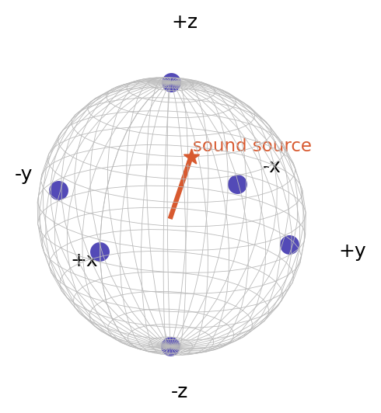
Figure 1: Distribution of the six microphones on the poles of the sphere and the direction of a sound source.

3.2 Enclosure Design (new)
The sensor was designed as a 160 mm sphere made of two hemispheres (Figure 2). The upper hemisphere carries the microphone ports; the lower hemisphere carries the bottom port and a hollow mounting stem that routes the cables down the mast. The hemispheres join with a lip, so the sphere can be opened for maintenance, and the mast keeps the sphere away from the rotor wash.
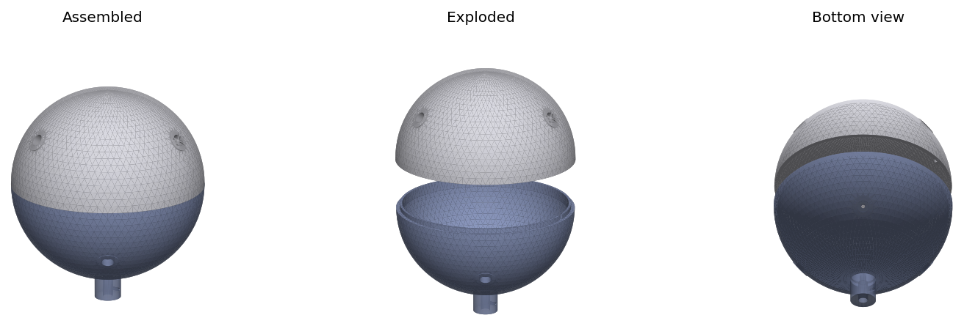
Figure 2: Sensor enclosure (D = 160 mm): assembled, exploded (two hemispheres) and bottom view with the mounting stem.

3.3 Pickup Coverage (new)
Figure 3 shows the six microphones with their cardioid pickup lobes; opposite pairs share a color because each pair yields one component of the direction vector. The six lobes together cover the whole sphere without gaps, so any sound falls within at least three lobes at different levels, and the direction vector is built from these differences. Figure 4 is the interactive 3D rendering of the sensor on its mast above the drone body: when the directivity slider is moved toward zero (omnidirectional microphones), the lobes become identical overlapping spheres and no intensity difference remains, which is why directional microphones are required for the intensity method. The sensor works in three-dimensional space but covers six polar directions, two on each axis; it is best described as a three-axis, six-direction acoustic sensor.
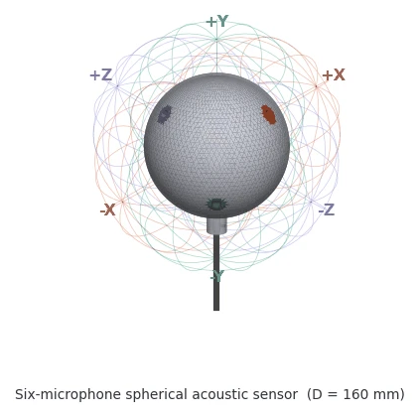
Figure 3: Six-microphone spherical acoustic sensor (D = 160 mm) with cardioid pickup lobes; opposite pairs share a color.
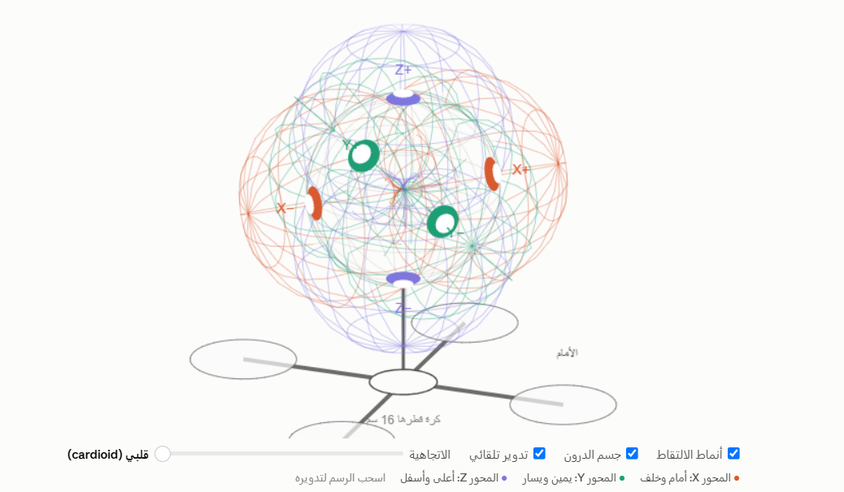
Figure 4: Interactive 3D rendering of the sensor on a mast above the drone (directivity slider and display options).

4. Phase One Method: Beacon Homing with Silence Windows

4.1 Overall Architecture
The Phase One system is a closed-loop chain (Figure 5): six-channel acquisition, a silence window with the rotors braked, classification, direction and distance estimation, Kalman tracking, guidance, and velocity commands to the flight controller.
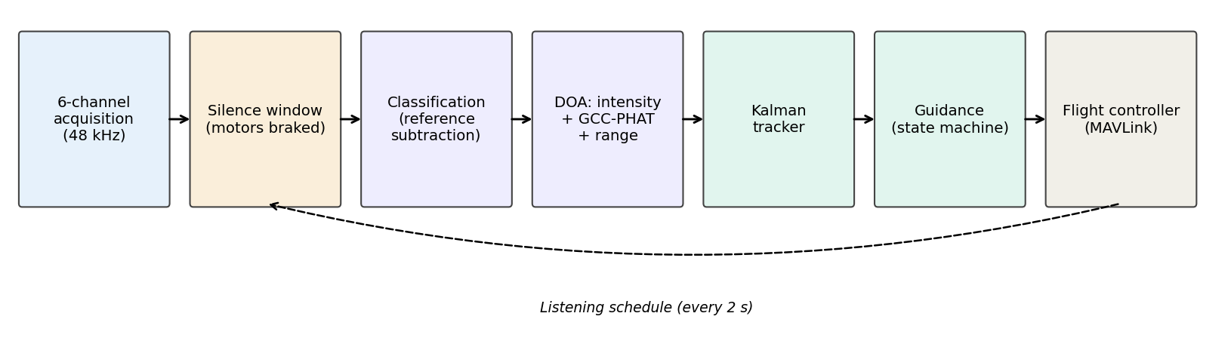
Figure 5: Phase One system diagram and data flow between its stages.

4.2 The Acoustic Beacon
The weather drone emits a frequency-swept pulse (chirp) from 3 to 6 kHz every 50 ms. A wide band is used rather than a single tone because a tone makes the time difference ambiguous on this sphere: 0.47 ms is longer than one period of a 4.5 kHz tone. The known band also simplifies classification.

4.3 Silence Windows
Stopping the rotors for two seconds was rejected because free fall would cause a 20 m drop at nearly 20 m/s, generating wind noise louder than the rotors. Direction estimation needs only 0.2 s (9,600 samples per channel at 48 kHz), so short repeated windows are used (Table 3).
Table 3: Effect of rotor shutdown duration on drop and speed (free fall without air resistance).
Silence duration (s) | Drop (m) | Speed (m/s) | Assessment
0.2 | 0.20 | 2.0 | Safe, easy recovery
0.3 | 0.44 | 2.9 | Safe, easy recovery
0.5 | 1.23 | 4.9 | Possible with sufficient altitude
1 | 4.91 | 9.8 | Dangerous, high wind noise
2 | 19.62 | 19.6 | Dangerous, high wind noise

The cycle repeats every two seconds (Figure 6): a 0.3 s pre-climb at 1.5 m/s to compensate for the drop, 0.1 s of active rotor braking via DShot, 0.2 s of listening, then normal flight.
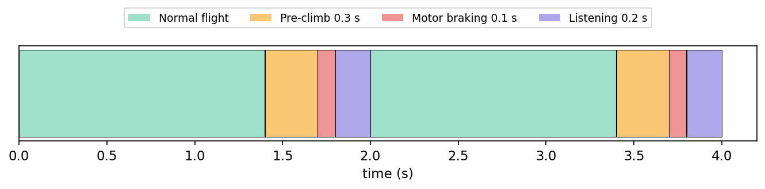
Figure 6: Timing of the listening cycle over two consecutive seconds.

4.4 Detection, Direction and Distance
A beacon is detected if the SNR in the 3–6 kHz band exceeds 6 dB relative to a beacon-free band (7–10 kHz). Six-pair intensity method: the noise-corrected band energy of each channel gives
v = [ E(+x) − E(−x), E(+y) − E(−y), E(+z) − E(−z) ]
For a cardioid microphone the difference of an opposite pair reduces exactly to cos θ, so the vector is exact without noise, whereas the originally proposed top-three-microphones method deviates as the source moves away from the center of a spherical octant. GCC-PHAT: for each opposite pair the phase-weighted cross-correlation in the beacon band, interpolated 16×, gives
s_x = − c · Δτ_x / (2r)
The two vectors are fused with fixed weights (0.4 intensity, 0.6 GCC-PHAT) and renormalized. Distance follows from the inverse-square law after calibrating the total energy P_ref at 1 m; the sum of the six channel energies is independent of direction:
d = √( P_ref / P )

4.5 Tracking and Guidance
A constant-velocity Kalman filter estimates the target position and velocity. The measurement covariance separates range and cross-range errors,
R = σ_r² · u uᵀ + (d · σ_θ)² · (I − u uᵀ)
with σ_r = 0.3d and σ_θ = 6°. Outliers are rejected by a Mahalanobis test at 16.27 (χ², 3 degrees of freedom, 99.9%), the filter is reinitialized after three consecutive rejections, and the target speed is capped at 3 m/s. A state machine (Search, Approach, Terminal) commands
v_cmd = clip( k · (d − d_s) ) · u + v̂_target
with k = 0.8, d_s = 2 m and a maximum speed of 8 m/s, sent with the MAVLink message SET_POSITION_TARGET_LOCAL_NED.

4.6 Simulation Parameters
Table 4: Main Phase One simulation parameters.
Parameter | Value
Sampling rate | 48 kHz
Sphere radius | 8 cm
Beacon band | 3 to 6 kHz
Listening cycle / window | Every 2 s / 0.2 s
Initial distance | About 80 m
Target motion | Circle of 4 m radius with wind drift
Maximum drone speed | 8 m/s
Hand-over distance | 2 m
Microphone sensitivity mismatch | 0.5 dB
Rotor ego-noise model | 40 harmonics + broadband noise

Arrival is successful if the drone remains in the Terminal state for three seconds with a true distance of 1–4 m; arrival declared outside this range is a false arrival.

5. Data and Training (new)

5.1 Drone Sound Library: Data Sources
Phase Two learns from data, so a drone sound library was assembled from two kinds of sources: parametric (synthetic) drone models that run offline, and public datasets of real recordings (Table 5). Datasets marked automatic are downloaded by the software (python -m droneloc download <name>) with a shallow, sparse git checkout of only the needed folders.
Table 5: Data sources of the drone sound library and their role.
Source | Content | Role in this work | Access
Synthetic drone models (this work) | 7 drone types, physically motivated rotor-noise model, calibrated SPL | Training of all stages; target drone in the simulations | Built in
DroneAudioDataset [17] | 1 s mono clips, 16 kHz: Parrot Bebop (666), Parrot Mambo (666), background | Real source signals; calibration of the Parrot models; voiceprint training | Automatic
Drone-detection dataset [18] | Audio of drones, helicopters and background (+ IR and visible video) | Additional drone / non-drone voiceprint data; multimodal extensions | Automatic
ESC-50 [19] | 2,000 clips × 5 s, 50 classes (wind, rain, birds, engines, helicopter) | Interference library for reference subtraction | Automatic
DREGON [9] | 8-mic array on a quadrotor, ego-noise, ground-truth source positions | Validation of localization on real array data | Manual
IEEE SP Cup 2019 [20] | Drone-embedded 8-mic recordings with direction labels | Benchmark of direction estimation | Manual
DroneNoise Database (Univ. of Salford) | Calibrated outdoor measurements of commercial drones | Calibration of the 1 m reference level (planned) | Manual

5.2 Synthetic Drone Models
Each synthetic drone is generated from its rotor physics. The fundamental of the voiceprint is the blade-passing frequency
BPF = (RPM / 60) · B
where B is the number of blades. Each rotor contributes BPF harmonics with a model-specific harmonic pattern, slightly different RPM per rotor (beating), shaft-rate imbalance lines, BLDC motor whine at multiples of the pole-pair frequency, slow thrust-control RPM fluctuation and broadband turbulence modulated at the blade passage. The harmonic pattern is fixed per model, so it acts as a reproducible voiceprint. Signals are scaled to the model's sound pressure level at 1 m (Table 6).
Table 6: Synthetic drone models in the library (selected with --drone).
Key | Drone type | Rotors × blades | Hover RPM | BPF (Hz) | SPL at 1 m (dB)
dji_mini | DJI Mini (sub-250 g) | 4 × 2 | 9600 | 320 | 70
dji_mavic | DJI Mavic class | 4 × 2 | 6600 | 220 | 76
dji_phantom4 | DJI Phantom 4 | 4 × 2 | 5400 | 180 | 80
parrot_bebop2 | Parrot Bebop 2 | 4 × 3 | 7900 | 395 | 75
parrot_mambo | Parrot Mambo (toy) | 4 × 2 | 18400 | 613 | 68
dji_matrice300 | DJI Matrice 300 (heavy) | 4 × 2 | 3300 | 110 | 88
hexa_swap | Battery-swap hexacopter (custom) | 6 × 2 | 4500 | 150 | 84

Values are representative; the Parrot Bebop and Mambo models were tuned on real recordings (Section 5.3) and the others must be re-tuned on recordings of the actual drone. hexa_swap represents the custom battery-swap hexacopter and is the default target.

5.3 Calibration on Real Recordings
The real Parrot recordings of the DroneAudioDataset were high-pass filtered at 80 Hz to remove handling and wind rumble, and their averaged spectra were analyzed (Figure 7). The Mambo shows a clear harmonic series with BPF ≈ 613 Hz (2 blades, about 18,400 RPM); the Bebop shows its BPF at ≈ 395 Hz (3 blades, about 7,900 RPM) with weaker harmonics. The synthetic models were adjusted to these values, so the voiceprint frequencies of the library match real drones.
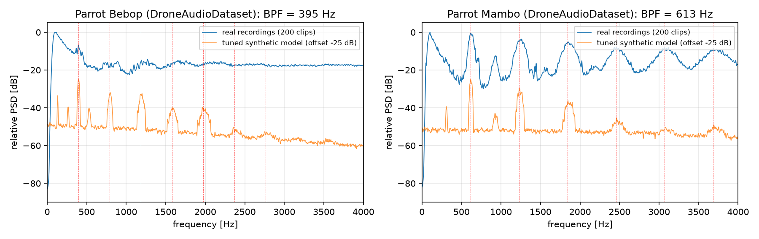
Figure 7: Averaged spectra of real Parrot recordings (DroneAudioDataset) and of the tuned synthetic models; dashed lines mark the BPF harmonics.

5.4 Training Sets per Stage
Table 7: Training data, size and model for each trained stage (default run, seed 0).
Stage | Training data | Size / split | Model and output
Voiceprint classifier | 1 s segments of each of 7 drone models at SNR −3 to +25 dB over wind, pink noise, station machinery and birds, plus a background class; RPM varied ±12%. With --dataset droneaudio the Parrot classes are drawn from the real clips | 120 segments × 8 classes = 960; 80/20 hold-out, then refit on all | Random Forest (300 trees) on 57 features → drone type, P(target), BPF
Reference subtraction | 8 s drone-free recording of the scene (array + reference microphone + vibration sensor) | One calibration window; validated on a new 4 s window | Multichannel Wiener filter per frequency (2048-point STFT) → interference-free array signals
Neural localizer | 0.5 s simulated frames of the target at random positions (range 2–60 m, elevation 5–70°), cleaned by the trained canceller | 1,200 frames; 85/15 hold-out, then refit on all | MLP (256-128) on GCC-PHAT lag windows and levels → direction and log-range
3D sound meter | Clean target signal at 1 m | 4 s calibration | Harmonic-band level at 1 m (no other training)

6. Phase Two Method: Passive Voiceprint Localization (new)

6.1 Architecture
In Phase Two the six-microphone sphere is mounted on the battery-swap station and listens to the arriving drone itself (Figure 8). The array signals are first cleaned by multimodal reference subtraction; the voiceprint identifies the drone and estimates its BPF; the BPF defines a harmonic comb that weights both the direction estimate and the level measurement; the 3D sound meter yields direction and range; and a Kalman filter tracks the drone, updating only on frames that the voiceprint attributes to the target.
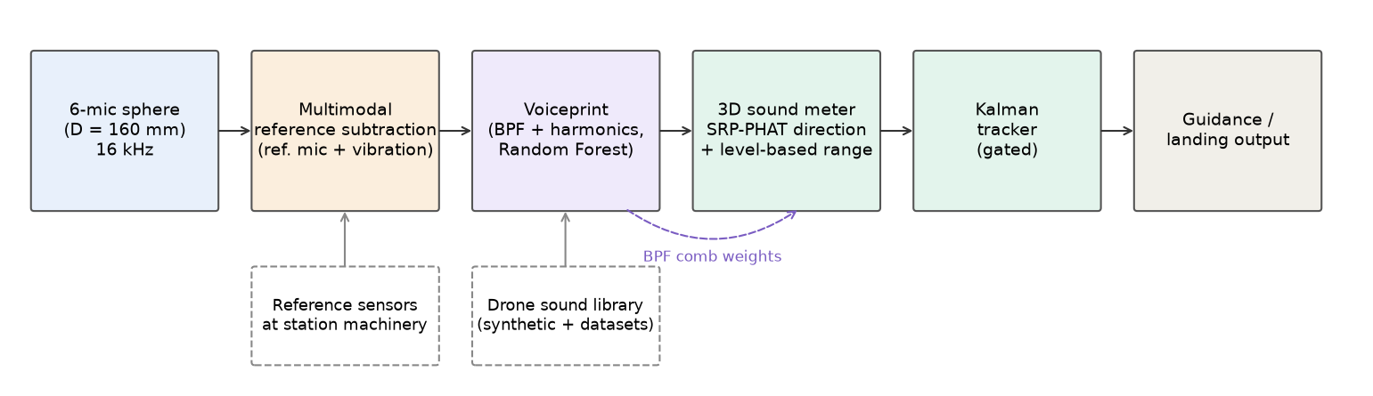
Figure 8: Phase Two processing chain; dashed boxes are the reference sensors and the drone sound library used for training.

6.2 Multimodal Reference Subtraction
Each array microphone y_m hears the drone plus interference that R reference sensors x_r also observe through different paths: an acoustic reference microphone 7 cm from the station machinery, and a vibration sensor on its frame that sees the structure-borne excitation without any airborne drone leakage. During a drone-free window the canceller learns, for every frequency f, the multichannel Wiener (least-squares) transfer
H(f) = R_yx(f) · ( R_xx(f) + λ I )⁻¹
and later subtracts the predicted interference, E = Y − H X. The filter is linear and time-invariant, so the inter-microphone phase of the drone, which the direction estimate needs, is preserved. λ is a small diagonal loading (10⁻³ of the mean reference power).

6.3 Drone Voiceprint
From each 1 s segment a 57-element, level-independent feature vector is computed: 40 normalized log-mel bands (50–7000 Hz), the levels of the first 12 BPF harmonics relative to the strongest, the BPF itself and its harmonic salience, spectral centroid, flatness and roll-off. The BPF is estimated by a harmonic sum over candidate frequencies; for the target it is searched within 0.7–1.35 × the nominal BPF to avoid octave errors. A Random Forest classifies the segment into one of the drone types or background and gives the probability that it is the target drone.

6.4 3D Sound Meter
Direction. PHAT-weighted cross-spectra of all 15 microphone pairs are multiplied by the harmonic comb W(f) of the estimated BPF, so wind and residual interference outside the drone harmonics are ignored. The steered response power is evaluated on about 6,000 directions (Fibonacci grid, elevation ≥ −30°) and refined by a weighted average around the peak:
SRP(u) = Σ_pairs Σ_f W(f) · Re{ G_ij(f) / |G_ij(f)| · e^{ j2πf τ_ij(u) } }, τ_ij(u) = (p_j − p_i) · u / c
Range. The harmonic-band level L (noise floor removed with a running median) is compared with the level L_1m calibrated at 1 m for the identified drone:
r = 10^( (L_1m − L) / 20 )
This is the same inverse-square principle as Phase One, but the reference level now comes from the voiceprint of the drone instead of a beacon.

6.5 Neural Localizer
As a trainable alternative, a multilayer perceptron maps the GCC-PHAT lag windows of the 15 pairs (±max-lag at 4× interpolation), the per-microphone level differences and the level relative to L_1m to the unit direction vector and log₁₀ of the range. It is trained entirely in simulation (Table 7) and can later be retrained on real array data such as DREGON.

6.6 Tracking
The Kalman filter of Section 4.5 is reused with σ_θ = 3° and a relative range deviation of 0.12 decades, a χ² gate of 16, and reinitialization after eight consecutive rejections. Frames with P(target) < 0.5 are not used for updates.

6.7 Simulation Scene
Table 8: Phase Two simulation scene.
Element | Model
Array | 6 microphones, octahedral (±x, ±y, ±z), radius 8 cm (D = 160 mm), center 1 m above ground, 16 kHz
Target drone | Battery-swap hexacopter (hexa_swap), 6 rotors × 2 blades, BPF 150 Hz, 84 dB at 1 m
Trajectory | 40 s spiral descent from about 43 m (altitude 18 m) to 3 m from the array
Propagation | Moving source with delay, 1/r spreading, Doppler, ground reflection (coefficient 0.5)
Interference | Station machinery 0.75 m from the array, 74 dB at 1 m: transformer hum, 7-blade cooling fan, actuator whine bursts
Reference sensors | Acoustic reference microphone 7 cm from the machinery; vibration sensor on its frame
Other noise | Incoherent gusty wind (40 dB) at each microphone, bird chirps, sensor self-noise

7. Simulation Results

7.1 Phase One

7.1.1 Six Pairs versus Top Three Microphones
Over 3,000 random directions with cardioid microphones, the six pairs give zero error without noise, whereas the top-three method deviates by about 9° even without noise, so its bias is structural (Table 9, Figure 9).
Table 9: Direction error (degrees): median and 95th percentile.
Noise level | Pairs: median | Pairs: 95th pct. | Top three: median | Top three: 95th pct.
No noise | 0.0 | 0.0 | 8.9 | 15.0
2% | 1.9 | 4.0 | 9.0 | 15.7
5% | 4.7 | 9.7 | 9.4 | 18.7

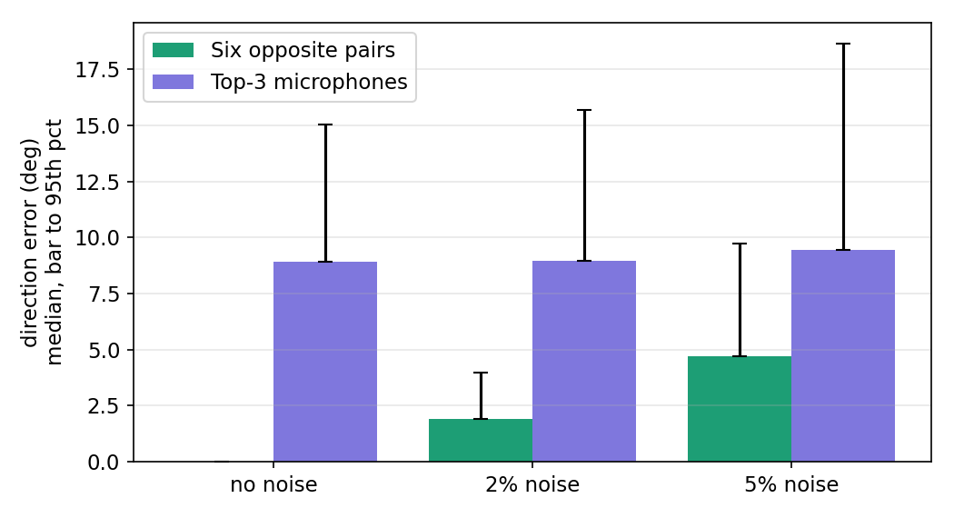
Figure 9: Direction error of the six-pair method and the top-three-microphones method.

7.1.2 Direction and Distance Accuracy versus Range
With 150 random directions per distance, during a silence window and a 3 m/s descent, detection succeeded at every distance up to 120 m (Table 10, Figure 10).
Table 10: Median direction error (degrees) and relative distance error.
Distance (m) | Intensity | GCC-PHAT | Fused | Distance error
5 | 6.1 | 0.11 | 2.4 | 3.5%
20 | 6.2 | 0.11 | 2.6 | 3.5%
40 | 5.9 | 0.13 | 2.5 | 3.4%
80 | 6.6 | 0.20 | 2.8 | 4.4%
120 | 6.1 | 0.27 | 2.9 | 5.2%

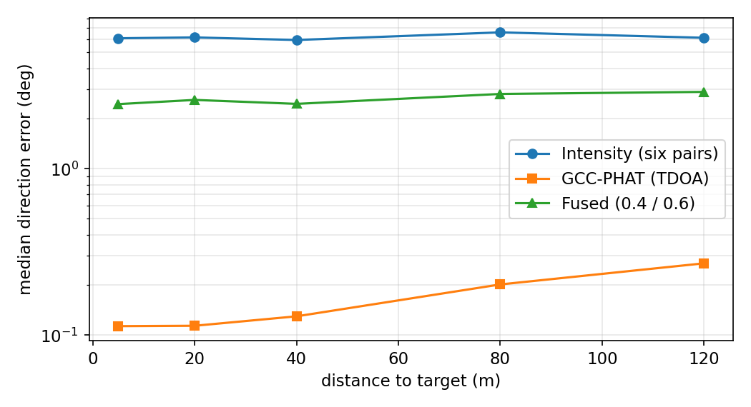
Figure 10: Median direction error of each method versus distance (logarithmic scale).

7.1.3 Example of a Complete Flight
In a typical flight (Figure 11) the drone heads toward the target in a nearly straight line and reaches the hand-over zone after about 18 s, with small altitude ripples caused by the pre-climb and short-drop cycles.
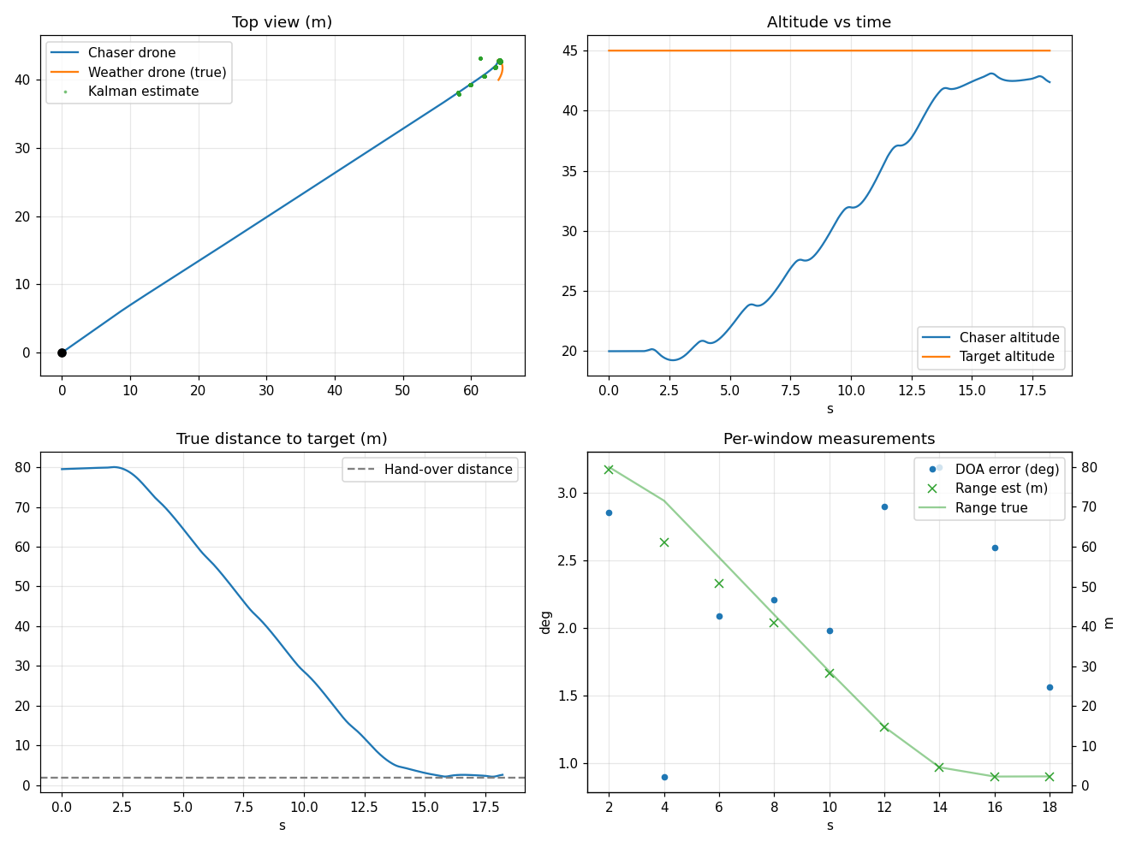
Figure 11: A typical Phase One flight: trajectory, altitude, distance to target and per-window measurements.

7.1.4 Effect of Silence Windows (Monte Carlo)
Table 11: Results of 30 randomized trials for each case.
Metric | Silence windows | Motors running
Successful arrivals | 28 / 30 | 0 / 30
False arrivals | 2 | 30
Mean arrival time | 18.2 s | —
Mean final distance | 2.9 m | —
Median direction error | 2.5° | 97.8°
Minimum altitude during trials | 19.2 m | 18.7 m

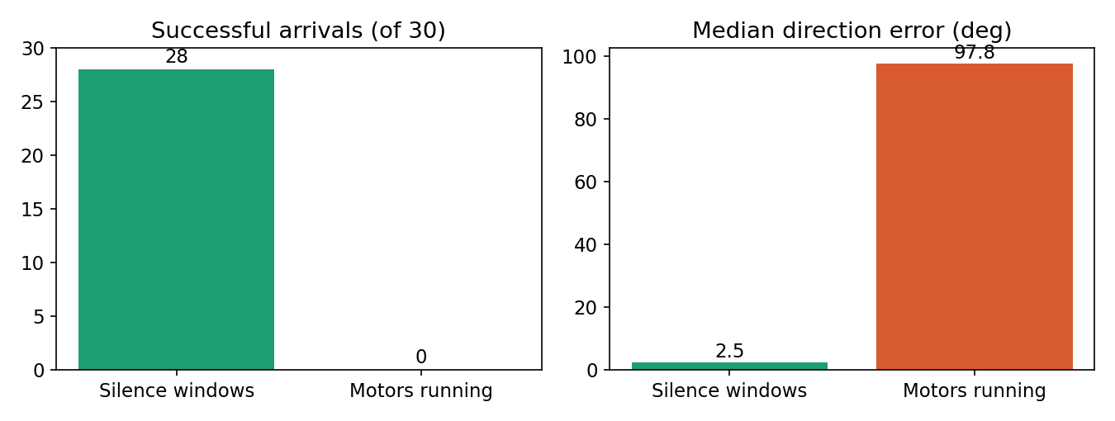
Figure 12: Successful arrivals and median direction error with and without silence windows.

7.1.5 Effect of Microphone Directivity
Table 12: Effect of the directivity coefficient α (15 trials per value).
α | Successful arrivals | False arrivals | Median direction error | Mean arrival time
1.0 | 14 / 15 | 1 | 2.5° | 18.3 s
0.6 | 15 / 15 | 0 | 2.9° | 18.3 s
0.3 | 15 / 15 | 0 | 6.4° | 19.1 s

Direction error grows as directivity decreases, but arrival remains successful because the time-difference method does not depend on directivity.

7.2 Phase Two (new)

7.2.1 Voiceprint Classification
The voiceprint classifier reached 97.9% accuracy on the held-out 20% of segments (Table 13). Remaining confusions occur mainly between drones with close BPFs and the background class at the lowest SNRs. During the mission the target was recognized in 96% of the frames.
Table 13: Confusion matrix of the voiceprint classifier on the held-out set (rows: true class, columns: predicted).
True \ predicted | 1 | 2 | 3 | 4 | 5 | 6 | 7 | 8
1. dji_mini | 25 | 0 | 0 | 0 | 0 | 0 | 0 | 0
2. dji_mavic | 0 | 22 | 0 | 0 | 0 | 0 | 1 | 0
3. dji_phantom4 | 0 | 2 | 23 | 0 | 0 | 0 | 0 | 0
4. parrot_bebop2 | 0 | 0 | 0 | 20 | 0 | 0 | 0 | 0
5. parrot_mambo | 0 | 0 | 0 | 0 | 26 | 0 | 0 | 0
6. dji_matrice300 | 0 | 0 | 0 | 0 | 0 | 20 | 0 | 1
7. hexa_swap | 0 | 0 | 0 | 0 | 0 | 0 | 26 | 0
8. background | 0 | 0 | 0 | 0 | 0 | 0 | 0 | 26

7.2.2 Reference Subtraction
Table 14: Effect of multimodal reference subtraction (default scene).
Metric | Value
Interference reduction, acoustic + vibration references | 26.8 dB
Interference reduction, acoustic reference only | 26.8 dB
Array SNR before subtraction | -7.1 dB
Array SNR after subtraction | 19.7 dB

Figure 13 shows the first 12 s of the mission at microphone 1. Before subtraction the drone's harmonics (BPF 150 Hz and multiples) are hidden under the machinery tones and the gliding actuator whine; after subtraction the drone harmonics are clearly visible and closely match the drone-only ground truth.
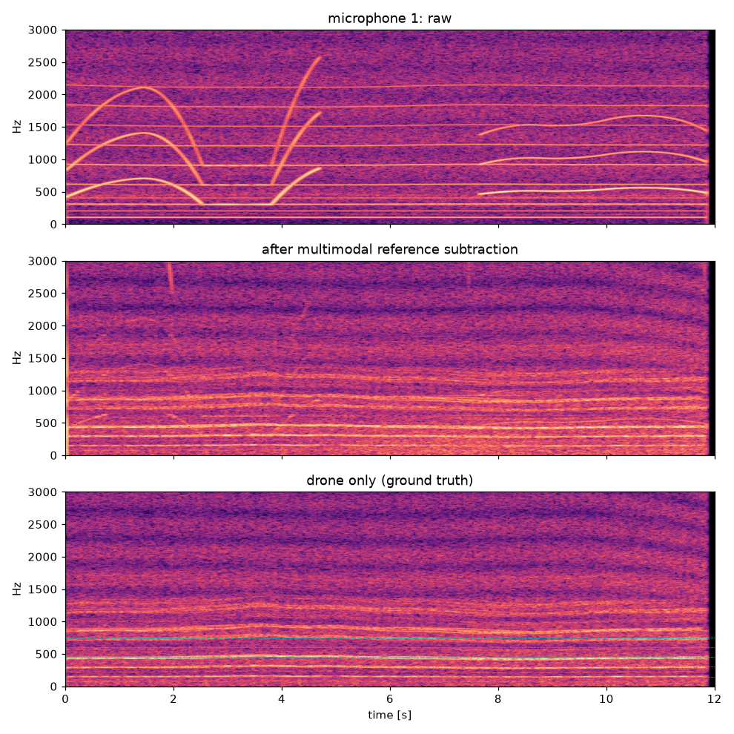
Figure 13: Spectrograms at microphone 1: raw, after multimodal reference subtraction, and drone only (ground truth); dashed lines mark the BPF harmonics.

7.2.3 3D Localization and Tracking
Table 15 compares the methods (Figure 14 shows the paths) over the 40 s approach. Without subtraction the meter locks onto the machinery (median error 54.9°) and the range collapses to a few meters. With subtraction the 3D sound meter achieves a median direction error of 0.8° and a median range error of 9%, and the Kalman track reaches a final position error of 0.06 m at the end of the approach.
Table 15: Localization accuracy over the simulated 40 s approach of the battery-swap hexacopter.
Method | Direction (median) | Range error (median) | Position (median) | Position (90th pct.) | Final position
SRP + level, no subtraction | 54.9° | 75% | 16.84 m | 39.61 m | 0.21 m
3D sound meter (cleaned) | 0.8° | 9% | 1.76 m | 6.96 m | 0.09 m
Neural localizer (cleaned) | 5.8° | 50% | 7.31 m | 34.50 m | 0.93 m
Kalman track | 0.6° | 10% | 1.75 m | 6.55 m | 0.06 m

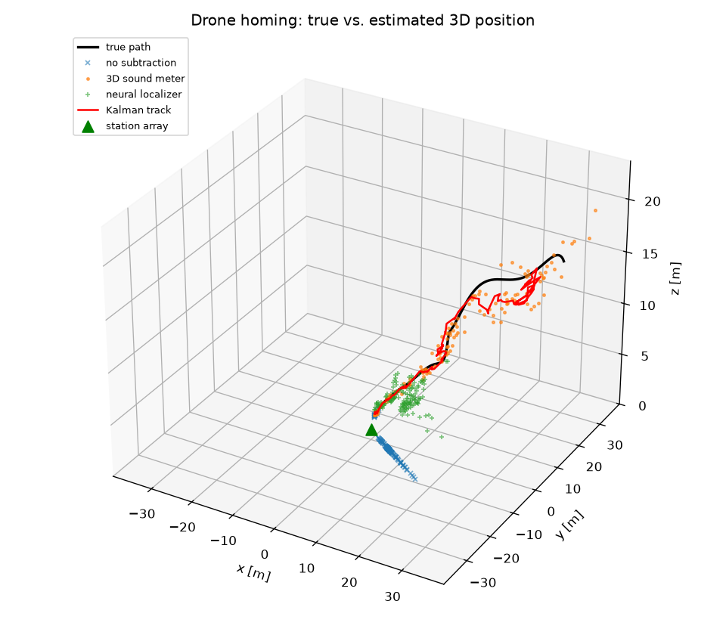
Figure 14: True path of the drone and the estimates of each method; the green triangle is the station array.
Figure 15 shows the errors over time. Position error decreases as the drone approaches because the angular error translates into a smaller lateral error and the harmonic SNR increases; most large range errors occur beyond 30 m, where the drone level approaches the wind floor.
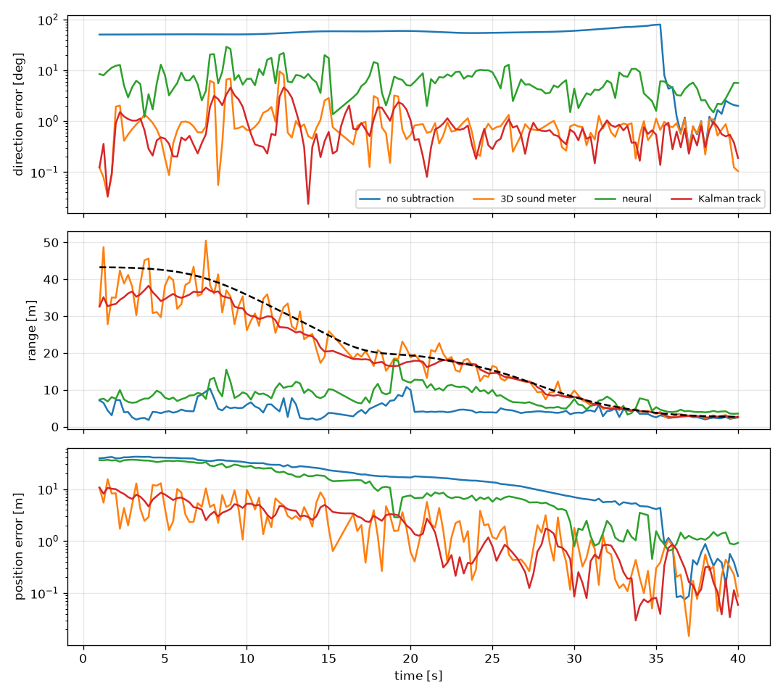
Figure 15: Direction error, estimated range and position error versus time for each method.

7.2.4 Real Drone Recordings as Sources
The mission was repeated with real recordings from the DroneAudioDataset as the drone source (Table 16). These clips are uncalibrated single-microphone recordings, so the profile's 1 m level is assumed.
Table 16: Results with real recordings as the drone source.
Source | Voiceprint accuracy | Detection rate | SNR before → after | Direction (median) | Range error (median) | Track position (median)
Parrot Mambo (real) | 94.8% | 24% | -22.1 → 8.8 dB | 0.8° | 35% | 8.59 m
Parrot Bebop (real) | 94.8% | 73% | -16.7 → 12.9 dB | 0.8° | 44% | 6.53 m
Hexacopter (synthetic) | 97.9% | 96% | -7.1 → 19.7 dB | 0.8° | 9% | 1.75 m

Direction accuracy is preserved with real voiceprints (median 0.8° for the Mambo and 0.8° for the Bebop), and reference subtraction still raises the SNR by about 30 dB. Two weaknesses appear. First, the level-based range error grows to 35–44% because the concatenated clips were recorded at different, unknown distances, so the source level fluctuates from clip to clip. Second, the target was recognized in only 24% of the frames for the Mambo (the quietest drone, 68 dB at 1 m) and 73% for the Bebop; with few accepted frames the Mambo track lags behind the drone (median track error 8.6 m although the per-frame meter error is 1.6 m). Both point to the same need: calibrated, distance-labelled recordings of the target drone for training the voiceprint and the 1 m level.

8. Discussion

8.1 Silence Windows Are an Essential Requirement
The clearest Phase One result is 28 successes out of 30 with silence windows and none without them. Rotor harmonics fall within the beacon band, so the simplified detector mistakes them for the target, and their energy makes the target appear very close, so the system declares arrival after 5 s while still 80 m away. This confirms both the rotor-silencing idea and the need for a robust classifier, which Phase Two now provides.

8.2 Fusion Weights Need Adjustment
GCC-PHAT alone (under 0.3°) is far more accurate than intensity (about 6°, due to sensitivity mismatch), and fixed-weight fusion (about 2.5°) is worse than GCC-PHAT alone. Part of this accuracy comes from the free-field model. Adaptive weights inversely proportional to each method's variance, estimated from ground tests, and microphone sensitivity calibration are recommended.

8.3 Distance Accuracy
The 3–5% distance error of Phase One assumes a constant beacon level and no air absorption or ground reflection; loudspeaker directivity, wind and humidity will increase it in practice.

8.4 Accuracy Near the Target
Position accuracy near the target is 0.5–1 m, sufficient to bring the drone close but not to dock, so the final phase must be handed over to an optical (AprilTag) or radio (UWB) system.

8.5 Practical Challenges
- Stopping and restarting motors in the air is not a standard PX4 or ArduPilot feature and requires firmware changes or careful kill-switch testing in SITL.
- Each silence window causes a drop of about 44 cm and a stability disturbance, requiring a safe altitude and power margin.
- Near the target the drop may pose a collision risk; silence windows may need to be disabled in the Terminal phase.
- The weather drone's downwash affects an approach from below and must shape the final approach path.

8.6 Simulation Limitations
Both phases use free-field propagation without scattering around the sphere; Phase One assumes a level drone during listening and a single geometry per window; rotor noise is an approximate model. The results are an upper bound on performance and require confirmation on hardware.

8.7 Reference Subtraction Plays the Role of Silence Windows (new)
In Phase Two the dominant interference is not the listener's rotors but equipment next to the array. Without subtraction the direction error was 54.9° and the estimated range stayed at a few meters for the whole approach, the same failure mechanism as listening with motors running in Phase One. Reference subtraction removes this interference without interrupting listening, which makes it an alternative to silence windows whenever the interference can be observed by a reference sensor.

8.8 The Voiceprint Guides Localization (new)
The voiceprint is used twice: to decide whether a frame belongs to the target drone, and to weight the localization spectrum with the BPF harmonic comb. The second use is what keeps the direction error near 1° at 40 m, because wind energy below 250 Hz and residual machinery tones fall between the harmonics and are ignored.

8.9 Vibration Sensor and Neural Localizer (new)
The vibration sensor added no measurable benefit in the default scene (26.8 dB with both references and 26.8 dB with the acoustic reference alone) because the acoustic reference microphone is close to the machinery and sees little drone sound. It is expected to help when the reference microphone is exposed to wind or to the drone itself, which must be tested. The neural localizer was less accurate than the model-based meter (5.8° vs. 0.8°, range error 50% vs. 9%) with 1,200 training frames; it is kept as a trainable option for real array data.

8.10 Limits of the Training Data (new)
The public recordings are single-channel, uncalibrated and recorded at varying distances, so they provide realistic voiceprints but not absolute levels or array geometry. The level-based range also assumes that the drone's sound power is constant, whereas it rises with throttle. Calibrated recordings (e.g. the Salford DroneNoise Database) and multichannel recordings of the actual battery-swap drone with the 160 mm sensor are needed before field use.

9. Conclusion and Future Work
This report presented an acoustic guidance and localization system built on a 160 mm six-microphone sphere. Phase One showed in closed-loop simulation that short rotor silence windows are essential for beacon homing and that the six-pair method outperforms the top-three-microphones method. Phase Two, new in this version, implemented the planned reference-subtraction classifier as a multimodal canceller and a drone voiceprint, assembled a drone sound library from synthetic models and public datasets, and showed that a voiceprint-guided 3D sound meter locates an approaching drone with a median direction error of about 1° where the unprocessed array fails completely. The code, data scripts and figures are public in the project repository.
Next steps:
- Integrate the subtractive-reference classifier — completed in Phase Two.
- Record the actual battery-swap drone with the 160 mm sensor to train its voiceprint and calibrate its 1 m level.
- Validate direction estimation on DREGON and SP Cup 2019 recordings, and retrain the neural localizer on them.
- Adopt adaptive fusion weights and calibrate microphone sensitivity.
- Ground-test the array with a moving loudspeaker and a hovering drone and compare with ground truth.
- Connect the system to the PX4 SITL simulator and develop a safe listening mode in the firmware.
- Fly at a safe altitude, first without silence windows and then with them; integrate with the docking and battery-replacement project.

Data and Code Availability
The source code, data download scripts, figures and this report are available in the GitHub repository https://github.com/husham-eng/Multimodal-Reference-Subtraction-Voiceprint-and-Three-Dimensional-Sound-Meter-for-Drone-Localization [24] and are archived on Zenodo with the persistent identifier 10.5281/zenodo.23122228 (concept DOI, all versions) [25]; the version described in this report (v2.0.0) is 10.5281/zenodo.23122229, published as GitHub release v2.0.0 on October 3, 2026. Each GitHub release is archived automatically as a new Zenodo version under the same concept DOI. The public datasets used for training are available from their original sources [9], [17]–[20]; they are not redistributed with the code.

References
[1] C. H. Knapp and G. C. Carter, "The generalized correlation method for estimation of time delay," IEEE Trans. Acoustics, Speech, and Signal Processing, vol. 24, no. 4, pp. 320–327, 1976.
[2] R. O. Schmidt, "Multiple emitter location and signal parameter estimation," IEEE Trans. Antennas and Propagation, vol. 34, no. 3, pp. 276–280, 1986.
[3] J.-M. Valin, F. Michaud, J. Rouat, and D. Létourneau, "Robust sound source localization using a microphone array on a mobile robot," in Proc. IEEE/RSJ IROS, 2003.
[4] K. Nakadai, T. Takahashi, H. G. Okuno, H. Nakajima, Y. Hasegawa, and H. Tsujino, "Design and implementation of robot audition system 'HARK' — open source software for listening to three simultaneous speakers," Advanced Robotics, vol. 24, no. 5–6, pp. 739–761, 2010.
[5] M. Basiri, F. Schill, P. U. Lima, and D. Floreano, "Robust acoustic source localization of emergency signals from micro air vehicles," in Proc. IEEE/RSJ IROS, 2012.
[6] K. Furukawa, K. Okutani, K. Nagira, T. Otsuka, K. Itoyama, K. Nakadai, and H. G. Okuno, "Noise correlation matrix estimation for improving sound source localization by multirotor UAV," in Proc. IEEE/RSJ IROS, 2013.
[7] L. Wang and A. Cavallaro, "Ear in the sky: Ego-noise reduction for auditory micro aerial vehicles," in Proc. IEEE AVSS, 2016.
[8] Y. Hioka, M. Kingan, G. Schmid, and K. A. Stol, "Speech enhancement using a microphone array mounted on an unmanned aerial vehicle," in Proc. IWAENC, 2016.
[9] M. Strauss, P. Mordel, V. Miguet, and A. Deleforge, "DREGON: Dataset and methods for UAV-embedded sound source localization," in Proc. IEEE/RSJ IROS, 2018. Data: http://dregon.inria.fr
[10] S. F. Boll, "Suppression of acoustic noise in speech using spectral subtraction," IEEE Trans. Acoustics, Speech, and Signal Processing, vol. 27, no. 2, pp. 113–120, 1979.
[11] B. Widrow et al., "Adaptive noise cancelling: Principles and applications," Proceedings of the IEEE, vol. 63, no. 12, pp. 1692–1716, 1975.
[12] R. E. Kalman, "A new approach to linear filtering and prediction problems," Journal of Basic Engineering, vol. 82, no. 1, pp. 35–45, 1960.
[13] Y. Bar-Shalom, X. R. Li, and T. Kirubarajan, Estimation with Applications to Tracking and Navigation. New York: Wiley, 2001.
[14] L. Meier, D. Honegger, and M. Pollefeys, "PX4: A node-based multithreaded open source robotics framework for deeply embedded platforms," in Proc. IEEE ICRA, 2015.
[15] E. Olson, "AprilTag: A robust and flexible visual fiducial system," in Proc. IEEE ICRA, 2011.
[16] K. A. O. Suzuki, P. Kemper Filho, and J. R. Morrison, "Automatic battery replacement system for UAVs: Analysis and design," Journal of Intelligent & Robotic Systems, vol. 65, pp. 563–586, 2012.
[17] S. Al-Emadi, A. Al-Ali, A. Mohammad, and A. Al-Ali, "Audio based drone detection and identification using deep learning," in Proc. 15th Int. Wireless Communications & Mobile Computing Conf. (IWCMC), 2019, pp. 459–464. Data: https://github.com/saraalemadi/DroneAudioDataset
[18] F. Svanström, F. Alonso-Fernandez, and C. Englund, "A dataset for multi-sensor drone detection," Data in Brief, vol. 39, 107521, 2021. Data: https://github.com/DroneDetectionThesis/Drone-detection-dataset
[19] K. J. Piczak, "ESC: Dataset for environmental sound classification," in Proc. 23rd ACM Int. Conf. on Multimedia, 2015, pp. 1015–1018. Data: https://github.com/karolpiczak/ESC-50
[20] A. Deleforge, D. Di Carlo, M. Strauss, R. Serizel, and L. Marcenaro, "Audio-based search and rescue with a drone: Highlights from the IEEE Signal Processing Cup 2019 student competition," IEEE Signal Processing Magazine, vol. 36, no. 5, pp. 138–144, 2019.
[21] J. H. DiBiase, H. F. Silverman, and M. S. Brandstein, "Robust localization in reverberant rooms," in Microphone Arrays: Signal Processing Techniques and Applications, M. Brandstein and D. Ward, Eds. Berlin: Springer, 2001, pp. 157–180.
[22] L. Breiman, "Random forests," Machine Learning, vol. 45, no. 1, pp. 5–32, 2001.
[23] F. Pedregosa et al., "Scikit-learn: Machine learning in Python," Journal of Machine Learning Research, vol. 12, pp. 2825–2830, 2011.
[24] H. Saied, "Multimodal reference subtraction, voiceprint and three-dimensional sound meter for drone localization," GitHub repository, 2026. https://github.com/husham-eng/Multimodal-Reference-Subtraction-Voiceprint-and-Three-Dimensional-Sound-Meter-for-Drone-Localization
[25] H. Saied, "Multimodal Reference Subtraction, Drone Voiceprint and Three-Dimensional Sound Meter for Drone Localization" (software and report, versions 2.0.0–2.0.1, MIT license), Zenodo, 2026. doi: 10.5281/zenodo.23122228 (all versions); version 2.0.0: doi: 10.5281/zenodo.23122229. https://doi.org/10.5281/zenodo.23122228

Appendix A: Source Code and Reproducibility

A.1 Repository
Table 17: Project identifiers.
Item | Identifier
GitHub repository | https://github.com/husham-eng/Multimodal-Reference-Subtraction-Voiceprint-and-Three-Dimensional-Sound-Meter-for-Drone-Localization
Release described in this report | v2.0.0 (October 3, 2026) — https://github.com/husham-eng/Multimodal-Reference-Subtraction-Voiceprint-and-Three-Dimensional-Sound-Meter-for-Drone-Localization/releases/tag/v2.0.0
Zenodo DOI, all versions | 10.5281/zenodo.23122228 — https://doi.org/10.5281/zenodo.23122228
Zenodo DOI, version 2.0.0 | 10.5281/zenodo.23122229 — https://doi.org/10.5281/zenodo.23122229
License | MIT (code); see the LICENSE file in the repository
Latest release | v2.0.1 — adds the MIT license and this final report; always reachable through the all-versions DOI

All Phase Two code, data download scripts, tests and figures are in the public repository https://github.com/husham-eng/Multimodal-Reference-Subtraction-Voiceprint-and-Three-Dimensional-Sound-Meter-for-Drone-Localization (branch main) [24], archived on Zenodo as 10.5281/zenodo.23122228 [25]. The files CITATION.cff and .zenodo.json in the repository hold the citation and archive metadata.

A.2 Phase Two Package droneloc (new)
Table 18: Modules of the droneloc package and their role.
File | Role
catalog.py | Drone sound library: synthetic drone models and public dataset catalog
synth.py | Rotor-noise synthesis (BPF harmonics, shaft lines, motor whine, turbulence) and ambient noise
datasets.py | Dataset download (sparse git checkout), WAV loading, real/synthetic source bank
simulation.py | Station scene: 6-mic array, moving drone, machinery, reference sensors, wind, birds, ground reflection
reference_subtraction.py | Multichannel Wiener reference canceller (multimodal references)
voiceprint.py | BPF estimation, voiceprint features, Random Forest classifier, 1 m level calibration
localization.py | Voiceprint-weighted GCC-PHAT, SRP-PHAT, 3D sound meter, neural localizer
tracking.py | Constant-velocity Kalman filter with direction/range covariance and gating
pipeline.py, plots.py, __main__.py | Training of all stages, mission run, report, figures, audio and command line
tests/test_droneloc.py | Unit tests (11 tests)

A.3 Reproducing the Results
With Python 3.10 or newer:
pip install -r requirements.txt
python -m droneloc libraries
python -m droneloc run --drone hexa_swap
python -m droneloc download droneaudio
python -m droneloc run --drone parrot_mambo --dataset droneaudio
python -m pytest tests
Each run writes report.json, the figures and audio files (mic1_raw.wav, mic1_clean.wav, drone_truth.wav) to outputs/. Results in this report use seed 0 and an array radius of 8 cm.

A.4 Phase One Scripts
Table 19: Phase One source files (not yet included in the repository).
File | Role
config.py | All system parameters in one place
acoustics.py | Simulation of the six channels, the beacon and noise
doa.py | Detection, classification, direction and distance estimation
tracker.py | Kalman filter with outlier rejection
guidance.py | Silence-window scheduling and the guidance state machine
simulate.py | Closed loop, plots and Monte Carlo trials
mavlink_interface.py | Interface with PX4/ArduPilot for real flight

Appendix B: Original Project Concept
The project started from the following concept note, reproduced here in edited form:
- Build an application that controls a drone heading toward another drone in order to replace the batteries of the other drone, which flies for long periods to monitor the weather.
- Sound direction meter: applications hear sound but do not know where it comes from; applications hear and understand sound but do not know who produced it.
- Proposal: mount six microphones on the surface of a sphere covering its six poles, on top of a drone. Classify the sound first with the subtractive reference of the previous work, analyze the intensity in the six channels, build the direction vector and locate the source in 3D space, and steer the drone toward it.
Phase One replaced the top-three-microphones vector by the six-pair difference vector fused with GCC-PHAT, and Phase Two implemented the subtractive reference and the “who produced it” part as the drone voiceprint.

