A Systematic Comparison of Six Classifier Families for ECG-Based Myocardial Infarction Localization
An extension study for the ecg-mi-classifier project — evaluating Random Forest, a single Decision Tree, Support Vector Machines (SVM), Nearest Centroid, K-Means Cluster Prototypes, and PCA-reduced Logistic Regression, all fed the same intersection-stemmed feature representation and evaluated with patient-level GroupKFold cross-validation

1. Objectives and Motivation
The deployed ecg-mi-classifier application relies on a Random Forest classifier to localize myocardial infarction type from ECG morphology, after a signal-processing step ("stemming") that keeps only the portions of a beat that deviate from a statistically-derived normal range. A prior experiment tested replacing Random Forest with a simpler "Nearest Centroid" classifier; it did not outperform Random Forest. However, that single pairwise comparison used two classifiers under two slightly different feature pipelines, leaving an open question: was Random Forest's advantage specific to that one comparison, or does it generalize across many classifier families?
This paper widens that experiment into a systematic comparison across six classifier families, all fed the exact same feature representation (intersection stemming, same swept envelope width k, same cross-validation folds), so that any performance difference can be attributed to the final decision rule alone — not to incidental differences in preprocessing. A second, equally important goal of this design is methodological: by holding every classifier to the same strict patient-level GroupKFold evaluation, we deliberately avoid the well-known trap of beat-level or record-level splits, which can leak a patient's other beats into the training set and produce inflated accuracy figures that do not reflect performance on genuinely unseen patients. Every number reported in this paper comes from data held out at the patient level.

2. Methodology
2.1 Data
492 real patients from the open PTB-XL database (physionet.org/content/ptb-xl), independently diagnosed by cardiologists, across four supported ECG leads: Lead I, aVR, V2, and V6 — 5,952 beats per lead.
2.2 Shared feature pipeline: intersection stemming
For every beat, a statistical envelope (mean ± k·std) is built for each class separately — the Normal class and every pathological class individually, not only Normal as in the classic approach. "Intersection stemming" then keeps only the samples of a beat that fall outside the Normal envelope AND inside at least one pathological class's envelope; every other sample is zeroed out, including anything past the beat's own dynamic cutoff point. This exact representation, at the same k for a given run, is fed to all six classifiers, which is what makes the comparison fair.
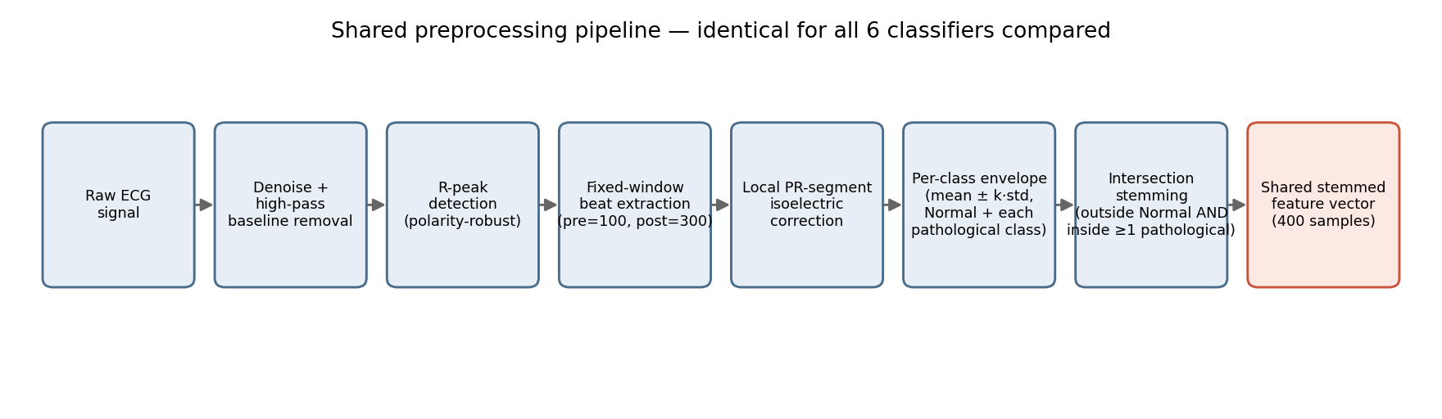
Figure 1: Shared preprocessing pipeline, identical for all six classifiers compared in this study.
2.3 The six compared methods
• Random Forest — 300 trees, max depth 12, matching the current production model's configuration.
• Decision Tree — a single tree at the same depth as Random Forest, isolating the effect of ensembling itself.
• SVM (RBF kernel) — chosen for its ability to capture non-linear decision boundaries, with class-balanced weighting.
• Nearest Centroid — one centroid (mean residual shape) per class, classified by Euclidean distance.
• Cluster Prototypes — a generalization of Nearest Centroid: 3 K-Means clusters built within each class rather than a single centroid, classified by nearest cluster among all classes' clusters.
• PCA + Logistic Regression — dimensionality reduction (retaining 95% of variance) followed by a simple linear classifier, to test whether the "curse of dimensionality" (400 raw samples) is itself a bottleneck.
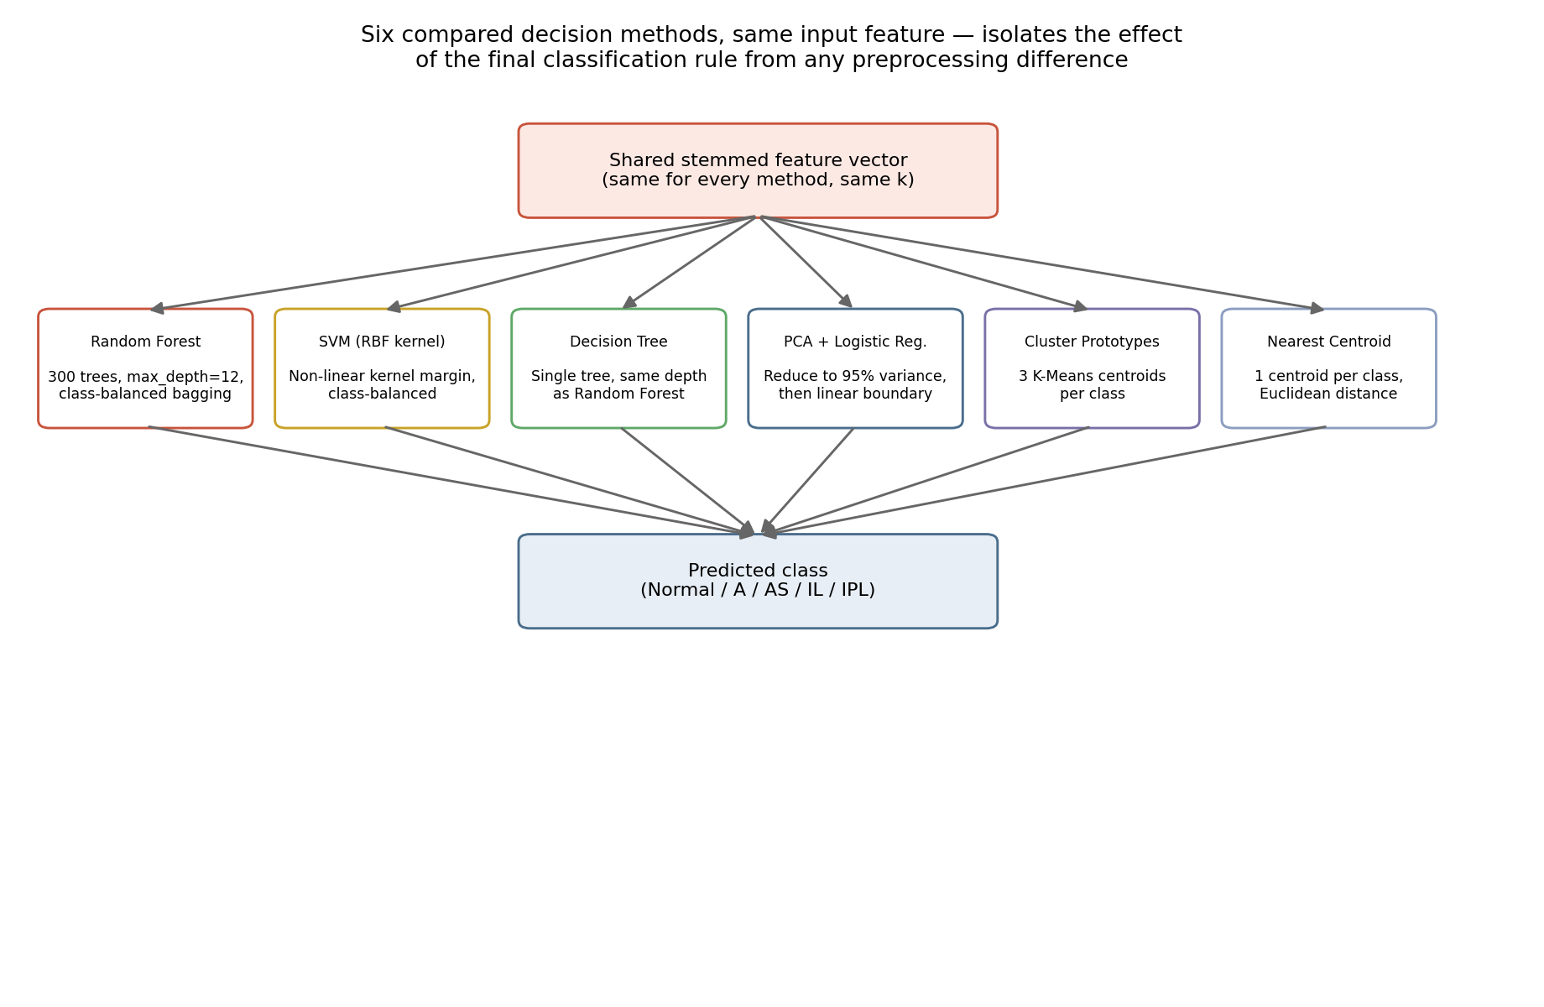
Figure 2: The six decision methods branch from the same shared feature vector, isolating the effect of the final classification rule.
2.4 Evaluation protocol
Patient-level GroupKFold, 5 folds — no patient's beats appear in both the training and test portions of the same fold, which prevents data leakage and ensures the reported numbers reflect performance on genuinely unseen patients. Metric: Macro-F1 (unweighted average F1 across classes, appropriate given the unequal number of patients per class). The envelope width k was swept over {0.75, 1.25, 1.75, 2.25, 2.5}; the best result per method/lead is reported.

3. Results
3.1 Feature reduction achieved by stemming
Before comparing classifiers, it is worth quantifying how much of the raw beat intersection stemming actually removes. Across all four leads, between 77.6% and 80.6% of the 400 samples in a beat are zeroed out by stemming (measured on the full dataset, at k=1.25 — Random Forest's winning width on every lead):
Lead | k | Samples zeroed by stemming
Lead I | 1.25 | 79.1%
aVR | 1.25 | 80.5%
V2 | 1.25 | 79.7%
V6 | 1.25 | 77.7%
In other words, each classifier is effectively working with roughly one-fifth of the original signal — a substantial dimensionality reduction achieved purely by domain-driven signal processing, before any classifier-specific feature selection.
3.2 Macro-F1 by lead and method — corrected (lead-supported classes only)
Following the fix in Section 5, aVR, V2, and V6 are now evaluated on 376 patients / 4,529 beats each (the "A" pathology class, not supported on these leads, is excluded entirely rather than leaking into training/evaluation as five classes). Lead I is unaffected (it supports all four pathology classes) and remains at 492 patients / 5,952 beats. Best Macro-F1 achieved by each method, per lead (ordered by performance; ★ marks the best result on that lead):

Lead I (492 patients, 5,952 beats)
Method | Macro-F1 | ± std | Best k
Random Forest | 0.302 ★ | 0.045 | 1.25
SVM (RBF kernel) | 0.301 | 0.023 | 1.25
Decision Tree | 0.297 | 0.029 | 1.75
PCA + Logistic Regression | 0.280 | 0.028 | 1.75
Cluster Prototypes (K-Means) | 0.267 | 0.012 | 1.75
Nearest Centroid | 0.245 | 0.039 | 2.25

aVR (376 patients, 4,529 beats)
Method | Macro-F1 | ± std | Best k
Random Forest | 0.480 ★ | 0.044 | 1.25
SVM (RBF kernel) | 0.460 | 0.017 | 0.75
Decision Tree | 0.449 | 0.040 | 1.25
PCA + Logistic Regression | 0.429 | 0.021 | 1.25
Cluster Prototypes (K-Means) | 0.415 | 0.053 | 2.25
Nearest Centroid | 0.413 | 0.030 | 1.75

V2 (376 patients, 4,529 beats)
Method | Macro-F1 | ± std | Best k
Random Forest | 0.608 ★ | 0.030 | 1.25
Decision Tree | 0.568 | 0.034 | 1.75
SVM (RBF kernel) | 0.514 | 0.019 | 1.75
PCA + Logistic Regression | 0.483 | 0.045 | 1.75
Nearest Centroid | 0.476 | 0.045 | 1.75
Cluster Prototypes (K-Means) | 0.453 | 0.019 | 2.25

V6 (376 patients, 4,529 beats)
Method | Macro-F1 | ± std | Best k
Random Forest | 0.542 ★ | 0.041 | 1.75
SVM (RBF kernel) | 0.531 | 0.038 | 1.25
Decision Tree | 0.518 | 0.041 | 1.75
PCA + Logistic Regression | 0.473 | 0.038 | 1.25
Cluster Prototypes (K-Means) | 0.444 | 0.036 | 1.25
Nearest Centroid | 0.442 | 0.034 | 1.75

Overall ranking (average across the four leads)
Rank | Method | Average Macro-F1
1 | Random Forest | 0.483
2 | Decision Tree | 0.458
3 | SVM (RBF kernel) | 0.452
4 | PCA + Logistic Regression | 0.416
5 | Cluster Prototypes (K-Means) | 0.395
6 | Nearest Centroid | 0.394
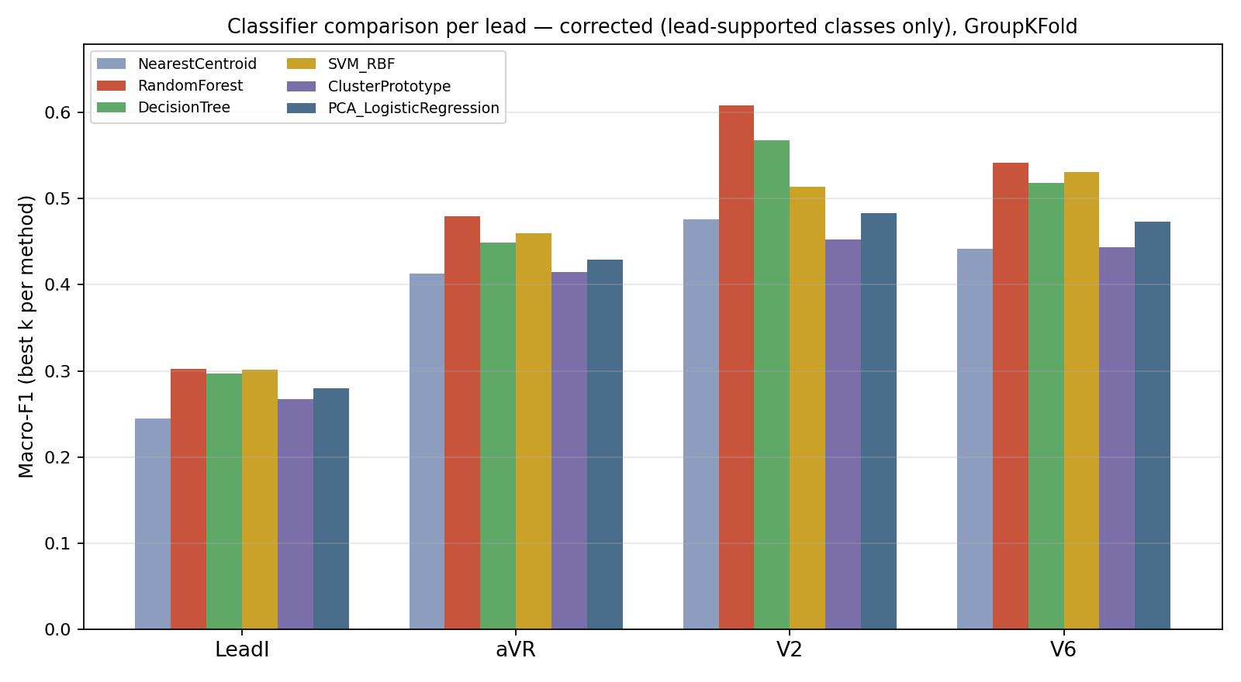
Figure 3: Macro-F1 (best k) for every method, across all four leads. Random Forest leads on every single lead.
3.3 Where does Random Forest actually succeed and fail? Out-of-fold confusion matrices
Aggregate Macro-F1 hides which specific confusions drive the score. The matrices below combine every patient's out-of-fold prediction (each patient predicted exactly once, from a fold that never saw them during training) into a single confusion matrix per lead, for Random Forest — the overall winning method. aVR, V2, and V6 are shown with their four supported classes only, reflecting the fix in Section 5.
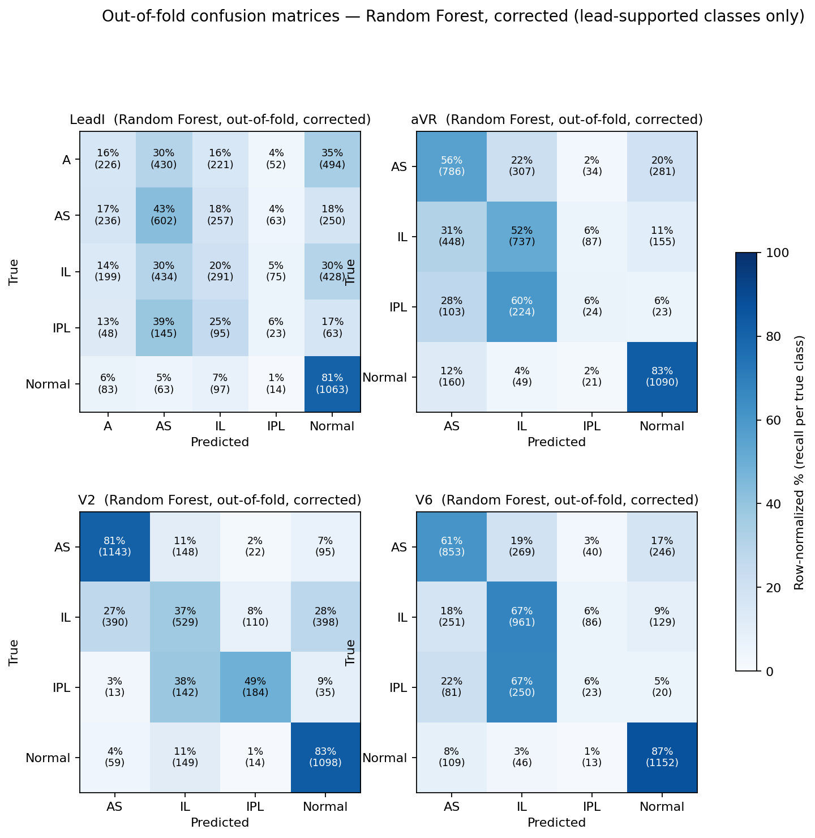
Figure 4: Out-of-fold confusion matrices for Random Forest, all four leads, corrected (row-normalized % with raw counts in parentheses).
Three consistent patterns stand out:
• The Normal class is recognized reliably everywhere (81-87% recall) — the model rarely mistakes a genuinely normal beat for a pathological one.
• AS recall varies sharply by lead: only 43% on Lead I, but 81% on V2 — V2 appears to be a particularly informative lead for this specific pathology, consistent with V2's anatomical position over the anteroseptal region.
• IPL — the rarest pathological class — is recognized poorly on three of the four leads (6% recall on Lead I, aVR, and V6), and only moderately on V2 (49%). This lines up with the known data limitation noted throughout this project: IPL has substantially fewer training patients than the other classes, and is the most consistent weak point across every lead and every method tested.

4. Discussion
4.1 Random Forest wins consistently and by a clear margin
Random Forest achieved the best Macro-F1 on all four leads without exception, and by a margin exceeding the typical fold-to-fold standard deviation in most cases — most clearly on V2, where it beat the next-best method (Decision Tree) by 4 percentage points. This confirms and generalizes the earlier Nearest-Centroid-vs-RF finding: Random Forest's advantage is not specific to that one comparison — it outperformed all five other methods tested here as well.
4.2 Decision Tree and SVM are close runners-up, well ahead of centroid-based methods
Averaged across leads, a single Decision Tree (avg. Macro-F1 0.458) and SVM with an RBF kernel (avg. 0.452) are nearly tied for second place — closer to each other than to Random Forest above them or to PCA+Logistic Regression below. This is a more nuanced picture than a simple "ensembles beat everything else": a lone decision tree, despite its known high variance, performs competitively here, while Random Forest's ensemble averaging still adds a clear, consistent margin over its own individual building block on every lead.
4.3 Centroid-based methods are consistently the weakest
Nearest Centroid was the weakest method on 3 of 4 leads, and its generalization to multiple prototypes per class (Cluster Prototypes) improved on it only slightly. This suggests that distinguishing pathological classes is not simply a shift of the centre of mass, as the centroid assumption implies, but depends on finer interactions between specific positions within the beat — exactly the kind of pattern that tree-based and non-linear-margin models capture better than a direct Euclidean distance.
4.4 Dimensionality reduction does not close the gap
PCA+Logistic Regression improved on the centroid-based methods but still trailed Random Forest and SVM on every lead. This indicates that the "curse of dimensionality" from 400 raw samples is not the primary cause of the performance gap — even after reducing dimensionality, a simple linear model did not close the gap with the non-linear models. The deeper issue appears to be the non-linear nature of the underlying relationship itself, not the number of dimensions.
4.5 The most important finding: even the best method remains moderately accurate
Despite its clear lead over the other five methods, Random Forest's best result (60.8% on V2) remains well short of a level of reliability suitable for independent clinical use. This matches the earlier experiment's conclusion: the choice of classification algorithm is not the primary bottleneck in this problem — none of the six methods compared here crossed that ceiling. The confusion matrices reinforce this: Normal beats are separated reliably, but the rarest pathological class (IPL) is missed on most leads regardless of classifier, pointing to a data-availability limitation rather than an algorithmic one.

5. A Correction Applied Before This Revision
An earlier pass of this comparison contained a cross-lead class-label mismatch: aVR, V2, and V6 are documented in the project as not supporting the "A" (Anterior) pathology class for stemming purposes. However, because all four leads are simultaneous recordings of the same patients, "A"-labeled beats were still physically present in the cached data for these three leads, and the original comparison script did not exclude them from training or evaluation — effectively scoring these leads on five classes instead of the four the production model actually targets there. This was corrected by filtering each lead's data to {Normal} ∪ its documented pathological classes before any envelope-building, stemming, or classifier fit/predict. All numbers in Section 3 above already reflect this fix (376 patients / 4,529 beats for aVR, V2, V6, versus the full 492 / 5,952 for Lead I) — the corrected scores are meaningfully higher than the pre-fix pass (e.g. Random Forest on V2 rose from 52.9% to 60.8%), confirming the earlier numbers had understated real performance on these three leads.

6. Limitations
• The k grid swept here (5 values) is narrower than the earlier two-method comparison (10 values), to keep runtime manageable on free-tier Colab compute — a better k outside this grid cannot be fully ruled out.
• Position-aware IDF/specificity weighting (used in the actual production model) was deliberately not applied to any of the six methods here, to isolate the effect of the classifier itself. It is plausible that adding this weighting specifically to Random Forest or SVM would improve results further than this stripped-down comparison suggests.
• Each classifier's hyperparameters (e.g., number of trees, SVM's C and gamma, number of clusters) used reasonable defaults rather than an independent tuning pass per method — relative results could shift somewhat after full hyperparameter optimization.
• The sample (376-492 patients depending on lead) remains relatively limited for strong statistical generalization, particularly for the rarer pathological classes (A and IPL specifically have substantially fewer patients than Normal and AS).

7. Conclusion and Recommendation
The core finding is unambiguous: Random Forest remains the best choice among the six methods tested on every lead, reaffirming the earlier decision to keep it in the deployed model. A single Decision Tree and an RBF-kernel SVM are close, roughly tied runners-up — both comfortably ahead of the three simpler, prototype- or projection-based methods. However, the real gap in this project is not the choice of classification algorithm — it is the need for wider training data, and possibly richer feature extraction (such as explicitly incorporating ST-T segment information, or learning representations directly from the raw signal via deep learning instead of hand-designed stemming) as the next research direction.

8. Simplified Explanation of the Processing Pipeline
For readers without a signal-processing background, every heartbeat passes through four steps before reaching any classifier. First, noise and slow baseline drift (e.g. from a patient's breathing) are removed. Second, the R-peak of the beat is located as a reference point, and a fixed window is cut around it (100 samples before, 300 after). Third, a small correction is applied using the quiet PR segment just before the peak, so the beat's zero-level is accurate. Fourth and finally, the beat's shape is compared against a statistically-derived "normal" range — any portion that matches what is expected is zeroed out entirely ("stemming"), leaving only the "unusual" portion that may carry diagnostic signal. It is only this residual portion — not the whole beat — that is fed to any of the six methods compared in this study.

9. Data and Code Availability
This study is conducted entirely within the ecg-mi-classifier-v4 project, independent of any other repository or publication.
• Code repository: github.com/husham-eng/ecg-mi-classifier-v4
• Live application: ecg-mi-classifier-v4.onrender.com
• Archived release (Zenodo, DOI): https://doi.org/10.5281/zenodo.22670284
• Training data: PTB-XL, physionet.org/content/ptb-xl (Wagner et al., 2020; see References)
• Reproducible experiment scripts: tools/classifier_comparison_experiment_colab.py and tools/diagnostics_experiment_colab.py in the repository above

References
PTB-XL dataset and benchmarking
1. Wagner P, Strodthoff N, Bousseljot R, Samek W, Schaeffter T. PTB-XL, a large publicly available electrocardiography dataset. Scientific Data. 2020;7:154.
2. Strodthoff N, Wagner P, Schaeffter T, Samek W. Deep Learning for ECG Analysis: Benchmarks and Insights from PTB-XL. IEEE J Biomed Health Inform. 2021;25(5):1519-1528.
3. Strodthoff N, Mehari T, Nagel C, et al. PTB-XL+, a comprehensive electrocardiographic feature dataset. Scientific Data. 2023;10:279.
4. Bousseljot R, Kreiseler D, Schnabel A. Nutzung der EKG-Signaldatenbank CARDIODAT der PTB über das Internet. Biomedizinische Technik. 1995;40(s1):317-318.
5. Goldberger AL, Amaral LAN, Glass L, et al. PhysioBank, PhysioToolkit, and PhysioNet. Circulation. 2000;101(23):e215-e220.
Machine learning for ECG-based MI classification
6. A Robustness Evaluation of Machine Learning Algorithms for ECG Myocardial Infarction Detection. J Clin Med. 2022;11(17):4935.
7. Machine Learning Methods in Predicting Patients with Suspected Myocardial Infarction Based on Short-Time HRV Data. Sensors. 2022;22(18):7033.
8. Machine learning models for classification of myocardial infarction using the PTB-XL dataset. Lund University student thesis.
9. Herman R, et al. Machine learning for ECG diagnosis and risk stratification of occlusion myocardial infarction. Nature Medicine. 2023.
10. Garg S, et al. ECG-Lens: Benchmarking ML & DL Models on PTB-XL Dataset. arXiv:2604.15822.
Deep learning approaches (for context/comparison)
11. Detection of Acute Myocardial Infarction Using Deep Learning on Lead-I ECG Data. medRxiv. 2024.
12. An integrated algorithm for single lead electrocardiogram signal analysis using deep learning with 12-lead data.
13. Study of the Few-Shot Learning for ECG Classification Based on the PTB-XL Dataset. PMC. 2022.
R-peak detection and signal preprocessing
14. Pan J, Tompkins WJ. A Real-Time QRS Detection Algorithm. IEEE Trans Biomed Eng. 1985;32(3):230-236.
15. Khan NM, et al. Pan-Tompkins++: A Robust Approach to Detect R-peaks in ECG Signals. arXiv:2211.03171.
16. An Adaptive and Time-Efficient ECG R-Peak Detection Algorithm. PMC. 2017.
Theoretical foundations of the six compared methods
17. Breiman L. Random Forests. Machine Learning. 2001;45(1):5-32.
18. Cortes C, Vapnik V. Support-Vector Networks. Machine Learning. 1995;20(3):273-297.
19. Tibshirani R, Hastie T, Narasimhan B, Chu G. Diagnosis of multiple cancer types by shrunken centroids of gene expression. PNAS. 2002;99(10):6567-6572.
20. Jolliffe IT, Cadima J. Principal component analysis: a review and recent developments. Phil Trans R Soc A. 2016;374(2065):20150202.
Reproducibility
Full reproducible experiment scripts: tools/classifier_comparison_experiment_colab.py and tools/diagnostics_experiment_colab.py in the project repository (see Section 9).

