<https://wordcloud.timdream.org/#wikipedia:Cloud>

267 FAST

109 Framework

88 Open-Source

73 GUI

65 Non-GUI

59 FIX

55 BDD.

54 Cucumber

53 TestNG

50 Junit

50 CD

50 ICG JIRA

50 Bitbucket

46 ICG Build

45 Citi Artifactory

44 Cloud

43 Docker

42 Openshift

42 MSST

41 FAST

41 Framework

40 Open-Source

40 GUI

40 Non-GUI

40 FIX

39 BDD.

39 Cucumber

39 TestNG

39 Junit

39 CD

38 ICG JIRA

38 Bitbucket

38 ICG Build

38 Citi Artifactory

38 Cloud

38 Docker

38 Openshift

38 MSST

37 FAST

37 Framework

37 Open-Source

37 GUI

37 Non-GUI

37 FIX

37 BDD.

37 Cucumber

37 TestNG

37 Junit

37 CD

36 ICG JIRA

36 Bitbucket

36 ICG Build

35 Citi Artifactory

35 Cloud

35 Docker

35 Openshift

34 MSST

34 FAST

34 Framework

34 Open-Source

34 GUI

34 Non-GUI

34 FIX

34 BDD.

34 Cucumber

34 TestNG

34 Junit

34 CD

34 ICG JIRA

34 Bitbucket

34 ICG Build

34 Citi Artifactory

34 Cloud

33 Docker

33 Openshift

33 MSST

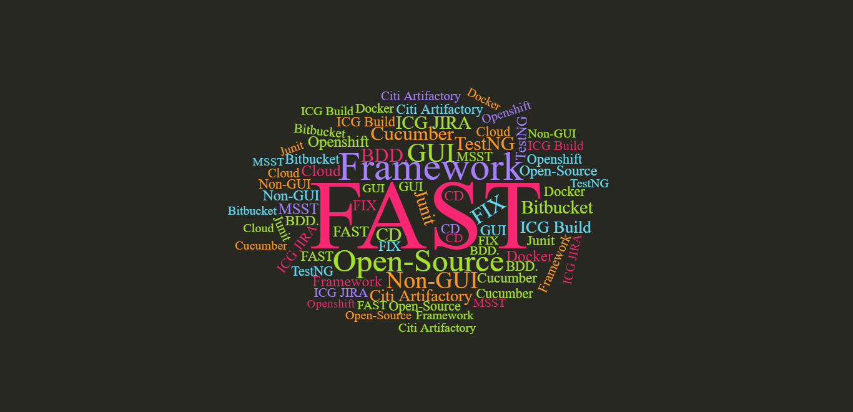

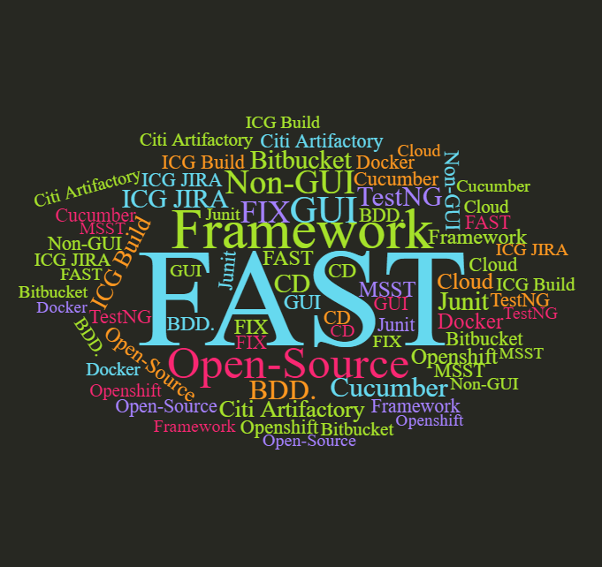

Keywords:

Internal Open-Source

Test Automation ecosystem

Address varied automation needs across multiple technology stacks(e.g. GUI, Non-GUI and FIX)

BDD based on Cucumber

Integrated with TestNG/Junit

Integrated with CD tools like ICG JIRA, Bitbucket, ICG Build, Citi Artifactory

Leverage Cloud(Docker/Openshift)

Adopted by teams with MSST

Benefits:

Standardize the framework and tools globally across teams

Reduce time to market

Save effort across different teams

Create mature, scalable and maintainable solution for Continuous Testing and Continuous delivery