开发环境：

前端：vue 2 + elementUI 2 +Chrome 64

后台：Mybatis + Spring MVC + MySQL + Postman

采用vue的axios去调用后台API获取数据信息展示在前端。

**axios(config)**

*// Send a POST request*

axios({

  method**:** 'post',

  url**:** '/user/12345',

  data**:** {

    firstName**:** 'Fred',

    lastName**:** 'Flintstone'

  }

});

*// GET request for remote image*

axios({

  method**:**'get',

  url**:**'http://bit.ly/2mTM3nY',

  responseType**:**'stream'

})

  .then(function(response) {

  response.data.pipe(fs.createWriteStream('ada_lovelace.jpg'))

});

Login:

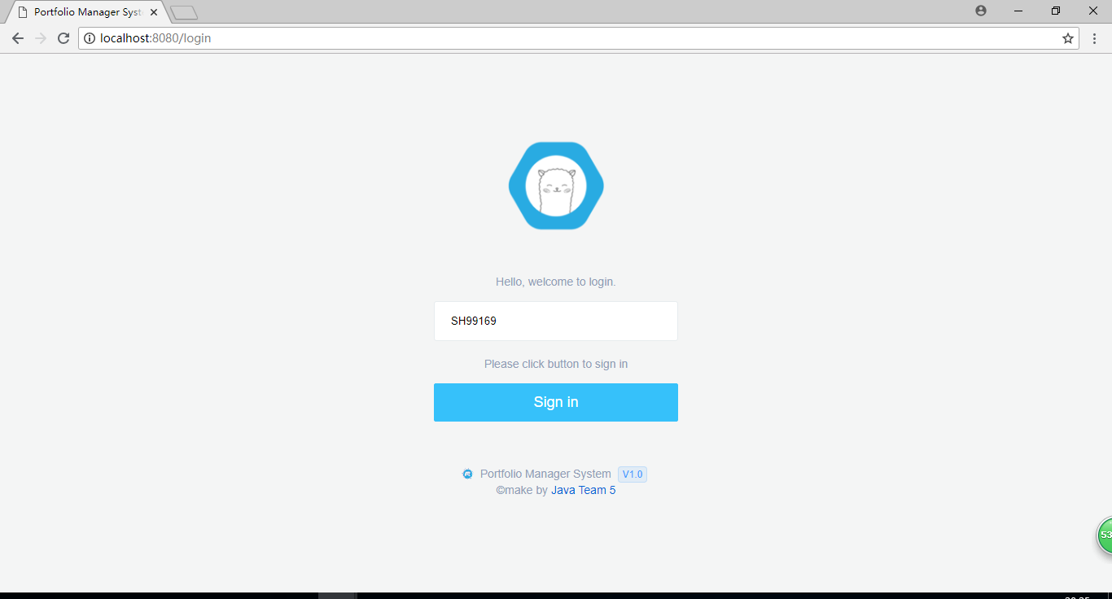

Administrator Sign in:

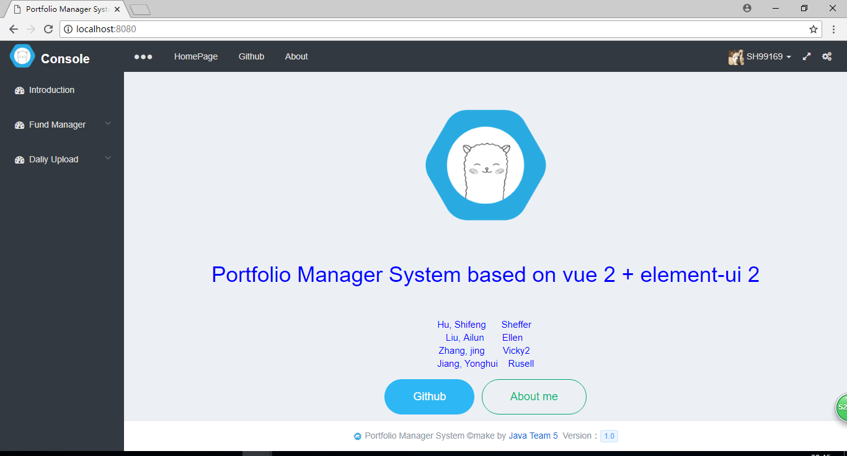

Administrator Menus(Left View):

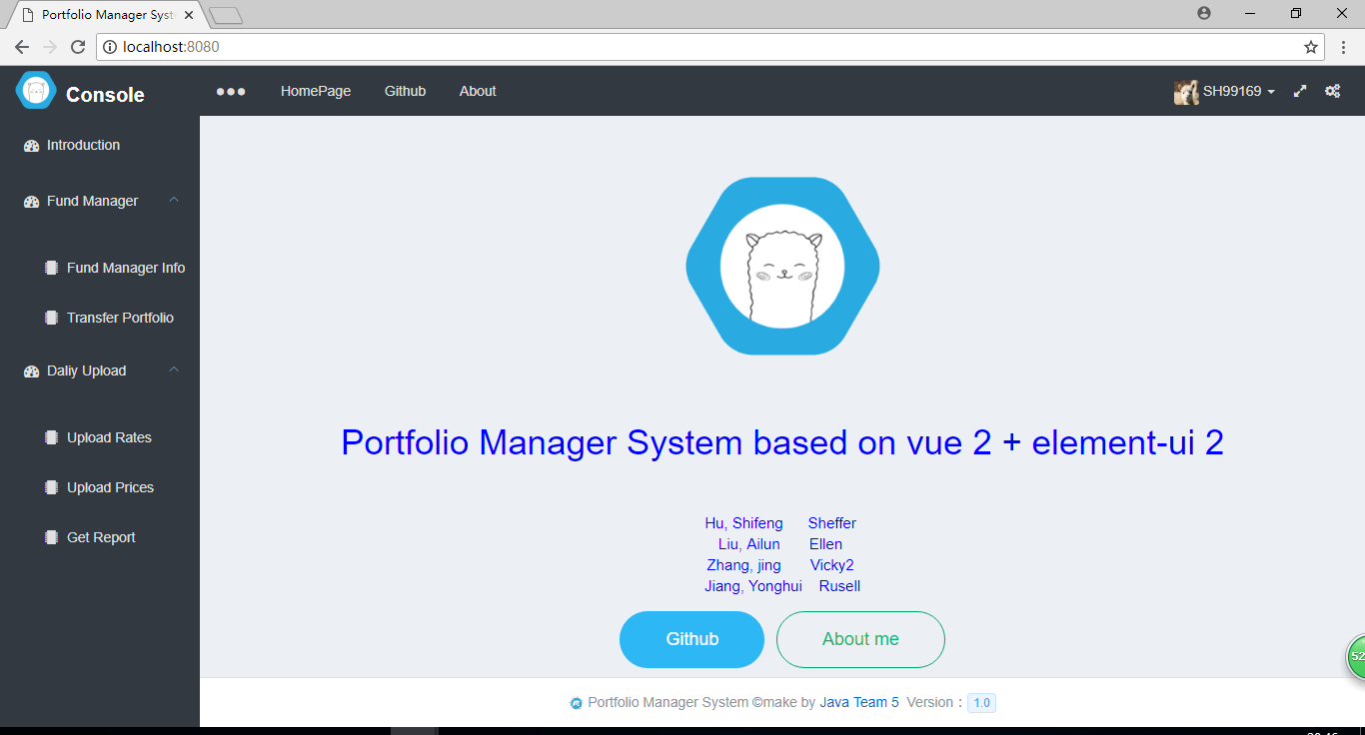

Fund Manager Info:

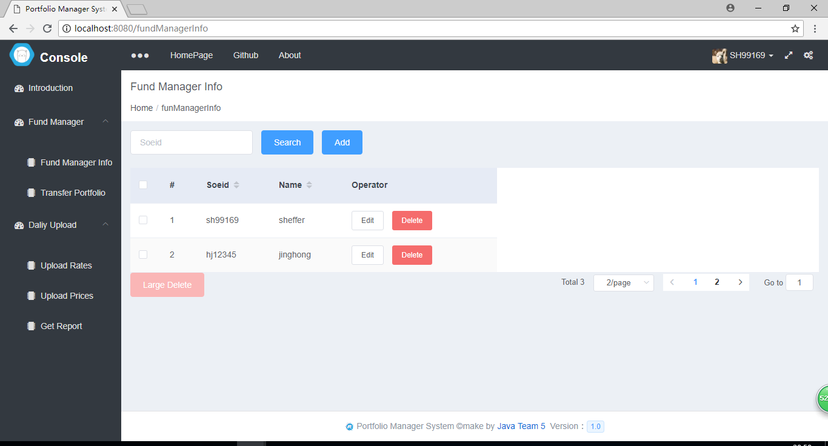

Transfer Portfolio:

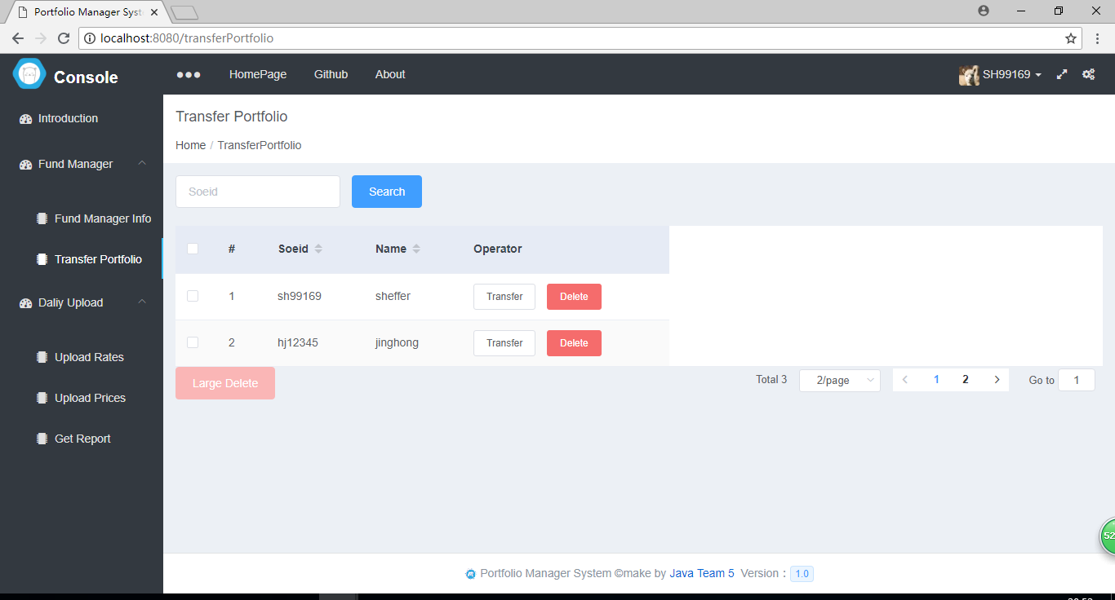

Upload Rates:

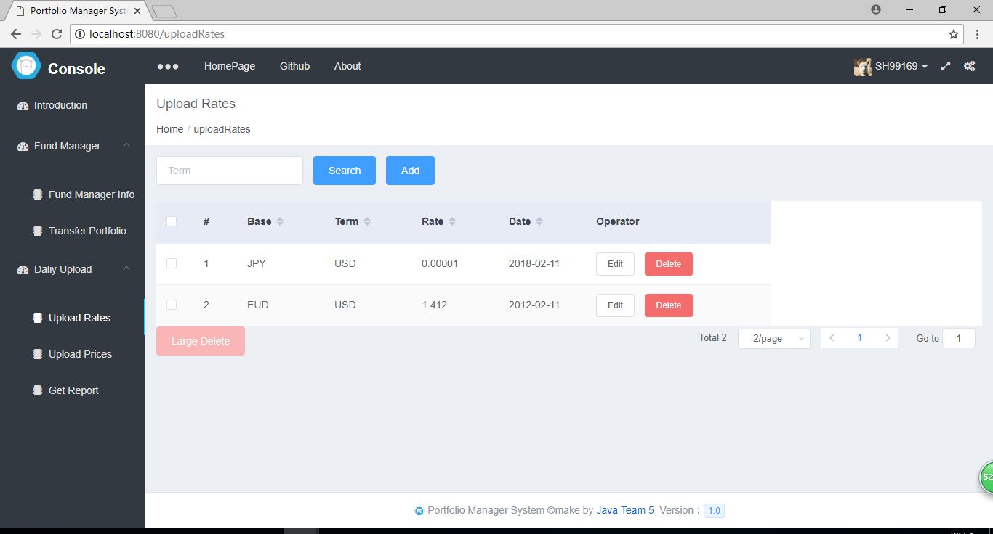

Upload Prices:

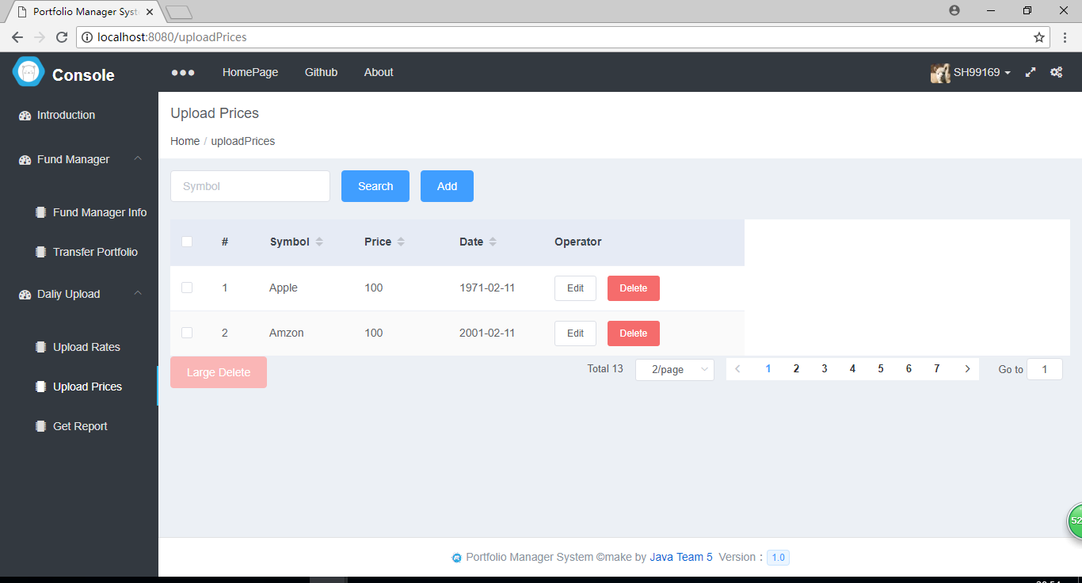

Get Report:

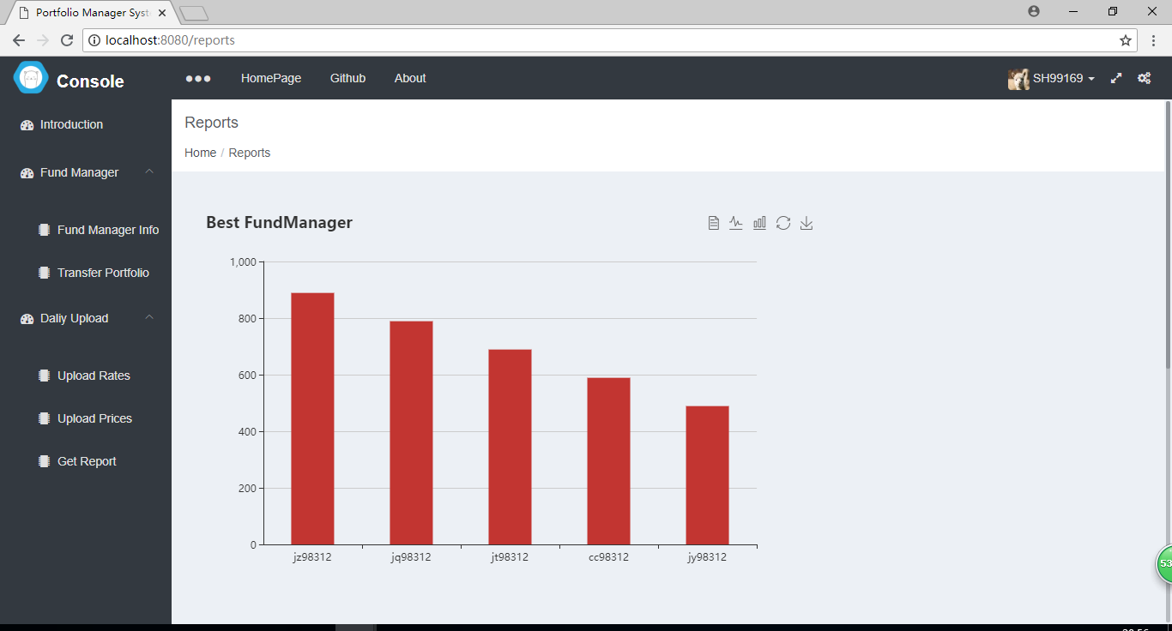

Fund Manager Sign in:

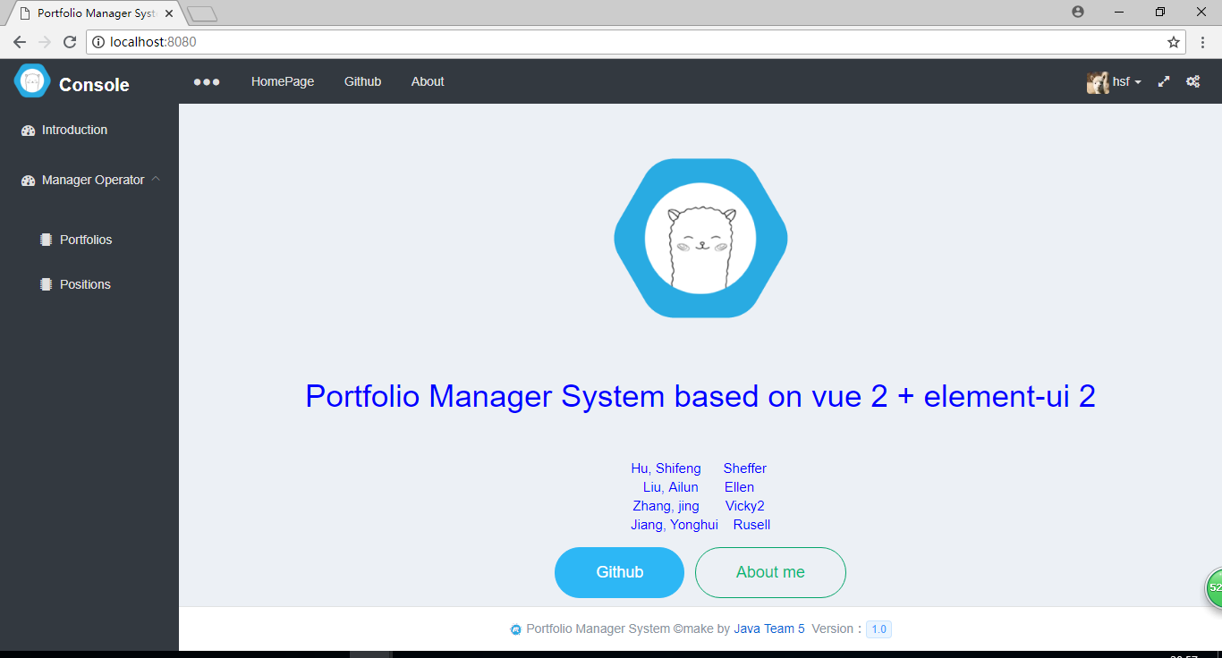

Portfolios:

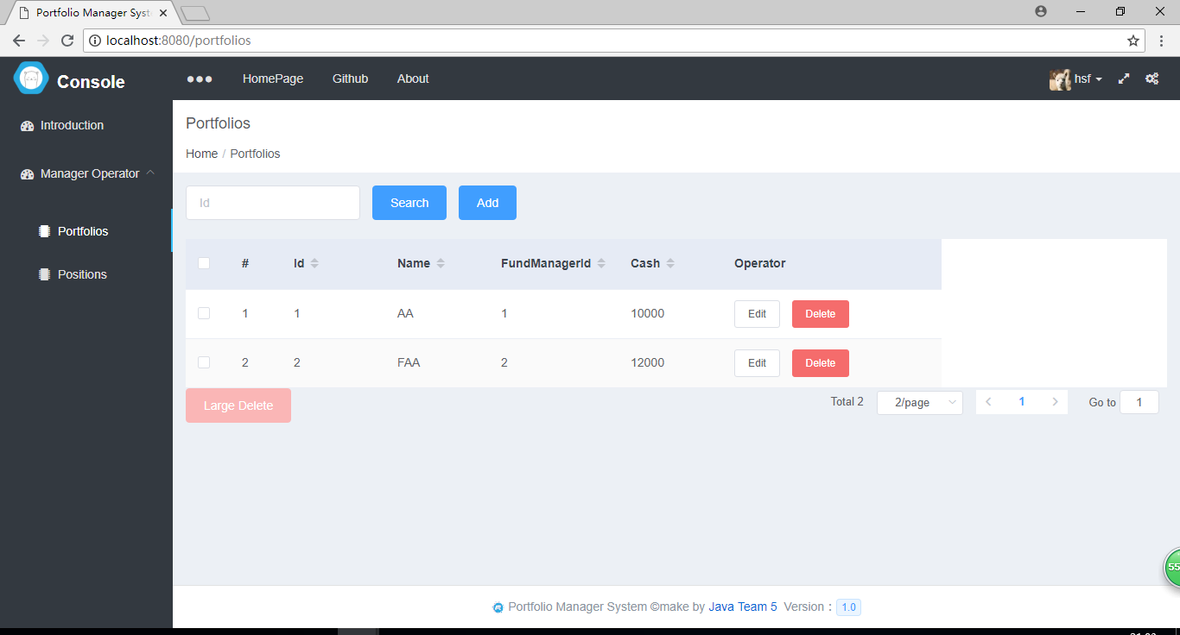

Positions:

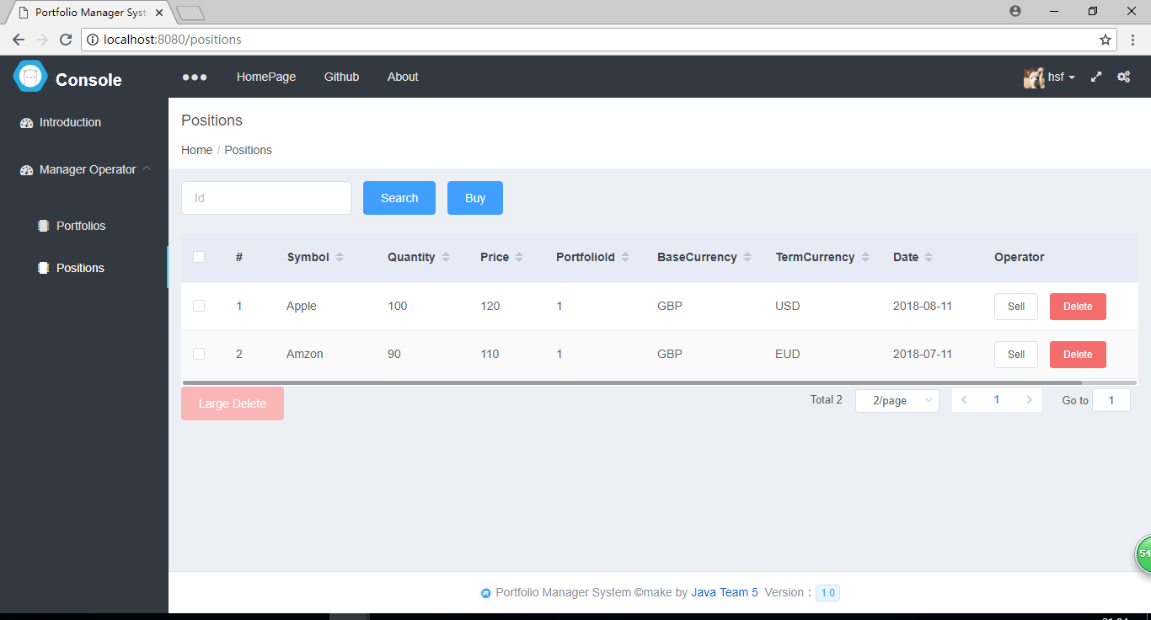

Buy:

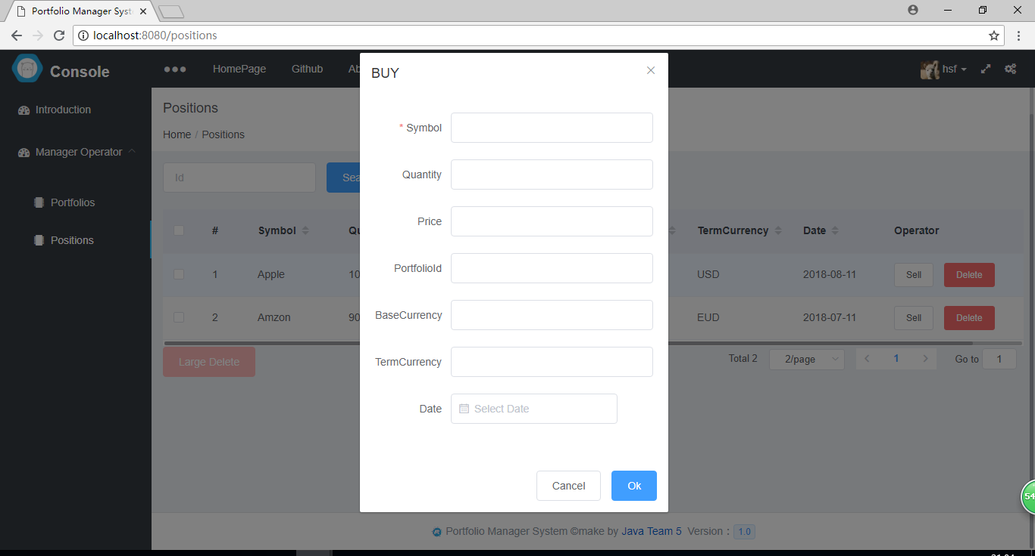

Sell:

