例33. 查询每个学生及其选修课程的情况

SELECT Student.\*，SC.\*

FROM Student, SC

WHERE Student.Sno = SC.Sno;

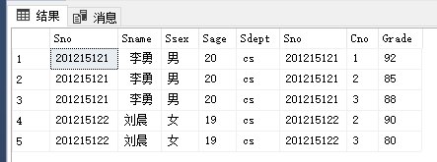

例34. 对[例33]用自然连接完成

SELECT Student.Sno, Sname, Ssex, Sage, Sdept, Cno, Grade

FROM Student, SC

WHERE Student.Sno = SC.Sno;

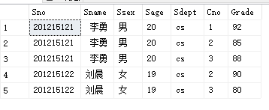

例35. 查询每一门课的间接先修课（即先修课的先修课）

SELECT FIRST.Cno, SECOND.Cpno

FROM Course FIRST, Course SECOND

WHERE FIRST.Cpno = SECOND.Cno;

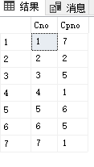

例36. 改写[例33]查询每个学生及其选修课程

SELECT Student.Sno, Sname, Ssex, Sage, Sdept, Cno, Grade

FROM Student LEFT OUTER JOIN SC ON (Student.Sno=SC.Sno);

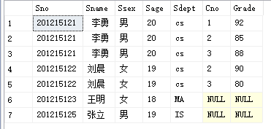

例37. 查询选修2号课程且成绩在90分以上的所有学生

SELECT Student.Sno, Sname

FROM Student, SC

WHERE Student.Sno = SC.Sno AND

SC.Cno= ‘2’ AND SC.Grade > 90;

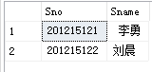

例38. 查询每个学生的学号、姓名、选修的课程名及成绩

SELECT Student.Sno, Sname, Cname, Grade

FROM Student, SC, Course

where Student.Sno =SC.Sno

AND SC.Cno = Course.Cno;

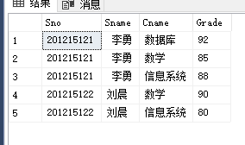

例39. 查询与“刘晨”在同一个系学习的学生

SELECT Sno,Sname,Sdept

FROM Student

WHERE Sdept IN

(SELECT Sdept

FROM Student

WHERE Sname= '刘晨');

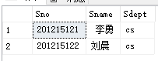

例40. 查询选修了课程名为“信息系统”的学生学号和姓名

SELECT Sno,Sname,Sdept

FROM Student

WHERE Sno IN

(SELECT Sno

FROM SC

WHERE Cno in

(Select Cno

from Course

where Cname='信息系统'

));

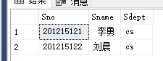

例41. 找出每个学生超过他选修课程平均成绩的课程号

select Sno,Cno

from SC x

where Grade >=

(select AVG(Grade)

from SC y

where y.Sno=x.Sno)

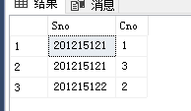

例42. 查询其他系中比计算机科学系某一学生年龄小的学生姓名和年龄

Select Sname, Sage

from Student

where Sage < ANY

(select Sage

from Student

where Sdept='CS')

AND Sdept<>'CS';

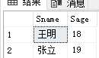

例43. 查询其他系中比计算机科学系所有学生年龄都小的学生姓名及年龄

SELECT Sname, Sage

FROM Student

WHERE Sage < ALL

(SELECT Sage

FROM Student

WHERE Sdept= ' CS ')

AND Sdept <> 'CS';

