**A Project Report on**

**Human Age Classification in Transform Domain**

Submitted in partial fulfilment of

The requirements of for the Degree of

Bachelor of Engineering

(Electronics and Telecommunication Engineering)

By

**Raunak Borwankar**

**Saurabh Deshpande**

**Gaurav Pednekar**

**Purva Sawant**

Under the guidance of

**Mr. Satishkumar Chavan**



DEPARTMENT OF ELECTRONICS AND TELECOMMUNICATION

**DON BOSCO INSTITUTE OF TECHNOLOGY**

**UNIVERSITY OF MUMBAI**

2014-15

**CERTIFICATE**

*This is to certify that the following project members of the Final year class have satisfactorily completed a project on* ***Human Age Classification in Transform Domain*** *in the partial fulfilment of the Electronics & Telecommunication Course of Bachelor of Engineering(B.E. Degree) of the University of Mumbai during Academic Year 2014-2015*

**Project Team Members**

|  |  |
| --- | --- |
| **Name** | **Roll No.** |

|  |  |
| --- | --- |
| Raunak Borwankar | 12 |
| Saurabh Deshpande | 21 |
| Gaurav Pednekar | 58 |
| Purva Sawant | 67 |

Mr. Satishkumar Chavan Mrs. Aparna Telgote

(Internal Guide) (Project Co-ordinator)

Dr. S. S. Mande Dr. Prasanna Nambiar

(H.O.D. (EXTC)) (Principal)

**Project Report Approval**

This project report entitled “**Human Age Classification in Transform Domain”** by

**Raunak Borwankar (Roll No: 12)**

**Saurabh Deshpande (Roll No: 21)**

**Gaurav Pednekar (Roll No: 58)**

**Purva Sawant (Roll No: 67)**

Is approved for the degree of

**Bachelor of Engineering in Electronics and Telecommunication**

University of Mumbai.

**Examiners:**

Name and Signature: Name and Signature:

Date:

Place:

**Acknowledgments**

We are thankful to our Dr. Prasanna Nambair, Principal for her support and encouragement to complete our project successfully.

We would like to extend our thanks to our Dr.S.S.Mande, Head of Department of Electronics and Telecommunications for his valuable advice over the implementation of project.

With great pleasure, we avail this opportunity to express our deep sense of gratitude to our guide, Prof. Satish Chavan, for his spirited guidance and inspiration. We have a deep sense of admiration for her innate goodness and inexhaustible enthusiasm. It helped us to work in right direction to attain desired objective.

We are also thankful to our Prof. Aparna Telgote, Project Coordinator who devoted her valuable time and helped us in all possible ways towards successful completion of this work. We thank all those who have contributed directly or indirectly to this work.

Finally, we take this opportunity to extend our deep appreciation to our family and friends; for all that they meant us during the crucial times of the duration of our project.

.

**Abstract**

The age estimation and classification is a very simple task for human, but it is very difficult for machine to classify age based on facial information. Many researchers have made efforts to achieve age classification using spatial and transform domain techniques with various classifiers. But transform domain classification is not as explored as spatial domain. This paper aims to develop algorithms in transform domain to achieve maximum possible efficiency. The transforms like Discrete Cosine Transform (DCT), Discrete Wavelet Transform (DWT), Dual Tree Complex Wavelet Transform (DTCWT) and GABOR Transform are used to extract features from images. These features are used to classify given facial image into a range of age groups viz. child, adolescent, young, middle aged, old aged using variance as a classifier. The experimental results prove that the feature extraction of Gabor transform using Hybrid Variance II provides better classification efficiency than that of DCT, DWT and DTCWT for same classifier.

**CONTENTS**

**Acknowledgement ii**

**Abstract iii**

**Contents iv**

**List of Figures vi List of Tables vii**

1. **Introduction 1** 
   1. Motivation  2
   2. Organization of Report 2
2. **Literature Survey 3**

1. **Proposed Work 5**
   1. Block Diagram 6
   2. Image acquisition and pre-processing 6
   3. Feature extraction 6
      1. Discrete Cosine Transform (DCT) 7
      2. Discrete Wavelet Transform (DWT) 10
      3. Dual Tree Complex Wavelet Transform (DTCWT) 12
      4. GABOR Transform 14
   4. Image classification 15
      1. Variance Classifier 15
      2. KNN Classifier 15
      3. Hybrid Variance Classifier 17
2. **Implementation 18**
   1. Discrete Cosine Transform (DCT) 19
   2. Discrete Wavelet Transform (DWT) 20
   3. Dual Tree Complex Wavelet Transform (DTCWT) 23
   4. GABOR Transform 25
3. **Result and Discussion 27**
4. **Conclusion and Future Scope 36**
5. **Bibliography 37**

**List of Figures**

1 BLOCK DIAGRAM . . . . . . . . . . . . . . . . . 6

2 FREQUENCY DISTRIBUTION OF DCT . . . . . 7

3 DCT COEFFICIENTS OF VECTOR LENGTH 5 . . 8

4 DCT COEFFICIENTS OF VECTOR LENGTH 9 . . 9

5 FREQUENCY DISTRIBUTION OF DWT. . . . . . . 10

6 BLOCK DIAGRAM OF DWT . . . . . . . . . . . . 10

7 BLOCK DIAGRAM OF DTCWT . . . . . . . . . . . 12

8 FILTER RESPONSE OF COMPLEX WAVELET . . . 13

9 FILTER RESPONSE OF COMPLEX WAVELET. . . 13

10 LEVEL1 DECOMPOSITION DISCRETE WAVELETS 21

11 LEVEL2 DECOMPOSITION DISCRETE WAVELETS 21

12 LEVEL3 DECOMPOSITION DISCRETE WAVELETS 21

13 LEVEL4 DECOMPOSITION DISCRETE WAVELETS 21

14 LEVEL5 DECOMPOSITION DISCRETE WAVELETS 22

15 LEVEL6 DECOMPOSITION DISCRETE WAVELETS 22

16 LOW FREQUENCY BANDS OF DTCWT . . . . . . . 23

17 LF NEGATIVE ORIENTATION OF DTCWT. . . . . . 23

18 HIGH FREQUENCY BANDS OF DTCWT. . . . . . . 24

19 HF NEGATIVE ORIENTATION OF DTCWT. . . . . 24

20 GABOR TANSFORMED IMAGE. . . . . . . . . . . . 24

21 RESULTS OF GABOR TRANSFORM. . . . . . . . . 25

22 EFFICIENCY OF WAVELETS FOR EUCLIDEAN. . 26

23 EFFICIENCY OF WAVELETS FOR CITYBLOCK. . 30

24 EFFICIENCY OF WAVELETS FOR COSINE. . . . 30

25 EFFICIENCY OF WAVELETS FOR CORRELATION .31

26 EFFICIENCY OF 35 DIFFERENT DEBAUCHIES. . . 31

**List of Tables**

1 COMPARATIVE RESULTS FOR SYMLET. . . . . 28

2 COMPARATIVE RESULTS FOR BIORSPLINE. . . 28

3 COMPARATIVE RESULTS FOR REVERSEBIOR. 29

4 COMPARATIVE RESULTS FOR DMEYER. . . . . 29

5 COMPARATIVE RESULTS FOR DEBAUCHIES. . 32

6 MAXIMUM EFFICIENCY. . . . . . . . . . . . . . 35

**Chapter 1**

**Introduction**

In artificial intelligence, the need of the day application by far is age estimation and classification. Age estimation and classification can be introduced in day-to-day applications where human intervention is not possible and system does not possess enough intelligence to provide comparable results to that of human.

So over last decade, efforts are being made in this direction. The motivation behind this paper is to develop a system or train the intelligence of a machine in such a way that it will be able to classify images into correct age group, thus age estimation and classification, with efficiency that is comparable with human age detection and classification.

Human facial images are important in age classification and estimation; as human face reflects one's age prominently. There has been number of experiments carried out in image processing attempting to classify and estimate human age from facial images. Some approaches used spatial approach while some used transformed domain or both. Depending upon the image size, resolution and type of facial image taken the result and efficiency for each technique varies. Human Age Classification in transform Domain uses the frontal facial images of the person, extracts features from it by taking its transform, and compares the features from the images in database having large number of subjects. The comparison leads to the conclusive age classification of the person in an image.

* 1. **Motivation**

We all live in the age of technology, where for our day to day life we take the assistance of sophisticated systems. As world’s population is growing day by day, we need automation of all the systems in which records of many people are to be maintained, or large number of people visiting any place, need to be checked whether all of them fulfil the criteria specified or not.

In a multiplex, if a movie is being shown which is to be watched by restricted audience (i.e. only by people of particular age group), then at the booking counter itself we can use the system which takes the photo of person, and immediately can classify the age group, if the person has no age proof with him/her. This system can save time required for verification, and shares the workload of a person sitting at the booking counter, whenever required.

Same system can work at the entrance of the Liquor Shop, Pub or bar where child age group is prohibited.

The computer monitor can adjust the text size depending upon person in which age group is sitting next to the monitor. If the person sitting in front of monitor is from old age group, then the font size will automatically be adjusted.

* 1. **Organization of Report**

Chapter 1 gives brief introduction about the project. It consists of motivation that leads us to work on this project.

Chapter 2 consists of information about literature survey. It gives brief information about different papers that we referred in build up to this project.

Chapter 3 is the heart of our project. It consists of block diagram various transforms used viz. DCT, DWT, DTCWT, GABOR.

Chapter 4 is the brain of our project. It explains the implementation of the transforms used and shows what happens after we apply those transforms. It consist of method for comparison as well which is variance, Knn classifier and hybrid variance.

Chapter 5 consists of results and analysis. It provides us various tables and graphs which reflects our work and efficiency achieved.

Chapter 6 provides the conclusion and future scope of our project.

**Chapter 2**

**Literature Survey**

In his paper “Application of Wavelet Transform and its Advantages Compared to Fourier Transform”, 2009, M Siffuzzaman and M.R. Islam gives an introduction to wavelet and fourier transform; highlighting the advantages of using wavelet analysis over fourier analysis. They also gives an insight into some applications of wavelet such as data compression, recording of a sound signal, music signal, fingerprint verification with the help of a wavelet transform.

"Digital Image Processing" by RC Gonzalez and Richard Woods gives an in-depth look into the fundamental concepts and an

overview of the wavelet, fourier and cosine transform. It is neatly structured into various chapters "Filtering in the Frequency Domain" and "Wavelet and Multiresolution Processing". It gives a thorough description of wavelet transforms, wavelet properties and discrete wavelets. Use of wavelet transform was acquainted by Prof. S. Sengupta, Dept of Electronics and Electrical Communication Engg, IIT Kharagpur in his complete online tutorial on “Discrete Wavelet Transforms”. It gives a look on “why wavelet function ?” , the discrete wavelet transform respectively.

Having established idea about transforms, face Age classification is examined in "Face Age classification on consumer images with gabor and Fuzzy LDA method "Advances in Biometrics, LNCS, Vol. 5558, pp. 132-141 by Feng Gao and Haizhou Ai. This paper gives an idea about a different type of transform Gabor. Dennis Gabor in 1946, first introduced the windowed-Fourier transform, i.e. short-time Fourier transform known later as Gabor transform. Gabor feature is extracted for face representation and used in LDA (Linear discriminant analysis) classifiers. In this paper gabor features beats other features and the fuzzy lda is proven to be a better classifier then lda. J.Nithyashri and Dr.G.Kulanthaivel [1] presented "Classification of Human Age based on Neural Network Using FG-NET Aging Database and Wavelets",IEEE- Fourth International Conference on Advanced Computing, (ICoAC2012), pp.1-5, 2012. In this work the facial images are pre-processed and then the face features are extracted using Wavelet Transformation.

“Classifying the Human Age Using Discrete Wavelet Transform” Journal of Computer Applications, Volume VI, Issue 4, 2013, KNN Classifier and MORPH Database give a very good description about Discrete Wavelet Transformation (DWT) for extracting the facial features and a K-Nearest Neighbour (KNN) classifier for classifying the various age groups: Adolescence (13-18), Adult (19-59) and Senior Adult (60 and above).In this paper pre-processing technique includes gamma correction, dog filtering and histogram equalization. In this work, Mrs.J.Nithyashri and Dr.G.Kulanthaivel used the following distance measures Euclidean, City block, cosine, correlation and hybrid of all these distance measures to find distance between k nearest neighbour. "Automatic age classification with LBP", Proc. of IEEE, International conference on Computer vision and Image Processing, 2008. Asuman Gunay and Vasif V. Nabiyev give an enormous amount of information regarding age classification LBP (local binary pattern). In this paper, faces are divided into small regions and LBP histograms are extracted and concatenated to feature vector. KNN classifiers are used for classifying the various age groups. “Content based image retrieval using advanced color and texture features” was developed by Sagar Soman Mitali Ghorpade Vrushali Sonane and Satish Chavan [4]. In this paper block wise DCT is applied to extract texture features and colour features were extracted by moment of colours. A comparative study of colour and texture features extraction was done.

In our paper we examine the use of various transforms for face feature extraction and present a reference model of "Human Age Classification” that can be used possibly even for security purposes.

**Chapter 3**

**Proposed work**

The input consists of the face of the person seeking classification. The facial image is captured by a camera. The entire program has been structured into three modules

* Image acquisition and pre-processing section
* Feature extraction section
* Classification
* Let us consider each of the above sections and understand the design details.
  1. **Block Diagram**

TRAINING TESTING

Get Database Images

Get Database images

Get Query Image

Resize and grayscale

Resize & Grayscale

Apply DCT, DWT, DTCWT or GABOR transform

Apply DCT, DWT, DTCWT or GABOR

Compute the coefficient as a feature vector for database matrix

Compile the coefficients as a feature vector for images

Classify

Compare

**Fig. 1. The block diagram representation is of algorithm of proposed work**

* 1. **Image Acquisition and Analysis**

Image acquisition and analysis includes pre-processing the image. The images are gray scaled as luminance is more important in distinguishing visual features and grey scaled images contain only luminance information. After Grey scaling is done images are resized to according to requirements of transform used

* 1. **Feature Extraction**

Features are extracted from the image seeking classification by applying various transforms on it. It is nothing but capturing low and high frequencies from various orientations as well as various levels.

* + 1. **Discrete Cosine Transform (DCT)**

Normally the digital images are displaying on a screen immediately after they are captured. There are two represent types for digital image that is spatial domain or frequency domain [9]. Spatial domain image can be realizes through our human eyes, but frequency domain use to analysis of spatial domain. In general, human eyes are more sensitive through the medium and low spatial domain, and the image features with high spatial frequency those could not be realized easily [9]. For simplicity, Discrete Cosine Transformation (DCT) can convert the spatial domain image to frequency domain image [8]

A discrete cosine transform (DCT) expresses a finite sequence of data points in terms of a sum of cosine functions oscillating at different frequencies [1]. In particular, a DCT is a Fourier-related transform similar to discrete Fourier transform (DFT) but using only real numbers. There are 8 different variants of DCT out of which 8*8 DCT is most efficient. The DCT, and in particular the DCT-2, is often used in signal and image processing, especially for lossy compression, because it has a strong "energy compaction" property. The DCT transforms images from spatial domain to frequency domain. The low frequencies in an image are visually significant than high frequencies. The DCT relinquishes the high frequencies and rationalizes the remaining coefficients. Typically, the energy concentration is observed in top left corner as shown in Fig. 3.

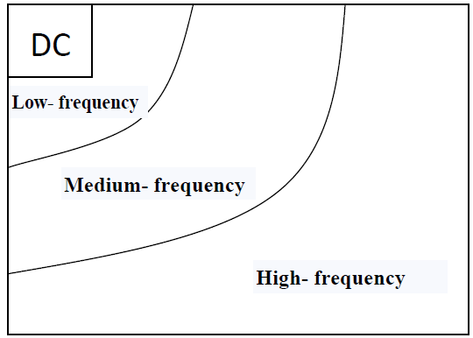

**Fig. 2 Frequency distribution of DCT**

Fig. 3 showed that frequency distribution of the image which is converted by Discrete Cosine Transformation (DCT). According to the Fig.3 images converted can be distributed by 3 parts, the coefficient on the left-top named DC value, others are named AC values. The DC value represents the average illumination and the AC values are coefficients of high frequency. It is observed that the image has more detail information then some basis in DCT have higher coefficient values.

The 2D-DCT of M x N matrix of an image for every pixel is given by:

(1)

Where F(u,v) is DCT domain representation of f(i,j),the pixel value at co-ordinate(M,N) and u as well as v represent vertical and horizontal frequencies respectively.

  (2)

The 2D DCT is applied on each block to get DCT coefficients. Due to energy compaction property of DCT, energy of every block gets concentrated in top left corner of each block. The feature vector is created by scanning top left corner in diagonally downward direction. The length of this feature vector is 5 and 9 as shown in Fig.1a and Fig. 1b respectively.

|  |  |  |  |  |  |  |  |
| --- | --- | --- | --- | --- | --- | --- | --- |
| 1 | 2 | 2 | 3 | 3 | 4 | 4 | 5 |
| 2 | 2 | 3 | 3 | 4 | 4 | 5 |  |
| 2 | 3 | 3 | 4 | 4 | 5 |  |  |
| 3 | 3 | 4 | 4 | 5 |  |  |  |
| 3 | 4 | 4 | 5 |  |  |  |  |
| 4 | 4 | 5 |  |  |  |  |  |
| 4 | 5 |  |  |  |  |  |  |
| 5 |  |  |  |  |  |  |  |

|  |  |  |  |  |
| --- | --- | --- | --- | --- |
| 1 | 2 | 3 | 4 | 5 |

5-Vectored DCT coefficients =

**Fig 3. The DCT coefficients pattern to form the DCT coefficient vector of length 5.**

|  |  |  |  |  |  |  |  |
| --- | --- | --- | --- | --- | --- | --- | --- |
| 1 | 2 | 2 | 3 | 3 | 4 | 4 |  |
| 2 | 2 | 3 | 3 | 4 | 4 |  |  |
| 2 | 3 | 3 | 4 | 4 |  |  |  |
| 3 | 3 | 4 | 4 |  |  |  |  |
| 3 | 4 | 4 |  |  |  |  |  |
| 4 | 4 |  |  |  |  |  |  |
| 4 |  |  |  |  |  |  |  |
|  |  |  |  |  |  |  |  |

|  |  |  |  |  |  |  |  |
| --- | --- | --- | --- | --- | --- | --- | --- |
|  | 7 | 7 | 7 | 7 | 7 | 7 | 7 |
| 5 | 9 | 8 | 8 | 8 | 8 | 8 | 8 |
| 5 | 6 | 9 | 9 |  |  |  |  |
| 5 | 6 | 9 | 9 | 9 |  |  |  |
| 5 | 6 |  | 9 | 9 | 9 | 9 |  |
| 5 | 6 |  |  | 9 | 9 |  |  |
| 5 | 6 |  |  | 9 |  |  |  |
| 5 | 6 |  |  |  |  |  |  |

|  |  |  |  |  |  |  |  |  |
| --- | --- | --- | --- | --- | --- | --- | --- | --- |
| 1 | 2 | 3 | 4 | 5 | 6 | 7 | 8 | 9 |

9-Vectored DCT coefficients =

**Fig 4. The DCT coefficients pattern to form the DCT coefficient vector of length 9.**

Coefficient 1 contains highest information, and 9 vectored DCT provides better feature extraction than 5 vectored DCT as shown above in Fig. 2.

* + 1. **Discrete Wavelet Transform (DWT)**

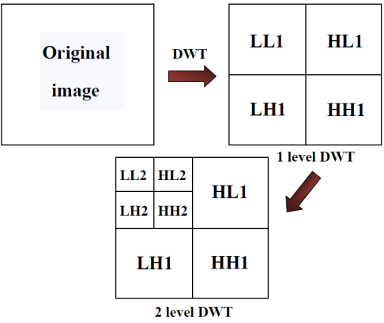

**Fig. 5 Frequency distribution of DWT**

DWT also converts the image from the spatial domain to frequency domain. According to the Fig. 4, the image is divided by vertical and horizontal lines and represents the first-order of DWT, and the image can be separated with four parts those are LL1, LH1, HL1 and HH1. In additional, those four parts are represented four frequency areas in the image. For the low-frequency domain LL1 is sensitively with human eyes [7].

Image Matrix

LPF

HPF

Result

Result

LPF

HPF

LPF

HPF

LL

LH

HH

HL

**Fig. 6 The block diagram representation of the DWT of an input image matrix.**

In Fig. 5. LL piece (low-low) comes from low pass filtering in both directions; it is most like the original picture and so is called the approximation. HL comes from high pass filtering in the horizontal direction and low pass filtering in vertical direction and so has the label HL. The visible details such as edges have overall vertical orientation. Consequently they are called vertical details.

Multi scale analysis done on the sequence in fact turned out to be equivalent to using the Haar Wavelet. Discrete Wavelets extend the idea of wavelets (presented in section to enable general wavelets to be used on sequences of numbers. This is very use as there are many instances in which data is recorded as a discrete sequence (such as when dealing with images; which are typical stored as pixels) rather than as a function.

Using discrete wavelets sequences can be analyzed. This leads to many applications in data analysis, signal coding and data compression as well as use in image processing.

To define the discrete mother and father wavelet functions the Kronecker delta function will first have to be defined.

φ1,n=Pkhn−2kδ0,k =hn form =0,...,L1 −1

φ(j+1),n=Pkhn−2kφj,k form=0,...,Lj+1−1

The discrete mother wavelet sψj are defined in the same way using {gk} instead of {hk}.

The formal definition of wavelet transform is given by

The parameter a is often termed as scale or scaling factor, and it represents the degree of scaling or compression of information. The term is called as the Basis function for the wavelet function defined above. The parameter b determines the time location of the wavelet. Depending upon the value of the scaling parameter a, the wavelet function has different value than

singleton ‘mother wavelet’ function (t). Thus, the above Wavelet functions have time widths adapted to their frequencies.

* + 1. **Dual Tree Complex Wavelet Transform (DTCWT)**

The Dual Tree Complex wavelet Transform (DTCWT) is a complex valued extension to the standard discrete wavelet transform (DWT). It is a two-dimensional wavelet transform which provides multi-resolution, sparse representation and useful characterization of the structure of an image. The DTCWT calculates the complex transform of a signal using two separate DWT decompositions (tree a and tree b). If the filters used in one are especially designed different from those in the other it is possible for one DWT to produce the real coefficients and the other the imaginary. The dual-tree CWT is implemented as two separate two-channel filter banks. One cannot arbitrarily choose the scaling and wavelet filters used in two trees (tree a and tree b). The low-pass (scaling) and high-pass (wavelet) filters of one tree,{h0, h1} must generate a scaling function and wavelet that are approximate Hilbert transforms of the scaling function and wavelet generated by low-pass and high-pass filter of other tree,{g0, g1}. Therefore, the complex- valued scaling function and wavelet from the tree a and tree b are approximately analytic.

Tree a) Real Part

g0[n]

h0[n]

g1[n]

h1[n]

g0[n]

h0[n]

g1[n]

h1[n]

IMAGE

Tree b) Complex Part

**Fig. 7. The block diagram representation of the 2 level DTCWT of an input image matrix.**

DTCWT decomposes image into 16 bands out of which 12 are high frequency bands while 4 are low frequency bands. The 12 high frequency bands consist of 6 real and 6 imaginary bands. Now DTCWT uses 15, 45 and 75 degree orientation as well as -15, -45 and -75 orientation to obtain high frequency bands. For low frequency bands DTCWT uses 0, 45 and 90 degree orientation. We know that low frequency bands of image contain image information while high frequency bands of image contain high frequency data like edge information. DTCWT is applied to low frequency bands for further decomposition of image.

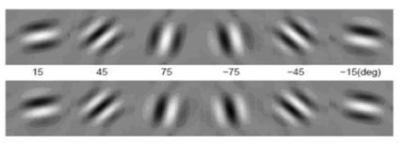

**Fig.8. Complex filter response showing the orientations of complex wavelets.**

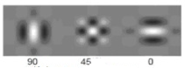

**Fig.9.Complex filter response showing the orientations of discrete wavelets**.

* + 1. **GABOR Transform**

Gabor filter is widely used linear filter in image processing used for edge detection. Gabor filter finds its application in appropriate texture representation and discrimination, since the frequency and orientation representation of Gabor filters are similar to those of human visual system.

The Gabor kernel consists of Gaussian Kernel function modulated by sinusoidal plane wave. The Gabor filter has its impulse response defined by a sinusoidal wave, which is multiplied by a Gaussian function. Due to multiplication-convolution property, the Fourier transform of Gabor filter’s impulse response is the convolution of the Fourier transform of sinusoidal plane wave or the harmonic function, and the Fourier transform of Gaussian function.

Mathematical Definition of Gabor filters transfer function.

(4)

Where

And

𝜆 represents the wavelength of the sinusoidal plane wave, 𝞱 is orientation of normal to the parallel stripes of Gabor function, ψ is phase shift, is standard deviation of the Gaussian curve and γ is the aspect ratio in spatial domain

* 1. **Image classification**
     1. **Variance Classifier**

The variance classifier is based on the concept of variance. It calculates how much the query image vector varies from the database image vector and classifies the query image into the nearest age group based on the variation.

* + 1. **K- Nearest Neighbour Classifier (KNN)**

The KNN classifier is very powerful and reliable classifier when it comes to machine learning algorithm. Its functionality is based on finding the nearest neighbour to a particular vector from given set of vectors. In KNN classifier, K indicates no. of neighbours taken into consideration for classification .In KNN classifier we have to provide 3 groups viz. SAMPLE, TRAINING and GROUP, where SAMPLE contains the database image feature matrix, TRAINING contains query image feature matrix and GROUP contain various age group in which query image is to be classified.

KNN classifier provides with four types of distance methods to classify viz.

1. Euclidean Distance
2. City block Distance
3. Cosine Distance
4. Correlation Distance
   * + 1. **EUCLIDEAN DISTANCE**

In mathematics, the Euclidean distance or Euclidean metric is the "ordinary" (i.e. straight line) distance between two points in Euclidean space. With this distance, Euclidean space becomes a metric space. The associated norm is called the Euclidean distance.

The Euclidean distance eqn. is given by:

(5)

Where,

u=(u1,u2,….un)…….Database image feature vector matrix.

v=(v1,v2,….vn)…….Query image feature vector matrix.

* + - 1. **CITYBLOCK DISTANCE**

It is a form of geometry in which the usual distance function of metric or Euclidean geometry is replaced by a new metric in which the distance between two points is the sum of the absolute differences of their Cartesian coordinates.

The City block distance eqn. is given by:

(6)

Where,

u=(u1,u2,….un)…….Database image feature vector matrix.

v=(v1,v2,….vn)…….Query image feature vector matrix.

* + - 1. **COSINE DISTANCE**

Cosine distance is a measure of similarity between two vectors of an inner product space that measures the cosine of the angle between them. The cosine of 0° is 1, and it is less than 1 for any other angle. It is thus a judgement of orientation and not magnitude: two vectors with the same orientation have a cosine similarity of 1, two vectors at 90° have a similarity of 0, and two vectors diametrically opposed have a similarity of -1, independent of their magnitude. Cosine distance is particularly used in positive space, where the outcome is neatly bounded in [0,1].

The Cosine distance eqn. is given by:

(7)

The cosine distance between vectors u and v, is given by dot product and magnitude [10].

Where,

U is Database image feature vector matrix.

V is Query image feature vector matrix.

* + - 1. **CORRELATION DISTANCE**

Correlation distance is a measure of statistical dependence between two random variables or two random vectors of arbitrary, not necessarily equal dimension. An important property is that this measure of dependence is zero if and only if the random variables are statistically independent. This measure is derived from a number of other quantities that are used in its specification, specifically: distance variance, distance standard deviation and distance covariance.

The correlation distance is given by formula:

(8)

The correlation distance is calculated by dividing distance covariance by product of distance standard deviation of u and v [9].

Where,

U is Database image feature vector matrix.

V is Query image feature vector matrix.

* + 1. **Hybrid Variance Classifier**

The hybrid variance classifier is further extension of variance classifier. It calculates how much the query image vector varies from the database image vector and classifies the query image into the nearest age group based on the variation. It mostly concentrates on thresholds set for various age groups.

**Chapter 4**

**Implementation**

The proposed system is divided into two parts viz. training and testing. In training a database of 200 face-only images of 200 different subjects is created. The images are resized to dimensions as per the specific requirements of a particular transform. The weiner and gauss filters are used to de-blur the images but they also cause smoothening which reduces edge detection and consequently the efficiency. After the images are resized they are gray scaled since the luminance information provides us the necessary parameters for age classification than the chrominance information. This comprises of pre-processing.

After pre-processing, feature extraction is carried out using in transform domain using transforms like DCT, DWT, DTCWT, GABOR.

* 1. **Discrete Cosine Transform Implementation**

In 2D-DCT, it is observed that 8x8 block processing gives better results.

1) The images are resized such that, 8x8 block processing can be applied on it.

2) After applying 2D-DCT on every block the result is multiplied with an 8x8 mask for feature extraction.

3) The feature extraction is done in two ways i.e. 5-vectored feature extraction as shown in Fig.1.a and 9-vectored feature extraction as shown in Fig.1.b.

4) Same procedure is applied on query image(s) and using various classifiers the query image(s) is classified in various age groups viz. child, adolescent, young, middle aged and old aged.

* 1. **Discrete Wavelet Transform Implementation**

1) In 2D-DWT, various types of wavelets were used viz. Debauchies, Symlets, Dmeyer, Biorsplines, Reversebior. But since different wavelets have different size of filter coefficients, the result obtained is not ideal.

2) So an algorithm is developed to achieve near ideal results for all 2D discrete wavelets.

3) After applying 2D-DWT we get result in form of LL, LH, HL, HH which is nothing but approximate transform, horizontal transform, diagonal transform and vertical transform respectively.

4) It is logical that more the decomposition of an image more information is obtained.

5) The images are resized to 256x256 and 6 level decomposition is done on approximate part of result so that after final decomposition we get LL, LH, HL, HH which cannot be further decomposed.

6) Using all these vectors from each level of decomposition a 22-vectored feature matrix is created for the database images.

7) Same procedure is applied on query image(s) and using various classifiers the query image(s) is classified in various age groups.

Following are the results after applying DWT on every level:

LEVEL 1:

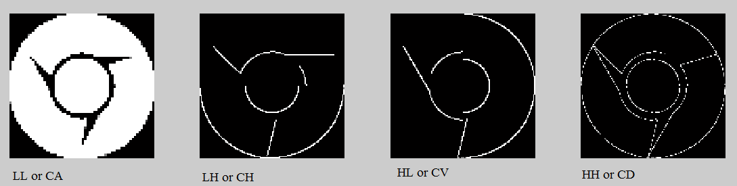

**Fig.10. Level 1 decomposition of discrete wavelets**

LEVEL 2:

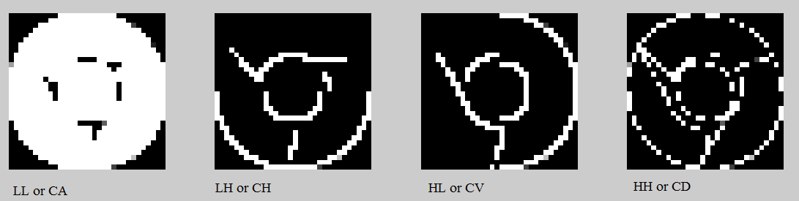

**Fig.11. Level 2 decomposition of discrete wavelets**

LEVEL 3:

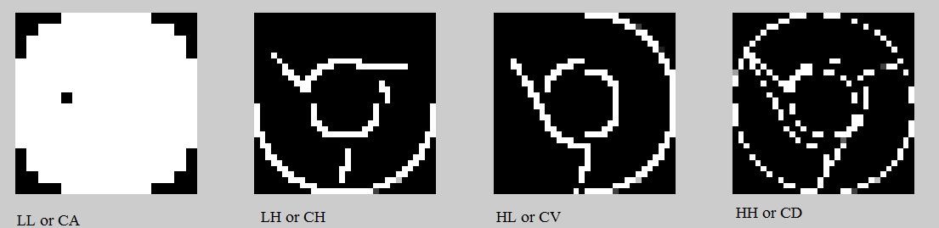**Fig.12. Level 3 decomposition of discrete wavelets**

LEVEL 4:

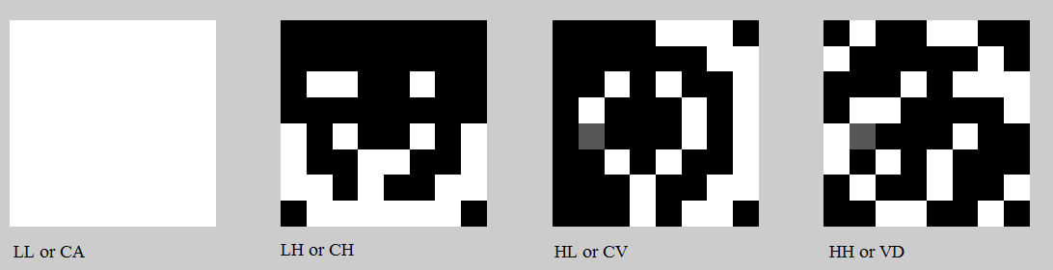**Fig.13. Level 4 decomposition of discrete wavelets**

LEVEL 5:

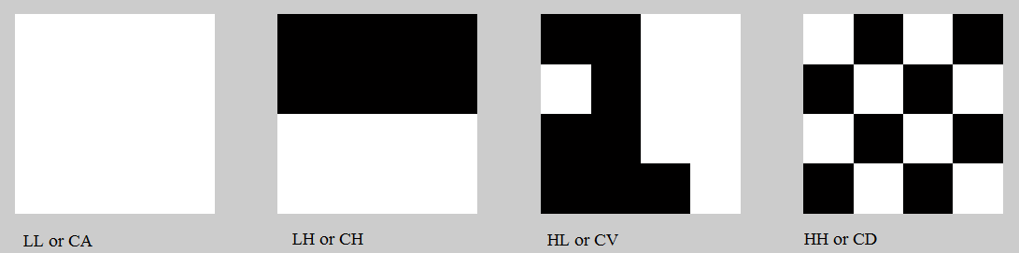

**Fig.14. Level 5 decomposition of discrete wavelets**

LEVEL 6:

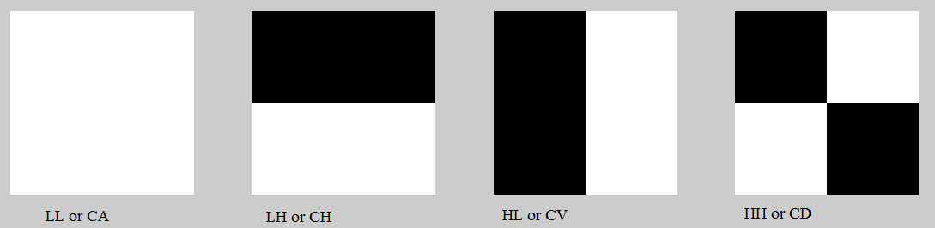

**Fig.15. Level 6 decomposition of discrete wavelets**

* 1. **Dual Tree Complex Wavelet Transform Implementation**

1) For 2D-DTCWT an algorithm is designed which generates DTCWT transform of image.

2) First order decomposition is carried out using ‘faf’ first order filters. ‘faf’ is called as farras filters.

3) Further decomposition is carried out using ‘af’ filters. As we define parameter “level”, ‘af’ filter is used for mentioned number of levels.

4) Before implementing this system we need to include ‘faf’ filter coefficients and ‘af’ coefficients in same directory.

5) Using these filters and dual tree complex wavelet function, dual tree complex wavelet transform of an image is achieved.

6) This transform provides 16 vectors for each level of decomposition. In further levels, the decomposition is done on low frequency bands.

7) The no. of levels of decomposition is subjective to quality of image and application.

8) Using classifier the query image(s) is classified into various age groups.

Following are the results after applying DTCWT:

Low frequency bands:

**Fig.16. Low frequency bands of DTCWT**

Low frequency negative orientation: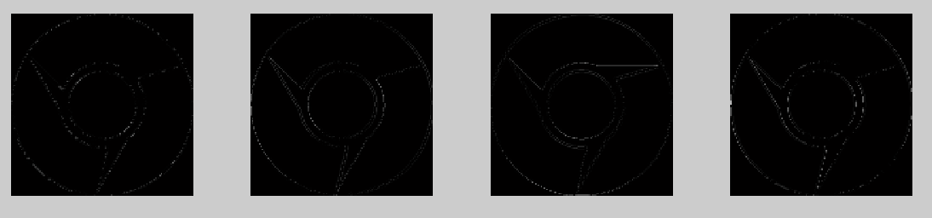

**Fig.17. Low frequency negative orientation of DTCWT**

High frequency bands:



**Fig.18. High frequency bands of DTCWT**

High frequency positive orientation:



**Fig.19. High frequency positive orientations of DTCWT**

* 1. **GABOR Transform Implementation**

1) The implementation involves the 2D convolution of the image taken and the Gabor filter function created.

2) This results in the multiplication of those frequency components present in the image which are corresponding to specified lambda value for harmonic function specified.

3) The Gaussian function ensures that only a specific portion or a band of harmonics is selected.

4) By changing the value of the sigma, the Gaussian envelope can select different bands from the image.

5) After no. of orientations is fixed, use the result obtained by those orientations and makes a feature vector.

6) Apply same steps on query image and make feature vector for query image.

7) Using various classifiers compare feature vector with that of query image feature vector and classify the query image into age groups.

Following are the results after applying GABOR Transform:

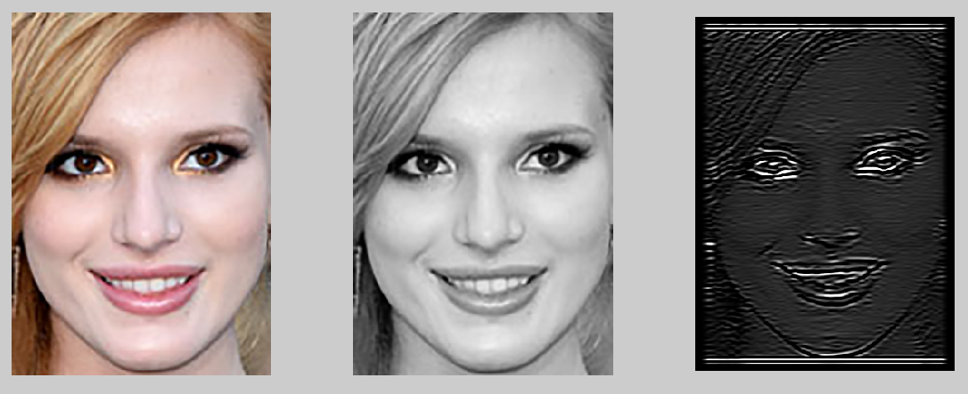

**Fig.20. GABOR transformed image**

Various orientations after applying GABOR Transform:

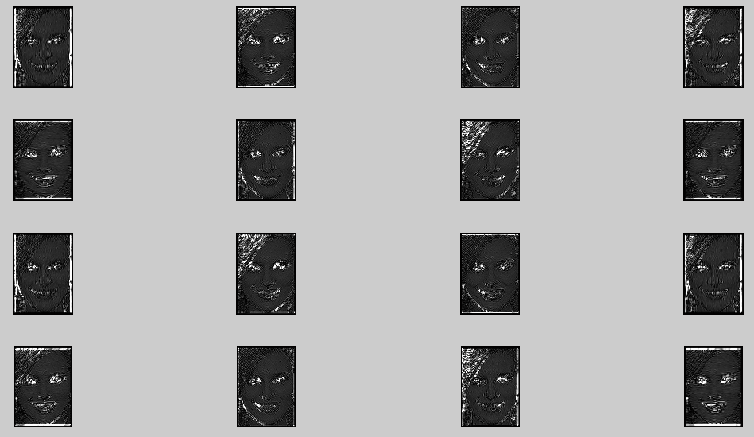

**Fig.21. Results of GABOR transform for various orientations**

**Chapter 5**

**Result and Discussion**

The algorithms are implemented in MATLAB for database of 200 images of 200 different subjects with 40 images of each class viz. child, adolescent, young, middle aged and old aged. The proposed method uses DCT, DWT, DTCWT and GABOR for feature extraction of facial images while variance, KNN classifier, Hybrid variance I and Hybrid variance II is used as a classifier. The variance classifiers give poor results across all transforms. To improve efficiency, KNN classifier is used and a steady improvement can be seen in all transforms. KNN classifier uses 4 different distances to find nearest neighbors.It was observed that from the 35 Debauchies, 7 Symlets, 15 Biorsplines and 14 reversebiorrs that were implemented using proposed algorithm, Db1 or ‘Haar’ wavelet provides maximum efficiency for all the classifiers used. DCT 5 and 9 vectored, both provide poor efficiency across all the classifiers except for Hybrid classifier II. Although DTCWT provides better feature extraction than DCT and DWT as it uses high as well as low frequency orientation, but it provides moderately poor efficiency for variance and KNN classifier but best efficiency for Hybrid variance I classifier. The GABOR transform stands apart from the rest transforms due to the freedom it provides for feature extraction. It gives best efficiency across all classifiers.

TABLE I. Comparative results for symlet wavelet using different knn classifiers

|  |  |  |  |  |
| --- | --- | --- | --- | --- |
| DWT METHOD | EUCLIDEAN | CITYBLOCK | COSINE | CORRELATION |
| SYMLET 2 | |  | | --- | | 46.667 | | 46.667 | 46.667 | 40.000 |
| SYMLET 3 | 46.667 | 53.333 | 40.000 | 40.000 |
| SYMLET 4 | 53.333 | 60.000 | 46.667 | 46.667 |
| SYMLET 5 | 53.333 | 53.333 | 40.000 | 40.000 |
| SYMLET 6 | 40.000 | 53.333 | 46.667 | 46.667 |
| SYMLET 7 | 53.333 | 46.667 | 66.667 | 66.667 |
| SYMLET 8 | 46.667 | 53.333 | 40.000 | 40.000 |

TABLE II. Comparative results for biorspline wavelet using different knn classifiers

|  |  |  |  |  |
| --- | --- | --- | --- | --- |
| DWT METHOD | EUCLIDEAN | CITYBLOCK | COSINE | CORRELATION |
| BIORSPLINE1.1 | |  | | --- | | **66.667** | | 53.3333 | 60.000 | 53.333 |
| BIORSPLINE1.3 | 53.333 | 46.6667 | 60.000 | 40.000 |
| BIORSPLINE1.5 | 60.000 | 53.3333 | 46.667 | 46.667 |
| BIORSPLINE2.2 | 53.333 | 53.3333 | 40.000 | 40.000 |
| BIORSPLINE2.4 | 53.333 | 60.0000 | 40.000 | 40.000 |
| BIORSPLINE2.6 | 53.333 | 60.0000 | 46.667 | 46.667 |
| BIORSPLINE2.8 | 53.333 | 60.0000 | 46.667 | 46.667 |
| BIORSPLINE3.1 | 20.000 | 20.0000 | 33.333 | 26.667 |
| BIORSPLINE3.3 | 46.667 | 40.0000 | 40.000 | 33.333 |
| BIORSPLINE3.5 | 40.000 | 40.0000 | 46.667 | 46.667 |
| BIORSPLINE3.7 | 40.000 | 40.0000 | 46.667 | 46.667 |
| BIORSPLINE3.9 | 33.333 | 26.6667 | 40.000 | 46.667 |
| BIORSPLINE4.4 | 40.000 | 40.000 | 40.000 | 40.000 |
| BIORSPLINE5.5 | 33.333 | 33.3333 | 53.333 | 46.667 |
| BIORSPLINE6.8 | 46.667 | 53.3333 | 40.000 | 40.000 |

TABLE III. Comparative results for Reversebior wavelet using different knn classifiers

|  |  |  |  |  |
| --- | --- | --- | --- | --- |
| DWT METHOD | EUCLIDEAN | CITYBLOCK | COSINE | CORRELATION |
| REVERSEBIOR1.1 | |  | | --- | | 66.667 | | 53.333 | 66.667 | 53.333 |
| REVERSEBOIR1.3 | 53.333 | 46.667 | 46.667 | 46.667 |
| REVERSEBIOR1.5 | 46.667 | 46.667 | 46.667 | 40.000 |
| REVERSEBIOR2.2 | 46.66 | 46.667 | 46.667 | 46.667 |
| REVERSEBIOR2.4 | 33.333 | 46.667 | 40.000 | 46.667 |
| REVERSEBIOR2.6 | 33.333 | 46.667 | 40.000 | 46.667 |
| REVERSEBIOR3.1 | 40.000 | 26.667 | 60.000 | 73.333 |
| REVERSEBIOR3.3 | 53.333 | 46.667 | 53.333 | 53.333 |
| REVERSEBIOR3.5 | 46.667 | 46.667 | 46.667 | 46.667 |
| REVERSEBIOR3.7 | 46.667 | 53.333 | 53.333 | 53.333 |
| REVERSEBIOR3.9 | 46.667 | 53.333 | 53.333 | 53.333 |
| REVERSEBIOR4.4 | 46.667 | 60.000 | 40.000 | 40.000 |
| REVERSEBIOR5.5 | 53.333 | 60.000 | 40.000 | 40.000 |
| REVERSEBOIR6.8 | 46.667 | 53.333 | 40.000 | 40.000 |

TABLE IV. Comparative results for DMeyer wavelet using different knn classifiers

|  |  |  |  |  |
| --- | --- | --- | --- | --- |
| DWT METHOD | EUCLIDEAN | CITYBLOCK | COSINE | CORRELATION |
| DMEYER | |  | | --- | | 53.333 | | 53.333 | 46.667 | 46.667 |

Below are Graphical results obtained for various wavelets using KNN Classifier:

1) EUCLIDEAN DISTANCE

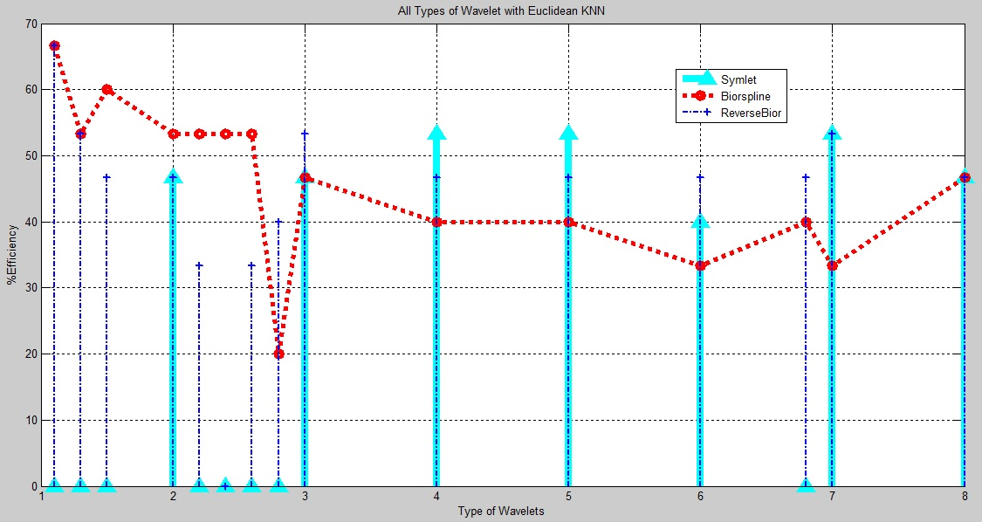

**Fig. 22. The curve shows % efficiency (on y axis) for different wavelets Biorspline , Symlets, Reverse bior (x axis) for Euclidean KNN classifier**

2) CITY BLOCK DISTANCE

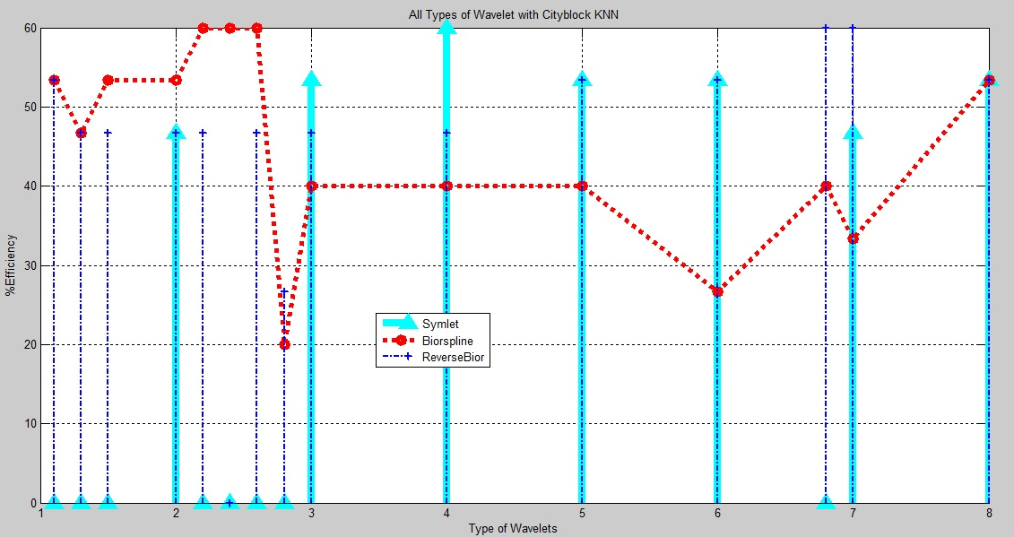

**Fig. 23. The curve shows % efficiency (on y axis) for different wavelets Biorspline , Symlets, Reverse bior (x axis) for City Block KNN classifier**

3) COSINE DISTANCE

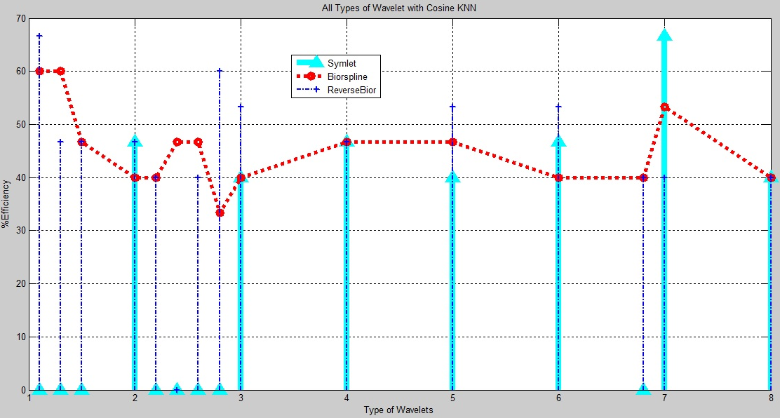

**Fig. 24. The curve shows % efficiency (on y axis) for different wavelets Biorspline , Symlets, Reverse bior (x axis) for Cosine KNN classifier**

4) CORRELATION DISTANCE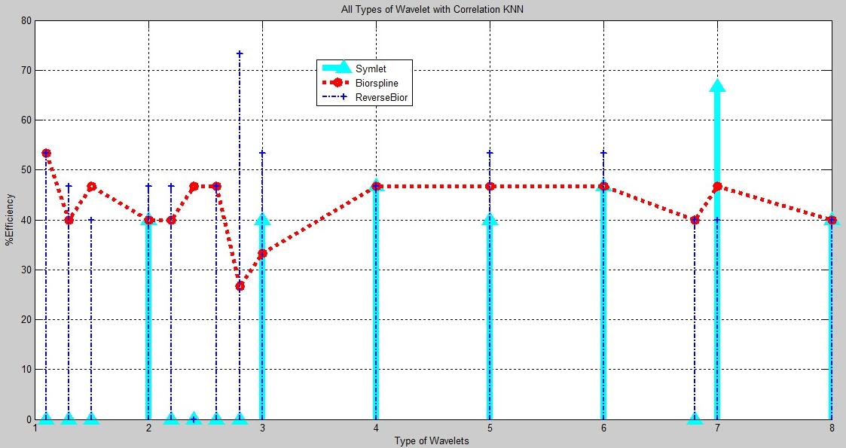

**Fig. 25. The curve shows % efficiency (on y axis) for different wavelets Biorspline , Symlets, Reverse bior (x axis) for Correlation KNN classifier**

TABLE V. Comparative results for Debauchies wavelet using different knn classifiers

|  |  |  |  |  |
| --- | --- | --- | --- | --- |
| DWT METHOD | EUCLIDEAN | CITYBLOCK | COSINE | CORRELATION |
| DEBAUCHIES1 | **73.333** | 53.333 | 66.667 | 66.667 |
| DEBAUCHIES2 | 46.667 | 46.667 | 46.667 | 40.000 |
| DEBAUCHIES3 | 53.333 | 53.333 | 40.000 | 40.000 |
| DEBAUCHIES4 | 46.667 | 46.667 | 40.000 | 40.000 |
| DEBAUCHIES5 | 53.333 | 53.333 | 46.667 | 33.333 |
| DEBAUCHIES6 | 46.667 | 53.333 | 40.000 | 40.000 |
| DEBAUCHIES7 | 46.667 | 53.333 | 40.000 | 26.667 |
| DEBAUCHIES8 | 46.667 | 46.667 | 53.333 | 46.667 |
| DEBAUCHIES9 | 46.667 | 53.333 | 53.333 | 53.333 |
| DEBAUCHIES10 | 40.000 | 46.667 | 40.000 | 40.000 |
| DEBAUCHIES11 | 40.000 | 46.667 | 40.000 | 40.000 |
| DEBAUCHIES12 | 53.333 | 46.667 | 46.667 | 46.667 |
| DEBAUCHIES13 | 53.333 | 53.333 | 46.667 | 46.667 |
| DEBAUCHIES14 | 53.333 | 53.333 | 40.000 | 40.000 |
| DEBAUCHIES15 | 40.000 | 60.000 | 40.000 | 40.000 |
| DEBAUCHIES16 | 46.667 | 53.333 | 40.000 | 40.000 |
| DEBAUCHIES17 | 53.333 | 53.333 | 46.667 | 53.333 |
| DEBAUCHIES18 | 40.000 | 53.333 | 46.667 | 40.000 |
| DEBAUCHIES19 | 46.667 | 53.333 | 46.667 | 46.667 |
| DEBAUCHIES20 | 46.667 | 53.333 | 40.000 | 40.000 |
| DEBAUCHIES21 | 53.333 | 53.333 | 53.333 | 53.333 |
| DEBAUCHIES22 | 40.000 | 40.000 | 40.000 | 40.000 |
| DEBAUCHIES23 | 46.667 | 53.333 | 46.667 | 46.667 |
| DEBAUCHIES24 | 40.000 | 53.333 | 40.000 | 40.000 |
| DEBAUCHIES25 | 53.333 | 53.333 | 53.333 | 60.000 |
| DEBAUCHIES26 | 53.333 | 46.667 | 46.667 | 40.000 |
| DEBAUCHIES27 | 46.667 | 53.333 | 40.000 | 46.667 |
| DEBAUCHIES28 | 46.667 | 53.333 | 40.000 | 40.000 |
| DEBAUCHIES29 | 60.000 | 53.333 | 53.333 | 53.333 |
| DEBAUCHIES30 | 46.667 | 66.667 | 40.000 | 40.000 |
| DEBAUCHIES31 | 46.667 | 53.333 | 46.667 | 46.667 |
| DEBAUCHIES32 | 40.000 | 53.333 | 40.000 | 46.667 |
| DEBAUCHIES33 | 46.667 | 53.333 | 46.667 | 40.000 |
| DEBAUCHIES34 | 53.333 | 46.667 | 46.667 | 46.667 |
| DEBAUCHIES35 | 60.000 | 60.000 | 53.333 | 46.667 |

Below are Graphical results obtained for Debauchies wavelets using KNN Classifier:

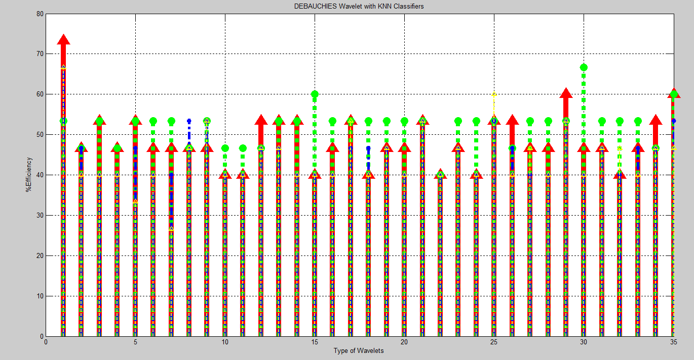

**Fig. 26. The curve shows % efficiency (on y axis) for 35different Debauchies wavelets (x axis) for different KNN classifier**

TABLE VI. Maximum efficiency achieved for different classifiers using various transforms

|  |  |  |  |  |  |  |  |
| --- | --- | --- | --- | --- | --- | --- | --- |
| %  M E  A F  X F  I I  M C  U I  M E  N  **C**  **Y** | V  A  R  I  A  N  C  E | E D  U I  C S  L T  I A  D N  E C  A E  N | C D  I I  T S  Y T  A  B N  L C  O E  C  K | C D  O I  S S  I T  N A  E N  C  E | C D  O I  R S  R T  E A  L N  A C  T E  I  O  N | H V  Y A  B R  R I  I A  D N  C  E  I | H V  Y A  B R  R I  I A  D N  C  E  II |
| DCT 5-vectored | 34 | 34 | 34 | 27 | 27 | 34 | 67 |
| DCT 9-Vectored | 40 | 40 | 34 | 34 | 40 | 34 | 54 |
| DB1 | 47 | 74 | 54 | 67 | 67 | 74 | 67 |
| SYM7 | 34 | 54 | 47 | 67 | 67 | 60 | 74 |
| Rbior1.1 | 20 | 67 | 54 | 67 | 54 | 54 | 54 |
| Bior 1.1 | 20 | 67 | 54 | 60 | 54 | 67 | 67 |
| DTCWT | 47 | 34 | 34 | 34 | 40 | 80 | 60 |
| GABOR | 54 | 80 | 80 | 74 | 80 | 87 | 74 |

Chapter 6

Conclusion and Scope

This project report presents comparative analysis of Gabor transform for various classifiers viz. variance, KNN classifier, Hybrid variance I and Hybrid variance II. As it can be seen in TABLE VI. Gabor transform provides best efficiency for all the classifiers used when compared to the efficiency given by DCT, DWT and DTCWT for same classifiers. Out of all the classifiers used Hybrid Variance II gives consistently better efficiency over all transforms while Hybrid transform I gives best efficiency of 87% for GABOR transform. Since this paper uses a particular small self-generated database of 200 images of 200 different subjects, the efficiency obtained is not close to 100 %. A more standard database like MORPH database, FG-NET database, GOOGLE database or any standard database may provide better efficiency. Pre-processing the image by using DoG filtering or Gamma correction may also provide better efficiency. This work can be further extended by using various other complex or discrete wavelet or rounded wavelet.

**Chapter 7**

**Bibliography**

[1] J. Nithyashri and G. Kulanthaivel, “Classification of Human Age based on Neural Network Using FG-NET Aging Data-base and Wavelets,” IEEE- Fourth International Conference on Advanced Computing, (ICoAC2012), pp.1-5, 2012

[2]Asuman Gunay and Vasif V. Nabiyev, “Automatic Age Classification with LBP”, Proc. of IEEE, International conference on Computer vision and Image Processing,2008.

[3]Feng Gao and Haizhou Ai, “Face Age Classification on Consumer Images with Gabor Features and Fuzzy LDA method,” Advances in Biometrics, LNCS, Vol. 5558, pp. 132-141, 2009.

[4]S. Soman, M. Ghorpade, V. Sonane, and S. Chavan, “Content based image retrieval using advanced color and texture features,” IJCA Proceedings on International Conference in Computational Intelligence, iccia - Number 9,2012.

[5]Nagi J.and Nagi F. “A MATLAB based Face Recognition System using Image Processing and Neural Networks,” 4th International Colloquium on Signal Processing and its Applications, March 7-9, 2008.

[6]M.Sifuzzaman , M. Islam and M.Ali, “Application of Wavelet Transform and its Advantages Compared to Fourier Transform,” Journal of Physical Sciences, Vol. 13,2009.

[7] Eidinger, E.; Enbar, R.; Hassner, T., "Age and Gender Estimation of Unfiltered Faces," Information Forensics and Security, IEEE Transactions on , vol.9, no.12, pp.2170,2179, Dec. 2014.Baldonado, M., Chang, C.-C.K., Gravano, L., Paepcke, A.: The Stanford Digital Library Metadata Architecture. Int. J. Digit. Libr. 1 (1997) 108–121.

[8] M.R. Kosorok, “Discussion of Brownian distance covariance”, Ann. Appl. Stat. 3 (4) 1270–1278, 2009.

[9] Bei-Ji Zou,” Shape - Based Trademark Retrieval Using Cosine Distance Method Intelligent Systems Design and Applications” , ISDA '08. Eighth International Conference on 26-28 Nov. 2008.

[10] Xiaoyang Tan and Bill Triggs,“Enhanced Local Texture Feature Sets for Face Recognition Under Difficult Lighting Conditions”, IEEE Transactions on Image Processing vol.19, (6), pp.1635-1649,2010.

[11] Saeid. Fazli and Leila. Ali Heidarloo,” Wavelet Based Age Invariant Face Recognition using Gradient Orientation” International Conference on Advances in Computer and Electrical Engineering (ICACEE'2012) Nov. 17-18, 2012 .

[12] Li Liu, Jianming Liu, Jun Cheng , “Age – group classification of facial images”, Proceedings of International Conference on Machine Learning and Applications,12-15,Dec 2012.

[13] Ce Zhan, Wanqing, Philp Ogunbona, “ Age estimation based on Extended non-negative matrix factorization”, 13th IEEE Inter national Workshop on Multimedia Signal Processing, MMSP 2011 (pp. 1-6). USA.

[14] Karl Ricanek, Tamirat Tesafaye, ” MORPH: A longitudinal image database of normal adult age- progression”, International conference on Automatic face and Gesture Recognition, pp 341-345,2006.

[15]Geng.X, Zhou.Z.H, Smith-Miles.K , “ Automatic age estimation based on facial aging patterns, IEEE Transaction on PatternAnalysis and Machine Intelligence . Vol. 29, pp: 2234- 2240, 2007.

[15] Gonzales and Richard E.woods,”Digital Image Processing”, 3rd edition, Prentice Hall of India, 2007.

[16]Young Ho Kwon and Niels Da Vitoria Lobo,” Age classification of facial images”, Journal of Computer Vision and Image understanding, vol. 74, pp. 1-21, 1999.

COMPARATIVE ANALYSIS OF FACIAL IMAGES USING GABOR TRANSFORM FOR HUMAN AGE CLASSIFICATION USING HYBRID VARIANCE AND KNN CLASSIFIERS

Raunak M. Borwankar1, Gaurav S. Pednekar2, Saurabh A. Deshpande3, Purva S. Sawant4, Satishkumar Chavan5

Department of Electronics and Telecommunications Engineering,

Don Bosco Institute of Technology, Kurla(W), Mumbai, India.

1raun_borwankar@yahoo.co.in, 2gpednekar4@gmail.com, 3saurabhdeshpande1994@gmail.com, 4sawant.purva@gmail.com, 5satyachavan@yahoo.co.in

***Abstract.--The age estimation and classification is a very simple task for human, but it is very difficult for machine to classify age based on facial information. Many researchers have made efforts to achieve age classification using spatial and transform domain techniques with various classifiers. But transform domain classification is not as explored as spatial domain. This paper aims to develop algorithms in transform domain to achieve maximum possible efficiency. The transforms like Discrete Cosine Transform (DCT), Discrete Wavelet Transform (DWT), Dual Tree Complex Wavelet Transform (DTCWT) and GABOR Transform are used to extract features from images. These features are used to classify given facial image into a range of age groups viz. child, adolescent, young, middle aged, old aged using variance as a classifier. The experimental results prove that the feature extraction of Gabor transform using Hybrid Variance II provides better classification efficiency than that of DCT, DWT and DTCWT for same classifier.***

***Keywords--Age Classification; Discrete Cosine Transform (DCT); Discrete Wavelet Transform (DWT); Dual Tree Complex Wavelet Transform(DTCWT); GABOR; Hybrid variance; KNN Classifier.***

1. Introduction

In artificial intelligence, the need of the day application by far is age estimation and classification. Age estimation and classification can be introduced in day-to-day applications where human intervention is not possible and system does

not possess enough intelligence to provide comparable results to that of human.

So over last decade, efforts are being made in this direction. The motivation behind this paper is to develop a system or

Train the intelligence of a machine in such a way that it will be able to classify images into correct age group, thus age estimation and classification, with efficiency that is comparable with human age detection and classification.

Human facial images are important in age classification and estimation; as human face reflects one's age prominently.

There has been number of experiments carried out in image processing attempting to classify and estimate human age from facial images. Some approaches used spatial approach while some used transformed domain or both. Depending upon the image size, resolution and type of facial image taken the result and efficiency for each technique varies. Human Age Classification in transform Domain uses the frontal facial images of the person, extracts features from it by taking its transform, compares the features from the images in database having large number of subjects. The comparison leads to the conclusive age classification of the person in an image.

The contents of this manuscript are structured as follows. Chapter II is about related work done, Chapter III focuses on overview of the proposed work, Chapter IV shows the experimental work, Chapter V gives results and discussion and Chapter VI gives conclusion and future directions.

1. Related work

In literature, different perspectives of age progression are studied including age estimation [8].They applied dropout SVM for face attribute estimation, provided a unique dataset of facial images and also offered a robust face alignment technique.Age classification can be done in spatial or frequency domain. In frequency domain transform is applied to extract features, these features are used to classify age groups using classifier. The most related work with ours is on age classification [7].It is also the most recent work.[7] used Discrete Wavelet Transform for feature extraction and KNN algorithm for classification into three categories adolescence adult and senior adult.

Gabor is yet another technique used for feature extraction. In [3] GABOR features beats other features such as LBP and pixel intensity also the fuzzy LDA is proven to be a better classifier then SVM and LDA.

Along with estimation and classification we also studied face recognition. [5] Use features from DCT coefficients and SOM is used a classifier. The benefit of it is great processing ability and small computational necessities

In [4] block wise DCT is applied to extract texture features and color features were extracted by moment of colors. A comparative study of color and texture features extraction was done.

[6] did a relative study of wavelet and Fourier transform. They demonstrated wavelet transform to be better and dependable. They also discussed application of wavelet such as fingerprint verification.

1. Proposed work

This paper concentrates on age classification in transform domain using different transforms as well as classifiers to find out the best possible combination of a transform and a classifier for age classification. To achieve this purpose a system is designed based on an algorithm which is further classified as training algorithm and testing algorithm. The training algorithm will provide us database feature vector matrix after applying a particular transform on database images. The testing algorithm will use the same transform which is used in training algorithm and apply it on query image(s) and provide us with query feature vector matrix. Using the database feature vector matrix as reference we classify the query image(s) into different age group viz. child, adolescent, young, middle aged and old aged using a particular classifier. This process is repeated for various combinations of transforms and classifiers. Both, the training and testing algorithms are divided into two parts viz. pre-processing the image and feature extraction using transforms. The testing algorithm has an additional part of using classifiers to classify the query image into an age group.

Following are training and testing algorithms:

1. *Preprocessing of the Image*

The images are gray scaled as luminance is more important in distinguishing visual features and grey scaled images contain only luminance information. After Grey scaling is done images are resized according to requirements of transform used.

Training Algorithm Testing Algorithm

Get Database images

Get Query Image

Resize and grayscale

Resize & Grayscale

Apply DCT or Discrete and Complex Wavelet transform or GABOR

Apply DCT or DWT or CWT or GABOR

Compute the coefficient as a feature vector for database matrix

Compile the coefficients as a feature vector for query images

Compare

Classify

Fig. 1.The block diagram representation is of algorithm of proposed work

1. *Feature Extraction using Transforms*

Feature extraction is done in transform domain using following transforms viz.

1. Discrete Cosine Transform(DCT)
2. Discrete Wavelet Transform (DWT)
3. Dual Tree Complex Wavelet Transform(DTCWT)
4. GABOR Transform.
5. *Discrete Cosine Transform (DCT)*

A discrete cosine transform (DCT) expresses a finite sequence of data points in terms of a sum of cosine functions oscillating at different frequencies [1]. In particular, a DCT is a Fourier-related transform similar to discrete Fourier transform (DFT) but using only real numbers. There are 8 different variants of DCT out of which 8*8 DCT is most efficient. The DCT, and in particular the DCT-2, is often used in signal and image processing, especially for lossy compression, because it has a strong "energy compaction" property. The DCT transforms images from Spatial domain to frequency domain. The low frequencies in an image are visually significant than high frequencies. The DCT relinquishes the high frequencies and rationalizes the remaining coefficients. Typically, the energy concentration is observed in top left corner. The 2D-DCT of M x N matrix of an image for every pixel is given by:

Where F(u, v) is DCT domain representation of f(i, j),the pixel value at co-ordinate(M,N) and u as well as v represent vertical and horizontal frequencies respectively.

  (2)

Every image in database of 100 images is divided in 8x8 blocks. The 2D DCT is applied on each block to get DCT coefficients. Due to energy compaction property of DCT, energy of every block gets concentrated in top left corner of each block. The feature vector is created by scanning top left corner in diagonally downward direction. The length of this feature vector is 5 and 9 as shown in Fig.2 and Fig. 3 respectively.

|  |  |  |  |  |  |  |  |
| --- | --- | --- | --- | --- | --- | --- | --- |
| 1 | 2 | 2 | 3 | 3 | 4 | 4 | 5 |
| 2 | 2 | 3 | 3 | 4 | 4 | 5 |  |
| 2 | 3 | 3 | 4 | 4 | 5 |  |  |
| 3 | 3 | 4 | 4 | 5 |  |  |  |
| 3 | 4 | 4 | 5 |  |  |  |  |
| 4 | 4 | 5 |  |  |  |  |  |
| 4 | 5 |  |  |  |  |  |  |
| 5 |  |  |  |  |  |  |  |

5-Vectored DCT coefficients=

|  |  |  |  |  |
| --- | --- | --- | --- | --- |
| 1 | 2 | 3 | 4 | 5 |

|  |  |  |  |  |
| --- | --- | --- | --- | --- |
| 1 | 2 | 3 | 4 | 5 |

Fig. 2. The DCT coefficients pattern to form the DCT coefficient vector of length 5. Coefficient 1 contains highest information.

|  |  |  |  |  |  |  |  |  |  |  |  |  |  |  |  |
| --- | --- | --- | --- | --- | --- | --- | --- | --- | --- | --- | --- | --- | --- | --- | --- |
| 1 | 2 | 2 | 3 | 3 | 4 | 4 |  |  | 7 | 7 | 7 | 7 | 7 | 7 | 7 |
| 2 | 2 | 3 | 3 | 4 | 4 |  |  | 5 | 9 | 8 | 8 | 8 | 8 | 8 | 8 |
| 2 | 3 | 3 | 4 | 4 |  |  |  | 5 | 6 | 9 | 9 |  |  |  |  |
| 3 | 3 | 4 | 4 |  |  |  |  | 5 | 6 | 9 | 9 | 9 |  |  |  |
| 3 | 4 | 4 |  |  |  |  |  | 5 | 6 |  | 9 | 9 | 9 | 9 |  |
| 4 | 4 |  |  |  |  |  |  | 5 | 6 |  |  | 9 | 9 |  |  |
| 4 |  |  |  |  |  |  |  | 5 | 6 |  |  | 9 |  |  |  |
|  |  |  |  |  |  |  |  | 5 | 6 |  |  |  |  |  |  |

9-vectored DCT coefficients =

|  |  |  |  |  |  |  |  |  |
| --- | --- | --- | --- | --- | --- | --- | --- | --- |
| 1 | 2 | 3 | 4 | 5 | 6 | 7 | 8 | 9 |

Fig.3. The DCT coefficients pattern to form the DCT coefficient vector of length 9 for a block of 8x8.

1. *Discrete Wavelet Transform(DWT)*

The Wavelet Transform is different from classical Fourier transform. The 2 dimensional Fast Fourier transform, when applied to an image, we get the real as well as imaginary parts of transformed image. The reason behind extensive use of Wavelet transform is due to the multi-resolution property of wavelet transform.

Image Matrix

LPF

HPF

Result

Result

LPF

HPF

LPF

HPF

LL

LH

HH

HL

Fig. 4.The block diagram representation of the DWT of an input image matrix.

The formal definition of wavelet transform is given by

(3)

The parameter a is often termed as scale or scaling factor, and it represents the degree of scaling or compression of information. The term is called as the Basis function for the wavelet function defined above. The parameter b determines the time location of the wavelet. Depending upon the value of the scaling parameter a, the wavelet function has different value than singleton ‘mother wavelet’ function (t). Thus, the above Wavelet functions have time widths adapted to their frequencies.

1. *Dual Tree Complex wavelet Transform(DTCWT)*

The Dual Tree Complex wavelet Transform (DTCWT) is a complex valued extension to the standard discrete wavelet transform (DWT). It is a two-dimensional wavelet transform which provides multi-resolution, sparse representation and useful characterization of the structure of an image. The DTCWT calculates the complex transform of a signal using two separate DWT decompositions (tree a and tree b). If the filters used in one are especially designed different from those in the other it is possible for one DWT to produce the real coefficients and the other the imaginary. The dual-tree CWT is implemented as two separate two-channel filter banks. One cannot arbitrarily choose the scaling and wavelet filters used in two trees (tree a and tree b). The low-pass (scaling) and high-pass (wavelet) filters of one tree,{h0, h1} must generate a scaling function and wavelet that are approximate Hilbert transforms of the scaling function and wavelet generated by low-pass and high-pass filter of other tree,{g0, g1}. Therefore, the complex- valued scaling function and wavelet from the tree a and tree b are approximately analytic.

DTCWT decomposes image into 16 bands out of which 12 are high frequency bands while 4 are low frequency bands. The 12 high frequency bands consist of 6 real and 6 imaginary bands. Now DTCWT uses 15, 45 and 75 degree orientation as well as -15, -45 and -75 orientation to obtain high frequency bands. For low frequency bands DTCWT uses 0, 45 and 90 degree orientation. We know that low frequency bands of image contain image information while high frequency bands of image contain high frequency data like edge information. DTCWT is applied to low frequency bands for further decomposition of image.

1. *GABOR Transform*

Gabor filter is widely used linear filter in image processing used for edge detection. Gabor filter finds its application in appropriate texture representation and discrimination, since the frequency and orientation representation of Gabor filters are similar to those of human visual system.

The Gabor kernel consists of Gaussian Kernel function modulated by sinusoidal plane wave. The Gabor filter has its impulse response defined by a sinusoidal wave, which is multiplied by a Gaussian function. Due to multiplication-convolution property, the Fourier transform of Gabor filter’s impulse response is the convolution of the Fourier transform of sinusoidal plane wave or the harmonic function, and the Fourier transform of Gaussian function.

Mathematical Definition of Gabor filters transfer function.

(4)

Where

And

𝜆 represents the wavelength of the sinusoidal plane wave, 𝞱 is orientation of normal to the parallel stripes of Gabor function, ψ is phase shift, is standard deviation of the Gaussian curve and γ is the aspect ratio in spatial domain.

1. *CLASSIFIERS*
2. *Hybrid Variance*

The hybrid variance is based on the concept of variance. It calculates how much the query image vector varies from the database image vector and classifies the query image into the nearest age group based on the variation.

1. *K- Nearest Neighbor Classifier(KNN)*

The KNN classifier is very powerful and reliable classifier when it comes to machine learning algorithm. Its functionality is based on finding the nearest neighbor to a particular vector from given set of vectors. In KNN classifier, K indicates no. of neighbors taken into consideration for classification .In KNN classifier we have to provide 3 groups viz. SAMPLE, TRAINING and GROUP, where SAMPLE contains the database image feature matrix, TRAINING contains query image feature matrix and GROUP contain various age group in which query image is to be classified.

1. EUCLIDEAN DISTANCE

The Euclidean distance eqn. is given by:

(5)

Where,

u=(u1,u2,….un)…….Database image feature vector matrix.

v=(v1,v2,….vn)…….Query image feature vector matrix.

1. CITYBLOCK DISTANCE

The City block distance eqn. is given by:

(6)

Where,

u=(u1,u2,….un)…….Database image feature vector matrix.

v=(v1,v2,….vn)…….Query image feature vector matrix.

1. COSINE DISTANCE

The Cosine distance eqn. is given by:

(7)

The cosine distance between vectors u and v , is given by dot product and magnitude[10].

Where,

U is Database image feature vector matrix.

V is Query image feature vector matrix.

1. CORRELATION DISTANCE

The correlation distance is given by formula:

(8)

The correlation distance is calculated by dividing distance covariance by product of distance standard deviation of u and v [9].

Where,

U is Database image feature vector matrix.

V is Query image feature vector matrix.

1. Experimental work

The proposed system is divided into two parts viz. training and testing. In training a database of 200 face-only images of 200 different subjects is created. The images are resized to dimensions as per the specific requirements of a particular transform**.** After the images are resized they are gray scaled since the luminance information provides us the necessary parameters for age classification than the chrominance information. This comprises of pre-processing. After pre-processing, feature extraction is carried out using in transform domain using transforms like DCT, DWT, DTCWT, and GABOR.

In 2D-DCT, it is observed that 8x8 block processing gives better results. The images are resized such that, 8x8 block processing can be applied on it. After applying 2D-DCT on every block the result is multiplied with an 8x8 mask for feature extraction. The feature extraction is done in two ways i.e. 5-vectored feature extraction as shown in Fig.1.a and 9-vectored feature extraction as shown in Fig.1.b. Same procedure is applied on query image(s) and using various classifiers the query image(s) is classified in various age groups viz. child, adolescent, young, middle aged and old aged.

In 2D-DWT, various types of wavelets were used viz. Debauchees’, Symlets, Dmeyer, Biorsplines, Reversebior. But since different wavelets have different size of filter coefficients, the result obtained is not ideal. So an algorithm is developed to achieve near ideal results for all 2D discrete wavelets. After applying 2D-DWT we get result in form of LL, LH, HL, HH which is nothing but approximate transform, horizontal transform, diagonal transform and vertical transform respectively. It is logical that more the decomposition of an image more information is obtained. The images are resized to 256x256 and 6 level decomposition is done on approximate part of result so that after final decomposition we get LL, LH, HL, HH which cannot be further decomposed. Using all these vectors from each level of decomposition a 22-vectored feature matrix is created for the database images. Same procedure is applied on query image(s) and using various classifiers the query image(s) is classified in various age groups.

For 2D-DTCWT an algorithm is designed which generates DTCWT transform of image. First order decomposition is carried out using ‘faf’ first order filters. ‘faf’ is called as farras filters. Further decomposition is carried out using ‘af’ filters. As we define parameter “level”, ‘af’ filter is used for mentioned number of levels. Before implementing this system we need to include ‘faf’ filter coefficients and ‘af’ coefficients in same directory. Using these filters and dual tree complex wavelet function, dual tree complex wavelet transform of an image is achieved. This transform provides 16 vectors for each level of decomposition. In further levels, the decomposition is done on low frequency bands. The no. of levels of decomposition is subjective to quality of image and application. Using classifier the query image(s) is classified into various age groups.

Gabor filter transfer function consists of the Gaussian function modulated with the sinusoidal waveform. The parameters in Gabor filter transfer function are as follows:

θ= Angle in degrees or radians.

λ=Wavelength of harmonic function used (i.e. the sin wave)

ψ= Phase shift of the harmonic function.

σ= standard deviation of the Gaussian function.

γ= aspect ratio of the each Gabor filter function created using program.

The actual implementation involves the 2D convolution of the image taken and the Gabor filter function created. This results in the multiplication of those frequency components present in the image which are corresponding to specified lambda value for harmonic function specified. The Gaussian function ensures that only a specific portion or a band of harmonics is selected. By changing the value of the sigma, the Gaussian envelope can select different bands from the image.

1. Results and discussion

The algorithms are implemented in MATLAB for database of 200 images of 200 different subjects with 40 images of each class viz. child, adolescent, young, middle aged and old aged. The proposed method uses DCT, DWT, DTCWT and GABOR for feature extraction of facial images while variance, KNN classifier, Hybrid variance I and Hybrid variance II is used as a classifier. The variance classifiers give poor results across all transforms. To improve efficiency, KNN classifier is used and a steady improvement can be seen in all transforms. KNN classifier uses 4 different distances to find nearest neighbors.It was observed that from the 35 Debauchies, 7 Symlets, 15 Biorsplines and 14 reversebiorrs that were implemented using proposed algorithm, Db1 or ‘Haar’ wavelet provides maximum efficiency for all the classifiers used. DCT 5 and 9 vectored, both provide poor efficiency across all the classifiers except for Hybrid classifier II. Although DTCWT provides better feature extraction than DCT and DWT as it uses high as well as low frequency orientation, but it provides moderately poor efficiency for variance and KNN classifier but best efficiency for Hybrid variance I classifier. The GABOR transform stands apart from the rest transforms due to the freedom it provides for feature extraction. It gives best efficiency across all classifiers.

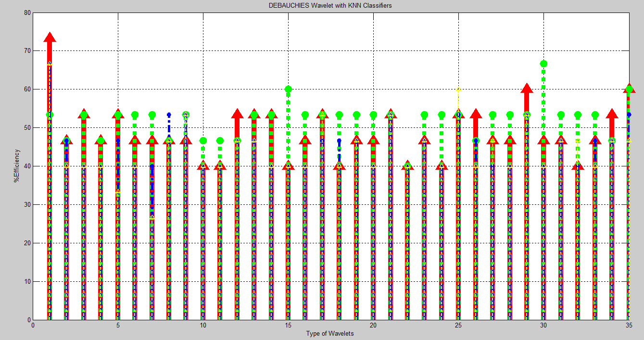Fig. 5. The curve shows % efficiency (on y axis) for 35different Debauchies wavelets (x axis) for different KNN classifier

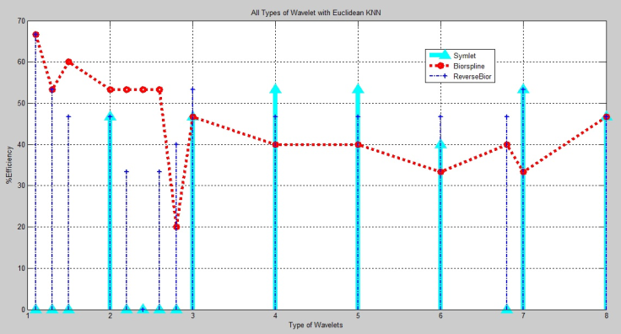

Fig. 6. The curve shows % efficiency (on y axis) for different wavelets Biorspline , Symlets, Reverse bior (x axis) for Euclidean KNN classifier

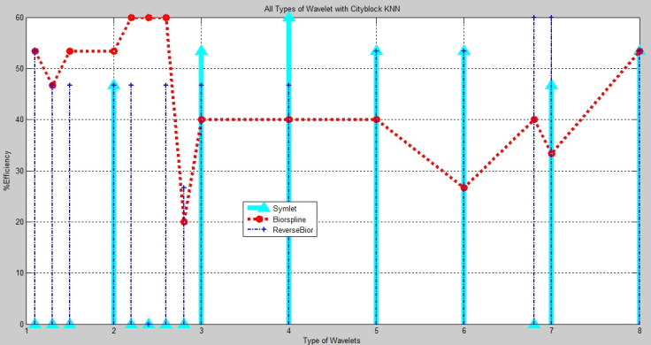

Fig. 7. The curve shows % efficiency (on y axis) for different wavelets Biorspline , Symlets, Reverse bior (x axis) for City Block KNN classifier

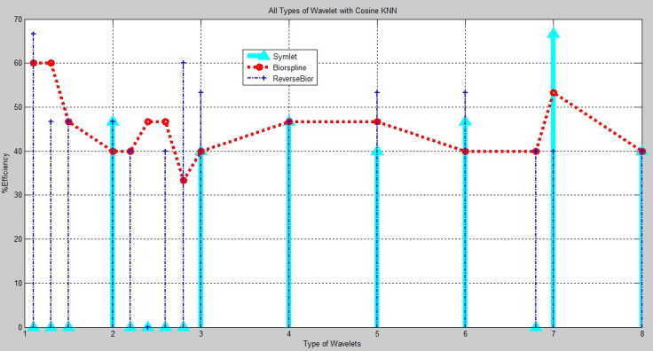

Fig. 8. The curve shows % efficiency (on y axis) for different wavelets Biorspline , Symlets, Reverse bior (x axis) for Cosine KNN classifier

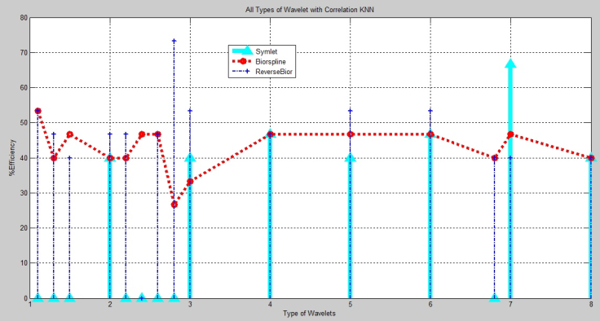Fig. 9. The curve shows % efficiency (on y axis) for different wavelets Biorspline , Symlets, Reverse bior (x axis) for Correlation KNN classifier

1. Conclusion and scope

This paper presents comparative analysis of Gabor transform for various classifiers viz. variance, KNN classifier, Hybrid variance I and Hybrid variance II. As it can be seen in TABLE I. Gabor transform provides best efficiency for all the classifiers used when compared to the efficiency given by DCT, DWT and DTCWT for same classifiers. Out of all the classifiers used Hybrid Variance II gives consistently better efficiency over all transforms while Hybrid transform I gives best efficiency of 87% for GABOR transform. Since this paper uses a particular small self-generated database of 200 images of 200 different subjects, the efficiency obtained is not close to 100 %. A more standard database like MORPH database, FG-NET database, GOOGLE database or any standard database may provide better efficiency. Pre-processing the image by using DoG filtering or Gamma correction may also provide better efficiency. This work can be further extended by using various other complex or discrete wavelet or rounded wavelet.

**References**

[1] J. Nithyashri and G. Kulanthaivel, “Classification of Human Age based on Neural Network Using FG-NET Aging Data-base and Wavelets,” IEEE- Fourth International Conference on Advanced Computing, (ICoAC2012), pp.1-5, 2012

[2]Asuman Gunay and Vasif V. Nabiyev, “Automatic Age Classification with LBP”, Proc. of IEEE, International conference on Computer vision and Image Processing,2008.

[3]Feng Gao and Haizhou Ai, “Face Age Classification on Consumer Images with Gabor Features and Fuzzy LDA method,” Advances in Biometrics, LNCS, Vol. 5558, pp. 132-141, 2009.

[4]S. Soman, M. Ghorpade, V. Sonane, and S. Chavan, “Content based image retrieval using advanced color and texture features,” IJCA Proceedings on International Conference in Computational Intelligence, iccia - Number 9,2012.

[5]Nagi J.and Nagi F. , “A MATLAB based Face Recognition System using Image Processing and Neural Networks,” 4th International Colloquium on Signal Processing and its Applications, March 7-9, 2008.

[6]M.Sifuzzaman , M. Islam and M.Ali, “Application of Wavelet Transform and its Advantages Compared to Fourier Transform,” Journal of Physical Sciences, Vol. 13,2009.

[7] Eidinger, E.; Enbar, R.; Hassner, T., "Age and Gender Estimation of Unfiltered Faces," Information Forensics and Security, IEEE Transactions on , vol.9, no.12, pp.2170,2179, Dec. 2014.Baldonado, M., Chang, C.-C.K., Gravano, L., Paepcke, A.: The Stanford Digital Library Metadata Architecture. Int. J. Digit. Libr. 1 (1997) 108–121.

[8] M.R. Kosorok, “Discussion of Brownian distance covariance”, Ann. Appl. Stat. 3 (4) 1270–1278, 2009.[9] Bei-Ji Zou,” Shape - Based Trademark Retrieval Using Cosine Distance Method Intelligent Systems Design and Applications” , ISDA '08. Eighth International Conference on 26-28 Nov. 2008.

TABLE I. Maximum efficiency achieved for different classifiers using various transforms

|  |  |  |  |  |  |  |  |
| --- | --- | --- | --- | --- | --- | --- | --- |
| %  M E  A F  X F  I I  M C  U I  M E  N  **C**  **Y** | V  A  R  I  A  N  C  E | E D  U I  C S  L T  I A  D N  E C  A E  N | C D  I I  T S  Y T  A  B N  L C  O E  C  K | C D  O I  S S  I T  N A  E N  C  E | C D  O I  R S  R T  E A  L N  A C  T E  I  O  N | H V  Y A  B R  R I  I A  D N  C  E  I | H V  Y A  B R  R I  I A  D N  C  E  II |
| DCT 5-vectored | 34 | 34 | 34 | 27 | 27 | 34 | 67 |
| DCT 9-Vectored | 40 | 40 | 34 | 34 | 40 | 34 | 54 |
| DB1 | 47 | 74 | 54 | 67 | 67 | 74 | 67 |
| SYM7 | 34 | 54 | 47 | 67 | 67 | 60 | 74 |
| Rbior1.1 | 20 | 67 | 54 | 67 | 54 | 54 | 54 |
| Bior 1.1 | 20 | 67 | 54 | 60 | 54 | 67 | 67 |
| DTCWT | 47 | 34 | 34 | 34 | 40 | 80 | 60 |
| GABOR | 54 | 80 | 80 | 74 | 80 | 87 | 74 |