**Purpose:** We present a new algorithm for multi-modal symmetric diffeomorphic image registration and propose a protocol based on existing manually annotated datasets to quantitatively evaluate multi-modal image registration algorithms.

**Methods:** Given a pair of input images **I**, **J**, we aim to find two diffeomorphisms **I, J** that map the input images to a reference space **R**, in which both images get aligned. This symmetric approach was proposed by Avants *et al.* [3], where each of the aforementioned transformations is regarded as the mid-point of a time-varying diffeomorphic flow. To accommodate multimodal images, we assume the existence of a pair of transfer functions **FI**, **FJ** that approximately map image intensities from **I** to **J** and from **J** to **I**, respectively. In eq. (1), the *warped* (aligned) images in the reference space can be approximated by applying the transfer functions, and any residual differences are modeled as small additive noise, denoted by **I, J**. This *functional dependency* assumption, has been previously successfully used by Roche *et al.* [2] and recently extended by Arce *et al.* [1]. Roche *et al.* [2] assumed constant variance for the random variables **I, J**, giving rise to the Correlation Ratio metric, while Arce’s model [1] dropped the homoscedasticity assumption to obtain a more general metric which exploits the uncertainty associated to each intensity. The transfer functions may be modeled as two sets of conditionally independent hidden random fields, **Y(x) =** **FJ[J(J (x))], Z(x) =** **FI[I(I (x))]** (eq. 2). After similar computations as in Arce *et al.* [1], the resulting dissimilarity metric is the sum of two functions measuring the dissimilarity of the input images in both modalities. The resulting metric is minimized in the space of diffeomorphisms using a variation of the Symmetric Normalization (SyN) algorithm proposed by Avants et al. [3], called SyN-EM, since the Expectation Maximization (EM) algorithm was used to derive it, as in [1].

**Figure 1: Semi-synthetic, manually annotated images for quantitative evaluation of multi-modal non-linear image registration algorithms**

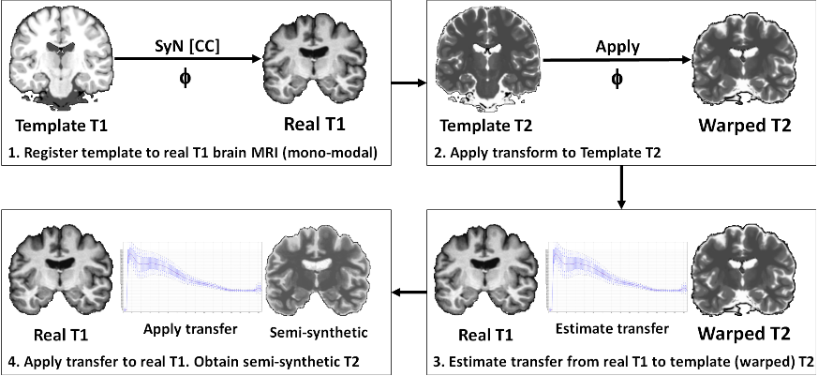

**Equation 1: Observation model.**



**Equation 2: Transfer functions modeled as two conditionally independent random fields.**



**Results:** We validate our algorithm using the publicly available Internet Brain Segmentation Repository (IBSR), consisting of 18 manually annotated T1 brain images, and the Brainweb synthetic template [6], which provides perfectly aligned brain images in T1, T2 and PD modalities. After registering the T1 template to each real IBSR T1 brain image using ANTS (a mono-modal registration problem) with normalized Cross Correlation (CC), the same transformation allows us to align any template modality to the real brain image, which is used to synthetically generate other modalities for the real T1 image: the transfer is computed as the average T2 intensity associated to each T1 intensity (which is justified by the E-step of the EM algorithm [1]). These semi-synthetic images (real anatomy with synthetic intensities) keep the manual annotations of the original T1 image unchanged, which allows us to quantitatively evaluate multi-modal registration algorithms by measuring the overlap of anatomical regions after registration. This process is illustrated in figure 1. Figure 2 depicts the Jaccard index for each of 31 manually annotated anatomical regions, averaged over 612 registrations (all possible pairs of registrations between 18 T1 and 18 T2 brain images, each used as fixed and moving image: 18x17x2 = 612).

**Conclusion:** We presented a method, called SyN-EM, for multi-modal symmetric diffeomorphic image registration. Our model differs from [1] and [2] in two main aspects: 1) we estimate both transfer functions between the two modalities, while in [1] and [2] one of the two modalities needs to be chosen as reference, 2) we optimize the resulting similarity metric in the space of diffeomorphisms by extending the SyN algorithm proposed by Avants *et al.* [3], while in [1] and [2] an elastic deformation model was used. We also proposed a quantitative evaluation protocol for multi-modal image registration, which can be used to overcome the lack of manually annotated multi-modal images (to the best of our knowledge, there are no manually annotated multi-modal brain MR images publicly available). This validation protocol allows us to quantitatively compare the performance of registration algorithms in the multi-modal case, which reveals that the Cross Correlation metric, may be severely affected in the multi-modal case, even though it has proven to be one of the most robust and accurate metrics for mono-modal registration [4]. Our algorithm, publicly available in Dipy [5], compares favorably to SyN with CC (in the multi-modal case) and is very competitive with SyN with Mutual Information (MI). The aspect that makes SyN-EM an interesting alternative to MI is that the estimated transfer functions may be used to extend other metrics that perform remarkably well in the mono-modal case, like CC, to the multi-modal case, which is part of our future work.

**Figure 2: Jaccard index of 31 anatomical regions averaged over 612 multi-modal registrations. Regions were sorted in decreasing score obtained using the CC metric (which appears as the bottom line).**

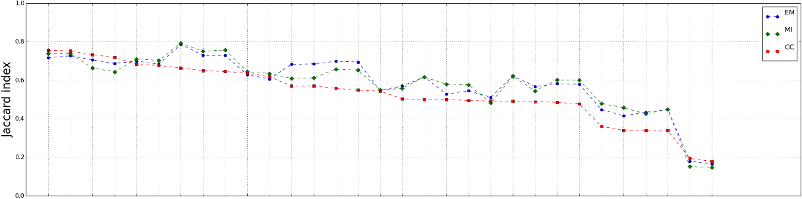

**References:**

[1] Arce-Santana, E. et al., In Proc. 6th PSIVT 2013, 36-47.

[2] Roche, A. et al., In Proc. MICCAI 1998, 1115-1124.

[3] Avants, B. et al., Medical Image Analysis 2008. 12(1): 26-41.

[4] Klein, A., et al. NeuroImage 2009. 46(3): 786-802.

[5] Garyfallidis, E. et al., Frontiers in Neuroinformatics 2014. 8:8.

[6] Cocosco, C.A. et al., NeuroImage. 5(4) Part 2/4, S425, 1997.