* Double click “run_app.vbs” to start the application.

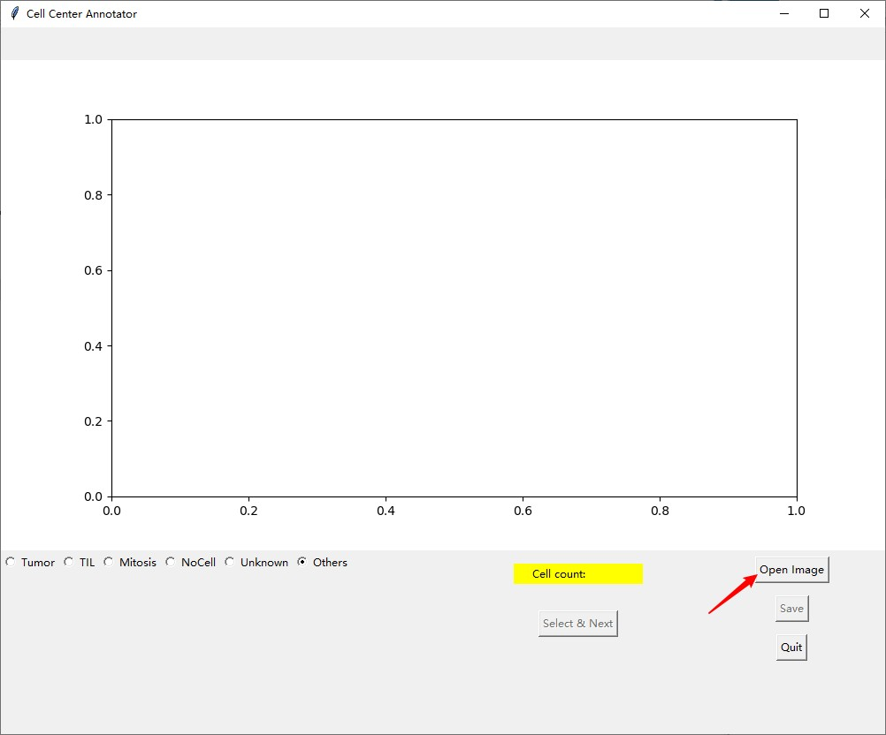

* Click the “Open Image” button to select one image.

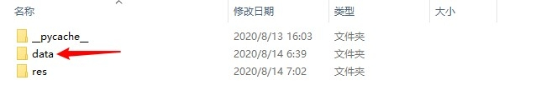

* Open the folder “data”.

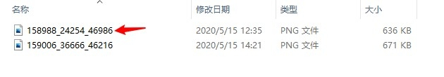

* Select one image.

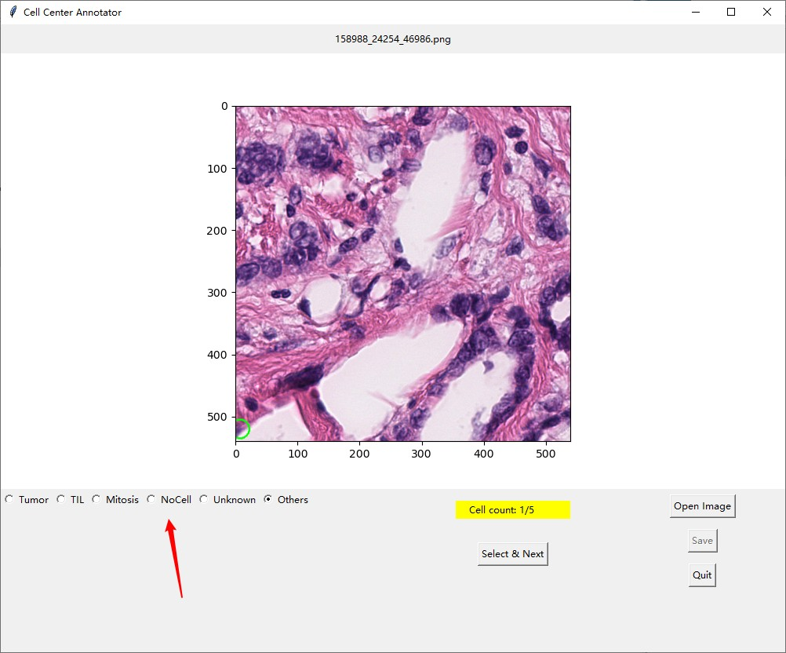

* The above image shows the interface with the opened image. The available cell will be circled out by a green circle. The user could classify this circled cell based on the image. Then select the cell type.

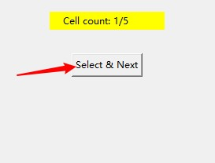

* Click “Select & Next” button to record the class information and change to the next available cell.

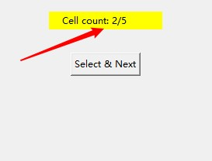

* The yellow background region displays the progress.

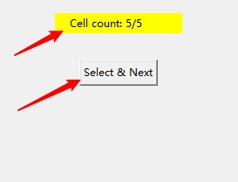

* When reach the last cell, click “Select & Next” button to record the annotation and there will be a dialogue window.

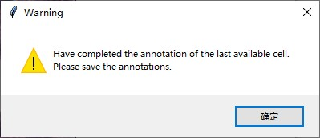

* This window confirms the completion of the annotation and prompts to save.

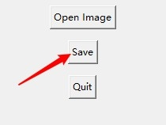

* Click “Save” button to save the annotation file.

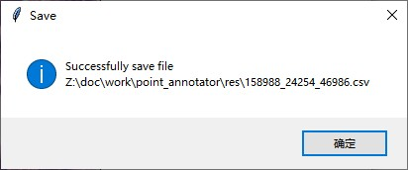

* The window prompts the saving information. Please note the default saving folder is “./res”.
* Then the user could click “Open Image” button to import another image to start another annotation.

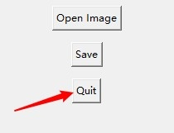

* Besides, the user could use “Quit” button to close the application window.